September 13, 2016 HILLARY FABULIST

Twenty years ago NY Times columnist William Safire tagged Hillary Clinton as a "congenital liar." The weekend's health event was just another example of the fact that the default position of HRC is always a lie. John Hinderaker posts on her LSAT tale where she claims to have been harassed taking the law school test by a bunch of (dare I say it) deplorables. It's a little thing but illustrative of her continuing ongoing mendacity.
I am not a psychiatrist, and am not qualified to say what causes Hillary Clinton to lie constantly, with almost every breath she takes.

Gersh Kuntzman in the Daily News opines;
... Why not just admit the pneumonia? It's not as if there's a stigma to catching it. After all, Hillary Clinton's full-time job right now is rushing from place to place on those tube-shaped petri dishes called airplanes, speaking for hours on end with little sleep, and then diving into crowds of often unwashed deplorables thrusting babies into her face.
If she didn't catch some sort of bug, I'd say she'd need to be examined to ensure that she's human.
So instead of being forced to admit her own frailty, Clinton concocted a lie: it's just allergies, you know, which come from happy things like flowers. It's not a disease that brings to mind decay, 19th century industrial slums and physical weakness.
The larger question that will be raised by the "health scare" is the one that has dogged Clinton forever: Why does she create cover stories rather than reveal the truth? At many critical turns in her lengthy career, Clinton has chosen obfuscation rather than revelation. ...

He was one of the first to say it. Scott Adams in the Dilbert Blog reviews some of his past posts on Hillary's health. This was from last December.
... One of the skills a hypnotist has to master is reading people’s inner thoughts based on their body language. That’s a common skill for people in the business world too, but hypnotists go deeper than looking at crossed arms and furrowed brows. We learn to look for subtle changes in breathing patterns, tiny changes in muscle tone, variations in skin color (blushing or not), word choice, pupil dilation, and more. I assume law enforcement people look for similar tells when doing interrogations.
As regular readers know, I’m a trained hypnotist. And to me, Hillary Clinton looks as if she is hiding a major health issue. If you read Malcolm Gladwell’s book, Blink, you know that so-called “experts” can sometimes instantly make decisions before they know why. In my case, I am going to make an “expert” hypnotist prediction about Hillary Clinton without knowing exactly which clues I am picking up, or whether I am hallucinating them.
Prediction: I’ll put the odds at 75% that we learn of an important Clinton health issue before the general election. That estimate is based on my own track record of guessing things about people without the benefit of knowing why. I think Trump is picking up the same vibe. He has already questioned Clinton’s “stamina.” ...

David Harsanyi writes on Ricky Ray Rector's contribution to the Clinton future. An example of deplorable.

... Enter Ricky Ray Rector.
In 1981, Rector shot a man for refusing to allow his friend into a nightclub. Later, he shot another friend of his — a police officer — who came to arrest him. Rector then performed a partial lobotomy by shooting himself in the head in a suicide attempt.
Whether you support the death penalty or not, there was a plausible contention that Rector was unable to put forward a proper defense because he couldn’t even comprehend the charges against him. For his last meal, Rector reportedly asked the guard to put aside his pecan pie because he was “saving it for later.”
In 2002, the Supreme Court ruled that putting mentally retarded people to death was “cruel and unusual.” But in 1993, the Clintons, with wilting poll numbers, saw an opportunity to show Bill was tough on crime and move beyond the Flowers’ fiasco.
In 1979, as governor Clinton commuted the sentence of a mentally ill murderer named James Surridge. He would go on to kill again. Now, during the 1992 primary race, faced with the prospects of losing his shot at the presidency, Clinton refused to even issue an order of executive clemency — not freedom — to stop the execution of another one.
That alone might have been understandable. This time, though, Clinton — I should say the Clintons — made a big show of traveling back to Little Rock in the midst of the campaign for the presidency so Bill could personally preside over the execution. It was covered by every major media outlet in the nation.
Rector was executed by lethal injection, ...

Leaving Hillary's lies, Sputnik News posts on proof Google is in the tank for HRC. This is long and will take some time to absorb, but it is written by a research psychologist, a Clinton supporter by the way, who is aghast at the lengths Google will go to support Hillary. The comparisons of three search engines, Bing, Yahoo, and Google will convince you to stop using Google as a search engine. For example if you enter "when is the election" Google will provide a picture of a healthy looking Hillary. No Trump, just her.
... For the record, I am a moderate politically, and I support Hillary Clinton for president. I do not believe, however, that it would be right for her to win the presidency because of the invisible, large-scale manipulations of a private company. That would make democracy meaningless, and that is why I am trying to keep the public informed about my research findings.Biased search rankings can swing votes and alter opinions, and a new study shows that Google's autocomplete can too. ...
A scientific study I published last year showed that search rankings favoring one candidate can quickly convince undecided voters to vote for that candidate — as many as 80 percent of voters in some demographic groups. My latest research shows that a search engine could also shift votes and change opinions with another powerful tool: autocomplete.
Because of recent claims that Google has been deliberately tinkering with search suggestions to make Hillary Clinton look good, this is probably a good time both to examine those claims and to look at my new research. As you will see, there is some cause for concern here.
In June of this year, Sourcefed released a video claiming that Google's search suggestions — often called "autocomplete" suggestions — were biased in favor of Mrs. Clinton. The video quickly went viral: the full 7-minute version has now been viewed more than a million times on YouTube, and an abridged 3-minute version has been viewed more than 25 million times on Facebook.
The video's narrator, Matt Lieberman, showed screen print after screen print that appeared to demonstrate that searching for just about anything related to Mrs. Clinton generated positive suggestions only. This occurred even though Bing and Yahoo searches produced both positive and negative suggestions and even though Google Trends data showed that searches on Google that characterize Mrs. Clinton negatively are quite common — far more common in some cases than the search terms Google was suggesting. Lieberman also showed that autocomplete did offer negative suggestions for Bernie Sanders and Donald Trump.
"The intention is clear," said Lieberman. "Google is burying potential searches for terms that could have hurt Hillary Clinton in the primary elections over the past several months by manipulating recommendations on their site." ...
... Since then, my associates and I at the American Institute for Behavioral Research and Technology (AIBRT) — a nonprofit, nonpartisan organization based in the San Diego area — have been systematically investigating Lieberman's claims. What we have learned has generally supported those claims, but we have also learned something new — something quite disturbing — about the power of Google's search suggestions to alter what people search for. ...
... The impact of biased search rankings on opinions, which we call the Search Engine Manipulation Effect (SEME), is one of the largest effects ever discovered in the behavioral sciences, and because it is invisible to users, it is especially dangerous as a source of influence. Because Google handles 90 percent of search in most countries and because many elections are very close, we estimate that SEME has been determining the outcomes of upwards of 25 percent of the national elections in the world for several years now, with increasing impact each year. This is occurring, we believe, whether or not Google's executives are taking an active interest in elections; all by itself, Google's search algorithm virtually always ends up favoring one candidate over another simply because of "organic" search patterns by users. When it does, votes shift; in large elections, millions of votes can be shifted. You can think of this as a kind of digital bandwagon effect.
The new effect I have described in this essay — a search suggestion effect — is very different from SEME but almost certainly increases SEME's impact. If you can surreptitiously nudge people into generating search results that are inherently biased, the battle is half won. Simply by including or suppressing negatives in search suggestions, you can direct people's searches one way or another just as surely as if they were dogs on a leash, and you can use this subtle form of influence not just to alter people's views about candidates but about anything.
Google launched autocomplete, its search suggestion tool, in 2004 as an opt-in that helped users find information faster. Perhaps that's all it was in the beginning, but just as Google itself has morphed from being a cool high-tech anomaly into what former Google executive James Whittaker has called a "an advertising company with a single corporate-mandated focus," so has autocomplete morphed from being a cool and helpful search tool into what may be a tool of corporate manipulation. By 2008, not only was autocomplete no longer an opt-in feature, there was no way to opt out of it, and since that time, through strategic censorship, it may have become a tool for directing people's searches and thereby influencing not only the choices they make but even the thoughts they think. ...
... Without whistleblowers or warrants, no one can prove Google executives are using digital shenanigans to influence elections, but I don't see how we can rule out that possibility. There is nothing illegal about manipulating people using search suggestions and search rankings — quite the contrary, in fact — and it makes good financial sense for a company to use every legal means at its disposal to support its preferred candidates.
Using the mathematical techniques Robertson and I described in our 2015 report in the Proceedings of the National Academy of Sciences, I recently calculated that SEME alone can shift between 2.6 and 10.4 million votes in the upcoming US presidential race without anyone knowing this has occurred and without leaving a paper trail.
I arrived at those numbers before I knew about the power search suggestions have to alter searches. The new study suggests that autocomplete alone might be able to shift between 800,000 and 3.2 million votes — also without anyone knowing this is occurring.
Perhaps even more troubling, because Google tracks and monitors us so aggressively, Google officials know who among us is planning to vote and whom we are planning to vote for. They also know who among us are still undecided, and that is where the influence of biased search suggestions and biased search rankings could be applied with enormous effect.

Very good cartoons today.

Power Line
Hillary’s LSAT Lie
by John Hinderaker
I noticed a news story a day or two ago in which Hillary Clinton described taking the Law School Admission Test (LSAT) as a senior at Wellesley. Hmm, I thought: what Hillary says can’t possibly be true. But I got distracted, and am now writing about it belatedly, preceded by Ann Coulter among others.
Hillary told the story of how she took the LSAT in the face of a barrage of male chauvinism to Humans of New York:
I was taking a law school admissions test in a big classroom at Harvard.
Hillary didn’t go to Harvard, she went to Wellesley. Did students for many miles around take the LSAT at Harvard? That seems unlikely, but I can’t say for sure that Hillary’s account is untrue.
My friend and I were some of the only women in the room.
Oh, come on. Hillary was a senior during the 1968-1969 school year, and presumably took the LSAT in the fall of 1968. Women were not exactly pioneers in the law business at that time. Seven percent of the first year law class of 1969 was female, a percentage that rose rapidly over the next few years.
I was feeling nervous. I was a senior in college. I wasn’t sure how well I’d do. And while we’re waiting for the exam to start, a group of men began to yell things like: ‘You don’t need to be here.’ And ‘There’s plenty else you can do.’ It turned into a real ‘pile on.’
I don’t believe this. It was just two years later when I took the LSAT, at Dartmouth, and it is inconceivable to me that men shouted such things at women who showed up to take the test anywhere in 1968, let alone at Harvard. This is an after-the-fact fantasy of the supposedly horrible pre-feminist days.
Now we come to the demonstrable lie:
One of them even said: ‘If you take my spot, I’ll get drafted, and I’ll go to Vietnam, and I’ll die.’ And they weren’t kidding around. It was intense. It got very personal.
When I first read this, I thought it was ridiculous. College students got deferments during the Vietnam era, but graduate students, including law students, didn’t. Hillary’s account made no sense. Ann Coulter corrected my memory: there was a time when graduate students were immune from the draft, but that era was over before Hillary took the LSAT:
[H]er senior year began in autumn, 1968. She says she was a senior during this harrowing experience, which is when the LSAT is normally taken. But the LBJ administration ended all graduate school deferments on February 16, 1968, except for medical, dental and divinity students, when Hillary was still a junior in college.
That is correct. So the climax of Hillary’s story: “If you take my spot, I’ll get drafted, and I’ll go to Vietnam”–is a lie. Trust me, anyone taking the LSAT in the fall of 1968 knew exactly what the law was on draft deferments for graduate school.
It turns out that Hillary has told this lie before. In May 2016, she told the identical tale, in strikingly similar words to New York Magazine:
She told a story about the time she and a friend from Wellesley sat for the LSAT at Harvard. “We were in this huge, cavernous room,” she said. “And hundreds of people were taking this test, and there weren’t many women there. This friend and I were waiting for the test to begin, and the young men around us were like, ‘What do you think [you’re] doing? How dare you take a spot from one of us?’ It was just a relentless harangue.” Clinton and her friend were stunned. They’d spent four safe years at a women’s college, where these kinds of gender dynamics didn’t apply.
“I remember one young man said, ‘If you get into law school and I don’t, and I have to go to Vietnam and get killed, it’s your fault.’”
So it wasn’t a slip of the tongue, or a spontaneous flight of fancy. It was part of Hillary’s repertoire of lies.
I am not a psychiatrist, and am not qualified to say what causes Hillary Clinton to lie constantly, with almost every breath she takes. My amateur guess is that she suffers from a deep-seated insecurity that comes from having been overrated through almost all of her life. She apparently feels a need to make up stories that put her in a heroic light–named after the world’s most famous mountain climber! almost shot down over Bosnia! turned down by the sexist Marines! left the White House dead broke and lifted ourselves up by our bootstraps! a pioneer feminist beset by baying male chauvinist hounds!
Far from these flights of fancy, the real Hillary is a small, unoriginal, not very talented woman who was fortunate enough (in some respects) to marry Bill Clinton. Pretty much everything else is a lie.

NY Daily News
Clinton’s cover story for her pneumonia diagnosis further proves her first instinct is to lie
by Gersh Kuntzman
Hillary Clinton will beat pneumonia. But she won't beat a condition far more fatal: untrustworthiness.
In the hours after the Clinton campaign finally came clean (or did it?) Sunday about the candidate's pneumonia diagnosis two days earlier, the only question that mattered was, as NBCNews.com put it, "Clinton's core vulnerability is that most Americans don't find her honest or trustworthy. Will voters now feel like they've been misled about her health?"
Why is this even a question? Of course it raises trust issues. Worse, it plays into the hands of Clinton foes who assume everything she says is already a lie.
Let's go over the latest Clinton error of judgment:
After a coughing fit and during an otherwise false internet frenzy over her health fanned in part by Rudy Giuliani, Clinton chose to not tell the public that she had been diagnosed with pneumonia on Friday.
Instead, the coughing had been attributed to seasonal allergies.
Why not just admit the pneumonia? It's not as if there's a stigma to catching it. After all, Hillary Clinton's full-time job right now is rushing from place to place on those tube-shaped petri dishes called airplanes, speaking for hours on end with little sleep, and then diving into crowds of often unwashed deplorables thrusting babies into her face.
If she didn't catch some sort of bug, I'd say she'd need to be examined to ensure that she's human.
So instead of being forced to admit her own frailty, Clinton concocted a lie: it's just allergies, you know, which come from happy things like flowers. It's not a disease that brings to mind decay, 19th century industrial slums and physical weakness.
The larger question that will be raised by the "health scare" is the one that has dogged Clinton forever: Why does she create cover stories rather than reveal the truth? At many critical turns in her lengthy career, Clinton has chosen obfuscation rather than revelation.

(One caveat: She is running against a man who says he is successful in business yet has not released his taxes and who lauds the leadership style of a dictator who kills opponents and invades neighbors, so it's not exactly a great year for honesty.)
A short Clinton list:
The Goldman-Sachs speeches: What could she possibly have said to investment bankers that the public just can't know? Probably nothing. So why hide it?
Classified documents: She is still saying she never received or sent classified material. PolitiFact calls that false.
The email server itself: Why delete tens of thousands of emails off your private server? Hitting "delete" means "I don't want the public to see this." Telling the public "I don't want you to see this" can be translated to, "I am not trustworthy."
Bill Clinton's infidelity: It's perfectly acceptable to stay with a cheating husband, but it's not acceptable to smear people who are telling the truth about said husband as part of a "vast right-wing conspiracy." And the actual existence of the "vast right-wing conspiracy" doesn't justify the lie, either.
Landing under sniper fire in Bosnia in 1996? It never happened, so why say it did? Being forced to admit the lie years later was far more damaging than having the public know at the time that as First Lady, Hillary Clinton was never fired upon but was, instead, given a bouquet of flowers by a young girl.
Missing law firm records from the 1970s? She said she was a minor player in Whitewater. But if that was true, why hide documents?
The list goes on: Her fixed cattle futures investments, her denials that her husband sold a presidential pardon to Marc Rich, her explanation of why the White House travel office staff was fired and replaced with Clinton friends, defending the false narrative about Benghazi.
In all cases, Hillary Clinton's first instinct was to deny, hide or create a cover story. Many times, her cover story is completely believable or even reasonable. But sometimes it isn't. And therein lies the problem because once a cover story is revealed to be a lie, no one can believe any of the cover stories anymore.
Or, as Mark Twain supposedly once said, "If you tell the truth, you don't have to remember anything."
So do you think the public — nearly 60% which doesn't trust her already, according to polls — will again feel "misled" by Hillary Clinton and her failure to be honest about her health?

Dilbert's Blog
Checking My Predictions About Clinton's Health
by Scott Adams
In a blog post I wrote on December 27th, 2015, I said this…
Bonus Thought 1: One of the skills a hypnotist has to master is reading people’s inner thoughts based on their body language. That’s a common skill for people in the business world too, but hypnotists go deeper than looking at crossed arms and furrowed brows. We learn to look for subtle changes in breathing patterns, tiny changes in muscle tone, variations in skin color (blushing or not), word choice, pupil dilation, and more. I assume law enforcement people look for similar tells when doing interrogations.
As regular readers know, I’m a trained hypnotist. And to me, Hillary Clinton looks as if she is hiding a major health issue. If you read Malcolm Gladwell’s book, Blink, you know that so-called “experts” can sometimes instantly make decisions before they know why. In my case, I am going to make an “expert” hypnotist prediction about Hillary Clinton without knowing exactly which clues I am picking up, or whether I am hallucinating them.
Prediction: I’ll put the odds at 75% that we learn of an important Clinton health issue before the general election. That estimate is based on my own track record of guessing things about people without the benefit of knowing why. I think Trump is picking up the same vibe. He has already questioned Clinton’s “stamina.”

On December 29th, 2015 I blogged that Trump would be seen as “running unopposed” before election day. I mentioned Clinton’s health as a possible reason.
While I’m on the topic, I’ll add another prediction to the Master Persuader series. I predict that by the time Trump is in the general election and running against Clinton, you will start hearing that Trump (Lucky Hitler) is – for all practical purposes – “running unopposed” as Clinton’s poll numbers plummet.
That can happen in a variety of ways. One way is if Clinton’s health or legal issues rise to the point of being disqualifying, and Trump persuades us to think about those things more than we think about anything else. Once you imagine there is one candidate in the race who is eligible and one who might not survive the term, or might be in jail, you start to imagine it as a one-person race.
And you will. That’s how you get a landslide.
Look for the words “running unopposed” in pundit articles and quotes within a few months of election day. And it still counts if it started here, because it won’t catch on unless it actually fits.
On April 29th of 2016 I expanded on the thought in this post.
I have blogged and tweeted that Hillary Clinton looks unhealthy to me. And I have mentioned on Twitter that one of the skills of a hypnotist is identifying subtle bodily changes. Observation is a huge part of a hypnotist’s skill. You look for micro changes in muscle tone, breathing, posture, and anything else that can tell you whether your technique is working or you need to quickly pivot to a new approach. Think of it as rapid A-B testing on humans. And like any skill, one gets better with practice. I have more than three decades of practice for this specific skill.
What I see in Clinton’s health is an unusual level of variability. Sometimes her eyes bug out, sometimes they are tired and baggy. Sometimes she looks puffy, sometimes not. It would be easy to assume fatigue is the important variable. And that is clearly a big factor. But notice that the other candidates have little variability in their physicality. Trump always looks like Trump. Cruz always looks like Cruz, and so on. Sometimes we think we can detect fatigue in their answers, but visually the other candidates appear about the same every day.
Clinton, on the other hand, looks like an entirely different person every few days. That suggests some greater variability in her health. And that’s probably a tell for medications that are waxing and waning but rarely at the ideal levels. Or perhaps the underlying conditions have normal variability. Or both.
Under normal circumstances it would be deeply irresponsible for a cartoonist to give a medical diagnosis to a stranger he hasn’t met. I trust you to ignore my medical opinions. I do this to build a record of my persuasion-related predictions and to show you the method.
I give Clinton a 50% chance of making it to November with sufficiently good health to be considered a viable president. Judging from her performance on the campaign trail, she is managing her health effectively to get the job done. But I would think most people who run for president end up sacrificing their health in some measure. The big question is how much buffer she has left.
To be clear, there is no dependable evidence of Clinton having an undisclosed major health issue. But it looks that way to observers.

The Federalist
That Time The Clintons Lied About Bill’s Mistress And Then Let A Mentally Disabled Man Be Executed To Distract Us
Maybe someone should ask Hillary what happened?
by David Harsanyi
One of the most irritating aspects of the 2016 presidential election — and God knows there are so many to choose from — is this moral superiority Democrats display over the GOP’s unfortunate nomination of Donald Trump. As if choosing one of the most mendacious and corrupt people in American politics makes them exemplars of responsible governance.
Younger voters who weren’t around in the 1990s may not be fully aware of the range and depth of the Clintons’ duplicitous behavior. We’re getting a little taste of it now, but it’s worth remembering that these are people who used the execution of a man with a partial lobotomy to divert attention away from Bill’s lying about an extramarital affair.
The context:
In 1992, Gennifer Flowers, a former Arkansas news anchor and actress, claimed she and Clinton had engaged in a 12-year sexual relationship. As usual, Bill was adamant about his innocence. The Clintons appeared on a special post-Super Bowl edition of “60 Minutes,” then the highest-rated show on television, to deny it. Host Steve Kroft offered the Arkansas governor multiple chances to “level with the American people,” and the future president, who never really paid a price for his dalliances, reiterated his lie.
Hillary was there too, of course, abetting her husband as he smeared a woman she almost certainly knew (or, at the very least, suspected) was telling the truth. That’s what Hillary always did. According to Carl Bernstein in his “exhaustive biography,” Hillary was a full political partner — she boasted that voting for Bill meant “buy one, get one free” — who spearheaded an “aggressive” campaign to “discredit” Flowers.
This was nothing new. George Stephanopoulos, a Clinton loyalist, noted in his book that Hillary had said “We have to destroy her story” when Connie Hamzy, another woman who claims to have had an affair with Hillary’s husband, came forward in 1991.
As we would soon learn, the Clintons were exceptionally gifted at defaming and demonizing their accusers (although if that didn’t work they could always pay them off). The problem in this case was that Flowers had made tapes of telephone conversations where Bill Clinton discussed how to cover up the affair. “All you got to do is deny it,” Bill tells her.
Although he would perjure himself when asked about a more infamous affair, Bill knew enough to admit to this one under oath in 1997. In 1992, though, the couple was in trouble. While most Democrats were familiar with his proclivities, straight-out lying to the American public on national television — a habit the couple hasn’t been able to kick since then — was not playing well. Add to the Flowers scandal revelations of Bill’s draft-dodging (still a big political deal back in those days) and the Clintons’ poll numbers took a dramatic hit. Something had to be done.
There’s another aspect to the 1992 presidential campaign worth remembering, as well: Many liberals were (and I guess some still are) under the impression that Michael Dukakis was trounced in his 1988 bid for the White House because of a George H.W. Bush ad depicting rapist Willie Horton in a revolving door of prison furloughs (by the way: much like people conveniently forget Hillary’s supporters first used the “birther” smear on Barack Obama, Al Gore’s campaign first used Willie Horton-style furloughs as an issue against Dukakis in 1988). Democrats were obsessed with not being seen as weak on crime.
Enter Ricky Ray Rector.
In 1981, Rector shot a man for refusing to allow his friend into a nightclub. Later, he shot another friend of his — a police officer — who came to arrest him. Rector then performed a partial lobotomy by shooting himself in the head in a suicide attempt.
Whether you support the death penalty or not, there was a plausible contention that Rector was unable to put forward a proper defense because he couldn’t even comprehend the charges against him. For his last meal, Rector reportedly asked the guard to put aside his pecan pie because he was “saving it for later.”
In 2002, the Supreme Court ruled that putting mentally retarded people to death was “cruel and unusual.” But in 1993, the Clintons, with wilting poll numbers, saw an opportunity to show Bill was tough on crime and move beyond the Flowers’ fiasco.
In 1979, as governor Clinton commuted the sentence of a mentally ill murderer named James Surridge. He would go on to kill again. Now, during the 1992 primary race, faced with the prospects of losing his shot at the presidency, Clinton refused to even issue an order of executive clemency — not freedom — to stop the execution of another one.
That alone might have been understandable. This time, though, Clinton — I should say the Clintons — made a big show of traveling back to Little Rock in the midst of the campaign for the presidency so Bill could personally preside over the execution. It was covered by every major media outlet in the nation.
Rector was executed by lethal injection, although it took doctors almost an hour to find a proper vein. When a friend told Clinton about the delay, after spending a couple of minutes on the topic he moved on to more pressing matters: his “execution.”
From a 1993 Marshall Frady piece in a The New Yorker (not online; read Christopher Hitchens’ “No One Left To Lie To” for more on the interaction):
Staley [friend of Clinton’s] then told him, ‘Bill, I’m so sorry. We’ve had two executions this week, haven’t we.’ She meant the Flowers allegations. ‘He just groaned,’ she remembers, and they moved on to discussing that topic. Ultimately, she says, the conversation wound up ‘much more about the Jennifer Flowers matter’ than about what was happening to Rector at that moment down at Cummins.
So an American presidential candidate used a tragedy, and one of the dead bodies it would produce, as a political prop. We would later learn there was almost nothing the Clintons wouldn’t do to divert attention from their incessant scandals (in many of which Hillary played an integral part).
Hillary was always recalibraing her position on the death penalty to extract maximum political reward. In 1976, while leading a legal aid group at the University of Arkansas, Hillary claims to have helped save Henry Giles from the electric chair. Hillary stopped taking this position on the death penalty when her husband ran for Arkansas attorney general. In subsequent years, she supported capital punishment, even lobbying Congress to make certain federal crimes eligible for the death penalty in 1994. In 1996, when crime was again at the forefront of a national debate, law-and-order Hillary went out on the road for her husband and warned Americans about “superpredator” kids and so on.
As a carpetbagger Senate candidate in New York, Hillary claimed her position on the death penalty was “unenthusiastic support.” Today she supports the death penalty in limited cases and complains about “mass incarceration” that were prompted by Clinton-era policies.
Since Hillary is now running on a record heavily reliant on her role in her husband’s presidency; and since she supported the execution of Rector – “buy one, get one free” — perhaps someone should ask her to explain the incident. And since we have no compunction delving into the life and times of Donald Trump — nor should we — perhaps someone could set aside a few moments to query Hillary, women’s rights advocate, on what role she played in slandering her husband’s many mistresses?

Sputnik News
Research Proves Google Nanipulates Millions to Favor Clinton
by Robert Epstein

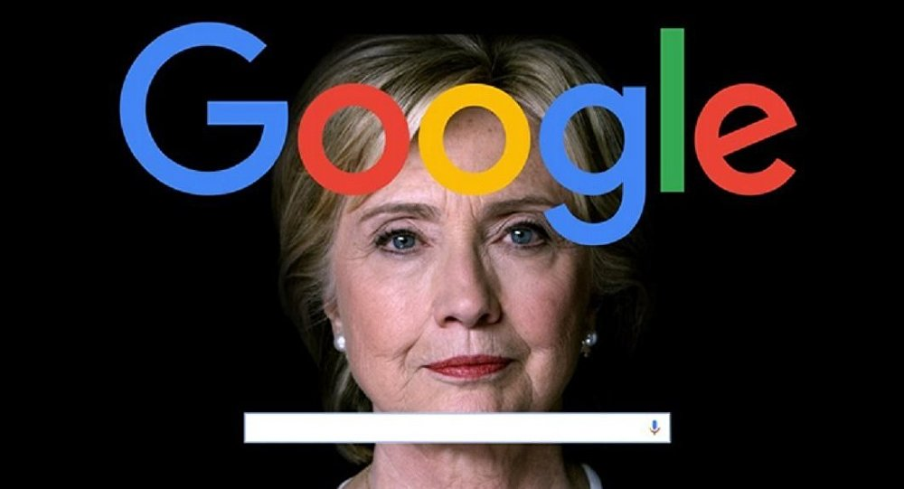

In this exclusive report, distinguished research psychologist Robert Epstein explains the new study and reviews evidence that Google's search suggestions are biased in favor of Hillary Clinton. He estimates that biased search suggestions might be able to shift as many as 3 million votes in the upcoming presidential election in the US.
Biased search rankings can swing votes and alter opinions, and a new study shows that Google's autocomplete can too.
A scientific study I published last year showed that search rankings favoring one candidate can quickly convince undecided voters to vote for that candidate — as many as 80 percent of voters in some demographic groups. My latest research shows that a search engine could also shift votes and change opinions with another powerful tool: autocomplete.
Because of recent claims that Google has been deliberately tinkering with search suggestions to make Hillary Clinton look good, this is probably a good time both to examine those claims and to look at my new research. As you will see, there is some cause for concern here.
In June of this year, Sourcefed released a video claiming that Google's search suggestions — often called "autocomplete" suggestions — were biased in favor of Mrs. Clinton. The video quickly went viral: the full 7-minute version has now been viewed more than a million times on YouTube, and an abridged 3-minute version has been viewed more than 25 million times on Facebook.
The video's narrator, Matt Lieberman, showed screen print after screen print that appeared to demonstrate that searching for just about anything related to Mrs. Clinton generated positive suggestions only. This occurred even though Bing and Yahoo searches produced both positive and negative suggestions and even though Google Trends data showed that searches on Google that characterize Mrs. Clinton negatively are quite common — far more common in some cases than the search terms Google was suggesting. Lieberman also showed that autocomplete did offer negative suggestions for Bernie Sanders and Donald Trump.
"The intention is clear," said Lieberman. "Google is burying potential searches for terms that could have hurt Hillary Clinton in the primary elections over the past several months by manipulating recommendations on their site."
Google responded to the Sourcefed video in an email to the Washington Times, denying everything. According to the company's spokesperson, "Google Autocomplete does not favor any candidate or cause." The company explained away the apparently damning findings by saying that "Our Autocomplete algorithm will not show a predicted query that is offensive or disparaging when displayed in conjunction with a person's name."
Since then, my associates and I at the American Institute for Behavioral Research and Technology (AIBRT) — a nonprofit, nonpartisan organization based in the San Diego area — have been systematically investigating Lieberman's claims. What we have learned has generally supported those claims, but we have also learned something new — something quite disturbing — about the power of Google's search suggestions to alter what people search for.
Lieberman insisted that Google's search suggestions were biased, but he never explained why Google would introduce such bias. Our new research suggests why — and also why Google's lists of search suggestions are typically much shorter than the lists Bing and Yahoo show us.
Our investigation is ongoing, but here is what we have learned so far:
Bias in Clinton's Favor

Can Google Tip the Scales on the US Presidential Election Without Anyone Knowing?
To test Lieberman's claim that Google's search suggestions are biased in Mrs. Clinton's favor, my associates and I have been looking at the suggestions Google shows us in response to hundreds of different election-related search terms. To minimize the possibility that those suggestions were customized for us as individuals (based on the massive personal profiles Google has assembled for virtually all Americans), we have conducted our searches through proxy servers — even through the Tor network — thus making it difficult for Google to identify us. We also cleared the fingerprints Google leaves on computers (cache and cookies) fairly obsessively.
Google says its search bar is programmed to avoid suggesting searches that portray people in a negative light. As far as we can tell, this claim is false.
Generally speaking, we are finding that Lieberman was right: It is somewhat difficult to get the Google search bar to suggest negative searches related to Mrs. Clinton or to make any Clinton-related suggestions when one types a negative search term. Bing and Yahoo, on the other hand, often show a number of negative suggestions in response to the same search terms. Bing and Yahoo seem to be showing us what people are actually searching for; Google is showing us something else — but what, and for what purpose?
As for Google Trends, as Lieberman reported, Google indeed withholds negative search terms for Mrs. Clinton even when such terms show high popularity in Trends. We have also found that Google often suggests positive search terms for Mrs. Clinton even when such terms are nearly invisible in Trends. The widely held belief, reinforced by Google's own documentation, that Google's search suggestions are based on "what other people are searching for" seems to be untrue in many instances.
Google's Explanation
Google tries to explain away such findings by saying its search bar is programmed to avoid suggesting searches that portray people in a negative light. As far as we can tell, this claim is false; Google suppresses negative suggestions selectively, not across the board. It is easy to get autocomplete to suggest negative searches related to prominent people, one of whom happens to be Mrs. Clinton's opponent.
A picture is often worth a thousand words, so let's look at a few examples that appear both to support Lieberman's perspective and refute Google's. After that, we'll examine some counterexamples.
Before we start, I need to point out a problem: If you try to replicate the searches I will show you, you will likely get different results. I don't think that invalidates our work, but you will have to decide for yourself. Your results might be different because search activity changes over time, and that, in turn, affects search suggestions. There is also the "personalization problem." If you are like the vast majority of people, you freely allow Google to track you 24 hours a day. As a result, Google knows who you are when you are typing something in its search bar, and it sends you customized results.
For both of these reasons, you might doubt the validity of the conclusions I will draw in this essay. That is up to you. All I can say in my defense is that I have worked with eight other people in recent months to try to conduct a fair and balanced investigation, and, as I said, we have taken several precautions to try to get generic, non-customized search suggestions rather than the customized kind. Our investigation is also ongoing, and I encourage you to conduct your own, as well.
Let's start with a very simple search. The image below shows a search for "Hillary Clinton is " (notice the space after is) conducted on August 3rd on Bing, Yahoo, and Google. As you can see, both Bing and Yahoo displayed multiple negative suggestions such as "Hillary Clinton is a liar" and "Hillary Clinton is a criminal," but Google is showed only two suggestions, both of which were almost absurdly positive: "Hillary Clinton is winning" and "Hillary Clinton is awesome."
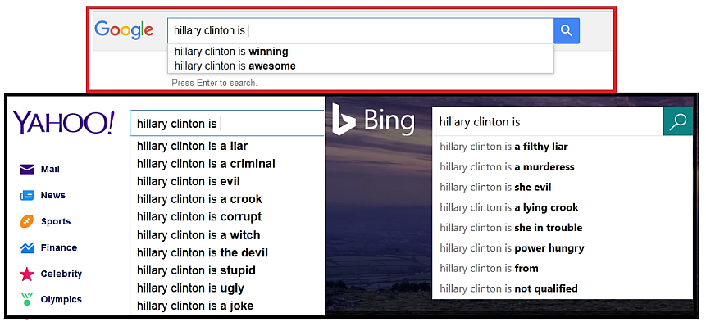
“Hillary Clinton is ”

To find out what people actually searched for, let's turn to Google Trends — Google's tabulation of the popularity of search results. Below you will see a comparison between the popularity of searching for "Hillary Clinton is a liar" and the popularity of searching for "Hillary Clinton is awesome." This image was also generated on August 3rd. "Hillary Clinton is a liar" was by far the more popular search term; hardly anyone conducted a search using the phrase, "Hillary Clinton is awesome."
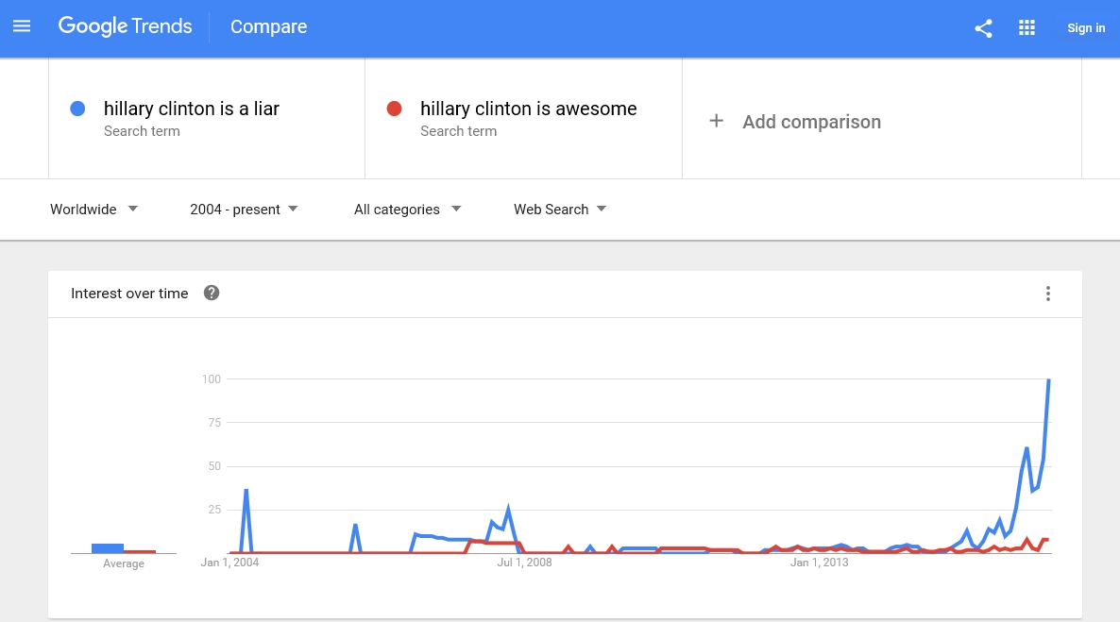
“Hillary Clinton is awesome.”

Okay, but Google admits that it censors negative search results; presumably, that is why we only saw positive results for Mrs. Clinton — even a result that virtually no one searched for. Does Google really suppress negative results? We have seen what happens with "Hillary Clinton is." What happens with "Donald Trump is "? (Again, be sure to include the space after is.)
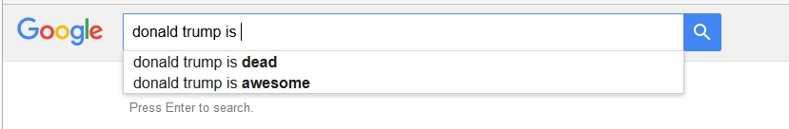
“Donald Trump is “?

In the above image, captured on August 8th, we again found the odd "awesome" suggestion, but we also saw a suggestion that appears to be negative: "Donald Trump is dead." Shouldn't a result like that have been suppressed? Let's look further.
Consider the following searches, conducted on August 2nd, for "anti Hillary" and "anti Trump." As you can see below, "anti Hillary" generated no suggestions, but "anti Trump" generated four, including "anti Trump cartoon" and "anti Trump song." Well, you say, perhaps there were no anti-Hillary suggestions to be made. But Yahoo — responding merely to "anti Hill" — came up with eight, including "anti Hillary memes" and "anti Hillary jokes."
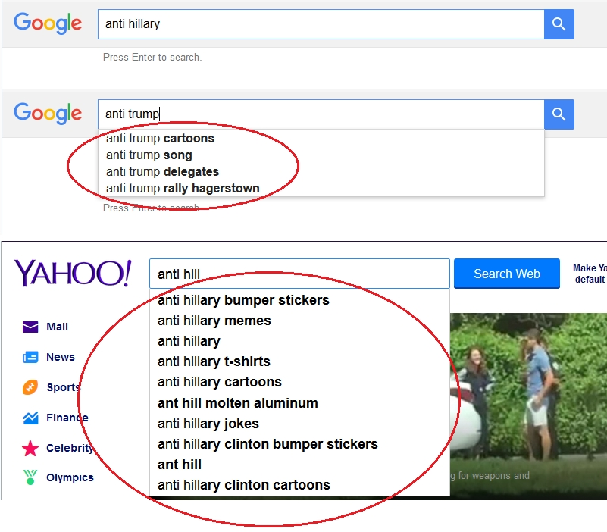
“anti Hillary” and “anti Trump.”

This seems to further refute Google's claim about not disparaging people, but let's dig deeper.
After Mrs. Clinton named Senator Tim Kaine to be her running mate, Mr. Trump dubbed him with one of his middle-school-style nicknames: "Corrupt Kaine." Sure enough, that instantly became a popular search term on Google, as this July 27th image from Trends confirms:
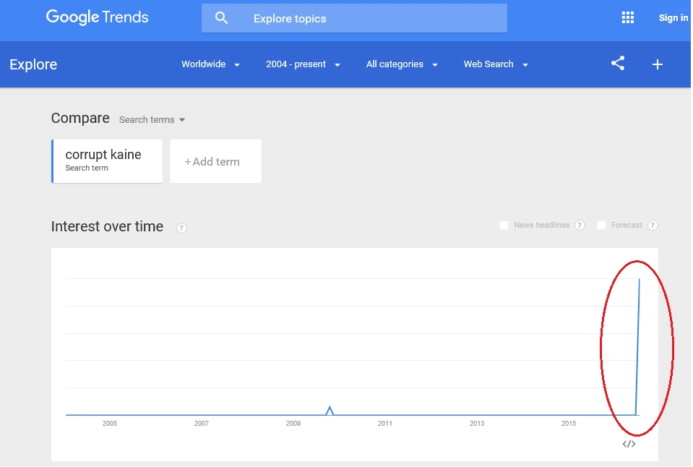
“Corrupt Kaine.”

Even so, as you can see in the image below, in response to "corrupt," the Google search bar showed us nothing about Senator Kaine, but it did show us both "Kamala" (Kamala Harris, attorney general of California) and "Karzai" (Hamid Karzai, former president of Afghanistan). If you clicked on the phrases "corrupt Kamala" and "corrupt Karzai," search results appeared that linked to highly negative web pages about Kamala Harris and Hamid Karzai, respectively.
Oddly enough, both on the day we looked up "corrupt Kaine" and more recently when I was writing this essay, Google Trends provided no popularity data for either "corrupt Kamala" or "corrupt Karzai." It is hard to imagine, in any case, that either search term has been popular in recent months. So why did the Google search bar disparage Attorney General Harris and President Karzai but not Mrs. Clinton?
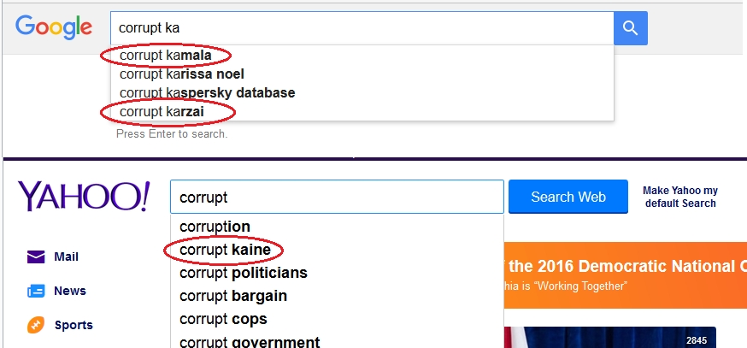
“corrupt Kaine”, “corrupt Kamala”, “corrupt Karzai.”

If you still have doubts about whether Google suggests negative searches for prominent people, see how Senators Cruz, Rubio and Sanders fared in the following searches conducted between July 23rd and August 2nd:
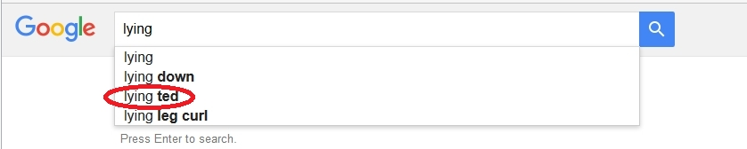
Searches conducted between July 23rd and August 2nd - Lying Ted

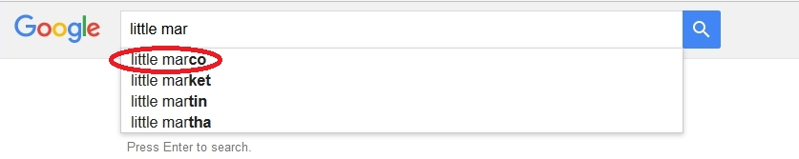
Searches conducted between July 23rd and August 2nd - Little Marco

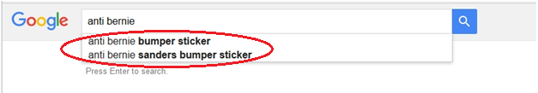
Searches conducted between July 23rd and August 2nd - Anti-Bernie

I could give you more examples, but you get the idea.
The brazenness of Google's search suggestion tinkering become especially clear when we searched for "crooked" — Mr. Trump's unkind nickname for Mrs. Clinton — on Google, Bing, and Yahoo on various dates in June and July. On Google the word "crooked" alone generated nothing for Mrs. Clinton, even though, once again, its popularity was clear on Google Trends. Now compare (in the image following the Trends graph) what happened on Bing and Yahoo:
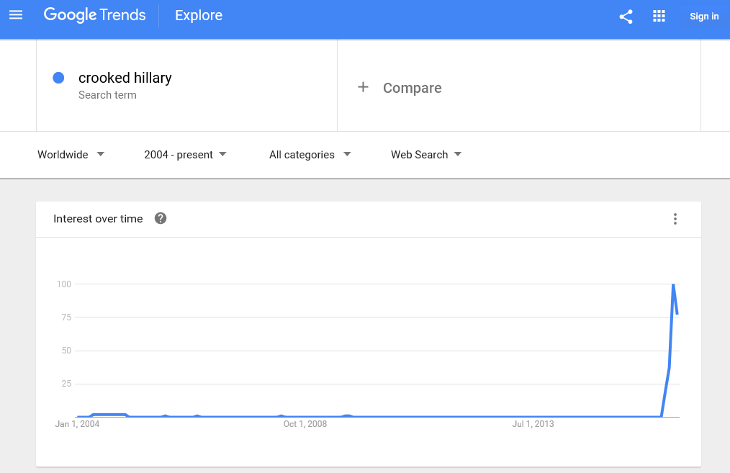
“crooked”

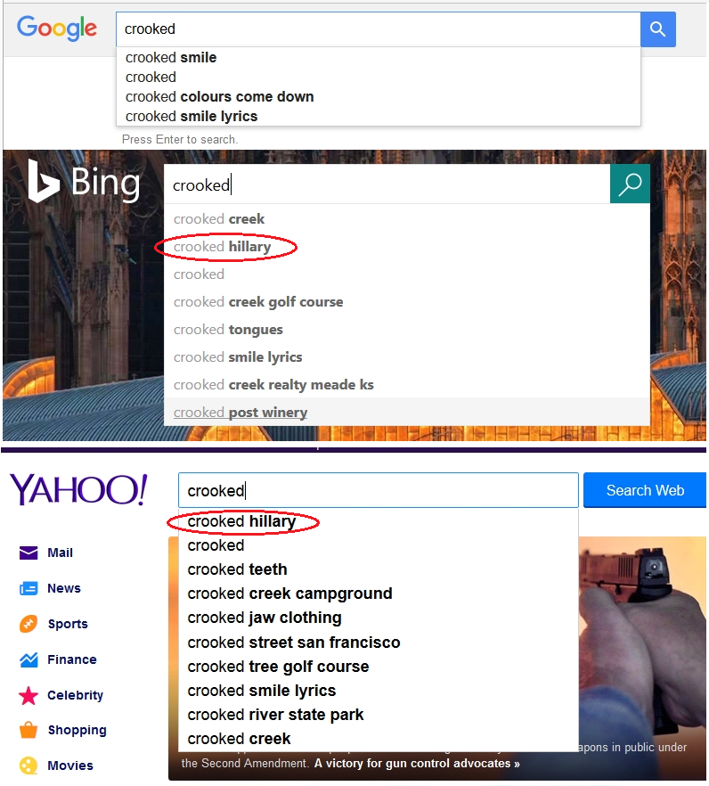
“crooked”

No surprise here. Consistent with Google's own search popularity data, Bing and Yahoo listed "crooked Hillary" near the top of their autocomplete suggestions.
The weird part came when we typed more letters into Google's search bar, trying to force it to suggest "crooked Hillary." On June 9th, I had to go all the way to "crooked H-I-L-L-A" to get a response, and it was not the response I was expecting. Instead of showing me "crooked Hillary," I was shown a phrase that I doubt anyone in the world has ever searched for — "crooked Hillary Bernie":
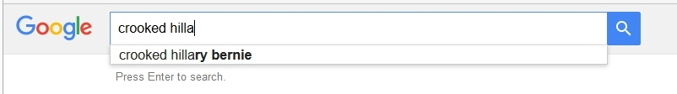
“crooked H-I-L-L-A”

Crooked Hillary Bernie? What the heck does that mean? Not much, obviously, but this is something my associates and I have found repeatedly: When you are able to get Google to make negative suggestions for Mrs. Clinton, they sometimes make no sense and are almost certainly not indicative of what other people are searching for.
Masking and Misleading
There are also indications that autocomplete isn't always pro-Clinton and isn't always anti-Trump, and in this regard the Sourcefed video overstated its case. While it is true, for example, that "anti Hillary" generated no suggestions in our study, both "anti Clinton" and "anti Hillary Clinton" did produce negative results when we search on August 8th, as you can see below:
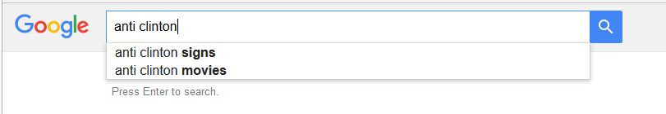
“anti Clinton”

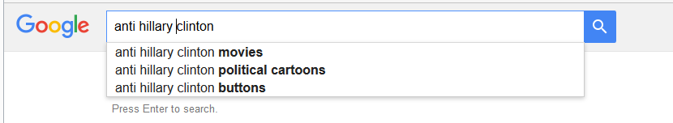
“anti Hillary Clinton”

At times, we were also able to generate neutral or at least partially positive results for Donald Trump. Consider this image, for example, which shows a search for "Donald Trump" on August 8th:
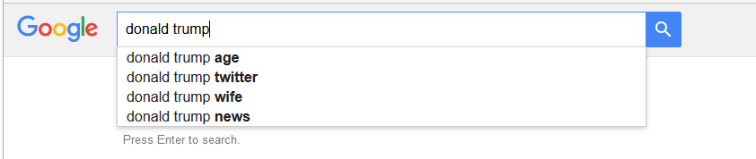
Search for “Donald Trump” on August 8th

If you believe Google can do no wrong and that it never favors one candidate over another (even though Google and its top executives donated more than $800,000 to Obama in 2012 and only $37,000 to Romney), so be it. But trying to be as objective as possible in recent months, my staff and I have concluded that when Google occasionally does give us unbiased election-related search suggestions, it might just be trying to confuse us. Let me explain.
When Ronald Robertson and I began conducting experiments on the power that biased search rankings have over voter preferences, we were immediately struck by the fact that few people could detect the bias in the search results we showed them, even when those results were extremely biased. We immediately wondered whether we could mask the bias in our results so that even fewer people could detect it. To our amazement, we found that a very simple mask — putting a search result that favored the opposing candidate into the third search position (out of 10 positions on the first page of search results) — was enough to fool all of our study participants into thinking they were seeing unbiased search results.
Masking a manipulation is easy, and Google is a master of obfuscation, as I explained a few years ago in my TIME essay, "Google's Dance." In the context of autocomplete, all you have to do to confuse people is introduce a few exceptions to the rule. So "anti Clinton" and "anti Hillary Clinton" produce negative search suggestions, while "anti Hillary" does not. Because those counter-examples exist, we immediately forget about the odd thing that's happening with "anti Hillary," and we also ignore the fact that "anti Donald" produces negative suggestions:
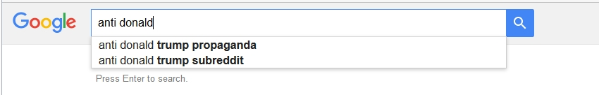
“anti Donald”

Meanwhile, day after day — at least for the few weeks we were monitoring this term — "anti Hillary" continued to produce no suggestions. Why would Google have singled out this one phrase to protect? As always, when you are dealing with the best number crunchers in the world, the answer has to do with numbers. What do you notice when you look below at the frequency of searches for the three anti-Hillary phrases?
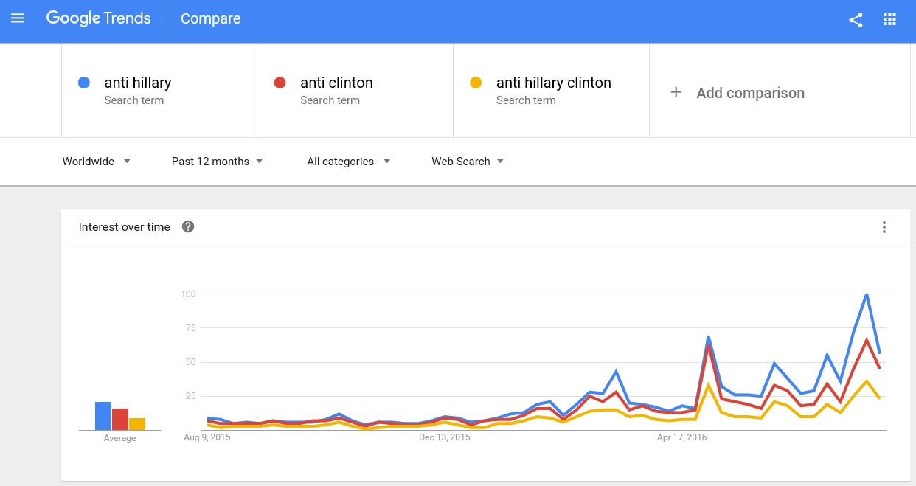
“anti Hillary”

That's right. "Anti Hillary" was drawing the most traffic, so that was the phrase to protect.
Sourcefed's video was overstated, but, overall, our investigation supports Sourcefed's claim that Google's autocomplete tool is biased to favor Mrs. Clinton — sometimes dramatically so, sometimes more subtly.
Sputnik's Recent Claims
All of the examples I've given you of apparent bias in Google's search suggestions are old and out of date — conducted by me and my staff over the summer of 2016. Generally speaking, you won't be able to confirm what we found (which is why I am showing you screen shots). This is mainly because search suggestions keep changing. So the big question is: Do new search suggestions favor Mr. Trump or Mrs. Clinton.
Recently, Sputnik News reported that Google was suppressing search suggestions related to trending news stories expressing concern about Mrs. Clinton's health. Sure enough, as you can see in the following screen shots captured on August 29th, suggestions on Bing and Yahoo reflected the trending news, but suggestions on Google did not:
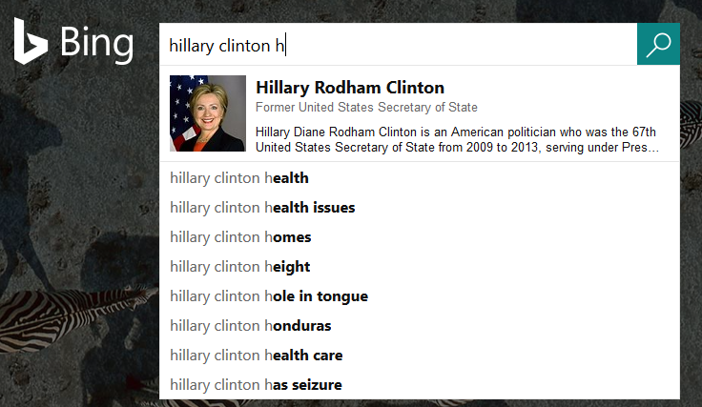
Bing
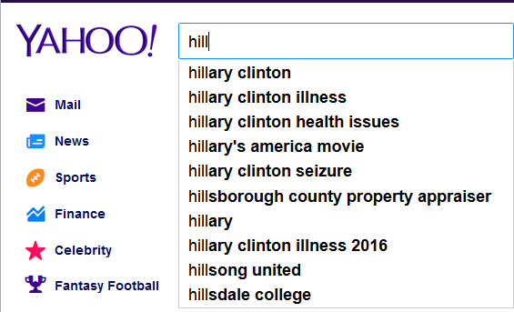
Yahoo
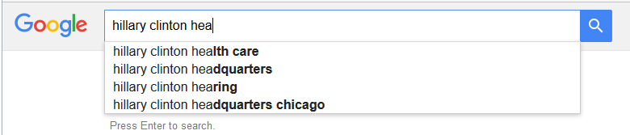
Google

And, yes, once again, Google Trends showed a recent spike in searches for the missing search suggestions:
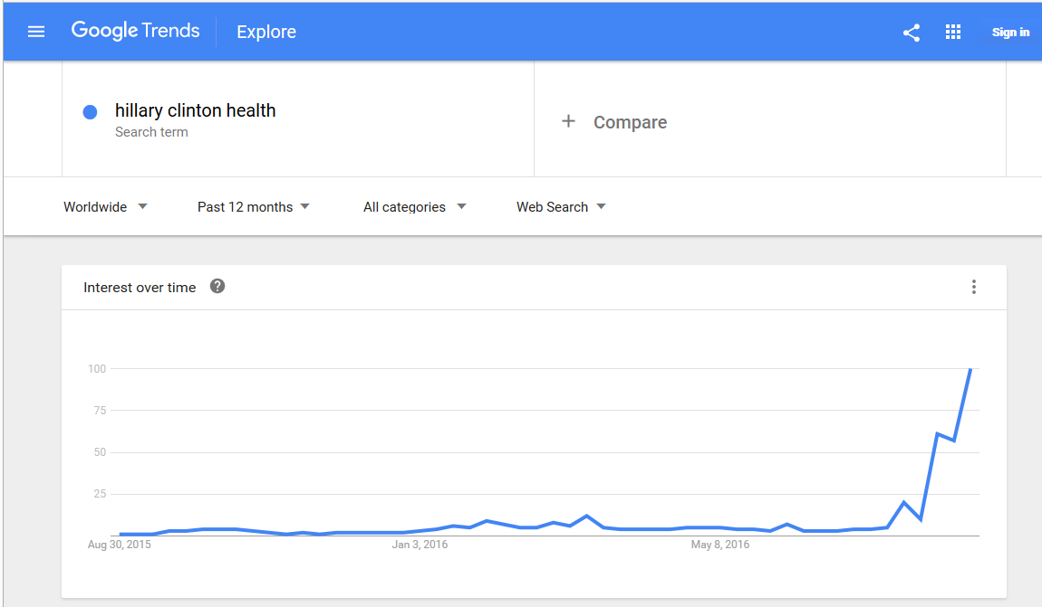
Google Trends

While the news was buzzing about Mrs. Clinton's health, hundreds of stories were also being published about Mr. Trump's "flip flopping" on immigration issues, and that too was reflected on Google Trends:
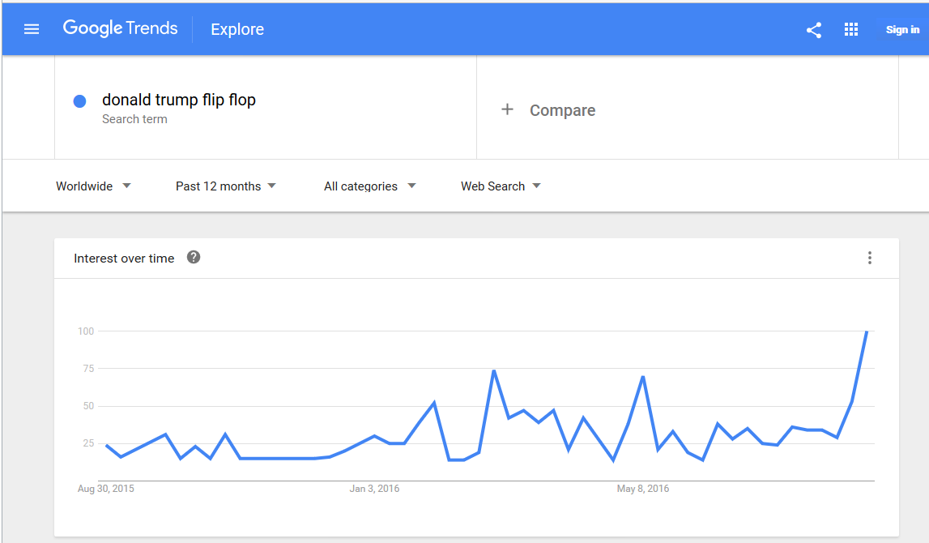
Mr. Trump’s “flip flopping”

But, as you can see, Google did not suppress "Donald Trump flip flops" from its suggestions:
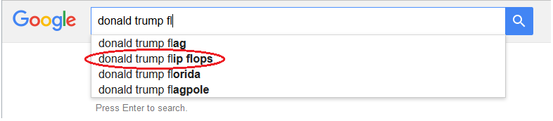
“Donald Trump flip flops”

Google, it seems, is playing this game both consistently and slyly. It is saving its bias for the most valuable real estate — trending, high-value terms — and eliminating signs of bias for terms that have lost their value.
And that brings me, at last, to a research project I initiated only a few weeks ago. If Google is really biasing its search suggestions, what is the company's motive? A new study sheds surprising and disturbing light on this question.
How Google's Search Suggestions Affect Our Searches
Normally, I wouldn't talk publicly about the early results of a long-term research project I have not yet published in a scientific journal or at least presented at a scientific conference. I have decided to make an exception this time for three reasons: First, the results of the study on autocomplete I completed recently are strong and easy to interpret. Second, these results are consistent with volumes of research that has already been conducted on two well-known psychological processes: negativity bias and confirmation bias. And third, the November election is growing near, and the results of my new experiment are relevant to that election — perhaps even of crucial importance.
I began the new study asking myself why Google would want to suppress negative search suggestions. Why those in particular?
In the study, a diverse group of 300 people from 44 U.S. states were asked which of four search suggestions they would likely click on if they were trying to learn more about either Mike Pence, the Republican candidate for vice president, or Tim Kaine, the Democratic candidate for vice president. They could also select a fifth option in order to type their own search terms. Here is an example of what a search looked like:
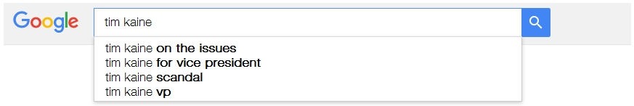
Tim Kaine

Two of the searches we showed people contained negative search suggestions (one negative suggestion in each search); all of the other search suggestions were either neutral (like "Tim Kaine office") or positive (like "Mike Pence for vice president").
Each of the negative suggestions — "Mike Pence scandal" and "Tim Kaine scandal" — appeared only once in the experiment. Thus, if study participants were treating negative items the same way they treated the other four alternatives in a given search, the negative items would have attracted about 20 percent of the clicks in each search.
By including or suppressing negatives in search suggestions, you can direct people's searches one way or another just as surely as if they were dogs on a leash.
But that's not what happened. The three main findings were as follows:
1) Overall, people clicked on the negative items about 40 percent of the time — that's twice as often as one would expect by chance. What's more, compared with the neutral items we showed people in searches that served as controls, negative items were selected about five times as often.
2) Among eligible, undecided voters —the impressionable people who decide close elections — negative items attracted more than 15 times as many clicks as neutral items attracted in matched control questions.
3) People affiliated with one political party selected the negative suggestion for the candidate from their own party less frequently than the negative suggestion for the other candidate. In other words, negative suggestions attracted the largest number of clicks when they were consistent with people's biases.
These findings are consistent with two well-known phenomena in the social sciences: negativity bias and confirmation bias.
Negativity bias refers to the fact that people are far more affected by negative stimuli than by positive ones. As a famous paper on the subject notes, a single cockroach in one's salad ruins the whole salad, but a piece of candy placed on a plate of disgusting crud will not make that crud seem even slightly more palatable.
Negative stimuli draw more attention than neutral or positive ones, they activate more behavior, and they create stronger impressions — negative ones, of course. In recent years, political scientists have even suggested that negativity bias plays an important role in the political choices we make — that people adopt conservative political views because they have a heightened sensitivity to negative stimuli.
Confirmation bias refers to the fact that people almost always seek out, pay attention to, and believe information that confirms their beliefs more than they seek out, pay attention to, or believe information that contradicts those beliefs.
When you apply these two principles to search suggestions, they predict that people are far more likely to click on negative search suggestions than on neutral or positive ones — especially when those negative suggestions are consistent with their own beliefs. This is exactly what the new study confirms.
Google data analysts know this too. They know because they have ready access to billions of pieces of data showing exactly how many times people click on negative search suggestions. They also know exactly how many times people click on every other kind of search suggestion one can categorize.
To put this another way, what I and other researchers must stumble upon and can study only crudely, Google employees can study with exquisite precision every day.
Given Google's strong support for Mrs. Clinton, it seems reasonable to conjecture that Google employees manually suppress negative search suggestions relating to Clinton in order to reduce the number of searches people conduct that will expose them to anti-Clinton content. They appear to work a bit less hard to suppress negative search suggestions for Mr. Trump, Senator Sanders, Senator Cruz, and other prominent people.
This is not the place to review the evidence that Google strongly supports Mrs. Clinton, but since we're talking about Google's search bar, here are two quick reminders:
First, on August 6th, when we typed "When is the election?," we were shown the following image:
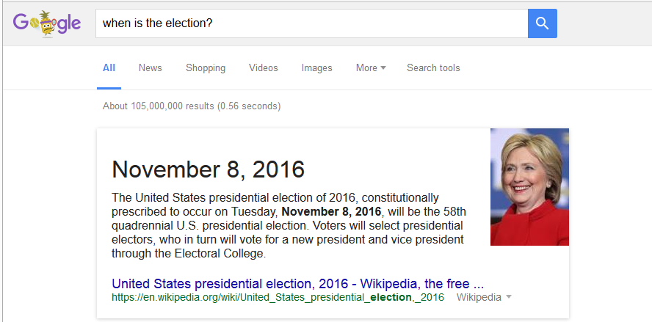
“When is the election?”

See anything odd about that picture? Couldn't Google have displayed two photos just as easily as it displayed one?
And second, as reported by the Next Web and other news sources, in mid 2015, when people typed "Who will be the next president?," Google displayed boxes such as the one below, which left no doubt about the answer:
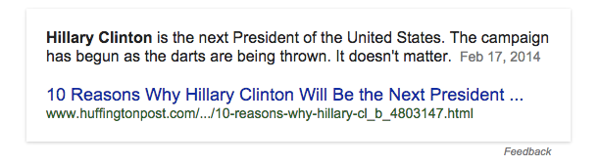
“Who will be the next president?”

Corporate Control
Over time, differentially suppressing negative search suggestions will repeatedly expose millions of people to far more positive search results for one political candidate than for the other. Research I have been conducting since 2013 with Ronald Robertson of Northeastern University has shown that high-ranking search results that favor one candidate can easily shift 20 percent or more of undecided voters toward that candidate — up to 80 percent in some demographic groups, as I noted earlier. This is because of the enormous trust people have in computer-generated search results, which people mistakenly believe are completely impartial and objective — just as they mistakenly believe search suggestions are completely impartial and objective.
The impact of biased search rankings on opinions, which we call the Search Engine Manipulation Effect (SEME), is one of the largest effects ever discovered in the behavioral sciences, and because it is invisible to users, it is especially dangerous as a source of influence. Because Google handles 90 percent of search in most countries and because many elections are very close, we estimate that SEME has been determining the outcomes of upwards of 25 percent of the national elections in the world for several years now, with increasing impact each year. This is occurring, we believe, whether or not Google's executives are taking an active interest in elections; all by itself, Google's search algorithm virtually always ends up favoring one candidate over another simply because of "organic" search patterns by users. When it does, votes shift; in large elections, millions of votes can be shifted. You can think of this as a kind of digital bandwagon effect.
The new effect I have described in this essay — a search suggestion effect — is very different from SEME but almost certainly increases SEME's impact. If you can surreptitiously nudge people into generating search results that are inherently biased, the battle is half won. Simply by including or suppressing negatives in search suggestions, you can direct people's searches one way or another just as surely as if they were dogs on a leash, and you can use this subtle form of influence not just to alter people's views about candidates but about anything.
Google launched autocomplete, its search suggestion tool, in 2004 as an opt-in that helped users find information faster. Perhaps that's all it was in the beginning, but just as Google itself has morphed from being a cool high-tech anomaly into what former Google executive James Whittaker has called a "an advertising company with a single corporate-mandated focus," so has autocomplete morphed from being a cool and helpful search tool into what may be a tool of corporate manipulation. By 2008, not only was autocomplete no longer an opt-in feature, there was no way to opt out of it, and since that time, through strategic censorship, it may have become a tool for directing people's searches and thereby influencing not only the choices they make but even the thoughts they think.
Look back at the searches I have shown you. Why does Google typically show you far fewer search suggestions than other search engines do — 4 or fewer, generally speaking, compared with 8 for Bing, 8 for DuckDuckGo and 10 for Yahoo? Even if you knew nothing of phenomena like negativity bias and confirmation bias, you certainly know that shorter lists give people fewer choices. Whatever autocomplete was in the beginning, its main function may now be to manipulate.
Perhaps you are skeptical about my claims. Perhaps you are also not seeing, on balance, a pro-Hillary bias in the search suggestions you receive on your computer. Perhaps you are also not concerned about the possibility that search suggestions can be used systematically to nudge people's searches in one direction or another. If you are skeptical in any or all of these ways, ask yourself this: Why, to begin with, is Google censoring its search suggestions? (And it certainly acknowledges doing so.) Why doesn't it just show us, say, the top ten most popular searches related to whatever we are typing? Why, in particular, is it suppressing negative information? Are Google's leaders afraid we will have panic attacks and sue the company if we are directed to dark and disturbing web pages? Do they not trust us to make up our own minds about things? Do they think we are children?
Without whistleblowers or warrants, no one can prove Google executives are using digital shenanigans to influence elections, but I don't see how we can rule out that possibility. There is nothing illegal about manipulating people using search suggestions and search rankings — quite the contrary, in fact — and it makes good financial sense for a company to use every legal means at its disposal to support its preferred candidates.
Using the mathematical techniques Robertson and I described in our 2015 report in the Proceedings of the National Academy of Sciences, I recently calculated that SEME alone can shift between 2.6 and 10.4 million votes in the upcoming US presidential race without anyone knowing this has occurred and without leaving a paper trail.
I arrived at those numbers before I knew about the power search suggestions have to alter searches. The new study suggests that autocomplete alone might be able to shift between 800,000 and 3.2 million votes — also without anyone knowing this is occurring.
Perhaps even more troubling, because Google tracks and monitors us so aggressively, Google officials know who among us is planning to vote and whom we are planning to vote for. They also know who among us are still undecided, and that is where the influence of biased search suggestions and biased search rankings could be applied with enormous effect.
[Postscript: Google declined to comment on the record when queried about some of the concerns I have raised in this article. Instead, on August 17th, a company representative sent me to a blog post released by the company on June 16th; you can read Google's official position on autocomplete there. For the record, I am a moderate politically, and I support Hillary Clinton for president. I do not believe, however, that it would be right for her to win the presidency because of the invisible, large-scale manipulations of a private company. That would make democracy meaningless, and that is why I am trying to keep the public informed about my research findings. Also for the record, I have chosen to publish this article through Sputnik News because Sputnik agreed to publish it in unedited form in order to preserve the article's accuracy. —R.E.]
EPSTEIN (@DrREpstein) is Senior Research Psychologist at the American Institute for Behavioral Research and Technology in Vista, California. A PhD of Harvard University, Epstein has published fifteen books on artificial intelligence and other topics. He is also the former editor-in-chief of Psychology Today.





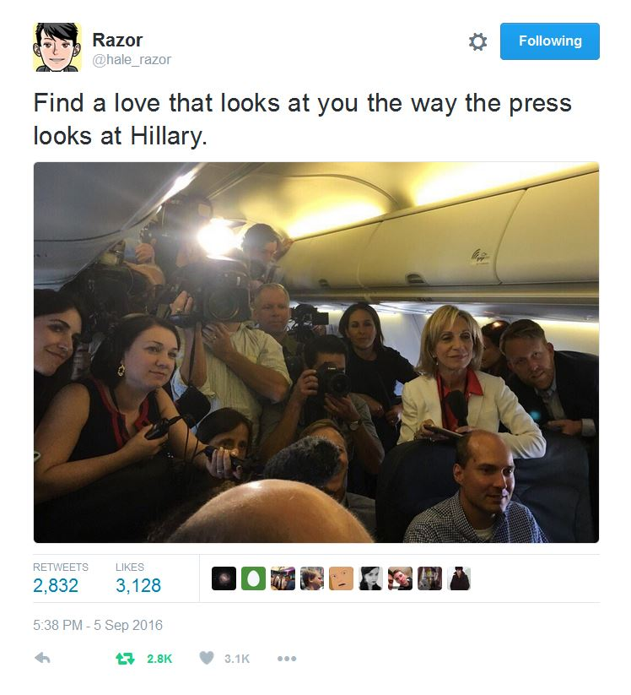
And now . . .
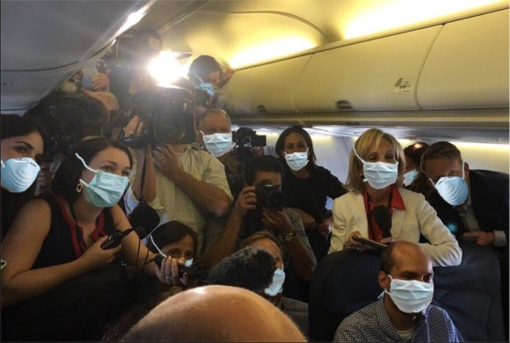

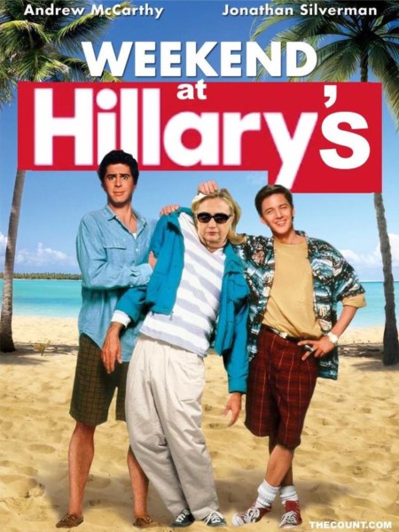

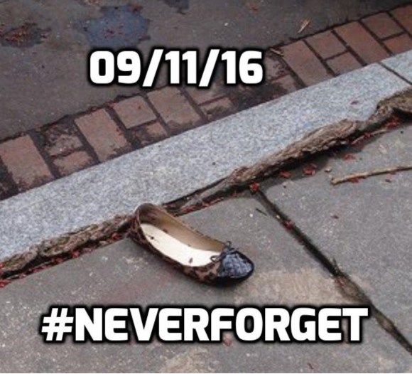

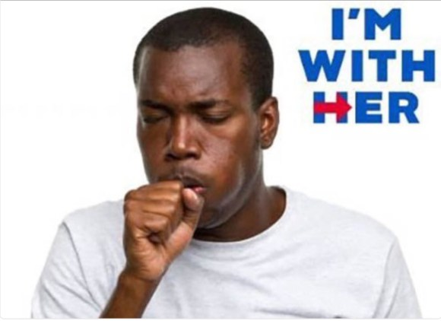



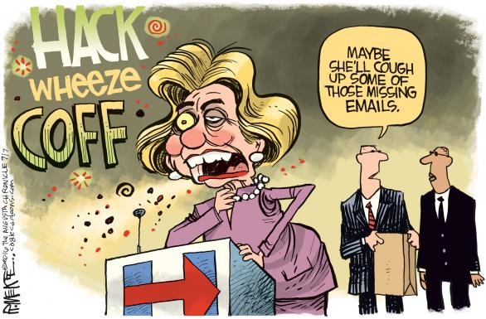
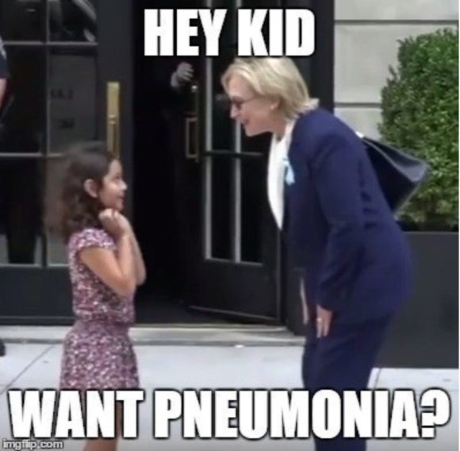

Hillary Campaign's New Logo


