July 4, 2016

In the future will Brits celebrate the Fourth of July on June 23rd?

Paul Meringoff of Power Line posts that the Brexit result is another example of White House cluelessness.
President Obama and his foreign policy team are perpetually surprised by the world. The rise of ISIS, the fall of Mubarak and the Muslim Brotherhood leader who succeeded him, the chaos in Libya, Putin’s aggression, Netanyahu’s reelection — all of these key developments (and others) wrong-footed the president and his advisers. You might almost think they don’t understand the world at all.
Brexit is the latest manifestation of Team Obama’s cluelessness. Once again, the president has been caught by surprise. Surely, that is why, as Walter Russell Mead recounts, Obama, though strongly favoring the “remain” cause, did nothing to advance it until at the last minute he “parachuted in, made a speech, and expected his charisma and wisdom to work miracles.”
Many believe that Obama’s speech, in which he tried to brow-beat the British into remaining in the EU, was counterproductive. In any event, it failed to carry the day. ...
... Mead concludes:
[R]arely has a presidency seen so many things go so badly for the U.S. in foreign policy. Obama’s track record is not looking good: at the end of his watch, the Middle East, Europe, and East Asia are all in worse shape than when he entered office, relations with Russia and China are both worse, there are more refugees, more terrorists and more dangerous terrorist organizations.
Obama’s fiercest critics say that much of Obama’s foreign policy wreckage is the intended result of his policy. They are right, I think, to some degree.
But Obama didn’t want Brexit. Nor is it reasonable to suppose that he wanted a failed state in Libya, an ISIS caliphate in Syria and Iraq, and a Ukraine compromised by Russian aggression.
Obama’s foreign policy failures cannot be understood without reference to his incompetence and inability to understand the world as it is.

And this. Two weeks ago the president was spanked by 51 State Department career foreign service officers who dissent from his passivity in the Middle East. Of course, the media made little mention so we have a piece from Austin Bay in The Observer.
Dissenting State Department officials are demanding President Barack Obama wage war on the Assad dictatorship—which is a short step away from demanding regime change.
Late on June 16 The Wall Street Journal reported that the “near collapse” of the current ceasefire had spurred 51 “mid-to high-level State Department officers involved with advising on Syria policy” to sign a “dissent channel cable” calling on the Obama Administration to target Syria’s Assad regime with repeated “military strikes.”
At the moment, the article remains behind The Journal’s paywall, so I’ll include several extended quotes. Journal reporters who personally reviewed the cable described the document as “a scalding internal critique of a longstanding U.S. policy against taking sides in the Syrian war, a policy that has survived even though the regime of President Bashar al-Assad has been repeatedly accused of violating cease-fire agreements and Russian-backed forces have attacked U.S.-trained rebels.”
The dissenters argue “Failure to stem Assad’s flagrant abuses will only bolster the ideological appeal of groups such as Daesh, even as they endure tactical setbacks on the battlefield.” ...
... Obama’s Syrian chemical weapons red-line fiasco is a major factor in this mess. Obama had warned the Assad regime that using chemical weapons on civilians was a red-line—implying he would respond to chemical weapons employment with a punitive military attack. On August 21, 2013 a nerve gas attack by Assad regime forces killed approximately 1,500 Syrian civilians. In the aftermath Obama’s “red line” promise was exposed as a bombastic falsehood that sure sounded macho on CNN and MSNBC.
Obama “talked back” his warning. Red line? Here’s the White House transcript, so judge for yourself.
Oh heck, here it is, from August 20, 2012—a year and a day before the nerve gas attack
President Obama:
“…the point that you made about chemical and biological weapons is critical. That’s an issue that doesn’t just concern Syria; it concerns our close allies in the region, including Israel. It concerns us. We cannot have a situation where chemical or biological weapons are falling into the hands of the wrong people.
We have been very clear to the Assad regime, but also to other players on the ground, that a red line for us is we start seeing a whole bunch of chemical weapons moving around or being utilized. That would change my calculus. That would change my equation.”
Former Secretary of Defense Robert Gates has made a judgment. Gates says Obama’s failure to respond was a “serious mistake” that damaged U.S. global credibility.
Did it ever. State Department pros agree. ...
... During the George W. Bush Administration, when dissent was the highest form of patriotism, State’s Dissent Channel policy dissenters would instantly become 24-7 cable news channel heroes—you know, lionized public servants speaking truth to CheneyBusHitler power? The intense, relentless media attention would have translated a heavy intellectual blow into a heavy political blow. Restrained media treatment of State’s Syria dissent cable, however, softens the political impact of its truly devastating intellectual and expert condemnation.
The Times report does note the Syrian civil war has killed 400,000 people. I think that tragic figure is highly credible.
For the Obama Administration, the 400,000 death toll is a moral challenge historians will not miss even if au courant media do. As I note in the Creators Syndicate column linked above (at StrategyPage.com) “If we had a Republican president I’m rather certain we’d be hearing demands that the U.S. has a ‘responsibility to protect’ vulnerable civilians. The abbreviation for this policy is R2P. During the Bush Administration the Obama Administration’s current U.N. Ambassador, Samantha Power, was a vocal advocate of R2P. Now? Not so much. History will note the 400,000 Syrian dead died on her president’s watch.” ...

David Harsanyi writes on the "radical Islam" kerfuffle.
After a meeting with the National Security Council to discuss the Orlando massacre, the deadliest mass shooting in American history, Barack Obama was angry. He’s more impassioned than we’ve ever seen him. He was speaking from the heart. He’s lashing out! Because you know what really grinds his gears? Republicans.
“That’s the key, they say,” Obama said, eviscerating the GOP. “We can’t defeat them unless we call them radical Islamists. What exactly would using this label accomplish? What exactly would it change?”
A lot, actually.
As a matter of realpolitik, perhaps it makes sense to avoid the phrase “radical Islam.” We don’t want to offend the Mullahs, theocratic sheiks, oligarchic princes, Arab strongmen, and future junta leaders of the Middle East. We need to work with these people, after all. What should bother you, though, is that Obama constantly tries to chill speech by insinuating that anyone who does associate violence with radical Islam—which includes millions of adherents—is a bigot. This is a president who also intimates that anyone who is critical of everyday Islam’s widespread illiberalism—for example, all nations where homosexuality is punishable by death are Muslim—is also a bigot. ...

MORE THAN TWO SCORE GREAT CARTOONS!

Power Line
Brexit: The latest example of Obama’s cluelessness
by Paul Mirengoff
President Obama and his foreign policy team are perpetually surprised by the world. The rise of ISIS, the fall of Mubarak and the Muslim Brotherhood leader who succeeded him, the chaos in Libya, Putin’s aggression, Netanyahu’s reelection — all of these key developments (and others) wrong-footed the president and his advisers. You might almost think they don’t understand the world at all.
Brexit is the latest manifestation of Team Obama’s cluelessness. Once again, the president has been caught by surprise. Surely, that is why, as Walter Russell Mead recounts, Obama, though strongly favoring the “remain” cause, did nothing to advance it until at the last minute he “parachuted in, made a speech, and expected his charisma and wisdom to work miracles.”
Many believe that Obama’s speech, in which he tried to brow-beat the British into remaining in the EU, was counterproductive. In any event, it failed to carry the day.
What could Obama have done that might have prevented the Brexit? Mead says he could have helped persuade the EU to offer better terms to Britain. Doing so would have enabled David Cameron to make a more persuasive case in favor of “remain” and at the same time strengthened the EU itself.
This, in Mead’s view, “is exactly where skillful, patient, low-profile but engaged and informed U.S. diplomacy could have made a difference.” Instead, “Washington sat on the sidelines until Cameron was campaigning on a weak offer.”
Now that Brexit is a reality, the U.S. has finally engaged. John Kerry has undertaken shuttle diplomacy in the hope of persuading both sides to make the divorce as smooth as possible. In Kerry’s less than articulate words:
It is absolutely essential that we stay focused on how, in this transitional period, nobody looses their head, nobody goes off half-cocked, people don’t start ginning up scatterbrained or revengeful premises.
It’s good that the Obama administration is using its influence in this way. But given Obama’s strong opposition to Brexit, his team should have engaged in the diplomacy that might have prevented the divorce.
Mead concludes:
[R]arely has a presidency seen so many things go so badly for the U.S. in foreign policy. Obama’s track record is not looking good: at the end of his watch, the Middle East, Europe, and East Asia are all in worse shape than when he entered office, relations with Russia and China are both worse, there are more refugees, more terrorists and more dangerous terrorist organizations.
Obama’s fiercest critics say that much of Obama’s foreign policy wreckage is the intended result of his policy. They are right, I think, to some degree.
But Obama didn’t want Brexit. Nor is it reasonable to suppose that he wanted a failed state in Libya, an ISIS caliphate in Syria and Iraq, and a Ukraine compromised by Russian aggression.
Obama’s foreign policy failures cannot be understood without reference to his incompetence and inability to understand the world as it is.

Observer
As Assad Continues to Wipe Out Syria, State Dept. Dissenters Confront Obama
Diplomats deliver a heavy blow and scathing critique of the Administration’s anti-ISIS policies
by Austin Bay
Dissenting State Department officials are demanding President Barack Obama wage war on the Assad dictatorship—which is a short step away from demanding regime change.
Late on June 16 The Wall Street Journal reported that the “near collapse” of the current ceasefire had spurred 51 “mid-to high-level State Department officers involved with advising on Syria policy” to sign a “dissent channel cable” calling on the Obama Administration to target Syria’s Assad regime with repeated “military strikes.”
At the moment, the article remains behind The Journal’s paywall, so I’ll include several extended quotes. Journal reporters who personally reviewed the cable described the document as “a scalding internal critique of a longstanding U.S. policy against taking sides in the Syrian war, a policy that has survived even though the regime of President Bashar al-Assad has been repeatedly accused of violating cease-fire agreements and Russian-backed forces have attacked U.S.-trained rebels.”
The dissenters argue “Failure to stem Assad’s flagrant abuses will only bolster the ideological appeal of groups such as Daesh, even as they endure tactical setbacks on the battlefield.” The Journal adds that Daesh is an Arabic acronym for Islamic State in Iraq and Syria (ISIS).
The article provides excellent background information, noting the “Dissent Channel” is an authorized forum for expressing opposing views. It also quotes a former State Department official who acknowledged: “It’s embarrassing for the administration to have so many rank-and-file members break on Syria.” The dissent comes from “the heart” of the State Department bureaucracy—in other words, career, professional diplomats.
Embarrassing? That’s an underwhelming way to describe the dissent cable. The career professionals deliver a heavy intellectual blow to the Obama Administration’s Syria policy and, in the process, scathingly critique the Administration’s anti-ISIS policies. Several quoted passages condemn Russian military actions in Syria and quietly rebuke the Administration’s decision to cooperate with Russia in Syria.
Yes, Russia is allied with Syria. Obama’s decision to buddy-up with Vladimir Putin in Syria served Putin’s policy goal of keeping Russia’s client, Assad, in power. That sends a message Putin wants every dictator and authoritarian ruler on the planet to hear: it pays to have Russia as an ally. The Assad regime is also a client of Iran’s theocratic dictatorship.
By the transitive principle, this means the dissenters are advocating the U.S. and its NATO partners wage war on a Russian and Iranian ally.
Heavy thought, that, but worth an aside. I’ve read enough diplomatic-insider critiques to wager that several of the career U.S. diplomats who signed the cable are also disgusted with the Administration’s strategically-damaging failure to vigorously respond to Putin’s invasion and annexation of Crimea. They have concluded, with good reason, that the U.S. is already at war with Russia. Recent NATO exercises in Poland were designed to send the Kremlin a message: Diplomats know Russian military shenanigans in the Baltic have increased since 2012 and are explicitly intended to rattle NATO.
Putin and his cyber spies are rattling the 2016 U.S. election.
I think the Obama Administration’s Russian “re-set” policy of 2009 was, in domestic political and media terms, more “I’m not Bush” political theatrics. Over time, however, it had damaging international consequences. Obama’s September 2009 decision to not deploy NATO-approved anti-missile missiles to Poland capitulated to Kremlin demands for a “sphere of influence” arrangement in eastern Europe. The Poles certainly thought so.
The Russian 2014 invasion and annexation of Crimea were “sphere of influence” operations that violated the 1994 Budapest Accord and shattered the post-Cold War diplomatic framework for stabilizing eastern Europe. Career diplomatic pros know this “arcane” deep background stuff actually means something when it comes to creating the conditions which produce real peace—not fatuous Nobel Peace Prizes.
This brings us back to the cable. The dissenters know the Administration’s current Syria policy is creating conditions for greater chaos, destruction, bloodshed, instability and war. The Journal speculates the dissenters intend to affect policy in the next Administration. That’s probable, but at the minimum that is a delay of another 10 months. That’s thousands more dead and hundreds of thousands more refugees. NATO member Turkey has already clashed with Russia. Further clashes are not improbable.
The Journal also reported that ISIS remains a highly capable and dangerous organization, despite the President’s assertions to the contrary. CIA Director John Brennan told the Senate Intelligence Committee in his prepared remarks that ISIS remains “a formidable, resilient and largely cohesive enemy.” After fighting ISIS for over two years the Obama Administration has not blunted its “global reach.”
If I employed the harsh rhetoric of Bush Administration critics, I’d write: Obama lies and people continue to die. Yes, I did write it. Too harsh? Another take: Obama spins and we don’t win. I base “we don’t win” on Brennan’s testimony.
Obama’s Syrian chemical weapons red-line fiasco is a major factor in this mess. Obama had warned the Assad regime that using chemical weapons on civilians was a red-line—implying he would respond to chemical weapons employment with a punitive military attack. On August 21, 2013 a nerve gas attack by Assad regime forces killed approximately 1,500 Syrian civilians. In the aftermath Obama’s “red line” promise was exposed as a bombastic falsehood that sure sounded macho on CNN and MSNBC.
Obama “talked back” his warning. Red line? Here’s the White House transcript, so judge for yourself.
Oh heck, here it is, from August 20, 2012—a year and a day before the nerve gas attack
President Obama:
“…the point that you made about chemical and biological weapons is critical. That’s an issue that doesn’t just concern Syria; it concerns our close allies in the region, including Israel. It concerns us. We cannot have a situation where chemical or biological weapons are falling into the hands of the wrong people.
We have been very clear to the Assad regime, but also to other players on the ground, that a red line for us is we start seeing a whole bunch of chemical weapons moving around or being utilized. That would change my calculus. That would change my equation.”
Former Secretary of Defense Robert Gates has made a judgment. Gates says Obama’s failure to respond was a “serious mistake” that damaged U.S. global credibility.
Did it ever. State Department pros agree.
Credit The Wall Street Journal with providing excellent historical and State Department institutional context for understanding the details and significance of the dissent cable. However, after reading The New York Times’ restrained report and evaluation (no “widely recognized names” signed the cable), honest readers need to consider the broader “media response context.”
During the George W. Bush Administration, when dissent was the highest form of patriotism, State’s Dissent Channel policy dissenters would instantly become 24-7 cable news channel heroes—you know, lionized public servants speaking truth to CheneyBusHitler power? The intense, relentless media attention would have translated a heavy intellectual blow into a heavy political blow. Restrained media treatment of State’s Syria dissent cable, however, softens the political impact of its truly devastating intellectual and expert condemnation.
The Times report does note the Syrian civil war has killed 400,000 people. I think that tragic figure is highly credible.
For the Obama Administration, the 400,000 death toll is a moral challenge historians will not miss even if au courant media do. As I note in the Creators Syndicate column linked above (at StrategyPage.com) “If we had a Republican president I’m rather certain we’d be hearing demands that the U.S. has a ‘responsibility to protect’ vulnerable civilians. The abbreviation for this policy is R2P. During the Bush Administration the Obama Administration’s current U.N. Ambassador, Samantha Power, was a vocal advocate of R2P. Now? Not so much. History will note the 400,000 Syrian dead died on are her president’s watch.”
Austin Bay is a contributing editor at StrategyPage.com and adjunct professor at the University of Texas in Austin. His most recent book is a biography of Kemal Ataturk (Macmillan 2011). Mr. Bay is a retired US Army Reserve colonel and Iraq veteran. He has a PhD in Comparative Literature from Columbia University.

The Federalist
By Rejecting 'Radical Islam' Obama Rejects Reality
Instead, the president lashes out at America's real enemy: the GOP.
by David Harsanyi
After a meeting with the National Security Council to discuss the Orlando massacre, the deadliest mass shooting in American history, Barack Obama was angry. He’s more impassioned than we’ve ever seen him. He was speaking from the heart. He’s lashing out! Because you know what really grinds his gears? Republicans.
“That’s the key, they say,” Obama said, eviscerating the GOP. “We can’t defeat them unless we call them radical Islamists. What exactly would using this label accomplish? What exactly would it change?”
A lot, actually.
As a matter of realpolitik, perhaps it makes sense to avoid the phrase “radical Islam.” We don’t want to offend the Mullahs, theocratic sheiks, oligarchic princes, Arab strongmen, and future junta leaders of the Middle East. We need to work with these people, after all. What should bother you, though, is that Obama constantly tries to chill speech by insinuating that anyone who does associate violence with radical Islam—which includes millions of adherents—is a bigot. This is a president who also intimates that anyone who is critical of everyday Islam’s widespread illiberalism—for example, all nations where homosexuality is punishable by death are Muslim—is also a bigot.
It’s not as if Obama shies away from lecturing people about faith. Saying the words “radical Islam” is a step too far, but bringing up events from the year 1095 to create a tortured moral equivalence is just fine. Not only has Obama implored us to avoid critical rhetoric about Islam, but he demands that Americans (secular apostates like myself included) act as if all faiths are equally tolerant of our lives. This is the president who tells the world that “the future must not belong to those who slander the prophet of Islam.” Can you imagine Obama going to the United Nations General Assembly and declaring the same for Jesus Christ?
Nor has Obama hesitated to lecture Christians, who supposedly use religious freedom as an “excuse” for “discrimination,” to evolve and abandon their antiquated ways. After years of propaganda equating evangelicals with Islamic fundamentalists (who aren’t the true adherents of Islam, according to pundits who’ve probably never read a single book about the faith), many liberals make no distinction between the two anymore. For them, supporting the idea sex-specific bathrooms is only a small step from massacring gay Americans. This is what denial of reality can do to a society. You can see it all manifesting in liberal punditry.
Obama isn’t a secret Muslim, and, regardless of what many people tell me, I’m sure his intentions are good. But abdication of the most obvious truths allows demagogues like Donald Trump to appear to be brave truth-tellers. Blaming all Muslims is as dumb as pretending this terror has nothing to do with Islam. One absurd position just reinforces the other.
“We have a proposal from the presumptive Republican presidential nominee to bar all Muslims from immigrating to America,” Obama explained, claiming that those kinds of ideas do the terrorists’ job for them. I’m sure that Trump’s rhetoric on this matter is highly counterproductive. But if you’re willing to murder scores of innocent people in the name of Islam because a blowhard U.S. presidential candidate has an immigration proposal you dislike, that’s a you problem and an Islam problem before it’s a Trump problem. Also, the idea that we have a president more willing to accuse the GOP nominee of instigating terrorism than he is willing to accuse radical Islam is a problem for all of us.
Exempting Islam from discourse is to place Muslims outside the norms of American debate. This is a luxury no other political philosophy or theology enjoys. Obviously, this helps us make events like this about gay marriage or guns or whatever liberal agenda item can be squeezed from tragedy. That would be fine if we weren’t also asked to ignore the actual problem.
Islamists use planes and bombs, and sometimes guns. You can believe all the things you want about the NRA, the availability of “weapons of war,” and Christian homophobia, and still believe that Islamic terrorism is a unique movement that threatens us in a way that the random madman opening fire in a theater does not. Liberals love to point out how rare Islamic-inspired violence is—let’s ban white men! But they fail to point out that we spend billions every year to stop terrorism. If we didn’t, we’d be in for yearly 9/11s.
By the way, don’t you wish Obama would get this worked up about the FBI, which allowed Omar Mateen to slip away from two investigations—one of those, reportedly, because he blamed his actions on Islamophobia? Law enforcement sources now say that Disney notified the FBI that Omar and his wife may have been casing the amusement park back in April. Maybe there was nothing actionable for FBI. So rather than suggesting we undermine the Fifth Amendment and Second Amendment, maybe it’s time to ask why the billions of dollars we spend fighting terrorism are failing.
Mostly, though, I’m not sure why a peaceful Muslim would not appreciate being set apart from Islamists by the president. “Radical Islam” distinguishes between extremists and moderates. Other than allowing liberals to accuse anyone who brings up theological problems of being Islamophobic, what other purpose does ignoring this distinction achieve? The president has yet to explain.

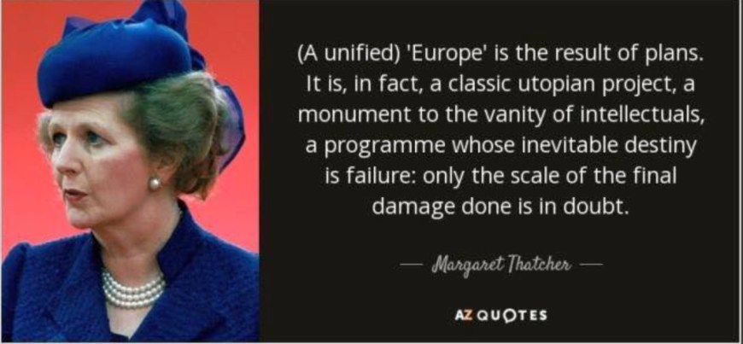

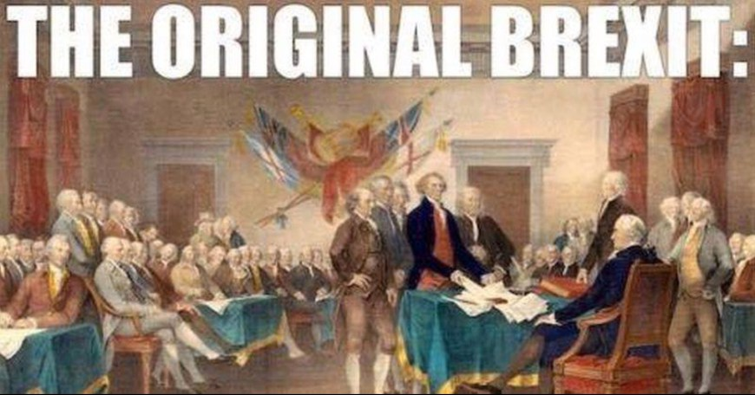

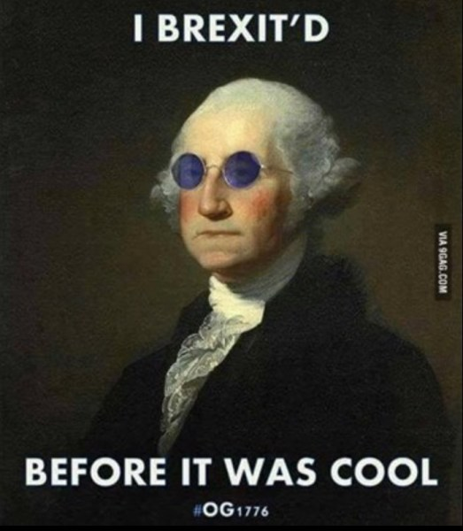

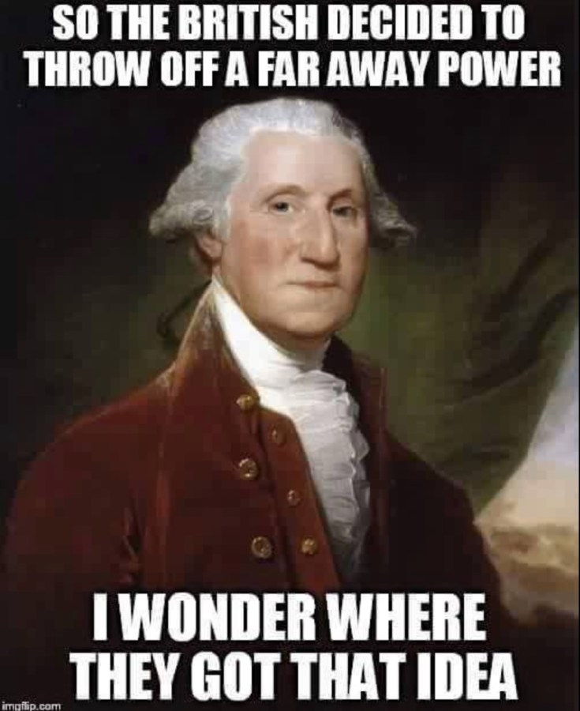

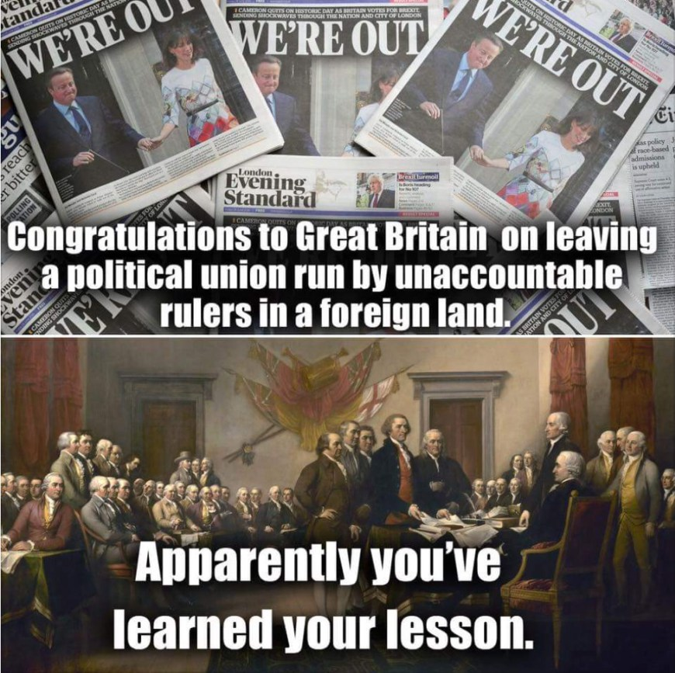

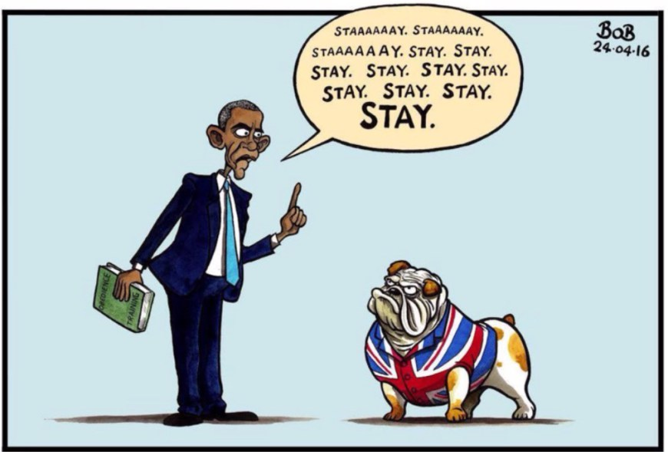

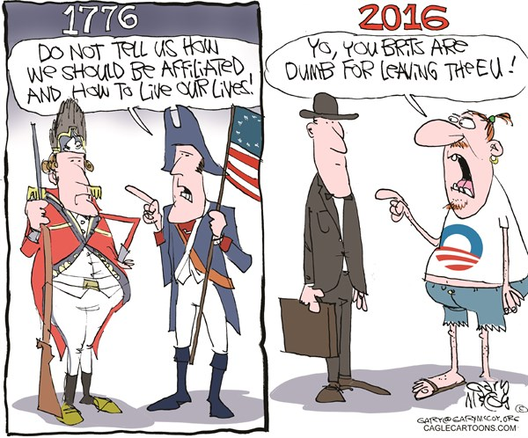

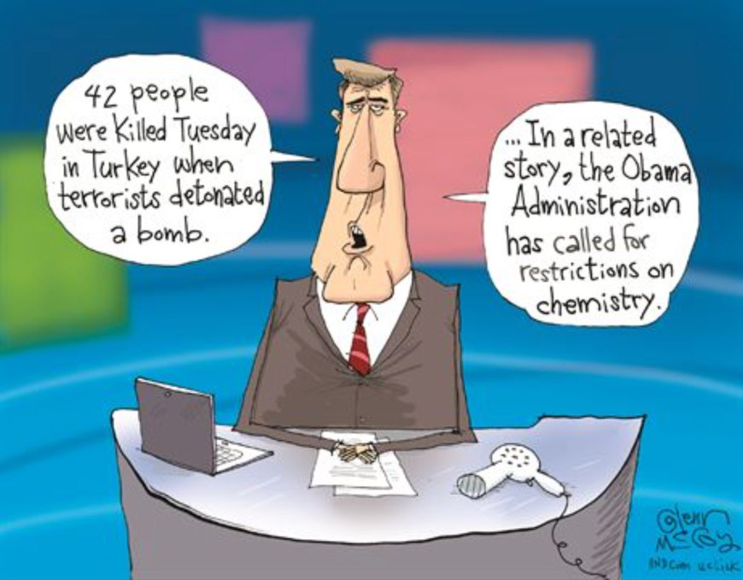

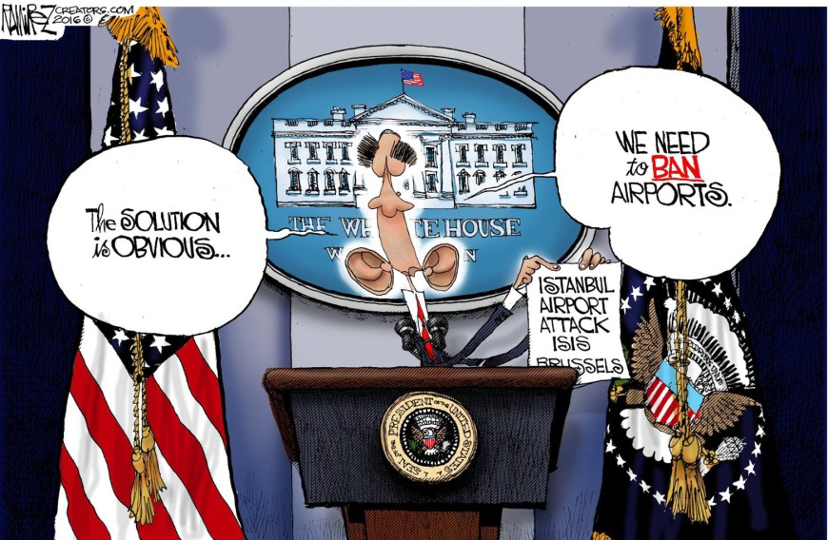

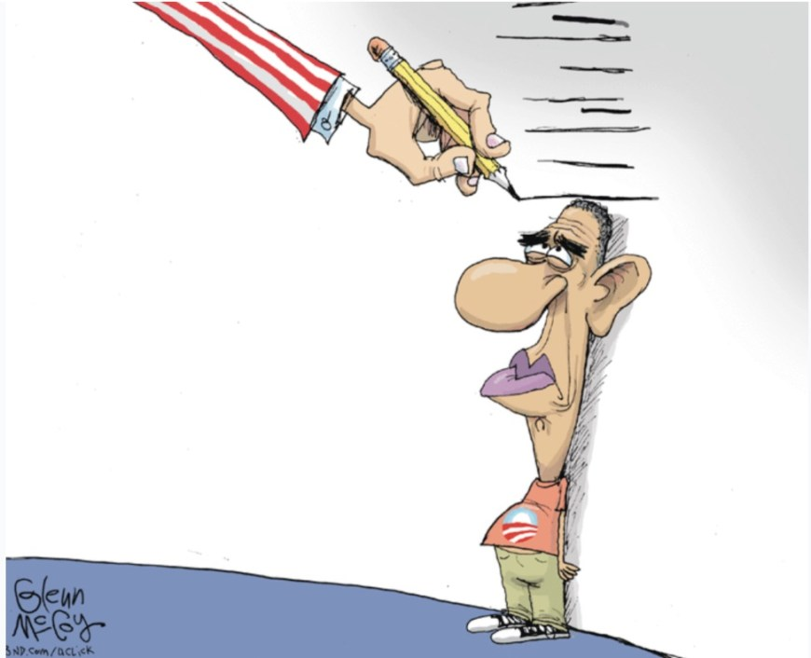

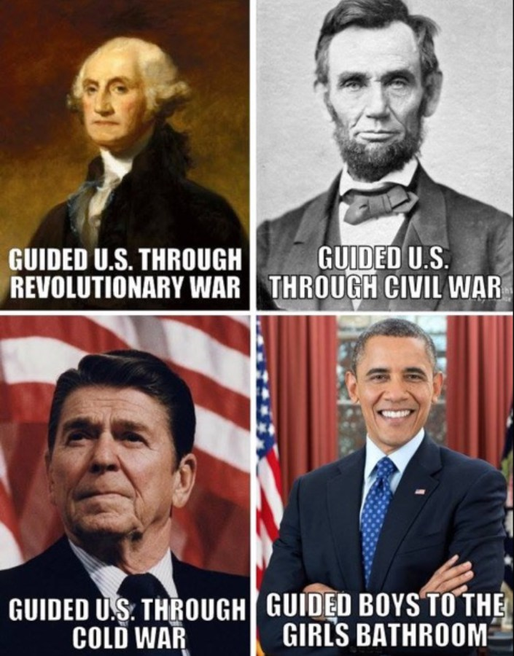

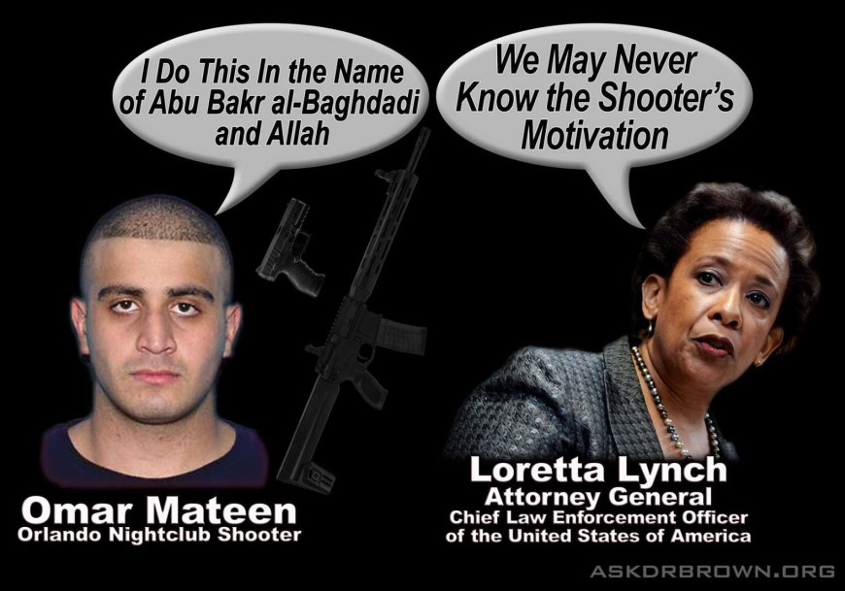

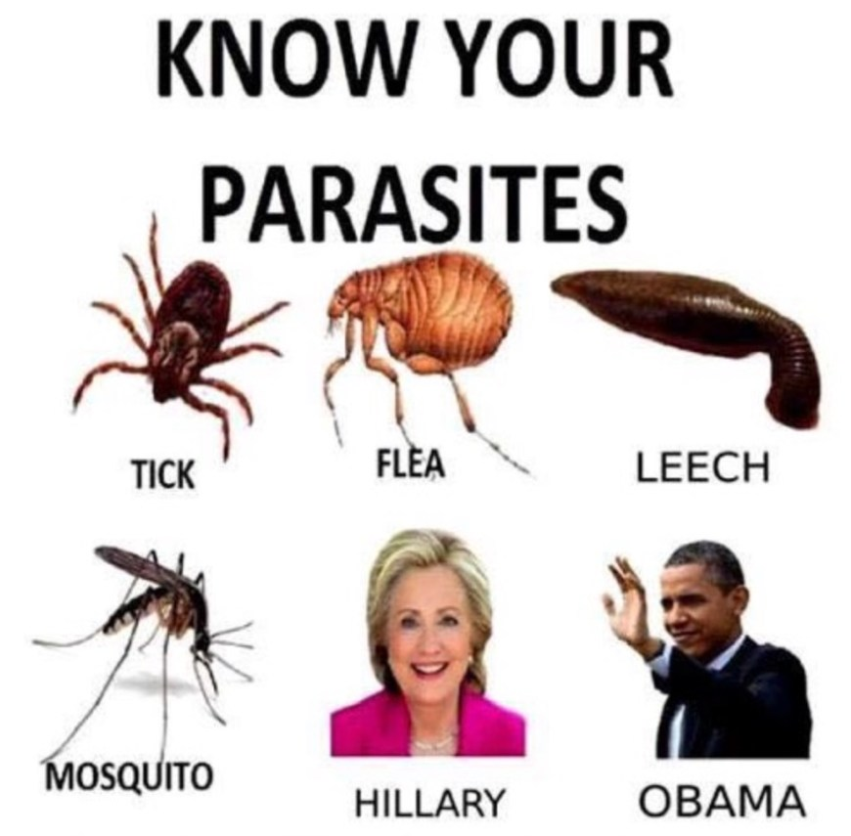

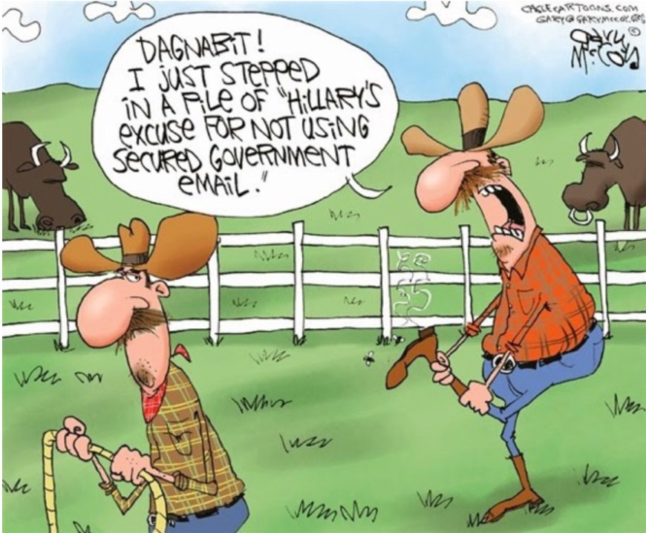

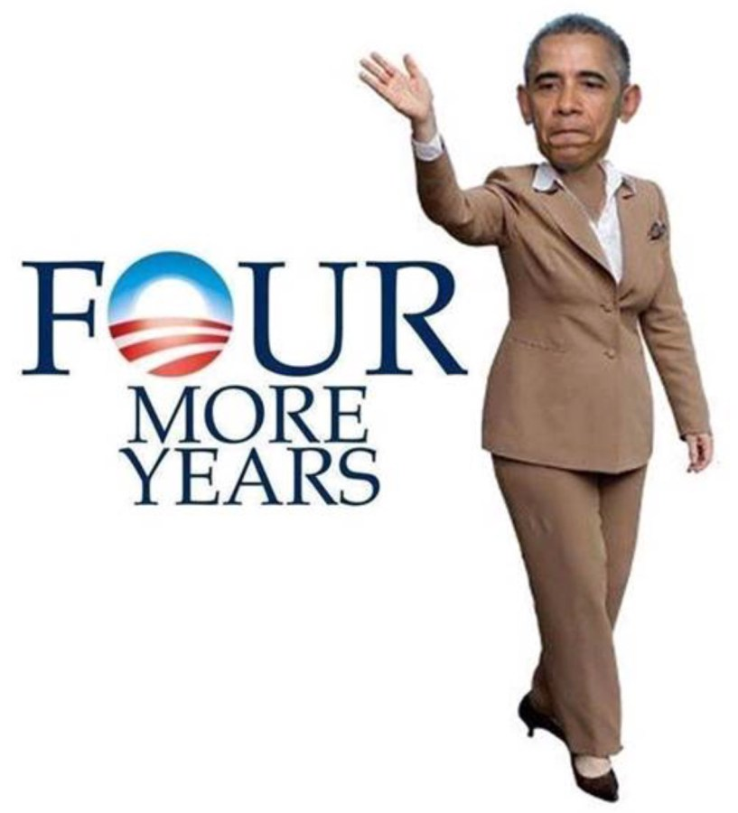



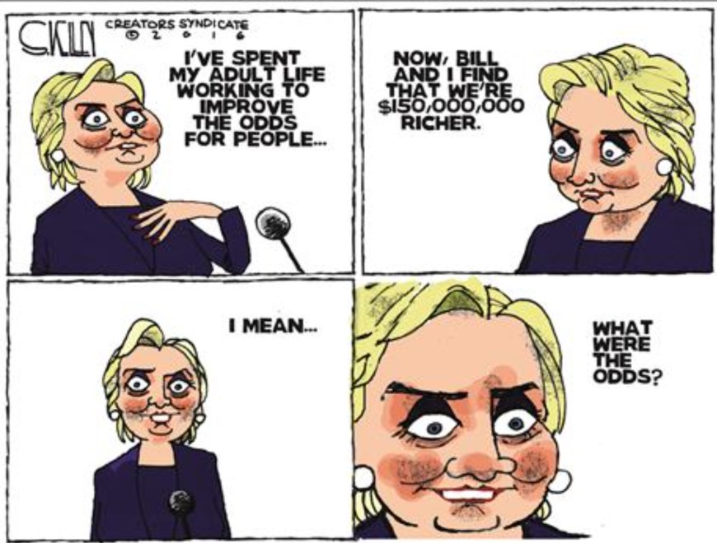

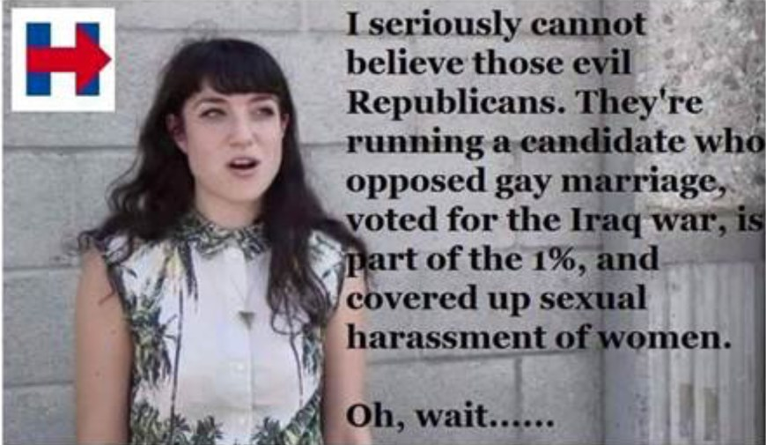

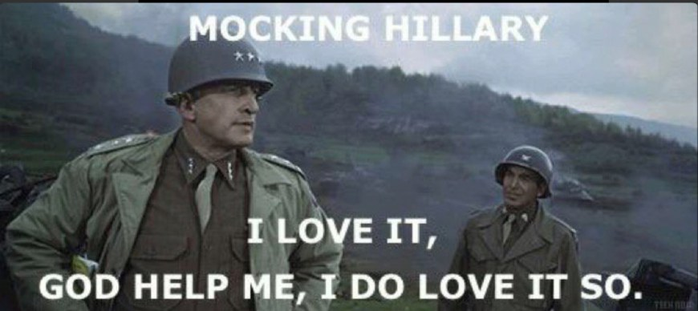

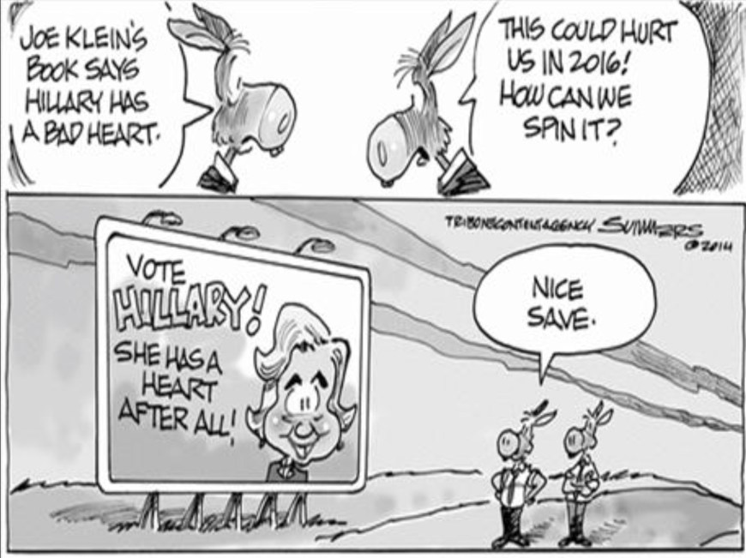

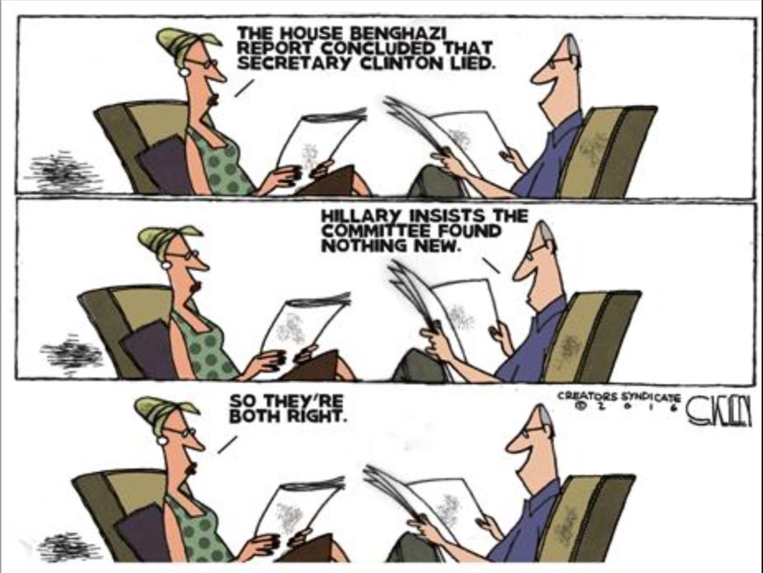

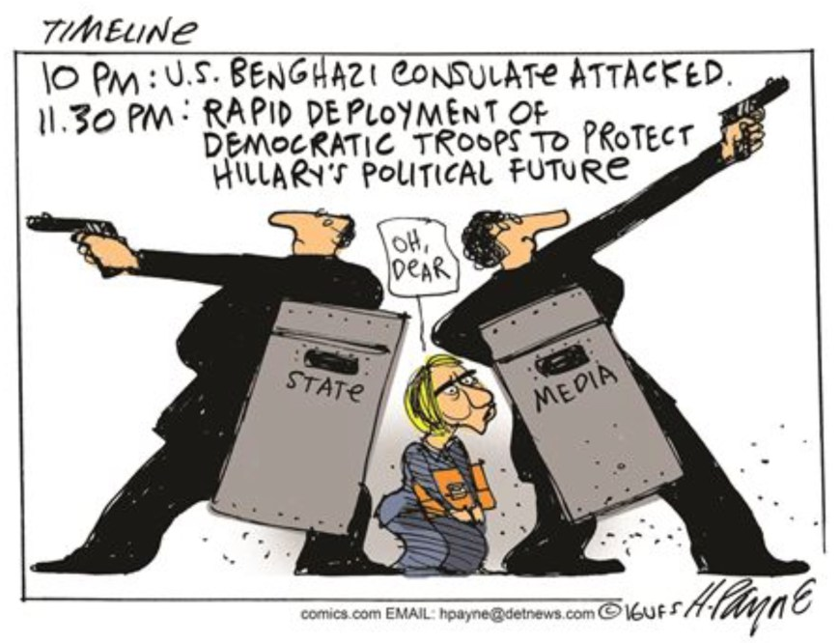

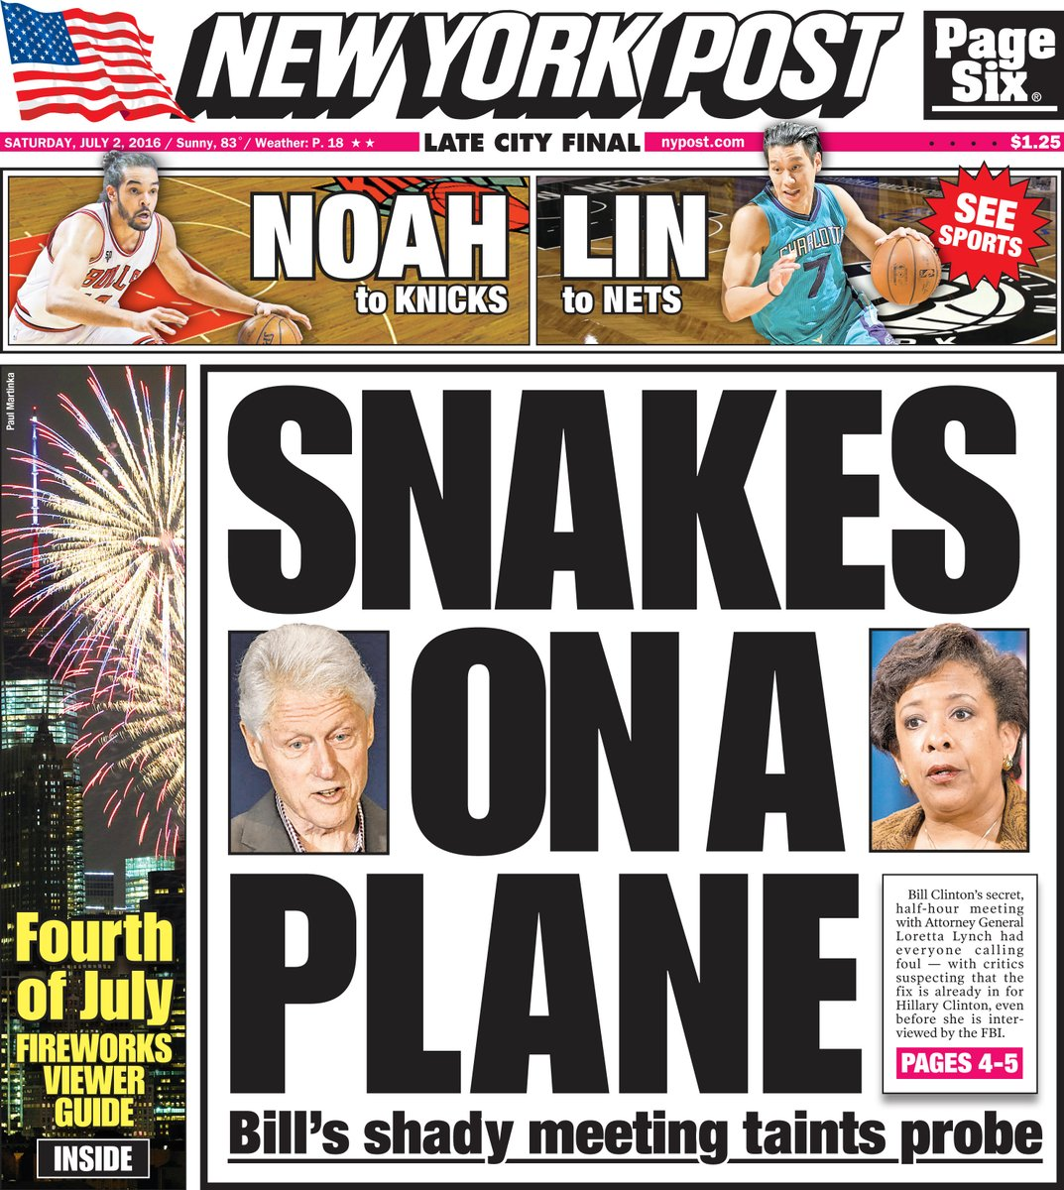

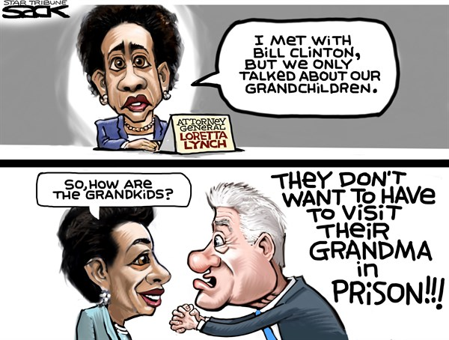

Hillary leg-alike
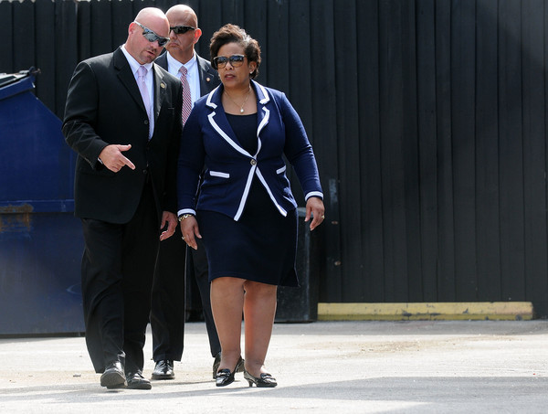

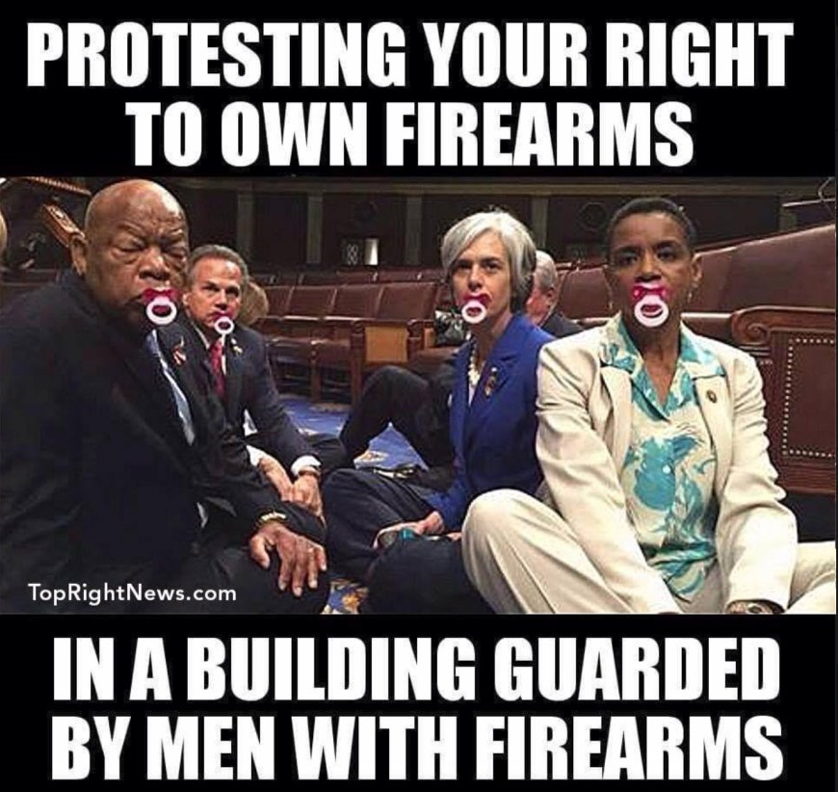

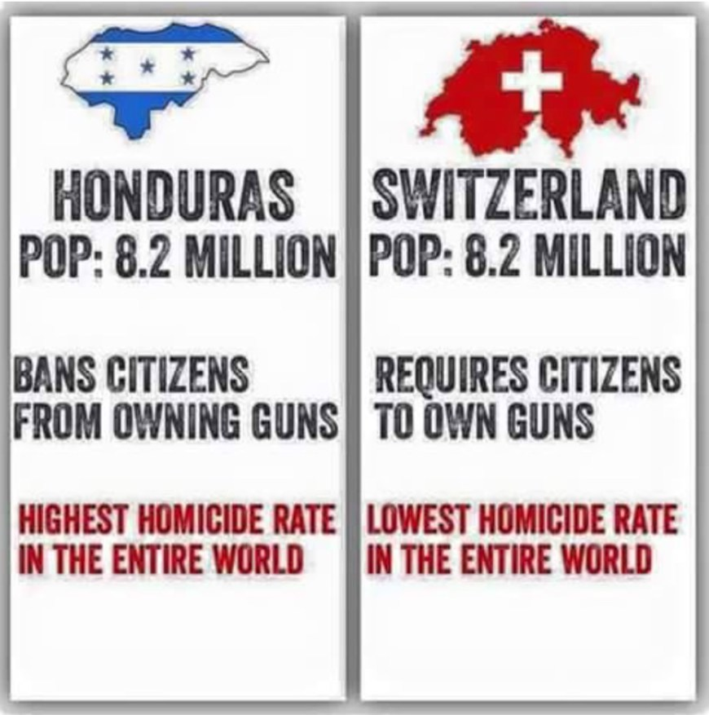

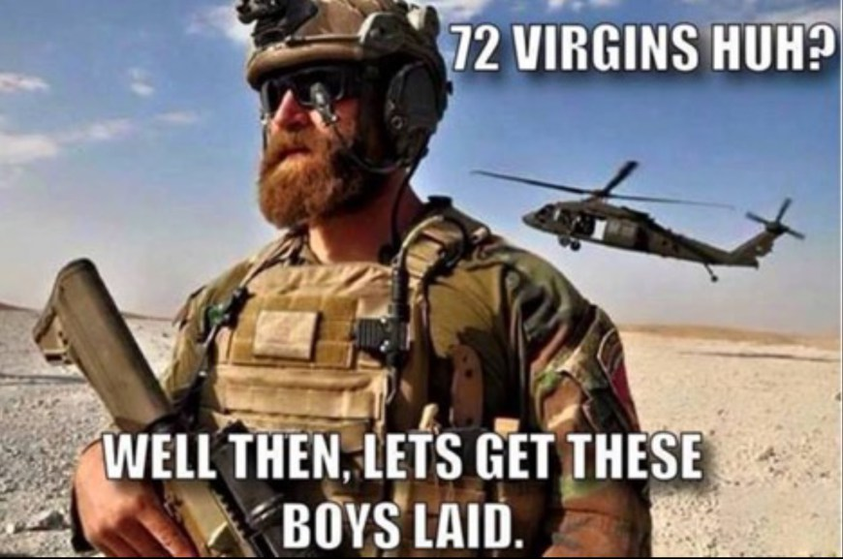

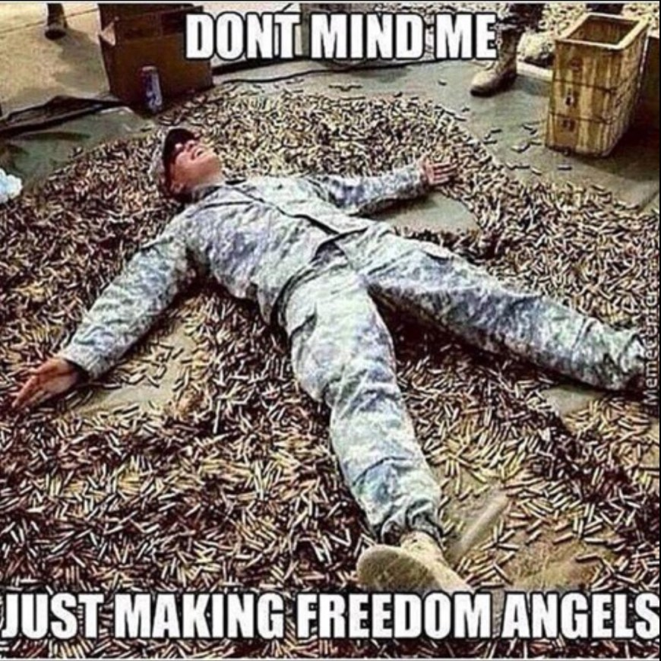

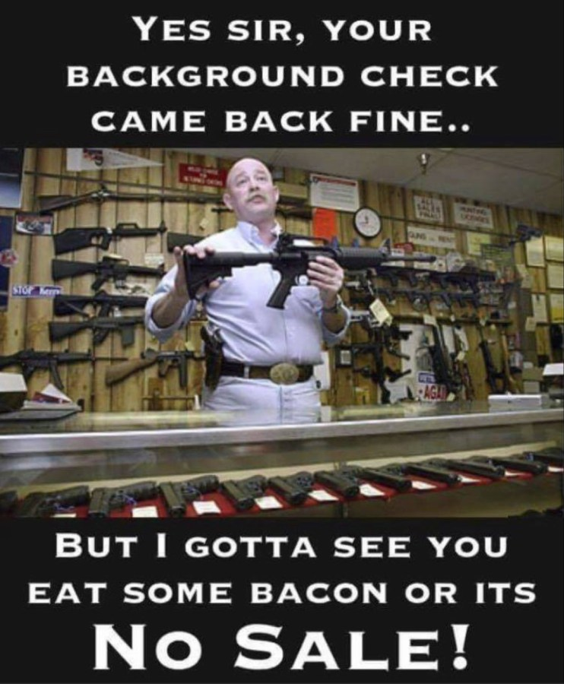

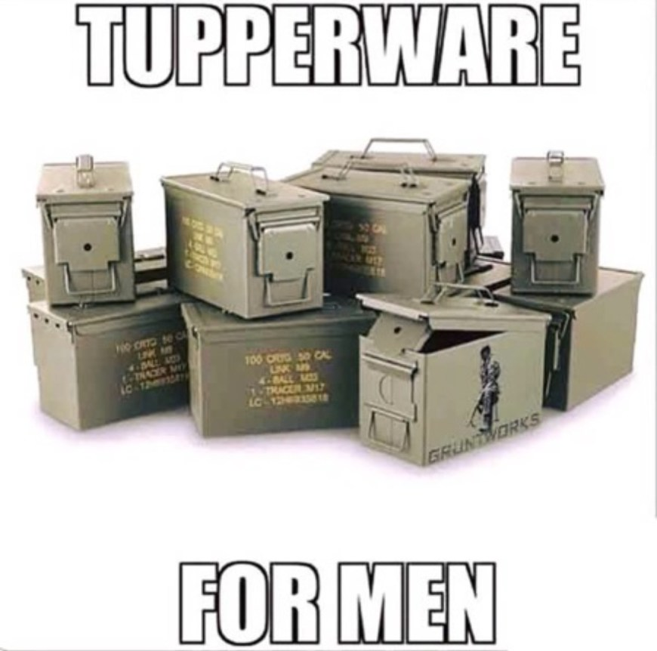

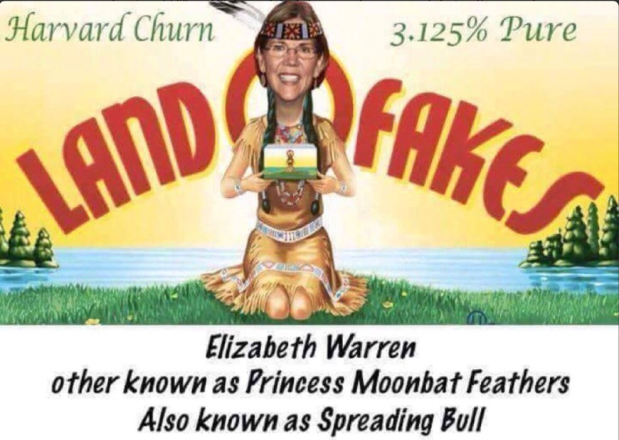
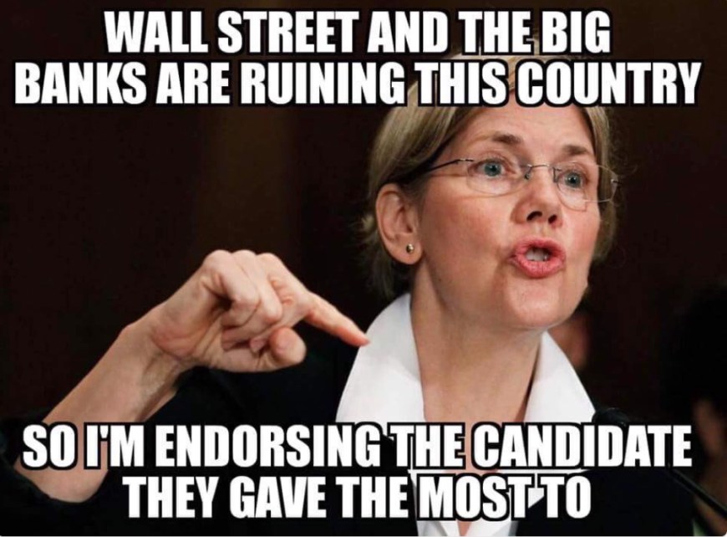

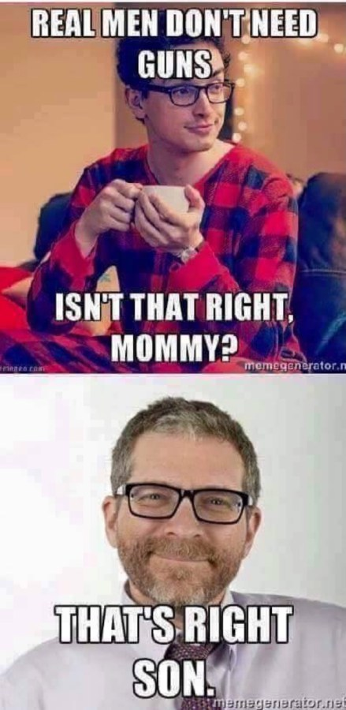

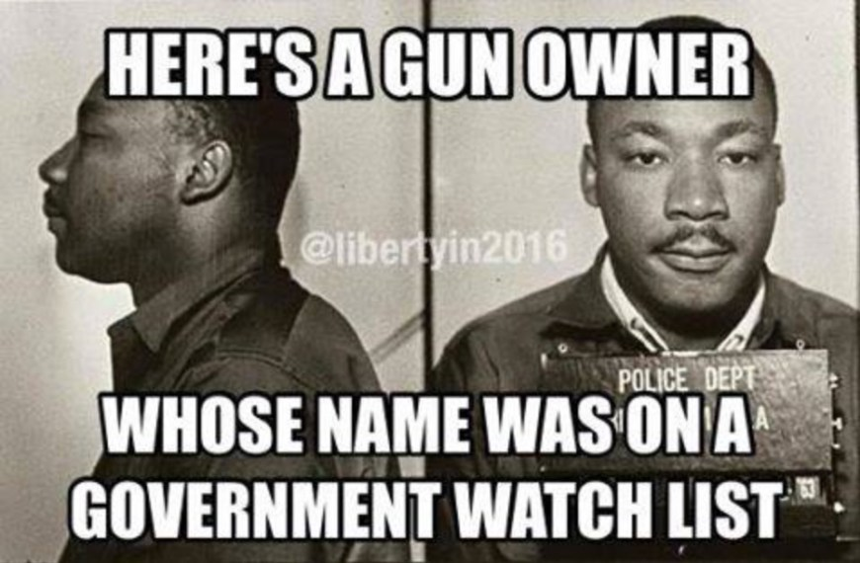

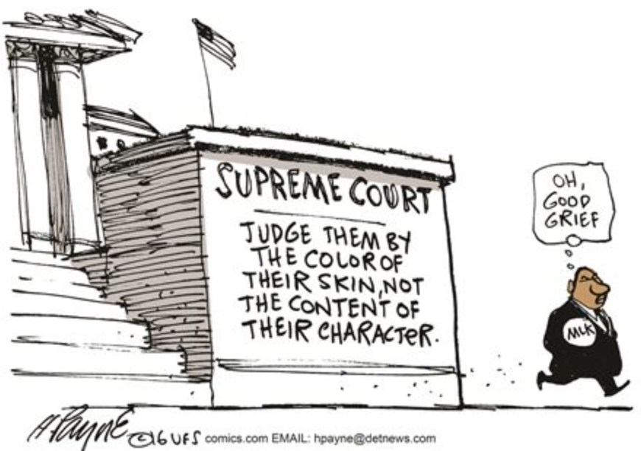

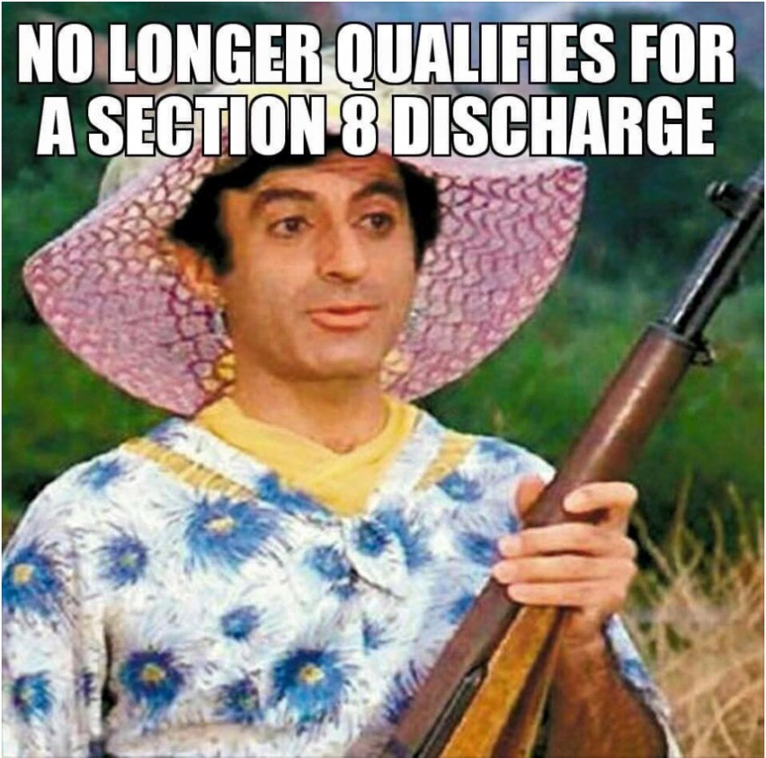

Shut the door!


