February 22, 2016 - CHEVY BOLT

It looks like GM has a sensible electric car that will be ready for delivery in the fourth quarter of this year.

Wired Magazine has our first item on the Chevy Bolt.
... over the past couple of years, a number of major automakers—General Motors, Nissan, Volkswagen—have lined up with plans to offer an electric car with (yep) approximately 200 miles of range, for a price somewhere around the average cost of a new American car, about $33,000. They all hope to do so quickly, as fuel efficiency requirements are ratcheting up every year. And they all hope to get there before media darling Tesla does. Musk—billionaire, celebrity, space and solar-energy mogul, would-be colonizer of Mars—has said since 2006 that Tesla’s "master plan" is to work toward building an affordable, long-range electric car. And in 2014 he said that goal was in sight: In 2016 Tesla would unveil a car called the Model 3 with a sticker price of $35,000 and 200 miles of range. Production would start in 2017.
In short, the electric car business has taken the form of an old-fashioned race for a prize—a race in very soft sand. There’s no Moore’s law for batteries, which are chemical not digital. Cell development is all slow, arduous trial and error. When your goal is to drive energy efficiency up while driving costs down on a mass industrial scale, there aren’t many shortcuts or late-night inspirations to be had. But now it looks pretty clear who the winner will be. And it ain’t Tesla. ...
... For GM, the Bolt stands to offer a head start in a new kind of market for electric cars. But for the rest of us, there’s a broader significance to this news. It’s not just that Chevy will likely be first. It’s that a car company as lumbering and gigantic as GM, with infrastructure and manufacturing capacity on an epic scale, has gotten there first—and is there now. Tesla is nimble, innovative, and fun to watch, as companies go. But the Bolt is far more significant than any offering from Tesla ever could be. Why? Think of the old saw about how long it takes to turn an aircraft carrier around: It’s slow, and there’s not much to see at any given moment. But the thing about people who actually manage to turn one around is: They’ve got a freaking aircraft carrier.
BEFORE WE GO any further, let’s pause for a moment to savor just how richly ironic it is that General Motors is about to take the lead in the electric car race. GM is, after all, a company that went bankrupt just seven years ago and survived only with the help of a federal bailout; a company whose board of directors was described by President Obama’s auto czar, Steven Rattner, as "utterly docile" in the face of impending disaster; a company that has been the butt of jokes about its lackluster, unreliable, macho cars for years; a company that churned out Hummers while Toyota gave us the Prius. And even more to the point, we’re talking about a company that has a long history with electric vehicles—the way South Park has a long history with Kenny. ...

The Wall Street Journal reviews the Bolt.
... Still, as much as GM might like to say otherwise, the Bolt is not a conceptual breakthrough but rather a triumph of procurement, namely, the small, lightweight and powerful battery concealed under the floor. Comprising 288 lithium cobalt prismatic cells arranged like rows of business envelopes, the Bolt’s battery pack holds a mighty charge of 60 kwh (with 140 kW peak output, or 200 hp) while weighing 960 pounds, including all the thermal management plumbing. There will be an eight-year/100,000-mile warranty on the battery.
When Chevy’s Volt plug-in hybrid got off the ground in 2008, GM was paying $1,000 for a kwh of automotive-grade lithium-ion storage. Today, that number is $145 per kwh, and GM gets its cell-level batteries from LG Electronics in South Korea.
Wall Street analysts forecast a price drop to around $125/kwh after Tesla’s Gigafactory in Nevada comes fully online. But, as Bolt battery engineer Bill Wallace noted, “The Koreans already have a Gigafactory.”
And what about Tesla? The Model 3 compact family sedan will make its public debut next month, with production for Q4, 2017 (but Tesla is famous for being on island time). Tesla also promises 200-plus range, and a price of $35,000, before the federal tax credits, effectively undercutting the Bolt by $2,500.
And just like that, the Bolt turns a corner. GM and Tesla, their competitors and all their proxies are poised to fight a price war, a procurement war, over the price of batteries that will drive energy storage below the $100/kwh mark. Numbers like that make electric cars for the masses a real, levelheaded engineering proposition.
Maybe, could be, nobody’s quite sure. But GM wants to be ready, just in case.

And the LA Times.
For years automakers have failed to make an electric car with the two qualities most drivers demand: a long driving range and a low sticker price.

Tesla Motors addressed half of the equation with its Model S, a sport sedan that travels 265 miles on a charge — but costs about $80,000. Other automakers tackled the other half, with electrics that are economical but go only about 80 miles between lengthy charging sessions.

Now General Motors, in a dramatic model debut in Detroit, says it has unlocked the magic formula. Its Chevrolet Bolt concept car will travel 200 miles between charges and sell in the low $30,000 range, after government incentives, GM executives said. The spacious four-door hatchback will go on sale in 2017.

If the automaker can deliver, the Bolt could transform the prospects for widespread adoption of electric cars. The Bolt could be "the first mass-market EV success," said one industry veteran.

"A 200-mile EV range at about $30,000 in a crossover body shape is a killer combination," said John Krafcik, president of auto shopping company TrueCar Inc. and former chief executive of Hyundai Motor America. "You are looking at annual sales of 100,000 vehicles."

The Bolt's range more than doubles that of Nissan's Leaf, the bestselling battery electric car, along with similar offerings from most major automakers. The car could help quell widespread skepticism about the future of electric cars, especially during a time of plummeting gas prices.

Tesla has promised a model with a Bolt-like price and range for years. But the automaker's next offering will be the repeatedly delayed Model X sport utility vehicle, now expected to launch late this year, for about the same price as the Model S. The affordable Model 3 is still years away. ..

Wired
Meet the Chevy Bolt, the First Electric Car for the Masses
by Alex Davies
TEN YEARS AGO, the room where I’m standing would have been filled with a deafening roar. The air would have pealed with the sound of a dozen V-8 engines, each one trembling atop its own laboratory pedestal as engineers in white shop coats used joysticks to adjust its throttle and load. ¶ Today, though, this former engine testing facility at General Motors’ Warren Technical Center, outside Detroit, is almost dead silent. From one end to the other—across a space roughly the size of two soccer fields—the room is blanketed with the low-frequency hum of cooling fans, interrupted only by the occasional clack of a keyboard and, on this particular morning, the chatter of Larry Nitz’s voice. ¶ "Let’s take a walk," he says after we’ve lingered in the doorway a moment. A voluble guy with a head of gray curls, Nitz is chief of electrification at General Motors, and this facility—the largest automotive battery lab in North America—is his domain.
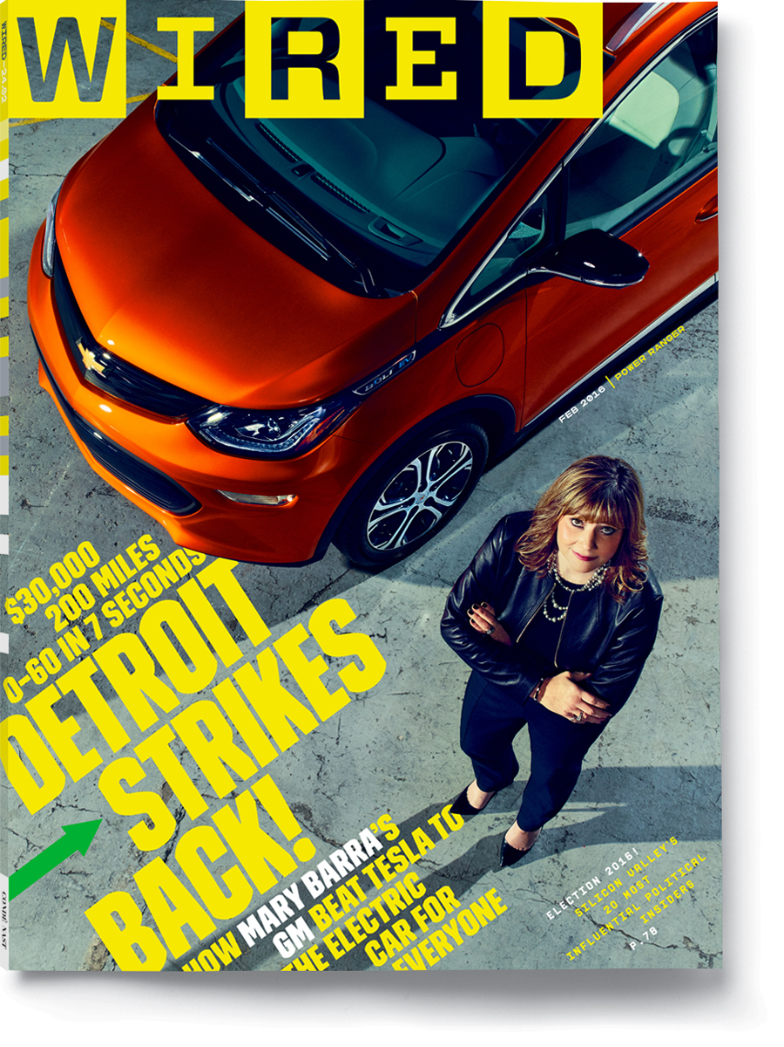
GM CEO Mary Barra

In place of all the old V-8s, a grid of 18 massive cobalt blue boxes, each 10 feet high and 8 feet wide, now dominate the lab. They look a little like walk-in freezers, which isn’t too far off. They’re climate simulators, Nitz says as we file past row after row of them. Battery chemistry is fiendishly sensitive to temperature and humidity, he explains, and electric cars have to hold up in every kind of weather. So inside each blue chamber, GM has created a virtual Yukon winter or Florida summer or Arizona spring. The enclosed batteries—not the familiar 40-pound bricks that need a jump start from time to time, but 1,000-pound behemoths built to power an entire car—are hooked up to testing equipment that charges and discharges them in patterns designed to mimic the ways people drive in cities, in the suburbs, and on the highway. The tests run 24 hours a day and in silence, generating terabytes of data.
But Nitz hasn’t brought me here just to show me a bunch of blue boxes. Near the end of the room, he finally stops us in front of a large industrial dolly. Sitting on top is a smooth black alien-looking thing, about the size and shape of a very thick rectangular kitchen tabletop. It’s 3 feet wide and 6 feet long and has dozens of plastic-tipped, copper-colored wires protruding from its surface in a sprawling mess of metallic spaghetti.
This dark monolith is the thing I’ve come to Detroit to see. It’s the technological heart of what promises to be the most significant vehicle General Motors has produced in decades: the first truly mass-market all-electric car. "This," Nitz says, "is the battery pack for the Bolt."


Inside the battery lab at the GM Technical Center in Warren, Michigan. These climatic testing chambers can subject batteries to temperatures varying from -85 to 185 degrees Fahrenheit, with humidy levels ranging from 0 to 100 percent.
ELECTRIC VEHICLES HAVE been available to American consumers for the better part of two decades. The first EVs looked like science projects only a Sierra Club member could love, while today an all-electric luxury sedan—the Tesla Model S—is routinely described as the coolest car on the planet. Early electric cars had a maximum range of 50 miles; today’s highest-rated EV—again, the Model S—can go as many as 300 miles before it needs to plug in. And yet, for all that progress, fully electric vehicles still make up less than 1 percent of US auto sales. There’s a straightforward reason for this: The only one that goes far enough costs far too much.
Most of us simply can’t shell out more than $70,000 for a Tesla. But comparatively affordable electrics like the Nissan Leaf still travel only about 80 miles on a charge—not far enough to dispel the dreaded "range anxiety" that such a low number provokes in most American drivers. A 2013 study by the California Center for Sustainable Energy found that only 9 percent of consumers said they would be satisfied with an electric car that can go 100 miles on a charge. Increase that range to 200 miles, though, and 70 percent of potential drivers said they’d be satisfied.
Tesla CEO Elon Musk has called 200 miles the "minimum threshold" for broad public adoption of electric cars. Offer that kind of range at a price that’s affordable to the average consumer and the potential market for electrics suddenly looks a whole lot bigger. Get there first and that new market could be all yours.
In its long history, General Motors has managed to kill the electric car not once but twice.
That’s why, over the past couple of years, a number of major automakers—General Motors, Nissan, Volkswagen—have lined up with plans to offer an electric car with (yep) approximately 200 miles of range, for a price somewhere around the average cost of a new American car, about $33,000. They all hope to do so quickly, as fuel efficiency requirements are ratcheting up every year. And they all hope to get there before media darling Tesla does. Musk—billionaire, celebrity, space and solar-energy mogul, would-be colonizer of Mars—has said since 2006 that Tesla’s "master plan" is to work toward building an affordable, long-range electric car. And in 2014 he said that goal was in sight: In 2016 Tesla would unveil a car called the Model 3 with a sticker price of $35,000 and 200 miles of range. Production would start in 2017.
In short, the electric car business has taken the form of an old-fashioned race for a prize—a race in very soft sand. There’s no Moore’s law for batteries, which are chemical not digital. Cell development is all slow, arduous trial and error. When your goal is to drive energy efficiency up while driving costs down on a mass industrial scale, there aren’t many shortcuts or late-night inspirations to be had. But now it looks pretty clear who the winner will be. And it ain’t Tesla.
General Motors first unveiled the Chevy Bolt as a concept car in January 2015, billing it as a vehicle that would offer 200 miles of range for just $30,000 (after a $7,500 federal tax credit). Barring any unforeseen delays, the first Bolts will roll off the production line at GM’s Orion Assembly facility in Michigan by the end of 2016. As Pam Fletcher, GM’s executive chief engineer for electric vehicles, recently put it to me with a confident grin: "Who wants to be second?"
For GM, the Bolt stands to offer a head start in a new kind of market for electric cars. But for the rest of us, there’s a broader significance to this news. It’s not just that Chevy will likely be first. It’s that a car company as lumbering and gigantic as GM, with infrastructure and manufacturing capacity on an epic scale, has gotten there first—and is there now. Tesla is nimble, innovative, and fun to watch, as companies go. But the Bolt is far more significant than any offering from Tesla ever could be. Why? Think of the old saw about how long it takes to turn an aircraft carrier around: It’s slow, and there’s not much to see at any given moment. But the thing about people who actually manage to turn one around is: They’ve got a freaking aircraft carrier.
BEFORE WE GO any further, let’s pause for a moment to savor just how richly ironic it is that General Motors is about to take the lead in the electric car race. GM is, after all, a company that went bankrupt just seven years ago and survived only with the help of a federal bailout; a company whose board of directors was described by President Obama’s auto czar, Steven Rattner, as "utterly docile" in the face of impending disaster; a company that has been the butt of jokes about its lackluster, unreliable, macho cars for years; a company that churned out Hummers while Toyota gave us the Prius. And even more to the point, we’re talking about a company that has a long history with electric vehicles—the way South Park has a long history with Kenny.
That’s right. General Motors killed the electric car. More than once.
In the earliest days of the auto industry, electric cars were about as popular as their combustion-powered counterparts. Just like today, they were cleaner and quieter but more limited in range than the competition. Plus, they didn’t require a hand crank to start—an annoying feature of early combustion vehicles that occasionally resulted in broken fingers. But in 1912, Cadillac, GM’s luxury arm, came out with the first electric starter for gas-powered vehicles. Electric cars died out shortly thereafter, and in a cloud of exhaust GM surged to become the world’s largest carmaker.
Fast-forward 84 years, and for a brief interlude it looked like GM was about to take the lead in bringing electrics back. In 1996, in response to a California mandate that required automakers to have zero-emissions vehicles ready for market by 1998, GM rolled out the EV1, the first mass-produced electric vehicle of the modern era. The funny-looking two-seater had a range of about 50 miles and was offered for lease to consumers in California and Arizona. It was impractical, dinky, and entirely doomed. It earned a small coterie of devotees but held little appeal for mainstream consumers. It used almost all unique parts, forfeiting the advantages of GM’s scale. And even as GM’s EV1 team was busy building the car, GM’s lawyers were lobbying hard, side by side with the other big automakers, to get California to back off its requirement.
Right around the time the EV1 was ready to hit dealerships, California weakened its mandate, relieving the legal pressure on automakers to offer zero-emissions cars. And after a few lackluster years marketing its electric automobile, GM unceremoniously dumped the money-bleeding EV1. It declined to renew the leases on the roughly 1,100 cars it had put on the road, recalled the vehicles, and—with an inadvertently theatrical flourish—crushed almost all of them and piled their carcasses in a junkyard. The experiment cost the company about $1 billion and was a public relations disaster. Years later a documentary that dramatically recounted the EV1 saga, Who Killed the Electric Car?, helped cement the perception that a feckless GM had committed technological infanticide.
By the mid-2000s, executives realized what a colossal mistake they had made. After riding out the ’90s with a doubled-down commitment to its traditional profit centers—SUVs and light trucks—GM sustained $8.6 billion in losses in 2005. Toyota, which boasted $9 billion in profits that same year, was on the verge of surpassing GM as the world’s largest carmaker. The Japanese firm was riding to victory on a reputation for economical, fuel-efficient cars, especially the Prius, an egg-shaped hybrid that delivered 50 miles per gallon and sold in the hundreds of thousands.
All of that pissed off Bob Lutz, GM’s vice chair for product development at the time. A cigar-chomping veteran of the car industry with a penchant for irascible quotes—he once panned GM’s cars for looking like "angry kitchen appliances"—Lutz was especially attuned to the big narratives that drive public perception of the auto industry (while under the surface, most of the real action is driven by recondite stuff like regulation, industrial and trade policy, labor economics, and logistics). Lutz hated how the Prius had put a saintly halo on Toyota, which sold plenty of SUVs and pickups, while hapless GM was mocked for making the Hummer. He also took notice when Silicon Valley upstart Tesla made a major splash with its public debut, announcing it planned to make a lithium-ion-battery-powered luxury sports car.
And so Lutz, a guy who would later declare that global warming is a "total crock of shit," began lobbying GM’s leadership to make the biggest, greenest play possible. He didn’t want GM to just build a me-too hybrid to compete with Toyota. He wanted GM to build a fully electric car that almost anyone could afford to buy and that wasn’t limited by range. He wanted, in effect, to build the Bolt. But the technology wasn’t there. The car that GM actually built at Lutz’s insistence—the Chevy Volt—went on to become one of the most talked-about American vehicles in decades, for a whole host of reasons, many of them symbolic. But in-house, says Tony Posawatz, the engineer who led the team that developed the Volt, it was very clear that this was going to be a transitional car—a warm-up for GM’s electric long game.
For the Volt, GM settled on a design that was neither a Prius-style hybrid nor a pure electric car but something in between called an extended-range electric vehicle. The setup would combine a plug-in battery strong enough to serve as the car’s main power train, plus a motor with a small gas engine that would work as a generator, creating electricity to keep the vehicle going when the battery was depleted. But even that hybrid design forced GM engineers, to a remarkable extent, to become cavemen rediscovering fire.
Being inside the Bolt feels a bit like flying economy class on a brand-new, state-of-the-art plane.
Nearly everything changes when you opt for a fundamentally different power train, so GM’s greatest advantage—more than a century of experience building cars—was all but moot. Car structure was different, since they were building around a battery, not an engine. The brakes, steering, and air conditioner were powered differently. New systems, from electromagnetics for the motors to onboard and off-board charging, each came with its own learning curve. The engineers didn’t have established tests to follow. Just turning on the car required finding the perfect sequence of electrical signals from more than a dozen modules. "Oh my God, it took us forever to get the first Volt to start," Fletcher says.
Then there was the battery. Lithium-ion chemistry was a new thing 10 years ago, and the Volt team quickly discovered how much of a pain in the neck it is. "Batteries wear out just sitting there, and they wear out when you cycle them," says Bill Wallace, GM’s head battery engineer. "And then they wear out if you over-discharge them, or if you overcharge them." They’re extremely sensitive to temperature. They change shape as they charge and discharge. They can also catch fire.
In short, all these problems were new to a company whose experience lay in what Lutz calls "the oily bits." So the team set about developing the expertise it lacked. GM established a curriculum with the University of Michigan to train battery engineers. It filled a vacant building in Brownstown, Michigan, with the equipment to make battery packs. The engineers created test procedures and wrote them down as they went. They modeled different use cases for the Volt, from a woman in northern Minnesota who plugs in every night to a guy in Miami who drives 100 miles a day. They built the battery lab and brought in the blue environmental chambers, then used them to see how the battery would stand up to each situation. "We invented the idea of what the lab should be," Fletcher says.Bolt is the People's Electric Car
The Volt project was still in its infancy when the US economy tanked in 2008, sending GM into shock. The company began losing $1 billion a month and started cleaving off limbs in desperation, eliminating or selling its Pontiac, Saturn, Saab, and Hummer brands. The Volt project could easily have fallen under the ax as well—but instead it took on an outsize significance. President Obama seized on the car as one reason GM was worth a $40 billion bailout, holding it up as a sign that the bankrupt automaker could adapt. The Volt finally went on sale in December 2010, to accolades ("A bunch of Midwestern engineers in bad haircuts and cheap wristwatches just out-engineered every other car company on the planet." —The Wall Street Journal) and jeers ("roller skates with a plug" —Fox News).
As for actual drivers, they were pretty into the Volt. The car posted stellar customer satisfaction ratings, and nearly 70 percent of its drivers were new to Chevy. The trouble was that there simply weren’t many buyers. In 2011, GM’s CEO at the time, Dan Akerson, told reporters he wanted to produce 60,000 Volts the next year. To date, Chevy has sold about 80,000—total. The Volt was a powerful symbol, but it wasn’t that significant a vehicle. Buyers soon had more innovative cars to choose from. The all-electric Nissan Leaf hit the market at around the same time as the Volt, for a similar price. In 2012, Tesla introduced its first-generation Model S, with upwards of 200 miles per charge.
But the real significance of the Volt was that it gave GM a brand-new manufacturing and engineering platform for electric vehicles, where it had had none before. "Once you make the leap, and you have a big battery, and you have electric motors," Posawatz says, "you’ve done all the hard stuff." And then you might just see an opportunity to gun for the finish line.
N THE MORNING of April 2, 2014, US senator Barbara Boxer glared down from behind a microphone in a Senate hearing room in Washington, DC, demanding answers from America’s industrial problem child, General Motors. The company had just instituted its largest recall ever, after reports that faulty ignition switches on millions of cars from the 2000s had been responsible for numerous deaths and injuries. Boxer, as part of a congressional investigative committee, was castigating GM’s new CEO, Mary Barra, who had been in the job a mere three weeks. "Woman to woman, I am very disappointed," Boxer said. "The culture that you are representing here today is a culture of the status quo."
Barra sat there, practicing the studiously neutral, calmly repentant facial nonexpression of someone getting grilled by Congress. The main theme of Barra’s testimony was that the old GM—with a docile, nodding bureaucratic culture that swept problems under the rug—had died with the company’s 2009 bankruptcy, bailout, and restructuring and that the new GM was different. But the "culture of the status quo" charge wasn’t so easy for Barra, of all people, to deflect: She’s not only a GM lifer, she’s a second-generation lifer. Her dad was a die-maker for Pontiac, and she started with the company when she was 18. (She’s 54 now.)
On the other hand, Barra had a strong hand in a lot of the most transformative stuff going on at GM. Chief case in point: Not long before she became CEO, Barra had been tapped to run development of new products, the position once held by Lutz. So by the time she was hauled before Congress in 2014 to answer for the company’s past sins, she had been overseeing the efforts of GM’s electrification gang for three years.
When I walk into Barra’s office one recent fall day, she’s standing in front of her desk wearing black pants, a black turtleneck, and an Apple Watch. (Offsetting the Steve Jobs vibe just a bit is a calendar on the wall that shows a fluffy white cat in the backseat of an Opel Corsa.) As Barra tells it, the process to develop the Bolt really took off when GM’s team was regrouping after a major setback. In 2012, GM invested in a California startup called Envia, which had developed a new battery that posted incredible performance numbers. Envia promised to deliver a 200-mile battery by fall 2013. But its technology turned out to be a flop.
Not only is GM likely to win the race, it may have the winner’s circle to itself for some time.
So in spring 2013, GM’s senior leaders and the most important figures on its electrification team gathered in the virtual reality room of the company’s Design Center to assess the situation. "We started to go, ‘OK, what can we do?’" Barra says. Was there another route to 200 miles? The EV folks hesitated but started pulling together different elements—improvements in battery life, cost savings in motors—that, combined, might represent a way forward. "We can push our way toward 200," Fletcher recalls thinking.
The meeting turned into a full-on brainstorming session, one that ended, Barra says, with what looked like a viable path to the Bolt: "And we all went, ‘Let’s do that.’"
And so the design team set to work devising a car that would appeal to consumers well beyond the ecowarrior, early-adopter demographic. Some flashy ideas were thrown out early on: A carbon fiber body? Lightweight but too expensive at this price point. Suicide doors? Eye-catching, but they added mass without functional benefits. Capped wheels? Good for aerodynamics, but they signaled something science project–y. "It’s got to look like a serious car," design lead Stuart Norris says. The team delivered as spacious an interior as possible, with upright glass to make the relatively small car feel more substantial and a raised driving position for a commanding view of the road.
Meanwhile, the technical folks set about making Norris’ design go 200 miles on a charge. At their most basic, batteries are made of powders, the morphology of which—grain size, distribution, how they’re bound together—is key to the power and energy of each cell. LG, General Motors’ battery provider, had cooked up a noticeably improved cell that retained energy capacity particularly well when it got hot, as lithium-ion batteries tend to. That meant Chevy could use a smaller cooling system and stick more cells in the battery pack for more range. LG also improved the battery’s conductivity, so the ions flowed faster, translating to quicker acceleration (the Bolt can go from 0 to 60 in seven seconds).
As soon as the battery was ready, engineers at GM’s Michigan proving ground hacked together a bastard car using the front half of a Chevy Sonic and the rear of a Buick Encore. They called it the Soncore and fitted it with the Bolt battery pack and motor, using the Franken-vehicle to make sure the propulsion system worked. That way, once the real Bolt body was in development, the teams responsible for the car’s chassis controls, vehicle dynamics, and suspension tuning could get right to work.
As 2014 bled into 2015, Chevy engineers built about 100 Bolt prototypes, shipping them around the US for real-world testing to verify the findings of the battery lab. The cars went to Arizona and Florida. The team drove them up the California coast and negotiated San Francisco traffic. They ran the prototypes over rough roads, looking for ways to reduce noise and vibration (extra-tricky in a car with no engine to mask odd sounds). They chose specially developed Michelin tires to minimize rolling resistance and improve range. Working fast, they made thousands of changes to the car, constantly looking for ways to improve. By the time I arrived for a test-drive, in October, the team still had more than 500 open work orders to complete.
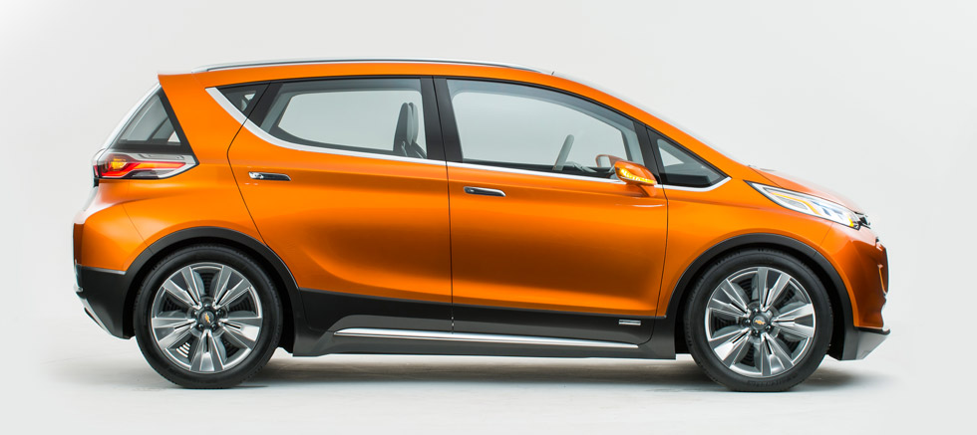
HE FIRST TIME I lay eyes on the Bolt, it’s wrapped in swirling black-and-white camouflage—the effect known as dazzle—designed to hide its curves and lines from cameras. That’s about as flashy as things get. There are no gull-wing doors or retracting handles like on some Teslas. The Bolt sits on modest 17-inch wheels. It appears to be a nice, of-the-moment-looking hatchback, like a Prius C or a Honda Fit with a shorter hood and taller roof. The main thing that indicates its revolutionary potential is the dashboard, which tells me I have 192 miles of range, a number I’ve only seen in Teslas.
Josh Tavel, the Bolt’s chief engineer, invites me to take a seat behind the steering wheel and, from the passenger seat, starts showing me around the interior. He begins with the caveat that the vehicle is only about 80 percent done—thus the big red emergency stop button just above the cup holders and the fire extinguisher in the backseat.
As I put the Bolt into drive and start exploring the GM Technical Center’s 11 miles of roads, Tavel gives me a tour of the interior. It’s decked out with a bunch of digital-age bells and whistles: On the dashboard is a high-definition 10.2-inch touchscreen. There’s a special space shaped to hold an iPhone 6, with a charge port right there, and a console compartment that fits a tablet. The rearview mirror can pipe in a display from cameras on the back of the car. The car also associates personal settings with different keys, so it knows whether you or your spouse is driving and tunes the radio appropriately. The backseat is remarkably roomy for a compact car, especially when it comes to headroom. I’m taller than average, and there are 3 or 4 inches between my head and the roof.
Overall, being inside the Bolt feels a little like flying in economy class on a brand-new, state-of-the-art plane. You’ve got a screen, an outlet to plug in your phone, enough legroom, and some sleek appointments. It’s not first class, but it doesn’t rub your nose in that fact the way some economy cabins (and some GM cars) do.
When I meet with Barra after my test-drive, we start by talking about the big-picture stuff: how the car could fundamentally change public attitudes toward electric vehicles. But she quickly moves on to the little things: the roominess, the connectivity, how the trunk opening is shaped so you can slide in that bookshelf you bought at Ikea. "No one’s gonna buy 200 miles if it doesn’t come with a great vehicle," Barra says.
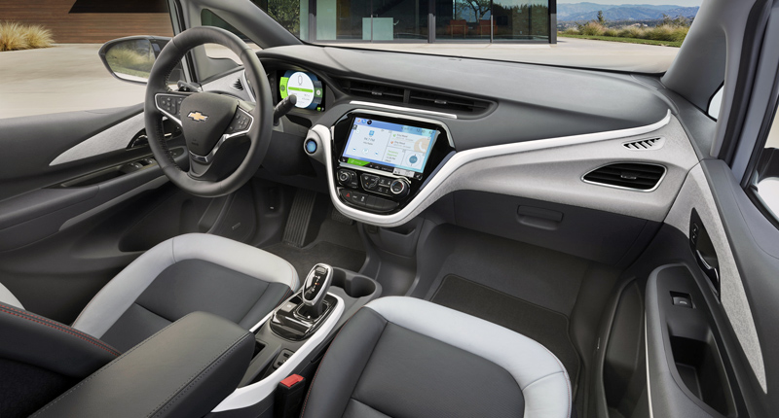

CHEVROLET SAYS IT is on track to start delivering the Bolt by year’s end. If that happens, it’s quite possible the company will have the winner’s circle to itself for some time. It now appears that the next Nissan Leaf will have 110 miles of range—a modest improvement over the current model. Volkswagen is at least two years away from its target. (It’s also tied up with a potentially ruinous scandal after cheating on emissions tests for millions of its diesel vehicles.) And Tesla has a track record of running about two years behind its production targets. But all the automakers will need to start building attractive zero-emissions vehicles somehow, and soon. It’s important to understand that the market for electric cars is still driven less by corporate profit-seeking than by government arm-twisting. In the US, federal fuel standards require automakers to achieve a fleet average of roughly 34 miles per gallon in 2016 and 49 mpg by 2025. On top of that, 10 states won’t let automakers operate unless they sell at least some zero-emission vehicles. All the automakers have to figure out how to get there.
If you’ve noticed certain names missing from the list of contenders for the race to 200 miles—chiefly Toyota—that’s mainly because Japanese and German automakers have focused on hydrogen fuel cell cars, an embryonic, expensive, and zero-carbon-emission technology that has its own problems, like a lack of national fueling infrastructure. Other automakers have responded to the rising tide of mandates with vehicles developed solely to meet requirements and avoid fines (shades of the EV1). The resulting cars are less than compelling and a pain for automakers. In May 2014, Fiat Chrysler CEO Sergio Marchionne actually asked people not to buy the all-electric version of the Fiat 500, saying, "Every time I sell one, it costs me $14,000." But the math of electric vehicles may begin to change with a mass-market EV like the Bolt, whose sales numbers could be in a different league. Barra wouldn’t disclose a sales goal—Chevy got pretty burned after missing its announced target for the Volt. Kelley Blue Book senior analyst Karl Brauer says that anything more than 50,000 units a year would be a huge coup. A number like that would make the Bolt the best-selling pure electric ever, ahead of Tesla and leagues ahead of Nissan’s Leaf and BMW’s new and funky i3.
Even if sales revenue from the Bolt doesn’t equal what GM has spent developing the car—which is likely, because battery power is still expensive—the Bolt will bring other benefits to GM. The car’s fuel economy rating will be so good that even just decent sales would significantly boost GM’s average fleet-fuel-economy numbers, ironically allowing the automaker to sell more pickups and SUVs, where the real profit margins are.
Perhaps most of all, executives are hoping that the Bolt will change the narrative about GM—which is important because a hapless company that churns out beefy trucks and lackluster sedans doesn’t have much place in the future. These days it’s a refrain among GM executives that in the next five to 10 years, the auto industry will change as much as it has in the past 50. As batteries get better and cheaper, the propagation of electric cars will reinforce the need to build out charging infrastructure and develop clean ways to generate electricity. Cars will start speaking to each other and to our infrastructure. They will drive themselves, smudging the line between driver and passenger. Google, Apple, Uber, and other tech companies are invading the transportation marketplace with fresh technology and no ingrained attitudes about how things are done.
The Bolt is the most concrete evidence yet that the largest car companies in the world are contemplating a very different kind of future too. GM knows the move from gasoline to electricity will be a minor one compared to where customers are headed next: away from driving and away from owning cars. In 2017, GM will give Cadillac sedans the ability to control themselves on the highway. Instead of dismissing Google as a smart-aleck kid grabbing a seat at the adults’ table, GM is talking about partnering with the tech firm on a variety of efforts. Last year GM launched car-sharing programs in Manhattan and Germany and has promised more to come. In January the company announced that it’s investing $500 million in Lyft, and that it plans to work with the ride-sharing company to develop a national network of self-driving cars. GM is thinking about how to use those new business models as it enters emerging markets like India, where lower incomes and already packed metro areas make its standard move—put two cars in every garage—unworkable.
This all feels strange coming from GM because, for all the changes of the past decade and despite the use of words like disruption and mobility, it’s no Silicon Valley outfit. The men and women who built the Bolt are pure Detroit. Mary Barra, Tony Posawatz, and Larry Nitz are all GM lifers. As a kid, Pam Fletcher built engines for race cars with her father. Josh Tavel raced motocross before getting into stock cars as both a driver and an engineer. He practically sweats gasoline. And yet he led the engineering team that could bring electric driving into the mainstream.
I’ve been driving the Bolt around the Technical Center campus for about 15 minutes when Tavel brings up something that’s been bothering him. "You haven’t really stepped on it yet," he says. I’ve been taking my time to get a feel for the car, treating it gently on wet roads in the presence of its chief creator. But knowing what I do about the fast pickup of electric cars—unlike combustion-powered vehicles, they deliver instant torque—I’m happy to oblige. I find a quiet corner of the campus and come to a stop with nothing but clear road ahead. I slam my right foot down and the nearly silent Bolt is suddenly a noise machine. The tires squeal on the wet pavement. After a half second, they catch and the Bolt zips ahead, if just a bit shakily. Chassis control is not quite perfect yet, Tavel says. That’ll be fixed before production starts—in just a few short months.

WSJ
In the Future, Chevy’s Going to Need a Bigger Bolt
Before long, the electric-car market will be a competitive battlefield and the latest from Chevrolet will be a solid player. But will the Bolt project be enough?
by Dan Neil
NO ONE KNOWS. That’s a fact. No one knows what the face of American personal mobility will be in 10 years. No. One. Knows.
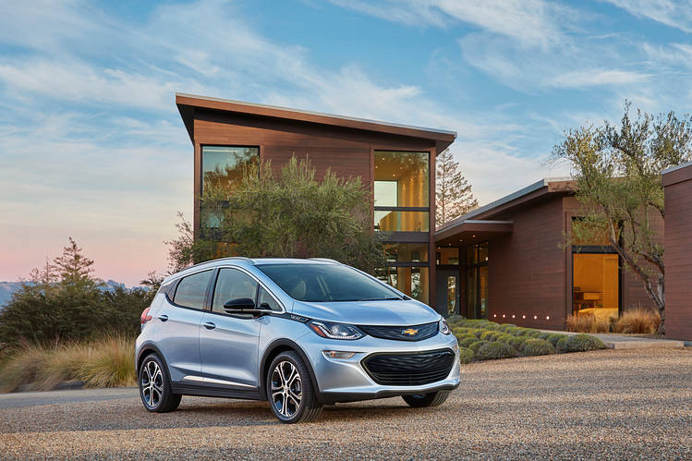
The new Chevy Bolt electric car promises a range of more than 200 miles
I recently spent a couple of days with the good people of General Motors in Detroit, who are, I assure you, very interested in what comes next, and they’re devilishly clever besides. But, as I say, they don’t have any idea what will become of the U.S. market’s record light-vehicle sales in 10 years; or whether oil prices will be sky-high or rock bottom; or what the hell the public will want then.
Five years? Oh, dude, they have that locked and loaded. I was able to drive a late-prototype Chevy Bolt EV around the campus of GM’s Warren Technical Center, which is still a sight to see, still redolent with midcentury optimism. The Bolt is an all-electric, B-segment hatch with a claimed range of more than 200 miles, 200 horsepower, sub 7-second acceleration, and a starting price, after the $7,500 tax credit, of around $30,000 (state credits may also apply). In the march to the practical, affordable electric car for the masses, those are magic metrics. Due date: Q4, 2016.
My pocket review: It’s a toaster, for an age when toast will be weirdly hip.
Meanwhile, in the sheds of Hamtramck they are knocking together the lightweight, mixed-material Cadillac CT6, a full-size sedan, in a flurry of robotic arms and laser beams. Marvy. But as to foreknowledge of the full-size sedan market 10 years out, they might as well be waving surrender.
Why? Because GM, the auto industry and American society on wheels (other markets are on other timelines) are about to be swept through twin wormholes of emissions regulation and vehicle autonomy, and no one knows what’s on the other side. Of special note is the federal Corporate Average Fuel Economy (CAFE) requirement of 54.5 mpg by 2025, a heroic figure that the Obama administration won from auto makers in the dark days of the bailout.

2017 Chervlote Bolt EV
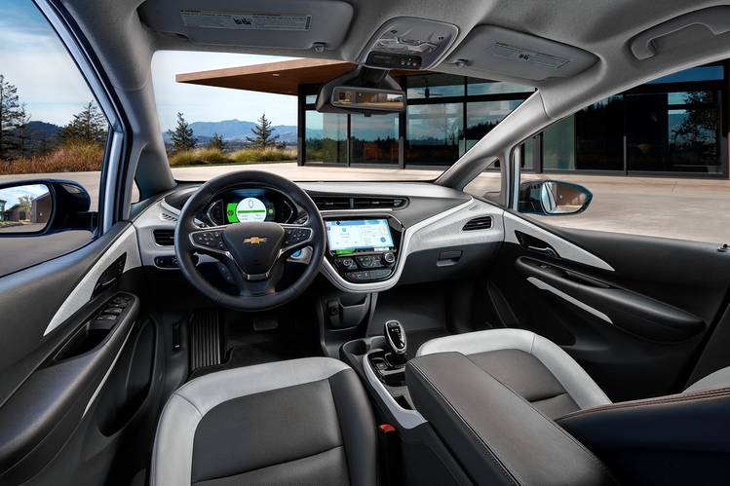
The Bolt boasts plenty of interior room
Base price: $37,500 (estimated, not including $7,500 federal tax credit)
Powertrain: Battery-electric vehicle with permanent-magnet electric motor and single gearset; 288-cell, 60-KWh lithium-ion battery; front-wheel drive.
Power/torque: 200 hp/266 lb-ft of torque
Length/weight: 164.0 inches/3,580 pounds
Wheelbase: 102.4 inches
0-60 mph: <7 seconds
Range: >200 miles (est)
Charge time: 90 miles/30 minutes (SAE Combo Fast Charge)
It was and is wise public policy, regardless of the current price of oil. Fuel economy/emissions standards are spiraling upward around the industrialized world as governments turn to face the challenge and politics of climate change. There was no way the U.S. auto sector could stay on those sidelines and remain globally competitive. That, we know.
CAFE has been the one lighthouse of certainty on the horizon. To hit that number, car makers are certain the machine has to change. Mass and general electrification will come to the U.S. light-vehicle market. Ten years, tops.
But, as I say, no one knows for sure.
The Bolt is built on the Uncertainty Principle. The significance of Chevrolet’s Bolt is that it marks the final readiness of EVs for the masses. No more measured praises, no more wait-and-see. Whichever way the market goes, the machine is sufficient to the task. You can’t object that the Bolt is too expensive, because it won’t be; you can’t say it doesn’t have enough range, because it certainly will. You can’t say EVs aren’t quick enough, because no one ever said they weren’t quick.
All this the Bolt accomplishes, or will, when it hits the showrooms late this year, a year ahead of of Tesla’s EV commuter-car, the Model 3.
The Bolt is no such moonshot. Compared with, for instance, BMW’s paradigm-shaking i Division—its Zaha Hadid-designed spaceport in Leipzig, specializing in carbon-composite construction—GM’s efforts toward electrification are measured and strategic, to a fault.
For example, the Bolt will not be built on a separate assembly line with dramatic lighting, like the BMW i3, but at the sturdy, unpicturesque hall at Orion Township, Mich. The Bolt deploys smart but fairly standard lightweight steel and aluminum construction for its body and chassis; but the fact is the CT6’s body in white is a more exotic structure.
While the Bolt has some strong and fearless character lines, the silhouette and envelope fairly scream multipurpose vehicle normalcy. It has a grille, though it doesn’t particularly need one. The doors and cabin openings are huge, and the distance between passengers and the swept windshield airy. GM cites a front passenger volume of 52.2 cubic feet (that’s about the size of an ice box outside a convenience store, if that helps).
Of my 45-minute tootle around GM’s campus, there isn’t much to tell, except that, like all EVs with batteries in the floor, the Bolt’s packaging is advantageous. GM’s Executive Chief Engineer of Electric Vehicles Pam Fletcher noted the Bolt offered D-segment interior space, in a car with a B-sized (compact) footprint. Adjustable regen braking, brisk steering. Nice.
Still, as much as GM might like to say otherwise, the Bolt is not a conceptual breakthrough but rather a triumph of procurement, namely, the small, lightweight and powerful battery concealed under the floor. Comprising 288 lithium cobalt prismatic cells arranged like rows of business envelopes, the Bolt’s battery pack holds a mighty charge of 60 kwh (with 140 kW peak output, or 200 hp) while weighing 960 pounds, including all the thermal management plumbing. There will be an eight-year/100,000-mile warranty on the battery.
When Chevy’s Volt plug-in hybrid got off the ground in 2008, GM was paying $1,000 for a kwh of automotive-grade lithium-ion storage. Today, that number is $145 per kwh, and GM gets its cell-level batteries from LG Electronics in South Korea.
Wall Street analysts forecast a price drop to around $125/kwh after Tesla’s Gigafactory in Nevada comes fully online. But, as Bolt battery engineer Bill Wallace noted, “The Koreans already have a Gigafactory.”
And what about Tesla? The Model 3 compact family sedan will make its public debut next month, with production for Q4, 2017 (but Tesla is famous for being on island time). Tesla also promises 200-plus range, and a price of $35,000, before the federal tax credits, effectively undercutting the Bolt by $2,500.
And just like that, the Bolt turns a corner. GM and Tesla, their competitors and all their proxies are poised to fight a price war, a procurement war, over the price of batteries that will drive energy storage below the $100/kwh mark. Numbers like that make electric cars for the masses a real, levelheaded engineering proposition.
Maybe, could be, nobody’s quite sure. But GM wants to be ready, just in case.

LA Times
Chevy Bolt electric car could be 'the first mass-market EV success'
by Jerry Hirsh
For years automakers have failed to make an electric car with the two qualities most drivers demand: a long driving range and a low sticker price.

Tesla Motors addressed half of the equation with its Model S, a sport sedan that travels 265 miles on a charge — but costs about $80,000. Other automakers tackled the other half, with electrics that are economical but go only about 80 miles between lengthy charging sessions.

Now General Motors, in a dramatic model debut in Detroit, says it has unlocked the magic formula. Its Chevrolet Bolt concept car will travel 200 miles between charges and sell in the low $30,000 range, after government incentives, GM executives said. The spacious four-door hatchback will go on sale in 2017.

If the automaker can deliver, the Bolt could transform the prospects for widespread adoption of electric cars. The Bolt could be "the first mass-market EV success," said one industry veteran.

"A 200-mile EV range at about $30,000 in a crossover body shape is a killer combination," said John Krafcik, president of auto shopping company TrueCar Inc. and former chief executive of Hyundai Motor America. "You are looking at annual sales of 100,000 vehicles."

The Bolt's range more than doubles that of Nissan's Leaf, the bestselling battery electric car, along with similar offerings from most major automakers. The car could help quell widespread skepticism about the future of electric cars, especially during a time of plummeting gas prices.

Tesla has promised a model with a Bolt-like price and range for years. But the automaker's next offering will be the repeatedly delayed Model X sport utility vehicle, now expected to launch late this year, for about the same price as the Model S. The affordable Model 3 is still years away.

Tesla said it welcomed the Bolt concept, which debuted Monday at the North American International Auto Show.

"Tesla is always supportive of other manufacturers who bring compelling electric vehicles to market," the automaker said in a statement. "We applaud Chevrolet for introducing the Bolt and are excited to learn more about the product."

The Bolt, which GM kept secret until the Detroit show, made its debut alongside a redesigned 2016 Volt, the second generation of Chevrolet's pioneering plug-in hybrid, first introduced in 2010. The new Volt will have an electric-only range of 50 miles before a gasoline engine takes over.

The original Volt was criticized for a high price and spotty execution. But GM's early start on electric development — the company also produced the low-selling subcompact Spark EV — may now pay off in lower production costs.

Improvements in battery technology, electric motors and the use of lightweight materials have helped slice nearly $10,000 off of the cost of manufacturing the Volt, said Mark Reuss, GM's executive vice president for global product development.

Those advancements will now be applied to its all-electric sibling, producing a battery-powered vehicle that won't leave owners constantly worried about running out of juice.

"The Bolt breaks the barrier on range anxiety," Reuss said.

It could also break the barrier of customer skepticism, said Akshay Anand, a senior analyst at Kelly Blue Book.

"Traditional electric-only vehicles have ranges well under 100 miles," Anand said. "Getting to the 200-mile mark is when you start to see potentially a much wider base of mainstream consumers who aren't just making short commutes, and don't just want to be 'green.'"

Some remain unconvinced that battery-powered cars can break through as a mainstream technology, especially in the short term.

"You have to wonder what the market will be for super-efficient vehicles at a time when oil is around $50 a barrel," said Jeremy Anwyl, an auto industry consultant.

Even Toyota, the global leader in gas-electric hybrids, doesn't see much future in cars powered by batteries alone. Toyota is moving instead into fuel cell cars, which rely on hydrogen to power their electric motors.

GM remains committed to battery power, despite the challenges it has faced. Chevrolet had hoped the original Volt would break through as a mainstream vehicle.

But the first Volt was a pricey and compromised car, said Jake Fisher, director of auto testing at Consumer Reports. The original Volt started at $41,000 for a base model, before incentives of up to $7,500 from the federal government and $2,500 from California.

"It was a really expensive vehicle that didn't feel expensive," he said. "Inside, it was basically a Chevy Cruze. And in the end, even the efficiency wasn't all that great."

The original Volt could travel 35 miles on battery power. But after the battery ran out, it achieved only 37 mpg operating as a hybrid. (The 2016 Volt will get 41 mpg in hybrid mode.) The current Prius, by comparison, achieves 51 mpg in city driving and offers more comfort and refinement at a substantially lower starting price.

Another big drawback: The Volt offered only four seats, because of space issues created by the large battery.

GM initially targeted 40,000 Volt sales annually, but purchases topped out at about 23,000 in 2012 and 2013 — and only after GM dangled heavy discounts and special lease deals. Sales fell to about 19,000 Volts in 2014.

The Volt succeeded by other measures, however. It has run a neck-and-neck race with the Nissan Leaf for the title of best-selling plug-in car. More important, it has created a loyal group of Volt owners eager to see the company's next-generation electric models.

In designing the 2016 Volt, Chevrolet systematically addressed consumer complaints about the original, said Andrew Farah, the lead engineer on both projects. Volt owners' highest priority, he said, was a longer electric-only driving range, followed by better hybrid mileage.

Chevrolet did not release pricing on the new Volt, but it isn't likely to increase much, if at all, from the current model, which starts at about $34,000 before government incentives. Farah said his team focused on giving customers a better car for the money.

"The improvement in range is significant, and miles per gallon is significant, but what really matters is how it feels driving down the road," he said. "That's where you hook people."

The debuts of the Bolt and redesigned Volt affirm the automaker's long-term commitment to electric vehicles, Reuss said.

"There are a lot of people who don't make snap decisions based on the current price of gas," Reuss said. "These are people who care about what they are doing to help the environment for the next generation."













