January 20, 2016 - DRONES

Warfare made a quantum leap just 15 years ago. The history of the development of weapons has been a constant effort to kill from greater and greater distances. In October 2001 a drone pilot executed a discreet kill of two Taliban guards from 6,900 miles away. The birth of drone warfare is covered in an article in Wired Magazine.
ON THE AFTERNOON of October 7, 2001, the first day of the war in Afghanistan, an Air Force pilot named Scott Swanson made history while sitting in a captain’s chair designed for an RV. His contribution to posterity was to kill someone in a completely novel way.
In the moments leading up to the act, Swanson was nervous. He sat in a darkened trailer tucked behind a parking garage at CIA headquarters in Langley, Virginia, remotely piloting a Predator drone over Kandahar, 6,900 miles away. Nearly everything about his rig had been cobbled together and hastily assembled. The Predator itself, one of just a handful in existence, was flying about 250 pounds heavier than usual. And the satellite communications link that connected Swanson to the aircraft would periodically shut down due to a power issue, which software engineers in California were frantically trying to patch.
When the order came through to take the shot, Swanson pulled a trigger on his joystick. A little more than a second later, a Hellfire missile slid off an aluminum rail on the Predator’s wing and sailed into the Afghan night.
Swanson’s target was a pickup truck parked outside a compound thought to be hiding Mullah Omar, the supreme commander of the Taliban. The missile killed two unidentified men believed to have been his bodyguards. It was the first time a US drone had fired a weapon in combat. It was the first time a modern drone had ever killed a human being. ...
... the national security establishment’s embrace of the drone has been so complete, it’s tempting to assume that this new paradigm of warfare was something dreamed up long ago by senior officials, who methodically plotted their way to it over a span of years and a string of defense contracts. That is, after all, how we got other major weapons like the M1 Abrams tank, the Apache helicopter, and the F-35 Joint Strike Fighter.
But that’s not how we got the modern drone. ...
... The tiny team of engineers and operators behind the program, who rarely speak publicly about their roles as the architects of remote warfare, worked under intense pressure, almost entirely free from the scrutiny of Pentagon acquisitions officers. In a series of breakthrough hacks, they hot-wired together the lethal, remotely piloted Predator over the course of just a few months in 2000 and 2001, in a mad dash to meet the heinous design challenges of a single job: to kill Osama bin Laden before he could commit an act of terror greater than al Qaeda’s bombing of the USS Cole in 2000.
The lethal Predator wasn’t a production vehicle. It was a hot rod, built for one all-out race against the clock. Of course, in those months before September 11, 2001, none of its designers knew the nature of the clock they were racing against. And most Americans have no idea quite how close they came to beating it. ...

... Sitting in his windowless office with a short public affairs staffer and a very tall security officer, the official—whom I’ll call Marshall—told me about that first time he saw the Predator in action in Hungary. "I was blown away," he says. "It flies at 70 miles an hour with a TV camera, but it can stay there forever." Marshall could see that it represented a strategic breakthrough comparable to that of the World War II codebreakers at Bletchley Park. From then on, he became a Predator evangelist, providing political cover and money when the project faced a roadblock. As I looked around Marshall’s office, I noticed several bottles of a wine called Predator Old Vine Zinfandel sitting on a bookshelf.
In 1998, Marshall helped see to it that the Predator program was handed over to a tiny outfit within the military that would essentially improvise the genesis of modern drone warfare: an entity known as Big Safari.
A HIGHLY SECRETIVE Air Force skunkworks based in Dayton, Ohio, Big Safari specialized in modifying standard Air Force aircraft for time-sensitive and highly classified operations, sometimes even for use in just a single mission. In 1961, for instance, when Nikita Khrushchev boasted that he was about to test the largest hydrogen bomb ever built, Big Safari had just five days to retrofit a Boeing KC-135 to carry a small lab’s worth of sensing equipment—shored up with two-by-fours—to snoop on the enormous detonation. ...

... Today the Big Safari team members don’t have much to do with the Predator. They’re mainly retired or doing other things, while the national security establishment that once disparaged the drone has thoroughly embraced it. The Predator has ushered in a more precise era of warfare. It has also inspired new kinds of nightmares for those who live under drones—and those who fly them.
In the summer, Swanson Skypes me from Antigua. During those first missions, he says, he was struck by the intimacy of this new form of warfare. "You’re watching these people coming and going," he says. "You’re watching them go out and take dumps or pees in the middle of the night.
"I’m not saying you ever really bond with the target," he goes on. But you dwell on them for dramatically longer than with any other weapons system, he says. His pauses begin to draw out.
I ask how it feels to have participated in the creation of the Predator. He mentions a recent drone strike that killed Nasir al-Wuhayshi, al Qaeda’s second-in-command. "I feel proud to have been part of the team that brought that forward," he says.
What about when a strike misses its target or is used for ill? That has less to do with what the Predator can and cannot do, he says. "That is just the ugly nature of war. And yeah, there’s always a little twinge of regret with that." Swanson pauses again. "The world is not black-and-white," he says. "It’s shades of gray presented to you in an infrared image."

Wired had another piece on drones; When Good Drones Go Bad.
LATE IN THE summer of 2014, surveillance footage of Syria’s Tabqa air base showed up on YouTube. That it was taken by ISIS forces is unremarkable. That it was shot with a DJI Phantom FC40—a popular consumer drone at the time, the kind you might have found under the Christmas tree—certainly was.
In the intervening year and a half, small quadcopter drones have become even more affordable and more broadly available. That’s enabled them to find all sorts of positive new purposes, from agriculture to inspecting cell towers. That increased accessibility, though, has also inspired a proportionate amount of concern about the misuse of drones. A new report (PDF) from the non-profit group Open Briefing lays bare just how far the threat from hobbyist drones has evolved, and how seriously we should take it. ...

For comic relief, late night from Andy Malcolm.
Conan: New electronic gadgets out include a drone that follows you around and lets you take selfies 24/7. The device was developed by a team of the world’s leading Kardashiologists.
Fallon: I don't want to say Hillary Clinton's upset about Bernie Sanders’ poll rise. But this morning she was spotted shouting into a volcano, “YOU SAID WE HAD A DEAL!”
Meyers: The federal government has unveiled new nutritional guidelines, recommending people eat more fruit, vegetables and whole wheat. Or at the very least, cut back on foods that have the word “triple” in their name.

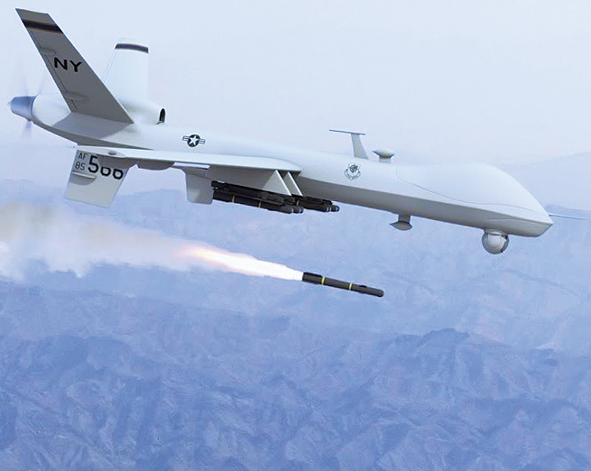

Wired
How Rogue Techies Armed the Predator, Almost Stopped 9/11, and Accidentally Invented Remote War
by Arthur Holland Michel
ON THE AFTERNOON of October 7, 2001, the first day of the war in Afghanistan, an Air Force pilot named Scott Swanson made history while sitting in a captain’s chair designed for an RV. His contribution to posterity was to kill someone in a completely novel way.
In the moments leading up to the act, Swanson was nervous. He sat in a darkened trailer tucked behind a parking garage at CIA headquarters in Langley, Virginia, remotely piloting a Predator drone over Kandahar, 6,900 miles away. Nearly everything about his rig had been cobbled together and hastily assembled. The Predator itself, one of just a handful in existence, was flying about 250 pounds heavier than usual. And the satellite communications link that connected Swanson to the aircraft would periodically shut down due to a power issue, which software engineers in California were frantically trying to patch.
When the order came through to take the shot, Swanson pulled a trigger on his joystick. A little more than a second later, a Hellfire missile slid off an aluminum rail on the Predator’s wing and sailed into the Afghan night.
Swanson’s target was a pickup truck parked outside a compound thought to be hiding Mullah Omar, the supreme commander of the Taliban. The missile killed two unidentified men believed to have been his bodyguards. It was the first time a US drone had fired a weapon in combat. It was the first time a modern drone had ever killed a human being.
THE PILOT
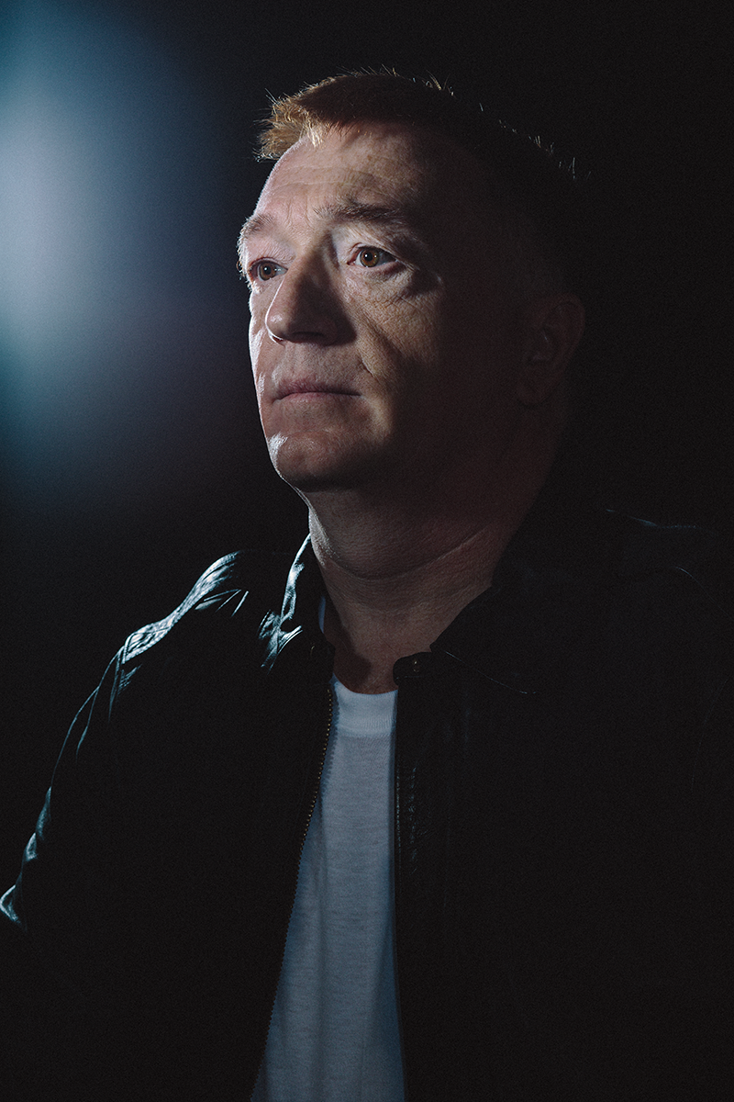
Scott Swanson, a Minnesota-born Air Force captain, made the first-ever kill from a remotely operated drone 14 years ago.
Fourteen years later, the drone is the quintessential weapon of the American military, which now boasts roughly a thousand Predator pilots. At any given moment, scores of them sit in darkened trailers around the country, staring at the bright infrared camera feeds from drones that might be flying over Afghanistan, Iraq, Syria, Pakistan, or Somalia. Between August 2014 and August 2015, a single Predator squadron—the 432nd Air Expeditionary Wing in Nevada—flew 4,300 sorties and dropped 1,000 warheads on ISIS targets. By enabling the White House to intervene without committing troops to battle, the drone has transformed US foreign policy.
Indeed, the national security establishment’s embrace of the drone has been so complete, it’s tempting to assume that this new paradigm of warfare was something dreamed up long ago by senior officials, who methodically plotted their way to it over a span of years and a string of defense contracts. That is, after all, how we got other major weapons like the M1 Abrams tank, the Apache helicopter, and the F-35 Joint Strike Fighter.
But that’s not how we got the modern drone. The Predator as we know it—with its capacity to be piloted from thousands of miles away and its complement of Hellfire missiles—wasn’t developed with the expectation that entire wars might one day be fought by pilots sitting in trailers. As a matter of fact, most military planners at the time regarded the Predator as pretty much a technological dead end.
The tiny team of engineers and operators behind the program, who rarely speak publicly about their roles as the architects of remote warfare, worked under intense pressure, almost entirely free from the scrutiny of Pentagon acquisitions officers. In a series of breakthrough hacks, they hot-wired together the lethal, remotely piloted Predator over the course of just a few months in 2000 and 2001, in a mad dash to meet the heinous design challenges of a single job: to kill Osama bin Laden before he could commit an act of terror greater than al Qaeda’s bombing of the USS Cole in 2000.
The lethal Predator wasn’t a production vehicle. It was a hot rod, built for one all-out race against the clock. Of course, in those months before September 11, 2001, none of its designers knew the nature of the clock they were racing against. And most Americans have no idea quite how close they came to beating it.
AMERICA’S FIRST LETHAL drone pilot was obsessed with flying from an early age. Growing up in Minnetonka, Minnesota, he joined the Civil Air Patrol at 13, got his private pilot’s license at 18, and enrolled in the Air Force ROTC program at the University of Minnesota just after graduating from high school. During the first Gulf War, he flew UH-1 Iroquois "Huey" helicopters. After Iraq, Swanson became a special operations pilot, focusing on sensitive and covert missions. Whenever he was at home base, he would volunteer to help test new Air Force weapons.
In 1997, Swanson was coming up on the end of a two-year mission in Iceland, some details of which remain classified. ("The Icelandic women were amazing" is about as much as he’ll volunteer.) Contemplating his next move, he searched a database of Air Force duty openings and found a curious posting that asked for rated pilots to join the Eleventh Reconnaissance Squadron at Indian Springs Air Force Base, near Las Vegas. The two-year assignment was to fly the Air Force’s newest aircraft, a little-known bird called the Predator Unmanned Aerial Vehicle.
An avid reader of Aviation Week, Swanson already knew a bit about the unmanned aircraft. Hand-built by a small, idiosyncratic California startup called General Atomics Aeronautical Systems, it had been used in the Balkans for surveillance since 1995. But it was not well loved by the defense establishment. The Predator was unarmed, couldn’t fly in bad weather, and could only be operated within a 500-mile range of the pilot. In 1997, an evaluation by the Defense Department found that it suffered mechanical failures in a staggering 12 percent of missions.
To most Air Force pilots, the idea of operating a drone would be a nonstarter. Pilots fly in planes. But Swanson had always been interested in tinkering, technology, and experimental weapons. (As a teenager, he once used a homemade batch of cellulose nitrate to fire a projectile through the door of an abandoned car.) And as a special operations pilot, he grasped the Predator’s surveillance capability right away. "It kind of clicked," he says.
So Swanson signed up with the Eleventh, and before the year was out he was in Taszár, Hungary, flying surveillance drones over Bosnia on a four-month deployment—the beginning of a years-long career with the Predator.
It was also in Taszár that the Predator caught the eye of another figure who would be crucial in its development, a senior Defense Department officer who was among the first to recognize the aircraft’s potential. This past spring, I made my way to the Pentagon to meet him. (For security reasons, he declined to be named.)

THE GODFATHER
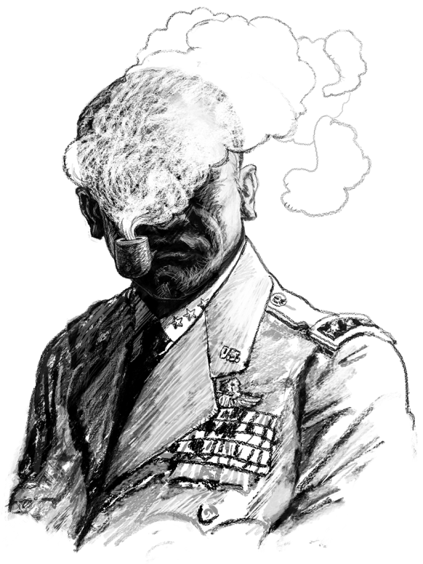
“Marshall” was the Predator program’s main advocate within the Pentagon, ushering it past administrative hurdles and helping put it in the hands of Big Safari.
Sitting in his windowless office with a short public affairs staffer and a very tall security officer, the official—whom I’ll call Marshall—told me about that first time he saw the Predator in action in Hungary. "I was blown away," he says. "It flies at 70 miles an hour with a TV camera, but it can stay there forever." Marshall could see that it represented a strategic breakthrough comparable to that of the World War II codebreakers at Bletchley Park. From then on, he became a Predator evangelist, providing political cover and money when the project faced a roadblock. As I looked around Marshall’s office, I noticed several bottles of a wine called Predator Old Vine Zinfandel sitting on a bookshelf.
In 1998, Marshall helped see to it that the Predator program was handed over to a tiny outfit within the military that would essentially improvise the genesis of modern drone warfare: an entity known as Big Safari.
A HIGHLY SECRETIVE Air Force skunkworks based in Dayton, Ohio, Big Safari specialized in modifying standard Air Force aircraft for time-sensitive and highly classified operations, sometimes even for use in just a single mission. In 1961, for instance, when Nikita Khrushchev boasted that he was about to test the largest hydrogen bomb ever built, Big Safari had just five days to retrofit a Boeing KC-135 to carry a small lab’s worth of sensing equipment—shored up with two-by-fours—to snoop on the enormous detonation.

THE CHIEF
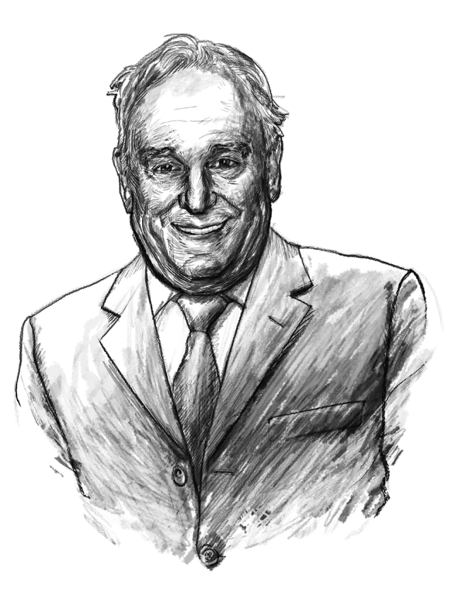
Bill Grimes was head of Big Safari, the secretive Air Force skunkworks that transformed the early Predator from a motorized glider with a camera into a remote killing machine.

"We generally didn’t do anything from scratch," says retired colonel Bill Grimes, Big Safari’s director from 1985 to 2002. "We took existing hardware that was maybe for one purpose and adapted it to a completely different one for our needs." Like at a tech startup, Big Safari’s teams were small and horizontal. Expediency, agility, and thrift were essential. "The most important thing was to get something useful to the war fighter quickly," Grimes says.
Big Safari set up its Predator office inside the General Atomics factory in San Diego, where the drone was made. And in the spring of 1999, during the Kosovo War, they got their first major chance to tinker with it. The Air Force came to Big Safari looking for a new way to steer laser-guided bombs dropped by jet fighters. US pilots wanted to stay above the range of Serbian antiaircraft fire, but their jets’ laser designators—devices that beam pulses of light onto targets to guide missiles toward them—could not penetrate the region’s heavy cloud cover. Big Safari’s idea was to bolt a helicopter’s laser designator onto a Predator. That way, the drone could stay below the clouds, in harm’s way, and paint laser bull’s-eyes on the ground for the jets high overhead.
In a typically lightning-fast turnaround, Big Safari had a modified Predator ready to be airlifted to the battlefield within 45 days. And its pilot—both in preliminary testing and on the ground in Kosovo—was none other than Scott Swanson.

THE TECHNICAL LEAD

Brian Raduenz led the small team that came up with all the modifications to Big Safari’s Predator, from its laser weapons-guidance system to its customized Hellfire missiles.

Ordinarily, before a modified military aircraft is dispatched into combat, it has to pass through a lengthy vetting process that can take years. But Big Safari liked to deploy its creations before they were fully polished. The team referred to this as "the 80 percent solution" (because sometimes the last 20 percent of a job takes the longest). It was like releasing the beta version of a piece of software, says Brian Raduenz, then the commander of Big Safari’s Predator detachment. "We would need to get it out there, get it into the hands of the guys doing the job, and then pay close attention to what they had to say about how it was working."
The rest of the Air Force was naturally allergic to this approach. At one point, authorities at Air Combat Command—an entity that had jurisdiction over all the Air Force’s Predators—ordered Grimes to relay all his communication with Predator test pilots through the command’s headquarters in Virginia. Unwilling to play a game of telephone, Grimes just gave Swanson a secure line so he could report back to Big Safari on the sly.
In Kosovo itself, Swanson participated in just one strike before the war ended. But by then, the pilot and his colleagues at Big Safari could tell they were onto something; a drone that could pinpoint targets was no joke. "We knew it was the future," Swanson says. And that future was about to come at them in a rush.
BIG SAFARI’S WORK on the Predator really took off when the group was enlisted in a high-stakes manhunt. In 1999, the CIA began to focus intently on Osama bin Laden, who had claimed responsibility for the US embassy bombings in Kenya and Tanzania in 1998. Intelligence reports indicated that bin Laden was planning further attacks. The agency wanted to put eyes on the al Qaeda leader and possibly target him, so it went looking for a covert way to get a high-powered camera over Afghanistan. The agency and the Pentagon considered several options, including a bizarre plan to mount a giant telescope on the side of a mountain. But after dispatching a group of officials in July 2000 to Indian Springs for a demonstration by Swanson, the CIA settled on the Predator.
First off, Big Safari had to figure out a way to sneak the Predator into Afghan airspace. Between maintenance crews, pilots, and field officers, it took several dozen people on the ground to sustain the operations of a single drone. According to Richard Whittle, whose book Predator authoritatively recounts the drone’s history, the ground control station and satellite terminal were too large to conceal anywhere within a 500-mile radius of Kandahar. To make the operation truly covert, they would need to separate the drone from those controlling it by several thousand miles—by situating the command center at Ramstein Base in Germany. Ginger Wallace, an Air Force intelligence officer who was assigned to work on the project, thought the idea was ludicrous. "There’s no way," she remembers thinking. "We can’t really do that."

THE INTEL OFFICER
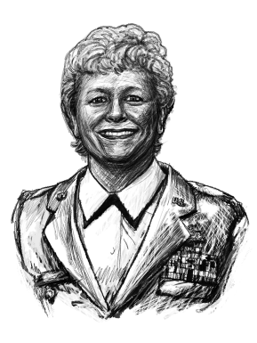
Ginger Wallace was a member of the team that operated the Predator on its first Afghan missions. She provided information about the landscape passing beneath the drone’s camera feed.

The guy who figured out how to do exactly that—how to wage war from thousands of miles away with a few clever modifications—was known among his colleagues in Big Safari as the Man With Two Brains, for his freakish intelligence. Without him, Grimes tells me, "it would not have happened."
An independent contractor who started working on the Predator in 1994, the Man With Two Brains almost never gives interviews. He spoke on condition of strict anonymity. At the beginning of our conversation, which I was allowed to record with a pen and paper only, I was scanned with a small black device, for a wire.
The basic premise of his remote control system, called split operations, was simple. A small, covert team of General Atomics contractors would post up at an airfield somewhere in a country bordering Afghanistan (the location of the site remains classified). There, they would launch the drone using a traditional line-of-sight remote control link. Once the drone was airborne, an onboard antenna would connect to a commercial satellite, which would relay the link to the ground control station hidden inside Ramstein Air Base, where Swanson, Wallace, and the rest of the operations team—working in secrecy—would control the drone as it scanned the desolate Afghan desert for the CIA’s target.
True to Big Safari hacking tradition, the system did not require any significant new technology. But it did pose certain creative challenges. For instance, the plan required an antenna in Germany powerful enough to pick up a distant satellite signal—and the only option was a 36-foot "big-ass dish" located, appropriately enough, at Air Combat Command headquarters in Virginia. A team of contractors dismantled and made off with the satellite dish in a single night. By the time one of the lower-level staffers who managed the dish discovered it was gone and began circulating angry emails demanding its return, it was already en route to Germany, as were Swanson, some General Atomics contractors, and a joint CIA and Air Force operations team.
The team found what they were looking for during one of the Predator’s very first split operations missions in early September 2000. Swanson was circling over Tarnak Farms, a walled compound near the Kandahar airport where bin Laden—or UBL as the team called him, referring to the alternative spelling, Usama—was thought to be living. Jeff Guay, an Air Force master sergeant on the team, was controlling the drone’s camera. Sure enough, a man in white, surrounded by an entourage, soon emerged on their screens.
"When UBL walked out of that one building," Swanson says, "the way he appeared much taller than everybody, the people were deferential around him, the way he was dressed, Jeff and I just looked at each other and it’s like, ‘Yeah, that’s got to be him.’" Swanson assumed a cruise missile would be dispatched in the direction of bin Laden while the Predator loitered overhead to make sure he stayed put. The team had been instructed to continue circling for as long as necessary, even if that meant running out of fuel and crashing.
But for reasons obscure to the team, no strike was ordered. With Swanson gripping his joystick, unable to do anything but stare, America’s final chance to kill Bin Laden before September 11 slipped away.

IT WAS CLEAR: If the Predator had been armed, Swanson could have done the killing himself. And sure enough, the flight over Tarnak Farms kicked into high gear a project that had been quietly under way for months. Air Combat Command had decided to look into arming the Predator in 1999. When they put Big Safari on the case, Grimes convened a gathering of engineers and weapons specialists at the Big Safari office in Dayton. On the first day of what would become a two-day meeting, he noticed that some of the engineers were laughing at the proposition of mounting a missile on a motorized glider. "We identified those who were leaning forward, who felt like this could be done, and I privately got ahold of them and invited them the next day," he says. "The remainder were totally unaware of the second meeting."
Grimes and his team briefly considered packing the Predator with explosives and flying it directly into its targets, but a projectile that chugged along at highway speed was too slow to reliably surprise anyone. Big Safari needed a weapon that was small enough to fit on the Predator’s delicate wings but powerful and precise enough to destroy a car or a person from high in the air.
Eventually they settled on the Hellfire, the Army’s low-altitude, laser-guided helicopter missile. But the technical challenges of taking an antitank weapon designed to be fired from no higher than 2,000 feet and converting it into an antipersonnel missile that would be shot from above 10,000 feet were considerable. Among other things, the Predator would need a new forward-looking infrared camera, the team would need to recode the guidance systems on each missile, and someone was going to have to figure out how to give an armor-piercing munition the kind of grenade-like, shrapnel-spewing blast that would be effective at killing humans. "Even with a Big Safari mentality, that’s a big-ass project to get done," Swanson says.
The team certainly didn’t lack for motivation, however. In October 2000, just six weeks after the crew had first set eyes on bin Laden at Tarnak Farms, al Qaeda carried out its attack on the USS Cole in Yemen, killing 17 sailors. Big Safari had already proven it was possible to get a Predator within striking distance of the al Qaeda leader. Now their goal was to get a shot at him with an armed Predator before the next winter. When the CIA approved the idea of a lethal Predator and put its weight behind the program, the project went into overdrive. "You could see and tell with the energy of the team that you had a real no-shit goal with this," Swanson says. "We’re gonna arm this thing and go hunting."
The Hellfire program’s deadline was set for September 1, 2001. And everything was on schedule until a new roadblock shot up—a political problem that would inspire Big Safari’s most historically significant technological hack.
In the summer of 2001, the German government decided that it would not permit the US to operate its newly armed Predators from Ramstein. So the CIA’s deputy counterterrorism chief convened a briefing to announce that the effort to deploy an armed Predator to Afghanistan in search of bin Laden would be tabled until they could figure out somewhere else to base their operation. When the floor was opened for questions, the Man With Two Brains says, he raised his hand. He had an idea.
For years he had told Grimes and others at Big Safari that it would be technically feasible to operate Predator drones around the globe from within the US. He called his concept remote split operations. Now he realized that such a system wouldn’t just make deployments easier, it would solve the agency’s legal conundrum. The idea was to use the military’s existing fiber-optic network to put 4,000 miles between the drone pilot, who would now be in the US—unaffected by Germany’s laws—and the big-ass satellite dish, which would still be located at Ramstein.
This time, the challenges were technical: The Man With Two Brains had to find a way to package the various kinds of data traveling between the drone and the operators—flight commands in one direction, data from the camera and the drone’s other sensors in the other—and shuttle them across the Atlantic without creating a lot of lag time.
To package the data, the Man With Two Brains turned to something called a multiplexer, a fairly cheap commercial device that Internet companies were using to bundle various kinds of files, like MPEGs, into fiber-optic-friendly packets for streaming. He split an encoding device in the Predator’s existing satellite link system in two and placed each half on either end of the military’s 4,000-mile undersea fiber-optic cable. Discarding a modem, he installed in its place two multiplexers, which encapsulated the data traveling in both directions.
Figuring out how to minimize lag time, or latency, was an equally devilish challenge. Anyone who has tried to have a conversation over a laggy Skype connection will have a sense of the problem. CIA and Air Force engineers had run their own calculations and determined that the new system would increase the total latency to five seconds, too much to safely operate a weapons system.
The Man With Two Brains wanted three months to complete the entire project; he got six weeks. Working in a lab in Washington, DC, the contractor spliced fiber-optic cables, soldered switchboards, and created a variety of loops and circuits that more resembled a Rube Goldberg machine than a device that would enable the killing of a human being from half a world away.

THE GENIUS (AKA - THE MAN WITH TWO BRAINS)
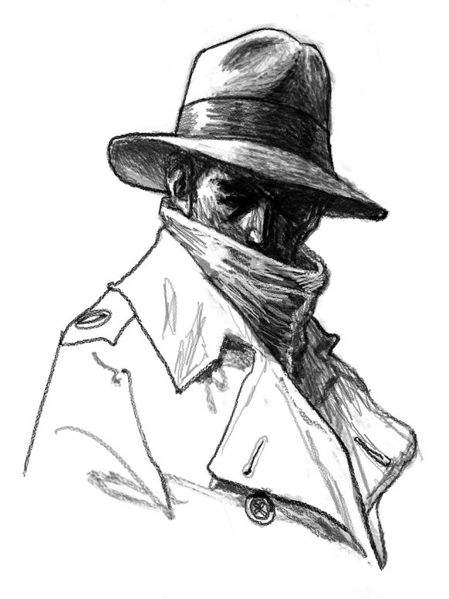
The Man With Two Brains, as colleagues nicknamed him, conceived the remote control system that enabled drones to be operated from thousands of miles away.

Once he completed the hack—on schedule—he traveled to Southern California to see how it would work on a real Predator. On the first day of flights, the remote split link passed various stress tests. The Man With Two Brains planned to conduct further tests the next day—which was September 11, 2001.

TIME SLOWED DOWN for millions of Americans that morning, but for the Predator team it sped up. The remote split system was promptly approved for operation by the CIA; in Alabama, a batch of Big Safari’s modified Hellfires was loaded into a transport pallet bound for Afghanistan; and Scott Swanson packed his bags for Langley, where the team’s ground control station—the darkened trailer—was waiting by the CIA parking garage. Major Mark Cooter, the operation’s director, started making calls to the other members of the group that had flown the Predator over Tarnak Farms, telling them it was time to get the band back together.
CIA electrical engineers had set up a sleek-looking control console in the team’s trailer at Langley, but it didn’t work, so Cooter instructed his own team to rip it out and replace it with a more functional setup, partly held together with zip ties and Velcro. On September 17, the team fired up the remote split link for the first time. Everyone watched as Swanson moved his joystick; 1.3 seconds later, the Predator responded. The addition of 4,000 miles of fiber-optic cable had increased latency by only 200 milliseconds, round-trip.

THE OPS DIRECTOR
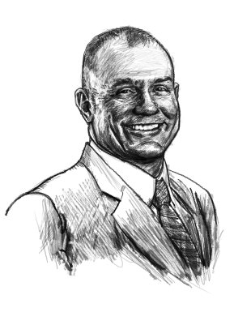
Mark Cooter helped direct the first secret missions that sent the drone over Afghanistan.

The 80 percent solution wasn’t perfect, of course. "There were glitches," Swanson says. The data link, which shared a satellite with several cable television networks, would drop out unexpectedly, as happened on October 7, when a white-knuckled Swanson killed Mullah Omar’s two presumed bodyguards. During another strike, the Predator’s communications system went into a reboot at the precise moment Swanson launched one of its Hellfires at a radar site. In the first three months of the war, the team lost at least two Predators due to malfunctions. "Oh yeah, it was a duct tape war," Marshall says.
Bit by bit, the team racked up some early successes, including a strike that killed Mohammed Atef, the military commander of al Qaeda. Word of their exploits spread, and elite forces on the ground would specifically request air support from the Predator team, which had been given the codename Wildfire. The team framed a copy of a 2000 Defense Department report that had declared the Predator a failure and hung it on a wall next to a list of what Marshall called their greatest hits. That October, an unnamed official said in a Pentagon briefing that theater commanders were "begging for more Predators." In a December 2001 speech, then-president George W. Bush singled out the Predator as a harbinger of the military’s future. "It is clear the military does not have enough unmanned vehicles," he said. In the space of three years, Big Safari had transformed an albatross on the verge of extinction into a lethal bird that was now being hailed as the chief weapon in the War on Terror.
And they kept hacking. Using consumer electronics, the Man With Two Brains figured out how to transmit the Predator’s live feed to AC-130 gunships and, later, to ground forces. The team even figured out how to channel a cable television feed into the Predator’s video dissemination system, essentially turning the drone into a flying TV antenna: That way, forward-operating Special Ops teams could watch NFL games and movies during their downtime.
SWANSON, WHO NOW works as a consultant out of Antigua, Guatemala, has a stiff crop of red hair that turns to gray at the sideburns. His eyes are small and intense, and he chooses his words with the concentration of someone who knows a lot of secrets.
Today the Big Safari team members don’t have much to do with the Predator. They’re mainly retired or doing other things, while the national security establishment that once disparaged the drone has thoroughly embraced it. The Predator has ushered in a more precise era of warfare. It has also inspired new kinds of nightmares for those who live under drones—and those who fly them.
In the summer, Swanson Skypes me from Antigua. During those first missions, he says, he was struck by the intimacy of this new form of warfare. "You’re watching these people coming and going," he says. "You’re watching them go out and take dumps or pees in the middle of the night.
"I’m not saying you ever really bond with the target," he goes on. But you dwell on them for dramatically longer than with any other weapons system, he says. His pauses begin to draw out.
I ask how it feels to have participated in the creation of the Predator. He mentions a recent drone strike that killed Nasir al-Wuhayshi, al Qaeda’s second-in-command. "I feel proud to have been part of the team that brought that forward," he says.
What about when a strike misses its target or is used for ill? That has less to do with what the Predator can and cannot do, he says. "That is just the ugly nature of war. And yeah, there’s always a little twinge of regret with that." Swanson pauses again. "The world is not black-and-white," he says. "It’s shades of gray presented to you in an infrared image."

Wired
When Good Drones Go Bad
by Brian Barrett
LATE IN THE summer of 2014, surveillance footage of Syria’s Tabqa air base showed up on YouTube. That it was taken by ISIS forces is unremarkable. That it was shot with a DJI Phantom FC40—a popular consumer drone at the time, the kind you might have found under the Christmas tree—certainly was.
In the intervening year and a half, small quadcopter drones have become even more affordable and more broadly available. That’s enabled them to find all sorts of positive new purposes, from agriculture to inspecting cell towers. That increased accessibility, though, has also inspired a proportionate amount of concern about the misuse of drones. A new report (PDF) from the non-profit group Open Briefing lays bare just how far the threat from hobbyist drones has evolved, and how seriously we should take it.

The Threat Abroad
Let’s start with a healthy dose of perspective. Consumer drones aren’t currently a major part of the ISIS arsenal. There aren’t roaming packs of DJI Phantoms or Parrot Bebops terrorizing the streets of Ramadi. Even that first public incident, the 2014 Tabqa footage, "appeared to be for propaganda purposes only," according to the Open Briefing report.
That perspective need also include, though, the swift evolution of the uses ISIS forces have found for these quadcopters. "The range of scenarios that threat groups have or are likely to use drone in can be broadly divided into two types of threat: intelligence gathering or attack," says Chris Abbott, founder and executive director of Open Briefing.
His group’s report details multiple instances of the former. ISIS used a hobbyist UAV in April of last year to help coordinate its attack on Iraq’s Baiji oil refinery complex. The following month, Kurdish forces shot down an ISIS drone that had been monitoring their positions. And these are just the times they’ve been caught.
Reports of weaponized drones are more muddled, though one unconfirmed report claims that Kurdish forces recently shot down a small drone—the kind you can make at home from a mail-order kit— carrying explosives. Most consumer drones can’t currently carry heavy enough payloads to do very significant harm, but that doesn’t mean they’re ineffective.
"It’s a really crude method of packing a drone with explosives, and using it like a flying IED," says Colin Clarke, associate political scientist at the RAND Corporation. "It’s more of a psychological threat than anything. It’s probably far more effective to lob artillery, or mortars, or RPGs toward the front line. But if all of a sudden you’ve got this drone flying forth, it strikes fear in the heart of the enemy."
Clarke and Abbott agree that ISIS primarily leans on drones for intelligence gathering at the moment, and even that effort could be charitably described as piecemeal. Both also, though, see the potential for much more harmful pursuits ahead.
"These groups are highly adaptable. They’re able to learn from each other and their own mistakes," says Clarke. "They’re going to get better at this stuff. They’re going to perfect it."
However steep that learning curve turns out to be, it likely ends not in Syria or Iraq, but in one of the Western nations ISIS has clear intent to attack.
"The failure of Islamic State to successfully use drones for attack in Iraq and Syria shows that the method of attack has some difficulties," says Abbott. "However, Iraq and Syria provides the group with the testing ground to perfect the delivery of IEDs by unmanned aerial or ground vehicles. Once perfected, multiple sources have suggested that the group is looking to use drone swarms to overwhelm any defenses and deliver spectacular attacks."
The idea of a coordinated drone attack rightly sounds terrifying. (These are, after all, terrorists). For that matter, so does a precisely placed lone wolf quadcopter. How likely that type of attack is to take place outside of the Middle East theater, though, remains a question of some debate.

The Threat at Home
While the Open Briefing report focuses on the UK, the findings can largely be applied to the United States as well, especially in terms of the range of bad actors that could make use of drones.
A lone wolf. A terrorist group. Drug cartels. Espionage-minded corporations. Activist organizations. The list of those who could benefit—or already have—from the illicit use of drones is long, and not getting any shorter.
There appears to be no shortage of opportunity, either. You might remember the rogue DJI Phantom quadcopter that crash-landed on the White House lawn a year ago, or an unidentified drone that collided with the Sydney Opera House last fall, or any number of college and professional football stadium fly-bys over the last two years.
These incidents all turned out to be benign, the result of poor piloting, poor judgment, or both. Still, they and a cascade of similar events illustrate the ease with which consumer drones can occupy vulnerable spaces. And while drones have yet to be used in a terrorist attack in Europe or the United States, not all close quadcopter encounters have been entirely innocent.
"What could be was demonstrated in April 2015 when a man landed a drone on the Japanese prime minister’s office in Tokyo," recounts the Open Briefing report. "The drone was carrying a bottle containing radioactive sand from Fukushima, which was emanating up to 1.0 microsievert per hour." What’s scary here isn’t the amount, which is roughly the same exposure you’d get from a single arm X-ray. It’s the proximity.
It’s not all bad news. The availability of drones, and even their ability to fly near or into restricted places, is still a far cry from those drones causing significant harm.
"While consumer drones are readily available, lightweight explosives and weapons of mass destruction are not," said Gregory McNeal, an associate professor of law and public policy at Pepperdine University, at a Congressional hearing last March. "Even if terrorists were able to procure explosives or WMD, using a consumer drone to conduct an attack would be one of the least effective means of carrying out an attack."
Then again, an effective drone attack wouldn’t necessarily require scale.
"Whether or not an attack does real damage, the psychological is tremendous," says Clarke. "It’ll be picked up by the media, emphasized far beyond what it is. Even if it kills one person and injures three, the damage has already been done. The images have already been built."
There are easier ways to do harm than arming a drone. There aren’t many that can grab the same headlines.

Countermeasures
Let’s assume that a quadcopter attack will happen at some point in the United States. It very well may not! The threat is real enough, though, to merit at least some preparedness, at least in so far as one can prepare.
In fact, there’s plenty that’s already been done in response to those errant drones mentioned above, as well as to the possibility of bad actors in the future.
"DJI pioneered geofencing in the consumer drone sector in 2013, integrating no-fly zones into our aerial platforms and app, preventing takeoff in and flight into areas deemed off-limits for security reasons," says DJI spokesman Adam Najberg. Current restrictions on DJI drones include not being allowed to fly within a 15.5 mile radius of the White House. The company also maintains a list of No Fly Zones that prevent certain of its products from taking off in locations where drones are dangerous or illegal, or keep them from entering those spaces if already in the air.
Not all drones are made by DJI, though, and not all manufacturers are quite so fastidious. Besides which, security features based on drone software have the same vulnerabilities any software solution does: It can be tampered with.
"With only minor changes to [a] UAV’s autopilot software, of which highly capable open-source variants exist, an attacker could readily disable geofencing and could configure the UAV to operate under ‘radio silence,’ ignoring external radio control commands and emitting no radio signals of its own," said Todd Humphreys, associate professor at UT-Austin, before Congress last March.

In truth, no single effort can guarantee safety from a determined drone attacker. "The best defense against the hostile use of drones is to employ a hierarchy of countermeasures encompassing regulatory countermeasures, passive countermeasures and active countermeasures," says the Open Briefing report.
Regulatory measures include those that are already present in the United States, which include drone registration and maintaining a line of sight. Those could be expanded to include certain manufacturing restrictions and mandates, which range from requiring DJI-type geofencing of all quadcopter makers to putting limits on carrying capacity and range.
Passive countermeasures include traditional technologies like radar tech and the newer drone detection devices like DroneShield, which "contains a database of common acoustic signatures unique to drones," and informs nearby security of their presence. Radio jammers are also effective, though Open Briefing notes that blocking popular drone control frequencies would also interfere with mobile phones.
Active defense, meanwhile, is exactly what it sounds like: shoot the drone. Missile, bullet, rock, net, laser, another drone, doesn’t matter. Just hit the drone with something that makes it go plop.
Abbot says that all of these defense mechanisms—aside from lasers that shoot drones out of the sky—are available today. As you might imagine, though, each comes with its own set of benefits and drawbacks. A missile would make short work of a DJI Phantom, but also any nearby buildings. Regulations are often more effective on paper than in practice. And passive drone detection and prevention presents a host of problems all its own.
"Imposing restrictions on small UAVs beyond the sensible restrictions the Federal Aviation Administration recently proposed would not significantly reduce the threat of rogue UAVs yet would shackle the emerging commercial UAV industry," testified Humphreys. "Powerful GPS jamming around the White House, for example, would deny GPS aiding to commercial aircraft at nearby Reagan National Airport. Similarly, anti-UAV laser or electromagnetic pulse systems are a danger to nearby civil infrastructure and transport."
The trick, then, will be finding the right combination of the three that prevent harm while still enabling good.
Ultimately, though, there may be no perfect solution. Hobbyist drones, like cars or pressure cookers or any number of household objects, can be used for ill.
"Is there, realistically, a regulation that could—or should—be put in place to restrict sale and use of consumer products and technology used properly by hundreds of thousands or even millions of people," asks DJI’s Najberg. "I’m not seeing that. Do you ban all sales and use of trucks all over the world?"
Well, no. But you do invent roadblocks, and require drivers licenses, and keep trucks away from areas where they could cause undo harm. Eventually, we’ll find an effective version of that for small flying toys. Or come to terms with the reality of a world where there isn’t one.

IBD
Late Night Humor
by Andrew Malcolm

Fallon: Wherever he is after a late-night speech Donald Trump always flies back to sleep in New York. Unless he's really tired. Then, he buys a hotel.
Conan: Donald Trump’s wife is speaking out. Melania Trump said she was initially attracted to Donald because of his energy. By the way, “energy” is the Slovenian word for “money.”
Conan: Twitter is testing a feature that will allow you to write a post that contains up to 10,000 characters. They’re calling this exciting new feature “Facebook.”
Fallon: Hillary Clinton is on the show tonight. Backstage, she told me she's a huge fan of the show. And I said, "I know, I read it in your e-mails."
Conan: The government of Iraq has offered to mediate between Saudi Arabia and Iran. You know the Middle East is in trouble when your greatest hope for peace is “meeting up in Iraq.”
Fallon: Ben and Jerry's ice cream wants to make a flavor inspired by Bernie Sanders. Whatever flavor it winds up being, we know Bernie will hate it for being too rich.
Conan: One of the hottest new trends among pet owners is pants for dogs. Not so popular— “thongs for cats.”
Meyers: The White House admits Obama met privately with Bernie Sanders. When she heard this, Hillary Clinton fake-smiled so hard, her ears touched in the back.
Fallon: President Obama criticized companies for not being loyal enough to their employees. Employees would agree, but they were too busy buying Powerball tickets so they could quit their jobs.
Conan: Speaking at Liberty University, Donald Trump misquoted the Bible, saying “two Corinthians” instead of “Second Corinthians.” And several times, instead of saying “God” he said “Donald Trump.”
Conan: A new study finds the more porn a man watches, the less motivation he has. I was going to read more of the study but for some reason I just completely lost interest.
Conan: Reports today that 62 people own half of the world’s wealth. The other half bet on the Green Bay Packers.
Conan: Khloe Kardashian has announced she’ll be hosting a new talk show where she drinks cocktails with her guests. The show will be called, “Throwing Up With The Kardashians.”
Fallon: The Obama White House has joined Snapchat. It's a great platform for this White House, because moments after the president makes a promise, it magically disappears.
Conan: New electronic gadgets out include a drone that follows you around and lets you take selfies 24/7. The device was developed by a team of the world’s leading Kardashiologists.
Fallon: I don't want to say Hillary Clinton's upset about Bernie Sanders’ poll rise. But this morning she was spotted shouting into a volcano, “YOU SAID WE HAD A DEAL!”
Meyers: The federal government has unveiled new nutritional guidelines, recommending people eat more fruit, vegetables and whole wheat. Or at the very least, cut back on foods that have the word “triple” in their name.
Meyers: Netflix recently announced that subscribers have viewed nearly 12 billion hours of content during the last three months. The only thing they still haven’t viewed is the sun.
Meyers: Trump says Hillary Clinton doesn’t have the “stamina” to take on the country’s enemies. Which is a ridiculous thing to say about someone who’s been running for president for 68 years.
Fallon: Bernie Sanders attacked Hillary Clinton for taking $600,000 in speaking fees from Goldman Sachs. In response, Hillary said, “Oh, come on. That was just one speech!”
Fallon: Pope Francis visited a synagogue in Rome over the weekend. When the Pope and a rabbi walked in, people in the crowd said, “I've heard this one before.”
Fallon: A new umbrella is on sale for $125. It alerts your phone if you leave the umbrella behind. Unfortunately, there's nothing yet that warns when you're about to spend $125 on an umbrella.



