November 27, 2015 - CLIMATE REPORT

The ship of fools will be visiting Paris next week for the Climate Summit. Take that, ISIS! Time for another CLIMATE REPORT.

Just to prove some college professors have played the part of idiots for a long time, Real Science has found a 1941 paper from Cincinnati that quotes a U of Cinncy prof who says it was climate problems that caused Hitler. He says warmer weather makes people more docile. Just for added grins they included in the post some stuff from CIA pukes in 1974 and 1976 that predicted global instability caused by a cooling climate.

CLIMATE - there's nothing it can't do!

And here, all along, Pickerhead thought that was solely the power of bacon.

Steve Hayward of Power Line says the New Yorker is trying to be as silly as the NY Times.
Oh, good grief. The New Yorker is trying to give the New York Times a run for its money as the most pathetic attempt to put The Onion out of business:
'Why a Climate Deal Is the Best Hope for Peace
By Jason Box and Naomi Klein
. . . The connection between warming temperatures and the cycle of Syrian violence is, by now, uncontroversial. As Secretary of State John Kerry said in Virginia, this month, “It’s not a coincidence that, immediately prior to the civil war in Syria, the country experienced its worst drought on record. As many as 1.5 million people migrated from Syria’s farms to its cities, intensifying the political unrest that was just beginning to roil and boil in the region.” ...'

Some scientists say the Climate Summit is based on nonsense. Climate Depot has the story.
A team of prominent scientists gathered in Texas today at a climate summit to declare that fears of man-made global warming were “irrational” and “based on nonsense” that “had nothing to do with science.” They warned that “we are being led down a false path” by the upcoming UN climate summit in Paris.
The scientists appeared at a climate summit sponsored by the Texas Public Policy Foundation. The summit in Austin was titled: “At the Crossroads: Energy & Climate Policy Summit.”
Climate Scientist Dr. Richard Lindzen, an emeritus Alfred P. Sloan Professor of Meteorology at the Department of Earth, Atmospheric and Planetary Sciences at MIT, derided what he termed climate “catastrophism.”
“Demonization of CO2 is irrational at best and even modest warming is mostly beneficial,” Lindzen said.
Lindzen cautioned: “The most important thing to keep in mind is – when you ask ‘is it warming, is it cooling’, etc. — is that we are talking about something tiny (temperature changes) and that is the crucial point.”
Lindzen also challenged the oft-repeated UN IPCC claim that most of warming over past 50 years was due to mankind. ...

Ed Rogers understands why the upcoming Paris climate change conference is perfect for this president. Yes, this is a repeat from the last Climate Report. But, this post is about climate fools so recycling is appropriate.
After failing at almost every foreign policy challenge he has been confronted with, perhaps there is now something on the horizon that actually sets up nicely for President Obama. The Paris Conference on Climate Change, which will be held from Nov. 30 to Dec. 11, could be an event that perfectly matches his skills and interests.
The U.N.-sponsored Paris festival lends itself to unrealistic giveaways and meaningless rhetoric — the more self-righteous and pretentious, the better. The meeting won’t produce any particular result, and the day of reckoning where we find out it was all for naught won’t be scientifically determined until many years in the future. It seems well-suited for this president.
All Obama has to do is go to Paris, give a vapid speech about saving the planet, capitulate to those who would like to see the United States weakened, pretend that others will fulfill their pledges to reduce carbon emissions and then return home to a round of self-congratulations from his own staff and sycophant appointees. To follow up on his brave proposals, all he has to do is sign a couple of executive orders that slap American businesses with some gratuitous, onerous regulations and declare that a noble deed has been done. And, by the way, the White House will have to do whatever it takes to keep any agreement reached in Paris from being voted on in Congress. ...

John Barrasso, Wyoming senator, says Congress can cool off obama's climate plans.
When the U.N. climate-change talks convene in Paris next week, the risks will be high for American taxpayers. President Obama wants a climate deal and is willing to pay dearly to get it. The inevitable outcome is a plan with unproven benefits and unreachable goals, but very real costs. It will be up to Congress to check the president’s ambition of committing the U.S. to an international green scheme that will produce little or no return.
The ostensible goal of the Paris talks (Nov. 30-Dec. 11) is to convince countries to commit to enacting laws that reduce carbon emissions. That fits President Obama’s vision of a world without fossil fuels such as coal, oil and natural gas. The American people oppose these policies, but the president has shown himself determined to circumvent Congress.
The Obama administration has already imposed burdensome regulations—for instance, the sprawling Clean Power Plan aimed at wiping out the coal industry—that will raise the cost of energy and put hundreds of thousands of Americans out of work. Now the president wants his negotiators to use these international climate talks to pile on more restrictions. ...

Actually, the earth is coming into a cold spell reports the Nation.
The sun will go into "hibernation" mode around 2030, and it has already started to get sleepy. At the Royal Astronomical Society's annual meeting in July, Professor Valentina Zharkova of Northumbria University in the UK confirmed it - the sun will begin its Maunder Minimum (Grand Solar Minimum) in 15 years. Other scientists had suggested years ago that this change was imminent, but Zharkova's model is said to have near-perfect accuracy.
So what is a "solar minimum"?
Our sun doesn't maintain a constant intensity. Instead, it cycles in spans of approximately 11 years. When it's at its maximum, it has the highest number of sunspots on its surface in that particular cycle. When it's at its minimum, it has almost none. When there are more sunspots, the sun is brighter. When there are fewer, the sun radiates less heat toward Earth.
But that's not the only cooling effect of a solar minimum. A dim sun doesn't deflect cosmic rays away from Earth as efficiently as a bright sun. So, when these rays enter our atmosphere, they seed clouds, which in turn cool our planet even more and increase precipitation in the form of rain, snow and hail. ...

... Other researchers and organisations are also predicting global cooling - the Russian Academy of Science, the Astronomical Institute of the Slovak Academy of Scientists, the Institute of Terrestrial Magnetism Russia, Victor Manuel Velesco Herrera at the National University of Mexico, the Bulgarian Institute of Astronomy, Dr Tim Patterson at Carleton University in Canada, Drs Lin Zhen at Nanjing University in China, just to name a few.
For now nevertheless, the IPCC and other authoritative agencies are sticking to their CO2-dominant climate-forcing theory. They attribute the cold spells to a disruption in the jet stream caused by Anthropogenic Global Warming. Some of their theories have heads being scratched, for instance the "pause" in global warming they attribute to heat being absorbed deep into the oceans. When Antarctic ice reached record levels in 2013, scientists were "baffled" because the water beneath the ice was warm, they claimed. In climate science old and new, nothing is certain.
We conclude with a bit of good news, though. Recent research has determined that the famous Stradivarius violin owes its unique, esteemed sound to the last Maunder Minimum. The solar condition changed the texture of the trees that provided the wood from which the instrument was crafted. So lovers of classical music can place their orders for the next generation of incomparable violins, coming - giving the trees time to mature - in about 100 years.

Meanwhile polar bears are doing great. The story from Breitbart.
Global polar bear populations are at a fifty-year record high. Yet the International Union for the Conservation of Nature (IUCN) has just released a study suggesting that they are doomed.
Which version of events should we believe?
Well that all depends on where you prefer to place your trust: on reality or on computer models concocted by activists who desperately want the polar bear to retain its status as the ursine victim of the man-made global warming apocalypse.
If you prefer to go with reality, here’s the good news from Susan Crockford, who puts the global polar bear population at a very healthy 26,000. This would mean, she has noted before, that the population has increased by around 4,200 since 2001.
Ironically, the IUCN—the world’s leading conservation monitoring body, responsible for producing the "Red List" which classifies endangered species—agrees with her estimates. What it won’t do is admit that the news is good. (Well, good if you think having lots of extra polar bears is good. I’m not so sure. I’d agree with my friend Steven Crowder that actually they are evil: one of only two species—the other being the Saltwater crocodile—which deliberately hunts down human beings as prey). ..

Real Science
Science 1941 : Global Warming Caused Hitler
by Steven Goddard
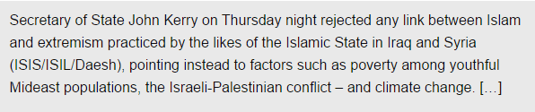
Kerry Blames Global Warming And Israel For Rise Of ISIS… | Weasel Zippers
John Kerry says that global warming at 400 PPM CO2 produced drought and ISIS. This is a familiar theme, because in 1941 experts said that global warming at 310 PPM CO2 produced Hitler.
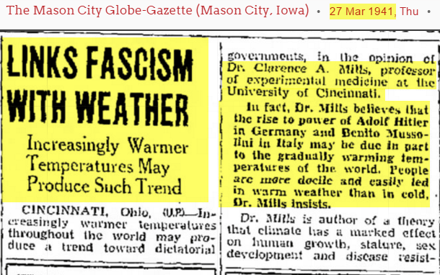
27 Mar 1941, Page 3 – at Newspapers.com
In 1974, the CIA said that global cooling at 330 PPM CO2 caused drought and political instability.
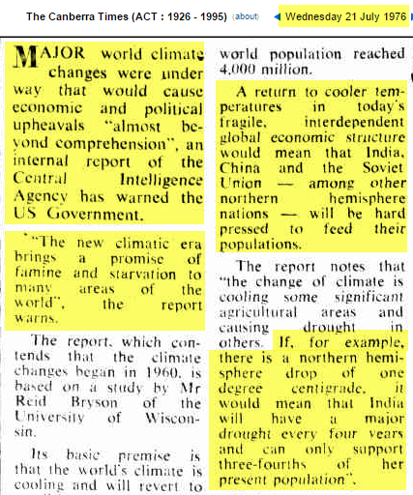
21 Jul 1976 – C.I.A. WARNING Changes to climate to bring uphea…
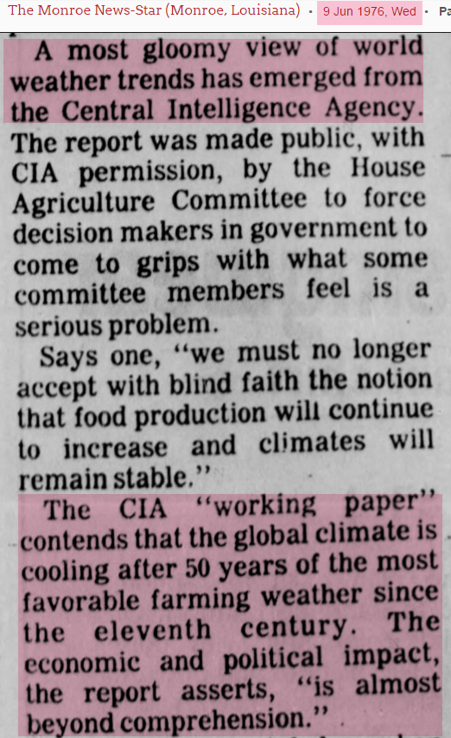
9 Jun 1976, Page 4 – at Newspapers.com
The chart below sums this up.
- Global warming heat at 310 PPM CO2, and global cooling cold at 330 PPM CO2, occur at the same temperature.
- The symptoms of global warming and global cooling are identical.
- Global warming used to be cold, but now global warming is hot.
- Brutality has nothing to do with the level of CO2 in the atmosphere.
- Climatologists are complete morons who understand absolutely nothing about science, history or logic.
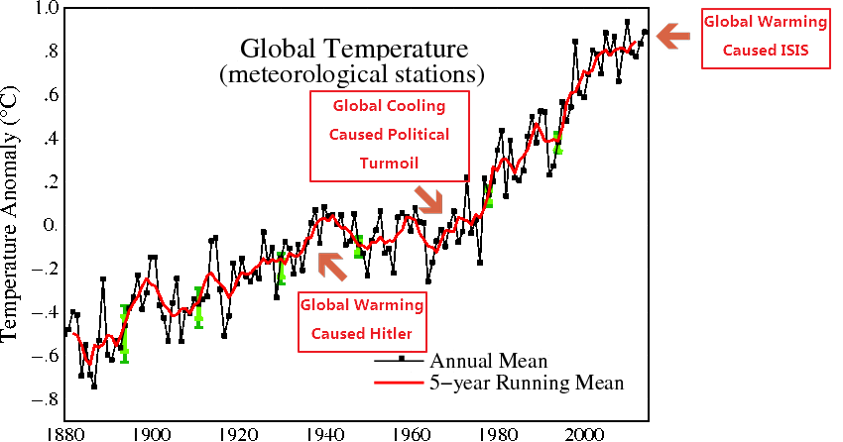

Power Line
The New Yorker Becomes The Onion
by Steven Hayward
Oh, good grief. The New Yorker is trying to give the New York Times a run for its money as the most pathetic attempt to put The Onion out of business:
Why a Climate Deal Is the Best Hope for Peace
By Jason Box and Naomi Klein
. . . The connection between warming temperatures and the cycle of Syrian violence is, by now, uncontroversial. As Secretary of State John Kerry said in Virginia, this month, “It’s not a coincidence that, immediately prior to the civil war in Syria, the country experienced its worst drought on record. As many as 1.5 million people migrated from Syria’s farms to its cities, intensifying the political unrest that was just beginning to roil and boil in the region.” . . .
[A]s the author and energy expert Michael T. Klare argued weeks before the attacks, Paris “should be considered not just a climate summit but a peace conference—perhaps the most significant peace convocation in history.”
Nope: not going to give a coveted Green Weenie for this. As has been noted, funny how climate change doesn’t seem to cause Lutherans, Hindus, Jews, or Zoroastrians to become terrorists or start wars, though as we have seen climate change caused Hitler and Nazism, so there’s that. If the climate-Syrian war connection is “uncontroversial,” it’s because it is . . . completely idiotic. Is it really the case that if it were four degrees cooler in Syria there’d be no civil war? Gosh, why are we wasting all of this time on peace negotiations between Israel and the Palestinians? Just send air conditioners and tankers full of Evian to Gaza.
And Klein forgot her usual mantra, which is that the only solution to climate change is to abolish capitalism. I’m sure we’ll get plenty of rhetoric out of the Paris “peace conference” starting next week about that. Incidentally, how did the last big Paris peace conference work out? Oh, yeah—climate change ruined it, I think.
And as a reminder:
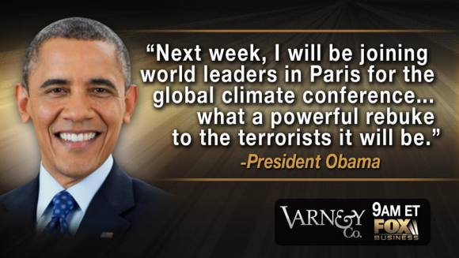

Climate Depot
Prominent Scientists Declare Climate Claims Ahead of UN Summit ‘Irrational’ – ‘Based On Nonsense’ – ‘Leading us down a false path’
by Marc Morano

MIT Climate Scientist Dr. Richard Lindzen: 'Demonization of CO2 is irrational at best and even modest warming is mostly beneficial.' - 'When someone says this is the warmest temperature on record. What are they talking about? It’s just nonsense. This is a very tiny change period.'

Princeton Physicist Dr. Will Happer: 'Policies to slow CO2 emissions are really based on nonsense. We are being led down a false path. To call carbon dioxide a pollutant is really Orwellian. You are calling something a pollutant that we all produce. Where does that lead us eventually?'

Greenpeace Co-Founder Dr. Patrick Moore: 'We are dealing with pure political propaganda that has nothing to do with science.'

Note: CFACT’s new skeptical documentary, Climate Hustle, is set to rock the UN climate summit with red carpet’world premiere in Paris.
#
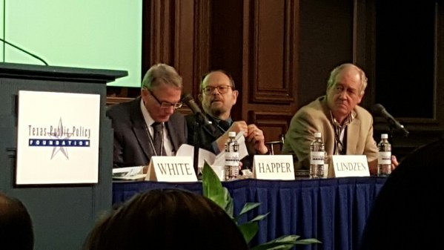
From Left to Right: Dr. Will Happer, Dr. Richard Lindzen & Dr. Patrick Moore
AUSTIN, Texas – A team of prominent scientists gathered in Texas today at a climate summit to declare that fears of man-made global warming were “irrational” and “based on nonsense” that “had nothing to do with science.” They warned that “we are being led down a false path” by the upcoming UN climate summit in Paris.
The scientists appeared at a climate summit sponsored by the Texas Public Policy Foundation. The summit in Austin was titled: “At the Crossroads: Energy & Climate Policy Summit.”
Climate Scientist Dr. Richard Lindzen, an emeritus Alfred P. Sloan Professor of Meteorology at the Department of Earth, Atmospheric and Planetary Sciences at MIT, derided what he termed climate “catastrophism.”
“Demonization of CO2 is irrational at best and even modest warming is mostly beneficial,” Lindzen said.
Lindzen cautioned: “The most important thing to keep in mind is – when you ask ‘is it warming, is it cooling’, etc. — is that we are talking about something tiny (temperature changes) and that is the crucial point.”
Lindzen also challenged the oft-repeated UN IPCC claim that most of warming over past 50 years was due to mankind.
“People get excited over this. Is this statement alarming? No,” Lindzen stated.
“We are speaking of small changes 0.25 Celcius would be about 51% of the recent warming and that strongly suggests a low and inconsequential climate sensitivity – meaning no problem at all,” Lindzen explained.
“I urge you when looking at a graph, check the scales! The uncertainty here is tenths of a degree,” he noted.
“When someone points to this and says this is the warmest temperature on record. What are they talking about? It’s just nonsense. This is a very tiny change period. And they are arguing over hundredths of a degree when it is uncertain in tenths of a degree,” Lindzen said.
“And the proof that the uncertainty is tenths of a degree are the adjustments that are being made. If you can adjust temperatures to 2/10ths of a degree, it means it wasn’t certain to 2/10ths of a degree,” he said. (Also See: Scientists balk at ‘hottest year’ claims: Ignores Satellites showing 18 Year ‘Pause’ – ‘We are arguing over the significance of hundredths of a degree’ – The ‘Pause’ continues)
“The UN IPCC wisely avoided making the claim that 51% of a small change in temperature constitutes a problem. They left this to the politicians and anyone who took the bait,” he said.
Lindzen noted that National Academy of Sciences president Dr. Ralph Cicerone has even admitted that there is no evidence for a catastrophic claims of man-made global warming. See: Backing away from climate alarm? NAS Pres. Ralph Cicerone says ‘we don’t have that kind of evidence’ to claim we are ‘going to fry’ from AGW
Lindzen also featured 2006 quotes from Scientist Dr. Miike Hulme, Professor of Environmental Sciences at the University of East Anglia, and Director of the Tyndall Centre for Climate Change Research, admitting that claims of a climate catastrophe were not the “language of science.”
“The discourse of catastrophe is a campaigning device,” Hulme wrote to the BBC in 2006. “The language of catastrophe is not the language of science. To state that climate change will be ‘catastrophic’ hides a cascade of value-laden assumptions which do not emerge from empirical or theoretical science,” Hulme wrote.
“Is any amount of climate change catastrophic? Catastrophic for whom, for where, and by when? What index is being used to measure the catastrophe?” Hulme continued.
Lindzen singled out Secretary of State John Kerry for his ‘ignorance’ on science.
“John Kerry stands alone,” Lindzen said. “Kerry expresses his ignorance of what science is,” he added.
Lindzen also criticized EPA Chief Gina McCarthy’s education: “I don’t want to be snobbish, but U Mass Boston is not a very good school,” he said to laughter.
Lindzen concluded his talk by saying: “Learn how to identify claims that have no alarming implications and free to say ‘So what?’”

Princeton Physicist Dr. Will Happer, who has authored over 200 peer-reviewed papers, called policies to reduce CO2 “based on nonsense.”
“Policies to slow CO2 emissions are really based on nonsense. They are all based on computer models that do not work. We are being led down a false path.
“Our breath is not that different from a power plant,” he continued.
“To call carbon dioxide a pollutant is really Orwellian. You are calling something a pollutant that we all produce. Where does that lead us eventually?” he asked.
“Coal, formed from ancient CO2, is a benefit to the world. Coal is CO2 from ancient atmospheres. We are simply returning CO2 to the atmosphere from which it came when you burn coal. And it’s a good thing since it is at very low levels in the atmosphere. We are in a CO2 famine. It is very, very low,” Happer explained.
Happer continued: “CO2 will be beneficial and crop yields will increase.” “More CO2 will be a very significant benefit to agriculture,” he added.
Happer then showed a picture of polluted air in China with the caption: “Real pollution in Shanghai.”
“If you can see it, it’s not CO2,” Happer said.
“If plants could vote, they would vote for coal,” Happer declared.
Happer also rebutted the alleged 97% consensus.
“97% of scientists have often been wrong on many things,” he said.

Ecologist and Greenpeace founding member Dr. Patrick Moore discussed the benefits of rising carbon dioxide in the atmosphere.
“Let’s celebrate CO2!” Moore declared.
“We know for absolute certain that carbon dioxide is the stuff of life, the foundation for life on earth,” Moore said.
“We are dealing with pure political propaganda that has nothing to do with science,” he continued.
“The deserts are greening from rising CO2,” he added.
“Co2 has provided the basis of life for at least 3.5 billion years,” Moore said.

Washington Post
Obama’s road to Paris is paved with pretentious hypocrisy
by Ed Rogers
After failing at almost every foreign policy challenge he has been confronted with, perhaps there is now something on the horizon that actually sets up nicely for President Obama. The Paris Conference on Climate Change, which will be held from Nov. 30 to Dec. 11, could be an event that perfectly matches his skills and interests.
The U.N.-sponsored Paris festival lends itself to unrealistic giveaways and meaningless rhetoric — the more self-righteous and pretentious, the better. The meeting won’t produce any particular result, and the day of reckoning where we find out it was all for naught won’t be scientifically determined until many years in the future. It seems well-suited for this president.
All Obama has to do is go to Paris, give a vapid speech about saving the planet, capitulate to those who would like to see the United States weakened, pretend that others will fulfill their pledges to reduce carbon emissions and then return home to a round of self-congratulations from his own staff and sycophant appointees. To follow up on his brave proposals, all he has to do is sign a couple of executive orders that slap American businesses with some gratuitous, onerous regulations and declare that a noble deed has been done. And, by the way, the White House will have to do whatever it takes to keep any agreement reached in Paris from being voted on in Congress.
Let’s remember that the Obama administration failed in its pivot to Asia, could not reset with Russia, could not find an opening to the Arab world, could not successfully negotiate with Iran, could not successfully end two wars, could not follow through on its own red lines drawn in Syria — much less change the regime — so forgive me if I am skeptical that this president can go to Paris and save the world. Isn’t it a little ironic that the elite will meet in Paris, of all places, to plan the energy scarcity they want the rest of us to endure? The bar at the Hotel George V seems to be the perfect place to decide that Africa will remain energy-starved and the rest of us will have to pay more for the energy we have.
The pious media parade has already begun. The solemn coverage of the “road to Paris” has started, and it almost universally has an earnest, determined and reverent tone that suggests the whole affair should be treated as something almost spiritual. And you can bet it will be a gathering of true believers. No skeptics will be given the microphone. Only the most zealous among the affluent will be allowed to talk and only the most compliant among the poor will be allowed to beg. And oh, by the way, Obama will make commitments to burden the rest of us with higher energy prices and even lifestyle changes that will never apply to him.
Thankfully, a few sober Republican senators, including Sen. James Inhofe (R-Okla.), are on the case, and they are already objecting to the idea that the president could make commitments in Paris that will escape the necessity of a vote in Congress before they take effect.
The 2015 Paris Conference on Climate Change deserves a lot of attention. Insiders will be reading a lot more about it right here. I hope the presidential candidates in both parties will talk about what they would propose for Paris, exactly what it would cost and who would pay.

WSJ
Congress Can Cool Off Obama’s Climate Plans
At the Paris talks next week, the U.S. may make harmful commitments on spending and carbon.
by John Barrasso
When the U.N. climate-change talks convene in Paris next week, the risks will be high for American taxpayers. President Obama wants a climate deal and is willing to pay dearly to get it. The inevitable outcome is a plan with unproven benefits and unreachable goals, but very real costs. It will be up to Congress to check the president’s ambition of committing the U.S. to an international green scheme that will produce little or no return.
The ostensible goal of the Paris talks (Nov. 30-Dec. 11) is to convince countries to commit to enacting laws that reduce carbon emissions. That fits President Obama’s vision of a world without fossil fuels such as coal, oil and natural gas. The American people oppose these policies, but the president has shown himself determined to circumvent Congress.
The Obama administration has already imposed burdensome regulations—for instance, the sprawling Clean Power Plan aimed at wiping out the coal industry—that will raise the cost of energy and put hundreds of thousands of Americans out of work. Now the president wants his negotiators to use these international climate talks to pile on more restrictions.
This pact is as unnecessary as it will be damaging. America’s share of world-wide greenhouse-gas emissions has been declining for more than a decade, to 13% today from 24% in 2000. China pumps out 23% of the world’s emissions. Emissions from India, which account for 6%, are expected to triple between 2010 and 2030.
In an agreement with China, President Obama has already pledged to reduce America’s net greenhouse-gas emissions by more than 25% by 2025. In return, China has agreed to “peak” its carbon-dioxide emissions in 2030. In other words, the U.S. will have to make drastic emissions reductions immediately, while China is allowed to carry on for the next 15 years.
Todd Stern, the chief American negotiator heading to Paris, has tried to justify the disconnect. Mr. Stern recently told the Senate that developing countries need to be allowed to keep emitting so that their economies can continue to grow by 8%-9% a year. “If you’re an economy which is growing at eight or nine percent a year because that’s the stage of development you’re in,” he testified, “it’s pretty hard to say you’re supposed to slam on the brakes and go negative overnight.”
Why should the U.S. accept a plan—and pay to grease the deal—that keeps its economy stuck at 2% growth while American taxpayers subsidize other countries’ economies growing at 9%?
Almost as bad is that President Obama will likely pledge $3 billion of taxpayers’ money to the U.N.’s Green Climate Fund. Developing nations are eager to accept this cash, which in theory they will use to address the effects of extreme weather. It seems more likely that the money will end up in the pockets of government officials in Africa, Asia and elsewhere.
If President Obama and the experts in Paris want to help the developing world, they should focus on things that actually will do good, rather than those that will make the negotiators feel good. They could start by helping these countries tap their own energy resources. Building power plants would do more to lift people out of poverty than the Green Climate Fund ever will.
The envoys in Paris should understand: Congress does not support the president’s $3 billion promise. Earlier this year Mr. Obama requested in his budget the first $500 million installment. That budget was voted down 98-1. Congress should continue to reject this spending and insist that any agreement reached in Paris be subject to Senate approval—regardless of whether or not the administration formally calls it a treaty.
Whatever comes of the Paris talks, there is reason to be wary. We’ve seen the Obama administration’s negotiating skills. Anyone who watched the Iran nuclear agreement play out has good reason to be nervous about the concessions this administration will make in closed-door negotiations.
Consider that Russian President Vladimir Putin has reportedly bankrolled environmental causes in Europe to stop fossil-fuel exploration. It is a cynical ploy to stifle competition so that he can continue to hold Europe hostage to Russian energy exports. Yet President Obama seems to be playing into Mr. Putin’s plans.
Other countries will gladly support a deal that transfers money to them while weakening the U.S. They are sure to praise President Obama’s “leadership” in the process. The question is whether the American people—and Congress—will allow such a deal to slip by, or whether they will stand up and be heard.
Mr. Barrasso, a Republican, represents Wyoming in the U.S. Senate.

The Nation
Cold sun rising
New studies flip climate-change notions upside down
by Sam Khoury

The sun will go into "hibernation" mode around 2030, and it has already started to get sleepy. At the Royal Astronomical Society's annual meeting in July, Professor Valentina Zharkova of Northumbria University in the UK confirmed it - the sun will begin its Maunder Minimum (Grand Solar Minimum) in 15 years. Other scientists had suggested years ago that this change was imminent, but Zharkova's model is said to have near-perfect accuracy.
So what is a "solar minimum"?
Our sun doesn't maintain a constant intensity. Instead, it cycles in spans of approximately 11 years. When it's at its maximum, it has the highest number of sunspots on its surface in that particular cycle. When it's at its minimum, it has almost none. When there are more sunspots, the sun is brighter. When there are fewer, the sun radiates less heat toward Earth.
But that's not the only cooling effect of a solar minimum. A dim sun doesn't deflect cosmic rays away from Earth as efficiently as a bright sun. So, when these rays enter our atmosphere, they seed clouds, which in turn cool our planet even more and increase precipitation in the form of rain, snow and hail.
Solar cycles
Since the early 1800s we have enjoyed healthy solar cycles and the rich agriculture and mild northern temperatures that they guarantee. During the Middle Ages, however, Earth felt the impact of four solar minimums over the course of 400 years.
The last Maunder Minimum and its accompanying mini-Ice Age saw the most consistent cold, continuing into the early 1800s.
The last time we became concerned about cooler temperatures - possibly dangerously cooler - was in the 1970s. Global temperatures have declined since the 1940s, as measured by Pacific Decadal Oscillation. The PDO Index is a recurring pattern of ocean-atmosphere climate variability centred over the Pacific Ocean. Determined by deep currents, it is said to shift between warm and cool modes. Some scientists worried that it might stay cool and drag down the Atlantic Decadal Oscillation with it, spurring a new Ice Age. The fear was exacerbated by the fact that Earth has been in the current inter-glacial period for 10,000 years (depending on how the starting point is gauged).
If Earth were to enter the next Ice Age too quickly, glaciers could advance much further south, rainforests could turn into savannah, and sea levels could drop dramatically, causing havoc.
The BBC, all three major American TV networks, Time magazine and the New York Times all ran feature stories highlighting the scare. Fortunately, by 1978 the PDO Index shifted back to warm and the fear abated.
Climate science vs the sceptics
By the 1990s the UN's Intergovernmental Panel on Climate Change (IPCC) had formed the "97 per cent consensus". The consensus was that Earth was warming more than it should, not just due to natural causes but also human activity. This was termed Anthropogenic Global Warming. The culprit was identified as carbon dioxide generated from the burning of fossil fuels.
CO2 is a greenhouse gas and its increase in the atmosphere could be dangerous, the panel claimed. Some of these scientists, particularly those working at the US National Oceanic and Atmospheric Administration (NOAA), Nasa's Goddard Institute for Space Studies and Britain's Meteorological Office, have gone so far as to declare CO2 as the primary driver of climate on Earth. This modern "climate science" has stirred unprecedented controversy in the field. Sceptics, clinging to more traditional approaches, say the science has been corrupted by the billions of dollars in government funding for climate-change research and agencies and industries that claim to be "fighting climate change". The counter-argument is that the sceptics are backed by the oil, gas and coal industries or are affiliated with conservative political groups.
The biggest bone of contention between the two groups is how the data are assessed. In the United States, the recorded temperature data go back to 1880, and elsewhere not even that far. Those data have to be "stapled on" to the ice-core data used to determine temperatures in earlier times. This has led to controversial representations, such as the infamous "hockey stick" graph released by the IPCC that gave the impression the world is hotter now than ever. Many scientists slammed the graph as wholly unrealistic, insisting that previous eras, such as the medieval warm period and the Holocene maximum were warmer than today.
Another issue is the urban "heat island" effect. Black asphalt roads and concrete structures absorb heat from the sun. Roy Spencer, a climatologist at the University of Alabama and former IPCC alumnus, charged in 2013 that the NOAA was "warming up" readings at rural temperature stations to match the urban ones rather than the reverse. A spokesman for the NOAA responded but stopped short of denying it.
In the 2009 "climategate scandal", e-mails and documents from IPCC-affiliated scientists were leaked that indicated they had manipulated data and reports to jibe with the AGW theory. References were made to "hiding the decline" through the use of "tricks". Then in 2012 Anthony Watts, a meteorologist and self-described whistle-blower, caught the NOAA changing temperature data from the 1930s to make the decade appear colder than it had been. Another whistle-blower, blogger Tony Heller, although clearly aligned with conservative groups like the Heartland Institute, has amassed impressive data. He claims that, since 1997, the world has actually been getting colder and Goddard and the NOAA are committing "climate fraud". The NOAA has declined to respond.
Global cooling?
Around 2000, the PDO Index started to blow cold again, possibly causing global warming to "pause", as the mainstream scientists describe it. IPCC-affiliated scientists as well as Nasa and the NOAA attribute the pause to other factors. This is when the plot thickens.
Solar cycle 24 - two cycles prior the cycle that's expected to bottom out into a Maunder Minimum - was weak. In 2013-14 it reached its maximum far below average. Meanwhile extreme cold-weather anomalies have occurred around the world. Last year "polar vortices" slammed into the central US and Siberia as a third hovered over the Atlantic. All 50 US states, including Hawaii, had temperatures below freezing for the first time in recorded history. Snowfall records were broken in cities in the US, Canada, Italy, New Zealand, Australia, Japan and elsewhere. Southern American states and central Mexico, where snow is rare, got heavy snow, as did the Middle East.
This past summer the cold didn't let up, with more temperature records across the US and rare summer snows seen in Canada, the US and China. Birds have migrated early in the last two years. Antarctic sea ice set a new record in 2013 and it was broken again in 2014.
Not even Thailand was immune. In 2014 Bangkok hit its coldest low in 30 years, while 63 lives were lost in the North.
Scientists at the Climate and Environmental Physics and Oeschger Centre for Climate Change Research at the University of Berne in Switzerland have recently backed up theories that support the sun's importance in determining the climate on Earth. A paper published last year by the American Meteorological Society contradicts claims by IPCC scientists that the sun couldn't be responsible for major shifts in climate. Judith Curry, chair of the School of Earth and Atmospheric Sciences at the Georgia Institute of Technology, rejected IPCC assertions that solar variations don't matter. Among the many studies and authorities she cited was the National Research Council's recent report "The Effects of Solar Variability on Earth's Climate".
Other researchers and organisations are also predicting global cooling - the Russian Academy of Science, the Astronomical Institute of the Slovak Academy of Scientists, the Institute of Terrestrial Magnetism Russia, Victor Manuel Velesco Herrera at the National University of Mexico, the Bulgarian Institute of Astronomy, Dr Tim Patterson at Carleton University in Canada, Drs Lin Zhen at Nanjing University in China, just to name a few.
For now nevertheless, the IPCC and other authoritative agencies are sticking to their CO2-dominant climate-forcing theory. They attribute the cold spells to a disruption in the jet stream caused by Anthropogenic Global Warming. Some of their theories have heads being scratched, for instance the "pause" in global warming they attribute to heat being absorbed deep into the oceans. When Antarctic ice reached record levels in 2013, scientists were "baffled" because the water beneath the ice was warm, they claimed. In climate science old and new, nothing is certain.
We conclude with a bit of good news, though. Recent research has determined that the famous Stradivarius violin owes its unique, esteemed sound to the last Maunder Minimum. The solar condition changed the texture of the trees that provided the wood from which the instrument was crafted. So lovers of classical music can place their orders for the next generation of incomparable violins, coming - giving the trees time to mature - in about 100 years.

Breitbart News
Polar Bears Doing Great, Except in Greenies’ Fantasy Computer Models
by James DelingpoleOTHY A. CLARY/AFP/Getty Images01
Global polar bear populations are at a fifty-year record high. Yet the International Union for the Conservation of Nature (IUCN) has just released a study suggesting that they are doomed.
Which version of events should we believe?
Well that all depends on where you prefer to place your trust: on reality or on computer models concocted by activists who desperately want the polar bear to retain its status as the ursine victim of the man-made global warming apocalypse.
If you prefer to go with reality, here’s the good news from Susan Crockford, who puts the global polar bear population at a very healthy 26,000. This would mean, she has noted before, that the population has increased by around 4,200 since 2001.
Ironically, the IUCN—the world’s leading conservation monitoring body, responsible for producing the "Red List" which classifies endangered species—agrees with her estimates. What it won’t do is admit that the news is good. (Well, good if you think having lots of extra polar bears is good. I’m not so sure. I’d agree with my friend Steven Crowder that actually they are evil: one of only two species—the other being the Saltwater crocodile—which deliberately hunts down human beings as prey).
There are two main reasons for this discrepancy of opinion.
The first is that the doomsday scenario for polar bears comes, not from real-world observation but from computer-modeled predictions of what might happen in the future if the ice caps melt, etc. Like all computer models—global warming—these have little if any bearing on reality.
Unless, of course, you are the Guardian, which helpfully reports:
Latest projections indicate that swaths of the Arctic could be ice-free for five months of the year or more by mid-century. Three of the 19 sub-population groups of polar bears studied are already in decline, in Baffin Bay, Kane Basin and the Southern Beaufort Sea.
But warming temperatures could also increase diseases among the polar bear’s traditional prey, further reinforcing the negative spiral. Pollution, human encroachment, and resource exploitation such as oil drilling only add to this dynamic.
The second reason that some people argue that polar bears are doomed—even when they are obviously closer to being a verminous plague than a species in any kind of danger—is that threatened polar bears have long been one of the main pillars of the green faith.
To suggest that polar bears are in no danger—even though that is what the evidence clearly shows—would for any true-believing greenie be an act of heresy.
When a greenie tells you, against all evidence, that polar bears are "vulnerable," it is the equivalent of Takiyah (the special rule that allows Muslims to lie to the infidel in order to further the interests of their faith).
Hence quotes like this:
"There is a high risk of extinction and the threat is serious," said Dena Cator of the IUCN’s species survival commission. "You could consider polar bears to be a canary in the coal mine. They are an iconic and beautiful species that is extremely important to indigenous communities. But changes to their sea ice habitat are already being seen as a result of climate change."
It’s all nonsense. But as with so many of the factoids you hear being regurgitated by environmentalists about our doomed planet, it’s not about the truth—it’s about the narrative.



