October 17, 2015

One of the reasons Pickerhead has been so scarce lately, is the postseason of the Chicago Cubs. Life is in suspended animation. The National League Championship Series against the Mets starts with two games this weekend in New York and picks up on Tuesday with three games in Chicago. This baseball issue will start though with some items on Yogi Berra who died a few weeks ago. This from Jason Gay in the WSJ.
He was a spectacular baseball player. That sometimes gets forgotten in all the folksy warmth surrounding Yogi Berra, who died Tuesday at age 90. The numbers are staggering, almost supernatural, something out of a comic book: 18 seasons as a catcher for the New York Yankees, 10 World Series rings, 14 Series appearances, 15 All-Star Games and three most valuable player awards. There’s never been a career like it, before or since. I once emailed the groundbreaking statistician (and “Moneyball” godfather) Bill James about Berra’s rank among baseball’s all-timers, and his response was instant and unequivocal:
“I certainly think that Yogi was the greatest catcher who ever lived,” James wrote. “I have no doubt of this, honestly.”
Statistics tell only a fraction of his story. Berra was the son of immigrants, a World War II veteran who had left a Yankees farm club to join the Navy and served at D-Day, a gunner’s mate on a landing craft support vessel. “I think his military service has been a little overlooked, because men like him really didn’t talk about it much,” Carmen Berra, Yogi’s wife of 65 years, told the Star-Ledger a year before her death in 2014. “It wasn’t a big thing to him…it was just what they had to do.”
Such humility defined his life. Yogi Berra was not a pretentious man. His exceptional talent didn’t yield the type of payday that is now customary for ballplayers today—Berra never made more than $65,000 in a season, and never had more than a one-year contract. His easygoing style and proclivity for malapropisms—actually, it’s not fair to call them malapropisms; they’re Yogi-isms, sui generis, many of them brilliant (“Baseball is 90 percent mental. The other half is physical,” not even Twain was that good)—made him a beloved figure even to those who hated the mighty Yankees. Berra returned the laughs with a twinkle of self-awareness: Yogi made people chuckle, but he always got to be in on the joke. ...

NewsMax has 53 of Yogi's best Yogi-isms.
"So I’m ugly. I never saw anyone hit with his face."

"Take it with a grin of salt."

"We were overwhelming underdogs."

"The towels were so thick there I could hardly close my suitcase."

"You should always go to other people’s funerals, otherwise, they won’t come to yours."

"When you come to a fork in the road, take it."

"It was impossible to get a conversation going, everybody was talking too much."

Turning to the Cubs, we learn first about their unorthodox manager, Joe Maddon. Brian Costa writes in the WSJ
Inside their clubhouse at Wrigley Field, Chicago Cubs players can find each day’s schedule on a whiteboard near the door. On any other team, the rundown would typically include times for stretching, batting practice, meetings and other pre-game work. But for the Cubs, the itinerary often entails little more than showing up within a couple hours of the first pitch.
In his quest to lead the team to its first championship since 1908, manager Joe Maddon is encouraging players to do something that defies the ingrained culture of baseball. He’d like them to prepare less. And if it’s all right with them, he’d rather they not show up for work quite so early.
In an effort to preserve players’ energy for games, Maddon has all but eliminated batting practice, a tradition that is nearly as old as the sport itself. Though he has long considered the routine to be archaic, this season represents Maddon’s greatest challenge yet to the popular notion that more practice leads to better performance.
The Cubs recently went more than a month without taking batting practice at Wrigley Field and have done so before only three games overall since Aug. 29. Even when Maddon allows such practices, players are often free to skip them.

Cubs bench coach Dave Martinez, who worked alongside Maddon with the Tampa Bay Rays, said the manager has never reduced his team’s practice time on the field to this extent. A few Cubs veterans said they have never seen anything like it. ...

The inexperienced Cubs took their series with the playoff veterans of the Cardinals 3 games to 1. Grantland writes on the rookies who carried the ball.
Going into the series against the battle-tested St. Louis Cardinals, a lack of playoff experience was supposed to be a problem for the Chicago Cubs. They were relying on four rookies — Kris Bryant, Addison Russell, Kyle Schwarber, and Jorge Soler — and another near rook in Javier Baez. Hell, only two of their starting position players (Miguel Montero and Dexter Fowler) had ever even played in the postseason before.
After Tuesday night’s 6-4 win over the Cardinals, the Cubs are now moving on to the National League Championship Series — and the virtues of playoff maturity lie in tatters throughout the Wrigley Field bleachers.
Bryant smashed the Game 3 go-ahead homer that gave the Cubs a lead they wouldn’t relinquish. Russell whacked a pulse-stopping triple in Game 3 and knocked in the go-ahead run in Game 2 with a well-timed squeeze play. Schwarber showed off his cartoonish power, clubbing his second and third homers of the postseason. Soler and Baez didn’t even open the series in the starting lineup. But by the time Hector Rondon struck out Stephen Piscotty in the ninth inning Tuesday, Soler had emerged as the best player of the series and Baez had delivered one of the biggest blows of the postseason — an unlikely, electrifying, opposite-field three-run homer that started the Cubs on their way toward a clinching victory. They all make the guy who hit last night’s game-winning homer in the sixth — 26-year-old Anthony Rizzo — seem like a grizzled vet.
For as talented as all those kids are, the havoc-wreaking of Schwarber, Baez, and Soler in particular made it hard not to wonder: In an admittedly small sample size of games, what made these youngsters seem so immune to playoff pressure? ...
... The Cardinals battled valiantly, but simply couldn’t muster the talent to match the Cubs’ cavalcade of free-swinging young’uns. Aside from a well-placed double in that sixth inning, Tony Cruz looked overmatched as an injury replacement for Molina. Jaime Garcia suffered from a stomach ailment in Game 2. Holliday’s lingering quad injury rendered him punchless in this series, just as he was upon his return from the DL in mid-September. A seemingly deep bullpen unraveled during both games at Wrigley. And adding insult to injury, the Cubs’ own pen proved instrumental in victory, providing six innings of relief in support of Hammel, including appearances by three different pitchers who’d been designated for assignment at some point this season.
This deep into the postseason, every team will have plenty of mashers and bat-missers at its disposal. But the remaining team with the best regular-season record has more position-player talent to throw at opponents than either of its potential NLCS foes. Throw in the historic Jake Arrieta and these guys just might be the Senior Circuit favorites.
When a young group makes the playoffs, we’ll often hear about how the players weren’t supposed to be there this quickly. Well, the Cubs still are. And with this group of precocious pulverizers taking the field, don’t count on them going away anytime soon.

Yahoo News covers the money side of the Cubs rebuild.
... Everything starts with the play on the field, where this year the Cubs have this year shed their lovable losers' image and fans are instead dreaming of winning the World Series.
The losing before this year led Epstein to rebuild the team with an emphasis on lower-priced, young players and that in turn has given the team flexibility to spend on expensive free agents such as the signing of pitcher Jon Lester this past offseason.
"They took their lumps for a while, but now it's bearing fruit," said Sal Galatioto, president of sports banker Galatioto Sports Partners, which represented the Ricketts family in their purchase of the Cubs. "Great performance gives you leverage in doing anything."
The financial trends all look good for the Cubs.
In 2009, the Cubs' payroll was more than $141 million, or third highest among MLB's 30 pro teams, according to Baseball Prospectus.
That fell last year to 20th at $93.2 million as the team brought in young stars like third baseman Kris Bryant and outfielder Kyle Schwarber, but missed the playoffs. The Cubs' payroll climbed back to $120.3 million, or 13th in the league, this year.
The Ricketts family bought 95 percent of the Cubs for $845 million and in March, Forbes magazine valued the entire club at $1.8 billion, the fifth highest in the league and up 50 percent from the prior year. The New York Yankees are No. 1 with an estimated value of $3.2 billion. ...

CNN Money says tickets to playoff games at Wrigley Field are becoming dear.
Fans have already paid an average of $674 for the Cubs' first game in the National League Championship Series at Wrigley Field, slated for October 20. Tickets for the second game the following night sold for an average of $729, according to SeatGeek.
For Cubs fans who haven't bought their tickets yet, those prices look like a bargain. Tickets to the Cubs home playoff games were listed for a record average $1,325.93 as of Wednesday morning, according to TiqIQ, another tracking service. That's nearly twice the previous record set for a league championship ticket, which was for the San Francisco Giants in 2012.
The most expensive Cubs ticket now is a first-row box seat in the infield listed for $11,700. ...

According to YardBarker, the towering home run bit by Kyle Schwarber in the last game of the Cubs/Cardinals series was found on top of the right field scoreboard where the ball will stay at least through the post season where it will provide a hex on visiting teams.
The Chicago Cubs reportedly intend to leave the home run ball hit by Kyle Schwarber in the 7th inning of Tuesday’s series-clinching 6-4 win over the St. Louis Cardinals right where the slugger deposited it: On top of the new scoreboard at Wrigley Field.
A source with the team on Wednesday confirmed to the Chicago Tribune that the team will leave the ball where it landed until the conclusion of the Cubs’ participation in the postseason.
The team did send an employee to inspect the ball so it could be confirmed that it was Schwarber’s moon shot home run ball, and an MLB postseason watermark verified its authenticity.
The Cubs also intend to place a plexiglass box around the ball to keep the ball safe from the elements and a security staffer will escort any person who travels to the top of the scoreboard until the ball is taken down.
The Cubs obviously know a thing or two about curses — to put it mildly — and the perceived toll such things can have upon an organization, whether it’s real or utter nonsense. Whatever the case, perhaps it’s not surprising the team is attempting to create some positive mojo by leaving Schwarber’s moon shot home run ball right where it landed … instead of waiting around and succumbing to the supposed curses of generations past.

Five Thirty Eight says this year is the Cubs best chance to break their curse.
Seeing the Chicago Cubs in the National League Championship Series is a little like seeing a four-leaf clover — it’s uncommon, but nature does allow it from time to time. And after holding off the St. Louis Cardinals for a 6-4 win on Tuesday night at Wrigley Field, Chicago has stumbled across the rarest of shamrocks — a legitimately dominant Cubs team on the cusp of the World Series.
Three earlier Cubs teams have breathed the crisp, autumnal NLCS air: the 1984, 1989 and 2003 teams. (The league championship series format was introduced in 1969.) Those three squads lost their respective series, but according to our Elo ratings, this year’s NLCS-bound Cubs team is the strongest of the bunch. And even though they’ll cede home-field advantage to either the New York Mets or Los Angeles Dodgers, the 2015 Cubs have the best chance of any of their predecessors at winning the NLCS and advancing to the World Series. Our ratings give the Cubs a 60 percent chance of reaching the World Series; it would be the team’s first appearance there since 1945. ...
Norman Rockwell portrayed the hapless Cubs as the team watched a bonehead play perhaps at Ebbet’s Field in Brooklyn. You can find it at the end of the cartoons.

WSJ
The Extraordinary Journey of Yogi Berra
In 90 years, the Yankee legend lived many lives: war veteran, humorist, manager and baseball’s greatest catcher
by Jason Gay
He was a spectacular baseball player. That sometimes gets forgotten in all the folksy warmth surrounding Yogi Berra, who died Tuesday at age 90. The numbers are staggering, almost supernatural, something out of a comic book: 18 seasons as a catcher for the New York Yankees, 10 World Series rings, 14 Series appearances, 15 All-Star Games and three most valuable player awards. There’s never been a career like it, before or since. I once emailed the groundbreaking statistician (and “Moneyball” godfather) Bill James about Berra’s rank among baseball’s all-timers, and his response was instant and unequivocal:
“I certainly think that Yogi was the greatest catcher who ever lived,” James wrote. “I have no doubt of this, honestly.”
Statistics tell only a fraction of his story. Berra was the son of immigrants, a World War II veteran who had left a Yankees farm club to join the Navy and served at D-Day, a gunner’s mate on a landing craft support vessel. “I think his military service has been a little overlooked, because men like him really didn’t talk about it much,” Carmen Berra, Yogi’s wife of 65 years, told the Star-Ledger a year before her death in 2014. “It wasn’t a big thing to him…it was just what they had to do.”

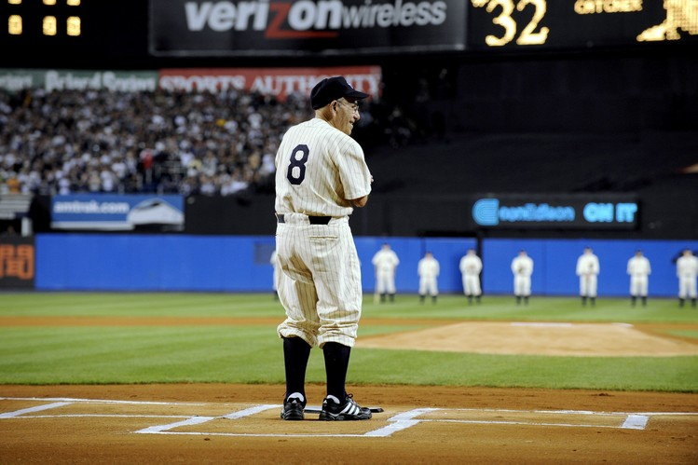
Yogi Berra stands at home plate during ceremonies marking the final
game to be played at the old Yankee Stadium on Sept. 21, 2008.
Such humility defined his life. Yogi Berra was not a pretentious man. His exceptional talent didn’t yield the type of payday that is now customary for ballplayers today—Berra never made more than $65,000 in a season, and never had more than a one-year contract. His easygoing style and proclivity for malapropisms—actually, it’s not fair to call them malapropisms; they’re Yogi-isms, sui generis, many of them brilliant (“Baseball is 90 percent mental. The other half is physical,” not even Twain was that good)—made him a beloved figure even to those who hated the mighty Yankees. Berra returned the laughs with a twinkle of self-awareness: Yogi made people chuckle, but he always got to be in on the joke.
He had lives as a manager, a commercial pitchman, an actor (that’s Yogi, with Mickey Mantle, Cary Grant and Doris Day in 1962’s “That Touch of Mink,” which they filmed during a Yankees West Coast trip). Berra had his battles—there was a memorable feud with George Steinbrenner that lasted for nearly a decade and a half after the Yankee owner dismissed Berra as manager in 1985. (Steinbrenner, acting on advice from Joe DiMaggio, eventually visited Berra to apologize, leading to an overdue thawing.)
As often with cherished public figures, the best stories about Yogi Berra are the quieter ones. This past May in the Journal, David Kaplan, the director of the Yogi Berra Museum and Learning Center near Berra’s town of Montclair, N.J., gave a remarkable account of Berra’s relationship with a once-troubled local teenager named Carlos Lejnieks whom he mentored and helped get into Brown University. Today, Lejnieks is the CEO of the Big Brothers Big Sisters program in Newark.
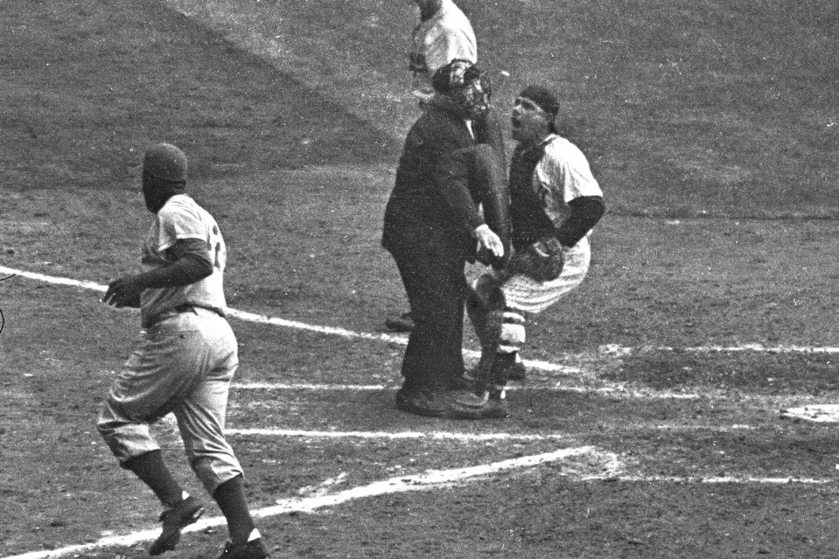
Umpire Bill Summers’s decision to rule Jackie Robinson safe on a steal of home enraged Mr. Berra during the World Series opener at New York's Yankee Stadium on Sept. 28, 1955.
I spoke to Lejnieks Wednesday. While he said that Berra had made a significant positive impact upon his life, he also knew he was not alone. “I know he did it in so many quiet ways for so many other people,” he said. “He was so understated.”
I met Berra once. In 2011 I went to go see the movie “Moneyball” with him. I don’t remember how I came up with the idea, but I know it took a long time to put together—Kaplan had asked if it might be possible to screen it in the museum’s screening room, but the movie studio was struggling to get a copy to us, and it looked like it would fall apart. At the last minute, we wound up seeing the Brad Pitt film at the old Bellevue Theater on Bellevue Avenue in Montclair. It was late afternoon. Carmen came, too. Yogi got a bag of popcorn and settled in the back of the theater.
I recall two things vividly about the screening: 1) Berra was friends with Art Howe, the manager of the Oakland A’s in the time “Moneyball” is set, and while he thought Philip Seymour Hoffman was a good actor, Yogi felt he looked nothing like Art Howe. The other thing—and this I didn’t know was coming—was that there’s a key scene in the movie in which the A’s reel off a record 20 game winning streak. And in the moment, they show real-life footage of the last American League team that had won 19 games—the 1947 New York Yankees, for whom Yogi played his first full season in the major leagues.
“I’d almost forgotten,” Yogi said afterward. “You get old, you know? But we did win 19 in a row.”
We all went to dinner at a restaurant around the corner. Yogi ordered scallops, and a vodka with extra ice. He talked about his early playing days and his first contract ($90 a month) and what they served the Yankees between games of a doubleheader (“a hardboiled egg”). He talked about going to Toots Shor’s with DiMaggio and knowing Connie Francis and Spencer Tracy. He talked humbly about those World Series titles and he reached over and showed me his 1953 ring, which was the only championship one he wore.
“I was very lucky,” he said.
He spoke about these indelible moments like they’d happened only weeks ago, and weren’t the memories of an extraordinary American life. To Yogi Berra, these were just fortunate things that had happened along the way. He didn’t view his life as extraordinary, which only makes it more so.

NewsMax
53 Yogi Berra Quotes: His Funniest One-Liners and Witticisms
by Nick Sanchez
Baseball legend Yogi Berra died Tuesday at age 90, and while many will certainly remember him as a 10-time World Series champion, many will also remember him for his brilliant one-liners.
"When I'm sittin' down to dinner with the family, stuff just pops out," Berra insisted during a recent interview, The Associated Press reported. "And they'll say, 'Dad, you just said another one.' And I don't even know what the heck I said."
The well-known book "Bartlett's Familiar Quotations" lists eight of Berra's witticisms, but we've gathered 53 below attributed to the baseball great.
- "I never said most of the things I said."
- "It ain’t over till it’s over."
- "Mickey Mantle was a very good golfer, but we weren’t allowed to play golf during the season; only at spring training."
- "If the people don’t want to come out to the ballpark, nobody’s going to stop them."
- "Baseball is 90 percent mental. The other half is physical."
- "I can see how he (Sandy Koufax) won 25 games. What I don’t understand is how he lost five."
- "In baseball, you don’t know nothing."
- "I never blame myself when I’m not hitting. I just blame the bat and if it keeps up, I change bats. After all, if I know it isn’t my fault that I’m not hitting, how can I get mad at myself?"
- "I think Little League is wonderful. It keeps the kids out of the house."
- "I wish everybody had the drive he (Joe DiMaggio) had. He never did anything wrong on the field. I’d never seen him dive for a ball, everything was a chest-high catch, and he never walked off the field."
- "It’s deja vu all over again."
- "I usually take a two-hour nap from 1 to 4."
- "Never answer an anonymous letter."
- "We made too many wrong mistakes."
- "You can observe a lot by watching."
- "The future ain’t what it used to be."
- "If you don’t know where you are going, you might wind up someplace else."
- "You’ve got to be very careful if you don’t know where you are going, because you might not get there."
- "It gets late early out here."
- "Even Napoleon had his Watergate."
- "Pair up in threes."
- "We have deep depth."
- "Why buy good luggage, you only use it when you travel."
- "Nobody goes there anymore. It’s too crowded."
- "All pitchers are liars or crybabies."
- "A nickel ain’t worth a dime anymore."
- "Bill Dickey is learning me his experience."
- "He hits from both sides of the plate. He’s amphibious."
- "I always thought that record would stand until it was broken."
- "I don’t know (if they were men or women fans running naked across the field). They had bags over their heads."
- "I’m a lucky guy and I’m happy to be with the Yankees. And I want to thank everyone for making this night necessary."
- "I’m not going to buy my kids an encyclopedia. Let them walk to school like I did."
- "It ain’t the heat, it’s the humility."
- "So I’m ugly. I never saw anyone hit with his face."
- "Take it with a grin of salt."
- "We were overwhelming underdogs."
- "The towels were so thick there I could hardly close my suitcase."
- "You should always go to other people’s funerals, otherwise, they won’t come to yours."
- "When you come to a fork in the road, take it."
- "It was impossible to get a conversation going, everybody was talking too much."
- "If you ask me anything I don’t know, I’m not going to answer."
- "Little League baseball is a very good thing because it keeps the parents off the streets."
- "You don’t have to swing hard to hit a home run. If you got the timing, it’ll go."
- "I’m lucky. Usually you’re dead to get your own museum, but I’m still alive to see mine."
- "If I didn’t make it in baseball, I won’t have made it workin’. I didn’t like to work."
- "If the world were perfect, it wouldn’t be."
- "No one goes there nowadays, it’s too crowded."
- "You better cut the pizza in four pieces because I’m not hungry enough to eat six."
- "You wouldn’t have won if we’d beaten you."
- "Slump? I ain’t in no slump . . . I just ain’t hitting."
- "How can you think and hit at the same time?"
- "I tell the kids, somebody’s gotta win, somebody’s gotta lose. Just don’t fight about it. Just try to get better."
- "A lot of guys go, 'Hey, Yog, say a Yogi-ism.' I tell 'em, 'I don’t know any.' They want me to make one up. I don’t make ’em up. I don’t even know when I say it. They’re the truth. And it is the truth. I don’t know."

WSJ
The Cubs’ New Approach: Work Less
Chicago’s new manager Joe Maddon keeps his team fresh by cutting the classic baseball ritual of batting practice
by Brian Costa

Chicago Inside their clubhouse at Wrigley Field, Chicago Cubs players can find each day’s schedule on a whiteboard near the door. On any other team, the rundown would typically include times for stretching, batting practice, meetings and other pre-game work. But for the Cubs, the itinerary often entails little more than showing up within a couple hours of the first pitch.
In his quest to lead the team to its first championship since 1908, manager Joe Maddon is encouraging players to do something that defies the ingrained culture of baseball. He’d like them to prepare less. And if it’s all right with them, he’d rather they not show up for work quite so early.
In an effort to preserve players’ energy for games, Maddon has all but eliminated batting practice, a tradition that is nearly as old as the sport itself. Though he has long considered the routine to be archaic, this season represents Maddon’s greatest challenge yet to the popular notion that more practice leads to better performance.

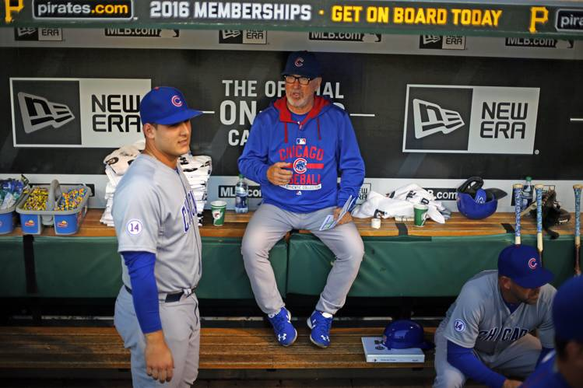
Chicago Cubs manager Joe Maddon, center, sits in the dugout talking with
Anthony Rizzo before a recent game against the Pittsburgh Pirates.
The Cubs recently went more than a month without taking batting practice at Wrigley Field and have done so before only three games overall since Aug. 29. Even when Maddon allows such practices, players are often free to skip them.
Cubs bench coach Dave Martinez, who worked alongside Maddon with the Tampa Bay Rays, said the manager has never reduced his team’s practice time on the field to this extent. A few Cubs veterans said they have never seen anything like it.
“Hitting on the field has really no specific purpose at this time of year other than fans watching it,” Maddon said. “It’s the most overrated thing we do on a daily basis.”
In another season, such a departure from baseball’s conventional wisdom might cause some angst among long-suffering Cubs fans. But Maddon’s emphasis on recovery over repetition has coincided with the team’s first winning season since 2009.
Since the start of August, the Cubs have won more games than any other team in the majors. They have scored more runs per game during that span than every other National League team except the New York Mets. They appear bound for a wild-card game against the Pittsburgh Pirates, whom they will host in a three-game series beginning Friday.
“The first time you don’t take batting practice for a week, you worry about, am I going to be ready for the game?” outfielder Chris Denorfia said. “But it’s just not the case. You sort of get over that addiction.”
The results are clear: The Cubs have dominated the time of year when players tend to wear down. “A lot of us have never felt this fresh in September,” Denorfia said.
Cubs players are free to work on their swings in indoor batting cages before a game, which is generally less taxing and more efficient than outdoor batting practice. And infielders can still practice taking ground balls on the field. But the classic spectacle of hitters clobbering soft tosses from gray-haired coaches while pitchers make small talk in the outfield has become a rarity.
The reduction in batting practice, which usually lasts 45 to 50 minutes per team, has condensed players’ pre-game schedules at a time when fatigue is becoming more of an issue throughout the sport. In 2014, less than 9% of position players appeared in 150 or more games, the lowest such percentage in major-league history.
“Sometimes, the culture is you spend so much time at the ballpark,” Cubs general manager Jed Hoyer said. “You’re watching video, working out, taking batting practice. At some point, it’s overkill.”
That idea is catching on with other teams. The New York Yankees have cut down on batting practice in recent months. Though nobody keeps a hard count, Yankees manager Joe Girardi said this year’s team has done it less often than any other team he has managed. In addition to canceling batting practice before day games after night games, as is typical with many teams, the Yankees have eliminated it before some midweek night games.
“We’re the only sport that practices not in real time, in terms of game speed,” Yankees general manager Brian Cashman said. “Our practice sessions are kind of like a football team’s walk-through without pads. I think it’s just something players are used to doing, but the value of it is probably not significant.”
From a fatigue standpoint, the Cubs face a unique challenge. A city ordinance prohibits them from scheduling more than 35 of their 81 regular-season home games at night. Major leaguers are generally accustomed to staying up late, sleeping late and peaking when the sun goes down.
Because the home team always hits first, starting roughly two and a half hours before the game, batting practice requires Cubs players to arrive even earlier than their opponents. With the addition of a second indoor batting cage under the right-field bleachers this year, Cubs hitters can swing inside on their own schedule, without regard for their opponents.
That, in turn, has allowed players to maintain a more regular sleep pattern, helping them outwork other teams when Maddon wants them to: from the first pitch on.
“Sometimes the old adage, less is more, there’s some truth to that,” catcher David Ross said. “I really believe that.”

Grantland
Talent Rules Tenure: The Cubs Batter the Cardinals on Their Way to the NLCS
by Jonah Keri
Going into the series against the battle-tested St. Louis Cardinals, a lack of playoff experience was supposed to be a problem for the Chicago Cubs. They were relying on four rookies — Kris Bryant, Addison Russell, Kyle Schwarber, and Jorge Soler — and another near rook in Javier Baez. Hell, only two of their starting position players (Miguel Montero and Dexter Fowler) had ever even played in the postseason before.
After Tuesday night’s 6-4 win over the Cardinals, the Cubs are now moving on to the National League Championship Series — and the virtues of playoff maturity lie in tatters throughout the Wrigley Field bleachers.
Bryant smashed the Game 3 go-ahead homer that gave the Cubs a lead they wouldn’t relinquish. Russell whacked a pulse-stopping triple in Game 3 and knocked in the go-ahead run in Game 2 with a well-timed squeeze play. Schwarber showed off his cartoonish power, clubbing his second and third homers of the postseason. Soler and Baez didn’t even open the series in the starting lineup. But by the time Hector Rondon struck out Stephen Piscotty in the ninth inning Tuesday, Soler had emerged as the best player of the series and Baez had delivered one of the biggest blows of the postseason — an unlikely, electrifying, opposite-field three-run homer that started the Cubs on their way toward a clinching victory. They all make the guy who hit last night’s game-winning homer in the sixth — 26-year-old Anthony Rizzo — seem like a grizzled vet.
For as talented as all those kids are, the havoc-wreaking of Schwarber, Baez, and Soler in particular made it hard not to wonder: In an admittedly small sample size of games, what made these youngsters seem so immune to playoff pressure?
“They really are good makeup guys,” said manager Joe Maddon after the game. “They’re great character guys. They don’t make excuses. They’re very accountable to the moment.”
There’s that, and then there’s Maddon’s claim that Chicago’s veteran players and coaches provided steady leadership that helped the young guys succeed. But maybe it’s more simple: Talent wins out above all else. And by series end, the Cubs just had more of it than the Cardinals — even if a lot of their key contributors, by baseball’s standards, are still wearing diapers.
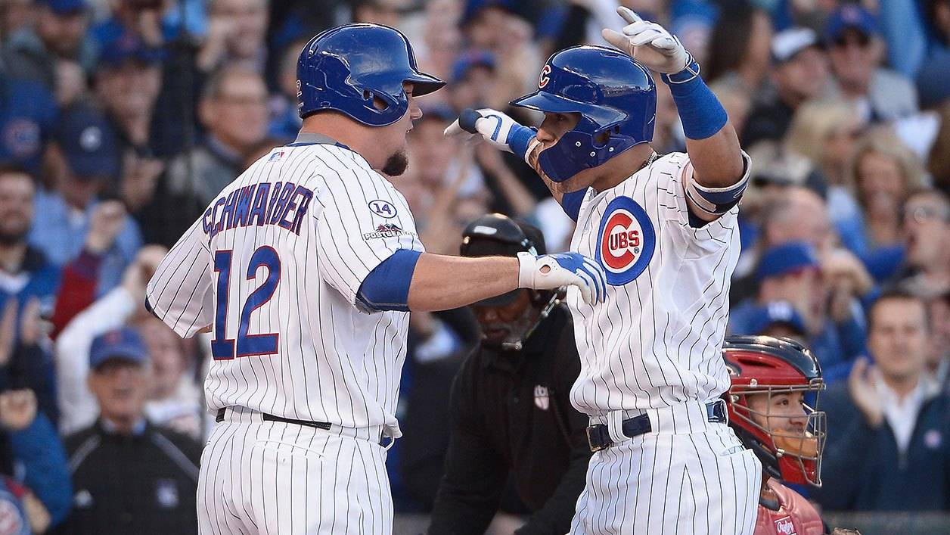
Kyle Schwarber and Javier Baez celebrate after Baez’s three-run homer in the second inning.
Of course, there’s the history: The Cubs haven’t won a World Series in 107 years. This was only their second playoff-series win in as much time. And it was Chicago’s first series-clinching victory at Wrigley Field, which first welcomed the franchise in 1916. Yet what makes this win resonate even louder is how the Cubs did it: by beating the Cardinals at their own game.
To win 100 games and the NL Central crown this year, St. Louis had to overcome an avalanche of injuries. Adam Wainwright tore his Achilles, and his bullpen-restricted return before season’s end was a shocker. Matt Holliday played in just 73 games thanks to a major quad injury. Yadier Molina, Matt Adams, and other contributors also missed significant chunks of time. But the Cardinals’ parade of young talent enabled them to overcome all of that. New faces like Randal Grichuk, Stephen Piscotty, and Tommy Pham became the newest faces of #CardinalsDevilMagic, which is really just a silly, superstitious way to describe a player development machine that’s been the envy of the rest of baseball for years.
The Cubs still have lots of work to do to catch the Cardinals when it comes to producing quality homegrown pitchers. But as far as hitters go, the North Siders’ own player development success now takes a backseat to no one.
Consider Schwarber. In one sense, he’s a 22-year-old blue-chip prospect now doing what blue-chip prospects are supposed to do. The no. 4 overall pick in last year’s draft, Schwarber’s combination of patience at bat and light-tower power made him look like a future star. But his doughy build and, especially, his shaky defense made some observers wonder if the Cubs had overreached. Could a kid whose best position is DH play most days for a National League team? The Cubs tried Schwarber at catcher, eventually moved him to the outfield, and simply overlooked his weaknesses to focus on his strengths.
So far in these playoffs, the results have been phenomenal. After going 2-for-3 with a tape-measure homer against the Pirates in the wild-card game, Schwarber batted .500/.582/1.100 in 12 trips to the plate during the NLDS. In the seventh inning of Game 4, he pummeled a Kevin Siegrist pitch so high and so far that it cleared the top of the damn scoreboard. It’s easy to fall into hyperbole with rookies, because all the great things they do make up an outsize portion of a limited résumé. And Schwarber certainly has holes in his game, including his so-so defense, his lack of speed, and — despite the rocket shot off Siegrist — his inability to hit tough left-handers. But you watch his swing-for-the-moon approach, the way the ball flies off his bat, his lumpy physique, hell, even his facial features, and, well …
The 22-year-old Baez navigated a bumpier road to reach this point. Last August, he whacked three homers in his first series (against the Rockies) in the big leagues. But then he became a relentless strikeout monster, whiffing 92 times and posting a .161/.223/.281 slash line in his final 199 at-bats of last season. In retrospect, Baez’s initial big league splash might’ve had more to do with playing at the hitter fun house that is Coors Field than his own raw power.
Those holes in Baez’s swing marooned him in Triple-A for most of this season. Then the Cubs called him up as part of the September 1 roster expansion, and suddenly he was back in the lineup, taking advantage of an unsettled second-base situation and Maddon’s tinkering tendencies. He made 80 plate appearances over the rest of the regular season. He still showed a lousy batting eye (24 strikeouts against just four walks) and rarely showed his power potential (just one home run). But he also played four different infield positions, establishing himself as a solid defender and versatile insurance policy who still had that pop in his repertoire.
Then Russell left Game 3 after hurting his hamstring legging out a triple. Suddenly the Cubs had to cash in for Game 4. With two outs in the bottom of the second, Maddon left Jason Hammel in to face John Lackey with two men on. Hammel slapped a run-scoring single up the middle to cut the Cards’ lead to 2-1. Baez stepped up next. Lackey’s first pitch was a good two or three inches off the outside corner … and Baez walloped it into a thicket of delirious right-field bleacher creatures.
That proved to be the second time this series that a kid took over a lineup spot previously manned by another player. After a Game 1 shutout in which the Cubs managed just three hits and with the team next facing a left-hander in Game 2, Maddon tapped Soler to take Chris Coghlan’s spot in the lineup. Soler immediately ascended to a higher ethereal plane, cracking a homer and a double while walking twice. He then singled, homered, and walked twice in Game 3, making it an incredible nine straight times that he’d reached base, including a pinch-hit walk in Game 1.
Here was a bit of vindication both for Soler and for Maddon. Like Baez, Soler had shown flashes of incredible talent in his first brush with the big leagues last year, but the outfielder kept it going for longer, batting a robust .292/.330/.573 in 97 plate appearances. He looked so good in that cameo that Maddon likened his 22-year-old human toolbox to Vladimir Guerrero … with better plate discipline. But Soler didn’t live up to that promise for most of this year, hitting just 10 homers in 101 games and striking out nearly four times as often as he walked.
Then he went absolutely nuts when the Cubs needed it most. Last night, he crunched balls with his violent right-handed swing, showed off that promising batting eye that Maddon insisted he had, and made a crucial throw to quell a sixth-inning Cardinals rally at one of the most pivotal moments of the series.
The Cardinals battled valiantly, but simply couldn’t muster the talent to match the Cubs’ cavalcade of free-swinging young’uns. Aside from a well-placed double in that sixth inning, Tony Cruz looked overmatched as an injury replacement for Molina. Jaime Garcia suffered from a stomach ailment in Game 2. Holliday’s lingering quad injury rendered him punchless in this series, just as he was upon his return from the DL in mid-September. A seemingly deep bullpen unraveled during both games at Wrigley. And adding insult to injury, the Cubs’ own pen proved instrumental in victory, providing six innings of relief in support of Hammel, including appearances by three different pitchers who’d been designated for assignment at some point this season.
This deep into the postseason, every team will have plenty of mashers and bat-missers at its disposal. But the remaining team with the best regular-season record has more position-player talent to throw at opponents than either of its potential NLCS foes. Throw in the historic Jake Arrieta and these guys just might be the Senior Circuit favorites.
When a young group makes the playoffs, we’ll often hear about how the players weren’t supposed to be there this quickly. Well, the Cubs still are. And with this group of precocious pulverizers taking the field, don’t count on them going away anytime soon.

Yahoo News
No longer losers, Chicago Cubs see success off baseball field as well
by Ben Klayman

(Reuters) - Major League Baseball's Chicago Cubs have thrilled fans with a run to the National League championship, but the team formerly known more for tough losses and bad luck is now set for a long and lucrative stretch both on and off the baseball field.
Their run going forward will be fueled by young, less costly players, a $650 million renovation of Wrigley Field that will turn the storied ballpark into even more of a cash cow, and the expected future establishment of a dedicated television network worth billions of dollars, analysts and bankers said.
"The Cubs are going to be a team to reckon with on the field and as a business enterprise for the next decade or so," said Marc Ganis, president of consulting firm Sportscorp Ltd, which advised Tribune Co in its sale of the Cubs to the Ricketts family in 2009.
While the Cubs have not won a World Series since 1908 and fans over the years have bemoaned black cat and billy goat curses, the mood is more jubilant now following Monday's series-clinching victory over their archrival St. Louis Cardinals.
Many fans believe the worm has finally turned, but seeds for the changes under way were planted when the Ricketts family purchased control of the team and picked up speed after Theo Epstein moved from the Boston Red Sox to become the club's general manager two years later.
Everything starts with the play on the field, where this year the Cubs have this year shed their lovable losers' image and fans are instead dreaming of winning the World Series.
The losing before this year led Epstein to rebuild the team with an emphasis on lower-priced, young players and that in turn has given the team flexibility to spend on expensive free agents such as the signing of pitcher Jon Lester this past offseason.
"They took their lumps for a while, but now it's bearing fruit," said Sal Galatioto, president of sports banker Galatioto Sports Partners, which represented the Ricketts family in their purchase of the Cubs. "Great performance gives you leverage in doing anything."
TRENDING POSITIVE
The financial trends all look good for the Cubs.
In 2009, the Cubs' payroll was more than $141 million, or third highest among MLB's 30 pro teams, according to Baseball Prospectus.
That fell last year to 20th at $93.2 million as the team brought in young stars like third baseman Kris Bryant and outfielder Kyle Schwarber, but missed the playoffs. The Cubs' payroll climbed back to $120.3 million, or 13th in the league, this year.
The Ricketts family bought 95 percent of the Cubs for $845 million and in March, Forbes magazine valued the entire club at $1.8 billion, the fifth highest in the league and up 50 percent from the prior year. The New York Yankees are No. 1 with an estimated value of $3.2 billion.
That increase in the team's value is partly driven by the funds pulled in at Wrigley, where the Cubs have the third highest ticket prices in the league and generate even more from concessions, according to research firm Team Marketing Report, which tracks the industry. Cubs tickets average almost $45 apiece, compared with a league average of nearly $29.
Attendance at Wrigley Field, which can seat over 41,000 people, hit almost 3 million this season, good for sixth in the league. That is an increase of almost 12 percent from 2014, when the Cubs ranked 11th in attendance. The Cubs drew 3.3 million fans in 2008.
Based on merchandise sales at MLB.com/shop, Cubs merchandise finished sixth overall in the league as sales rose 80 percent, baseball officials said. That was up from ninth place last year.
TO THE VICTOR...
With the team's success, however, both attendance and ticket prices may continue to rise.
Famous for its ivy-covered outfield walls and urban location where home run balls sometimes drop onto a residential street, Wrigley Field is a top tourist attraction and has been declared a city landmark. The ballpark is over 100 years old.
The Cubs last fall started the renovation of Wrigley, which will be completed in phases. It has included a controversial left field videoboard and a right field sign that were protested unsuccessfully in federal court by owners of rooftop bars across the street from the ballpark, who complained their views into the stadium would be blocked.
The project has also entails the addition of new bleachers, a new clubhouse, a restaurant and an outdoor plaza. It is expected to be completed by opening day in 2019.
"They've taken all the steps to turn the Wrigley area into a Cubs experience and they didn't do that just to make the fans happy," said Michael Cramer, director of the sports media program at the University of Texas and the former president of a group that previously owned the Texas Rangers baseball club.
The Ricketts family has said the renovations were needed to keep the team competitive.
The real big payoff is still to come, as the Ricketts plan to establish a Cubs regional sports TV network following the 2019 season.
Given the development of digital technologies, a Cubs network likely be worth more than the $3 billion at which the New York Yankees' YES Network was valued, analysts and bankers said.
"We look at ourselves as a baseball team first, but lots of businesses after that, and on the media side we're really excited about the future," Crane Kenney, the Cubs president of business operations, said in an interview.
"We're in the third inning of our plan," he added. "We're very, very early in our growth cycle."

CNN Money
Cubs ticket prices are sky high
Cubs fans are paying top dollar to watch their team try to make it to the World Series for the first time since 1945.
by Chris Isidore

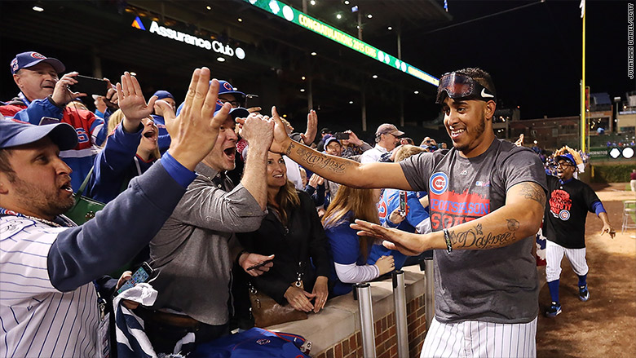
Cubs pitcher Hector Rondon celebrates with fans at Wrigley Field Tuesday night after the Cubs advanced to the next round of the playoffs.

Fans have already paid an average of $674 for the Cubs' first game in the National League Championship Series at Wrigley Field, slated for October 20. Tickets for the second game the following night sold for an average of $729, according to SeatGeek.
For Cubs fans who haven't bought their tickets yet, those prices look like a bargain. Tickets to the Cubs home playoff games were listed for a record average $1,325.93 as of Wednesday morning, according to TiqIQ, another tracking service. That's nearly twice the previous record set for a league championship ticket, which was for the San Francisco Giants in 2012.
The most expensive Cubs ticket now is a first-row box seat in the infield listed for $11,700. The cheapest ticket is a $500 upper deck ticket for Game 3.
Only one of the other six teams still alive in the playoffs - the Los Angeles Dodgers - even existed the last time the Cubs made it to the series, and they were playing in Brooklyn at the time. All the other teams in the playoffs have been to the World Series in the last 25 years.
Few if any living Cubs fans have ever seen them win a championship, since their last World Series win came in 1908. That's the longest drought in sports history.
In the next round of playoffs the Cubs will play either the New York Mets or the Dodgers, and ticket prices for the home games in those cities are a relative bargain. Tickets in New York are available for an average price of $846.43. Tickets to Los Angeles games have an average listing price of $366.24. That means that Cubs fans might be better off buying a plane ticket to either New York or Los Angeles to watch a game there rather than buying a ticket for a game at Wrigley.

YardBarker
Cubs to leave Schwarber’s HR ball on Wrigley scoreboard
by Jason Rowan
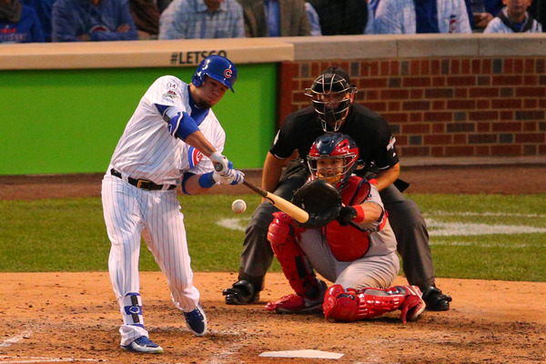
Kyle Schwarber's mammoth home run put the ball on top of the Wrigley Field scoreboard, where it will remain for the foreseeable future.

The Chicago Cubs reportedly intend to leave the home run ball hit by Kyle Schwarber in the 7th inning of Tuesday’s series-clinching 6-4 win over the St. Louis Cardinals right where the slugger deposited it: On top of the new scoreboard at Wrigley Field.
A source with the team on Wednesday confirmed to the Chicago Tribune that the team will leave the ball where it landed until the conclusion of the Cubs’ participation in the postseason.
The team did send an employee to inspect the ball so it could be confirmed that it was Schwarber’s moon shot home run ball, and an MLB postseason watermark verified its authenticity.
The Cubs also intend to place a plexiglass box around the ball to keep the ball safe from the elements and a security staffer will escort any person who travels to the top of the scoreboard until the ball is taken down.
The Cubs obviously know a thing or two about curses — to put it mildly — and the perceived toll such things can have upon an organization, whether it’s real or utter nonsense. Whatever the case, perhaps it’s not surprising the team is attempting to create some positive mojo by leaving Schwarber’s moon shot home run ball right where it landed … instead of waiting around and succumbing to the supposed curses of generations past.

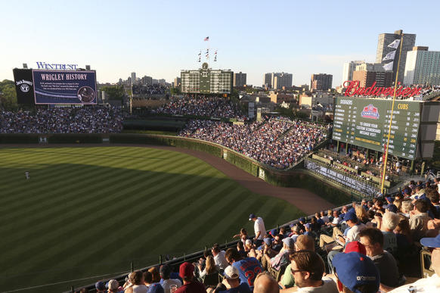

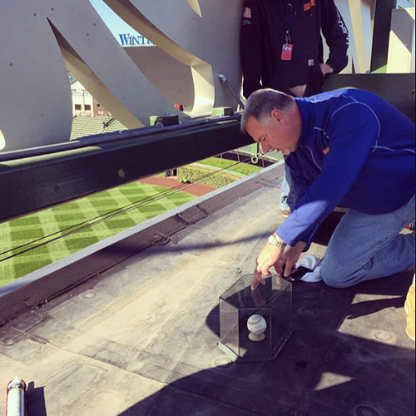

Five Thirty Eight
This Is The Cubs’ Best Chance Yet To Break Their Curse
by Neil Paine and Oliver Roeder

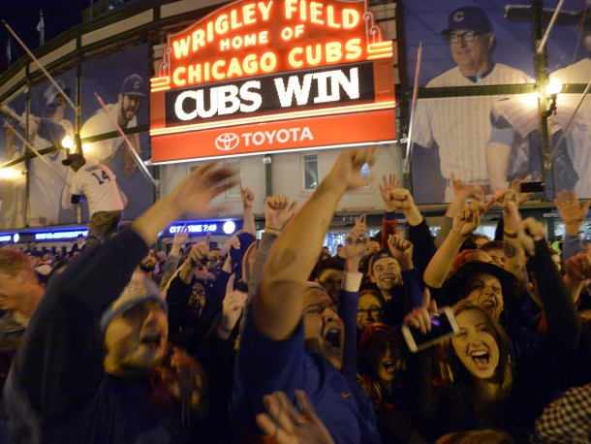
Fans gathered Tuesday outside of Wrigley Field after the Cubs’ 6-4 win in Game 4 of the team’s National League Division Series against the St. Louis Cardinals.
Seeing the Chicago Cubs in the National League Championship Series is a little like seeing a four-leaf clover — it’s uncommon, but nature does allow it from time to time. And after holding off the St. Louis Cardinals for a 6-4 win on Tuesday night at Wrigley Field, Chicago has stumbled across the rarest of shamrocks — a legitimately dominant Cubs team on the cusp of the World Series.
Three earlier Cubs teams have breathed the crisp, autumnal NLCS air: the 1984, 1989 and 2003 teams. (The league championship series format was introduced in 1969.) Those three squads lost their respective series, but according to our Elo ratings, this year’s NLCS-bound Cubs team is the strongest of the bunch. And even though they’ll cede home-field advantage to either the New York Mets or Los Angeles Dodgers,¹ the 2015 Cubs have the best chance of any of their predecessors at winning the NLCS and advancing to the World Series. Our ratings give the Cubs a 60 percent chance of reaching the World Series; it would be the team’s first appearance there since 1945.

Comparing the NLCS Cubs teams of the past
YEAR | W-L | NLCS OPPONENT | TOP PLAYER (WAR) | ELO | OPP. ELO | WIN %
2015 | 97-65 | Mets/Dodgers | Arrieta (8.9) | 1565 | 1529 | 60.0%
2003 | 88-74 | Marlins | Prior (8.0) | 1526 | 1552 | 42.8
1989 | 93-69 | Giants | Sandberg (6.1) | 1538 | 1533 | 52.7
1984 | 96-65 | Padres | Sandberg (8.5) | 1549 | 1523 | 59.2
We used data from Fangraphs to compare the strengths and weaknesses of the 2015 Cubs to those of past Cubs NLCS teams. For each year that the Cubs advanced as far in the playoffs, we computed the team’s percentile rankings, which grade on a 0 to 100 scale within the season in question (where 100 represents the best in baseball and 0 represents the worst), in six categories.² The 2015 Cubs, for instance, had a starting rotation that was better than that of all other major league teams this year but were the worst at avoiding strikeouts (that is, making contact).

How the four NLCS Cubs teams compare
 | PERCENTILE
YEAR | CONTACT | POWER | SPEED | DEFENSE | STARTERS | BULLPEN
2015 | 0 | 66 | 83 | 97 | 100 | 90
2003 | 7 | 55 | 7 | 76 | 97 | 72
1989 | 44 | 72 | 76 | 68 | 80 | 32
1984 | 12 | 72 | 88 | 60 | 96 | 76
Other than their propensity for strikeouts,³ this year’s Cubs are good at just about everything, possessing a particularly elite defense and pitching staff. Perhaps troublingly, the previous NLCS Cubs teams failed while following a similar blueprint — good power, pitching and defense. But this year’s Cubs appear to be the most complete of the bunch. The ill-fated 2003 team, for instance, had the starting rotation but inferior power and none of the 2015 squad’s speed. The Cubs of 1989 made better contact but had a weak bullpen, and the 1984 edition couldn’t match the current version’s defense.
And so far in the postseason, the Cubs have been leaning even more heavily on power hitting. In Monday’s NLDS Game 3, the Cubs belted six home runs, good for a postseason major league record. Rookies Kris Bryant, Kyle Schwarber and Jorge Soler all contributed to the tally, and Schwarber homered again on Tuesday. (His home run ball still sits atop the newly added video board in right field.) These are the hallmarks of the 2015 Cubs playoff run: young and long. Cubs hitters this year are four-and-a-half years younger, on average, than those on the Bartman-era 2003 NLCS squad.
Game 1 of the NLCS is on Saturday, and while the Cubs will be favored in the series (by Elo at least), no matter who they face, our numbers still say there’s a 40 percent chance they won’t win. So we don’t want to get Cubs fans’ hopes up too much. But fans should at least feel better going into this year’s NLCS than in any of the franchise’s previous three appearances — and that bodes well for the team’s chances of undoing certain 107-year-old droughts.

Footnotes
- Although they won 97 games, more than either the Mets or Dodgers, the Cubs can’t have home-field against either team because they did not win their division. ^
- ”Contact” represents the avoidance of offensive strikeouts as a percentage of all plate appearances; “power” is measured by Isolated Slugging; “speed’ is a composite of baserunning runs and speed score; “defense” is quantified using defensive runs above average; “starters” and “bullpen” grade each part of the pitching staff using park-adjusted fielding independent pitching. ^
- Their 1,518 regular-season strikeout tally — the most in the majors — dwarfed that of any other NLCS-bound Cubs team. In 2003, the second-worst showing by a Cubs NLCS team, they struck out “just” 1,158 times. ^

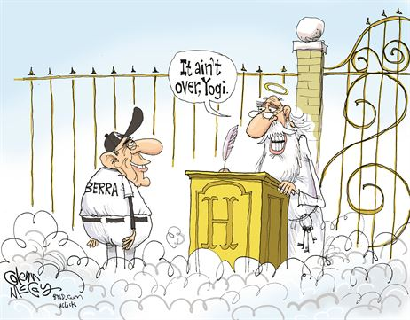

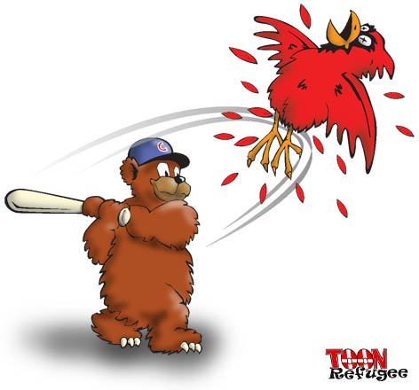

So they said.


