July 28, 2015

Back in April, a Pickings post led with a WaPo article on the huge number of museums in the country. 10,000 more than the 11,000 Starbucks and 14,000 McDonalds combined - 35,000. The Smithsonian Magazine writes on seven of the museums that sit along famed US Route 66.
... With the road cutting through big cities and small towns alike, Route 66 helped small businesses thrive. Diners, motels, trading posts, gas stations, natural wonders and roadside attractions all became part of the uniquely American experience the road provided.
But the Federal Highway Act of 1956 proved to be the beginning of the end of Route 66’s heyday. In response to the growing car culture of America, the law allocated money for newer, faster, better roads—like Interstate 40. These roads allowed for the near-total circumvention of Route 66. As the Mother Road saw less traffic, the small businesses alongside it died out. On June 27, 1985, Route 66 was officially decommissioned, meaning the road was no longer part of the US highway system.
Today, though, Route 66 has seen a bit of revival, thanks to recognition of its history and cultural value. The National Parks Service offers grants for preservation of the road. Travelers who want to experience a taste of mid-century Americana are hitting the road again. Even foreign tourists are making the trip to get their kicks on Route 66. While certainly not the fastest or easiest way to drive from Chicago to Los Angles (or vice versa), it is the most scenic, and still ripe for discovery.
So, buckle up—summer is road trip season and there is no better road to take than the one that so captivated the American imagination. Alongside the diners and natural wonders, Route 66 is a haven for off-the-wall collections and eclectic museums. Here are seven of the most fascinating: ...

Five Thirty Eight blog posts on the optimal speed of exercise.
There was a time when the optimal exercise speed was however fast you had to run to get away from a saber-tooth tiger. Even today, in much of the developing world, people exercise through activities such as farming and fetching water that are necessary for survival.
However, in the developed Western world, where exercise tends to be an extracurricular activity, there is apparently tremendous interest in just how fast you should move in order to improve your health. Consider, for example, the many posts on The New York Times’ Well blog on the topic (walking versus running, the “right dose of exercise,” “walk hard, walk easy”), all of which focus on the relative benefits of walking versus jogging versus running.
So is it better to walk? To walk fast? To run slow? To run fast? On its face, this question is poorly posed, since it says nothing about our goals or our constraints. Am I aiming to lose weight? To live longer? To win road races? Am I willing to exercise for three hours a day? Twenty minutes? Almost never? Clearly, these considerations matter when trying to determine the optimal speed. Here is how I would think about asking the question instead: What is the easiest way to reduce my chance of death? ...

And Huffington Post says running improves health.
1. Better Knees
Think running wears out your knees? Think again. One recent study found that it may actually help prevent knee osteoarthritis, a condition that affects roughly 9.2 million adults; another discovered that road warriors were up to 18 percent less likely than walkers to develop the condition, in part because running may increase the thickness of knee cartilage.
2. Less Stress
When it comes to the mood-boosting effects of running, science suggests you can get more than just an endorphin high. According to a lab study in The Journal of Neuroscience, running may reduce anxiety by triggering neurons that mute your response to stress. ...

Fulgurites are left behind when lightning hits sand. Amusing Planet has their story.
A single bolt of lightning can deliver 5 gigajoule of energy enough to power an average U.S. household for more than a month. When such a powerful lightning bolt strikes a sandy area like a beach or a dune, the sand particles can melt and fuse together in less than a second. Sand melts at about 1800 degrees Celsius, but the temperature in a bolt of lighting can reach 30,000 degrees, or more than five times the temperature on the surface of the sun. If conditions are right, the fused sand forms long hollow tubes called fulgurite. The term comes from the Latin word fulgur, which means "lightning". Although lightning strikes earth at least a million times each day, only rarely does fulgurites form. ...

Smithsonian
America's Road Trip: Route 66's Most Fascinating Museums
Take a drive on Route 66 and encounter the wonders of the road
by Matt Blitz

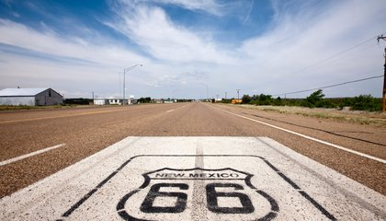
"Sixty-six is the mother road, the road of flight,” wrote John Steinbeck in his 1939 novel Grapes of Wrath.
When Route 66 was first established in 1926 as one of the first official US highways, it was nearly 2,500 miles of road that connected Chicago to Los Angeles. Never before had a route captured America’s sense of freedom, adventure and opportunity quite like 66 did. Given several nicknames—including “The Main Street of America,” and “The Will Rogers Highway”—Route 66 reigned supreme for about a quarter of a century, from the mid-1930s, when it was a migration route, until the late 1950s, when it became a major highway for postwar vacationers.
With the road cutting through big cities and small towns alike, Route 66 helped small businesses thrive. Diners, motels, trading posts, gas stations, natural wonders and roadside attractions all became part of the uniquely American experience the road provided.
But the Federal Highway Act of 1956 proved to be the beginning of the end of Route 66’s heyday. In response to the growing car culture of America, the law allocated money for newer, faster, better roads—like Interstate 40. These roads allowed for the near-total circumvention of Route 66. As the Mother Road saw less traffic, the small businesses alongside it died out. On June 27, 1985, Route 66 was officially decommissioned, meaning the road was no longer part of the US highway system.
Today, though, Route 66 has seen a bit of revival, thanks to recognition of its history and cultural value. The National Parks Service offers grants for preservation of the road. Travelers who want to experience a taste of mid-century Americana are hitting the road again. Even foreign tourists are making the trip to get their kicks on Route 66. While certainly not the fastest or easiest way to drive from Chicago to Los Angles (or vice versa), it is the most scenic, and still ripe for discovery.
So, buckle up—summer is road trip season and there is no better road to take than the one that so captivated the American imagination. Alongside the diners and natural wonders, Route 66 is a haven for off-the-wall collections and eclectic museums. Here are seven of the most fascinating:

The Vacuum Cleaner Museum: St. James, Missouri

“This museum really ‘sucks’ you in,” chuckles Tom Gasko, curator of the Vacuum Cleaner Museum in St. James, Missouri. Besides providing a little humor, Gasko looks after an impressive collection of vacuum cleaners, with machines that date back over 100 years. Many still work, as he often likes to demonstrate to visitors.
Located under the Tacony Manufacturing plant, the museum’s more notable artifacts include the vacuum used on Air Force One during George W. Bush’s administration. “When we got it, it smelled like piña colada,” says Gasko. Besides a machine suggestive of Air Force One's passengers' taste for tropical drinks, there are also several other “celebrity” vacuums at the museum. For example, the collections also include vacuums that appeared with Stan Kann, noted vacuum cleaner collector, on "The Tonight Show with Johnny Carson."

Devil's Rope Museum: McLean, Texas
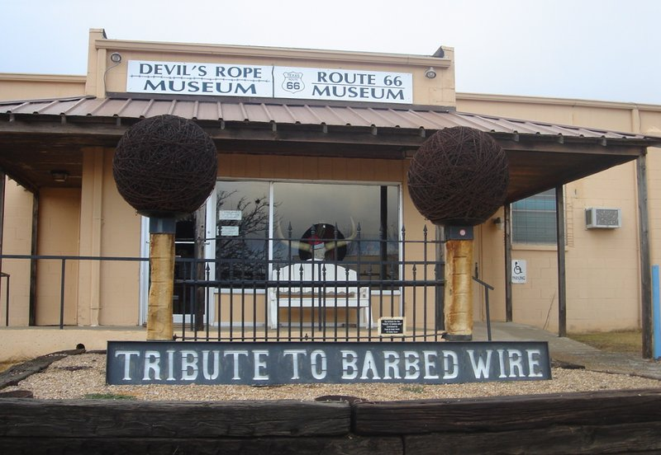
It is a relatively unknown fact that barbed wire contributed greatly to the settling of the American West. Originally invented in 1868 as a means of preventing cattle from eating crops, barbed wire was given its modern form by Joseph Glidden’s improvements in 1874. Prior to this, farmers often used Osage Orange, a small thorny tree found in Texas, as a naturally growing barrier.
Nicknamed “Devil’s Rope” by Native Americans, the wire proved highly effective on cattle, but also destructive against an entire ecosystem. One notable example: By impeding the American buffalo’s access to grazing land and water, it became a major factor in the near-extinction of the once-prominent creature.
This small museum in the Texas panhandle details the history of barbed wire. Located in a former bra factory, the museum has thousands of different types of barbed wire on display, plus demos on how to make your own “devil’s rope.” For art lovers, sculptures made entirely of barbed wire are featured both inside and outside the museum.

J.M. Davis Arms & Historical Museum: Claremore, Oklahoma

The largest private gun collection in the world is located in Claremore, Oklahoma, across the street from the Will Rogers Memorial Museum. A prominent local hotel owner, J.M. Davis leased his entire collection to the state of Oklahoma in 1965 for $1 a year. The museum opened in 1969 and Mr. Davis is still there, entombed in a crypt in 1973 on museum grounds so that he could stay with his guns forever.
While the guns are the highlight (notables include the world’s smallest manufactured automatic pistol and a Chinese cannon gun from the 14th century), the museum features other items as well. These include German beer steins, World War I posters and a rather creepy set of “used nooses.”

The Abraham Lincoln Presidential Library and Museum: Springfield, Illinois

From his stove top hat to his childhood log cabin, the legend of Abraham Lincoln is well-known. But the Abraham Lincoln Presidential Museum in the capital city of Illinois offers a different take on Honest Abe—a holographic take.
The centerpiece of the museum is their “Ghosts of the Library” show, complete with special effects, live actors and, yes, a hologram of Abraham Lincoln. It is grandiose, slightly bizarre and totally cool. Other Lincoln-related artifacts on display at the museum includes the former president's deathbed, the silver spoon Lincoln used at his last supper and Lincoln's notes from the third of his 1858 debates against Stephen A. Douglas.

Jesse James Wax Museum: Stanton, Missouri
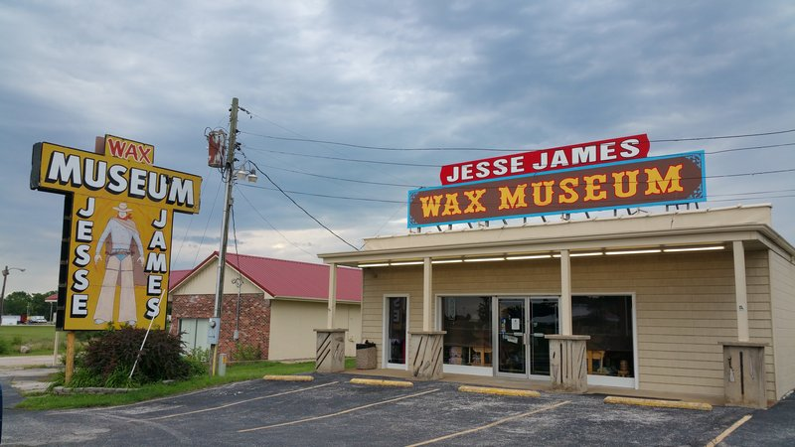
Wax figures of notorious outlaw Jesse James, famously shot by his supposed ally Robert Ford in 1882, would have been enough to make this museum on Missouri’s stretch of Route 66 a worthwhile stop. But the museum also presents an outlandish but fascinating theory: What if Jesse James didn’t die that day? What if his shooting was just an elaborate ruse? What if James lived to 1951 and died at age 104?
In 1948, a Texas man named J. Frank Dalton claimed that he was, in fact, Jesse James. After years of hiding the secret, Dalton said, he had finally decided to reveal his "true" identity to the world before his death. There were skeptics aplenty, but businessman Rudy Turilli believed and made it his life’s work to prove that J. Frank Dalton was Jesse James.
Today, the Turilli family still owns and runs the museum, along with the nearby Meramec Caverns where the James/Dalton gang supposedly hid out.

The National Museum of Nuclear Science and History: Albuquerque, New Mexico
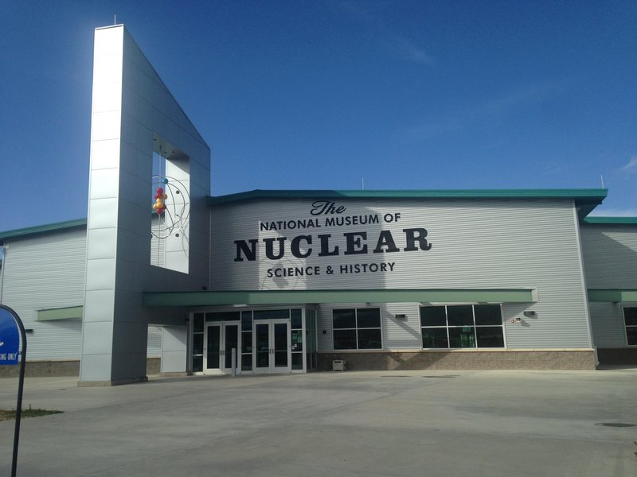
Driving Route 66 can feel like being transported via time machine into 1950s America—the days of pink Cadillacs, soda jerks and the threat of nuclear annihilation.
Located less than a mile off the historic road, the National Museum of Nuclear Science and History charts United States advancements in nuclear science. Besides exhibits on the Manhattan Project and Atomic Pinup Girls, the museum is home to some of the most remarkable artifacts of the atomic age. The B-29 Superfortress, the first type of plane to drop a nuclear bomb, is regarded as the “aircraft that won World War II.” There are only 17 still in existence, including the one stationed behind the museum, although the museum's plane never actually saw combat. The collection also includes two hydrogen bomb casings from the infamous Palomares incident, when American H-bombs were accidentally dropped (but not detonated) on Spain in 1966.

Museum of Osteology: Oklahoma City, Oklahoma
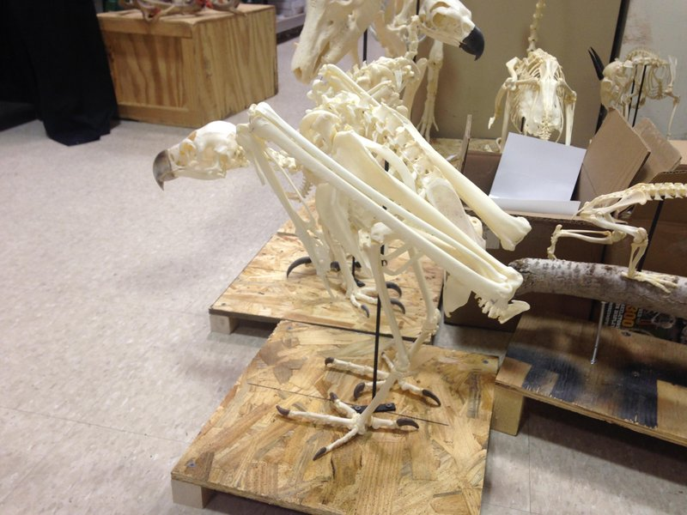
Despite its rather ordinary name, this facility on the outskirts of Oklahoma City is anything but. Jay Villemarette’s fascination with bones began as a kid, when he found a dog skull in his backyard. His collection grew, and soon he started a small skull-and-skeleton-sales business out of his house.
One thing that always proved difficult for Villamarette was getting the bones clean. He tried boiling, burning and bleaching, but all of these methods were potentially dangerous, expensive and didn’t work all that well. One day while out collecting, he noticed a specimen being eaten away by dermestid beetles, or skin beetles. Indiginous to North America, the beetles aid the natural decomposition process in the wild. Villamarette had found his solution to his bone-cleaning problem.
Today, Villamarette and his retail company, Skulls Unlimited, employ tanks of dermestid beetles to help clean the excess meat off specimens. One of these tanks, plus nearly 1,000 bone and skeleton specimens, are on display at the Museum of Osteology—“America’s only skeleton museum”—located next door to the processing plant of Skulls Unlimited.

Five Thirty Eight
What’s The Optimal Speed For Exercise?
Should you walk fast? Run slowly? Just sit still?
by Emily Oster
There was a time when the optimal exercise speed was however fast you had to run to get away from a saber-tooth tiger. Even today, in much of the developing world, people exercise through activities such as farming and fetching water that are necessary for survival.
However, in the developed Western world, where exercise tends to be an extracurricular activity, there is apparently tremendous interest in just how fast you should move in order to improve your health. Consider, for example, the many posts on The New York Times’ Well blog on the topic (walking versus running, the “right dose of exercise,” “walk hard, walk easy”), all of which focus on the relative benefits of walking versus jogging versus running.
So is it better to walk? To walk fast? To run slow? To run fast? On its face, this question is poorly posed, since it says nothing about our goals or our constraints. Am I aiming to lose weight? To live longer? To win road races? Am I willing to exercise for three hours a day? Twenty minutes? Almost never? Clearly, these considerations matter when trying to determine the optimal speed. Here is how I would think about asking the question instead: What is the easiest way to reduce my chance of death?
To analyze the impact of walking or running, researchers need a way to describe the effort exerted. The ideal measure would combine the length of time spent exercising with the amount of energy expended — basically, we want to figure out a way to credit people who walk at half the speed for twice as long the same amount as those who walk faster for less time.
The way researchers do this is with a measurement known as MET — metabolic equivalent of task — which gives a numeric value to various activities depending on their energy intensity. By multiplying an activity’s METs by the time you engage in it, you can get an overall measure of how much energy you expend.
The goal here is to use these METs and their relationship to health to analyze the value of walking compared with jogging or running. At least in this article, I won’t say anything about other kinds of exercise — no yoga or SoulCycle — though these have their own MET measures.
Let’s first look at the results from two papers — here and here — that relate energy expenditures from walking (in MET hours per day) to the risk of death.
Doing this analysis is a little complicated. You can’t look at the relationship between exercise and the chance of ever dying, because ultimately everyone dies. Instead, these studies look at whether exercise changes the risk of death at a given time. But since the people in the studies are of different ages, researchers can’t just look to see whether they have, say, a 2 percentage point lower risk of death in a given year, since that lower risk would mean a lot more for someone who is 30 than for someone who is 90. Results in these two papers — and basically all the others we’ll look at here — therefore report their results in “hazard ratios.” A hazard rate of 0.90, for example, means a 10 percent reduction in the risk of death. If there is a 10 in 1,000 chance you’ll die in the next year without exercise, this means by exercising you’d reduce that chance to 9 in 1,000.
This research shows that those who walk have a lower risk of mortality relative to people in the comparison group, who don’t walk for exercise at all (they probably do still walk some, just not for exercise). This risk of death is lower even with a very minimal energy expenditure. The lowest-energy-expenditure group in each study is walking at about 3 mph for 20 to 40 minutes per day. In other words, a mile or two of walking. In exchange, their risk of death goes down by 10 percent.
Walking a bit farther — say, 2 to 3 miles at 3 mph — gets you an additional death reduction of about 30 percent. But walking more than that, or more than an hour a day at this speed, is no better.
Other studies of walking find similar magnitudes. A large meta-analysis found that, on average, walking 1 to 3 miles at about a 20-minute-mile pace results in a reduction in death risk of about 10 percent.
Many of these studies do not separate out speed and duration, but to the extent they do, it seems like walking faster may be better than walking slower. Here is one study that shows large mortality reductions for fast walking even for short periods, and here is another showing that very slow walking has fewer benefits than faster walking.
At first glance, it may seem obvious that the harder you exercise, the better. If walking faster is more energy-intensive than walking slower, and running is more energy-intensive than walking, it seems like the health benefits of running would be even greater. In some sense, you’d hope so, since most of us find running more difficult than walking.
Broadly, over some range, this seems to be right. The chart below shows results for two studies of runners that, again, relate METs to hazard rates of death. Running — even slowly, like 5 mph — is far more energy-intensive than walking. An energy expenditure of 1.19 METs per day (the lowest-energy-expenditure group in the second study here) means about 20 minutes of running a 12-minute mile, three times a week.
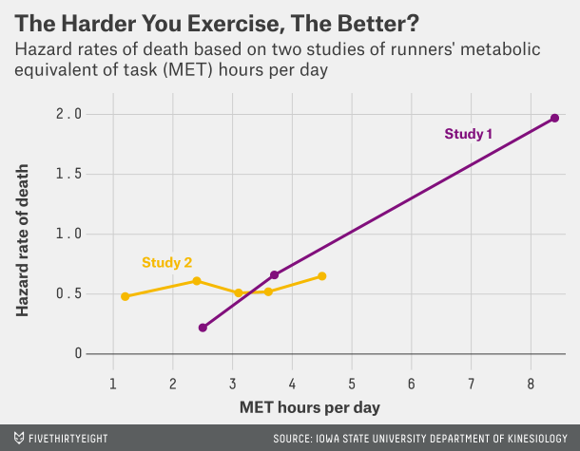
Slow running like this appears to have a much larger impact on mortality than walking. A hazard rate of 0.48 — compared with a sedentary group — suggests a much larger reduction in the risk of death than a hazard rate of 0.90. What is a bit surprising about this chart is that running faster or farther doesn’t seem to reduce death rates any more than running slowly and, in fact, in both cases is slightly worse.
In one of these studies it looks like running very intensely (faster than an eight-minute mile, more than four hours a week) increases your risk of death relative to not running at all. But a closer look at the data suggests that this is probably just a statistical artifact: This intense running group contains only 36 people and two deaths, versus hundreds of people in the more casual running groups.
Even if we dismiss the possibility that running harder is worse, it is probably useful to note that running harder or farther doesn’t seem to be better. I have occasionally felt guilty about my thrice-weekly 25-minute runs, especially in comparison to my brother, who runs a 2:45 marathon and once attempted the Leadville Trail 100. It is comforting to know that I can still outlive him.
One general problem with all of this research is that none of these studies is randomized. People who exercise are different from those who do not, and those who exercise more are different from those who exercise less. This should, as usual, give us some pause in trumpeting the virtues of exercise. However, I’d argue that the comparisons the studies make among runners are still valid.
To be more concrete: In most of these studies, the more intense runners are healthier (for example: less likely to smoke and thinner) than the less-intense runners. We may tend to attribute the health of this group to their running habits. The fact that even with this bias we see no large benefit — indeed, seemingly no benefit at all — to running more rather than running less reinforces the value of moderate running.
If we take this research at face value, we learn a few things. First, some exercise reduces your risk of death. Second, the optimal walking/jogging exercise is light to moderate jogging. The optimal speed is between 5 and 7 mph, and if you do 25 minutes about three times a week, you’re all set. Nothing in the data suggests that running more — farther, or faster — will do more to lower your risk of death.

Huffington Post
5 Wondrous Ways Running Improves Your Health
Running can do real wonders for your health, especially if you have the right gear.
1. Better Knees
Think running wears out your knees? Think again. One recent study found that it may actually help prevent knee osteoarthritis, a condition that affects roughly 9.2 million adults; another discovered that road warriors were up to 18 percent less likely than walkers to develop the condition, in part because running may increase the thickness of knee cartilage.
2. Less Stress
When it comes to the mood-boosting effects of running, science suggests you can get more than just an endorphin high. According to a lab study in The Journal of Neuroscience, running may reduce anxiety by triggering neurons that mute your response to stress.
3. Lower Breast Cancer Risk
A 2013 study of more than 70,000 women revealed that those who walked at least seven hours per week were 14 percent less likely to develop breast cancer than their more sedentary counterparts. The most active women, who worked out vigorously (running or swimming) for at least six hours a week, slashed their risk by 25 percent.
4. Sharper Mind
Good news: You don't have to slog away for a long time to reap impressive benefits. One small study found that people who engaged in light activity -- like walking on a treadmill for an hour -- three times a week saw gains in memory after just three months, suggesting that short-term fitness may slow age-related cognitive decline.
5. Longer Life
In a 2014 study of more than 55,000 people, those who ran daily -- even for just five to ten minutes -- lived, on average, three years longer than those who didn't run. Worth noting: Runners who logged longer workouts didn't significantly decrease their risk of death from heart disease more than those who ran less. Who doesn't have five minutes? Get going!

Amusing Planet
Fulgurite: What Happens When Lightning Strikes Sand
by Kaushik Tuesday
A single bolt of lightning can deliver 5 gigajoule of energy enough to power an average U.S. household for more than a month. When such a powerful lightning bolt strikes a sandy area like a beach or a dune, the sand particles can melt and fuse together in less than a second. Sand melts at about 1800 degrees Celsius, but the temperature in a bolt of lighting can reach 30,000 degrees, or more than five times the temperature on the surface of the sun. If conditions are right, the fused sand forms long hollow tubes called fulgurite. The term comes from the Latin word fulgur, which means "lightning". Although lightning strikes earth at least a million times each day, only rarely does fulgurites form.
Fulgurites are usually found beneath the surface of the sand, generally decreasing in diameter and sometimes branching outs as they descend. Their shape reflects the path lightning bolt took as it dispersed into the ground. Because of this, fulgurites are sometimes called “fossilized lightning”.
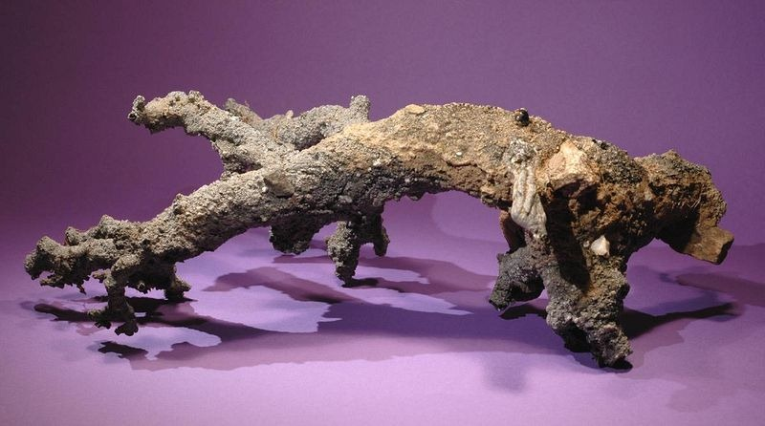
A 14 inch fulgurite found near Queen Creek, Arizona.
Fulgurites look like roots, due to its branching, and have a rough surface, covered with partially melted sand grains. But the inner surfaces are usually smooth and glassy due to rapid cooling and solidification of the sand. The size and length of a fulgurite depends on the strength of the lightning strike and the thickness of the sand bed. Many sand fulgurites average an inch or two in diameter and can be up to 30 inches long, but fulgurites as long as 16 feet have been found. Some fulgurites can penetrate deep into the soil, sometimes occurring as far as 49 feet below the surface that was struck.
Fulgurites can also form when lightning strikes rock, occurring as coatings or crust of glass and sometimes as veins on the rock surface lining preexisting fractures within the host rock.
Fulgurites have been described as early as 1711 and are found all all over the world, from mountain peaks to the Sahara desert, but are considered to be rare. They aren’t precious but are appreciated by many for their scientific value. By studying the distribution of fulgurites over a specific area, for instance, one can infer the occurrence of thunderstorm activity in the area during a certain period, which in turn can help understand past climates. 250-million-years-old fulgurites found in the Sahara has shown, or rather confirmed, that the desert was once a fertile region where rain thunderstorms were common.











