June 21, 2015

Two Eyes Watching has more on the newly discovered link between the brain and the immune system.
In last week’s issue of Nature, researchers led by University of Virginia neuroscientist Jony Kipnis describe their discovery of lymphatic vessels in the tissues beneath a mouse’s skull. Their observation was unexpected, to say the least. Lymphatic vessels complement the body’s blood vessels, carrying immune cells throughout the body instead of blood. But for decades, researchers had assumed that the lymphatic system stopped short of the brain. Kipnis’ team’s discovery turns that assumption on its head. “They’ll have to change the textbooks,” Kevin Lee, PhD, chairman of the UVA Department of Neuroscience, recounted telling his colleaguesupon hearing of their finding.
The science linking the brain and the body has come a long way in the past decade. Disorders like autism are anecdotally associated with gastrointestinal problems in children, and mouse models of autism have been empirically associated with the balance of their gut microbes. Similarly, an over-reacting immune system is associated with autism-like behaviors in mice, and can even transform strep throat into a psychiatric illness called PANDAS, a deceivingly cuddly acronym that stands for pediatric autoimmune neuropsychiatric disorders associated with streptococci.
But how are gut microbes, the immune system, and neurons connected in the first place? Until recently, this was anyone’s bet. ...

From Debrief Daily, a member of AA takes exception to the poor press the group is receiving.
... It seems every few years a new study comes out saying how Alcoholics Anonymous isn’t effective, or is a cult, or that something else has come along that is better. I’m not going to link to them, but they’re easily found online. I’m only here to share my own experience, since that’s the only thing that I can speak on with any authority. YMMV and all that.
To say I was a mess when I arrived in AA would be an understatement. If you’re interested in what got me to AA in the first place, you can read it all here. So any amount of hope was a welcomed change of pace. And I got that hope in AA. The hope that maybe I wouldn’t die drunk in the streets, or worse yet crud away like one of those old drunks you see. “But isn’t AA a cult?” you ask? It might be. I’ve never been in a cult. I will say that AA doesn’t fit the full definition of a cult, in that the requested behavior isn’t what I would call “deviant”. They ask that I not drink, turn my life over to god as I understand god, and help others do the same. Let’s look at their own description for a minute:
Alcoholics Anonymous is an international fellowship of men and women who have had a drinking problem. It is nonprofessional, self-supporting, multiracial, apolitical, and available almost everywhere. There are no age or education requirements. Membership is open to anyone who wants to do something about his or her drinking problem.
Oh yeah, the god thing. This is the hangup I most often see. ...

Mental Floss has a list of 15 amazing things aluminum foil can do. Pickerhead says it's still not bacon which can do anything.
Aluminum foil is more than just a handy way to wrap leftovers. The thin metal sheets are all-purpose powerhouses around the house, ready to help you with your cooking, cleaning, laundry, and even home decorating. There are plenty of unusual ways to put foil to use. You can use it as a ...

1. Dish scrubber
When the rough side of your sponge isn’t enough for set-in grease and food remains, use a balled-up piece of foil to wipe your baking dishes clean. Foil works just as well on a dirty grill.

2. Scissor sharpener
Fold a piece of aluminum foil several times. Cut a few straight lines through the foil with your dull scissors. This cleans and sharpens the blade, sort of like a razor strop. ...

So where do hummingbirds go in the winter? Garden and Gun has answers.
Where do they go? It’s what every Southern gardener wonders at some point after the ruby-throated hummingbirds disappear. These “glittering garments of the rainbow,” as John James Audubon called them, delight us all summer not only with their beauty, but also with their antics. They’re better than daytime drama. They are the bold and the beautiful, the young and the restless. Despite their appearance on genteel needlepoint pillows, they are not genteel. Despite eating sugar water, they are not sweet. At home in Oxford, Mississippi, I love to watch the dominant male who perches in our Bradford pear, hidden among the leaves, waiting for another hummer to even think about sipping his nectar. Should one try, he zings after it and bullies it off, then loops back to his perch and resettles himself with a cartoonish fluffing of his throat gorget. But round about time the maples start to redden and Ole Miss has started conference play, I realize we haven’t seen him in a day or two. And the feeder activity is definitely lighter. Then, a week later, the hummers have disappeared entirely. Long after the last sugar water has been dumped and the feeders washed and stored, the question remains. Where do they go?
As it turns out, they go exactly where many of us would go: due south for the winter. In late summer, the rubythroats start drifting down through North America, and when they reach the Gulf states, they linger. They gorge until they’ve doubled their weight, to roughly a nickel’s worth. Then they lift off one evening and fly through the night without stopping, a trip of five hundred miles, to winter in Mexico and Central America. Their migratory route appears to be hardwired into the genetic codes packed inside their BB-size brains. ...

Two Eyes Watching
Scientists Discover A New Link Between The Brain And The Immune System
by Levi Gadye
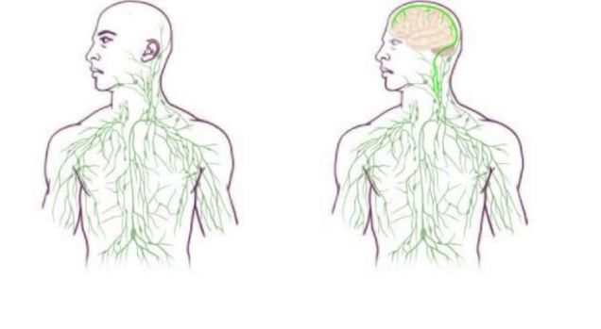
Maps of the lymphatic system: old (left) and updated to reflect the discovery discovery.
Last week, researchers announced they had discovered a physical connectionbetween the immune system and the brain’s blood supply. The finding gives researchers a novel approach to understanding diseases ranging from autism to multiple sclerosis, and strengthens the bridge between neuroscience and immunology.
In last week’s issue of Nature, researchers led by University of Virginia neuroscientist Jony Kipnis describe their discovery of lymphatic vessels in the tissues beneath a mouse’s skull. Their observation was unexpected, to say the least. Lymphatic vessels complement the body’s blood vessels, carrying immune cells throughout the body instead of blood. But for decades, researchers had assumed that the lymphatic system stopped short of the brain. Kipnis’ team’s discovery turns that assumption on its head. “They’ll have to change the textbooks,” Kevin Lee, PhD, chairman of the UVA Department of Neuroscience, recounted telling his colleaguesupon hearing of their finding.
The science linking the brain and the body has come a long way in the past decade. Disorders like autism are anecdotally associated with gastrointestinal problems in children, and mouse models of autism have been empirically associated with the balance of their gut microbes. Similarly, an over-reacting immune system is associated with autism-like behaviors in mice, and can even transform strep throat into a psychiatric illness called PANDAS, a deceivingly cuddly acronym that stands for pediatric autoimmune neuropsychiatric disorders associated with streptococci.
But how are gut microbes, the immune system, and neurons connected in the first place? Until recently, this was anyone’s bet. The immune system, which tracks and addresses threats to the body by way of the bloodstream, is directly exposed to neither the inside of the gut nor the brain. The gut microbiome is separated from the bloodstream by the lining of the intestines, and from the brain by the aptly named blood-brain barrier (BBB). Indeed, the brain was long considered to be “immune privileged,” or exempt from normal immune surveillance, both good and bad—a necessity given that, for instance, the brain can’t tolerate swelling from inside the skull.
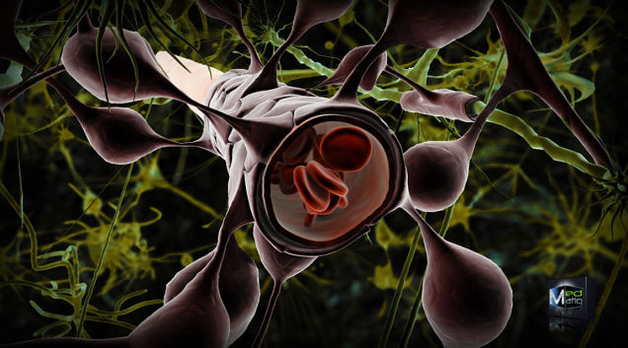
Blood vessels are sequestered from direct contact with the brain via the blood brain barrier – keeping the peripheral immune system at bay.
But in the last twenty years, the notion that the brain is immune privileged has been slowly dismantled. Careful studies have shown that the brain does interact with the peripheral immune system, albeit in unique ways. Immune cells do, somehow, circulate through the brain, and antigens—which would normally stoke an immune response—do drain from the brain into the lymph nodes. Moreover, neurological diseases like multiple sclerosis and Alzheimer’s have long been linked to changes in immune system function, and autoimmune diseases of the gut, like Crohn’s disease,correlate with psychiatric illness.
One major problem for the field, though, has been the lack of a physical connection between the brain and the body that could help explain the mystery behind these diseases. But last week, scientists at the University of Virginia stumbled across such a bridge: a network of lymphatic vessels that appears to directly link the brain with the immune system.
Kipnis’ team was studying the circulation of immune cells in the meninges, the blood-vessel-rich tissue that lies between the skull and the brain. They were looking at T-cells, specifically, a class of immune cell that detect trouble in the body and communicate it to the rest of the immune system. Other labs had noticed that T-cells injected into the brain eventually found their way to the cervical lymph nodes. What wasn’t clear was how they got there. (The BBB, certainly, would not allow T-cells to travel back and forth.)
A post-doctoral scientist in the Kipnis lab, Anthoine Louveau, came up with a nifty method for visualizing the meninges of a mouse brain without destroying it. “It was fairly easy, actually,” he explained in a press release. “There was one trick: We fixed the meninges within the skullcap, so that the tissue is secured in its physiological condition, and then we dissected it. If we had done it the other way around, it wouldn’t have worked.”
Louveau and his colleagues processed the carefully-mounted tissue so they could see immune cells and lymphatic vessels, which normally connect the rest of the body to the lymph nodes. Shockingly, there were lymphatic vessels that closely followed blood vessels down into the sinuses of the brain—anatomists had apparently missed this direct conduit for decades. In the press release, Louveau recalled the moment when he realized the import of what he was looking at: “I called Jony [Kipnis] to the microscope and I said, ‘I think we have something.’”

Probing The Connection Between Brain And Body
Outside experts say it’s a big discovery. Caltech biologist Elaine Hsiao—who studies the interaction between gut microbes, the immune system, and the brain, but was unaffiliated with the study—told me that Louveau’s team’s findings suggest “there may be more intimate interactions between the peripheral immune system and brain than we’ve ever realized.”
Hsiao has been at the forefront of the overlapping fields of neuroscience, immunology, and microbiology for nearly a decade. In recent years, along with others at Caltech, she characterized the importance of both the immune system and particular gut microbes in mouse models of autism. This past April, her lab showed that a particular type of gut microbe is responsible for spurring cells in the gut toproduce serotonin—nearly all the serotonin found in the body.
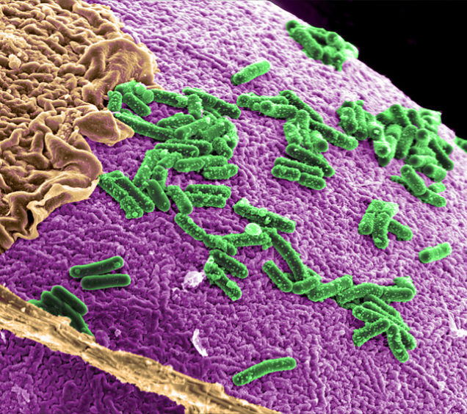
A model system of gut microbes believed to play a role in human diseases like Alzheimer’s.
While little of this peripheral serotonin crosses the blood-brain barrier, Hsiao says “there is an increasing appreciation that serotonin mediates pro-inflammatory responses.” Her recent study showed that without this microbe-induced serotonin production, a host of problems with gastrointestinal function emerge. Her lab is intrigued by the potential impact of this serotonin on other elements of physiology, such as immunity. Moreover, the recent discovery from the Kipnis lab “raises the question of whether microbial influences on the neuroimmune system, or neuro-immune interactions, can lead to changes in brain function and/or behavior.”
Could autism, or PANDAS, result from some alteration to the gut microbiome that impacts the immune system via serotonin, and then spurs some change in the brain? Is the lymphatic system of the brain failing to clear out the proteins that accumulate into toxic plaques and tangles during Alzheimer’s? Or is the immune system malfunctioning during multiple sclerosis, due to its encounters with the brain via these lymphatic vessels? All these speculations become fair game with this newfound appreciation of the brain’s connection to the immune system.
Wendy Ingram, a postdoctoral researcher in human translational genomics atGeisinger Medical Center in Pennsylvania, wonders whether this finding could shed light on her 2013 discovery that a particular parasite, Toxoplasma gondii, can cause mice to lose their fear of cat urine. After mice consume feces containing this parasite, the parasite somehow gets into the brain, and permanently disables an innate fear circuit—but until now, the options for traveling from gut to brain weren’t well understood.
One compelling route for the parasite could directly involve this new lymphatic connection to the brain. After crossing into the bloodstream from the gut, T. gondiimight hitch a ride with immune cells destined for the brain, “allowing them to transit into the CNS in a ‘trojan horse’ type of parasite delivery,” Ingram explains. Is the lymphatic system lighting the way for these parasites to get into the brain? Evenour brains?
Given that T. gondii permanently alters mouse behavior, even after it has been cleared from the brain, Ingram speculates there are numerous ways that the parasite might leave an indelible mark on brain function, though more research will be required to figure out how a microscopic parasite can actually eliminate the fear of cats in a mouse. “Suffice to say, there are likely many connections and interactions between the brain and the immune system which are completely unknown,” she says.
Hsiao is confident that scientists will waste no time in exploring the implications of Louveau’s team’s discovery. “In the next decade, I think that the collective ‘we’ will be on our way toward achieving an understanding of the neuro-immune system that matches the depth and breadth of our knowledge of the peripheral immune system,” she says. “I hope that we’ll be seeing new ways of using peripheral pathways to hack into brain function and behavior, to treat symptoms of neurological disease.”
But no matter exactly how this work is followed up, neuroscience and immunology now have even greater reason to collaborate. These findings “are going to crack open the chasm of the field of neuroimmunology in a wonderful way,” Ingram says. “Immunologists and neuroscientists have been politely ignoring each other for far too long.”

Debrief Daily
Sorry, that AA “study” is bullshit
by Andrew Norcross
I don’t care who published it. It’s wrong. And it could be the reason someone doesn’t try to get help.
—I’ll start by saying this: Alcoholics Anonymous is the sole reason I am not dead. So I’m biased as hell.
—It seems every few years a new study comes out saying how Alcoholics Anonymous isn’t effective, or is a cult, or that something else has come along that is better. I’m not going to link to them, but they’re easily found online. I’m only here to share my own experience, since that’s the only thing that I can speak on with any authority. YMMV and all that.
To say I was a mess when I arrived in AA would be an understatement. If you’re interested in what got me to AA in the first place, you can read it all here. So any amount of hope was a welcomed change of pace. And I got that hope in AA. The hope that maybe I wouldn’t die drunk in the streets, or worse yet crud away like one of those old drunks you see. “But isn’t AA a cult?” you ask? It might be. I’ve never been in a cult. I will say that AA doesn’t fit the full definition of a cult, in that the requested behavior isn’t what I would call “deviant”. They ask that I not drink, turn my life over to god as I understand god, and help others do the same. Let’s look at their own description for a minute:
Alcoholics Anonymous is an international fellowship of men and women who have had a drinking problem. It is nonprofessional, self-supporting, multiracial, apolitical, and available almost everywhere. There are no age or education requirements. Membership is open to anyone who wants to do something about his or her drinking problem.
Oh yeah, the god thing. This is the hangup I most often see. Yes, AA asks that you believe in a higher power. I call that higher power god because that’s what works for me. Not a Protestant god. Not a Catholic god. Just a god that loves me unconditionally. It took me a little while to get to that point, but I could get with that idea. My concept is simple: There is a god, and I’m not it. That’s the construct I came up with shortly after I arrived, and it’s still serving me well today. My god and your god aren’t the same. And that’s totally fine.
The funny thing about AA is that nearly everyone gets what they want when they show up. The problem is, not everyone wants to get sober. Many folks want to get rid of some consequences from their drinking. Maybe a job is forcing them to get help. Or their spouse kicked them out. Or they got a DUI and had to go to a certain number of meetings as part of their sentence. That’s why I get angry when I see people cite studies that include “success” rates. There are many people who go to AA that have absolutely no intention of getting sober. None. They want to get out of trouble. So if they get out of the temporary jam that they’re in, then leave AA, are they considered a “success”? Or how about the 19 year old who gets sent there because he got caught with a bag of weed? He’s not an alcoholic. He shouldn’t be there to begin with. So when he leaves (and he will), is he marked against this rate?
Don’t forget about the “anonymous” part of Alcoholics Anonymous. No official statistics are ever put out. Every few years Alcoholics Anonymous does a survey of its members, but it’s a small snapshot of the groups that participate. I’ve never “registered” anywhere in my nearly 12 years in AA. Not once have I been asked to provide information towards some data calculations. And until now, I’ve rarely made mention publicly that I’m even a member of AA. So any study is doomed from the start. And if you read them, you’ll see a common thread: former members who are unhappy, or people who have a vested interest in something else succeeding. Even if they don’t have an agenda (and almost all do), they’re still flawed in their construct. They aren’t studies. They’re surveys.
Now I do want to make one thing clear: AA is by no means the only way to get sober, or even the best. There is no “best” way.
The best way to get sober is how you got sober.
That’s for me, for you, for anyone who is giving it an honest try. Kicking booze and drugs is easily the hardest thing I’ve ever done, which includes having to re-learn how to walk at the age of 20 due to a major leg surgery. Some people go to church. Some people go through therapy of some kind. And some people just decide one day that they’re done, and they quit. Those people are rare. I’ve met 2 of them my entire life, and both were miserable as hell. Don’t know if one had anything to do with the other.
My point is this: unless you’re an alcoholic in AA, you have no experience with it. So telling someone else it’s bad / a cult / a waste of time is at best worthless, and at worst could be lethal. AA doesn’t need me to be a cheerleader for them. They did just fine before I walked in the door. They’ll do fine when I’m dead and buried. But while I’m still on this planet, I’m going to be protective of AA because my other alternative is the life I used to lead. And my life has become pretty damn awesome, so it’s not something I’m willing to give up.

Mental Floss
15 Amazing Things Aluminum Foil Can Do
by Shaunacy Ferro

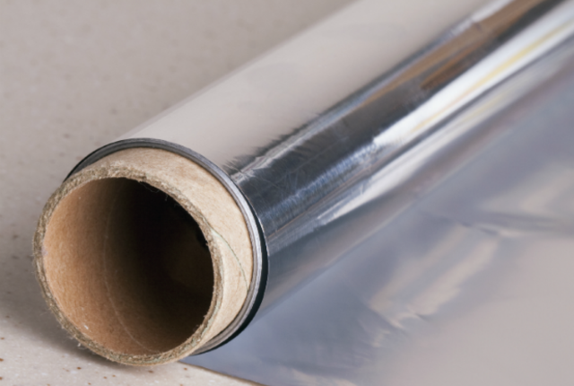
Aluminum foil is more than just a handy way to wrap leftovers. The thin metal sheets are all-purpose powerhouses around the house, ready to help you with your cooking, cleaning, laundry, and even home decorating. There are plenty of unusual ways to put foil to use. You can use it as a ...

1. Dish scrubber
When the rough side of your sponge isn’t enough for set-in grease and food remains, use a balled-up piece of foil to wipe your baking dishes clean. Foil works just as well on a dirty grill.

2. Scissor sharpener
Fold a piece of aluminum foil several times. Cut a few straight lines through the foil with your dull scissors. This cleans and sharpens the blade, sort of like a razor strop.

3. Cupcake holder
Make an easy-to-carry disposable cupcake or muffin holder by lining a regular cupcake pan with a layer of foil. Make sure to push the foil all the way into the recesses of the pan, creating cupcake-shaped indents. Pop it out, and wrap the whole thing (cupcakes inside) again in foil.

4. Makeshift funnel
Twist a piece of foil into a cone shape, and stick it in whatever bottle (or flask—we're not judging) you’re transferring to. Just make sure to hold the foil in place, and don’t pour too much too fast, or your funnel will come apart.

5. Grilling tray
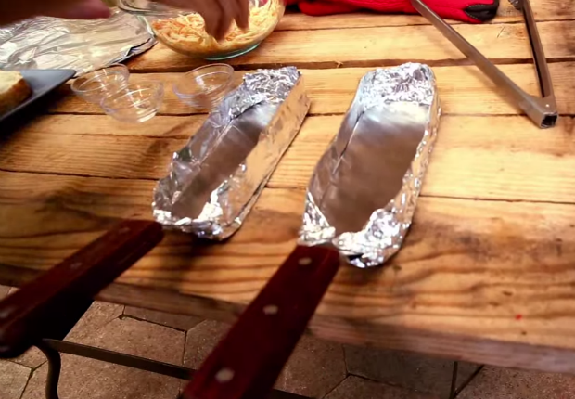
Keep melty or loose food from dripping and falling into your grill by turning your metal spatulas into miniature grilling trays. Fold around two feet of heavy-duty foil in half, put a griddle spatula in the middle, and fold the foil up around it to create a tray. See an example (pictured) in this grilled cheese tutorial by Alton Brown.

6. Vegetable crisper
To keep celery crisp, wrap it in aluminum foil before you put it in the fridge, so when it produces ethylene gas, it doesn’t get trapped in a plastic bag.

7. Silver polish
Silver becomes darker with age because of a chemical reaction with the sulfur in the air. Aluminum foil can help reverse the process by converting silver sulfide back into silver with the help of some baking soda and hot water. Coat the bottom of a pan with aluminum foil, and put whatever silver you’re looking to polish on top. Pour a mixture of boiling water and baking soda (one cup of baking soda for every gallon of water) into the pan, covering the silver, and wait until the tarnish disappears. If your silver is too big for a pan, use a bucket like in the video above.

8. Dryer sheet
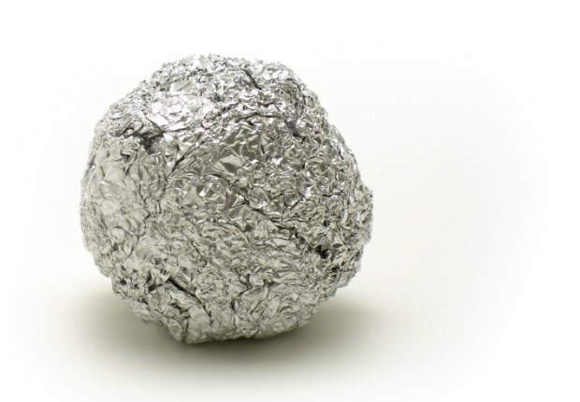
Throw a crumpled up foil ball or two into the dryer with your laundry instead of dryer sheets. While the trick doesn’t make your clothes quite as soft as a commercial softener, the foil will keep garments static-free.

9. Gift wrap
The best gifts come in shiny packages, and there is very little difference between silver wrapping paper and the aluminum foil you have lying around your kitchen.

10. Photography background
Crinkle up a large sheet of aluminum foil and tape it to the wall as a mod set piece for your photography.

11. Light reflector
Perk up the shadowy areas of your photos with a reflector made out of foil. Just tape foil to a large display board (like the kind you'd use for the science fair) and angle it to get the lighting conditions you want. Note that the two sides of aluminum foil aren’t the same—one is shinier. Make sure to keep the same side facing up throughout the board.

12. Hair curler
Wrap a piece of hair around two fingers and cover the resulting loop in foil. Clamp the packet of foil in a straight iron for a few seconds to heat up the hair, then let it cool. Instant waves.

13. Home decor
Use recycled aluminum foil to decorate your house. The project above turns foil from the tops of cans into handmade flowers using scissors, pliers, and a glue gun.

14. Millennium Falcon
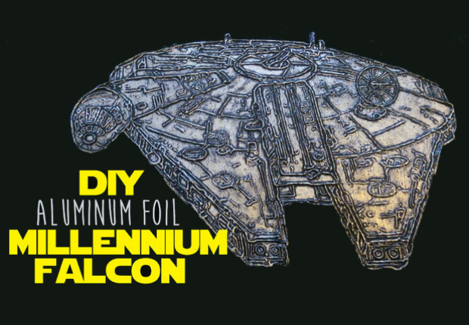
Image Credit: via Instructables.com
Who says aluminum foil can't be a toy? Check out this Instructable for turning a basic coloring-book image of the Star Wars Millennium Falcon into a piece of foil-relief art. Essentially, you glue an image of the space ship onto a piece of cardboard and trace its lines with tacky glue. Wrap the whole thing in foil and rub the foil into the space around the glue to create a shiny Millennium Falcon that pops.

15. Anti-bug mulch
Reflective mulch can help keep invading insects away from your vegetable garden. Cover pieces of cardboard with aluminum foil. Cut 4-inch diameter holes and plant seeds inside, or simply lay the aluminum foil between planter beds and bury their edges in soil. One study [PDF] associated aluminum foil mulch with a 96 percent reduction in aphids over a growing season.

BONUS: Anti-alien helmet

Never forget the most tried-and-true uses for foil: to keep aliens out of your head. Instructions: Wrap foil into a skullcap. Place on head. Wear until the threat of alien invasion passes. (Or you could just accept the inevitable: These caps probably wouldn't actually stop aliens.)

Garden and Gun
Adventures: Flight Pattern
by Beth Ann Fennelly

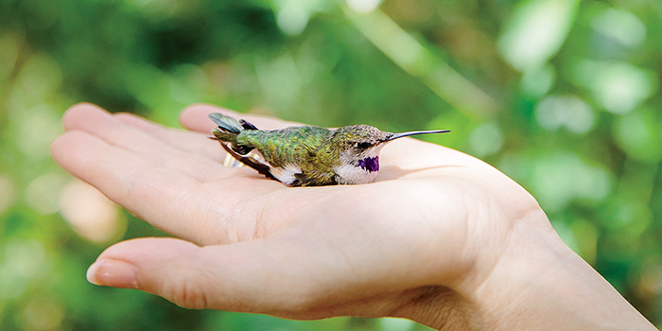
Where do they go? It’s what every Southern gardener wonders at some point after the ruby-throated hummingbirds disappear. These “glittering garments of the rainbow,” as John James Audubon called them, delight us all summer not only with their beauty, but also with their antics. They’re better than daytime drama. They are the bold and the beautiful, the young and the restless. Despite their appearance on genteel needlepoint pillows, they are not genteel. Despite eating sugar water, they are not sweet. At home in Oxford, Mississippi, I love to watch the dominant male who perches in our Bradford pear, hidden among the leaves, waiting for another hummer to even think about sipping his nectar. Should one try, he zings after it and bullies it off, then loops back to his perch and resettles himself with a cartoonish fluffing of his throat gorget. But round about time the maples start to redden and Ole Miss has started conference play, I realize we haven’t seen him in a day or two. And the feeder activity is definitely lighter. Then, a week later, the hummers have disappeared entirely. Long after the last sugar water has been dumped and the feeders washed and stored, the question remains. Where do they go?
As it turns out, they go exactly where many of us would go: due south for the winter. In late summer, the rubythroats start drifting down through North America, and when they reach the Gulf states, they linger. They gorge until they’ve doubled their weight, to roughly a nickel’s worth. Then they lift off one evening and fly through the night without stopping, a trip of five hundred miles, to winter in Mexico and Central America. Their migratory route appears to be hardwired into the genetic codes packed inside their BB-size brains.
It’s hard to believe, and for a long time people simply didn’t—hence the myth that hummers hitch rides on the backs of geese. After all, there was little evidence to prove migration. Although hummingbirds were first written about in 1558 by a French colonist in Brazil, our knowledge of them is full of holes. Hummers have left few fossils, so their evolution is largely conjectural. Taxonomists find them difficult to classify. Because they’re so fast—they have the most rapid wing beat of all birds and can fly sixty miles per hour during courtship dives—they’re hard to photograph. Because they’re so lightweight—you could mail eight of them for the price of a first-class stamp—they can’t wear tracking devices. Their wintering-ground behavior is unknown to us. The ornithologists of Central America are, quite naturally, more interested in their unique Central American birds than in half-year, fly-by-night migrants.
But Bill Hilton Jr. is very interested. He’s the executive director of Hilton Pond Center for Piedmont Natural History—“the world’s longest name for the smallest nature center,” he says, of basically his backyard pond and surrounding eleven acres in York, South Carolina. Hilton—trim, bespectacled, punctual, a former high school and college science teacher—is one of about two hundred licensed hummingbird banders in the United States. He’s also one of the “50 Best Brains in Science,” according to Discover magazine. He began banding rubythroats at Hilton Pond thirty-one years ago, and he’s banded more than 5,000 there since. Like the rest of us, he wondered where they disappear to. Unlike the rest of us, he made it his life’s mission to find out.
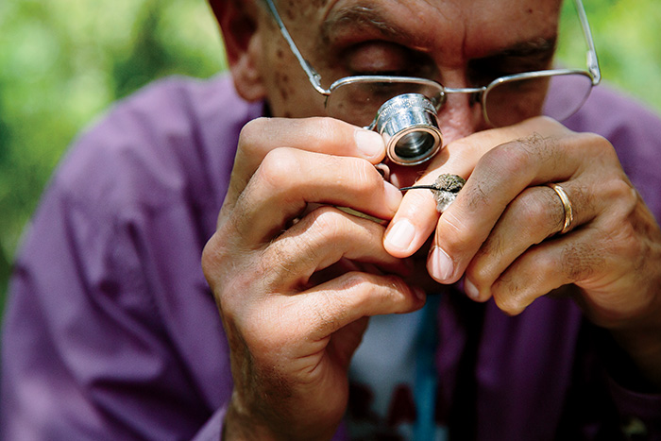
Thus began Operation RubyThroat. Prior to Hilton’s first trip in 2004, to Costa Rica, just 46 hummers had been banded in the Neotropics. Ten years and twenty-five trips later, Operation RubyThroat has banded 1,248 hummers. Every bird banded adds to the sum total of knowledge, which Hilton says “might make the difference in helping hummingbirds survive the onslaught of human development on both ends of their migratory path.” Hilton definitively established South–North spring migration when a hummer he’d banded in Costa Rica turned up in Baxley, Georgia. Now he’s determined to prove North–South fall migration. To do so, he needs to catch in the tropics a hummingbird previously banded in North America. A needle in a haystack? I think of the needle bill of the rubythroat and its huge territory, and know that Hilton’s chances are much slimmer.
But I like long shots. I scrolled through the upcoming banding trips on Hilton’s website and signed away my spring break to follow the hummingbirds to Belize.
The first thing that became clear is that rubythroats are superior travelers—they carry no baggage beyond the blister-like fat deposit on their chests that they draw down as they make the eighteen-to-twenty-four-hour flight, and they fly direct (no layover in Atlanta—so it is possible, after all!). We—the other thirteen “citizen scientists” and I—arrived via less elegant means, congregating at the Belize City airport. We were not yet “The Un-Belizeables”—every group earns a nickname—but a rather tetchy ragtag assortment, a handful of college students and their biology professor, some retirees, not so many in the middle.
We set off for the interior in the big van provided by our lodge, Bird’s Eye View, and soon learned another lesson about rubythroats: They’re wise to migrate to Belize. It’s delightful for human migrants as well—no jet lag, English the national language, and both Belize and U.S. dollars accepted everywhere. The country is the size of Massachusetts, with a population that fits in a single phone book. Located beneath Mexico, Belize leans its right shoulder into the Caribbean, bathing in warm-watered, flip-flopped, “yah mon” breezes. Its other shoulder is shaded by jungle, growing denser as one approaches Guatemala. It’s amazing how quickly sand-in-the-high-thread-count-sheets becomes mosquito-netted-bunks in the Central American rain forest. Somewhere between the two is the wetlands, where a huge lagoon surrounds an inland island, Crooked Tree Village, now a wildlife sanctuary and home to our lodge. Most of Crooked Tree’s thousand residents make their income from the cashews, which grow on thirty-foot-high trees that bloom in March with clusters of small pink nectar-dense flowers. The hummers find them delicious, so that’s where we were headed.
Our first day of banding, we were awakened before dawn and vanned to the site, where we walked among the trees and established net lanes, sometimes with the aid of a machete.Then we broke off into pairs to hammer stakes into the ground and plant tall metal poles with nets stretched between them. They looked like badminton nets, if badminton nets stretched to the ground, and if the object of the game wasn’t to hit over the net but into it, and if the birdies were, well, birdies. Then we withdrew beneath the canopy to begin our stakeouts.
It was not an unpleasant way to spend a morning, sitting on a field stool in the shade under the sweet-smelling cashews. Binoculars in hand, we listened to overlapping bird calls, so many they strafed the atmosphere in layers, the cussing of the catbird, the squeaky bicycle wheel of the black-and-white warbler, the tropical mockingbird mimicking the warbler. That it was pleasant might surprise a few. That it was dramatic might surprise more. The bird-loud symphony would be penetrated by a shout—“Bird! Bird, net six!”—galvanizing the troops. One net watcher would extract the bird, and the other would log the time, the net number, and the region of the net in which the bird had landed. Then the bird would be popped into a mesh bag to be carried to the banding table. “A lingerie bag?” I’d asked the first day. “If it’s good enough for Victoria’s secrets, it’s good enough for Mother Nature’s,” Hilton said. At the table, he presided like a god, or a surgeon, or a surgeon working on a tiny god, which, in a way, he was. The table was laid out with instruments, and on either side of Hilton an Un-Belizeable logged the statistics. With a dial caliper, Hilton measured the first rubythroat’s bill length (18.5 millimeters) and wing chord (44.2 millimeters). He slid the hummer into a paper tube to immobilize it and then weighed it (3.37 grams). He measured the tail and level of feather molt and zeroed in on the bird’s age. He blew onto its chest—this ruffling of feathers allowed him to evaluate the fat deposit. Then he guessed the bird to be a female based on its white throat and size—females are usually a little bigger than males—but he spread the wing to be sure. Immature males don’t have the red gorget until their first winter, so a bander sexes the birds by looking at the tip of the number-six primary feather—rounded in females, pointed in males. Bingo. His scribe wrote “female” in the log.
Meanwhile, Hilton cut off a minuscule piece of aluminum, photoengraved with a serial number, from his banding sheet. Looking through a jeweler’s loupe, he squeezed his pliers to clamp the tiny metal strip over the hummer’s leg. The band is so small it fits over Lincoln’s eye on a penny, the weight comparable to a wristwatch on a human. He slid the banded bird from the tube and gave its chest a dab with purple marker so that if we saw it in the net again we wouldn’t re-bag it. Then he allowed one of us the honor of releasing the bird. “Fly to Hilton Pond,” Hilton would shout after it, only half kidding. If one obeys, and he manages to recapture it, he’d extend the claims we can make about hummer migration. But anyone could help extend these claims; anyone could find the bird and report its number to the federal Bird Banding Laboratory in Maryland, though spotting the band isn’t easy, especially because hummers fly with their legs tucked. Still, it could happen. That guy in Baxley, Georgia, for example—an employee of a car dealership. He’d found a clump of cobwebs on the floor, inside of which was a dying hummingbird (presumably, the hummer flew into the truck bay, got trapped, and darted around the rafters until its wings were glued with webs). While trying to free the bird, the manager noticed its tiny bracelet. Puzzled, he called his local game warden, who made a call to someone, who made another call, and eventually the band was traced back to Hilton, that very small band on that very small bird becoming the first-ever proof of migration.
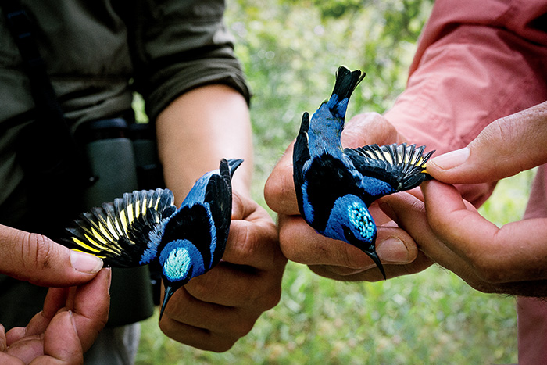
We never did recapture a rubythroat previously banded in North America, though we banded many, and caught plenty of other astonishing birds, too—twenty-one species, to be exact. Whenever Hilton drew a new one from the lingerie bag, he’d hold it aloft and wait for us to flip madly through our field guides. Everyone wanted to be the first to identify, to sing out “Red-legged honeycreeper!” Native nonmigrants were admired and then paroled—a little like catch-and-release fishing, if almost every fish you pulled out of the water was a different spectacularly colored species than the last. But any species that migrated received jewelry before parole. A few times, when Hilton extended a bird’s leg, it already wore some. If the band was shiny, we knew we’d caught the bird that week. If the anklet was tarnished, the bird was a precious recapture. We netted a yellow-breasted chat Hilton had banded in 2011 and recaptured every year since at this same four-acre cashew woodlot, “remarkable evidence of site fidelity,” he said, “and irrefutable evidence of the urgent need to protect even small pieces of habitat within the wintering range of these Neotropical species.” He looked off, and it wasn’t hard to imagine him worrying about the FOR SALE sign stabbed at the edge of the lot. In 2011, the aloe vera fields of Guanacaste, Costa Rica, were plowed down, and the seven years of Operation RubyThroat’s site fidelity study there macheted just as thoroughly.
But like any good scientist, Hilton focused on the here and now, the bird in the hand, in this case a hatch-year male rubythroat just starting to earn its red sequins. Hilton selected me to release it. “Fly to Hilton Pond,” he called out, then turned, ready for the next bag. The bird was still sitting in my palm. “And visit Oxford, Mississippi, on the way,” I whispered. Still it lingered—one Mississippi, two Mississippi—and then, faster than should be possible, zinged away, flying north.











