April 19, 2015

We are early because the debate contained herein amongst our friends, about global warming and the reasons for it, is hard to take all at once, so this will give everyone a chance to go back to it a few times before the next Pickings is posted Sunday night or Monday morning.

Ron Bailey of Reason Magazine, the house organ of the libertarian movement, posts on his growing belief that there is some human cause to the increase in temperatures.
In 2005, I changed my mind about climate change: I concluded that the balance of the scientific evidence showed that man-made global warming could likely pose a significant problem for humanity by the end of this century. My new assessment did not please a number of my friends, some of whom made their disappointment clear.
At the 2007 annual gala dinner of the Competitive Enterprise Institute, a D.C.-based free-market think tank, the master of ceremonies was former National Review editor John O'Sullivan. To entertain the crowd, O'Sullivan put together a counterfeit tale in which I ostensibly had given a lecture on environmental trends pointing out that most were positive. After my talk, O'Sullivan told the audience, a young woman supposedly approached me to express her displeasure with regard to my change of mind on climate change.
Continuing his fable, O'Sullivan recounted to the hundreds of diners that I had tried to explain why my views had shifted. Eventually realizing that the young woman was having none of it, I then purportedly asked her if it wasn't enough that we two actually agreed on most environmental policy issues. The young woman paused for a moment, said O'Sullivan, and then retorted, "I suppose that Pontius Pilate made some good decisions, too." Being compared, even in jest, to the Roman governor who consented to the crucifixion of Jesus is, to say the least, somewhat disconcerting.
Welcome to the most politicized science of our time. ...

Jonathan Adler, law prof at Case Western, posts in Volokh Conspiracy about his arrival at the same beliefs.
When it comes to climate change, there is an amazing confluence of policy preferences and scientific assessments. Those who generally favor aggressive regulatory interventions to address environmental concerns are convinced global warming is a serious (if not catastrophic) environmental concern, while those who generally oppose governmental interventions in the marketplace are skeptical of mainstream climate science. Each side of the policy debate has adopted a view of the science that confirms — or at least conforms with — its policy preferences.
It would be nice if reality lined up just so, but that’s not the world in which we live. As I wrote in 2008:
"Given my strong libertarian leanings, it would certainly be ideologically convenient if the evidence for a human contribution to climate change were less strong. Alas, I believe the preponderance of evidence strongly supports the claim that anthropogenic emissions are having an effect on the global climate, and that effect will increase as greenhouse gases accumulate in the atmosphere. While I reject most apocalyptic scenarios as unfounded or unduly speculative, I am convinced that the human contribution to climate change will cause or exacerbate significant problems in at least some parts of the world. For instance, even a relatively modest warming over the coming decades is very likely to have a meaningful effect on the timing and distribution of precipitation and evaporation rates, which will, in turn, have a substantial impact on freshwater supplies. That we do not know with any precision the when, where, and how much does not change the fact that we are quite certain that such changes will occur."
Over at Reason, Ronald Bailey points out that the cumulative evidence in support of the basic proposition that human emissions of greenhouse gases are contributing to a gradual warming of the atmosphere is substantial — even if it is inconvenient for a libertarian to admit.

Next Ron Bailey linked to a couple of critics of his post.
Last week, I wrote an article asking, "What Evidence Would Persuade You That Man-Made Climate Change Is Real?" Let's just say that it provoked some readers a bit. Now some participants in the climate change science controversy are explaining how I misinterpret or misunderstand what is going on. For the convenience of Reason readers I link to a couple below. ...
... Folks, as I have said, my best judgment is that the preponderance of the evidence - not beyond a reasonable doubt - suggests that man-made global warming could become a significant problem later in this century. Given my ideological commitments I would much prefer (and do hope) to be wrong. As noted, I intend to monitor the predictions made by those who think warming will be rapid and dangerous. If they fail, believe me, I will happily report those failures. ...

The first answer came from Roy Spencer who is a climatologist and principal research scientist at U of Alabama at Huntsville.
I just found out that Ron Bailey at Reason.com published an article a few days ago entitled, “What Evidence Would Persuade You That Man-Made Climate Change Is Real?”
I’ve spent some time with Ron, and he is a very sharp guy. That’s why I’m a little disappointed that he would publish this mixture of straw man arguments and uncritical thinking. He is the only deep thinker I know of who switched from being a skeptic about the causes of global warming to a believer…an epiphany which occurred in 2005, according to the article. (Hmmm…I wonder if he was fooled by all those major hurricanes that hit the U.S. that year? It’s now almost 10 years later, and we haven’t had one since.)
The first problem I have is with his premise: that skeptics believe humans have no role in climate change. I don’t know of any serious skeptics who hold such a view. Now, maybe he is addressing people who deny any human involvement in global warming. His article is vague, and maybe he can clarify his intent for us.
The second problem I have is with Ron’s list of a variety of evidences of global-average warming, which (again) no skeptic worth their salt disputes. The science dispute is over how much of the warming is manmade versus natural. Like too many others, Ron conflates climate change with human-caused climate change, which are not the same thing. ...

Next up is Christopher Monckton who sometimes appeers to write as Lord Monckton. He goes into serious detail. He's the main reason it's hard to read this all at once.
“What Evidence,” asks Ronald Bailey’s headline (www.reason.com, April 3, 2015), “Would Convince You That Man-Made Climate Change Is Real?”
The answer: a rational, scientific case rooted in established theory and data would convince me that manmade climate change is a problem. That it is real is not in doubt, for every creature that breathes out emits CO2 and thus affects the climate.
The true scientific question, then, is not the fatuous question whether “Man-Made Climate Change Is Real” but how much global warming our sins of emission may cause, and whether that warming might be more a bad thing than a good thing.
However, Mr Bailey advances no rational case. What, then, are the elements of a rational, scientific case that our influence on the climate will prove dangerous unless the West completes its current self-shutdown?
Here is the mountain the tax-gobbling classes who tend to favor profitable alarmism must climb before they can make out a rational, scientific case for doing anything about our greenhouse-gas emissions. ...

Now here's where Monckton can light you up.
... Whether mitigation measures should be attempted in any event is an economic question, answered by investment appraisal. The UK’s $8333-per-auto subsidy for electric cars will serve as an example. The two initial conditions for the appraisal are the fraction of global CO2 emissions a mitigation measure is intended to abate, and the cost of the measure.
Typical gasoline-powered auto engines are approximately 27% efficient. Typical fossil-fueled generating stations are 50% efficient, transmission to end user is 67% efficient, battery charging is 90% efficient and the auto’s electric motor is 90% efficient, so that the fuel efficiency of an electric car is also 27%. However, the electric car requires 30% more power per mile traveled to move the mass of its batteries.
CO2 emissions from domestic transport account for 24% of UK CO2 emissions, and cars, vans, and taxis represent 90% of road transport (DfT, 2013). Assuming 80% of fuel use is by these autos, they account for 19.2% of UK CO2 emissions. Conversion to electric power, 61% of which is generated by fossil fuels in the UK, would abate 39% of 19.2% (i.e. 7.5%) of UK CO2 emissions.
However, the battery-weight penalty would be 30% of 19.2% of 61%: i.e. 3.5% of UK CO2 emissions. The net saving from converting all UK cars, vans, and taxis to electricity, therefore, would be 4% of UK CO2 emissions, which are 1.72% of global CO2 emissions, abating 0.07% of global CO2 emissions of 2 μatm yr^{–1}, or 0.00138 μatm. From eqn. (2), assuming 400 μatm concentration at year end on business as usual, forcing abated by the subsidy for converting all UK cars to electricity would be 5.35 ln[400/(400-0.00138)], or 0.00002 W m^{–2}, which, multiplied by the Planck parameter λ₀, gives 0.000006 K warming abated by the subsidy.
The cost to the UK taxpayer of subsidizing the 30,000 electric cars, vans, and taxis bought in 2012 was a flat-rate subsidy of $8333 (£5000) for each vehicle and a further subsidy of about $350 (£210) per year in vehicle excise tax remitted, a total of $260.5 million. On that basis, the cost of subsidizing all 2,250,000 new autos sold each year (SMMT, 2013), would be $19.54 bn. ...
Monckton is a show-off.

Last today is Robert Tracinski who writes often for The Federalist. He closes with this;
... Given the abysmal record of climate forecasting, we should tell the warmists to go back and make a new set of predictions, then come back to us in 20 or 30 years and tell us how these predictions panned out. Then we’ll talk.
Ah, but we’re not going to be allowed to wait. And that’s one of the things that is deeply unscientific about the global warming hysteria. The climate is a subject which, by its nature, requires detailed study of events that take many decades to unfold. It is a field in which the only way to gain knowledge is through extreme patience: gather painstaking, accurate data over a period of centuries, chug away at making predictions, figure out 20 years later that they failed, try to discover why they failed, then start over with a new set of predictions and wait another 20 years. It’s the kind of field where a conscientious professional plugs away so maybe in some future century those who follow after him will finally be able to figure it all out.
Yet this is the field that has suddenly been imbued with the Fierce Urgency of Now. We have to know now what the climate will do over the next 100 years, we have to decide now, we have to act now. So every rule of good science gets trampled down in the stampede. Which also explains the partisan gap on this issue, because we all know which side of the political debate stands to benefit from the stampede. And it’s not the right.
So yes, I know exactly what it would take to convince me that catastrophic anthropogenic global warming is really happening. And no, the warmists haven’t even come close.

Reason
What Evidence Would Persuade You That Man-Made Climate Change Is Real?
Scientific evidence does not mandate any particular policy.
by Ronald Bailey

In 2005, I changed my mind about climate change: I concluded that the balance of the scientific evidence showed that man-made global warming could likely pose a significant problem for humanity by the end of this century. My new assessment did not please a number of my friends, some of whom made their disappointment clear.
At the 2007 annual gala dinner of the Competitive Enterprise Institute, a D.C.-based free-market think tank, the master of ceremonies was former National Review editor John O'Sullivan. To entertain the crowd, O'Sullivan put together a counterfeit tale in which I ostensibly had given a lecture on environmental trends pointing out that most were positive. After my talk, O'Sullivan told the audience, a young woman supposedly approached me to express her displeasure with regard to my change of mind on climate change.
Continuing his fable, O'Sullivan recounted to the hundreds of diners that I had tried to explain why my views had shifted. Eventually realizing that the young woman was having none of it, I then purportedly asked her if it wasn't enough that we two actually agreed on most environmental policy issues. The young woman paused for a moment, said O'Sullivan, and then retorted, "I suppose that Pontius Pilate made some good decisions, too." Being compared, even in jest, to the Roman governor who consented to the crucifixion of Jesus is, to say the least, somewhat disconcerting.
Welcome to the most politicized science of our time.
So what evidence would convince you that man-made climate change is possibly real? Keep in mind that despite what progressive dimwits like Naomi Klein might assert, the scientific evidence does not mandate any particular program.
What about higher temperatures? Obviously, in order for there to be any man-made global warming, temperatures must be going up. Are they? Yes.
Concentrations of greenhouse gases in the atmosphere have increased from 280 parts per million in the late 18th century to around 400 ppm today. And the trend in average global surface temperatures has been increasing since the late 19th century. As I've reported before, all of the global temperature datasets, both the instrumental and satellite, find that the atmosphere has warmed since the 1950s.
By how much? Summed over the past 35 years—that is, since the advent of satellite monitoring—temperatures have increased by at most 0.56 C° (1 F°) and at least by 0.455 C° (0.8 F°). In general, the instrumental records suggest that surface temperatures have warmed on average by about +0.9 C° (1.6 F°) since the 1950s.
Let's look at the near-term trends. The average rate of increase since 1979 varies among the temperature datasets from a high of +0.16 C° to a low of +0.13 C° per decade. The rate of surface temperature increase dramatically slowed after 1998 to rate of around +0.05 C° per decade. Of course, correlation does not imply causation, but how sure can you be that the rise in the atmospheric concentration of greenhouse gases just happens to coincide with an entirely natural increase in average temperatures? Conversely, how sure can you be that a natural decline in average temperatures is not temporarily countering a trend toward to higher temperatures caused by accumulating greenhouse gases? Explanations based on natural variability work both ways. I will address the recent “hiatus” in temperature trends below.
What about converging daytime and nighttime temperatures?
Climatologists predicted that man-made warming would produce a decrease in the differences between low nighttime temperatures and high daytime temperatures. And indeed, a decrease between day and night temperatures has been occurring in the United States, China, Spain, and other regions. This phenomenon is global, although more recently daytime and nighttime temperatures have been increasing at about the same rate. Along with the observed increases in average temperature, heat waves have become more common since the 1950s.
What about earlier spring and later fall seasons?
Many studies find that the onset of spring is occurring earlier than it did decades ago. A 2015 study reports that the advent of spring in the Northern Hemisphere occurs about 4 days earlier than in 1980. A 2006 European study found that spring is arriving about 3 days earlier, and a 2014 study reported that the growing season in the Northern Hemisphere is expanding.
Part of the reason that spring is advancing is that the extent of snow cover in March and April in the Northern Hemisphere has been falling. As a 2011 study in the journal Cryosphere reports, "The rate of decrease in March and April Northern Hemisphere (NH) Snow Cover Extent (SCE) over the 1970–2010 period is ~0.8 million km² per decade corresponding to a 7% and 11% decrease in NH March and April SCE respectively from pre-1970 values." The decline in snow cover is broadly in line with climate model predictions.
What about disappearing glaciers and Arctic sea ice?
The Arctic-wide melt season has lengthened at a rate of 5 days per decade from 1979 to 2013, according to a 2014 study in Geophysical Research Letters. A 2014 review article looks at what satellite data are telling us about recent climate trends in the Arctic. Temperatures are rising at 0.6°C per decade, about 4 times the global average. Sea ice extent has been falling at 3.8 percent per decade, and spring snow cover is dropping by 2.1 percent per decade. The Greenland ice sheet has been losing mass at a rate of 34 gigatons per year, though that has increased sevenfold since 2002 to an estimated 215 gigatons per year.
Ice is not melting only in the Arctic. Most of the world's 130,000 mountain glaciers are also disappearing.
The growing extent of sea ice in the Antarctic over the past decades is a climate change conundrum. On the face of it, more sea ice would indicate cooling rather than warming. Researchers are still trying to figure out what is going on. One idea is that warmer waters are melting the bases of freshwater Antarctic ice shelves. The fresh water then cools the sea surface thus promoting the freezing of more sea ice. When climate researchers don't understand what is going on they often attribute the empirical trends to "internal variability."

Volokh Conspiracy
What does it take to convince libertarians and conservatives that climate change is a problem?
Jonathan H. Adler
When it comes to climate change, there is an amazing confluence of policy preferences and scientific assessments. Those who generally favor aggressive regulatory interventions to address environmental concerns are convinced global warming is a serious (if not catastrophic) environmental concern, while those who generally oppose governmental interventions in the marketplace are skeptical of mainstream climate science. Each side of the policy debate has adopted a view of the science that confirms — or at least conforms with — its policy preferences.
It would be nice if reality lined up just so, but that’s not the world in which we live. As I wrote in 2008:
Given my strong libertarian leanings, it would certainly be ideologically convenient if the evidence for a human contribution to climate change were less strong. Alas, I believe the preponderance of evidence strongly supports the claim that anthropogenic emissions are having an effect on the global climate, and that effect will increase as greenhouse gases accumulate in the atmosphere. While I reject most apocalyptic scenarios as unfounded or unduly speculative, I am convinced that the human contribution to climate change will cause or exacerbate significant problems in at least some parts of the world. For instance, even a relatively modest warming over the coming decades is very likely to have a meaningful effect on the timing and distribution of precipitation and evaporation rates, which will, in turn, have a substantial impact on freshwater supplies. That we do not know with any precision the when, where, and how much does not change the fact that we are quite certain that such changes will occur.
Over at Reason, Ronald Bailey points out that the cumulative evidence in support of the basic proposition that human emissions of greenhouse gases are contributing to a gradual warming of the atmosphere is substantial — even if it is inconvenient for a libertarian to admit. He reaches this conclusion without relying upon the conclusions drawn by computer models or contested studies, such as Michael Mann’s infamous “Hockey Stick.” That is, even ignoring such studies, the evidence is quite strong. Writes Bailey:
It might be that it … just so happens that natural climate variability has boosted global temperatures and the trends discussed above are occurring coincidentally at the same time the concentrations of carbon dioxide are 30 percent above their highest levels in the past 800,000 years. Correlation does not imply causation. The data cited (and uncited) do not prove beyond a reasonable doubt that man-made climate change is real. However, in my best judgment the preponderance of the evidence suggests that the greenhouse gases produced by humanity are warming the climate and that it could be a significant issue later in this century.
As I’ve written elsewhere, it’s long past time that self-professed libertarians and others on the political right consider climate change to be a serious problem. (See also here.) The Niskanen Center’s Jerry Taylor makes a similar point here. Alas, many libertarians and conservatives reject evidence of humanity’ effect on the global climate system for fear such evidence will be used to justify climate policies libertarians and conservatives rightly dislike.
The right’s general posture on climate science leads Bailey to quote F.A. Hayek’s seminal essay, “Why I Am Not a Conservative”:
Personally, I find that the most objectionable feature of the conservative attitude is its propensity to reject well-substantiated new knowledge because it dislikes some of the consequences which seem to follow from it—or, to put it bluntly, its obscurantism. I will not deny that scientists as much as others are given to fads and fashions and that we have much reason to be cautious in accepting the conclusions that they draw from their latest theories. But the reasons for our reluctance must be rational and must be kept separate from our regret that the new theories upset our cherished beliefs.
More Bailey:
To restate: The existence of man-made warming does not mandate any particular policies. So back to the headline question: If generally rising temperatures, decreasing diurnal temperature differences, melting glacial and sea ice, smaller snow extent, stronger rainstorms, and warming oceans are not enough to persuade you that man-made climate is occurring, what evidence would be?
It is a question worth answering.
UPDATE: Additional thoughts from Ronald Bailey and Jerry Taylor.

Reason
Ronald Bailey Refuted On Evidence for Man-Made Climate Change?
Roy Spencer and Christopher Monckton school me on climate change
by Ronald Bailey
Last week, I wrote an article asking, "What Evidence Would Persuade You That Man-Made Climate Change Is Real?" Let's just say that it provoked some readers a bit. Now some participants in the climate change science controversy are explaining how I misinterpret or misunderstand what is going on. For the convenience of Reason readers I link to a couple below.
University of Alabama in Huntsville climatologist Roy Spencer posted his response in, "Answering Ron Bailey's Question" earlier this week. I briefly respond in the comment section to Spencer. I will mention that I intend to hold those predicting rapid warming to their prognostications:
...with regard to the falsifiable predictions I cite – I intend to hold them to it, e.g., if global average temperature is not rising at a rate +0.25 per decade by 2020 that will strongly tend to discredit the more catastrophic projections of future warming.
I do ask:
I am curious – if GMT does begin a sustained rapid ascent in the next few years such that the long term trends projected in the models begin to look plausible – how would that bear on your views about man-made contributions to climate change?
Next comes Christopher Monckton over at Watts Up With That with his response "How to Convince a Climate Skeptic that He Is Wrong."
First, Monckton is against the "tax gobblers" - by which he means those who want to use a "climate crisis" to justify the expansion of government. We agree. Please note that I began by stating in the subhead of my article: "Scientific evidence does not mandate any particular policy." Let's say it again: Progressives are flat out wrong when they try to claim that man-made warming necessarily implies adopting their preferred economic policies. That was one of the main points I was trying to make in my article.
In one response Monckton asks:
Is CO2 concentration rising to dangerous new levels?
No. Mr Bailey says CO2 concentration is 30% higher than the 800,000-year peak. So what?
Again, there are no definitive answers, but a new study in Nature Climate Change, "Causal Feedbacks in Climate Change" reports that the researchers ...
...demonstrate directly from ice-core data that, over glacial–interglacial timescales, climate dynamics are largely driven by internal Earth system mechanisms, including a marked positive feedback effect from temperature variability on greenhouse-gas concentrations.
Whether or not such increases will become "dangerous" depends upon how high climate sensitivity, the temperature response to doubling atmospheric carbon dioxide, turns out to be. An issue that I have pointed out is still unsettled science.
Monckton even mocks me from being wrong about the number of glaciers:
Actually there are more than 160,000 of them and nearly all of them are in Antarctica...
He could have clicked on the article from which I derived (and rounded) the figure to which I linked:
The World Glacier Inventory (WGI) which has extensive metadata on 132,000 glaciers and ice caps (WGMS and NSIDC, 2012). I also use the Global Land Ice Monitoring from Space (GLIMS) database which has glacier outlines and some metadata for 96,000 glaciers and ice caps (Armstrong et al., 2012). Finally, I use the newly compiled Randolph Glacier Inventory v2 (RGI) which contains, primarily, 170,000 glacier outlines with little additional metadata for each record.
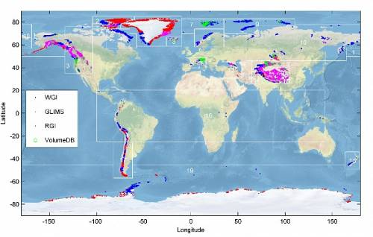
Map of glaciers from article above.
Folks, as I have said, my best judgment is that the preponderance of the evidence - not beyond a reasonable doubt - suggests that man-made global warming could become a significant problem later in this century. Given my ideological commitments I would much prefer (and do hope) to be wrong. As noted, I intend to monitor the predictions made by those who think warming will be rapid and dangerous. If they fail, believe me, I will happily report those failures.
In any case, I link to these two responses as a reader service as a convenience for those interested in this discussion.

Roy Spencer's Blog
Answering Ron Bailey’s Question: “What Evidence Would Persuade You That Man-Made Climate Change Is Real?”
by Roy W. Spencer, Ph. D.
I just found out that Ron Bailey at Reason.com published an article a few days ago entitled, “What Evidence Would Persuade You That Man-Made Climate Change Is Real?”
I’ve spent some time with Ron, and he is a very sharp guy. That’s why I’m a little disappointed that he would publish this mixture of straw man arguments and uncritical thinking. He is the only deep thinker I know of who switched from being a skeptic about the causes of global warming to a believer…an epiphany which occurred in 2005, according to the article. (Hmmm…I wonder if he was fooled by all those major hurricanes that hit the U.S. that year? It’s now almost 10 years later, and we haven’t had one since.)
The first problem I have is with his premise: that skeptics believe humans have no role in climate change. I don’t know of any serious skeptics who hold such a view. Now, maybe he is addressing people who deny any human involvement in global warming. His article is vague, and maybe he can clarify his intent for us.
The second problem I have is with Ron’s list of a variety of evidences of global-average warming, which (again) no skeptic worth their salt disputes. The science dispute is over how much of the warming is manmade versus natural. Like too many others, Ron conflates climate change with human-caused climate change, which are not the same thing.
Regarding his list, he seems to believe they are independent evidences of manmade warming. Wrong. To the extent warming occurs, even if it is entirely natural, warming would occur in the atmosphere and deep ocean; it would cause an increase in atmospheric water vapor, as well as precipitation; the warming would be stronger in the upper troposphere than the lower troposphere; and stronger over land than over the ocean.
These things would all occur together anyway, no matter the cause of the warming, Ron. And causation is, indeed, the question which science so far cannot answer.
Since climate models cannot even hindcast what has happened (let alone forecast), they clearly have no handle on multi-decadal temperature changes brought about by natural effects. There does not even need to be any forcing — e.g. the sun, volcanoes, etc. — in order for climate to change because the ocean-atmosphere system is nonlinear and dynamical — in a word, chaotic. It can change all by itself. For example, it this plot we see that global warming (and cooling) has been the rule, not the exception, for the last 2,000 years:
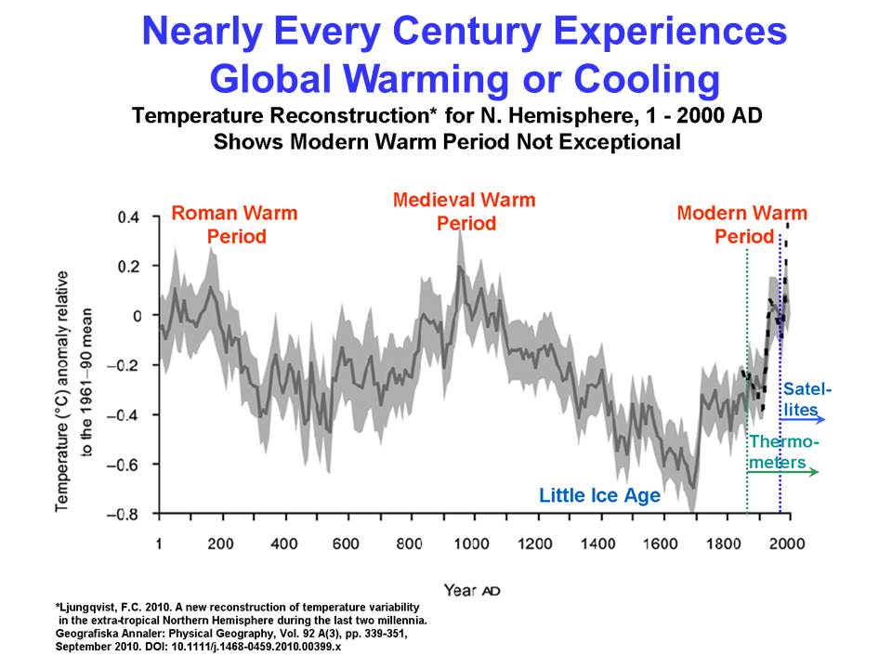
If the above graph is anywhere close to what has actually happened, then most centuries have experienced global warming or cooling. So, what would it take to predict global warming (along with all of the correlated changes, listed above) due to any cause you’d like to invoke?
Basically, all it takes is a flip of a coin.
If you wonder, how could so many scientists be wrong? Well, the medical community had millions of peptic ulcers to study, and it took decades (and two brave Australian researchers) to finally convince them of a bacterial basis for ulcers.
The Earth, in contrast, is a single subject, and we can’t easily or quickly test its response to various treatments. It would be very easy for group think to dominate the scientific community, especially when continued funding depends on a continued climate crisis.
A third problem I have with Ron’s article: he uses “falsifiable predictions” of the future as evidence supporting his case! Really? Well, we’ve already had abundant predictions of what would happen by now from modelers like James Hansen that have turned out to be wrong. There you go, skeptics have real falsified predictions they can point to….not predictions of what might happen 10 years from now.
Why didn’t he mention the recent increase in papers (our APJAS paper included) with evidence that recent warming has been partly natural? Yes, as he says, natural variability can work both ways (warming OR cooling), but the available evidence is that recent warming was partly due to nature. Significantly, that warming occurred during the period when climate modelers developed their models, and since they assumed all warming was manmade, they had to increase the models’ sensitivity. Now, they are between a rock and a hard place, continuing to publish overly-sensitivity models they know are wrong (based upon both surface AND deep ocean warming rates).
Such a travesty would never be allowed in a hard discipline that uses physics, like engineering. An impartial judge with any cajones wouldn’t even allow climate models as evidence in a court of law since they have, so far, largely failed in their predictions.
Does Ron know that the deep-ocean warming since the 1950s is so weak (if it is even real from an observational error perspective) that it represents only a 1 part in 1,000 imbalance between incoming and outgoing energy? Do we really believe that chaotic changes in the circulations of the ocean and atmosphere cannot create such a tiny imbalance? The above graph (along with historical evidence of the Little Ice Age and Medieval Warm Period) suggests such small changes are fairly routine.
So, Ron asks what evidence would convince me that recent warm was manmade? Well, how about knowledge of how much natural climate change would have occurred without human influence? Then we would know the remainder was human-induced. Except, there is no way to know the natural component. If there was, climate models would have reasonably replicated the temperature changes since the 1950s rather than looking like a bowl of spaghetti.
And since I already believe manmade climate change (to some non-zero extent) is real, maybe I can ask Ron: What evidence would persuade you that your original question is nothing more than a straw man argument?
I hate to impute motives, but I really have to wonder if he is succumbing to peer pressure, since believing anything that smacks of denial-ism is really frowned upon in the intellectual circles I’m sure Ron is part of.
Yes, I believe that adding CO2 to the atmosphere has probably caused some warming, even though there is no way to prove it. Just how much human-caused warming is the question. And, as Ron correctly notes, it says nothing about what if anything should (or even can) be done about it anyway.
Roy Warren Spencer is a climatologist, Principal Research Scientist at the University of Alabama in Huntsville, and the U.S. Science Team leader for the Advanced Microwave Scanning Radiometer (AMSR-E) on NASA's Aqua satellite. He has served as Senior Scientist for Climate Studies at NASA's Marshall Space Flight Center

Watt's Up With That?
How to convince a climate skeptic he’s wrong
by Christopher Monckton of Brenchley

“What Evidence,” asks Ronald Bailey’s headline (www.reason.com, April 3, 2015), “Would Convince You That Man-Made Climate Change Is Real?”
The answer: a rational, scientific case rooted in established theory and data would convince me that manmade climate change is a problem. That it is real is not in doubt, for every creature that breathes out emits CO2 and thus affects the climate.
The true scientific question, then, is not the fatuous question whether “Man-Made Climate Change Is Real” but how much global warming our sins of emission may cause, and whether that warming might be more a bad thing than a good thing.
However, Mr Bailey advances no rational case. What, then, are the elements of a rational, scientific case that our influence on the climate will prove dangerous unless the West completes its current self-shutdown?
Here is the mountain the tax-gobbling classes who tend to favor profitable alarmism must climb before they can make out a rational, scientific case for doing anything about our greenhouse-gas emissions.
The tax-gobblers’ mighty mountain
Step 10. Would the benefit outweigh the cost?
Step 9. Can we afford the cost of CO2 mitigation?
Step 8. Will any realistic measures avert the danger?
Step 7. Will warmer worldwide weather be dangerous?
Step 6. Will temperature feedbacks amplify that warming?
Step 5. Will greenhouse-gas emissions cause much warming?
Step 4. Are humankind raising CO2 concentration substantially?
Step 3. Are humankind increasing atmospheric CO2 concentration?
Step 2. Is a consensus among climate experts compatible with science?
Step 1. Has any climate warming beyond natural variability taken place?
If the answer to the question at any Step from 1 to 10 on the stony path up the tax-gobblers’ mighty mountain is “No”, there is no rational, scientific basis for climbing any further. Unless one can legitimately reach the top by answering Yes to all ten questions, there is no credible justification for any investment of taxpayers’ funds in trying to make global warming go away.
The mountain that the tax-gobblers have to climb is tall, steep, and difficult. Every policy-maker must climb that mighty mountain, and none can justify shelling out a single red cent on thwarting Thermageddon until he shall have demonstrated, at each step, that there is rational, scientific justification for climbing above that step. Gird your loins, sharpen your crampons, and grip your cromach. Let us climb.
Step 1. Is global warming exceeding natural climate variability?
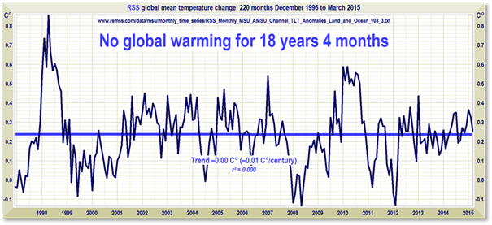
No.
Step 2. Is consensus among climate experts scientific?
No. And there isn’t one anyway. A recent paper by paid propagandists trying to prove that there was a consensus inadvertently proved that there was not. Cook et al. (2013) claimed that 97.1% of 11,944 papers on “global climate change” endorsed the consensus, which they defined in their introduction as the “scientific consensus” that “most current warming” is anthropogenic. However, setting aside the fact that there has been no “current warming” for getting on for two embarrassing decades, the authors’ own data file shows that they had marked only 64 papers out of 11,944, a dizzying 0.5%, as endorsing the “consensus”.
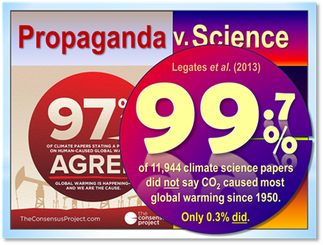
Step 3. Are we all guilty of increasing CO2 concentration?
No, not necessarily. True, our emissions of CO2 and its atmospheric concentration are rising, but anthropogenic CO2 represents only 3% of the total free CO2 in the Earth-atmosphere system. But in logic – it cannot be repeated often enough – mere correlation does not necessary imply causation.
Professor Murry Salby, late of Macquarie University, Australia, has established that it is the time-integral of temperature changes that causes changes in CO2 concentration, leaving little or no room for any detectable anthropogenic contribution. He is not alone in his findings. If he is right, there is no need to posit any role for CO2 or other anthropogenic influences. On that analysis, climate sensitivity may well be zero.
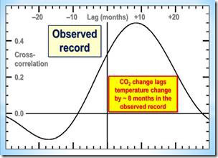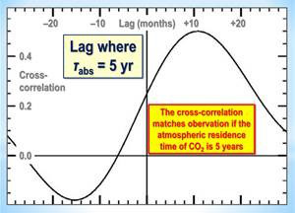
Cross-correlations by Professor Salby between CO2 change and temperature change. He has found by detailed inspection that the observed record shows CO2 concentration change lagging temperature change by about 8-10 months, approximately the lag that would be expected on the basis of an atmospheric residence time of about 5 years. It is a settled principle of logic that that which occurs second cannot have caused that which occurred first.
Step 4. Is CO2 concentration rising to dangerous new levels?
No. Mr Bailey says CO2 concentration is 30% higher than the 800,000-year peak. So what?
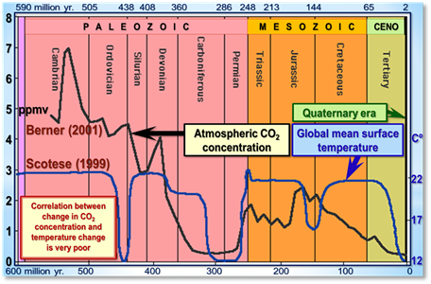
Step 5. Will greenhouse-gas emissions cause much warming?
No – and, on the evidence to date, certainly not as much as the IPCC predicted.
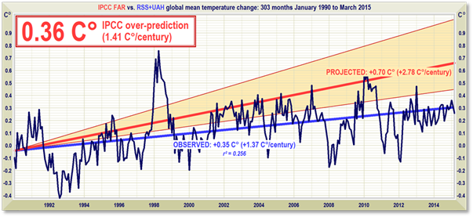
Near-term projections of warming at a rate equivalent to 2.8 [1.9, 4.2] K/century, made with “substantial confidence” in IPCC (1990), for the 303 months January 1990 to March 2015 (orange region and red trend line), vs. observed anomalies (dark blue) and trend (bright blue) at less than 1.4 K/century equivalent, taken as the mean of the RSS and UAH satellite monthly mean lower-troposphere temperature anomalies.
Step 6. Do temperature feedbacks amplify direct CO2 warming?
No. Measurements suggest feedbacks are negative, attenuating direct CO2 warming.
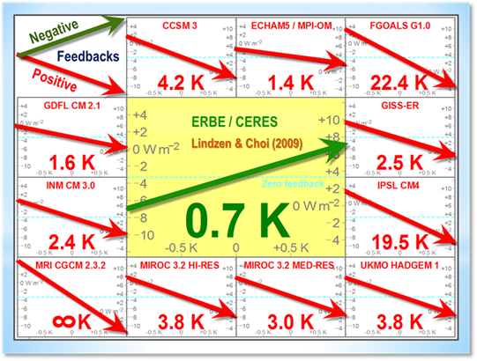
Furthermore, the range of mean global surface temperature change over the past 810,000 years was just 3.5 Cº either side of the long-run average – about the same as the range of temperatures permitted by an ordinary household thermostat. It is difficult to alter the Earth’s temperature, because the atmosphere is sandwiched between two vast heat-sinks: the oceans below and outer space above.
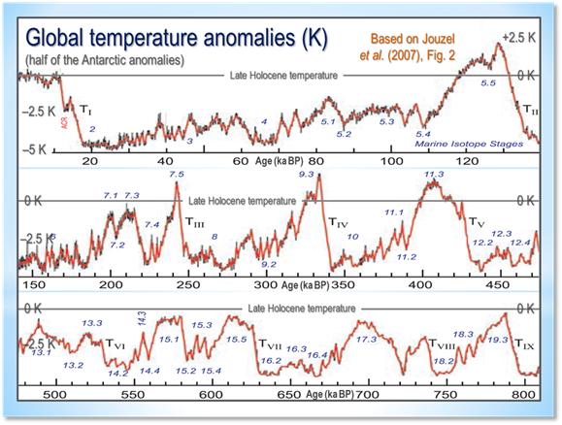
Global surface temperature change over the past 810,000 years, obtained by halving (to correct the result for polar amplification) the temperature anomalies inferred from atmospheric δ₁₈O ratios in ice cores from Vostok station, Antarctica. Absolute global temperature has varied by little more than ±1%.
Step 7. Will warmer worldwide weather be dangerous?
No. A growing body of papers in the literature finds climate sensitivity low – about 1 Cº per CO2 doubling. That is not enough to be harmful.
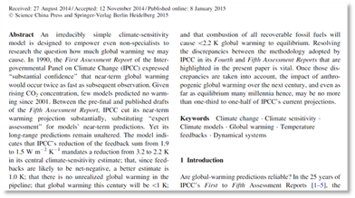
Steps 8-10. Will any realistic measures avert the danger?
No. Whether mitigation measures should be attempted in any event is an economic question, answered by investment appraisal. The UK’s $8333-per-auto subsidy for electric cars will serve as an example. The two initial conditions for the appraisal are the fraction of global CO2 emissions a mitigation measure is intended to abate, and the cost of the measure.

Going nowhere slowly: The Chevrolet Volt
Typical gasoline-powered auto engines are approximately 27% efficient. Typical fossil-fueled generating stations are 50% efficient, transmission to end user is 67% efficient, battery charging is 90% efficient and the auto’s electric motor is 90% efficient, so that the fuel efficiency of an electric car is also 27%. However, the electric car requires 30% more power per mile traveled to move the mass of its batteries.
CO2 emissions from domestic transport account for 24% of UK CO2 emissions, and cars, vans, and taxis represent 90% of road transport (DfT, 2013). Assuming 80% of fuel use is by these autos, they account for 19.2% of UK CO2 emissions. Conversion to electric power, 61% of which is generated by fossil fuels in the UK, would abate 39% of 19.2% (i.e. 7.5%) of UK CO2 emissions.
However, the battery-weight penalty would be 30% of 19.2% of 61%: i.e. 3.5% of UK CO2 emissions. The net saving from converting all UK cars, vans, and taxis to electricity, therefore, would be 4% of UK CO2 emissions, which are 1.72% of global CO2 emissions, abating 0.07% of global CO2 emissions of 2 μatm yr^{–1}, or 0.00138 μatm. From eqn. (2), assuming 400 μatm concentration at year end on business as usual, forcing abated by the subsidy for converting all UK cars to electricity would be 5.35 ln[400/(400-0.00138)], or 0.00002 W m^{–2}, which, multiplied by the Planck parameter λ₀, gives 0.000006 K warming abated by the subsidy.
The cost to the UK taxpayer of subsidizing the 30,000 electric cars, vans, and taxis bought in 2012 was a flat-rate subsidy of $8333 (£5000) for each vehicle and a further subsidy of about $350 (£210) per year in vehicle excise tax remitted, a total of $260.5 million. On that basis, the cost of subsidizing all 2,250,000 new autos sold each year (SMMT, 2013), would be $19.54 bn.
Though the longevity of electric autos is 50% greater than that of internal-combustion autos, the advantage is more than canceled by the very large cost of total battery replacement every few years. No allowance for this extra cost is made. Likewise, the considerable cost of using renewable energy to bring down the UK’s fossil-fueled generation fraction from the global mean 67% to 61% is not taken into account, though, strictly speaking, an appropriate share of the cost of “renewable” electricity generation should be assigned to electric vehicles.
Dividing the $19 bn annual cost by the warming abated gives a unit abatement cost of $3400 tn K^{–1}. Abating the 0.013 K projected warming by global methods of equivalent unit cost would thus cost $45 tn, or approaching $6500 a year per head of global population, or almost two-thirds of $71 tn global GDP.
Stern (2006) wrote that the cost of allowing the then-projected 3 K warming to occur over the 21st century would be 0-3% of global GDP. IPCC (2013, WGII) puts the cost at 0.2-2% of GDP. Assuming that 1 K 20th-century global warming would cost as much as 0.5% of GDP (in fact so small a warming would cost nothing), global mitigation by methods of equivalent unit cost to the UK’s subsidy program for electric vehicles would be 128 times costlier than adaptation.
In general, the cost of mitigation is 1-2 orders of magnitude greater than that of adaptation (Monckton of Brenchley, 2012). Affordable measures are ineffective: effective measures are unaffordable. Too little mitigation is achieved at far too great a cost. Since the premium is 10-100 times the cost of the risk insured, the precaution of insurance is not recommended.
Mr Bailey’s evidence
With that background, let us look at the evidence Mr Bailey adduces. He concedes that the warming rate since 1979 is 0.12-0.16 Cº decade (RSS and UAH respectively). But that is half of the rate predicted by the IPCC in 1990. He asks how we can be sure that the rise in greenhouse-gas concentration just happens to coincide with an entirely natural increase in mean temperature. But that is not what skeptics say. For it is possible that CO2 has contributed to the slight warming of the past 260 years, but it is not likely that CO2 is the major cause of the warming. Absence of correlation necessarily implies absence of causation, and the mismatch between the fluctuations in CO2 concentration change and temperature change demonstrates absence of correlation and hence of causation, at least in respect of the fluctuations.
Mr Bailey asks, “What about converging daytime and night-time temperatures?” That indicates two things: first, that there has been some warming, which is not denied; secondly, that the likelihood of severe storms outside the tropics is diminished, for it is temperature differentials, not absolute temperatures, that drive the intensity of storms. Sure enough, the IPCC admits in its 2013 report that there has been no increase in extra-tropical storminess (and none in tropical storminess, either).
Next, Mr Bailey cherry-picks a couple of months of the year and says that in those months northern-hemisphere snow cover is less by about a tenth than it was in the 1970s. Well, we had no means of measuring snow cover reliably till right at the end of the 70s; and besides, in the rest of the year there has been little, if any, decline in snow cover. Northern-hemisphere snow cover shows little change in the satellite era.
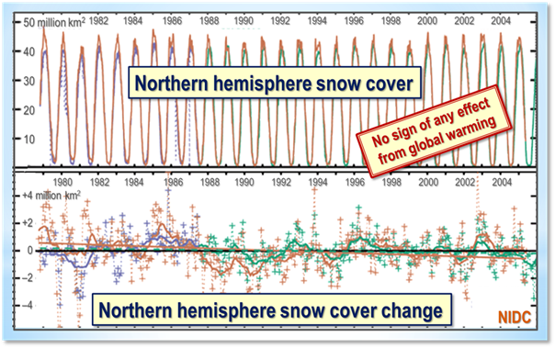
Next, Mr Bailey – who has certainly picked up all the talking-points – talks about Arctic and Antarctic sea ice, but without noticing that neither the extent nor the trend of global sea ice has changed much in the entire 35-year satellite record.
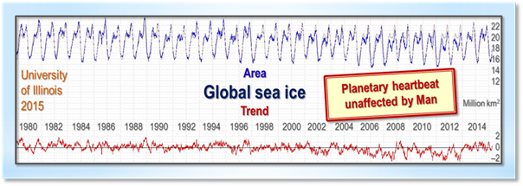
Next talking-point: Greenland, where Mr Bailey excitedly tells us the ice mass has been melting at 215 billion tons a year. However, he somehow fails to point out that the summit of the Greenland ice sheet was 2.5 Cº warmer than today a few thousand years ago, and the ice did not melt; and that from 1992-2003 a vast study area on the Greenland ice-sheet showed the ice growing at a rate of 2 feet per decade; and that even if we could measure accurately how much Greenland is gaining or losing ice 215 billion tons a year would cause an annual increase in sea level 0f – wait for drum-roll – half a millimeter.
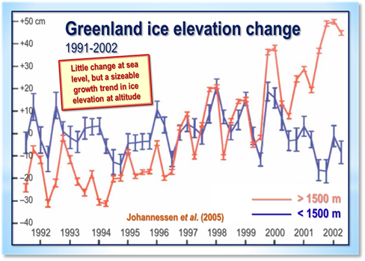
Next, Mr Bailey, still on message – just the wrong one – says “most of the world’s 130,000 mountain glaciers are also disappearing”. No, they’re not. Actually there are more than 160,000 of them and nearly all of them are in Antarctica, which has not warmed in the satellite era, so there is no particular reason for the glaciers to vanish, and they haven’t vanished. One of them is 40 miles wide and 250 miles long.
In those parts of the world where there has been some recession of mountain glaciers, such as the Alps, researchers are finding long-lost medieval forests, mountain passes and even an entire silver mine. Besides, the retreat of the mountain glaciers began in many places in 1880, long before we could have had any influence.
And there is evidence that all but the very highest peaks of the Cordillera de Merida in the Andes were ice-free thoughout most of the Holocene. They are not ice-free now.
Next, water vapor. Mr Bailey cites a couple of studies that say there has been some increase in column water vapor in the atmosphere since 1982. However, the ISCCP satellite data, probably the most accurate way of determining this tricky variable, do not show column water vapor increasing.
Mr Bailey has his science wrong here. He says, “As temperatures increase by 1 Celsius degree, global average water vapor in the atmosphere is expected to increase by around 7%. No, the carrying capacity of the space occupied by the atmosphere for water vapour is expected to increase by 7% per Celsius degree, in accordance with the Clausius-Clapeyron relation. Just because the atmosphere can carry more water vapor, that does not mean it will. The atmosphere is not 100% saturated.
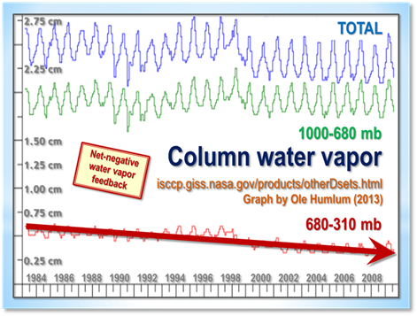
Then we are told precipitation is increasing. Well, the IPCC did not quite say that in its latest assessment report. It said confidence was high that precipitation had increased over northern-Hemisphere land areas since 1901, but that confidence in rainfall gains or losses elsewhere was low.
So let us look at the longest northern-Hemisphere mid-latitude rainfall record we have, to get some idea of how much the change in precipitation has been. Here goes.
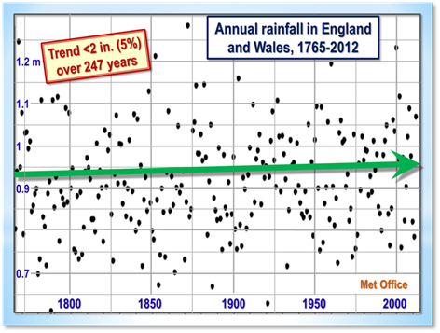
Less than two inches more rain per year after a quarter of a millennium. Not at all easy to distinguish that from natural variability.
Mr Bailey is no Pause Denier. He admits there has been little or no warming recently, and cites Roy Spencer’s analysis of 102 models that found they had all exaggerated the warming trend by a factor of 2-5. Yet he trots out the ClimComm talking-point about the “missing heat” having gone into hiding in the ocean.
So let us look at the rate of ocean warming, measured by the 3600+ ARGO automated bathythermograph buoys.
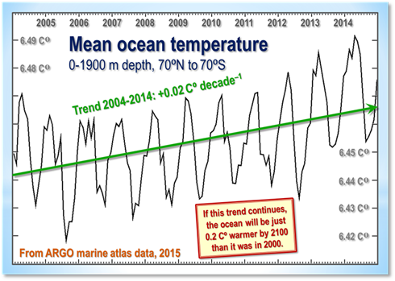
Much of Mr Bailey’s reasoning is based not on the observed data nor on theory but on predictions. For instance, he cites an article in Nature Climate Change, a less than reliable rent-seekers’ rag, predicting that the warming rate will rise to 0.25 Cº per decade by 2020. But the IPCC predicted short-term warming at 0.28 Cº per decade as far back as 1990, and the warming rate since then has been half what it predicted. Why should we now believe predictions that have proven exaggerated by double?
Mr Bailey says the main reason for his conversion to the Temple of Thermageddon is that some researchers think climate sensitivity to a doubling of CO2 concentration might be as high as 6 Celsius degrees. But the main reason for these high-sensitivity estimates was the belief that the Bode feedback-amplification equation would apply unmodified to the climate, and that in particular no homeostatic asymptote would bound the output temperature.
The graph of the Bode equation shows that if feedbacks are strongly net-positive the equation would lead us to expect rapidly increasing climate sensitivity. But it does not apply to the climate. Researchers had wandered into a field with which they were not familiar, and had made the huge mistake of assuming that an equation that represents the behavior of dynamical systems such as an electronic circuit is applicable unmodified and undamped to dynamical systems such as the climate. Well, it isn’t. And without it, high sensitivity vanishes.
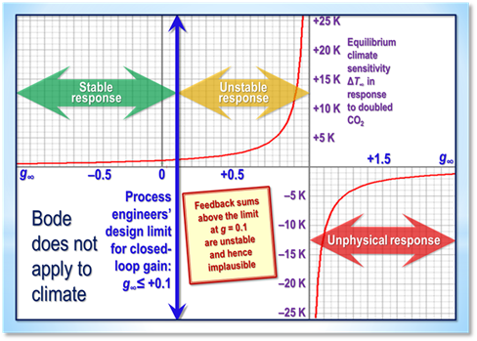
Mr Bailey concludes by asking:
“If generally rising temperatures, decreasing diurnal temperature differences, melting glacial and sea ice, smaller snow extent, stronger rainstorms, and warming oceans are not enough to persuade you that man-made climate is occurring, what evidence would be?”
Well, if Mr Bailey does me the courtesy of reading the above, he will realize that temperatures are not rising by much, glacial ice-melt (if occurring) is on too small a scale to raise sea level by much, global sea ice extent shows little change in two generations, ditto northern-hemisphere snow cover, there has been little increase in rainfall and (according to the IPCC) little evidence for “stronger rainstorms”, and the ocean warming is so small that it falls within the considerable measurement error.
The evidence he adduces is questionable at best on every count. The Temple of Thermageddon will have to do better than that if it wants to convince us in the teeth of the evidence.
I have presented much of the evidence in the form of simple graphs. Do readers like the way the graphs are presented, many of them with a small “Post-It note” highlighting the main point?
Conclusion
Back we go, down the tax-gobblers’ mighty mountain to base camp. Our attempt to climb it has failed at every single step. Even with the aid of CO2-emitting helicopters to lift us and our equipment to each new step as we fail to climb the one below it, no rational scientific or economic case can be made for taking any action whatsoever today in a probably futile and certainly cost-ineffective attempt to make global warming that is not happening as predicted today go away the day after tomorrow.
The correct policy to address what is likely to prove a non-problem – and what, even if it were every bit as much of a problem as the tax-gobblers would wish, could not by even their most creative quantitative easing be cost-effectively solved by any attempt at mitigation – is to have the courage to do nothing now and adapt later if necessary.
The question is why, in the teeth of the scientific and economic evidence, nearly all of the global governing class were so easily taken in or bought out or both by the strange coalescence of powerful vested interests who have, until now, profited so monstrously by the biggest fraud in history at such crippling expense in lives and treasure to the rest of us, and at such mortal threat to the integrity and trustworthiness of science itself.
Christopher Walter Monckton, 3rd Viscount Monckton of Brenchley, SMOM (born 14 February 1952) is a British public speaker and hereditary peer. He is known for his work as a journalist, Conservative political advisor, UKIP political candidate, and for his invention of the mathematical puzzle Eternity.

The Federalist
What It Would Take to Prove Global Warming
by Robert Tracinski
Recently, Reason‘s Ronald Bailey asked what it would take to convince conservatives and libertarians that global warming is real.
If generally rising temperatures, decreasing diurnal temperature differences, melting glacial and sea ice, smaller snow extent, stronger rainstorms, and warming oceans are not enough to persuade you that man-made climate [change] is occurring, what evidence would be?
This has since been picked up by Jonathan Adler at the Washington Post‘s token right-leaning blog, the Volokh Conspiracy. There’s no pressure: Bailey and Adler merely insinuate that you are “obscurantist”—that is, you hate new knowledge—if you don’t agree.
That, by the way—the smug insistence of global warming alarmists on presenting themselves as the embodiment of scientific knowledge as such—is one of the reasons I stopped taking them seriously. In fact, I have thought about what it would take to convince me global warming is real. And it’s pretty clear that Bailey has not thought about it.
He really hasn’t. He’s thought a lot about the various scientific claims made by those who insist global warming is a man-made catastrophe. But he has not thought about how those claims add up or how they would have to add up to be convincing. All Bailey’s piece amounts to is: here is a long list of factual claims that seem to support the global warming scare; how high do I have to pile up these claims before you are convinced?
There is no sense that the proof of global warming has to proceed according to some systematic method, requiring it to clear specific hurdles at specific stages. Which betrays an unscientific way of thinking.
When I refer to “global warming,” and when Bailey and Adler refer to it, that term is a stand-in, not just for the trivial claim that average global temperatures are rising, but for “catastrophic anthropogenic global warming”: i.e., global temperatures are rising, it’s our fault, and we’re all gonna die.
I’ve gone on record a long time ago sketching out what stages would be required to demonstrate that humans are causing rising global temperatures, never mind the much more dubious proposition that warmer weather is going to be a catastrophe. Let me elaborate on it here.
There are three main requirements.

1) A clear understanding of the temperature record.
The warmists don’t just have to show that temperatures are getting warmer, because variation is normal. That’s what makes “climate change” such an appallingly stupid euphemism. The climate is always changing. The environmentalists are the real climate-change “deniers” because they basically want global temperatures to maintain absolute stasis relative to 1970—not coincidentally the point at which environmentalists first began paying any attention to the issue.
That’s what makes ‘climate change’ such an appallingly stupid euphemism. The climate is always changing.
So to demonstrate human-caused global warming, we would have to have a long-term temperature record that allows us to isolate what the normal baseline is, so we know what natural variation looks like and we can identify any un-natural, man-made effect. A big part of the problem is that we only have accurate global thermometer measurements going back 135 years—a blink of an eye on the time-scales that are relevant to determining natural variation of temperature. Within that, we only have a few decades of warming that could conceivably be blamed on human emissions of carbon dioxide: a minor run up in temperatures from the 1970s to the late 1990s. Since then, warming has leveled off (despite strenuous attempts to pretend otherwise). I think it’s impossible to claim, on that basis, that we even know what natural temperature variation is, much less to demonstrate that we’ve deviated from it.
(This is putting aside doubts about whether adjustments made to the temperature record, which are necessary to account for things like changes in the locations of weather stations, have managed to screen out “urban heat island” effects or have been biased to exaggerate the extent of warming.)
Various environmentalist attempts to create a “hockey stick” that makes current temperatures look abnormal have been embarrassing failures, involving problems like an improper mixing of recent thermometer measurements with less accurate “proxy” measurements that estimate temperatures farther into the past. And they prove my point about warmists being believers in climate stasis. The hockey stick graphs all assume that global temperature have been basically flat for 2,000 or 10,000 years, so that minor recent warming looks like a radical departure. Who’s really denying climate change?
And if you look at temperatures on the really big scale, we’re all just playing for time until the next ice age comes.
Assuming we can eventually compile a temperature record that is long enough and reliable enough to distinguish the effect of human activity from natural variation, we would also have to understand how human beings are causing this effect. Which leads us to the second big requirement.

2) A full understanding of the underlying physical mechanisms.
We have to know what physical mechanisms determine global temperatures and how they interact. The glibbest thing said by environmentalists—and proof that the person who says it has no understanding of science—is that human-caused global warming is “basic physics” because we know carbon dioxide is a greenhouse gas. Carbon dioxide is a very weak greenhouse gas and there is no theory that claims it can cause runaway warming all on its own. The warmists’ theory requires feedback mechanisms that amplify the effect of carbon dioxide. Without that, there is no human-caused global warming. But those feedback mechanisms are dubious, unproven assumptions.
Basic questions about the “sensitivity” of the climate to carbon dioxide have never been answered. Even Bailey admits this.
In recent years, there has [been] a lot of back and forth between researchers trying to refine their estimates of climate sensitivity. At the low end, some researchers think that temperatures would increase a comparatively trivial 1.5 degrees Celsius; on the high end, some worry it could go as high as high 6 degrees Celsius…. In a 2014 article in Geophysical Research Letters, a group of researchers calculated that it would take another 20 years of temperature observations for us to be confident that climate sensitivity is on the low end and more than 50 years of data to confirm the high end of the projections.
Well, fine then. Is it okay if we wait? (No, it isn’t, and I’ll get to the implications of that in a few moments.)
And this leaves out the possibility that the climate’s sensitivity to carbon dioxide is even lower, that other mechanisms such as cloud-formation might serve to dampen temperature increases.
Recently, I was amused at news that new science is debunking the “low sodium” diet fad of the past few decades. It turns out that “the low levels of salt recommended by the government might actually be dangerous” (which is not so amusing). This seems like a timely warning. Like the human body, the global climate is a hugely complicated system with a lot of factors that interact. We’re not even close to understanding it all, and having the government jump in and pick sides risks cementing a premature “consensus.”
The immense, untamed complexity of the climate is reflected in the poor performance of computerized climate models, which leads us to our last major hurdle in proving the theory of global warming.

3) The ability to make forecasting models with a track record of accurate predictions over the very long term.
We don’t know whether current warming departs from natural variation, nor have scientists proven the underlying mechanisms by which humans could cause such an increase. But even if we did know these things, we would have to be able to forecast with reasonable accuracy how big the effect is going to be. A very small warming may not even be noticeable or may have mostly salutary effects, such as a slightly longer growing season, whereas the impact of a much larger warming is likely to cause greater disruption.
It’s pretty clear that scientists aren’t any good yet at making global climate forecasts.
I should also point out that the “catastrophic” part of “catastrophic anthropogenic global warming” is a much larger question that is even harder to forecast. For example, global warming was supposed to lead to more hurricanes, which is why movie posters for Al Gore’s An Inconvenient Truth featured a hurricane emerging from an industrial smokestack. Then hurricane activity in the Atlantic promptly receded to historical lows.
It’s pretty clear that scientists aren’t any good yet at making global climate forecasts. Current temperatures are at or below the low range of all of the climate models. Nobody predicted the recent 17-year-long temperature plateau. And while they can come up with ad hoc explanations after the fact for why the data don’t match their models, the whole point of a forecast is to be able to get the right answer before the data comes in.
Given the abysmal record of climate forecasting, we should tell the warmists to go back and make a new set of predictions, then come back to us in 20 or 30 years and tell us how these predictions panned out. Then we’ll talk.
Ah, but we’re not going to be allowed to wait. And that’s one of the things that is deeply unscientific about the global warming hysteria. The climate is a subject which, by its nature, requires detailed study of events that take many decades to unfold. It is a field in which the only way to gain knowledge is through extreme patience: gather painstaking, accurate data over a period of centuries, chug away at making predictions, figure out 20 years later that they failed, try to discover why they failed, then start over with a new set of predictions and wait another 20 years. It’s the kind of field where a conscientious professional plugs away so maybe in some future century those who follow after him will finally be able to figure it all out.
Yet this is the field that has suddenly been imbued with the Fierce Urgency of Now. We have to know now what the climate will do over the next 100 years, we have to decide now, we have to act now. So every rule of good science gets trampled down in the stampede. Which also explains the partisan gap on this issue, because we all know which side of the political debate stands to benefit from the stampede. And it’s not the right.
So yes, I know exactly what it would take to convince me that catastrophic anthropogenic global warming is really happening. And no, the warmists haven’t even come close.









