January 25, 2015

In one of our wonderful days with NO selections about Washington miscreants, we start with pictures of an underside of an iceberg. It's the topside now, since it flipped just before the photos were taken. The article is from the Smithsonian, so we have to be treated to a lecture about how this is happening more often now because of guess what ? ? ? ? ?

You got it! Global Warming!

Is there anything it can't do?

It can flip icebergs. Sorry about the regulation BS, but the photos are stunning and not often seen.
... Cornell’s guide suggested that the iceberg had recently flipped. Icebergs form when chunks of freshwater ice calve—or break off—from glaciers and ice shelves, as well as other icebergs. Because of the varying densities of ice and saltwater, only about 10 percent of an iceberg will ever show at the surface, and that protruding tip will gather dirt and snow. Melting can trigger calving, but it can also change the equilibrium of an iceberg, causing it to flip.
In the case of this jewel-like iceberg, the ice is probably very old. In glaciers, years of compression force out air pockets and gradually make the ice denser, according to the National Snow and Ice Data Center. "When glacier ice becomes extremely dense, the ice absorbs a small amount of red light, leaving a bluish tint in the reflected light, which is what we see.” In addition, minerals and organic matter may have seeped into the underwater part of the iceberg over time, creating its vivid green-blue color. ...

Gretchen Reynolds writes on the good that comes from lunch hour walks.
To combat afternoon slumps in enthusiasm and focus, take a walk during the lunch hour.
A new study finds that even gentle lunchtime strolls can perceptibly — and immediately — buoy people’s moods and ability to handle stress at work.
It is not news, of course, that walking is healthy and that people who walk or otherwise exercise regularly tend to be more calm, alert and happy than people who are inactive.
But many past studies of the effects of walking and other exercise on mood have focused on somewhat long-term, gradual outcomes, looking at how weeks or months of exercise change people emotionally.
Fewer studies have examined more-abrupt, day-to-day and even hour-by-hour changes in people’s moods, depending on whether they exercise, and even fewer have focused on these effects while people are at work, even though most of us spend a majority of our waking hours in an office.
So, for the new study, which was published in the Scandinavian Journal of Medicine and Science in Sports this month, researchers at the University of Birmingham and other universities began by recruiting sedentary office workers at the university.
Potential volunteers were told that they would need to be available to walk for 30 minutes during their usual lunch hour three times a week. ...

Discover Magazine reports on the exciting future of thorium nuclear energy because it doesn't use a chain reaction that could go rogue, and the byproducts cannot be used in nuclear weapons.
Nuclear power has long been a contentious topic. It generates huge amounts of electricity with zero carbon emissions, and thus is held up as a solution to global energy woes. But it also entails several risks, including weapons development, meltdown, and the hazards of disposing of its waste products.
But those risks and benefits all pertain to a very specific kind of nuclear energy: nuclear fission of uranium or plutonium isotopes. There’s another kind of nuclear energy that’s been waiting in the wings for decades – and it may just demand a recalibration of our thoughts on nuclear power.
Nuclear fission using thorium is easily within our reach, and, compared with conventional nuclear energy, the risks are considerably lower. ...
... Conventional nuclear power using a fuel cycle involving uranium-235 and/or plutonium-239 was seen as killing two birds with one stone: reducing America’s dependence on foreign oil, and creating the fuel needed for nuclear bombs. Thorium power, on the other hand, didn’t have military potential. And by decreasing the need for conventional nuclear power, a potentially successful thorium program would have actually been seen as threatening to U.S. interests in the Cold War environment.
Today, however, the situation is very different. Rather than wanting to make weapons, many global leaders are worried about proliferating nuclear technology. And that has led several nations to take a closer look at thorium power generation. ...

From the Smithsonian, we learn a startling fact. There are more tigers in captivity in the U. S. than there are wild tigers in the whole world.
Clayton James Eller loved going to his aunt’s house in Millers Creek, North Carolina, where he got to visit Tigger, her 317-pound pet Bengal tiger. One December day in 2003, ten-year-old C.J. was shoveling snow near Tigger’s outdoor pen when the animal attacked him from an opening in the chain-link fence and dragged him under. C.J.’s uncle grabbed his rifle and shot the tiger, but the boy died before he reached the hospital.
Tiger attacks in the United States are always dramatic news—there were 27 reported between 1990 and 2006, with seven people and most of the tigers killed. But maulings aren’t the only problem arising from the perhaps surprising fact that there are more captive tigers in the U.S. than there are wild tigers on earth.
Conservationists estimate that about 3,200 wild tigers remain around the world, while there are some 5,000 tigers in captivity in the U.S., according to the World Wildlife Fund. Even that number is probably low, says Carole Baskin, the founder of Big Cat Rescue, an animal sanctuary in Tampa, Florida, because reporting is "based on the honor system, and we’re dealing with a lot of people that are really dishonorable." Edward J. Grace, the U.S. Fish and Wildlife Service’s deputy assistant director for law enforcement, estimates that the nation is home to more than 10,000 captive tigers. Only about 350 of those, says the WWF, are held in facilities accredited by the Association of Zoos and Aquariums. ...

Why Files posts on the return of the carnivores to Europe.
A surprising new study shows that four big carnivores (brown bear, lynx, wolverine and wolf) are doing quite nicely in Europe, thank you very much, even without the wilderness protection that benefits some large predators in the United States.
"We find that in Europe we have twice as many wolves as in the lower 48 (American) states, on half the land area, with two times the human population density," says Guillaume Chapron of the Swedish University of Agricultural Sciences, the corresponding author of the new study.
In Europe, as in North America, large carnivores face ingrained hostility. It’s not just their ferocity, but also their need for a large range and lots of meat that makes them natural competitors.

Add it up, and both Europe and the United States had severe losses of carnivore populations by the 1960s.
Wilderness reserves and national parks in North America are intended to separate animals from people, but the new study points to other ways to ensure predator survival. "If we had followed the North American model of wilderness in Europe, we would not have predators, because in Europe everything is developed, we have roads everywhere," Chapron says. ...

The Atlantic tells us how Jelly Belly invents flavors.
In an echoing, high-ceilinged chamber in Northern California, there spin row upon row of what look like small cement mixers. The gleaming metal drums churn for hours on end while white-uniformed technicians pour in sugar, corn starch, color, and certain other, more miraculous concoctions. Out of one drum comes a whiff of red apple, conjuring a fall afternoon spent picking fruit; from another comes the buttered-popcorn scent of an evening at the movies. Out of drum after drum, all down the room, come smells evoking everything from apple pie to piña coladas to freshly mown grass.
Here, at the Jelly Belly candy factory, memories are reincarnated as jelly beans.
Flavor and scent are beloved for their ability to bring back memories long buried in the sensory deluge, a point made by Proust with his madeleine decades before modern science let us peer into the physiology of flavor. The flavor designers at the Jelly Belly Candy Company make it their business to speak this sensory language, and, through a process alternately technical and zany, to suss out exactly what it is that makes those tastes—and by extension, those memories—jump.
All Jelly Belly flavors, from toasted marshmallow to cappuccino—there are around 100 on the market at any given point—grow from ideas submitted by company employees, members of the public, retailers, and others, but the execution depends on a four-person team of food scientists, led by head of research and development Ambrose Lee and aided by the company's marketing and executive teams. ...

Smithsonian
An Iceberg Flipped Over, and Its Underside Is Breathtaking
On vacation in Antarctica, filmmaker and photographer Alex Cornell captured an unusual sight
by Melissa Wiley

Snow-covered icebergs dominate the scene near the shore of the Antarctic Peninsula, the northernmost part of the icy south polar region. Between the sun, the water and icy peaks, the beauty can be quite literally blinding.
“Everything is reflective and everything’s white,” recalls filmmaker Alex Cornell, who vacationed there last month with his family. “People had said that the first time you go, you’re kind of so overwhelmed that you take a lot of pictures of your feet and you don’t really know what’s going on … I definitely felt that,” he says with a laugh.
While exploring Cierva Cove, a glacial bay off the peninsula, a scientist aboard Cornell's boat became excited by one iceberg in particular. “Everything I was seeing was pretty exciting,” Cornell admits. “This particular iceberg at the time kind of blended in with all the crazy stuff we were seeing.”
But as they approached the mass, which rose about 30 feet out the water, Cornell understood his guide’s excitement. Whereas most iceberg tips are covered in snow or have been weathered by the elements, this one was free of debris, exposing glassy, aqua-green ice with water flowing through it—“almost like an ant colony,” he says.
Cornell’s guide suggested that the iceberg had recently flipped. Icebergs form when chunks of freshwater ice calve—or break off—from glaciers and ice shelves, as well as other icebergs. Because of the varying densities of ice and saltwater, only about 10 percent of an iceberg will ever show at the surface, and that protruding tip will gather dirt and snow. Melting can trigger calving, but it can also change the equilibrium of an iceberg, causing it to flip.
In the case of this jewel-like iceberg, the ice is probably very old. In glaciers, years of compression force out air pockets and gradually make the ice denser, according to the National Snow and Ice Data Center. "When glacier ice becomes extremely dense, the ice absorbs a small amount of red light, leaving a bluish tint in the reflected light, which is what we see.” In addition, minerals and organic matter may have seeped into the underwater part of the iceberg over time, creating its vivid green-blue color.

Justin Burton, an assistant professor at Emory University who has studied the physics of flipping icebergs, says that the phenomenon is occurring more frequently now due to climate change. Outlet glaciers are rivers of ice that flow outward from an ice cap or ice sheet and into the sea. According to Burton, outlet glaciers have been retreating in Antarctica and Greenland, and this contributes to iceberg flipping.
“Usually these tongues of ice would extend far out into the sea and actually be floating there. But now they’re not floating, and [icebergs] tend to break off right at the point where the ice touches the ground," he says. "It’s like squirting toothpaste out of a tube. A little bit of toothpaste comes out the tube, then it breaks off, and a little bit more comes out the tube, then it breaks off. So you get these really thin pieces of ice that flip over right when they’ve broken off.”

Burton is able to remotely record seismic signals and interpret when they're caused by large icebergs flipping. But he says that it is difficult to properly estimate how often a flip happens due to the need for visual confirmation and the dangers and expense of setting up recording equipment.
Given the rarity of the sight, Cornell is humbled to have captured this recently flipped iceberg. “It’s like if you see a double rainbow over a whale breaching … you’re just lucky that you’re there," he says. "Anybody could have been there and captured it, so I am happy that I was the one for this one.”

NY Times
The Benefits of a Lunch Hour Walk
by Gretchen Reynolds
To combat afternoon slumps in enthusiasm and focus, take a walk during the lunch hour.
A new study finds that even gentle lunchtime strolls can perceptibly — and immediately — buoy people’s moods and ability to handle stress at work.
It is not news, of course, that walking is healthy and that people who walk or otherwise exercise regularly tend to be more calm, alert and happy than people who are inactive.
But many past studies of the effects of walking and other exercise on mood have focused on somewhat long-term, gradual outcomes, looking at how weeks or months of exercise change people emotionally.
Fewer studies have examined more-abrupt, day-to-day and even hour-by-hour changes in people’s moods, depending on whether they exercise, and even fewer have focused on these effects while people are at work, even though most of us spend a majority of our waking hours in an office.
So, for the new study, which was published in the Scandinavian Journal of Medicine and Science in Sports this month, researchers at the University of Birmingham and other universities began by recruiting sedentary office workers at the university.
Potential volunteers were told that they would need to be available to walk for 30 minutes during their usual lunch hour three times a week.
Most of the resulting 56 volunteers were middle-aged women. It can be difficult to attract men to join walking programs, said Cecilie Thogersen-Ntoumani, the study’s lead author and now a professor of exercise science at Curtin University in Perth, Australia. Walking may not strike some men as strenuous enough to bother with, she said. But she and her colleagues did attract four sedentary middle-aged men to the experiment.
The volunteers completed a series of baseline health and fitness and mood tests at the outset of the experiment, revealing that they all were out of shape but otherwise generally healthy physically and emotionally.
Dr. Thogersen-Ntoumani and her colleagues then randomly divided the volunteers into two groups, one of which was to begin a simple, 10-week walking program right away, while the other group would wait and start their walking program 10 weeks later, serving, in the meantime, as a control group.
To allow them to assess people’s moods, the scientists helped their volunteers to set up a specialized app on their phones that included a list of questions about their emotions. The questions were designed to measure the volunteers’ feelings, at that moment, about stress, tension, enthusiasm, workload, motivation, physical fatigue and other issues related to how they were feeling about life and work at that immediate time.
A common problem with studies of the effect of exercise on mood, Dr. Thogersen-Ntoumani said, is that they rely on recall. People are asked to remember hours or days after the fact how exercise made them feel. Given how fleeting and mysterious our emotions can be, recalled responses are notoriously unreliable, Dr. Thogersen-Ntoumani said.
Instead, she and her colleagues wanted in-the-moment assessments from people of how they felt before and after exercise. The phone app questions provided that experience, she said, in a relatively convenient form.
Then the first group began walking. Each volunteer was allowed to walk during one of several lunchtime sessions, all of them organized by a group leader and self-paced. Slower walkers could go together, with faster ones striding ahead. There was no formal prescribed distance or intensity for the walks. The only parameter was that they last for 30 minutes, which the volunteers had said would still allow them time to eat lunch.
The groups met and walked three times a week.
Each workday morning and afternoon during the first 10 weeks, the volunteers in both groups answered questions on their phones about their moods at that particular moment.
After 10 weeks, the second group began their walking program. The first group was allowed to continue walking or not as they chose. (Many did keep up their lunchtime walks.)
Then the scientists compared all of the responses, both between groups and within each individual person. In other words, they checked to see whether the group that had walked answered questions differently in the afternoon than the group that had not, and also whether individual volunteers answered questions differently on the afternoons when they had walked compared with when they had not.
The responses, as it turned out, were substantially different when people had walked. On the afternoons after a lunchtime stroll, walkers said they felt considerably more enthusiastic, less tense, and generally more relaxed and able to cope than on afternoons when they hadn’t walked and even compared with their own moods from a morning before a walk.
Although the authors did not directly measure workplace productivity in their study, “there is now quite strong research evidence that feeling more positive and enthusiastic at work is very important to productivity,” Dr. Thogersen-Ntoumani said. “So we would expect that people who walked at lunchtime would be more productive.”
As a pleasant, additional outcome, all of the volunteers showed gains in their aerobic fitness and other measures of health at the completion of their 10 weeks of walking.
But, tellingly, many said that they anticipated being unable to continue walking after the experiment ended and a few (not counted in the final tally of volunteers) had had to drop out midway through the program. The primary impediment to their walking, Dr. Thogersen-Ntoumani said, had been “that they were expected by management to work through lunch,” suggesting that management might wish to acquaint themselves with the latest science.

Discover Magazine
Thorium Power Is the Safer Future of Nuclear Energy
by David Warmflash
Nuclear power has long been a contentious topic. It generates huge amounts of electricity with zero carbon emissions, and thus is held up as a solution to global energy woes. But it also entails several risks, including weapons development, meltdown, and the hazards of disposing of its waste products.
But those risks and benefits all pertain to a very specific kind of nuclear energy: nuclear fission of uranium or plutonium isotopes. There’s another kind of nuclear energy that’s been waiting in the wings for decades – and it may just demand a recalibration of our thoughts on nuclear power.
Nuclear fission using thorium is easily within our reach, and, compared with conventional nuclear energy, the risks are considerably lower.
Thorium’s Story
Ideas for using thorium have been around since the 1960s, and by 1973 there were proposals for serious, concerted research in the US. But that program fizzled to a halt only a few years later. Why? The answer is nuclear weapons. The 1960s and ’70s were the height of the Cold War and weaponization was the driving force for all nuclear research. Any nuclear research that did not support the US nuclear arsenal was simply not given priority.
Conventional nuclear power using a fuel cycle involving uranium-235 and/or plutonium-239 was seen as killing two birds with one stone: reducing America’s dependence on foreign oil, and creating the fuel needed for nuclear bombs. Thorium power, on the other hand, didn’t have military potential. And by decreasing the need for conventional nuclear power, a potentially successful thorium program would have actually been seen as threatening to U.S. interests in the Cold War environment.
Today, however, the situation is very different. Rather than wanting to make weapons, many global leaders are worried about proliferating nuclear technology. And that has led several nations to take a closer look at thorium power generation.
How Thorium Reactors Work
The isotope of thorium that’s being studied for power is called Th-232. Like uranium, Th-232 comes from rocks in the ground.
A thorium reactor would work like this: Th-232 is placed in a reactor, where it is bombarded with a beam of neutrons. In accepting a neutron from the beam, Th-232 becomes Th-233, but this heavier isotope doesn’t last very long. The Th-233 decays to protactinium-233, which further decays into U-233. The U-233 remains in the reactor and, similar to current nuclear power plants, the fission of the uranium generates intense heat that can be converted to electricity.
To keep the process going, the U-233 must be created continuously by keeping the neutron-generating accelerator turned on. By contrast the neutrons that trigger U-235 fission in a conventional reactor are generated from the fuel itself. The process continues in a chain reaction and can be controlled or stopped only by inserting rods of neutron-absorbing material into the reactor core. But these control rods aren’t foolproof: their operation can be affected during a reactor malfunction. This is the reason that a conventional fission reactor has the potential to start heating out of control and cause an accident. A thorium fuel cycle, by contrast, can be immediately shut down by turning off the supply of neutrons. Shutting down the fuel cycle means preventing the breeding of Th-232 into U-233. This doesn’t stop the heating in the reactor immediately, but it stops it from getting worse.
The increased safety of thorium power does not end there. Unlike the U-235 and plutonium fuel cycles, the thorium reactors can be designed to operate in a liquid state. While a conventional reactor heading to meltdown has no way to jettison the fuel to stop the fission reactions, a thorium reactor design called LFTR features a plug at the bottom of the reactor that will melt if the temperature of the reacting fuel climbs too high. If that happens the hot liquid would all drain out and the reaction would stop.
Powered Up
Thorium power has other attractions, too. Its production of nuclear waste would be orders of magnitude lower than conventional nuclear power, though experts disagree about exactly how much: Chinese researchers claim it’s three orders of magnitude (a thousandth the amount of waste or less), while U.S. researchers say a hundredth the amount of waste.
Thorium would be easier to obtain than uranium. While uranium mines are enclosed underground and thus very dangerous for the miners, thorium is taken from open pits, and is estimated to be roughly three times as abundant as uranium in the Earth’s crust.
But perhaps the most salient benefit of thorium power, in our geopolitically dicey world, is that the fuel is much harder to turn into a bomb. Thorium itself isn’t fissile. The thorium fuel cycle does produce fissile material, U-233, which theoretically could be used in a bomb. But thorium would not be a very practical route to making a weapon, especially with LFTR technology. Not only would the proliferator have to steal the fissile U-233 as hot liquid from inside the reactor; they’d also be exposed to an extremely dangerous isotope, U-232, unless they had a robot to carry out the task.
Future Fuel
China has announced that its researchers will produce a fully functional thorium reactor within the next 10 years. India, with one of the largest thorium reserves on the planet but not much uranium, is also charging ahead. Indian researchers are planning to have a prototype thorium reactor operational early next year, though the reactor’s output will be only about a quarter of the output of a typical new nuclear plant in the west. Norway is currently in the midst of a four-year test of using thorium fuel rods in existing nuclear reactors.
Other nations with active thorium research programs include the United Kingdom, Canada, Germany, Japan, and Israel.
There are some drawbacks to thorium fuel cycles, but they are highly technical. For instance, thorium reactors have been criticized as potentially having more neutron leak compared with conventional reactors. More neutron leak means more shielding and other protection is needed for workers at the power plant. And as in most types of alternative energy, thorium power faces a lack of funding for research and of financial incentives for power companies to switch over.
In recent decades, stories about safe, green nuclear power in popular media have tended to focus on the quest for nuclear fusion. Certainly, we can expect, and should hope, for continued progress toward that type of power. But while that happens, the investments by China, India, and other countries suggest that thorium is en route to contribute to the grid in the near term – and to dramatically improve the world’s energy sustainability in the process.

Smithsonian Magazine
America Has a Tiger Problem And No One’s Sure How to Solve It
No one even knows how many of the big cats are in the United States
by Max Kutner
Clayton James Eller loved going to his aunt’s house in Millers Creek, North Carolina, where he got to visit Tigger, her 317-pound pet Bengal tiger. One December day in 2003, ten-year-old C.J. was shoveling snow near Tigger’s outdoor pen when the animal attacked him from an opening in the chain-link fence and dragged him under. C.J.’s uncle grabbed his rifle and shot the tiger, but the boy died before he reached the hospital.
Tiger attacks in the United States are always dramatic news—there were 27 reported between 1990 and 2006, with seven people and most of the tigers killed. But maulings aren’t the only problem arising from the perhaps surprising fact that there are more captive tigers in the U.S. than there are wild tigers on earth.
Conservationists estimate that about 3,200 wild tigers remain around the world, while there are some 5,000 tigers in captivity in the U.S., according to the World Wildlife Fund. Even that number is probably low, says Carole Baskin, the founder of Big Cat Rescue, an animal sanctuary in Tampa, Florida, because reporting is "based on the honor system, and we’re dealing with a lot of people that are really dishonorable." Edward J. Grace, the U.S. Fish and Wildlife Service’s deputy assistant director for law enforcement, estimates that the nation is home to more than 10,000 captive tigers. Only about 350 of those, says the WWF, are held in facilities accredited by the Association of Zoos and Aquariums.
For the thousands of tigers in private hands, from those in big-top circuses and roadside attractions to others in backyard dens, the regulations are inconsistent at best. Six states (North Carolina, South Carolina, Wisconsin, Nevada, Alabama and West Virginia) place no restrictions on owning a tiger; 14 states require a permit; and 30 states prohibit ownership, though in some of those states people have been known to flout the law, as in the famous case of the man who kept a tiger in his apartment in Harlem.
One of the problems associated with these captive tigers, animal welfare advocates say, is that many of the creatures suffer. For example, the popular and stunningly beautiful white tigers—all descendants of a single, anomalous albino Bengal named Mohan, captured in 1951, and bred with his daughter—continue to be inbred with immediate family members to disabling effect; one frequent defect is severe strabismus, or crossed eyes, which hampers vision and coordination. Moreover, animal rescuers point out that many privately owned tigers live in deplorable conditions. Some tigers spend lifetimes in small, unsanitary enclosures. And wildlife advocates have accused tiger cub exhibitors of depriving the cats of sleep and exercise, and endangering both animals and people. One well-known captive animal is Tony the Tiger, a 550-pound Siberian-Bengal mix who has spent more than a decade in a cage at a truck stop in Louisiana. Baskin has been working with the Animal Legal Defense Fund to bring Tony to her sanctuary, but not everyone thinks his owner should be forced to send him. A Facebook group called "Keep Tony Where He Is" has more than 10,000 "Likes," and Tony’s owner has called animal rights activists terrorists.
Some advocates argue that America’s other tiger problem, to put it bluntly, is hypocrisy, at least on the world stage. In China, a booming market for tiger parts has fueled the growth of legal "tiger farms," where the animals are raised to be slaughtered for luxury décor (a tiger pelt can run tens of thousands of dollars) and pricey tiger-bone wine (up to $135 for a half-liter bottle). U.S. conservation groups and others have criticized the tiger farms both on humane grounds and for stoking demand for tigers—including poached wild animals. But Chinese officials dispute the claim that farmed tigers threaten animals in the wild, and, in any case, Americans have little credibility on the subject, given our own large but untallied population of neglected tigers and the patchwork of weak or nonexistent protections, according to J.A. Mills, a wildlife conservationist and author of the new book Blood of the Tiger. "U.S. tigers have a direct bearing on what China does," she says, "and what China does has a direct bearing on whether wild tigers survive."
So some advocates are heartened that America is trying to get its regulatory act together. The Fish and Wildlife Service has long overseen buying and selling "pure" tiger subspecies (such as Bengals and Amurs) across state lines, but the agency has limited authority because most privately held tigers are mixed breeds; a 2011 move to expand the agency’s authority over all tigers is reportedly close to being approved. Even more sweeping is the proposed Big Cats and Public Safety Protection Act, which would formally restrict tiger ownership to facilities accredited by the Association of Zoos and Aquariums. (A grandfather clause would allow unaccredited owners to keep their tigers as long as they register with the U.S. Department of Agriculture.) The bipartisan bill was introduced in 2013 and may come up again in the new Congressional term. Some tiger owners and businesses feel the bill is overly restrictive, but proponents say it would go a long way toward closing the gap between what we say about the treatment of captive tigers and what we’re actually willing to do about it.

Why Files
Europe: Return of the carnivores!
by David J. Tenenbaum
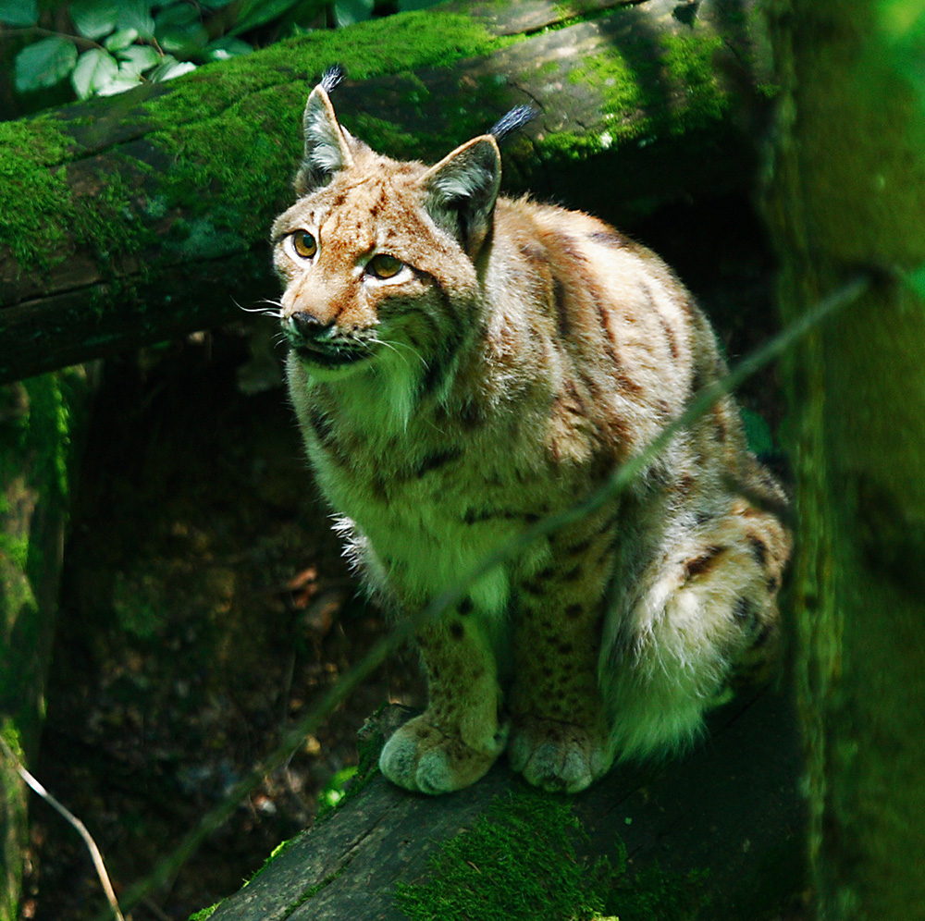
The Eurasian lynx is Europe’s largest cat. The new study finds them abundant in Finland, Sweden and Norway, the Baltics, Balkans and Romania.
A surprising new study shows that four big carnivores (brown bear, lynx, wolverine and wolf) are doing quite nicely in Europe, thank you very much, even without the wilderness protection that benefits some large predators in the United States.
"We find that in Europe we have twice as many wolves as in the lower 48 (American) states, on half the land area, with two times the human population density," says Guillaume Chapron of the Swedish University of Agricultural Sciences, the corresponding author of the new study.
In Europe, as in North America, large carnivores face ingrained hostility. It’s not just their ferocity, but also their need for a large range and lots of meat that makes them natural competitors.

Add it up, and both Europe and the United States had severe losses of carnivore populations by the 1960s.
Wilderness reserves and national parks in North America are intended to separate animals from people, but the new study points to other ways to ensure predator survival. "If we had followed the North American model of wilderness in Europe, we would not have predators, because in Europe everything is developed, we have roads everywhere," Chapron says.
The study, "shows that this coexistence, this ‘land sharing,’ does not just work in a particular context, it is working on a continental scale," says Chapron. "It’s possible to have predators living in a human-dominated landscape, and this is unexpected."

Predator stomping grounds
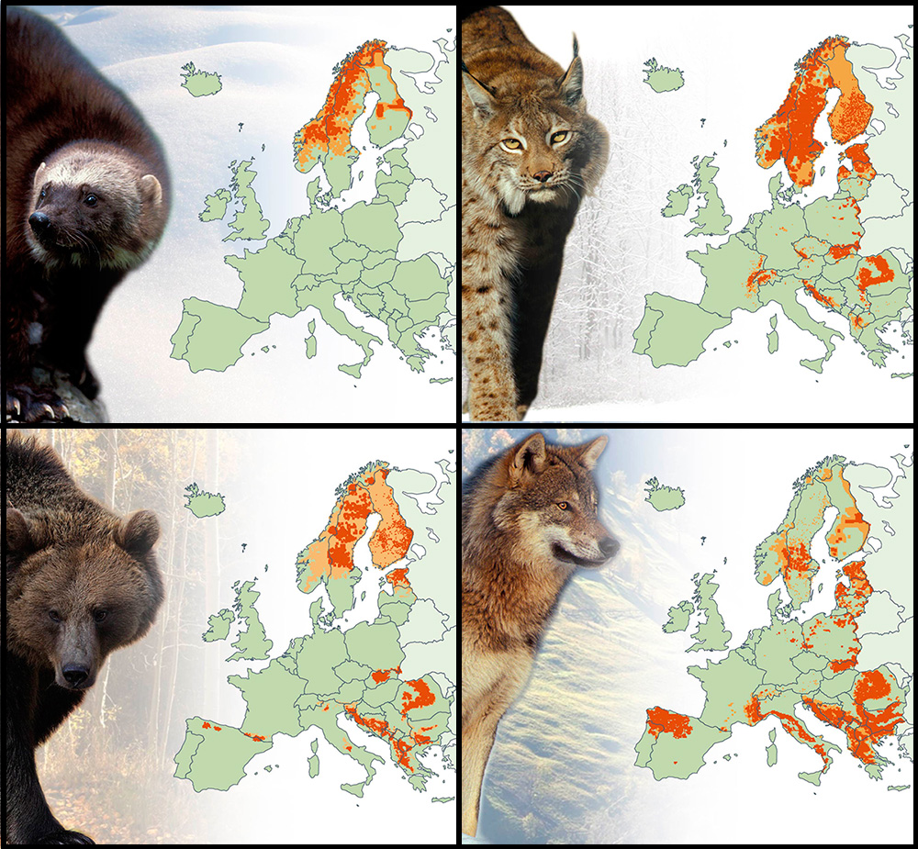
Location of bear, wolf, lynx and wolverine populations across Europe between 2010 and 2012; permanent populations shown in dark orange, and occasional sightings shown in light orange.

The 1970s: A turnaround

Wolverines are adapted to living in the snow. This one is near a pond in Finland.
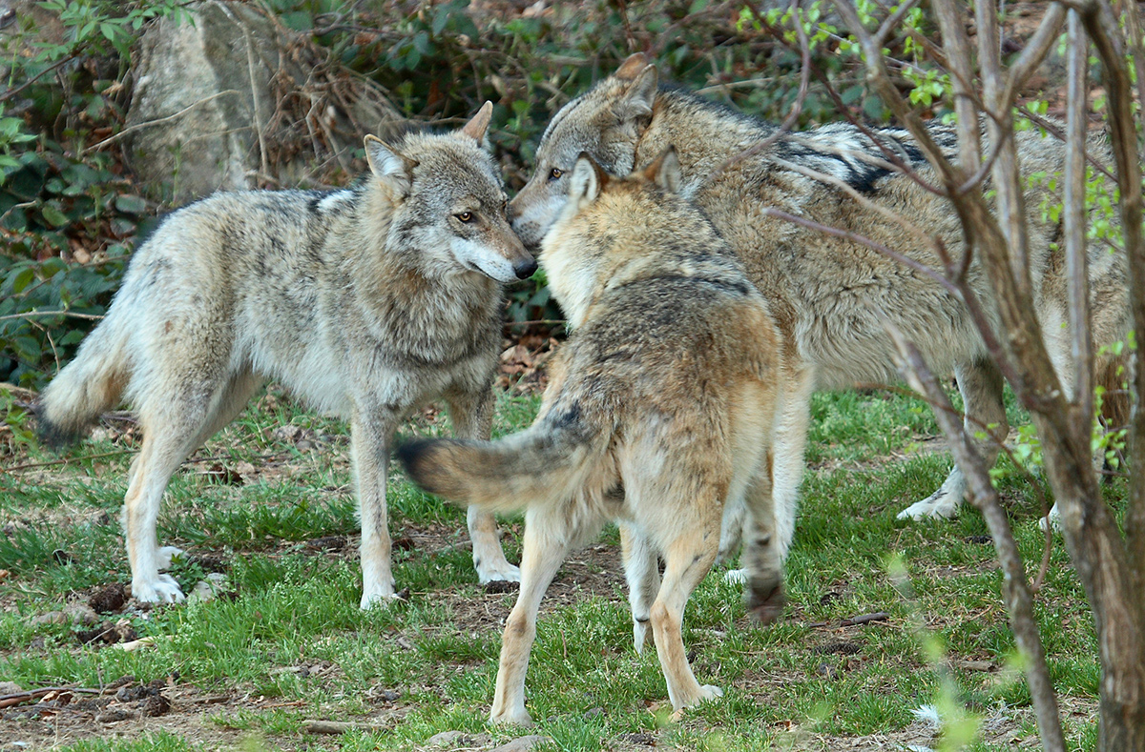
Highly intelligent and cooperative, the wolf pack forms a hunting machine with a large territory.
Of the four predators, the oft-feared wolf has staged the most dramatic recovery, Chapron says. Since the 1950s and ’60s, wolves have become more numerous in Finland and Poland, and breeding populations have returned to Sweden, France, Germany and Norway. "The wolf was never deliberately reintroduced in Europe," Chapron says. "The wolf has done all of this naturally."
The territory of European wolves has, on average, 37 people per square kilometer. (That’s 103 per square mile, or about the same density as the state of Alabama.) "That clearly shows the wolf can live in places with people; they don’t need a totally empty landscape," Chapron says.
Although the findings are encouraging for those who see predators as necessary to a healthy ecosystem, "This coexistence is not a peaceful love story," says Chapron. "With carnivores, there will always be conflicts. They are big, they eat the wrong type of meat, including meat we would like to eat. The goal is not to have no conflict at all, because I don’t think that’s possible."

The Atlantic
Sweet Memories: How Jelly Belly Invents Flavors
by Veronique Greenwood
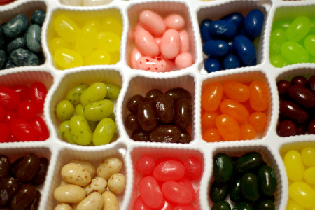

In an echoing, high-ceilinged chamber in Northern California, there spin row upon row of what look like small cement mixers. The gleaming metal drums churn for hours on end while white-uniformed technicians pour in sugar, corn starch, color, and certain other, more miraculous concoctions. Out of one drum comes a whiff of red apple, conjuring a fall afternoon spent picking fruit; from another comes the buttered-popcorn scent of an evening at the movies. Out of drum after drum, all down the room, come smells evoking everything from apple pie to piña coladas to freshly mown grass.
Here, at the Jelly Belly candy factory, memories are reincarnated as jelly beans.
Flavor and scent are beloved for their ability to bring back memories long buried in the sensory deluge, a point made by Proust with his madeleine decades before modern science let us peer into the physiology of flavor. The flavor designers at the Jelly Belly Candy Company make it their business to speak this sensory language, and, through a process alternately technical and zany, to suss out exactly what it is that makes those tastes—and by extension, those memories—jump.
All Jelly Belly flavors, from toasted marshmallow to cappuccino—there are around 100 on the market at any given point—grow from ideas submitted by company employees, members of the public, retailers, and others, but the execution depends on a four-person team of food scientists, led by head of research and development Ambrose Lee and aided by the company's marketing and executive teams.
The development process begins with a very specific idea. The taste must be instantly recognizable, says Lisa Brasher, a fifth-generation member of the founding family and executive vice chairman of the board. "When you say 'pickle,' do you mean sweet or dill? When you say 'potato chip,' do you mean regular or barbecue? Those are very important questions for us."
Thus, the food scientists and marketers taste-test extensively to find what sort of pickle is most pickle-y, whether Bartlett or D'Anjou screams "pear" loudest, and which specific combination of spices, dairy notes, and pumpkin puree sends you straight back to your grandma's pie. When they began development of the chili mango bean, Elise Bernstein, a food scientist, says, they descended on a local Trader Joe's and spirited bag after bag of the chili-covered fruit to their labs for tasting.
Sourcing inspirational ingredients is a matter of utmost importance in the design of a flavor. In its quest to know the taste of a pomegranate inside and out, the group taste-tested juices and fruit from different regions, climates, and providers. "Pomegranates from different areas taste different. Even the bottles they use [for juice] affect the flavor," Lee says.
Once the team decides exactly which version to mimic, the scientists retreat to their labs. They work to determine what mixture of juices, purees, and any of a huge variety of compounds can best call to mind their target. Sometimes they work backward from a sample of, say, pomegranate juice, which they run through a gas chromatograph and mass spectrometer, a pair of instruments that heat up the fluid and vaporize the juice's molecules one by one. The temperatures at which the molecules break down help the scientists determine what kinds of compounds are in the juice and guide them in constructing a faithful flavor.
With the precision of chemists, they mix batches with slightly different amounts of each component, adding compounds like aldehydes for a fresh green flavor, or esters for a fruity note. Sometimes the effects are not what they expect. "In the flavor industry, we sometimes say one plus one equals three," reflects Lee: mix pear with orange, for example, and what you get is peach. In addition, special compounds must be deployed to make flavors meld with the properties of their "vehicle," as the vessel for the flavor is known. Jelly Belly even has a secret ingredient that suppresses the sweetness of the bean so that savory flavors, like buttered popcorn, can show through.
The most promising permutations are incorporated into small batches of beans for taste-testing. At tasting parties, with the bean in one hand and the real deal in the other, food scientists, marketers, and executives silently rate the fidelity of the flavor. They hold up signs with numbers, and if the overall rating is not an 8, 9, or 10, the flavor doesn't pass on to the next stage of development, Brasher says. The new cocktail flavors were particularly fun to test, she says: "One of the guys in marketing who used to be a bartender made us up some pomegranate cosmos and peach bellinis and mojitos. We tasted the bean versions and tasted the real thing, and tasted the beans—and tasted the real thing again." (The three new flavors were released in June in sleek black boxes announcing, "It's five o'clock somewhere." None contains alcohol.)
Sometimes a flavor must be recalled: Grandma's Pumpkin Pie flavor, for instance, is back in development, because it turns out that nobody's grandma makes pumpkin pie in exactly the same way. Occasionally, the scientists' success overtakes them, as when an experimental four-cheese pizza bean managed to empty a whole mixing room with its noxious smell. But even disasters can redeem themselves: with the release of the company's Beanboozled novelty line, cheese pizza, with a few tweaks, became barf. "They sell like hotcakes," Brasher says.



Even with all his technical skill, Lee acknowledges, he sometimes finds that human taste buds are the most sensitive detectors of flavor: "They can pick up it when something is missing," he says. Intuition and creativity are also integral to his work. The buttered toast flavor was languishing in the lab, with something lacking from that delicious burnt taste, until Lee, on instinct, added a dab of caramel. Even the buttered popcorn flavor (loved by many, hated by many), was the result of his tinkering in the lab with corn, butter, and salt flavors, just to see what he could come up with. It is now one of Jelly Belly's top three flavors.
To those in the business of building flavors, memories of tastes and scents can be especially poignant. Brasher, who grew up eating pomegranates on a family farm, sent early pomegranate beans back to the kitchen because they lacked the distinctive tartness. And she recalls the way the air tastes when it's full of sugar from wandering the factory floor as a small child, watching row upon row of candy corn kernels ride up conveyor belts to be shipped.
For Bernstein, that special memory is of a certain spice cookie she ate as a child when her family lived in Germany: "Whenever I taste those, I go back to that time, when I was eleven or twelve. Cloves, nutmeg, cardamom, ginger ... the amounts of them, the way they're mixed, there's nothing else like it."
Lee, who once made a raw garlic bean by mistake, is ever the maverick: cloves still remind him of youthful dentist office visits. "[When] we were developing a pumpkin spice flavor and added cloves, that rang the dentist office bell for me," he laughs. "I hate that flavor."
It just brings back too many memories.



 Or a golf bag.





