December 2, 2014

The Conversation has a post suggesting traditional teaching methods may be the most successful.
Seventy teachers from the UK were sent to Shanghai to study classroom methods to investigate why Chinese students perform so well. Upon their return, the teachers reported that much of China’s success came from teaching methods the UK has been moving away from for the past 40 years.
The Chinese favour a “chalk and talk” approach, whereas countries such as the UK, US, Australia and New Zealand have been moving away from this direct form of teaching to a more collaborative form of learning where students take greater control.
Given China’s success in international tests such as PISA, TIMSS and PIRLS, it seems we have been misguided in abandoning the traditional, teacher-directed method of learning where the teacher spends more time standing at the front of the class, directing learning and controlling classroom activities.
Debates about direct instruction versus inquiry learning have been ongoing for many years. Traditionally, classrooms have been organised with children sitting in rows with the teacher at the front of the room, directing learning and ensuring a disciplined classroom environment. This is known as direct instruction. ...

Wired reports on a diesel powered airplane that may be produced in China.
If you’re the kind of person that tends to notice these things, a fair weather weekend stroll in any Chinese city or town lacks a distinct sound: the buzzing of light propeller aircraft in the sky. Outside the commercial and military realms, aviation is strictly limited, and private citizens who just want to take to the air have few options. That’s problematic, since booming growth in the country’s airline industry has generated a need for pilots, and it’s easier to recruit when you’ve got a population of men and women who already know how to fly.
Perhaps the biggest issue is that the majority of Chinese airspace is controlled by the military, and thus hard to access. Any fix on that front would come from the government (and rumor has it an overhaul is in the works), but a new plane from American-Chinese company Mooney could help address the other problems that are holding back Chinese aviation.
One problem is that airplane fuel is not only in limited supply, it’s extremely expensive—about double what it costs in the US. That makes training pilots costly and impractical (many learn to fly outside the country) in a place where flying even with a license is tricky. The Mooney M10, announced at China’s Zhuhai Airshow earlier this month, gets around that problem: It’s a diesel.
“Avgas is really hard to find in Asia” and it’s very expensive, says Peter Claeys, Mooney’s head of sales and marketing for China and a longtime champion of general aviation (the official term for civilian, non-commercial flight) in the region. Only one refinery in mainland China makes high octane low lead avgas, and delivery needs to be arranged ahead of time. It can cost more than $4 per kilogram (about $15 a gallon). Prices in the US—where fuel is also a cinch to find—fluctuate, but are often about half of what the Chinese pay.
Diesel engines have been around for more than a century but are a recent addition to the light airplane world. ...

WSJ with a discussion of the efficacy of electric cars.
Electric cars have been the future of transportation for nearly a century, and despite a flock of new entries, the battery-powered segment of the auto market remains a narrow niche.
Few transportation technologies provoke as much debate as electric vehicles. Fans love them for performance—a well-designed electric car can accelerate faster from a stop than many a muscle car—as much as for cleanliness. Skeptics ask why they should pay a premium or subsidize tax breaks for cars with limited range and utility.
In the discussion that follows, Andrew Tomko, Alex Venz and Margaret Burgoon make the case for EVs. Mr. Tomko, 52, an English professor at Bergen Community College in Paramus, N.J., owns an electric Fit subcompact from Honda Motor Co. Mr. Venz, 29, and Ms. Burgoon, 28, who are married, bought a Nissan Motor Co. Leaf two years ago. She’s an electrical engineer, he’s a technology consultant and photographer. They live in Lancaster, Calif.
University of Michigan Prof. John DeCicco presents the skeptic’s view. Prof. De Cicco developed an environmental scorecard and was a senior fellow for automotive strategies at the Environmental Defense Fund from 2001-2009.
Prof. DeCicco says at best he foresees a future market for electric vehicles as small, automated cars in densely populated urban areas. But even that is “pretty far away,” he says. ...

And Real Clear Politics has an item on the future of cars with or without batteries.
Elon Musk, founder and CEO of Tesla, has done what GM couldn’t when, 20 years ago, EV1 was introduced as the first (failed) mainstream, all-electric car. Tesla has moved electric vehicles (EVs) from cult to elite status. Seductively designed and impressively engineered, the nearly $100,000 Tesla is a must-own for one-percenters.
Could Tesla, in particular, with its to-be-released cheaper plug-in sedan, along with the other dozen major EV manufacturers, be the portent of an automotive revolution that finally displaces the vilified internal combustion engine? Or has Musk created—no small feat—a modern Maserati? (The latter celebrates its centennial on December 1, 2014.) At present, the wisdom of the stock market gives Tesla a value approaching that of GM, which produces as many cars in a week as Tesla does in a year.
One thing is certain about the future of personal transportation: People like it. So, in two decades, there will be 1 billion more cars on the road, up from today’s 800 million. Even in America there will be more cars. It turns out that the notion that bicycle-loving millennials eschew cars is wrong; the downturn in auto ownership breathlessly flagged by New Economy mavens turns out to have, instead, been about money. As the Great Recession slowly recedes, millennials are buying cars and surveys show they want them roughly as much as their boomer parents did. (Different styles to be sure, but there’s no evidence they’d prefer to bike, hitchhike, take the bus or walk.)
For Tesla’s aspirational acolytes, however, the future is obviously one where most cars will depend on batteries of electricity, not barrels of oil. Is this likely? ...

From Discovery we learn about Nicaragua's new cash crop - tarantulas.
His corn and bean fields ravaged by drought, Nicaraguan farmer Leonel Sanchez Hernandez grudgingly found a new harvest: tarantulas.
He gets a little over a dollar for each of the hairy critters, which breeders sell overseas as pets.
His take may not be much, but in Nicaragua, a dollar buys a kilo of rice or a liter (quart) of milk. And in just two weeks, Sanchez Hernandez, his aunt Sonia and cousin Juan caught more than 400 of the spiders.
The hunt is playing out in northern Nicaragua, which suffered severe drought from May to September. Sanchez Hernandez's fields were a total loss.
The 27-year-old was skittish at first about poking around in underground nests, under rocks and in tree trunks in search of the feisty arachnids.
But he donned thick gloves and mustered up the courage, because the alternative was to see his family go hungry.
"It is the first time we have gone out to look for tarantulas. We were a bit afraid, but we sucked it up and did it because of the drought," ...

Late Night Humor from Andrew Malcolm.
Conan: Justin Bieber has reportedly met with a rabbi to explore Judaism. After confering with Justin Bieber, the rabbi is exploring atheism.
Meyers: Justin Bieber will reportedly spend the next two weeks with a pastor to learn how to spread the word of God. “It won’t be easy, but I think it will make me a better person,” said the pastor.

The Conversation
‘Chalk and talk’ teaching might be the best way after all
by Kevin Donnelly

Seventy teachers from the UK were sent to Shanghai to study classroom methods to investigate why Chinese students perform so well. Upon their return, the teachers reported that much of China’s success came from teaching methods the UK has been moving away from for the past 40 years.
The Chinese favour a “chalk and talk” approach, whereas countries such as the UK, US, Australia and New Zealand have been moving away from this direct form of teaching to a more collaborative form of learning where students take greater control.
Given China’s success in international tests such as PISA, TIMSS and PIRLS, it seems we have been misguided in abandoning the traditional, teacher-directed method of learning where the teacher spends more time standing at the front of the class, directing learning and controlling classroom activities.

Direct instruction vs inquiry learning
Debates about direct instruction versus inquiry learning have been ongoing for many years. Traditionally, classrooms have been organised with children sitting in rows with the teacher at the front of the room, directing learning and ensuring a disciplined classroom environment. This is known as direct instruction.
Beginning in the late 1960s and early ‘70s, teachers began to experiment with more innovative and experimental styles of teaching. These included basing learning on children’s interests, giving them more control over what happened in the classroom and getting rid of memorising times tables and doing mental arithmetic. This approach is known as inquiry or discovery learning.
Based on this recent study of classrooms in the UK and China and a recent UK report titled What makes great teaching?, there is increasing evidence that these new-age education techniques, where teachers facilitate instead of teach and praise students on the basis that all must be winners, in open classrooms where what children learn is based on their immediate interests, lead to under-performance.
The UK report concludes that many of the approaches adopted in Australian education are counterproductive:
Enthusiasm for discovery learning is not supported by research evidence, which broadly favours direct instruction.
Especially during the early primary school years in areas like English and mathematics, teachers need to be explicit about what they teach and make better use of whole-class teaching.
As noted by John Sweller, a cognitive psychologist from the University of New South Wales in the recent Final Report of the Review of the Australian National Curriculum:
Initial instruction when dealing with new information should be explicit and direct.
Many in Australian education believe children are only really learning when they are active. As a result, teachers are told it is wrong to sit children at their desks and ask them to listen to what is being taught.
Again, the evidence proves otherwise. The UK report suggests that even when sitting and listening children are internalising what is being taught. Learning can occur whether they are “active” or “passive”.
Often derided as “drill and kill” or making children “parrot” what is being taught, the UK report and other research suggests that memorisation and rote learning are important classroom strategies, which all teachers should be familiar with.
The UK report states that teachers need to “encourage re-reading and highlighting to memorise key ideas”, while research in how children best learn concludes that some things, such as times tables and reciting rhymes, ballads and poems, must be memorised until they can be recalled automatically.

Trying to cater to everyone has no effect
One of the education fads prevalent across Australian classrooms, and classrooms in most of the English-speaking world, involves the concept that all children have different levels of intelligence and their own unique learning styles. (For example, some children learn best by looking at pictures, by being physically active, by hands-on, tactile learning or by simply reading the printed page.)
The UK report concludes such a teaching and learning strategy is misplaced:
The psychological evidence is clear that there are no benefits for learning from trying to present information to learners in their preferred learning style.
Instead of taking the time, energy and resources to customise what is being taught to the supposed individual learning styles of every child in the classroom, it is more effective to employ more explicit teaching strategies and to spend additional time monitoring and intervening where necessary.

Lavish praise does no-one any good
One of the prevailing education orthodoxies for many years is that students must be continually praised and that there is no room for failure. The times when “4 out of 10” or an “E” meant fail are long gone. Supposedly, telling children they are not good enough hurts their self-esteem.
The UK report says that, while praising students might appear affirming and positive,
the wrong kinds of praise can be very harmful to learning.
Overly praising students, especially those who under-perform, is especially counterproductive. It conveys the message that teachers have low expectations and reinforces the belief that near enough is good enough, instead of aiming high and expecting strong results.

There’s not just one way to teach
To argue that some teaching and learning strategies are ineffective does not mean that there is only one correct way to teach. While research suggests some practices are more effective than others, it also needs to be realised that teaching is a complex business. Teachers need various strategies.
In the early years of primary school, children need to memorise things like times tables and poems and ballads so that they can be recalled easily and automatically. Education is also about curiosity and innovation and there will be other times when rote learning will be unsuitable – for example, when students explore a topic that excites them and where they undertake their own research and analysis.
Depending on what is being taught, what has gone before and what is yet to come, whether students are well versed in a particular area of learning or are novices, and even the time of day, teachers must adapt their teaching to the situation and be flexible.
The problem arises when teachers and teacher education academics privilege one particular approach to the detriment of all others.
Kevin Donnelly is Senior Research Fellow - School of Education at Australian Catholic University

WIRED
Diesel Plane That Could Bring Private Flight to China
by Michele Travierso

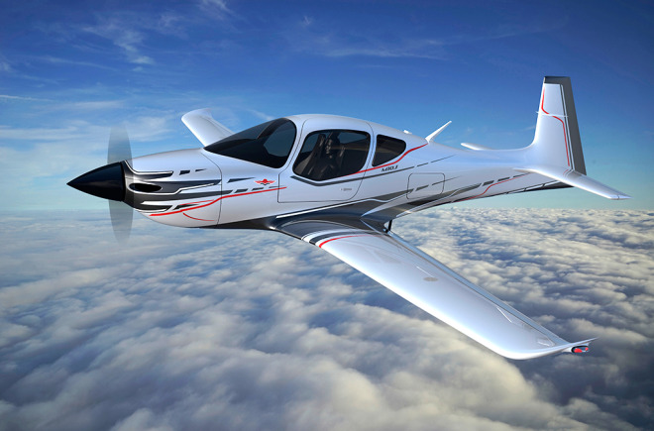
The Mooney M10, which will be produced in China, will run on diesel fuel.
If you’re the kind of person that tends to notice these things, a fair weather weekend stroll in any Chinese city or town lacks a distinct sound: the buzzing of light propeller aircraft in the sky. Outside the commercial and military realms, aviation is strictly limited, and private citizens who just want to take to the air have few options. That’s problematic, since booming growth in the country’s airline industry has generated a need for pilots, and it’s easier to recruit when you’ve got a population of men and women who already know how to fly.
Perhaps the biggest issue is that the majority of Chinese airspace is controlled by the military, and thus hard to access. Any fix on that front would come from the government (and rumor has it an overhaul is in the works), but a new plane from American-Chinese company Mooney could help address the other problems that are holding back Chinese aviation.
One problem is that airplane fuel is not only in limited supply, it’s extremely expensive—about double what it costs in the US. That makes training pilots costly and impractical (many learn to fly outside the country) in a place where flying even with a license is tricky. The Mooney M10, announced at China’s Zhuhai Airshow earlier this month, gets around that problem: It’s a diesel.
“Avgas is really hard to find in Asia” and it’s very expensive, says Peter Claeys, Mooney’s head of sales and marketing for China and a longtime champion of general aviation (the official term for civilian, non-commercial flight) in the region. Only one refinery in mainland China makes high octane low lead avgas, and delivery needs to be arranged ahead of time. It can cost more than $4 per kilogram (about $15 a gallon). Prices in the US—where fuel is also a cinch to find—fluctuate, but are often about half of what the Chinese pay.
Diesel engines have been around for more than a century but are a recent addition to the light airplane world. Traditionally, they’ve been heavy and offer short lifespans due to the higher compression rates in their cylinders, not good qualities for powering aircraft. Today’s diesels are marvels of engineering with low fuel consumption and emissions, and bulk and weight only marginally higher than those of conventional engines. And now those advances are finding their way to aviation.
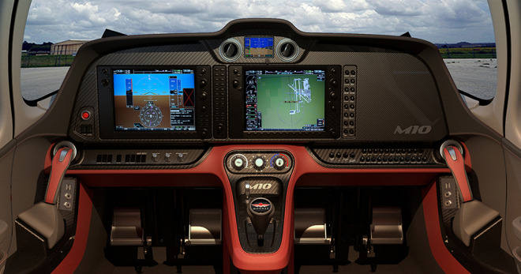
In addition to costing less than avgas, diesel actually has advantages for aircraft: The extra weight is balanced out by a lower burn rate that allows pilots to fly farther. Using diesel also means letting go of many levers and dials usually needed to ensure smooth engine running: they use a single level throttle control and a constant speed propeller. So it was a logical choice when Mooney started putting together the M10.
The Texas-based Mooney Aviation Company was founded in 1929 and is known for making blazing fast metal propeller planes. In 2009, it stopped production due to financial difficulties, entering a sort of cryogenic survival mode until it was acquired by a Chinese real estate firm a year ago. Back in action, the company, still headquartered in the US, with some production of the M10 planned for China, got to work developing two versions of the M10: the M10T, a 135-hp trainer, and the M10J, a 155-hp long-range tourer.
The engines they run on were actually first designed by Mercedes-Benz, for use in cars. They were converted for aviation by a now defunct German company called Thielert. Through a series of bankruptcies and acquisitions, the design ended up with Continental Motors (itself recently acquired by Chinese state-owned aerospace conglomerate AVIC), which counts Mooney as a customer.
The company is famous for making blazing fast metal aircraft, capable of hitting 240 knots (276 mph), but with the price tag and convenience of a single engine piston. The two-seater M10 is expected to be a bit slower (160 knots for the T version, 180 in the more powerful J), and to offer 500 to 900 nautical miles of range.
While production of Mooney’s faster and pricier legacy models will remain in Texas, the M10 will be mostly made in China, closer to what’s poised to become the world’s largest basic training aircraft market. With certification and first deliveries due for 2017, Chinese future pilots have another fancy pair of wings to look forward to.

WSJ
Should You Buy an Electric Car?
Three Owners Talk About the Benefits—and Frustrations—of Being Early Adopters
by Joseph B. White
Electric cars have been the future of transportation for nearly a century, and despite a flock of new entries, the battery-powered segment of the auto market remains a narrow niche.
Few transportation technologies provoke as much debate as electric vehicles. Fans love them for performance—a well-designed electric car can accelerate faster from a stop than many a muscle car—as much as for cleanliness. Skeptics ask why they should pay a premium or subsidize tax breaks for cars with limited range and utility.
In the discussion that follows, Andrew Tomko, Alex Venz and Margaret Burgoon make the case for EVs. Mr. Tomko, 52, an English professor at Bergen Community College in Paramus, N.J., owns an electric Fit subcompact from Honda Motor Co. Mr. Venz, 29, and Ms. Burgoon, 28, who are married, bought a Nissan Motor Co. Leaf two years ago. She’s an electrical engineer, he’s a technology consultant and photographer. They live in Lancaster, Calif.
University of Michigan Prof. John DeCicco presents the skeptic’s view. Prof. De Cicco developed an environmental scorecard and was a senior fellow for automotive strategies at the Environmental Defense Fund from 2001-2009.
Prof. DeCicco says at best he foresees a future market for electric vehicles as small, automated cars in densely populated urban areas. But even that is “pretty far away,” he says.
Here are edited excerpts of the drivers’ conversation by email, and Prof. DeCicco’s observations after the fact:

Why an EV?
WSJ: Why did you buy an electric car? And did you feel that the dealership knew more or less about EVs than you?
MR. TOMKO: When Honda dropped its lease price for the Fit EV in 2013, I immediately registered through the website and was told to contact a local dealer. The Honda dealership knew nothing about the EV, but at least admitted that and worked with me getting up to speed.
I do get amused every time I bring the Fit EV in for service and they want to offer me a free oil change.
MR. VENZ: We were filling the turbo Jetta one evening—I think [gasoline] was somewhere around $4.60 a gallon at the time—and we were somewhat surprised by the total cost. We went straight home and started putting together total-cost-of-ownership numbers for the Jetta and comparing them to the total cost of leasing a Leaf.
The total cost of leasing, including maintenance, electricity, insurance, putting a 240-volt outlet in the garage and getting a [charging station], was less than what the Jetta was worth and would put us up about $1,000 to $3,000, versus keeping the Jetta for 39 more months and then selling it.
Our experience at the local Nissan dealership was pretty poor. To this day, we still get oil-change offers.
MR. VENZ: Andrew, what was your motivation for looking into battery electric vehicles?
MR. TOMKO: I had been interested in BEVs since seeing “Who Killed the Electric Car?” and hearing about the development of the Tesla, Leaf and Volt. I guess my motivation was mostly a “green” one. But I am a bit of a tech nerd, and I like cars, so BEVs push all my buttons!
There was also an economic incentive: I have a long commute and have always looked for economical cars that were fun to drive.
MS. BURGOON: As an electrical engineer and the daughter of an electrical engineer, I have always had a keen interest in electronics, computers and software. To me, internal combustion engines have always been somewhat distasteful, not simply because they are dirty, smelly, loud and cause a great deal of vibration, but because they have always seemed like a complicated hodgepodge of parts in their need for service and repair. In short, they are unreliable, inefficient, dirty messes.

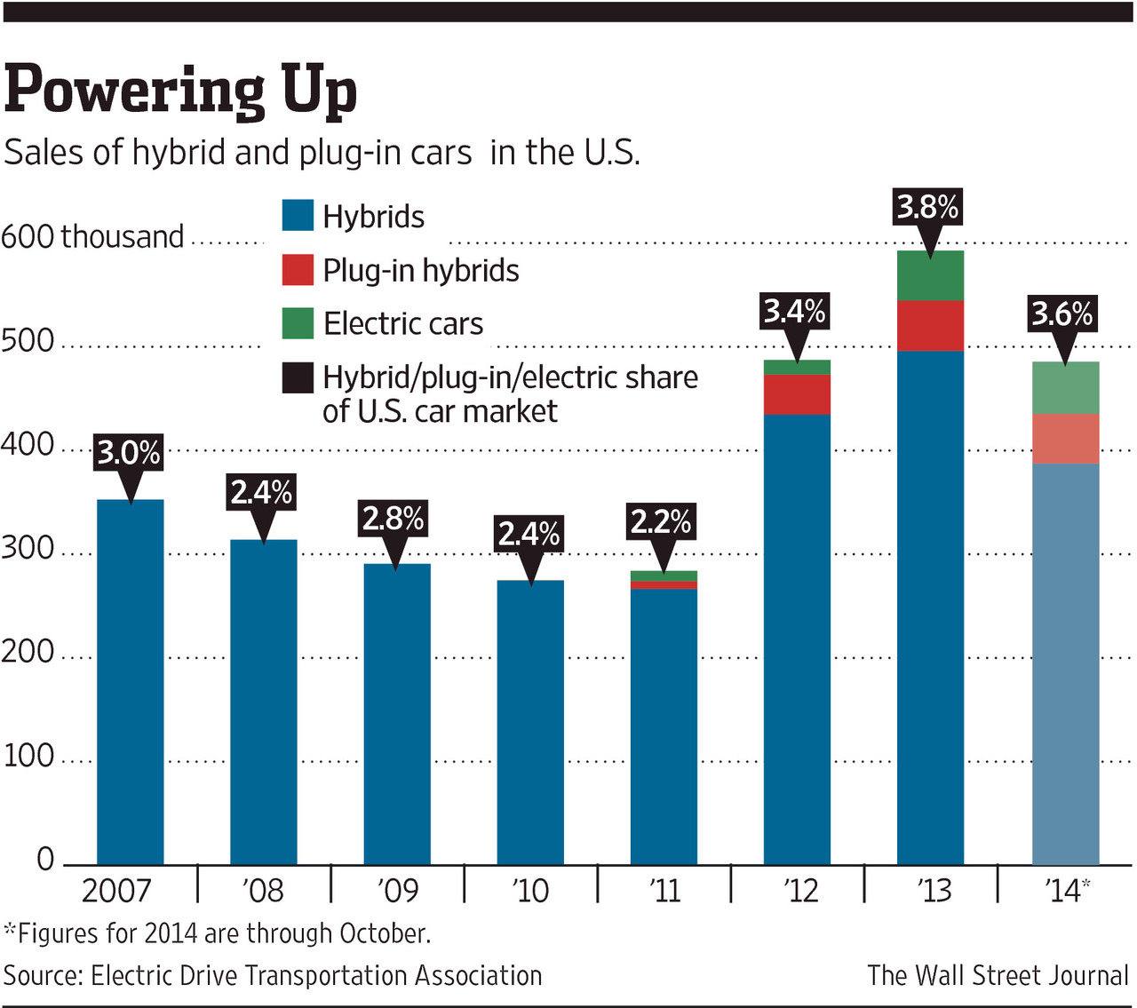

WSJ: What role did incentives, including tax breaks, access to HOV lanes, etc., have in your decision to buy an EV?
MR. TOMKO: The government tax break was a big factor in my decision. New York only has the federal $7,500 credit, and I would be happier if it had additional state incentives like California and Georgia. The HOV lanes were not a factor for me. The charging infrastructure also needs to be better; more public facilities should have chargers, even if one has to pay for electricity.
MR. VENZ: The federal EV credit rolled into the lease, along with the California rebate, were essential in making the numbers work to our advantage.
Without the $10,000 in subsidy, we probably wouldn’t have bothered. That said, I don’t think that increased subsidy is the answer. Producing better-designed, more mature and versatile products combined with better consumer education is a more solid long-term approach to boosting EV adoption.
MR. DECICCO: I’m not for public policies that provide special favors to electric vehicles or natural-gas vehicles. That doesn’t mean I’m against those technologies. You could see a business case for small, automated EVs in densely populated urban areas. But there’s a huge amount of policy support for plug-in cars. I question that. The realities of the market are self-evident.
It’s better to focus on the pollutant: Put carbon-dioxide standards in place, ratchet them down, repeat.

Home In on the Range
WSJ: Is the driving range between charges a concern?
MR. TOMKO: Range was and continues to be a big concern. My commute is 35 miles each way. For most of the year I can do a round-trip commute on one charge. What really swayed me, however, was my place of work installing two charging stations. The Honda Fit EV has been disappointing in very cold weather. A real 100-mile range would do it.
MR. VENZ: This comes down to honestly assessing your use and overall transportation situation. We concluded that the Leaf would be adequate for 100% of our local needs without having to rely on any chargers other than the one at our home. This has, with few exceptions, proved correct.
That said, we did have our first range-related mishap recently. My wife found herself with what seemed like insufficient charge to make it home after work last Friday. We called the Nissan EV support line and had the Leaf towed home at Nissan’s expense.
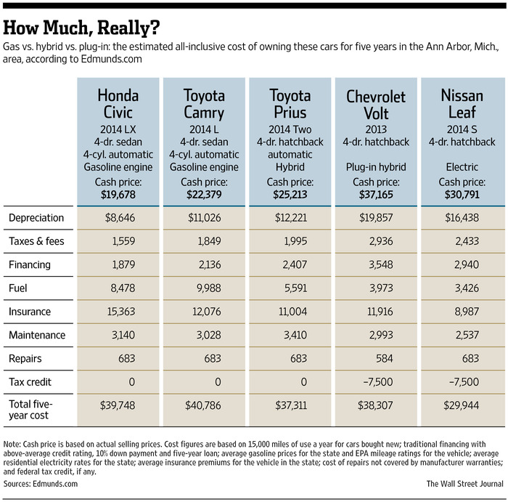
Later investigation of the incident [pulling data from the car’s onboard diagnostics port and performing an updated range test] revealed that she could have easily made it home, despite a detour to the dealership and the car indicating that she wouldn’t make it.
MS. BURGOON: I am very happy with the Leaf, despite its irritating tendency to try to scare you into not continuing on to your destination when you’re low on charge, even if it would really make it. And honestly, most of the time, that doesn’t matter in the slightest. It is truly a rare circumstance that I find myself low on charge.
Essentially, my first electric car has lived up to my expectation of it being better overall than any other car I have ever driven. My favorite thing about it is the fact that it has only one gear, and because of the way electric motors work, you get torque immediately and don’t need to worry about power bands.

Battery Degradation
MR. TOMKO: Alex, You mentioned battery degradation; have you seen much decrease in range yet? That was and is an issue that concerns me, especially if I consider buying instead of leasing. The range of the Fit suffers greatly in very cold temperatures.
MR. VENZ: I live in California’s high desert, about 30 minutes outside of Mojave. Summer days here can be as hot as 115 degrees and winter mornings/evenings can dip well below freezing. Like many Leaf owners in warmer climates, we have definitely seen some battery degradation.
Data from the car’s OBDII [onboard diagnostics system] port indicates that we’ve lost about 18% of pack capacity in two years. I would have preferred that Nissan make the actual state-of-charge and state-of-battery-health information available to the driver without having to resort to an OBDII adapter and third-party software like Leaf Spy.
MR. DECICCO: The idea that you can be an early adopter and usher in this revolution is a metaphor from the information-technology industry that doesn’t apply to energy.
We modeled battery cost out to 2050 [for a National Academy of Sciences study]. We found even by 2050 we could not foresee battery technology having the capability to scale across the entire fleet. The Leaf and Fit—subcompact cars in an urban setting—there’s definitely a niche there. But from a business point of view, it’s not scalable across platforms. It’s just not going to happen anytime soon.
WSJ: Would you buy another EV?
MR. TOMKO: I would never go back to a strictly gas-powered car. My lease ends in 2016, and I am sure there will be more options for EVs and better range.
MR. VENZ: In spite of the Leaf’s shortcomings, I don’t think that we’ll ever buy or lease another ICE [internal combustion engine] vehicle again. The major manufacturers have a long way to go before their products and franchise dealer networks are ready for EVs to go prime time, though.

Real Clear Politics
The Future of Cars: Batteries Included?
by Mark Mills

Elon Musk, founder and CEO of Tesla, has done what GM couldn’t when, 20 years ago, EV1 was introduced as the first (failed) mainstream, all-electric car. Tesla has moved electric vehicles (EVs) from cult to elite status. Seductively designed and impressively engineered, the nearly $100,000 Tesla is a must-own for one-percenters.
Could Tesla, in particular, with its to-be-released cheaper plug-in sedan, along with the other dozen major EV manufacturers, be the portent of an automotive revolution that finally displaces the vilified internal combustion engine? Or has Musk created—no small feat—a modern Maserati? (The latter celebrates its centennial on December 1, 2014.) At present, the wisdom of the stock market gives Tesla a value approaching that of GM, which produces as many cars in a week as Tesla does in a year.
One thing is certain about the future of personal transportation: People like it. So, in two decades, there will be 1 billion more cars on the road, up from today’s 800 million. Even in America there will be more cars. It turns out that the notion that bicycle-loving millennials eschew cars is wrong; the downturn in auto ownership breathlessly flagged by New Economy mavens turns out to have, instead, been about money. As the Great Recession slowly recedes, millennials are buying cars and surveys show they want them roughly as much as their boomer parents did. (Different styles to be sure, but there’s no evidence they’d prefer to bike, hitchhike, take the bus or walk.)
For Tesla’s aspirational acolytes, however, the future is obviously one where most cars will depend on batteries of electricity, not barrels of oil. Is this likely?
For cars, the future is determined by realities in two domains. First, physics determines what engineers can do at a price that most people will pay. Second, psychology determines what people want and pay for.
Start with psychology. Consumers want cars to provide five things well: comfort, convenience, reliability, safety, and style. All of it, and cheap. Real-world data show that fuel economy and environmental attributes are valued, but only a tiny niche elevate them to the detriment of cost and the five core attributes. And now there is a sixth attribute that surveys show young buyers often value more than fuel mileage—digital features and connectivity.
If consumers bought cars like commodities based solely on maximally efficient transport, the world’s roads would resemble a dystopian future of identical Chiclet-like pods. The truth is most car buyers have little interest in what’s under the hood (whether the propulsion comes from oil, corn alcohol, lithium batteries, or gerbils on tread mills), provided the six energy-gobbling attributes are delivered in the right mix at the right price. In this mix the solution to delivering fuel efficiency is always technology; for those who dream of a pure electric utopia, it is the battery-electric car.
The problem is that mass-producing better batteries is, put simply, really hard. Batteries are not good at storing energy compared to a steel gasoline tank. (We know how hard it is, in part, because the Obama administration spent $2 billion on stimulus subsidies for companies to build new battery factories in America. That experiment yielded neither a technological nor a domestic production revolution.)
We also know how difficult it is because of the inherent differences in the physical chemistry in the molecules used to store energy. Pound for pound (and pounds matter) the chemicals that comprise gasoline store 40 times more energy than the best chemicals in batteries. Gasoline is not only more dense but also remarkably safe, easy to store, and portable. Ask a chemist: if you started with a blank slate to design a near-ideal way to store energy for a mobile platform, you’d invent the oil molecule.
Such physics disparities are revealed in practice. A Tesla battery pack, plus motor, weighs over 1,500 pounds. A loaded fuel tank, plus motor, in a Mustang weighs just over 500 pounds. To offset this weight penalty, the Tesla uses a lot of aluminum. It bears noting, too, that aluminum consumes energy to fabricate (20-fold more than steel) that for all practical purposes it is solid electricity. Aluminum saves oil, in other words, by burning coal and fracked natural gas.
In addition, batteries are expensive. Driving 200 miles on kilowatt-hours, using 40 kWh, uses just $5 of electricity; each fill-up, on the other hand, costs about $90 when you include the amortized battery cost. Driving 200 miles in a VW GTI uses $15 of gasoline and $0.25 of steel, amortized. Such vast differences can only be disguised with subsidies.
As battery advocates rightly retort, there is always better technology. Although this is true, the underlying difference in energy density—hydrocarbons vs. electrochemistry—is locked in the physics of the associated atoms and molecules. No venture capital, government subsidy, or computer magic can change that. Technology, it is also true, gets better, and faster, in the use of gasoline.
A recent National Academy of Sciences study found that the R&D roadmap to a battery that is, say, two times better at any price is still unclear. But a two-times better internal-combustion engine is already available at a low price. Volvo, to name one example, recently unveiled a prototype tiny 4-cyclinder 450 hp engine, rivaling fire-breathing racecars. And that’s with yesterday’s technology. The inherent design of an internal combustion engine is far from tapped out.
There is a simple race in play, one between combustion chemistry and battery chemistry. Both will improve. The former has enormous inherent advantages. The only reason you’d subsidize the latter over the former is because you believe the world is running out of oil, or that batteries lower the use of hydrocarbons. Neither scenario is plausible in the near future. As America’s shale engineers have shown, the world is awash in oil. From a macro-resource perspective, there is no significant difference between the two vehicle futures—at the scale of fuels and hydrocarbons required in a world of tens of trillions of annual vehicle miles.
Still, there is a revolution in personal transportation coming, from silicon, software and new materials. Software (when combined with new classes of sensors) will yield better real-time traffic control. This is not a minor issue. Congestion is not only annoying and mind-numbing, but costs us 100 million barrels of oil a year in America alone. Super-computing software will also unveil mysteries of combustion that will translate into improve engine designs and software-controlled combustion with the potential to at least double average combustion efficiency. (Indeed, big data software is already enabling design of radical new classes of lightweight, high-strength materials that will do more for the average car than aluminum did for Tesla.)
Batteries will get better, too. And better, cheaper ones will enable the ubiquitous deployment of the hybrid architecture that so dramatically improves gasoline engine efficiency in city driving. Overall, technology will lead to far less fuel used per person-mile, though person-miles will grow faster for quite some time yet.
What about “black swan” technology? Radical new technologies are inevitable, but largely unpredictable. Once they emerge, given the scale of global transportation infrastructure, adoption and deployment takes decades, not years. If one were nonetheless betting on a black swan, visible hints do suggest what is possible. One can imagine a vehicle’s body panels fabricated from electricity-storing technology that could be recharged wirelessly and frequently from opportunistic points in urban areas. Highways would still run on gasoline, but city driving will one day reach the all-electric dream. One day.
Meanwhile, Tesla broke yet more new ground this month as the first electric vehicle to make it onto Car & Driver’s iconic annual Top 10 list, joining a $60,000 Corvette and Porsche. But you can bet the 99 percent will be buying cars more like another on that list: the VW Golf GTI. At half the price, the GTI matches the Tesla’s 0-to-60 mph and goes 1,500 miles on a barrel of oil.
One is tempted to paraphrase Winston Churchill: Hydrocarbon-burning internal-combustion engines are the worst way to propel vehicles, except for all the others. Except the truth, in this case, is that hydrocarbons may represent the best way.

Discovery
Tarantulas Are Nicaragua's New Crash Crop


An employee handles tarantulas, known as Costa Rican Tiger Rump at the Exotic Fauna Store in Managua, Nicaragua, on November 24, 2014.
His corn and bean fields ravaged by drought, Nicaraguan farmer Leonel Sanchez Hernandez grudgingly found a new harvest: tarantulas.
He gets a little over a dollar for each of the hairy critters, which breeders sell overseas as pets.
His take may not be much, but in Nicaragua, a dollar buys a kilo of rice or a liter (quart) of milk. And in just two weeks, Sanchez Hernandez, his aunt Sonia and cousin Juan caught more than 400 of the spiders.
The hunt is playing out in northern Nicaragua, which suffered severe drought from May to September. Sanchez Hernandez's fields were a total loss.
The 27-year-old was skittish at first about poking around in underground nests, under rocks and in tree trunks in search of the feisty arachnids.
But he donned thick gloves and mustered up the courage, because the alternative was to see his family go hungry.
"It is the first time we have gone out to look for tarantulas. We were a bit afraid, but we sucked it up and did it because of the drought," he told AFP.
Sanchez Hernandez has a wife and four kids to feed. His aunt is not well off, either -- she is a single mother of five children, and was also hit hard by the drought.
Their loot secured, the pair traveled more than 100 kilometers (60 miles) to the outskirts of the capital Managua.
There, they handed the tarantulas over to Exotic Fauna, a firm that started this month to breed the spiders for export.
With approval from the country's environment ministry, the company is hard at work, setting up glass cases with sawdust beds as part of a project to breed 7,000 tarantulas.
"We plan to sell them at a price even higher than that of boas," which go for up to $8 apiece, said Exotic Fauna owner Eduardo Lacayo.
Lacayo has invested more than $6,000 in the business. He got the money... from selling turtles.
Tarantulas are carnivores that eat crickets, worms and newly born mice that breeders drop in their tanks -- one tarantula per tank, so they don't fight and kill each other.
"It is easier to handle a boa than a spider," Lacayo said.
Tarantulas are territorial and when they feel threatened, they bite and secrete a toxic goo that causes allergies and pain, he said.
The spiders abound in tropical and arid parts of Central America. Despite the fact that they are so common, lots of people are afraid of them.
Females lay about 1,000 eggs when they give birth. The larvae come out in sacs, which the mother places in a spider web. Of that load, anywhere from 300 to 700 will hatch.
"We have customers who have confirmed they want this kind of species," Lacayo said, referring to clients in China and the United States.
Trade in tarantulas, which can live many years in captivity, is one of the ways Nicaragua is trying to diversify its exports by taking advantage of its rich biodiversity. The country is the second poorest in the Americas, after Haiti.
The first to get the bug was Ramon Mendieta, owner of an exotic animal farm in Carazo department, south of the capital. He sells around 10,000 tarantulas a year to clients in the US and Europe.
Mendieta, who has been at it for three years, says profit margins are thin because production costs are high. These costs include special care that the tarantulas need to protect them from parasites while in captivity.
But there is competition out there. Chile sells a species of tarantula that is less ornery than the Nicaraguan ones. Colombia and the United States are also market players.
"There are a lot of people that love to have them at home, some as pets and others because they like danger," said biologist Fabio Buitrago of the Nicaraguan Foundation for Sustainable Development.

IBD
Late Night Humor
by Andrew Malcolm
Fallon: Billionaire Warren Buffet says he‘s paying $3 billion for Duracell's 50 million shares. Buffet said he just wanted to buy three shares, but Duracell only sells them in packs of 50 million.
Meyers: Joe Biden’s birthday was the other day. Biden started the day with a dance party and a big piece of cake. And then he remembered it was his birthday.
Conan: Joe Biden’s pals wheeled in a large birthday cake. But Biden's thank-you speech was so long the stripper inside fell asleep.
Meyers: Police in Israel seized dozens of weapons that had been disguised as Christmas decorations. Israeli police became suspicious when they were Christmas decorations.
Conan: Scientists say the space probe that landed on a comet has discovered substances that are indispensable to life. So apparently, the comet is made of whiskey and Nutella.
Conan: The European Space Agency says its comet probe has detected organic matter there. This means there could either be life in space or a Whole Foods.
Fallon: Obama says by 2016, voters will want a “new car smell.” Americans were like, “Actually, we just want you to finally put the key in the ignition. We'd like you to do something, anything. Get a jump-start.”
Conan: Justin Bieber has reportedly met with a rabbi to explore Judaism. After confering with Justin Bieber, the rabbi is exploring atheism.
Conan: A consumer group has published its list of the 10 worst toys to get kids for Christmas. Topping the list — a Menorah.
Conan: Charles Manson has applied for a license to marry his 26-year-old girlfriend. There you go folks, another eHarmony success story!
Conan: Charles Manson’s future mother-in-law says she approves of her daughter marrying Charles Manson. She also said Manson has very nice personalities.
Conan: Analysts say President Obama’s immigration plan includes deporting violent criminals. So this could impact your fantasy football team.
Conan: A study finds that at Thanksgiving Americans discard at least $282 million worth of leftovers. And when you look at most Americans, that’s clearly not enough.
Meyers: A California man was arrested after stabbing his potential employer during a job interview. At least now he knows where he sees himself in five years.
Meyers: Justin Bieber will reportedly spend the next two weeks with a pastor to learn how to spread the word of God. “It won’t be easy, but I think it will make me a better person,” said the pastor.
Meyers: A New York plastic surgeon has invented enhanced 'vacation breasts' that last three weeks. That’s amazing, right? Who gets three weeks’ vacation?
Conan: The DEA raided several NFL teams suspected of giving prescription painkillers to their players. In his defense, the New York Jets doctor said, “We don’t give painkillers to our players. We give them to our fans.”
Conan: The company that makes Botox was recently purchased for $66 billion. Botox users were very surprised. They just couldn’t show it.
Conan: President Obama has recently pledged $3 billion to aid poor nations. All $3 billion is going to the United States.
Fallon: Obama denies he’s a king, saying, "The only guy at the White House who wears a crown is Biden when I take him to Burger King."
Fallon: Defense Secretary Chuck Hagel has resigned after sources say the White House became frustrated with his often embarrassing and contradictory remarks. At which point Joe Biden quietly started packing his things.

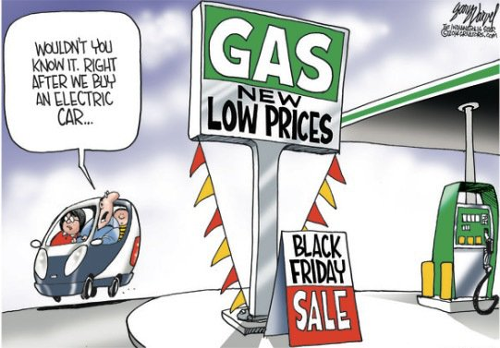



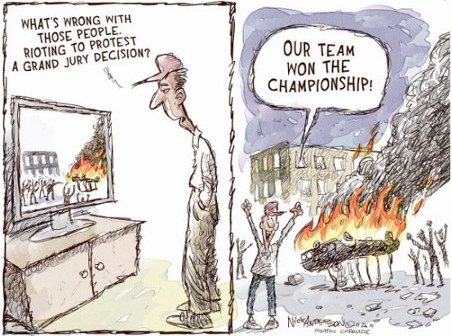

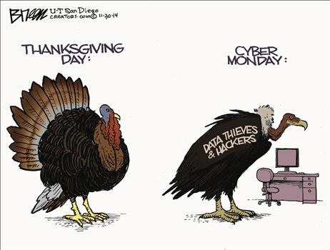

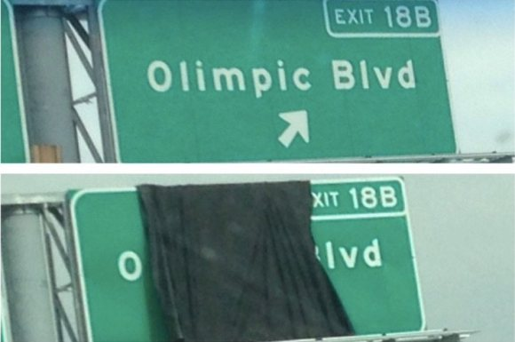
Your government at work.

