November 11, 2014

Tailgating at The University of Mississippi is covered in the NY Times. And the Times didn't look down its Northeast nose at the event.
OXFORD, Miss. — Perhaps there isn’t a word for the ritualized pregame revelry on the University of Mississippi campus. “Tailgating” certainly does not do it justice. It might be a gathering of football fans before a game, but it hardly resembles those celebrated scenes in Green Bay and Kansas City, which are modest by comparison.
For one, there are the $71,000 portable toilets. And then there’s this fall’s $750,000 university budget for the quintessentially Southern marvel known as the Grove. The price tags, and the orchestration, just keep getting grander.
“We want to put on the dog here,” one fan said, using regional vernacular for “over the top.”
Rebels fans began putting on the dog in high fashion again Friday night, when an estimated 2,500 tents were erected for Saturday’s game between Mississippi, ranked seventh in The Associated Press Top 25, and Auburn, ranked fourth. To help set the stage, here is a tour of one of the country’s most elaborate pregame gatherings. ...

... In many tents, food is served on silver trays, drinks splash through fountains and chandeliers hang from the metal supports. Fur coats abound. Jackets, ties and cowboy boots are common.
Prominent chefs are hired to cater meals, and chicken is a favored entree. “You don’t want to be a chicken in northern Mississippi on game day,” said Tim Walsh, the executive director of alumni affairs.
The tents themselves can be fashion statements. Some fans hire interior decorators. One tent on the Walk of Champions (the Grove’s Main Street) is painted with zebra stripes. One of its owners is Jane Foster, a converted Mississippi State fan. She brings in a rock band once a year. ...

Dilbert's Blog reviews the iPhone 6.
After a month-long wait - and salivating the entire time - I finally got my iPhone 6 Plus. I don't know how Apple manipulates my emotions so effectively but I am thoroughly impressed at the mental anguish they put me through while I waited.
My heart was racing as I removed the phone from its strikingly well-designed packaging. Apple makes the process of opening a box feel as if you are winning a prize. Every color, shape, texture and probably smell has been studied and tweaked to perfection. Simply touching the product or its associated packaging is a tactile joy.
The experience of getting the iPhone 6 Plus was like getting a puppy. ...

... But I needed a case. I tried to imagine my anguish if I accidentally dropped this new member of my family and cracked it. I needed protection.
So I went to the Verizon store and bought the only cover they had left that doesn't look like a six-year old girl's bedroom wall. The color of my new case could best be described as Colonoscopy Brown. It is deeply disturbing. But because I love my iPhone 6 Plus, and want to keep it safe, I put it on. ...

Jewish World Review article downplays the efficacy of Tamiflu. But it does recommend chicken noodle soup. What, you wanted gefilte fish?
Neuraminidase inhibitors including Tamiflu and Relenza are recommended by government health agencies for treating and preventing symptoms of the influenza virus in both children and adults. A review conducted by the Cochrane Collaboration has now revealed these treatment options may cause more harmful side effects compared to their ability to reduce and prevent flu-like symptoms. ...
... There are certain household treatments people suffering from flu-like symptoms can apply in order to achieve a natural remedy. For example, our best defense against any bodily ailment is staying hydrated. Drinking and avoiding alcohol, coffee, and soda can go a long way in maintaining a healthy immune system. With its anti-inflammatory properties, chicken noodle soup can also serve as a natural, at-home remedy for boosting the movement of immune system cells. Lastly, avoid dry places where cold viruses thrive and seek humidity. Adding moisture to your home via a humidifier can prevent a stuffy nose and scratchy throat by dampening our airways' mucous membrane.

From Fight Aging we learn dementia may be the result of many small strokes.
... The researchers conducted an intensive study to observe the development of this white matter disease over a short period of time, rather than on an annual basis - the interval at which previous studies have performed repeat brain imaging. The study involved 5 patients with white matter disease undergoing detailed MRI scanning of their brains every week for 16 consecutive weeks. The weekly MRI scans revealed new tiny spots arising in the brain's white matter that were, based on their MRI appearance, characteristic of small new strokes (cerebral infarcts). The lesions had no symptoms but, with time, came to resemble the existing white matter disease in the subjects' brains. In the study's random sampling, the majority of subjects had this phenomenon: Tiny strokes occurring without symptoms, and developing into the kind of white matter disease that causes dementia. ...

US Naval Institute says China's new stealth fighter has the attention of our pilots.
China’s new Shenyang J-31 stealth fighter — making its debut next week at the Zhuhai international airshow — could eventually become more than a match for American stealth fighters in battle, several U.S. military and industry officials told USNI News.
The J-31 is China’s latest crack at developing a modern so-called fifth-generation stealth fighter — equivalent in ability to Lockheed Martin’s F-22 Raptor or F-35 Lighting II Joint Strike Fighter.
“They’re still in the glossy brochure phase of development, so they still look ten feet tall and bulletproof,” one senior U.S. fighter pilot familiar with the F-35 program told USNI News.
“I think they’ll eventually be on par with our fifth gen jets — as they should be, because industrial espionage is alive and well.” ...

WSJ writes on the growing amount of unused retail space that is being converted to other uses.
The Internet is moving to a shopping center near you.
In Fort Wayne, Ind., a vacated Target store is about to be home to rows of computer servers, network routers and Ethernet cables courtesy of a local data-center operator. In Jackson, Miss., a former McRae’s department store will get the same treatment next year. And one quadrant of the Marley Station Mall south of Baltimore is already occupied by a data-center company that last year offered to buy out the rest of the building.
As America’s retailers struggle to keep up with online shopping, the Internet is starting to settle into some of the very spaces where brick-and-mortar customers used to shop. The shift brings welcome tenants to some abandoned stretches of the suburban landscape, though it doesn’t replace all the jobs and sales-tax revenue that local communities lost when stores left the building.
Venyu Solutions LLC, a data-center operator that is renovating the former department store in Jackson, sees more opportunity for conversion because of sheer amount of distressed retail properties. “Who else wants them?” said Brian Vandegrift, the company’s executive vice president of sales. “You’re not competing with people in substantial businesses who want those spaces.”
Many malls and neighborhood shopping centers are still grappling with vacancies five years after the recession. ...

Ever wonder while waiting to board a plane whether there's a faster way? Wired has a piece on how boarding could be improved.
No, there's not much chance it will be adopted. Just wanted you to know people are trying.
I was at the airport last week, and all I wanted to do was sit down, strap in, and lift off. Of course I couldn’t, because there were a bunch of people standing in my way. As the line crept along, I scanned ahead for malingerers, but everyone seemed sufficiently ready to board. I couldn’t help but wonder, is there a more efficient way for airlines to put get our butts into our seats, and into the air?
Millions of other people probably have pondered this question. At least one wrote a computer program to find the answer. Jason Steffen is an astrophysicist at Northwestern University, and several years ago he modeled different airline boarding methods to see what made them so slow. He also figured out how airlines could get us on board much faster. ...

ARS Technica says LED bulbs have pulled ahead of compact fluorescents in efficiency.
A few years back, when I got my first LED-based lightbulb, it seemed natural to stick it into a wattmeter to get a sense of its efficiency. At under 15 Watts of power drawn, it clearly beat any incandescent bulbs I'd ever put into the same lamp. But I was disappointed to find that it wasn't any better than a compact fluorescent bulb.
Based on the graph shown above, my experience was hardly unique; in fact, it was decidedly average. Although the technology behind LEDs had the potential to be far more efficient than any other lighting source, the complete LED bulb package wasn't doing that much better at the time than the far more mature fluorescent bulbs, which output roughly 60 lumens for every Watt put in.
After some small boosts in 2013, however, a new generation of more efficient LEDs hit the market this year, raising the typical efficiency to nearly 100 lumens per Watt. The increased efficiency is coming at a time when prices for the bulbs continue to drop; given their expected lifetimes, they're now far and away the most economical choice for most uses.
The graph also nicely displays why incandescents have been booted off the market for a failure to achieve sufficient efficiency, as they have flatlined at around 15 lumens per Watt.

NY Times
Tailgating Goes Above and Beyond at the University of Mississippi
by James K. Gentry

OXFORD, Miss. — Perhaps there isn’t a word for the ritualized pregame revelry on the University of Mississippi campus. “Tailgating” certainly does not do it justice. It might be a gathering of football fans before a game, but it hardly resembles those celebrated scenes in Green Bay and Kansas City, which are modest by comparison.
For one, there are the $71,000 portable toilets. And then there’s this fall’s $750,000 university budget for the quintessentially Southern marvel known as the Grove. The price tags, and the orchestration, just keep getting grander.
“We want to put on the dog here,” one fan said, using regional vernacular for “over the top.”
Rebels fans began putting on the dog in high fashion again Friday night, when an estimated 2,500 tents were erected for Saturday’s game between Mississippi, ranked seventh in The Associated Press Top 25, and Auburn, ranked fourth. To help set the stage, here is a tour of one of the country’s most elaborate pregame gatherings.
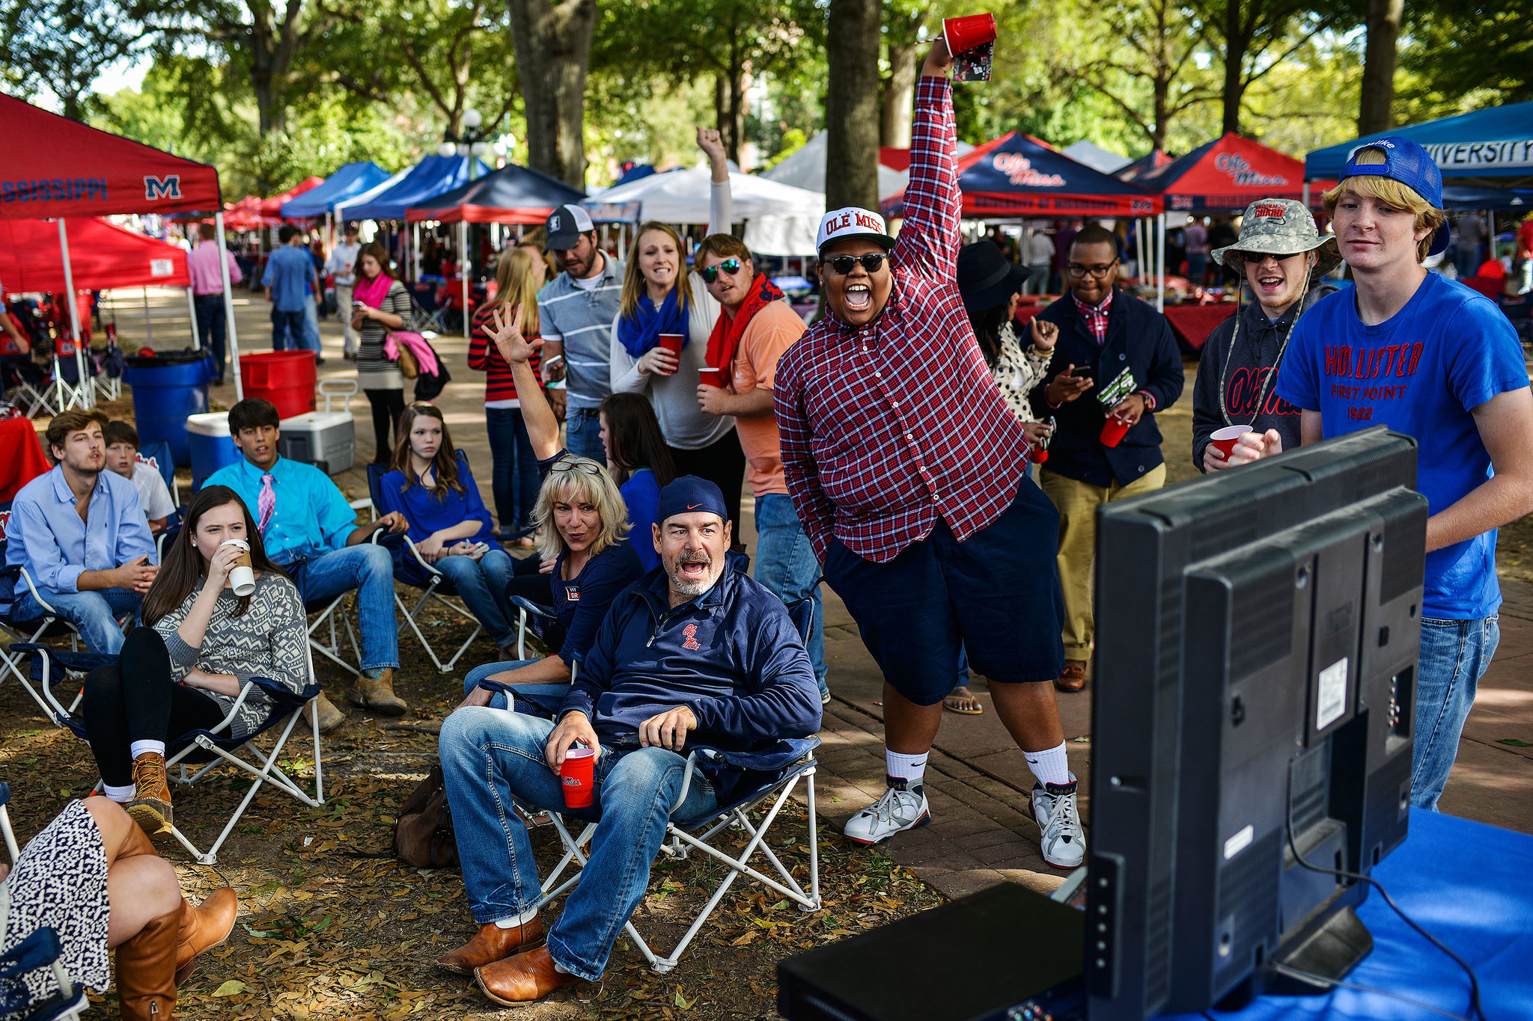 Not all fans make it into the stadium to watch the game. But they cheer anyway. An estimated 2,500 tents were erected for Saturday’s game between No. 7 Mississippi and No. 4 Auburn.
The Grove is 10 acres of mature oak and maple trees in the center of campus. For years fans drove into the Grove to share food and drink before games. Then, in 1991, the rules were changed to prohibit vehicles. Soon, fans started walking into the area with their provisions instead, establishing the roots of the scene we see today.
The university is deeply invested in this party, which can attract more than 100,000 of its most loyal supporters and curious visitors on any given weekend. It budgeted $750,000 this year for seven home games, said Larry Sparks, the vice chancellor for administration and finance.
The amount, which will probably be increased, covers things such as security, parking, transportation, custodians, postgame cleanup, trash-bin rentals, portable toilets, trash bag distribution and setup for the Hotty Toddy Potty trailers.
Yes, Hotty Toddy Potties. They are essentially classy restrooms on something like an 18-wheeler platform. The university deploys eight full-size units (the two most recent purchases cost $71,000 each; six older ones cost $50,000 each) and three Hotty Toddy Potty Jrs. It also rents 211 regular toilets and 10 handicapped-accessible toilets for game day.
 Fans packed the Grove, a 10-acre area of mature oak and maple trees in the center of campus.
There are restrictions. Rules control how alcohol is consumed and stored. For example, virtually all drinking is from red and blue cups — no beer cans or bottles. If coolers are not being watched, they must be locked to prevent minors from opening them.
Vehicles are not allowed to linger. Barbecue pits are limited. There are decibel limits on generators. Propane tanks are banned. If you try to run an extension cord from your tent to a building, a university worker will remove it.
The police would rather assist than arrest, and generally keep a respectful distance. One campus police officer compared his colleagues with the city police, saying, “We are the kinder, gentler police.”
Southern Hospitality
In many tents, food is served on silver trays, drinks splash through fountains and chandeliers hang from the metal supports. Fur coats abound. Jackets, ties and cowboy boots are common.
Prominent chefs are hired to cater meals, and chicken is a favored entree. “You don’t want to be a chicken in northern Mississippi on game day,” said Tim Walsh, the executive director of alumni affairs.
The tents themselves can be fashion statements. Some fans hire interior decorators. One tent on the Walk of Champions (the Grove’s Main Street) is painted with zebra stripes. One of its owners is Jane Foster, a converted Mississippi State fan. She brings in a rock band once a year.


Before the Oct. 4 Alabama game, fans prepared a spread of food.
“We never lose a party here at Ole Miss,” she said.
Eight others are zebra tent regulars, each paying $300 a year for setup.
At the Lyceum tent, Ty Bauer runs the show with help from his wife, Lee Ann. The tent got its name from the scale model of the Lyceum (administration building) that Bauer uses to hold and transport four TVs and liquor. The Bauers provide the liquor and the caterer. For the Alabama game, he spent $1,400 for 52 gallons of alcohol. He said he averaged $1,600 to $1,700 a game for food and liquor. Since his job involves hosting out-of-town visitors, he writes off some expenses.
Preparations for another tent, known as the Real Thing Tailgate, require a spreadsheet. Lamar Waddell handles the planning for the seven couples involved. Several hundred guests pass through the tent on any given Saturday. It recently had visitors from Italy, Holland, England, Argentina and Brazil.
Since the Grove is in the heart of the South, manners and hospitality prevail. Visiting teams’ fans are often surprised when strangers invite them into a tent for a beer or lunch. But it goes only so far.
“We have fans from every opposing team each weekend in this tent,” Waddell said before the Alabama game. “Right now there are at least four or five ’Bama fans. Here, hospitality reigns. Over there in the stadium. ...” He shook his head no and made the sign of slitting a throat.
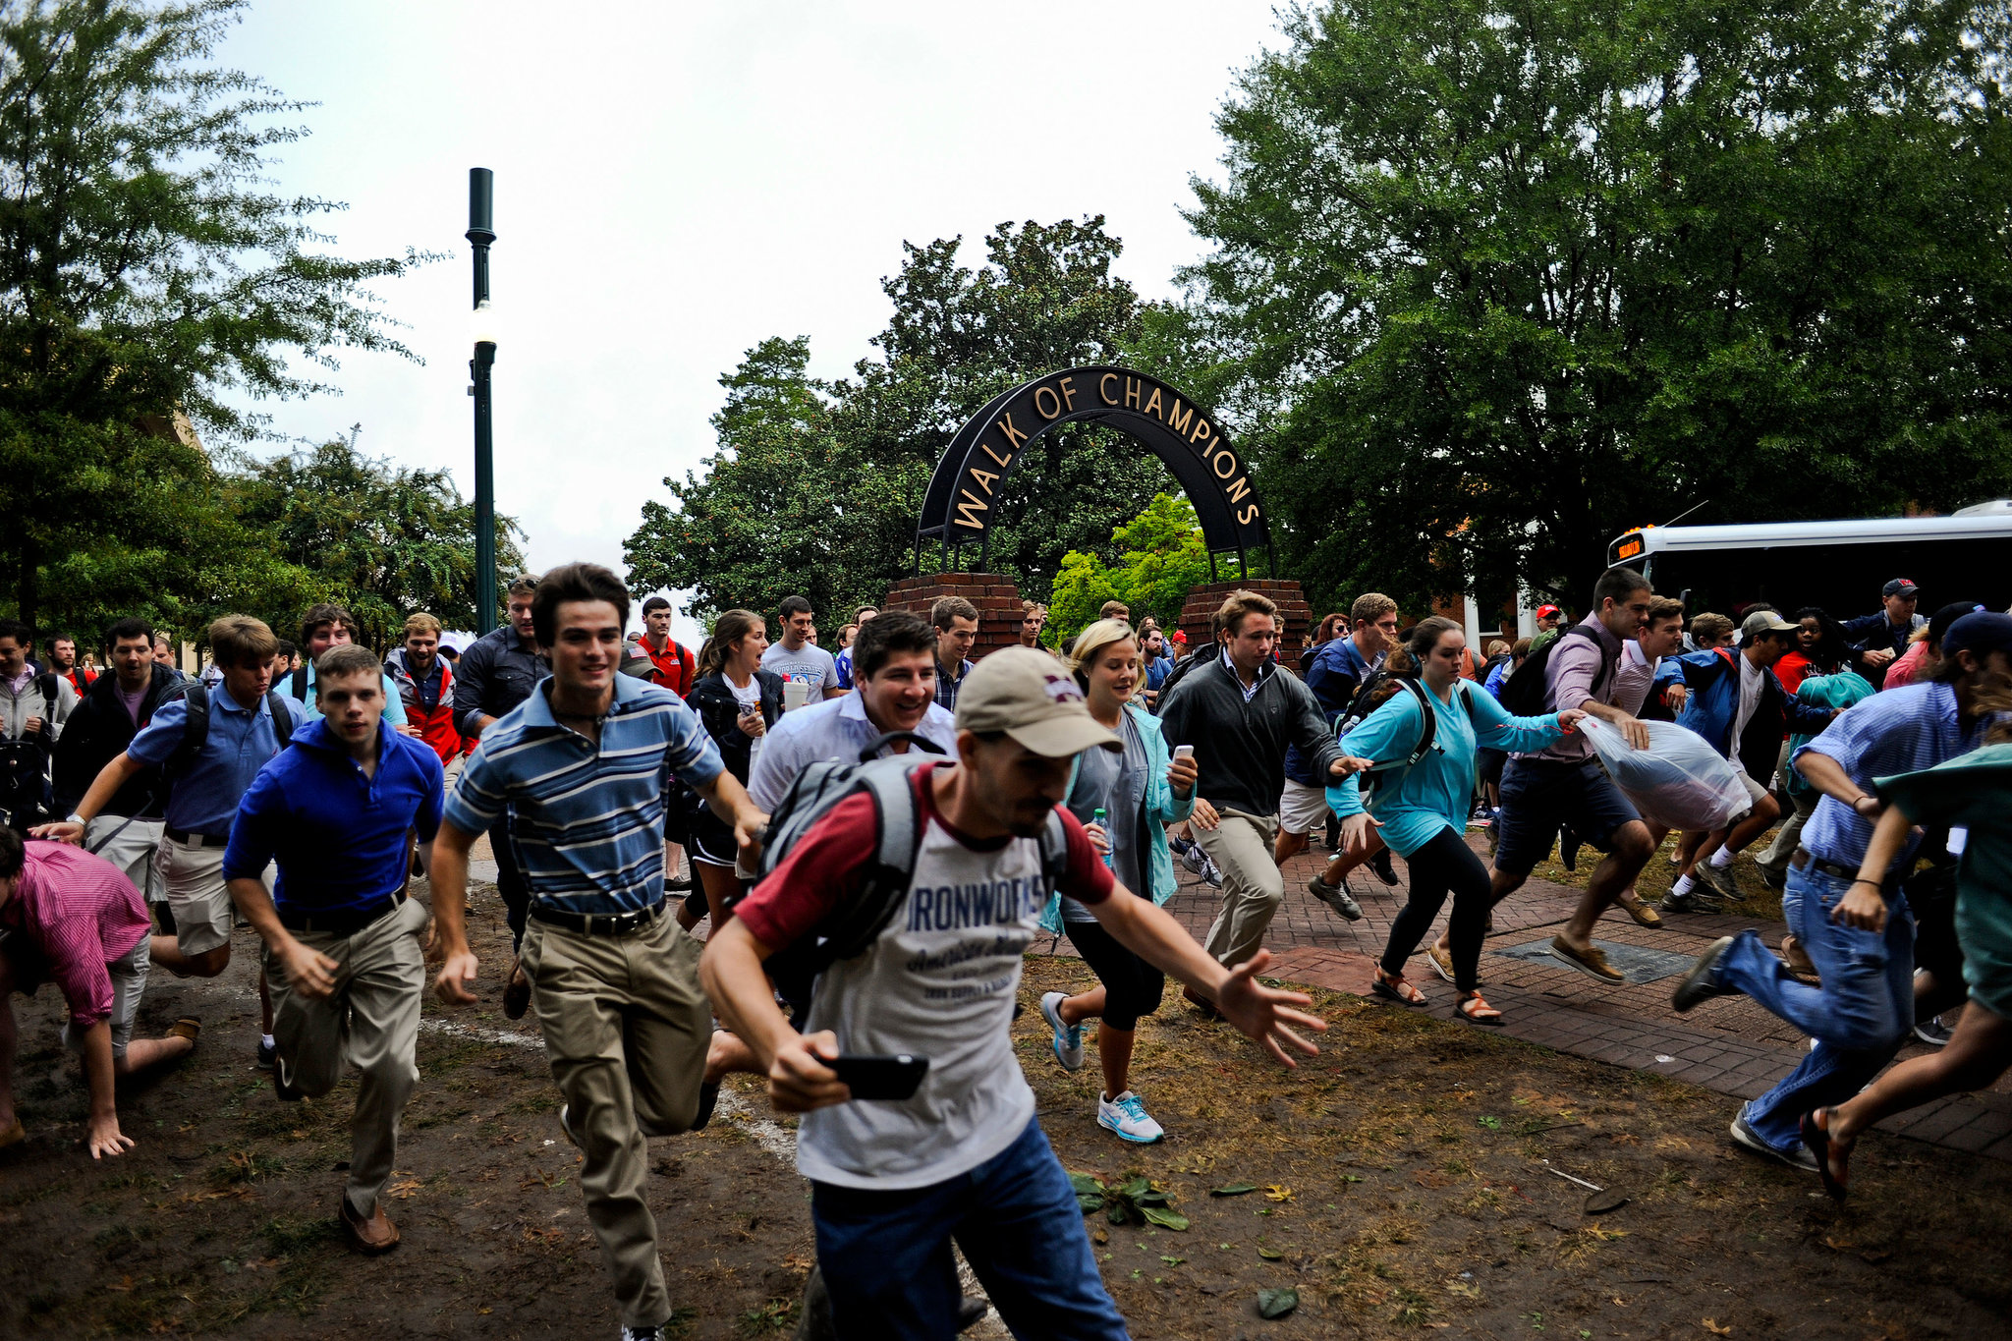 Minutes before 9 a.m. on a Friday before a game, students and alumni were allowed to storm the grove to try to reserve their tailgating spots.
Tent City
The tents, usually 10 feet by 10 feet, pop up overnight, often erected by companies hired for the task.
Before the tents are erected, however, their owners must follow rules. The process begins with occupants claiming their tent locations Friday morning (sometimes as early as 3 a.m., depending on the opponent). Students and others hurry into the Grove to stake a claim on a site their family or employer has occupied for years.
“It’s kind of like church,” Christy Knapp, a member of the Real Thing Tent, said of Grove etiquette. “You don’t sit in someone else’s pew.”
Spot savers arrange red and blue garbage barrels to help define their area. Trees also serve as markers. The spot savers, paid $8 to $10 an hour, cannot bring in chairs; they stand, sit or recline on blankets and hold the places until the tents are set up that night.
Around nightfall on Fridays before game days, the expectation builds and the crowd grows. At 8 p.m., a siren blares and out of the dark charges a caravan — pickup trucks, trailers, golf carts, men running — all hauling tents down University Avenue in what one tent provider described as a free-for-all.


Janna Hughes, class of 2006, sporting a sticker before the Oct. 4 Alabama game.
Joe Bynum runs one of the smaller tent operations, handling three locations all season and several others for Southeastern Conference games only. In his full-time job, he is an assistant road manager for the county.
Bynum’s prices: $100 to set up a 10-by-10 tent; $200 for a 10-by-20 tent; $10 for a table; a dollar or two per chair; $20 for a cooler with ice. He pays $150 for a vendor pass, which allows him to operate in the Grove. Customers typically own the tents, and Bynum stores them.
“I’m very content as a small vendor,” he said. “I’ll gross $11,500 this year and that will be fine.”
One of the largest vendors is SevenSouth Tailgating. Operated by the husband-and-wife team of Jordyn and Kyle Thornton, the company erected 326 tents the night before the Alabama game in October. The six-year-old company has more than 116 season clients and about 30 more who employ them game by game. Kyle declined to discuss the company’s revenue.
The Thorntons hold preseason training so their employees know client spots and how to put up the tents.
 Fans lined the Walk of Champions and cheered the Ole Miss football players as they made their way through the Grove for a game against Alabama in early October.
The Cleanup
When the university needed someone to handle its landscaping services in 2000, it turned to Jeff McManus, then with the Turnberry Isle Miami resort.
His crew has one especially large chore: cleaning up after the all-day Saturday binge, which produces dozens of tons of garbage. By 8 a.m. Sunday, the 10 acres are pristine again.
For many years, Grove cleanup started at 7 a.m. and ended at 4 or 5 p.m. Sunday, which was tough on the staff. “There was a lot of mental angst, and it weighed heavy on the crew,” McManus said.
Then the university decided to turn to local nonprofit organizations. Today, the Baptist Student Union, midshipmen from the Naval R.O.T.C. and high school baseball players are regularly on cleanup duty.
The biggest cleaning effort of the season so far came after the Alabama game. McManus said his crew arranged for 185 people to assist. “We started at 10 p.m. and finished in three hours,” he said. The total haul — 90 tons of trash — was a record, exceeding the 87 tons after the Texas game in 2012.
All this tidying does not come cheap. The cleaning bill for the 2013 season was $37,746. Annual landscape maintenance in the Grove is $53,120. But no one seems eager to show restraint. The Rebels are thriving, so the fans are happy and eager to outdo themselves at the Grove each weekend.
“The Grove for Ole Miss people is a spiritual place,” the former chancellor Robert Khayat said. “But on football game weekends, it becomes Mississippi’s No. 1 social event.”

Dilbert's Blog
My iPhone 6 Plus Review
by Scott Adams
After a month-long wait - and salivating the entire time - I finally got my iPhone 6 Plus. I don't know how Apple manipulates my emotions so effectively but I am thoroughly impressed at the mental anguish they put me through while I waited.
My heart was racing as I removed the phone from its strikingly well-designed packaging. Apple makes the process of opening a box feel as if you are winning a prize. Every color, shape, texture and probably smell has been studied and tweaked to perfection. Simply touching the product or its associated packaging is a tactile joy.
The experience of getting the iPhone 6 Plus was like getting a puppy. From my first touch of the sleek, sexy miracle of technology I was hooked. I loved it before I even charged it up.
It was large in my hand, and slippery to hold, but I didn't mind. That would be like complaining that my newborn baby was too heavy. This phone is pure art and emotion frozen in a design genius so subtle that competitors probably can't even duplicate it. It was pure beauty. Sometimes I found myself just staring at it on the desk because I loved it so. Oh, and it works well too.
But I needed a case. I tried to imagine my anguish if I accidentally dropped this new member of my family and cracked it. I needed protection.
So I went to the Verizon store and bought the only cover they had left that doesn't look like a six-year old girl's bedroom wall. The color of my new case could best be described as Colonoscopy Brown. It is deeply disturbing. But because I love my iPhone 6 Plus, and want to keep it safe, I put it on.
Now my phone is not so much a marvel of modern design. Nor would I say it is nourishing my soul with beauty and truth the way it did when naked.
Now it just looks like a Picasso that three hundred homeless people pooped on. You know there's something good under there but it is hard to care. Now when I see my hideous phone on my desk I sometimes think I can hear Siri beg me "Look away! Look away!"
So Apple sold me pure beauty but they cleverly put a short fuse on it so I would cherish the fleeting memory even more. They knew I would need a case, and they knew my phone would look terrible in it. But I still have that sweet memory of the day I removed the virginal phone from its packaging and saw it in all its natural beauty. Even then I knew that I would need to cover this sensual work of art with the equivalent of a phone burka just to keep my hands off it. I will not see my naked phone again until the day I upgrade and scrape away its rotting case. But I will always cherish the memory of my first look of the iPhone 6 Plus.
Beauty needs to be temporary to be appreciated. I think those magnificent bastards at Apple know that. I think they made the case slippery by design. They want you to know that if you keep your phone selfishly naked, and try to hoard the beauty that is designed to be temporary, that phone will respond by slipping out of your hand and flying to its crackly death on a sidewalk.
THAT, my friends, is good design.

Jewish World Review
Since Tamiflu Is (Apparently) Not Working, Here Are Some Natural Flu Remedies Instead
by Justin Caba

Neuraminidase inhibitors including Tamiflu and Relenza are recommended by government health agencies for treating and preventing symptoms of the influenza virus in both children and adults. A review conducted by the Cochrane Collaboration has now revealed these treatment options may cause more harmful side effects compared to their ability to reduce and prevent flu-like symptoms.
“We now have the most robust, comprehensive review on neuraminidase inhibitors that exists,” said Dr. David Tovey, editor-in-chief at Cochrane, in a statement. “Initially thought to reduce hospitalizations and serious complications from influenza, the review highlights that Tamiflu is not proven to do this, and it also seems to lead to harmful effects that were not fully reported in the original publications. This shows the importance of ensuring that trial data are transparent and accessible.”
Back in 2009, researchers from Cochrane attempted a thorough review of Tamiflu and Relenza including their overall effect on the health of influenza patients. Unfortunately, results of the trial were inconclusive due to a lack of data access. In light of the failed assessment, health policy agencies on state and government levels made the decision to stockpile the drug, a decision both the British Medical Journal and Cochrane are trying to dissuade via this most recent review. Following the H1N1 virus outbreak back in April 2009, use of Tamiflu, Relenza, and other influenza drugs have seen a dramatic increase in the United States and the United Kingdom.
“Drug approval and use cannot be based on biased or missing information any longer. We risk too much in our population’s health and economy,” the research team leading the Cochrane Neuraminidase Inhibitors Review explained. “This updated Cochrane review is the first time a Cochrane systematic review has been based only on clinical study reports and regulator’s comments. It is the first example of open science in medicine using full clinical study reports available without conditions. And therefore the conclusions are that much richer."
Researchers involved with Cochrane Neuraminidase Inhibitors Review recruited 24,000 individuals to participate in a total 46 clinical trials. In 20 trials involving Tamiflu, adults and children were either given a dose of the drug or a placebo. The same experiment was carried out in 26 trials involving Relenza. The Cochrane Neuraminidase Inhibitors Review research team set out to determine each drug’s effectiveness in preventing influenza complications, hospitalizations due to influenza, and any side effects caused by the drug.
Although Tamiflu and Relenza were able relieve flu-like symptoms in adults by only half a day, there was no foreseeable difference in children. The two drugs also had no effect on hospitalizations caused by influenza complications such as pneumonia, bronchitis, or sinus and ear infections. Of the patients who were given doses of Tamiflu or Relenza, the risk of nausea and vomiting increased by four percent in adults and five percent in children. Some of the participants also experienced certain neurological side effects, including headaches and psychiatric episodes. Results of the analysis were attributed to the drugs cutting off the body’s supply of antibodies for the purpose of fighting infection.
“We urge people not to trust in published trials alone or on comment from conflicted health decision makers, but to view the information for themselves,” the research team added.
There are certain household treatments people suffering from flu-like symptoms can apply in order to achieve a natural remedy. For example, our best defense against any bodily ailment is staying hydrated. Drinking and avoiding alcohol, coffee, and soda can go a long way in maintaining a healthy immune system. With its anti-inflammatory properties, chicken noodle soup can also serve as a natural, at-home remedy for boosting the movement of immune system cells. Lastly, avoid dry places where cold viruses thrive and seek humidity. Adding moisture to your home via a humidifier can prevent a stuffy nose and scratchy throat by dampening our airways' mucous membrane.

Fight Aging
Dementia as a Consequence of Many Small, Unnoticed Strokes
Dementia can result from age-related damage to the white matter in the brain, known as leukoaraiosis or white matter hyperintensities. Here researchers look at the source of this damage:
Quote:
Approximately 50 per cent of older individuals have evident white matter damage on their medical imaging scans. For most patients, these changes are harmless but when this damage is severe, it can cause impairment. Previous studies have already established that the more white matter disease there is in the brain, the more likely patients are to have symptoms of dementia such as cognitive impairment or changes in behaviour. What was not understood is why this white matter disease develops - the traditional assumption was that it might be the result of the natural aging process.
The researchers conducted an intensive study to observe the development of this white matter disease over a short period of time, rather than on an annual basis - the interval at which previous studies have performed repeat brain imaging. The study involved 5 patients with white matter disease undergoing detailed MRI scanning of their brains every week for 16 consecutive weeks. The weekly MRI scans revealed new tiny spots arising in the brain's white matter that were, based on their MRI appearance, characteristic of small new strokes (cerebral infarcts). The lesions had no symptoms but, with time, came to resemble the existing white matter disease in the subjects' brains. In the study's random sampling, the majority of subjects had this phenomenon: Tiny strokes occurring without symptoms, and developing into the kind of white matter disease that causes dementia.
"The findings suggest that the tiny, silent strokes are likely much more common than physicians previously appreciated, and these strokes are likely a cause of the age-related white matter disease that can lead to dementia. We don't yet know whether these small strokes are responsible only some or most of the white matter disease seen in older patients. But in those where it is the cause, the detection of white matter disease on brain imaging should trigger physicians to treat patients aggressively when managing stroke risk factors such as high blood pressure, diabetes, high cholesterol, cigarette smoking and lack of exercise not only to prevent further strokes, but also to reduce the development of cognitive impairment over time."

US Naval Institute
U.S. Pilots Say New Chinese Stealth Fighter Could Become Equal of F-22, F-35
by Dave Majumdar
China’s new Shenyang J-31 stealth fighter — making its debut next week at the Zhuhai international airshow — could eventually become more than a match for American stealth fighters in battle, several U.S. military and industry officials told USNI News.
The J-31 is China’s latest crack at developing a modern so-called fifth-generation stealth fighter — equivalent in ability to Lockheed Martin’s F-22 Raptor or F-35 Lighting II Joint Strike Fighter.

“They’re still in the glossy brochure phase of development, so they still look ten feet tall and bulletproof,” one senior U.S. fighter pilot familiar with the F-35 program told USNI News.
“I think they’ll eventually be on par with our fifth gen jets — as they should be, because industrial espionage is alive and well.”
Many suspect the J-31 is designed using technology stolen from the Pentagon’s nearly $400 billion Lockheed Martin F-35 Joint Strike Fighter program.
“They sure look like F-35 and F-22s don’t they?” one Air Force operational test pilot told USNI News.
The senior U.S. pilot familiar with the F-35 — who has extensive experience flying the Lockheed Martin F-16 Falcon — told USNI News the Chinese jet is now likely more than match for existing fourth generation non stealth American fighters like the Air Force Falcons, Boeing F-15 Eagles and the U.S. Navy’s F/A-18E/F Super Hornet.
“They’ll probably be a handful right off the bat for all of our fourth gen stuff,” the pilot said.
One former Air Force fighter pilot extensive experience with foreign hardware told USNI News potential air battles might be more about sheer number of jets the Chinese might be able to put into the air versus the superior training of U.S. pilots.
“I worry about numbers more than particular platforms,” the former fighter pilot said.
“I imagine their jets and their weapons are pretty good. Don’t know about the pilots or their capacity to employ.”
Further, the retired pilot noted, airshows are designed to show off weapons to potential buyers, but offer no real information about what jet can really do during an actual combat mission.
“Just remember that airshows are exactly that — airshows.” the former pilot said. “Airshows provide no real clue to capabilities. As such, airshows generally rely on spectacular maneuvers to garner attention without providing substance. No different from the F-15C or the F-22.”
One current Air Force test pilot told USNI News that it would be difficult to gauge just how good the Chinese jet will be.
“Overall at this stage they’re not [operational] so it’s hard, for anyone to truly make a reasonable assessment,” the test pilot said.
There are still many unanswered questions about how the Chinese will operate their aircraft and what kinds of weapons the jets will carry. Perhaps the most important question is how good are the Chinese radars and other sensors compared to their American equivalents.
“How well will organic sensors work to support those weapons?” the test pilot asked rhetorically.
For U.S. industry officials, the J-31’s debut at the Zhuhai airshow signals that the Chinese are planning on selling the jet on the open market.
“I would characterize the J-31 flying at the Chinese airshow as ‘incremental and measured,’” a senior industry official told USNI News.
“There have been some reports that the J-31 maybe be exported. If so, then showing it off makes even more sense to attract prospective buyers,” the official said.
The Chinese are making a lot of progress in developing their aerospace industry.
However, jet engines remain a weak spot for China.
“They have yet to field many of their “new” designs in any quantities,” the industry official said.
“Time will tell.”
Meanwhile, the Russia’s advanced Sukhoi Su-35 Flanker-E is also making it debut at the Zhuhai airshow.
The Chinese are reportedly interested in the purchase of 24 examples of the modernized Russian-built jet.
There has been much media speculation that the Chinese intend to reverse engineer the aircraft as they have with previous Flanker variants.
“I view the Su-35 buy as a conservative stop-gap measure while they wait for the J-20 and J-31 to enter service,” the industry official said.
“Gotta have aircraft to have an air force.”

WSJ
Malls Fill Vacant Stores With Server Rooms
Empty Department Stores Are Converted Into Data Centers; ‘Who Else Wants Them?’
by Drew FitzGerald and Paul Ziobro

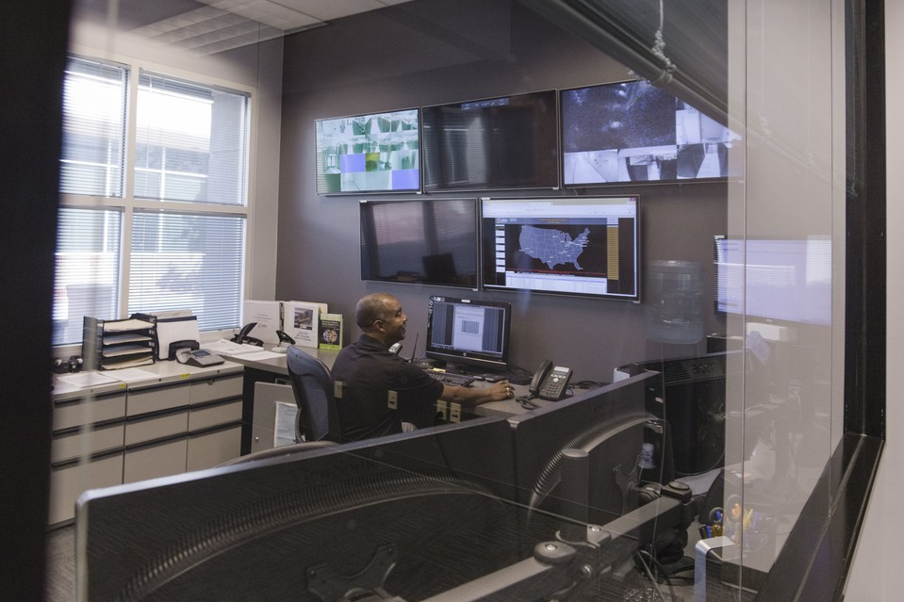
Zayo Group runs a data center and interconnection hub from part of Phoenix’s Park Central mall, which is now mostly used by office tenants.

The Internet is moving to a shopping center near you.
In Fort Wayne, Ind., a vacated Target store is about to be home to rows of computer servers, network routers and Ethernet cables courtesy of a local data-center operator. In Jackson, Miss., a former McRae’s department store will get the same treatment next year. And one quadrant of the Marley Station Mall south of Baltimore is already occupied by a data-center company that last year offered to buy out the rest of the building.
As America’s retailers struggle to keep up with online shopping, the Internet is starting to settle into some of the very spaces where brick-and-mortar customers used to shop. The shift brings welcome tenants to some abandoned stretches of the suburban landscape, though it doesn’t replace all the jobs and sales-tax revenue that local communities lost when stores left the building.
Venyu Solutions LLC, a data-center operator that is renovating the former department store in Jackson, sees more opportunity for conversion because of sheer amount of distressed retail properties. “Who else wants them?” said Brian Vandegrift, the company’s executive vice president of sales. “You’re not competing with people in substantial businesses who want those spaces.”
Many malls and neighborhood shopping centers are still grappling with vacancies five years after the recession. The average mall vacancy rate hovers around 5.8%, according to market researcher CoStar Group, the same level as in the third quarter of 2009. Strip-mall vacancy sits at 10.1%, down from 11.5% five years ago. Rents are down too. Asking rents at malls have fallen 16% over the past five years, while strip mall rents declined 12%, according to CoStar.

For companies that house the equipment that makes online shopping possible, however, business is booming, helped by surging volumes of Internet traffic. Revenue from the biggest data-center operators is expected to increase 15% this year, according to tech consultancy 451 Research.
Deepak Jain, the chief executive of data-center operator AiNET, bought a former Boscov’s department store in 2012 at Marley Station Mall, a shopping center south of Baltimore where Macy’s , Sears, and J.C. Penney still operate as anchor tenants. Last year, Mr. Jain offered to buy out the rest of the mall but said he was rebuffed.
In scouting properties, Mr. Jain said the most attractive real-estate prices are often in middle-class neighborhoods where many consumers have turned to online shopping. “The Internet helps serve that dislocation, and there’s no trend in sight that seems to change that,” Mr. Jain said.
Operators like AiNET and Venyu aren’t the first landlords to pack server stacks where clothing racks once stood. Midwestern data-center operator Cosentry Inc. turned a half of a vacant J.C. Penney store in Omaha, Neb., into a data center more than a decade ago. A PayPal office moved into the other side.
Zayo Group Holdings Inc. runs a hub for Internet providers’ connections from part of Phoenix’s Park Central mall, which is now largely an office park.


Zayo Group runs a data center from part of Phoenix’s Park Central mall.
Converting retail properties isn’t simple, however. Data-center operators have specific needs for their properties including access to heavy-duty fiber optic communications cables and reliable and affordable power access. The buildings need to be able to withstand tumultuous weather, from hurricanes to tornadoes. Windows are a negative.
For those reasons, the former big-box real estate locations are appealing though they are used by the less-demanding “retail” end of the data-center market that serves clients like local hospitals and law firms, which only need a few square feet of space to back up critical documents.
Venyu is in talks with a company that “mines” virtual currencies like Bitcoin by performing massive calculations around the clock for space in its converted mall in Baton Rouge, La. “We’re wanting to make sure he’s going to pay us with U.S. currency,” Mr. Vandegrift said.
Many websites aren’t likely to move into the shopping center down the street. Big brands like Amazon.com Inc. and Google Inc. are more likely to use custom-built server farms.
Equinix Inc., the country’s biggest independent data-center operator by revenue, avoids active malls because they don’t offer the kind of built-in security its customers need. Tenants like restaurants that use fire would represent a liability, said Charles Meyers, the company’s chief operating officer.

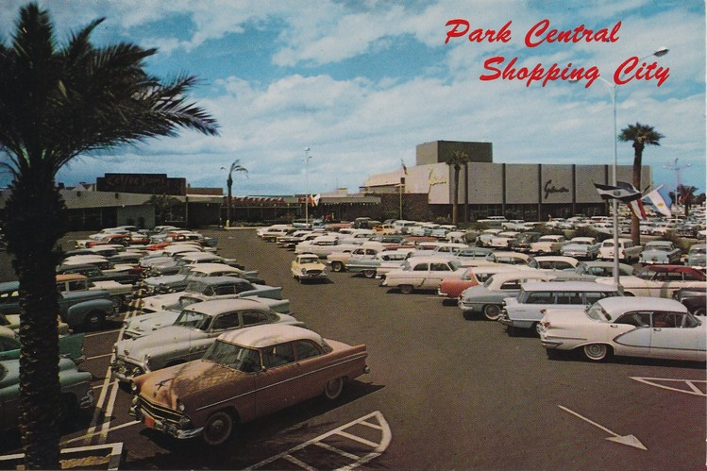
Phoenix’s Park Central mall, which was built in 1956, is now mostly used as office space. Shown, an undated postcard a few years after it opened.
Sears Holdings Corp. set up a new unit last year to try to sell excess space from its auto centers to telecom companies but has yet to find a customer.
And while data centers bring much needed occupants to often deserted locations, they aren’t restoring employment levels. Venyu plans to hire about 30 people for its new location in Jackson, Miss. The local department store employed twice as many.
In Fort Wayne, Lifeline Data Centers LLC said it would hire about 10 people to work in the 110,000 square foot space. That compares with roughly 90 when it was a Target store.
Lifeline’s investment will create months of construction work as it seeks to upgrade the property it bought in September that Target vacated nine years ago.
Rich Banta, a Lifeline co-founder, said Lifeline will spend $3.2 million, more than three times the price for the location, to fortify the walls with concrete and add steel girders to the roof to withstand tornado strength winds up to 130 miles an hour.
The company has done it before. In 2008, Lifeline bought an abandoned shopping mall in Indianapolis with the plan to level the building and build up the 41-acre site. But it turned out part of it was a fallout shelter in the 1950s, making that section suitable for servers.
Mr. Banta said the location of the Fort Wayne site—more than a half mile away from a highway, rail line or river, 5 miles from an airport and outside a flood zone—was what made it attractive. “By the time you’ve done all that vetting, most sites don’t fit that criteria,” he said.
The location happens to be across the street from a McDonald’s and a recently closed Kmart.

Slate
What’s Up With That: Boarding Airplanes Takes Forever
by Nick Stockton
I was at the airport last week, and all I wanted to do was sit down, strap in, and lift off. Of course I couldn’t, because there were a bunch of people standing in my way. As the line crept along, I scanned ahead for malingerers, but everyone seemed sufficiently ready to board. I couldn’t help but wonder, is there a more efficient way for airlines to put get our butts into our seats, and into the air?
Millions of other people probably have pondered this question. At least one wrote a computer program to find the answer. Jason Steffen is an astrophysicist at Northwestern University, and several years ago he modeled different airline boarding methods to see what made them so slow. He also figured out how airlines could get us on board much faster.
Most airlines board back-to-front, an approach that makes sense, at first glance. But Steffen argues boarding back-to-front is actually one of the worst ways to board a plane. The problem, as he sees it, is this method creates traffic jams as people stuff their stuff into the overhead bins above their seats. Even if the line were perfectly ordered, only one or two people at a time would be able hoist their bags into the bins. Meanwhile, those who share their row wait behind them, blocking the overhead bins for several rows.
In his model, Steffen started with the assumption that people would automatically move ahead until they ran into the person in front of them, or reached their row. Gaps closed fast, but the line moved slowly, as simulated passengers waited for space to load their gear. He says that even if the first people in line were seated in the last two rows of the plane, only a few would be able to put their luggage away at a time. Everybody else would wait. “All you have done is move the line from outside to inside the airplane,” Steffen told WIRED. “But the line doesn’t move any faster.” In fact, it turns out that the boarding time is almost exactly the same as boarding from the front to the back.
Steffen figured people would need to be manipulated in order to leave buffers between themselves and the people blocking their seats. So he started experimenting with rearranging the line by seat number. He ran his simulation ran over and over, and each time it switched the boarding order of two random passengers: If the plane boarded faster, it kept the switch. If the plane boarded more slowly, it switched them back. Then, the program ran again, switching another random pair. And again. And again. Each time, it moved closer to the optimal boarding order.

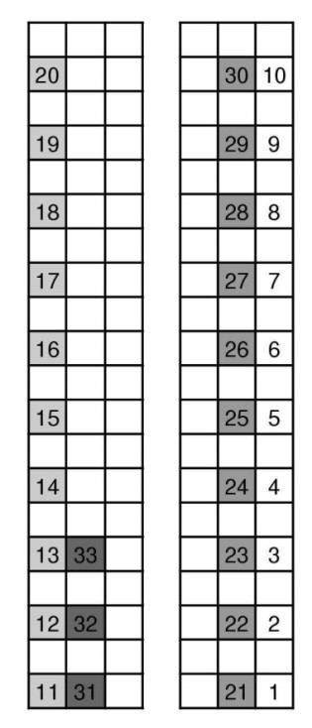
Skipping a row between each seat to board is the fastest way to get the plane in the air.
Eventually a pattern emerged. The first person in line should be in the back row, window seat (on either side of the plane). The next person would be in a window seat, two rows up. The line should proceed this way, skipping a row between each window-seated passenger all the way to the front of the plane. It would repeat this on the other side, then start filling the window seats in the empty rows between those already filled. The pattern repeats for the middle seats on each side, then the aisles.
According to Steffen’s calculations, his method boards at least five times faster than back-to-front (though this varies based on the size of the plane). And it didn’t only work in the model. A few years ago, Steffen’s method was tested on the web show This Vs. That, where it beat five other methods (the full episode is behind a paywall).
Airlines have tried a variety of tricks to hasten boarding, and Steffen isn’t the first mathy person to offer a promising solution. But to date, Steffen says only Virgin America has contacted him, and nothing came of it. The problem with his model, he admits, is that it does not account for human nature. For example, it’s hard to imagine people who are traveling together who would be willing to split up, just to stand in line (especially if that group contains small children). Add that to language barriers, people running late, and the overall difficulty in getting large groups to follow complicated directions, and it’s easy to see why Steffen’s idealized boarding model hasn’t been adopted. “It does require a bit of control over the passengers that I don’t think airlines really have,” he said.
Almost every airline uses some variation on back-to-front, either with or without zones. A few of the other methods are outside-in, used by United Airlines, and the free-for-all boarding of Southwest Airlines. Steffen says Southwest’s method is better than back-to-front, but still crippled by the fact people choose their own seats, and therefore create clusters that cause traffic jams. Truly random boarding, he says, would work pretty well.
Having learned this, I’ve resigned myself to slow, inefficient airplane boarding lines. And maybe this will make your airport waits a little less stressful during the impending holiday season. Steffen is undeterred, and says he is currently mulling over faster ways to move people through TSA checkpoints.

ARS Technica
LED bulb efficiency clearly pulling ahead of compact fluorescents
Lumens per Watt now in the area of 100. It's 15 for incandescents.
by John Timmer

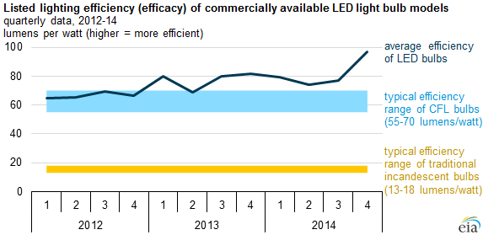
US EIA
A few years back, when I got my first LED-based lightbulb, it seemed natural to stick it into a wattmeter to get a sense of its efficiency. At under 15 Watts of power drawn, it clearly beat any incandescent bulbs I'd ever put into the same lamp. But I was disappointed to find that it wasn't any better than a compact fluorescent bulb.
Based on the graph shown above, my experience was hardly unique; in fact, it was decidedly average. Although the technology behind LEDs had the potential to be far more efficient than any other lighting source, the complete LED bulb package wasn't doing that much better at the time than the far more mature fluorescent bulbs, which output roughly 60 lumens for every Watt put in.
After some small boosts in 2013, however, a new generation of more efficient LEDs hit the market this year, raising the typical efficiency to nearly 100 lumens per Watt. The increased efficiency is coming at a time when prices for the bulbs continue to drop; given their expected lifetimes, they're now far and away the most economical choice for most uses.
The graph also nicely displays why incandescents have been booted off the market for a failure to achieve sufficient efficiency, as they have flatlined at around 15 lumens per Watt.









