October 5, 2014

So the students at a nothingburger college in Vermont invite a convicted cop-killer to be their graduation speaker. Pickerhead always said free speech makes it easy to spot the idiots. David Harsanyi posts on the controversy.
The perverted habit of glorifying people like Mumia Abu-Jamal has been part of tedious campus “radicalism” for the past 45 years. Still, I can’t get too worked up over the fact that a bunch of twits at Goddard College invited a murderer to their school. For one, these sorts of incidents help me compile a list of schools for my kids to avoid.
What is interesting, though, is how academics and administrators continue to rationalize moronic behavior:
“As a reflection of Goddard’s individualized and transformational educational model,” Goddard College Interim President Bob Kenny explained, “…choosing Mumia as their commencement speaker, to me, shows how this newest group of Goddard graduates expresses their freedom to engage and think radically and critically in a world that often sets up barriers to do just that.”
Oh, where to begin? ...

American Interest on the transformative power of shale.
Eleven years ago, energy majors Qatar Petroleum, Exxon Mobil, and Conoco Phillips came together to construct a $2 billion liquified natural gas import facility in Texas. The enormous Golden Pass terminal was meant to regassify liquified gas being shipped overseas, but lately it hasn’t seen much action. Thanks to the shale boom, the United States is flush with natural gas—fracking has destroyed the need for imports. Now, in an attempt to salvage some of their investment, Exxon Mobil and Qatar Petroleum are investing an estimated $10 billion in converting the import facility into one suitable for gas exports. ...
... You’d be hard-pressed to find a better example of the disruptive power of shale energy. ...

The Chamber of Commerce says the shale boom makes the US the world's top petroleum producer.
The International Energy Agency confirms what we’ve known for a while: The United States is the world’s top petroleum producer. The American Interest’s Walter Russell Mead quotes from a Financial Times story [subscription required]:
"US production of oil and related liquids such as ethane and propane was neck-and-neck with Saudi Arabia in June and again in August at about 11.5m barrels a day, according to the International Energy Agency, the watchdog backed by rich countries.
With US production continuing to boom, its output is set to exceed Saudi Arabia’s this month or next for the first time since 1991. [...]
Rising oil and gas production has caused the US trade deficit in energy to shrink, and prompted a wave of investment in petrochemicals and other related industries. [...] It is also having an impact on global security. Imports are expected to provide just 21 per cent of US liquid fuel consumption next year, down from 60 per cent in 2005. ..."

While we're having a boom, Europe is pretending to be green. American.com with the story.
“Germany produces half of energy with solar.” That was the recent headline on a German website of news in English, and it would have duly impressed anybody whose understanding of energy matters extends to just such headlines. But the headline, totally wrong, was also a perfect example of why it is so important to deconstruct the reports about green Europe.
Analysis by the Fraunhofer ISE research institute showed that the recent peak of Germany’s solar energy usage lasted for only 1 hour, and that the record share (50.6 percent) was due not only to hot, sunny weather but that day being a public holiday with lower than normal demand — and, most fundamentally, to the fact that solar and wind have legal priority over fossil fuels and when available must be used to the maximum possible extent. But the key error of that headline’s claim is that it was not half of energy use (Energieverbrauch), it was half of electricity production (Stormerzeugung). And in Germany, as in any modern economy, electricity accounts for only a fraction of overall energy use, known as total primary energy supply, which consists of all fuels (be they fossil or biofuels) and all electricity produced by nuclear reactors, water and wind turbines, solar photovoltaics (PV), and geothermal steam.
So how green is Germany’s and Europe’s energy supply in reality? ...

Nature tells us about new maps of the ocean floor provided by satellites.
As though someone had pulled a plug in the oceans and drained them away, a sea-floor map has exposed thousands of never-before-seen underwater mountains and ridges. The map — generated by the highest-resolution gravity model ever made for the oceans — will guide deep-sea research for years to come.
An international team of researchers led by David Sandwell, an oceanographer at the Scripps Institution of Oceanography in La Jolla, California, publishes the map in the 3 October issue of Science. The team created it using data mostly from two satellites: CryoSat-2, from the European Space Agency, and Jason-1, from NASA and the French space agency CNES.
Both satellites sought to chart the planet, but with different goals. The ongoing CryoSat-2 mission studies the polar ice caps, whereas Jason-1 studied changes in sea level before it was turned off last year. Both probes carried radar altimeters, instruments that measure the precise distance between the satellite and the surface of the land or ocean below. ...

Nautilus tells us about the sound so loud it circled the earth four times.
On 27 August 1883, the Earth let out a noise louder than any it has made since.
It was 10:02 AM local time when the sound emerged from the island of Krakatoa, which sits between Java and Sumatra in Indonesia. It was heard 1,300 miles away in the Andaman and Nicobar islands (“extraordinary sounds were heard, as of guns firing”); 2,000 miles away in New Guinea and Western Australia (“a series of loud reports, resembling those of artillery in a north-westerly direction”); and even 3,000 miles away in the Indian Ocean island of Rodrigues, near Mauritius (“coming from the eastward, like the distant roar of heavy guns.”) In all, it was heard by people in over 50 different geographical locations, together spanning an area covering a thirteenth of the globe.
Think, for a moment, just how crazy this is. If you’re in Boston and someone tells you that they heard a sound coming from New York City, you’re probably going to give them a funny look. But Boston is a mere 200 miles from New York. What we’re talking about here is like being in Boston and clearly hearing a noise coming from Dublin, Ireland. Travelling at the speed of sound (766 miles or 1,233 kilometers per hour), it takes a noise about 4 hours to cover that distance. This is the most distant sound that has ever been heard in recorded history. ...

Good news for couch potatoes. BioSpace says just a small amount of weight bearing exercise can improve memory.
... “Our study indicates that people don’t have to dedicate large amounts of time to give their brain a boost,” said Lisa Weinberg, the Georgia Tech graduate student who led the project .
Although the study used weight exercises, Weinberg notes that resistance activities such as squats or knee bends would likely produce the same results. In other words, exercises that don’t require the person to be in good enough shape to bike, run or participate in prolonged aerobic exercises. ...

We close with a sweet story. In a WSJ interview, actress Rene Russo talks about growing up broke in blue collar Burbank.
I grew up in Burbank—but not the Burbank of valet parking and TV studios. In the late 1950s, there was a small apartment complex on Elmwood Avenue that rented mostly to families on welfare. I lived there from age 3 to 11 and again from 14 to 18 with my mother, Shirley, and my younger sister, Toni. It wasn’t pretty. ...

... I dropped out of high school when I was in the 10th grade. My sister was in the eighth grade and dropped out, too. I took a job near our apartment at an eyeglass factory inspecting frames.
Then the oddest thing happened. In June 1972, I went with friends to see the Rolling Stones at the Los Angeles Forum. After the concert, as we crossed through the parking lot, a guy in a brown Mercedes stopped in the middle of the street and got out. He came up to me and asked if I had ever modeled. I could see he had a woman in the car and was well dressed, so I took the card he held out. He said, “Have your mother call me,” which put me at ease.
Me, a model? Crazy, I thought. When I got home, I told my mother. She called the guy—an agent named John Crosby—and we went to see him at his office on Sunset Blvd. ...
... As soon as the modeling checks started coming in 1974, I began saving to get my mom out of Elmwood. Within a year, I was able to move her into a rental apartment in Burbank near Studio City. Two years later in 1977, Toni and I decided to send my mom and two of her friends on vacation to Palm Springs. The day she returned, I picked her up and asked if she’d mind looking at a few open houses before I dropped her off at her apartment.
We passed a one-story ranch with an “open house” sign out front. Once inside, mom seemed puzzled. Looking around at the furnishings, she said, “Wow, that’s strange, I have a coffee table just like that one—and this lamp, too.” What she didn’t know is that Toni and I had saved enough to buy her the house and had moved in her stuff while she was away. In the backyard, all of her friends yelled, “Welcome home!” She was overjoyed—and still lives there today.
As for me, modeling turned into acting in 1987 when I auditioned for “Sable,” a TV series. Today, I live with my husband and our daughter in a one-story, three-bedroom contemporary house in the hills above Brentwood. As for John Crosby, he’s still my manager.

How about that? A complete edition of Pickings without items on the miscreants in our governments. We'll get back to those creeps tomorrow.

The Federalist
Want To Be Radical? Invite A Conservative To Your College
by David Harsanyi
The perverted habit of glorifying people like Mumia Abu-Jamal has been part of tedious campus “radicalism” for the past 45 years. Still, I can’t get too worked up over the fact that a bunch of twits at Goddard College invited a murderer to their school. For one, these sorts of incidents help me compile a list of schools for my kids to avoid.
What is interesting, though, is how academics and administrators continue to rationalize moronic behavior:
“As a reflection of Goddard’s individualized and transformational educational model,” Goddard College Interim President Bob Kenny explained, “…choosing Mumia as their commencement speaker, to me, shows how this newest group of Goddard graduates expresses their freedom to engage and think radically and critically in a world that often sets up barriers to do just that.”
Oh, where to begin? For starters, college conformists who fumble around for ideas that offend conservatives are neither radical nor critical thinkers. The thing is, if these graduates truly had the capacity or ability to engage in worthwhile dialogue, they would have invited an orthodox theologian or a libertarian economist to their school. Someone to challenge dogma rather than confirm their puerile worldview. Surely President Kenny understands this. If they really wanted to be radical, they might invite Ayaan Hirsi Ali, a women’s rights advocate and liberal, who wasn’t fit to receive an honorary degree according to the open-minded students at Brandeis University.
Second, in the United States there are very few institutional barriers to open debate. What we do as a society, generally speaking, is self-regulate. Goddard students could have invited Holocaust deniers or 9/11 Truthers and learned much from them, no doubt. No one stops them. But out here, we generally debate ideas that matter, or ideas that are grounded in reality, or ones that are intellectually stimulating, or maybe ones that just entertain us. And nowhere is free speech in more peril than on campuses. The lack of ideological diversity on campus is well documented. You don’t have to look further than commencement speakers. Earlier this year, Harry Enten at FiveThirtyEight looked at commencement speakers at the top 30 universities and the top 30 liberal arts colleges rated by U.S. News and World Report for 2013 and 2014. He couldn’t find a single “clearly aligned Republican political figure who spoke at any of these schools in the past two years.”
In the United States you can, as the University of New Mexico has this week, launch something called “Sex Week,” which includes agenda items and “workshops” like “How to be a Gentleman and Still Get Laid,” “Negotiating Successful Threesomes,” and “BJs and Beyond” with only mild complaints. But one can imagine the censorship frenzy that would erupt if a school launched “Morality Week” with seminars like “The Value of Life: From the moment of conception on” or the “The Moral Miracle of Carbon-based Fuels.” Because that would be really radical.

American Interest
Behold the Transformative Power of Shale
Eleven years ago, energy majors Qatar Petroleum, Exxon Mobil, and Conoco Phillips came together to construct a $2 billion liquified natural gas import facility in Texas. The enormous Golden Pass terminal was meant to regassify liquified gas being shipped overseas, but lately it hasn’t seen much action. Thanks to the shale boom, the United States is flush with natural gas—fracking has destroyed the need for imports. Now, in an attempt to salvage some of their investment, Exxon Mobil and Qatar Petroleum are investing an estimated $10 billion in converting the import facility into one suitable for gas exports. The New York Times reports:
Its 5,000 valves, 50 million pounds of steel and ship berth as big as 77 football fields — representing a $2 billion investment by Qatar Petroleum, Exxon Mobil and Conoco Phillips — have been dormant for nearly three years. The unexpected American shale fracking frenzy produced such a glut of domestic gas that the United States does not need Qatari gas anymore. [...]
The two companies propose to reverse some pipelines, using the existing gas storage tanks and docks and adding three enormous refrigerant plants to the complex on land now occupied by cattle grazing under a blazing sun. The plants will take American gas and cool it to minus 260 Fahrenheit, condensing it to a liquid that can be loaded on tankers and shipped to Asian, Latin American and European markets.
You’d be hard-pressed to find a better example of the disruptive power of shale energy. And while energy majors look to salvage their initial investment with a retooling in Texas, other firms are moving to construct export facilities elsewhere. In Cove Point, Maryland, Dominion Resources just received the go-ahead from the Federal Energy Regulatory Commission to construct an export terminal, the fourth such facility to be built.
The energy world isn’t nimble by nature. Projects require huge capital outlays, and typically take years to produce and start making that money back. It’s remarkable, then, that in just a decade America has gone from building out natural gas import capabilities to scrambling to find a way to unleash what has become a glut on global markets. We’re much, much more energy secure than we were pre-fracking, and the future looks even brighter.

US Chamber of Commerce
Shale Boom Makes United States World’s Top Petroleum Producer
by Sean Hackbarth

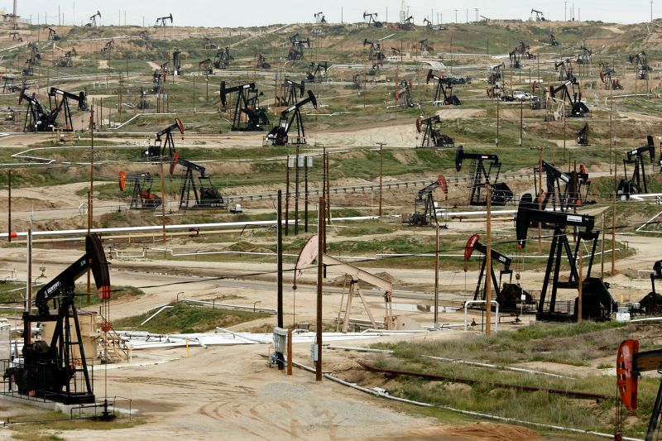
Oil pumps stand at the Chevron Corp. Kern River oil field in Bakersfield, California.
The International Energy Agency confirms what we’ve known for a while: The United States is the world’s top petroleum producer. The American Interest’s Walter Russell Mead quotes from a Financial Times story [subscription required]:
US production of oil and related liquids such as ethane and propane was neck-and-neck with Saudi Arabia in June and again in August at about 11.5m barrels a day, according to the International Energy Agency, the watchdog backed by rich countries.
With US production continuing to boom, its output is set to exceed Saudi Arabia’s this month or next for the first time since 1991. [...]
Rising oil and gas production has caused the US trade deficit in energy to shrink, and prompted a wave of investment in petrochemicals and other related industries. [...] It is also having an impact on global security. Imports are expected to provide just 21 per cent of US liquid fuel consumption next year, down from 60 per cent in 2005.
America’s energy situation has been transformed by the shale boom. According to Energy Information Administration (EIA) data, in 2006, Saudi Arabia produced 2.4 million barrels per day (bpd) more petroleum than the United States. Now, thanks to American innovation--combining horizontal drilling with hydraulic fracturing—the United States is out-producing the Middle East oil giant by more than 2.4 million bpd.
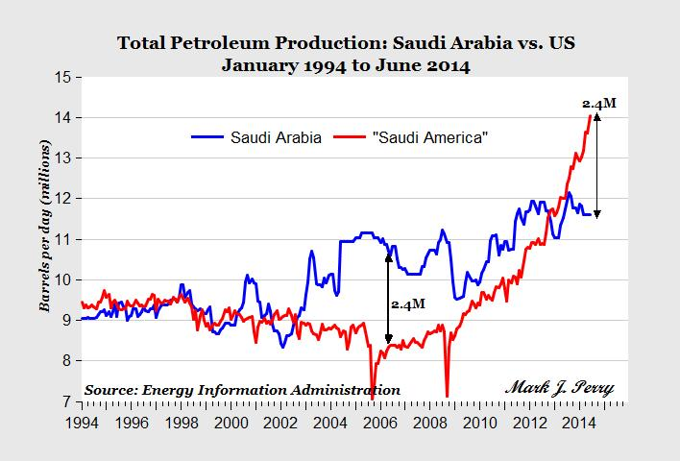

As a result, net petroleum imports are at a 28-year low, and we can seriously consider lifting the 40-year-old U.S. oil exports ban.
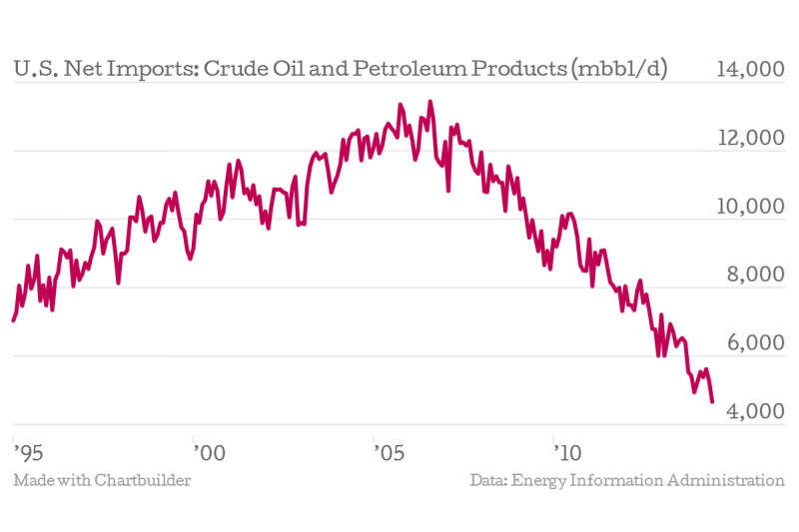
The shale boom has also fueled significant job creation. As I noted last week, the shale energy supply chain alone supports over 500,000 jobs. Earlier this year, the Wall Street Journal reported on how the construction industry will be winners from the boom. And according to a report for the U.S. Chamber’s Institute for 21st Century Energy, by 2025 shale energy will support 3.9 million jobs all along the value chain—from producing oil and natural gas to transforming it into products we use every day.
With the success we’ve seen, let’s be wary when federal agencies like EPA want to impose duplicative regulations on hydraulic fracturing when states have had a long track record of successful regulation. Shale energy has put the United States in a great position economically and geopolitically. With the right policies this success will continue.

American.com
How Green Is Europe?
A superficial look might indicate great achievements. Yet a closer view reveals how far European renewables have to go, and what irrational choices are made to meet EU green energy quotas.
by Vaclav Smil
“Germany produces half of energy with solar.” That was the recent headline on a German website of news in English, and it would have duly impressed anybody whose understanding of energy matters extends to just such headlines. But the headline, totally wrong, was also a perfect example of why it is so important to deconstruct the reports about green Europe.
Analysis by the Fraunhofer ISE research institute showed that the recent peak of Germany’s solar energy usage lasted for only 1 hour, and that the record share (50.6 percent) was due not only to hot, sunny weather but that day being a public holiday with lower than normal demand — and, most fundamentally, to the fact that solar and wind have legal priority over fossil fuels and when available must be used to the maximum possible extent. But the key error of that headline’s claim is that it was not half of energy use (Energieverbrauch), it was half of electricity production (Stormerzeugung). And in Germany, as in any modern economy, electricity accounts for only a fraction of overall energy use, known as total primary energy supply, which consists of all fuels (be they fossil or biofuels) and all electricity produced by nuclear reactors, water and wind turbines, solar photovoltaics (PV), and geothermal steam.
So how green is Germany’s and Europe’s energy supply in reality? Comprehensive comparative statistics always take a while to assemble, and the task is bound to be even more difficult when one has to deal first with 28 separate national entities. As a result, the European Union still has no official totals for 2013, but it has compiled all of its 2012 energy statistics.
A superficial look might indicate great achievements. The EU statistics show that in 2012 its 28 members derived 14.1 percent of their total primary energy supply from renewable sources. That share was well ahead of the interim target of 10.7 percent, and the union appears to be well on its course of reaching the EU-mandated 20 percent mark by 2020. Afterwards, the shift away from fossil fuels should continue, with the next (not yet officially mandated) goal of 30 percent by 2030 and, audaciously, 50 percent by 2050.
If you consult the annual BP World Energy Review statistics, however, you will see that it puts the share of EU’s renewables at 11.5 percent in 2013 and at 10.1 percent in 2012. This significant discrepancy (with the EU’s value being about 40 percent higher in 2012 than BP’s figure) is explained by different ways of accounting for biofuel consumption and by converting primary electricity to oil equivalent. But I will use the EU’s data, as the long-term goals for renewable energy shares are based on the EU accounting.
Deconstruction of the EU’s actual greenness must start by separating old renewables from new renewables — an essential task because in most countries the old renewables still provide the largest combined contribution in the green category. Readers of European news might be forgiven if they thought that wind turbines and PV panels, both heavily promoted and subsidized by many governments, lead the charge toward the continent’s renewable future. Actually, “solid biofuels” continue to be by far the largest category. In plain English, solid biofuels are wood, the oldest of fuels, be it trunks directly harvested for heat and electricity generation and burned as chips, or large amounts of wood-processing waste — a category particularly abundant in the EU’s two Nordic members with large forestry sectors. In 2012, 80 percent of Finland’s and 52 percent of Sweden’s renewable energy came from wood, and the average for EU-28 was 47 percent; even for Germany, the most aggressive developer of wind and solar, it was about 36 percent.
Burning logging and wood-processing wastes make sense; importing wood chips from overseas in order to meet green quotas does not. In 2013, the EU was burning more than 6 million tons of imported wood pellets. According to Forests and the European Union Resource Network, if all the EU states were to meet their 2020 green quotas, some of them would have to burn 50-100 percent more wood than they did in 2010. Imports now come mostly from North American and Russian forests, but Brazil is considered as the best source for future imports.
The irrationality of wood-based electricity generation is perhaps best illustrated by the conversion of Britain’s largest, originally coal-fired station to burning wood chips: initially they were to come from Brazil, but eventually more than 6 million tons a year will come from the swamp forests of North Carolina and tree plantations in Georgia. And wood-burning electricity generation would not be carbon-neutral even if all the trees cut down for chips were promptly replanted and if all of them regrew quickly and completely: more trees would have to be planted in order to offset carbon released by fossil fuels used in harvesting, processing, and intercontinental transportation of imported wood.
There is also nothing new about hydroelectricity (its generation began in 1882, in the same year Edison’s first coal-fired power-plant began operating). Europe was its early and vigorous developer, and now it has only a very limited unexploited potential, mainly in the Balkans. The EU’s deliberate push toward a higher share of renewables will thus benefit very little from new hydro capacities — but in 2012 they supplied 16 percent of the union’s renewables. Wood and water thus gave Europe nearly two-thirds (63 percent) of its renewable energy supply in 2012.
While water’s potential is limited, the continent can use more plant-based fuels by converting grain crops into ethanol, oil crops into biodiesel, or corn into biogas. By 2012, the European Union derived about 13 percent of its renewables from these modern biofuels — but for the past three decades I have argued for very careful and cautious development of these energy resources because their mass-scale production can have many negative consequences, ranging from higher food prices to excessive leaching of nutrients and enhanced soil erosion. Critical examinations of modern biofuels have uncovered many other inconvenient truths, not least the fact that crop-based fuels may actually increase (by 50 percent or even double) overall CO2 emissions. In the best of all green worlds, only waste biomass (such as logging residues and crop residues that do not have to be recycled) should be used for energy, not crops grown on arable land that should produce food.
Outside of Italy, Iceland, and Hungary, geothermal energy is a minor player in Europe, and ocean energy (wind and waves) does not figure yet in any energy statistics, so the new renewables are (or ideally should be) down to wind and solar.
Undoubtedly, the EU’s promotion of wind and solar resources resulted in consumption shares higher than anywhere else, but the contributions are uneven and remain small in absolute terms. Wind is big in Denmark (28 percent of all renewable energy) but marginal in France (6 percent of renewables), solar PV is relatively huge in cloudy Germany (but still only about 7 percent of all renewables) and negligible even in sunny Spain (4.9 percent of all renewables in 2012). And although they represent substantial shares of all electricity generated in several countries (38 percent in Denmark, 33 percent in Spain), their contribution to the EU’s total primary energy supply remains very small: in 2012 about 1.1 percent for wind and not quite 0.5 percent for solar PV. Even in Germany their combined share of total primary energy supply was just 2 percent in 2012. Germany’s nuclear reactors, slated for closure by the year 2022, generated 16 percent of the country’s electricity in 2012, compared to 11.9 percent for wind and solar, and these shares shifted little by 2013 (15.4 percent nuclear, 12.4 percent wind and solar). Germany in 2013 was thus still more dependent on nuclear fission than on new renewables.
What has been in it for the consumers? Germany has the highest residential electricity prices of all the major economies in the European Union, and even the lower prices charged to the country’s large industrial consumers are higher than in France or the United Kingdom (but lower than in Italy). What has this done to carbon emissions? Between 2008 and 2012, during the years of the fastest expansion of German wind and solar, the country’s CO2 emissions fell by 7 percent, while U.S. emissions, without similarly massively subsidized wind and PV generation, fell by 9.5 percent.
Moreover, the expansion of Europe’s new renewables does not appear to be accelerating, and in some cases the latest trends are even below the earlier growth rates. The latest Renewable Energy Progress Report mandated by the European Commission shows that of all the specific 2020 targets for the European Union, only one, PV electricity generation, is likely to be met — but that is the lowest contributor in terms of primary energy. Even if the European Union meets that target, it will add only about 7 million tons of oil equivalent (Mtoe) to the EU’s energy supply. In contrast, trends for all others indicate moderate to major underperformance. Offshore wind turbines were expected to generate an equivalent of 12 Mtoe by 2020, but will likely supply less than 4 Mtoe; onshore wind turbines were to bring in 30 Mtoe and will deliver only about 18 Mtoe; solid biomass will contribute less than 90 Mtoe, rather than the expected 104 Mtoe; and modern biofuels will add about 20 Mtoe, rather than 30 Mtoe.
Densely populated and highly industrialized Europe in general, and Germany in particular, are too dependent on imported Russian natural gas and Middle Eastern crude oil: they need more electricity generated domestically by new renewables such as wind and solar. They also should develop these resources in a gradual, organic manner, not by rhyming fiats (20 by 20, 30 by 30). And all people reporting on those achievements should take a while to check their technical terms and the real numbers. That headline should have said: “Germany produces less than half a percent of its energy with solar PV.”

Nature
Gravity map uncovers sea-floor surprises
Sharpest pictures yet of the ocean basins reveal uncharted volcanoes and other geological wonders.
by Alexandra Witze
As though someone had pulled a plug in the oceans and drained them away, a sea-floor map has exposed thousands of never-before-seen underwater mountains and ridges. The map — generated by the highest-resolution gravity model ever made for the oceans — will guide deep-sea research for years to come.
An international team of researchers led by David Sandwell, an oceanographer at the Scripps Institution of Oceanography in La Jolla, California, publishes the map in the 3 October issue of Science. The team created it using data mostly from two satellites: CryoSat-2, from the European Space Agency, and Jason-1, from NASA and the French space agency CNES.
Both satellites sought to chart the planet, but with different goals. The ongoing CryoSat-2 mission studies the polar ice caps, whereas Jason-1 studied changes in sea level before it was turned off last year. Both probes carried radar altimeters, instruments that measure the precise distance between the satellite and the surface of the land or ocean below.

Out with the old
By measuring tiny changes in the surface level of the ocean, then subtracting the effect of temporary phenomena such as waves, the satellites mapped how the ocean responds to the gravitational pull of underwater features such as mountain ranges. In essence, the probes map the sea surface as a proxy for the sea floor below.
“Over many years we’ve only had about two opportunities to get this kind of data,” says Sandwell. The first was in 1995, when the data from the US Navy's GEOSAT satellite were declassified and Europe’s ERS-1 satellite finished working in an orbit that was suitable for gravity mapping. That combination of data resulted in a 1997 Science paper from Sandwell and his team — at the time the sharpest global sea-floor map.
The latest data have now made the map at least twice as good. “Everything is getting sharper and popping into focus,” says Sandwell.
In the old map, scientists could detect the underwater volcanoes known as seamounts if the features rose more than about 2 kilometres from the seafloor. In the latest map, as many as 20,000 previously unknown seamounts, between 1.5 and 2 kilometres high, pop into view scattered along relatively young sections of the sea floor, says Sandwell.
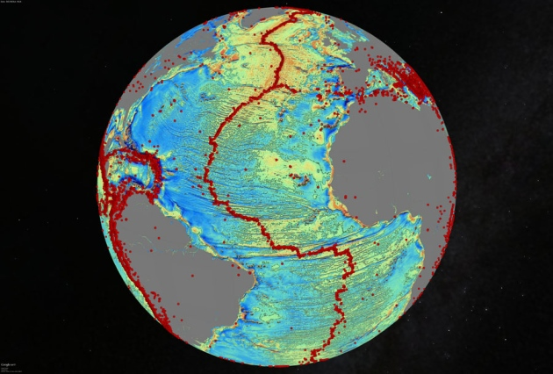
The gravity model of the North Atlantic ocean basin reveals tectonic history in sharp detail. Red dots show the location of past earthquakes of magnitude 5.5 or higher.

Hidden worlds
The map can also peer more clearly beneath sediments blanketing the sea floor. In the northern Indian Ocean, it reveals an underwater ridge running all the way through the Bengal Fan, a blanket of sediments more than 8 kilometres thick made up of the remains of rocks washed down from the high Himalayas. Similarly, the map revealed ridges in the Gulf of Mexico where fresh magma once rose to the surface to form new ocean crust. These ridges are now extinct and buried by sediment, but geologists can use their traces to reconstruct how the Yucatan and North American crustal plates moved in this region over time.
Geologists around the world can use the map to reconstruct how oceanic crustal plates shifted, says Joanne Whittaker, a marine geoscientist at the University of Tasmania in Hobart, Australia. She studies the poorly mapped parts of the Indian and Southern Oceans between Antarctica and Australia, and relies on gravity maps to help plan her research voyages. Whittaker has an upcoming cruise aboard Australia’s new research vessel, Investigator, to study the underwater Gulden Draak Knoll, which may be a fragment of an ancient continent. Thanks to the gravity data, she says, “we will be able to plan our voyage with more confidence, and we may even try to adjust the voyage somewhat based on all the new information.”
Oil and gas companies are also likely to make use of the map, says Sandwell. Among other things, it has revealed an extinct spreading ridge off the coast of Brazil, in an area of intense petroleum exploration. US energy company ConocoPhillips, based in Houston, Texas, was one of the early funders of Sandwell's research; other than such companies, he says, “almost nobody cares about the deep ocean any more”.
But there is only so much that the gravity map can do. It can resolve sea-floor features to about 5 kilometres, which is enough to discover a seamount but not enough to pinpoint smaller features, says Sandwell. Getting down to a resolution of about 100 metres will still require research ships pinging sonar to the seafloor. Even sharper detail — such as in the ongoing search for the Malaysia Airlines flight MH370 — requires the time-consuming process of towing sonar apparatus behind a ship.
For now, CryoSat-2 has funding to operate for at least three more years. Sandwell thinks that he can improve his gravity maps even further with more of the satellite's data.

Nautilus
The Sound So Loud That It Circled the Earth Four Times
by Aatish Bhatia
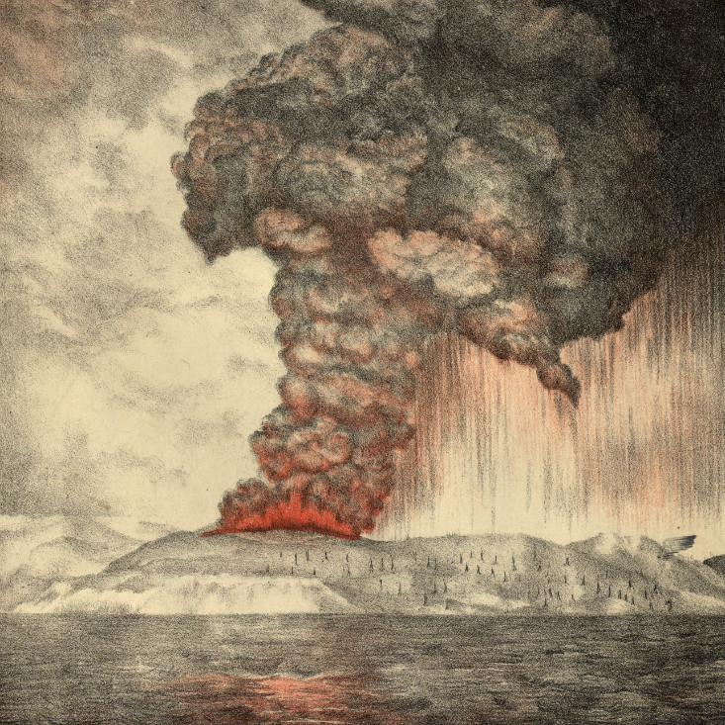
The Eruption of Krakatoa
On 27 August 1883, the Earth let out a noise louder than any it has made since.
It was 10:02 AM local time when the sound emerged from the island of Krakatoa, which sits between Java and Sumatra in Indonesia. It was heard 1,300 miles away in the Andaman and Nicobar islands (“extraordinary sounds were heard, as of guns firing”); 2,000 miles away in New Guinea and Western Australia (“a series of loud reports, resembling those of artillery in a north-westerly direction”); and even 3,000 miles away in the Indian Ocean island of Rodrigues, near Mauritius (“coming from the eastward, like the distant roar of heavy guns.”) In all, it was heard by people in over 50 different geographical locations, together spanning an area covering a thirteenth of the globe.
Think, for a moment, just how crazy this is. If you’re in Boston and someone tells you that they heard a sound coming from New York City, you’re probably going to give them a funny look. But Boston is a mere 200 miles from New York. What we’re talking about here is like being in Boston and clearly hearing a noise coming from Dublin, Ireland. Travelling at the speed of sound (766 miles or 1,233 kilometers per hour), it takes a noise about 4 hours to cover that distance. This is the most distant sound that has ever been heard in recorded history.
So what could possibly create such an earth-shatteringly loud bang? A volcano on Krakatoa had just erupted with a force so great that it tore the island apart, emitting a plume of smoke that reached 17 miles into the atmosphere, according to a geologist who witnessed it. You could use this observation to calculate that stuff spewed out of the volcano at over 1,600 miles per hour—or nearly half a mile per second. That’s more than twice the speed of sound.
This explosion created a deadly tsunami with waves over a hundred feet (30 meters) in height. One hundred sixty-five coastal villages and settlements were swept away and entirely destroyed. In all, the Dutch (the colonial rulers of Indonesia at the time) estimated the death toll at 36,417, while other estimates exceed 120,000.
The British ship Norham Castle was 40 miles from Krakatoa at the time of the explosion. The ship’s captain wrote in his log, “So violent are the explosions that the ear-drums of over half my crew have been shattered. My last thoughts are with my dear wife. I am convinced that the Day of Judgement has come.”
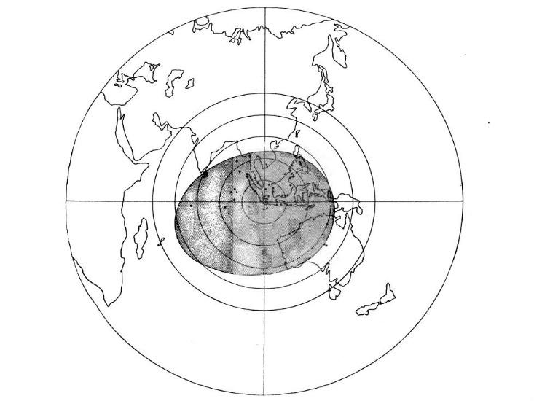
A map showing the area in which the Krakatoa explosion could be heard.
In general, sounds are caused not by the end of the world but by fluctuations in air pressure. A barometer at the Batavia gasworks (100 miles away from Krakatoa) registered the ensuing spike in pressure at over 2.5 inches of mercury. That converts to over 172 decibels of sound pressure, an unimaginably loud noise. To put that in context, if you were operating a jackhammer you’d be subject to about 100 decibels. The human threshold for pain is near 130 decibels, and if you had the misfortune of standing next to a jet engine, you’d experience a 150 decibel sound. (A 10 decibel increase is perceived by people as sounding roughly twice as loud.) The Krakatoa explosion registered 172 decibels at 100 miles from the source. This is so astonishingly loud, that it’s inching up against the limits of what we mean by “sound.”
When you hum a note or speak a word, you’re wiggling air molecules back and forth dozens or hundreds of times per second, causing the air pressure to be low in some places and high in other places. The louder the sound, the more intense these wiggles, and the larger the fluctuations in air pressure. But there’s a limit to how loud a sound can get. At some point, the fluctuations in air pressure are so large that the low pressure regions hit zero pressure—a vacuum—and you can’t get any lower than that. This limit happens to be about 194 decibels for a sound in Earth’s atmosphere. Any louder, and the sound is no longer just passing through the air, it’s actually pushing the air along with it, creating a pressurized burst of moving air known as a shock wave.
Closer to Krakatoa, the sound was well over this limit, producing a blast of high pressure air so powerful that it ruptured the eardrums of sailors 40 miles away. As this sound travelled thousands of miles, reaching Australia and the Indian Ocean, the wiggles in pressure started to die down, sounding more like a distant gunshot. Over 3,000 miles into its journey, the wave of pressure grew too quiet for human ears to hear, but it continued to sweep onward, reverberating for days across the globe. The atmosphere was ringing like a bell, imperceptible to us but detectable by our instruments.
The Krakatoa explosion registered 172 decibels at 100 miles from the source. This is so astonishingly loud, that it’s inching up against the limits of what we mean by “sound.”
By 1883, weather stations in scores of cities across the world were using barometers to track changes in atmospheric pressure. Six hours and 47 minutes after the Krakatoa explosion, a spike of air pressure was detected in Calcutta. By 8 hours, the pulse reached Mauritius in the west and Melbourne and Sydney in the east. By 12 hours, St. Petersburg noticed the pulse, followed by Vienna, Rome, Paris, Berlin, and Munich. By 18 hours the pulse had reached New York, Washington DC, and Toronto. Amazingly, for as many as 5 days after the explosion, weather stations in 50 cities around the globe observed this unprecedented spike in pressure re-occcuring like clockwork, approximately every 34 hours. That is roughly how long it takes sound to travel around the entire planet.
In all, the pressure waves from Krakatoa circled the globe three to four times in each direction. (Each city felt up to seven pressure spikes because they experienced shock waves travelling in opposite directions from the volcano.) Meanwhile, tidal stations as far away as India, England, and San Francisco measured a rise in ocean waves simultaneous with this air pulse, an effect that had never been seen before. It was a sound that could no longer be heard but that continued moving around the world, a phenomenon that people nicknamed “the great air-wave.”
Recently, an incredible home video of a volcanic eruption taken by a couple on vacation in Papua New Guinea started making the rounds on the Internet. If you watch closely, this video gives you a sense for the pressure wave created by a volcano.
Click here for a video of the sound from a volcanic explosion in Papua, New Guinea.
When the volcano erupts, it produces a sudden spike in air pressure; you can actually watch as it moves through the air, condensing water vapor into clouds as it travels. The people taking the video are (fortunately) far enough away that pressure wave takes a while to reach them. When it does finally hit the boat, some 13 seconds after the explosion, you hear what sounds like a huge gunshot accompanied by a sudden blast of air. Multiplying 13 seconds by the speed of sound tells us that the boat was about 4.4 kilometers, or 2.7 miles, away from the volcano. This is somewhat akin to what happened at Krakatoa, except the ‘gunshot’ in that case could be heard not just three but three thousand miles, away, a mind-boggling demonstration of the immense destructive power that nature can unleash.

BioSpace
Lifting Weights Can Improve Your Memory, Georgia Tech Study
Study finds that one short bout of resistance exercise can enhance episodic memory
Here’s another reason why it’s a good idea to hit the gym: it can improve memory. A new Georgia Institute of Technology study shows that an intense workout of as little as 20 minutes can enhance episodic memory, also known as long-term memory for previous events, by about 10 percent in healthy young adults.
The Georgia Tech research isn’t the first to find that exercise can improve memory. But the study, which was just published in the journal Acta Psychologica, took a few new approaches. While many existing studies have demonstrated that months of aerobic exercises such as running can improve memory, the current study had participants lift weights just once two days before testing them. The Georgia Tech researchers also had participants study events just before the exercise rather than after workout. They did this because of extensive animal research suggesting that the period after learning (or consolidation) is when the arousal or stress caused by exercise is most likely to benefit memory.
The study began with everyone looking at a series of 90 photos on a computer screen. The images were evenly split between positive (i.e. kids on a waterslide), negative (mutilated bodies) and neutral (clocks) pictures. Participants weren’t asked to try and remember the photos. Everyone then sat at a leg extension resistance exercise machine. Half of them extended and contracted each leg at their personal maximum effort 50 times. The control group simply sat in the chair and allowed the machine and the experimenter to move their legs. Throughout the process, each participant’s blood pressure and heart rate were monitored. Every person also contributed saliva samples so the team could detect levels of neurotransmitter markers linked to stress.
The participants returned to the lab 48 hours later and saw a series of 180 pictures – the 90 originals were mixed in with 90 new photos. The control group recalled about 50 percent of the photos from the first session. Those who exercised remembered about 60 percent.
“Our study indicates that people don’t have to dedicate large amounts of time to give their brain a boost,” said Lisa Weinberg, the Georgia Tech graduate student who led the project .
Although the study used weight exercises, Weinberg notes that resistance activities such as squats or knee bends would likely produce the same results. In other words, exercises that don’t require the person to be in good enough shape to bike, run or participate in prolonged aerobic exercises.
While all participants remembered the positive and negative images better than the neutral images, this pattern was greatest in the exercise participants, who showed the highest physiological responses. The team expected that result, as existing research on memory indicates that people are more likely to remember emotional experiences especially after acute (short-term) stress.
But why does it work? Existing, non-Georgia Tech human research has linked memory enhancements to acute stress responses, usually from psychological stressors such as public speaking. Other studies have also tied specific hormonal and norepinephrine releases in rodent brains to better memory. Interestingly, the current study found that exercise participants had increased saliva measures of alpha amylase, a marker of central norepinephrine.
“Even without doing expensive fMRI scans, our results give us an idea of what areas of the brain might be supporting these exercise-induced memory benefits,” said Audrey Duarte, an associate professor in the School of Psychology. “The findings are encouraging because they are consistent with rodent literature that pinpoints exactly the parts of the brain that play a role in stress-induced memory benefits caused by exercise.”
The collaborative team of psychology and applied physiology faculty and students plans to expand the study in the future, now that the researchers know resistance exercise can enhance episodic memory in healthy young adults.
“We can now try to determine its applicability to other types of memories and the optimal type and amount of resistance exercise in various populations,” said Minoru Shinohara, an associate professor in the School of Applied Physiology. “This includes older adults and individuals with memory impairment.”

WSJ Interview
Rene Russo’s Escape From Elmwood
The actress reflects on life in a tough Burbank apartment complex
by Marc Myers

Actress Rene Russo, 60, has appeared in 25 films, including “The Thomas Crown Affair” and “Get Shorty.” Her new film, “Nightcrawler,” opens Oct. 31.
I grew up in Burbank—but not the Burbank of valet parking and TV studios. In the late 1950s, there was a small apartment complex on Elmwood Avenue that rented mostly to families on welfare. I lived there from age 3 to 11 and again from 14 to 18 with my mother, Shirley, and my younger sister, Toni. It wasn’t pretty.
My mother left Fort Scott, Kan., in 1949 with friends in search of a better life in Los Angeles. There, she met my father, Nino, a stand-in for Tony Curtis. When my sister was born in 1956 and I was 2½, my father abandoned us. We had to move to my mother’s childhood home in Kansas. Four months later, she scraped together enough money to return to California.
Back in L.A., we moved into a ground-floor, two-bedroom unit in the Elmwood Avenue apartment complex. Kids ran around unattended, and the closer you lived to the street’s cul-de-sac, which we did, the more undesirable your neighbors. Many were high-strung or strung-out.


Actress Rene Russo at her home near Brentwood, Calif.
My mom worked for Lockheed Corp. in Burbank as an inspector of airplane parts. To help make ends meet, Dee, a friend of my mom’s from Lockheed, moved in. She was a lovely person and helped with our care for many years.

Rene Russo, right, with her sister, Toni, and her mother,
Shirley, in an undated photo, as they prepared for Halloween.
In 1965, when I was 11, we moved to a nicer apartment on Scott Road. Dee had gotten a raise, and the new place had a front yard. When my mother and Dee went their separate ways in 1968, we couldn’t afford to live there anymore. So we moved back to Elmwood Avenue.
Fortunately my mother was earning more, so we moved into a second-floor unit that was less cramped. Toni and I began cleaning apartments. At first, it wasn’t for the money. We were Type-As, probably because my mother worked two jobs then and her drive rubbed off on us. I also think we cleaned obsessively to create order in a chaotic environment. Eventually I figured out we could get paid to clean—and iron.
By high school, I was already tall—5-foot-8—and one day I made the mistake of wearing green tights. The football players all started calling me the Jolly Green Giant.
That’s when the bullying started, depression set in and I dropped out of high school when I was in the 10th grade. My sister was in the eighth grade and dropped out, too. I took a job near our apartment at an eyeglass factory inspecting frames.
Then the oddest thing happened. In June 1972, I went with friends to see the Rolling Stones at the Los Angeles Forum. After the concert, as we crossed through the parking lot, a guy in a brown Mercedes stopped in the middle of the street and got out. He came up to me and asked if I had ever modeled. I could see he had a woman in the car and was well dressed, so I took the card he held out. He said, “Have your mother call me,” which put me at ease.
Me, a model? Crazy, I thought. When I got home, I told my mother. She called the guy—an agent named John Crosby—and we went to see him at his office on Sunset Blvd. He set me up with a photographer and then sent my photo book to Nina Blanchard, Hollywood’s top modeling agent at the time. She sent it to agent Eileen Ford in New York, who sent it to Richard Avedon. He asked Eileen to fly me to New York immediately for a Revlon shoot. The shoot went well, and Eileen invited me to live with her. All of this happened within six months of the Stones concert.
As soon as the modeling checks started coming in 1974, I began saving to get my mom out of Elmwood. Within a year, I was able to move her into a rental apartment in Burbank near Studio City. Two years later in 1977, Toni and I decided to send my mom and two of her friends on vacation to Palm Springs. The day she returned, I picked her up and asked if she’d mind looking at a few open houses before I dropped her off at her apartment.
We passed a one-story ranch with an “open house” sign out front. Once inside, mom seemed puzzled. Looking around at the furnishings, she said, “Wow, that’s strange, I have a coffee table just like that one—and this lamp, too.” What she didn’t know is that Toni and I had saved enough to buy her the house and had moved in her stuff while she was away. In the backyard, all of her friends yelled, “Welcome home!” She was overjoyed—and still lives there today.
As for me, modeling turned into acting in 1987 when I auditioned for “Sable,” a TV series. Today, I live with my husband and our daughter in a one-story, three-bedroom contemporary house in the hills above Brentwood. As for John Crosby, he’s still my manager.







