September 21, 2014

Robert Rector posts on the failure of the war on poverty. We've spent $22 trillion and 14% of the nation is still living in poverty.
Today, the U.S. Census Bureau will release its annual report on poverty. This report is noteworthy because this year marks the 50th anniversary of President Lyndon Johnson’s launch of the War on Poverty. Liberals claim that the War on Poverty has failed because we didn’t spend enough money. Their answer is just to spend more. But the facts show otherwise.
Since its beginning, U.S. taxpayers have spent $22 trillion on Johnson’s War on Poverty (in constant 2012 dollars). Adjusting for inflation, that’s three times more than was spent on all military wars since the American Revolution.
The federal government currently runs more than 80 means-tested welfare programs. These programs provide cash, food, housing and medical care to low-income Americans. Federal and state spending on these programs last year was $943 billion. (These figures do not include Social Security, Medicare, or Unemployment Insurance.)
Over 100 million people, about one third of the U.S. population, received aid from at least one welfare program at an average cost of $9,000 per recipient in 2013. If converted into cash, current means-tested spending is five times the amount needed to eliminate all poverty in the U.S.
But today the Census will almost certainly proclaim that around 14 percent of Americans are still poor. The present poverty rate is almost exactly the same as it was in 1967 a few years after the War on Poverty started. Census data actually shows that poverty has gotten worse over the last 40 years. ...

And from the Sleuth Journal we learn that small business ownership is at an all time low.
According to the Federal Reserve, the percentage of American families that own a small business is at the lowest level that has ever been recorded. In a report that was just released entitled “Changes in U.S. Family Finances from 2010 to 2013: Evidence from the Survey of Consumer Finances“, the Federal Reserve revealed that small business ownership in America “fell substantially” between 2010 and 2013. Even in the midst of this so-called “economic recovery”, small business ownership in America has now fallen to an all-time low. If the economy truly was healthy, this would not be happening. And it isn’t as if Americans are flooding the labor market either. As I detailed yesterday, the labor force participation rate in this country is at a 36 year low. That would not be happening if the economy was actually healthy either. The truth is that the middle class in America is dying, and this new report from the Federal Reserve is more evidence of this very harsh reality.
In order to build wealth, middle class Americans either need to have their own businesses or they need good jobs. Sadly, the percentage of Americans that own a business continues to decline steadily. In the report that I mentioned above, the Federal Reserve says that the proportion of U.S. families that have an ownership interest in a small business fell from 13.3 percent in 2010 to a brand new all-time low of 11.7 percent in 2013.
This is one of the factors that is increasing the gap between the extremely wealthy and the rest of us in this country. And of course another of the major factors is the steady decline in good paying jobs. ...

The same progressive policies that make life dangerous for small business, are the policies that make cities like New York uninhabitable for the middle class. Kevin Williamson has the story.
A New report being released today by the Census Bureau finds that Manhattan has the highest level of income inequality in the United States. That is not entirely surprising, though it would also not have been surprising if it had been San Francisco or another progressive fiefdom. For all the rhetoric about wicked 1 percenters and inequality, progressivism is a luxury good, and progressive-dominated enclaves are generally pretty okay places to live if you have a fair amount of money, but sort of stink if you’re in the middle or at the lower end of the earnings curve.
Because most Americans experience New York City as tourists or in television shows and movies, it is easy to forget that the hometown of Wall Street and a very large population of obnoxious celebrities is a poor city: New York City is not only poorer than the New York State average, its median household income is, in absolute dollar terms, lower than that of such dramatically less expensive areas as Austin, Texas, or Cleveland County, Okla., where the typical household income is a few thousand dollars a year more than in New York City but the typical house costs less than a third of what the typical New York City home costs — and 17 percent of what the average Manhattan home costs. (And it’s a house, not a two-room coop.) ...
... What is particularly salient about the progressive governance of places such as New York City and San Francisco is not the income inequality coincident with it — which has many causes, only some of which are directly related to public policy — but the myriad ways in which misgovernment makes these cities such hostile places to live for people of relatively modest means.
As indicated above, the income figures by themselves hardly tell the story. The median household income in the city of New York is a few hundred dollars a year more than the median household income in the state of Texas, but in practical terms the average New York City household is much worse off. ...

Salon tells us about Alibaba.
The Chinese company Alibaba is going public at 9:30 AM ET on Friday. It is poised to be the largest IPO in history, expected to raise $21 billion. According to Fortune, the offering price will be in the range of $60 to $68 per share.
Unless you’ve spent the last several months eagerly waiting for this IPO, or have spent any time in China, it is possible you may not be familiar with Alibaba, or the implications of it going public.
Alibaba is China’s largest e-commerce company. (A primer on the company can be found here.) According to CNBC, it is used in 80 percent of all Chinese online commerce. The 15-year-old company is a combination of Amazon and eBay, along with some of the functions of Google, but it also has other components, including a PayPal-like system called Alipay. According to Pando Daily, it has also recently backed an Uber competitor.
Not only will this IPO make founder Jack Ma an exceedingly wealthy man; it also introduces the brand to the American public, establishes a level of credibility and sets an interesting precedent for future tech IPOs, some of which are waiting in the wings.
Past tech-related IPOs have been fair or underwhelming — as was the case in April of this year with China’s Twitter-like social media site Weibo. American social media companies Facebook and Twitter were also categorized as having “troubled” or “failed” IPOs. (Although in the case of Twitter that description is more controversial.) So what does this mean for Alibaba?
There are some reasons to be optimistic, yet also a few lingering concerns, which will all come to a head at the opening bell. Salon spoke to Professor Anthea Yan Zhang, a professor of Strategic Management at Rice University’s Jesse H. Jones Graduate School of Business to gain some insight on the upcoming IPO. ...

WaPo posts on Biden's hat trick of stupidity.
Vice President Biden's Wednesday kicked off with an acknowledgment that he had used a "poor choice of words." By day's end, he had put foot in his mouth again. Twice.
Biden opened the door to the possibility the United States could commit ground troops to fight the Islamic State in Iraq, a strategy the Obama administration has painstakingly avoided raising. That came shortly after he walked back his use of the word "Shylocks" and his use of the anachronistic term "Orient" to describe Asia.
Even for the gregarious and outspoken vice president, whose candor has all too often gotten him into hot water, the trio of eyebrow-raising remarks in about a 24-hour span was something to behold. Two of the "he said what?" moments came in Iowa, the first-in-the-nation caucus state where anyone thinking about running for president, a possibility Biden has not ruled out, needs to make a good impression. ...

Daily Signal
The War on Poverty Has Been a Colossal Flop
by Robert Rector
Today, the U.S. Census Bureau will release its annual report on poverty. This report is noteworthy because this year marks the 50th anniversary of President Lyndon Johnson’s launch of the War on Poverty. Liberals claim that the War on Poverty has failed because we didn’t spend enough money. Their answer is just to spend more. But the facts show otherwise.
Since its beginning, U.S. taxpayers have spent $22 trillion on Johnson’s War on Poverty (in constant 2012 dollars). Adjusting for inflation, that’s three times more than was spent on all military wars since the American Revolution.
The federal government currently runs more than 80 means-tested welfare programs. These programs provide cash, food, housing and medical care to low-income Americans. Federal and state spending on these programs last year was $943 billion. (These figures do not include Social Security, Medicare, or Unemployment Insurance.)
Over 100 million people, about one third of the U.S. population, received aid from at least one welfare program at an average cost of $9,000 per recipient in 2013. If converted into cash, current means-tested spending is five times the amount needed to eliminate all poverty in the U.S.
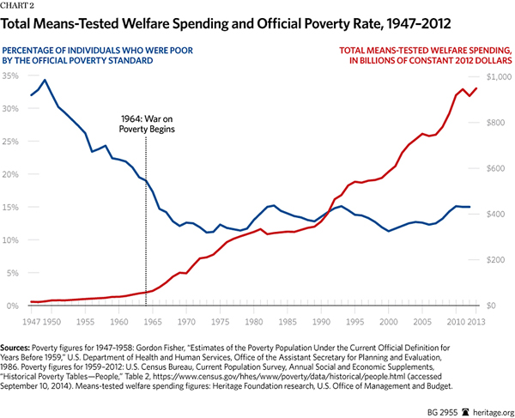
But today the Census will almost certainly proclaim that around 14 percent of Americans are still poor. The present poverty rate is almost exactly the same as it was in 1967 a few years after the War on Poverty started. Census data actually shows that poverty has gotten worse over the last 40 years.
How is this possible? How can the taxpayers spend $22 trillion on welfare while poverty gets worse?
The answer is it isn’t possible. Census counts a family as poor if its income falls below specified thresholds. But in counting family “income,” Census ignores nearly the entire $943 billion welfare state.
For most Americans, the word “poverty” means significant material deprivation, an inability to provide a family with adequate nutritious food, reasonable shelter and clothing. But only a small portion of the more than 40 million people labeled as poor by Census fit that description.
The media frequently associate the idea of poverty with being homeless. But less than two percent of the poor are homeless. Only one in ten live in mobile homes. The typical house or apartment of the poor is in good repair and uncrowded; it is actually larger than the average dwelling of non-poor French, Germans or English.
According to government surveys, the typical family that Census identifies as poor has air conditioning, cable or satellite TV, and a computer in his home. Forty percent have a wide screen HDTV and another 40 percent have internet access. Three quarters of the poor own a car and roughly a third have two or more cars. (These numbers are not the result of the current bad economy pushing middle class families into poverty; instead, they reflect a steady improvement in living conditions among the poor for many decades.)
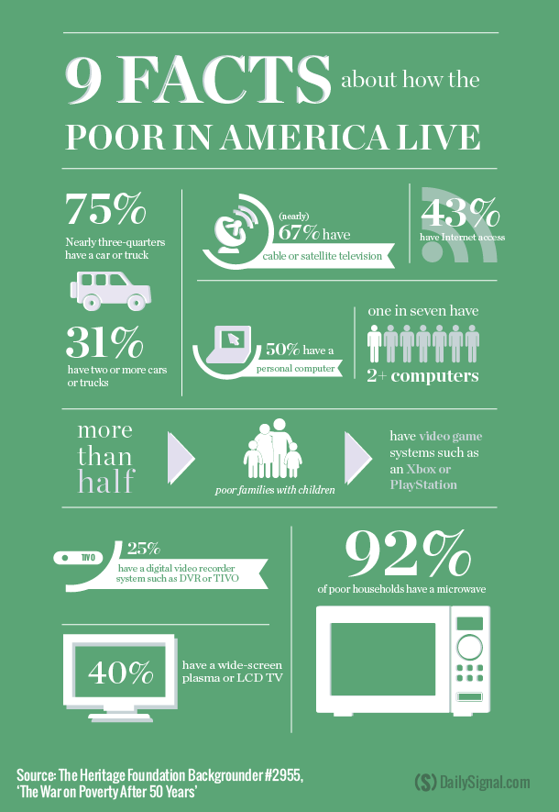
The intake of protein, vitamins and minerals by poor children is virtually identical with upper middle class kids. According to surveys by the U.S. Department of Agriculture, the overwhelming majority of poor people report they were not hungry even for a single day during the prior year.
We can be grateful that the living standards of all Americans, including the poor, have risen in the past half century, but the War on Poverty has not succeeded according to Johnson’s original goal. Johnson’s aim was not to prop up living standards by making more and more people dependent on an ever larger welfare state. Instead, Johnson sought to increase self-sufficiency, the ability of a family to support itself out of poverty without dependence on welfare aid. Johnson asserted that the War on Poverty would actually shrink the welfare rolls and transform the poor from “taxeaters” into “taxpayers.”
Judged by that standard, the War on Poverty has been a colossal flop. The welfare state has undermined self-sufficiency by discouraging work and penalizing marriage. When the War on Poverty began seven percent of children were born outside marriage. Today, 42 percent of children are. By eroding marriage, the welfare state has made many Americans less capable of self-support than they were when the War on Poverty began.
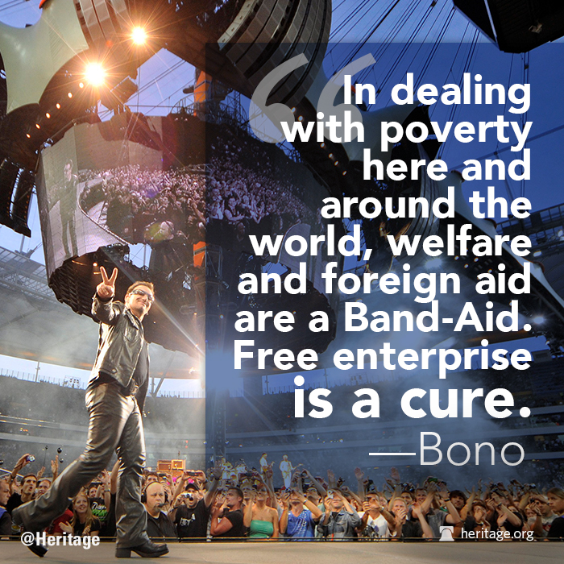
President Obama plans to spend $13 trillion dollars on means-tested welfare over the next decade. Most of this spending will flow through traditional welfare programs that discourage the keys to self-sufficiency: work and marriage.
Rather than doubling down on the mistakes of the past, we should restructure the welfare state around Johnson’s original goal: increasing Americans capacity for self-support. Welfare should no longer be a one way hand out; able-bodied recipients of cash, food and housing should be required to work or prepare for work as condition of receiving aid. Welfare’s penalties against marriage should be reduced. By returning to the original vision of aiding the poor to aid themselves, we can begin, in Johnson’s words, to “replace their despair with opportunity.”

Sleuth Journal
Small Business Ownership In America Is At An All-Time Low
by Michael Snyder
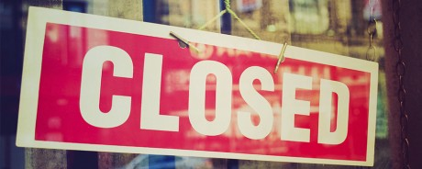
According to the Federal Reserve, the percentage of American families that own a small business is at the lowest level that has ever been recorded. In a report that was just released entitled “Changes in U.S. Family Finances from 2010 to 2013: Evidence from the Survey of Consumer Finances“, the Federal Reserve revealed that small business ownership in America “fell substantially” between 2010 and 2013. Even in the midst of this so-called “economic recovery”, small business ownership in America has now fallen to an all-time low. If the economy truly was healthy, this would not be happening. And it isn’t as if Americans are flooding the labor market either. As I detailed yesterday, the labor force participation rate in this country is at a 36 year low. That would not be happening if the economy was actually healthy either. The truth is that the middle class in America is dying, and this new report from the Federal Reserve is more evidence of this very harsh reality.
In order to build wealth, middle class Americans either need to have their own businesses or they need good jobs. Sadly, the percentage of Americans that own a business continues to decline steadily. In the report that I mentioned above, the Federal Reserve says that the proportion of U.S. families that have an ownership interest in a small business fell from 13.3 percent in 2010 to a brand new all-time low of 11.7 percent in 2013.
This is one of the factors that is increasing the gap between the extremely wealthy and the rest of us in this country. And of course another of the major factors is the steady decline in good paying jobs.
The U.S. Competitiveness Project at Harvard Business School is chaired by professors Michael E. Porter and Jan W. Rivkin. It just released a new report entitled “An Economy Doing Half Its Job”, and it addressed the fact that the middle class is deeply struggling even though many large U.S. corporations have been thriving. The following is an excerpt from an article in the Boston Globe about this report…
In a statement, Porter added: “Shortsighted executives may be satisfied with an American economy where firms operating here are winning without lifting US living standards. But leaders with longer perspectives understand that companies can’t thrive for long while their workers and their communities struggle.”
Unfortunately, this is not likely to change any time soon. In fact, that same report discovered that Harvard Business School alumni foresee “falling pay and fewer openings for full-time jobs” for American workers in the years ahead…
U.S. workers face a dim future, with stagnant or falling pay and fewer openings for full-time jobs.
That’s the picture that emerges from a survey of Harvard Business School alumni.
More than 40 percent of the respondents foresee lower pay and benefits for workers. Roughly half favor outsourcing work over hiring staffers. A growing share prefer part-time employees. Nearly half would rather invest in new technology than hire or retain workers.
The Obama administration continues to tell us that the unemployment rate is “going down” and that the economy is recovering, but that does not match the reality of what most Americans are experiencing on a day to day basis.
As David Stockman recently so aptly put it, outside of health and education the U.S. economy has not produced a single job since mid-2000 even though our population has grown greatly since that time…
In a few deft seconds, a “no jobs” nobody who apparently doesn’t actually have one himself, essentially explained the contents of the chart below to his silenced CNBC hosts. Over the course of 170 “jobs Fridays” since mid-2000, the latter have apparently never noticed the single most stunning fact embedded in the monthly BLS report. Namely, that outside of health and education there has not been one net new job created in the American economy since July 2000! Yes, not a single new job—as in none, nein, nichts, nada, zip!
In addition, most of the new jobs that are being “added to the economy” each month are part-time jobs. Right now, we still have 1.4 million fewer full-time jobs than we did in 2008 even though more than 100,000 people are added to the population each month.
What this means is that the middle class is shrinking.
We are witnessing an increasing concentration of wealth among the ultra-wealthy, and most of the rest of us are getting poorer. As a recent CNN article detailed, the Federal Reserve has also discovered that the gap between the rich and the poor in America is larger than the Fed has ever recorded before…
In its Study of Consumer Finances, released every three years, the Fed found that the wealthiest 3% of American households controlled 54.4% of the nation’s wealth in 2013, a slight increase from its last survey in 2010. It’s also substantially higher from the 44.8% they held in 1989, showing how quickly the income divide has been growing over the past decade or so.
At the same time, the share of wealth held by the bottom 90% fell to 24.7% in 2013. That’s compared to 33.2% in 1989.
How close does the share of wealth for the bottom 90 percent have to go before we admit that we have a major problem on our hands?
Is there anyone out there that would be okay with it hitting zero percent?
One of the big reasons why the wealthy have been doing so well is because the stock market has been soaring. The money printing policies of the Federal Reserve have sent stock prices to unprecedented heights. This has overwhelmingly benefited the extremely wealthy…
According to recent data from the Federal Reserve, America has the lowest level of stock ownership in 18 years. Yet stock ownership for the wealthy is at a new high—and that has accounted for most of their good fortune compared to the rest of America.
In fact, the Fed says that the wealthiest top 10 percent of all Americans now own 81 percent of all stocks…
Stock ownership is even more concentrated when it comes to share of total stock holdings. In 2010, the latest period available, the top 10 percent of Americans by net worth held 81 percent of all directly held or indirectly held stocks, according to Edward N. Wolff, an economics professor at New York University who specializes in inequality and Federal Reserve data.
Wolff said that share—which has not been released yet for 2013—has probably gone even higher than 81 percent since 2010.
Since the last financial crisis, the Federal Reserve has been very good to the elite.
But most of the rest of us have had a really hard time.
Until more Americans start getting good jobs and building small businesses, things are not going to turn around for the middle class.
But the policies being pursued by our politicians continue to kill good jobs and continue to kill small businesses, so I wouldn’t expect significant changes any time soon.
Michael T. Snyder is a graduate of the McIntire School of Commerce at the University of Virginia and has a law degree and an LLM from the University of Florida Law School. You can follow his work on The Economic Collapse blog, End of the American Dream and The Truth Wins. His new novel entitled “The Beginning Of The End” is now available on Amazon.com.

National Review
Where the Middle Class Goes to Die
In progressive Manhattan, inequality is maxed out.
by Kevin D. Williamson
A New report being released today by the Census Bureau finds that Manhattan has the highest level of income inequality in the United States. That is not entirely surprising, though it would also not have been surprising if it had been San Francisco or another progressive fiefdom. For all the rhetoric about wicked 1 percenters and inequality, progressivism is a luxury good, and progressive-dominated enclaves are generally pretty okay places to live if you have a fair amount of money, but sort of stink if you’re in the middle or at the lower end of the earnings curve.
Because most Americans experience New York City as tourists or in television shows and movies, it is easy to forget that the hometown of Wall Street and a very large population of obnoxious celebrities is a poor city: New York City is not only poorer than the New York State average, its median household income is, in absolute dollar terms, lower than that of such dramatically less expensive areas as Austin, Texas, or Cleveland County, Okla., where the typical household income is a few thousand dollars a year more than in New York City but the typical house costs less than a third of what the typical New York City home costs — and 17 percent of what the average Manhattan home costs. (And it’s a house, not a two-room coop.)
Inequality per se is a relatively minor and generally misunderstood issue, inasmuch as if New York’s median household earned four times what it does now but its top–5 percent households earned ten times what they do, there would be more income inequality but a much higher overall standard of living for rich and middle-class alike. What is particularly salient about the progressive governance of places such as New York City and San Francisco is not the income inequality coincident with it — which has many causes, only some of which are directly related to public policy — but the myriad ways in which misgovernment makes these cities such hostile places to live for people of relatively modest means.
As indicated above, the income figures by themselves hardly tell the story. The median household income in the city of New York is a few hundred dollars a year more than the median household income in the state of Texas, but in practical terms the average New York City household is much worse off.
The most obvious issue is the cost of housing, which for New Yorkers is about four times what it is for Texans. Housing prices are a function of supply and demand, and demand for New York City housing is relatively high, a fact that probably does not have very much to do with public policy. I have lived in New York City for some time, and I have never met anybody who says he moved here because it is so well governed.
On the other hand, supply is highly restricted, and that is a direct consequence of bad public policy, an economic reality that is obvious even to such sympathetic progressives as Matt Yglesias, who sensibly notes that limitations on the number of new housing units in places such as Washington, D.C., bias construction toward high-priced luxury homes, while hostile zoning codes in places such as San Francisco prevent markets from responding to demand and lead to “deliberately underutilized” mass-transit arteries. In New York City, housing prices are kept artificially high by draconian restrictions on new construction, rent control and the less aggressive “rent stabilization,” political interference with development financing, onerous union rules that drive up construction prices, byzantine regulation that imposes enormous compliance costs, and more. Even in a city in which four of the five boroughs are located on islands, there are vast tracts of underused real estate, the development of which could alleviate housing expenses for the middle class and the poor.
There is also the problem of the 13th month’s rent in New York City.
If you earn the median income of $52,223 in New York City and you live within the city limits — not just in Manhattan but in the distant Bronx and Staten Island, too — you pay the city nearly $1,800 a year in additional income tax for the privilege. You can basically forget about owning a home — the median house price in the city is more than a half a million dollars — but renting won’t be easy, either: Applying New York landlords’ prevailing 40-times-the-rent rule, you can afford about $1,300 a month; not impossible if you’re single, but a substantial challenge for a family. But in any case, you’ll be paying a 13th month’s rent and change to the city for the privilege of residing within its boundaries. Assuming you are single, taxes and rent would consume between 50 percent and 60 percent of your income. Move to Houston, and you’d get a $3,000-a-year discount before even accounting for the lower cost of housing.
If you are truly concerned about inequality, then that matters a great deal, because income inequality is only one kind of economic inequality, and one of the less important kinds: Wealth inequality is more significant. If the majority of your income is being consumed by taxes and rent, saving and investing becomes hard. And given progressives’ abysmal record in providing key municipal services such as effective law enforcement and decent public schools to low-income communities, there are powerful incentives to take on additional expenses by paying the premium for living in a better neighborhood or enrolling your children in private schools. When it comes time to pay for college or to leave behind a bequest for children or grandchildren — an important means of building wealth within families — you’re almost certainly better off in San Antonio or Provo than in New York or San Francisco.
Highly skilled, highly educated people are likely to do well wherever they are, and creative, dynamic, global cities such as New York are gold mines for them. But not everybody is going to be an investment banker or a tech entrepreneur. If you want to get a picture of what progressive policies look like for everybody else, try living in New York City for a year with an average New York City income — and try it with a family.

Salon
Why a company you’ve never heard of is about to take over the world
Chinese tech company Alibaba goes public tomorrow in what could be the largest IPO ever. But who are they?
by Sarah Gray

The Chinese company Alibaba is going public at 9:30 AM ET on Friday. It is poised to be the largest IPO in history, expected to raise $21 billion. According to Fortune, the offering price will be in the range of $60 to $68 per share.
Unless you’ve spent the last several months eagerly waiting for this IPO, or have spent any time in China, it is possible you may not be familiar with Alibaba, or the implications of it going public.
Alibaba is China’s largest e-commerce company. (A primer on the company can be found here.) According to CNBC, it is used in 80 percent of all Chinese online commerce. The 15-year-old company is a combination of Amazon and eBay, along with some of the functions of Google, but it also has other components, including a PayPal-like system called Alipay. According to Pando Daily, it has also recently backed an Uber competitor.
Not only will this IPO make founder Jack Ma an exceedingly wealthy man; it also introduces the brand to the American public, establishes a level of credibility and sets an interesting precedent for future tech IPOs, some of which are waiting in the wings.
Past tech-related IPOs have been fair or underwhelming — as was the case in April of this year with China’s Twitter-like social media site Weibo. American social media companies Facebook and Twitter were also categorized as having “troubled” or “failed” IPOs. (Although in the case of Twitter that description is more controversial.) So what does this mean for Alibaba?

There are some reasons to be optimistic, yet also a few lingering concerns, which will all come to a head at the opening bell. Salon spoke to Professor Anthea Yan Zhang, a professor of Strategic Management at Rice University’s Jesse H. Jones Graduate School of Business to gain some insight on the upcoming IPO.
Professor Zhang’s areas of expertise include include, but are not limited to, international strategic alliances and technology entrepreneurship in emerging markets and foreign direct investment. Her research has been published in the Academy of Management Journal, Strategic Management Journal, and Journal of International Business Studies.
The interview has been edited and condensed for clarity.
For a reader who isn’t familiar with the financial terms, could you explain exactly what’s going to happen on Friday, and what it means?
So as you mentioned, Alibaba is going to be the largest, or one of the largest IPOs in history. It’s even bigger than a few years ago another IPO from China, which is called Agricultural Bank of China. So this will be one of the largest ones. As you mentioned Alibaba is a well-known brand in China. It has a big business in China. And unlike many IT/e-commerce companies, Alibaba is actually very profitable. That is very different.
In China, Alibaba has two major websites, one is called Taobao, which is for consumers-to-consumers [transactions]. The other is Tmall, is for business [to sell to] consumers. So those two websites generate huge web traffic, and also bring in tremendous profit to Alibaba. In recent years Alibaba got into other business — for example online pay [with] Alipay — and also it got into the wealth management business. So if you look at Alibaba as a business model, it is really a combination of EBay, Amazon and also takes some function – product search function – of Google. It’s a very large business; it’s a very complex business, and is a profitable business. It’s a growing business. All these reasons contribute to the fact that Alibaba is going to be one of the largest IPOs in history.
There was an article recently in the AP headlined, “Alibaba Investors Beware, History is Not On Your Side.” It brought up that there’s not a great history of Chinese companies and IPOs in the U.S. Do you think that this is going change? Especially when tech IPOs don’t have a sterling track record, how will this be different?
I think Alibaba is different from other companies. One reason is that Alibaba is profitable, which is different from other tech IPOs. So its valuation is based upon real earnings and real profits, in place of pure speculation. So I think that’s very different.
I also think currently – at least in China – Alibaba is the number one. Much larger than any other competitors. I think in this winner-takes-all business, since Alibaba already built its scale and dominance in Chinese markets, it’s really just hard for competitors to catch up. Let it be Chinese competitors of foreign competitors like EBay or Amazon, it’s really hard for them to catch up to the dominance enjoyed by Alibaba. At least in the Chinese market.
I think if we talk about concerns with Alibaba, I would say there are a couple concerns. One is a governance issue of Alibaba. Because with Alibaba’s IPO it adopts a partnership-ownership structure is basically two classes of sharers. Even though Jack Ma, the founder of Alibaba and his team, only owns a small proportion of shares, they pretty much control the decision making in Alibaba. So external investors would have very limited influence on Alibaba’s decision making. So that is a number one concern.
Number two concern is that Alibaba is number one in China, and has plans to expand in overseas, but to what extent Alibaba’s successful history can be carted to overseas markets is a big question mark.
Why is the partnership share structure a concern?
With this two-classes share structure, Jack Ma and his team, the so-called “partners,” control the nomination of the board of directors. Thus external investors will have little say on Alibaba’s governance and business. That is why this is a concern.
Do you have any thoughts of what expansion or the IPO means for Amazon or eBay?
I don’t think that Alibaba will be an immediate threat to either eBay or Amazon, in the United States. Of course they compete in China, and Alibaba is winning the competition in China — no doubt about it. When we talk about the U.S. e-commerce market, I don’t think Alibaba would have immediate threat to eBay or Amazon in the U.S.
First of all, as you mention, Alibaba, even though it is well-known in China, average individual consumers in the U.S. don’t recognize that name. People are already used to the shopping malls or delivery modes of Amazon and eBay, so it would be hard and costly for Alibaba to change the consumer behaviors from eBay and Amazon to Alibaba website. So that’s number one.
Second, it takes time to build a supporting infrastructure. Amazon, in particular, has been very aggressive in building highly efficient, high-scale warehouses, and it has also been investing in delivery. Those kinds of infrastructures are very important to the market dominance, and also the efficiency of e-commerce. It would take a long time for Alibaba to catch up, and build those infrastructures in the U.S. So, from both the perspective of brand recognition, consumer shopping habits and also the development of infrastructure it will take a long time for Alibaba to penetrate the U.S. market.
Do you think that will have any effect on the company going public? Because I imagine that in tech and financial world, because they know the name Alibaba, and they’re probably pretty excited about the IPO, but do you think that for a smaller/individual who might want to buy stock, do you think the lack of recognition or infrastructure is going to affect that or affect share prices?
It is very likely that the first day, or the first few days, the stock will do very well. But in the long term, how the stock will do is really hard to predict. I think its IPO is still relevant to average investors for two reasons. Alibaba and its advisors are really doing a great job in PR – introducing this brand to investors and institutional investors. That generates a lot of interest.
Second, I think that from the investors perspective, if they want to buy Alibaba shares they want to buy into the Chinese economy. So the fact that Alibaba is doing so well – is dominating the e-commerce market in China – is probably good enough to many investors in the short term.
But in the long term, on one hand, I have concerns on how successful Alibaba can replicate its success in Chinese markets, and overseas markets. I do have my doubts on that issue. But the capital raised in the IPO will help them to penetrate and expand the overseas market, and equally important the credibility that they get from listing on New York Stock Exchange is also very important from a foreign consumer’s perspective when you think about a Chinese company we don’t know much about it. They may have their doubts. But now Alibaba is listed in the New York Stock Exchange and subject to various regulation of the U.S. government that will bring credibility to Alibaba in global markets. That will reduce the concerns of foreign host countries. So with it comes the financial resources and credibility. So listing in New York Stock Exchange is very crucial to Alibaba’s global space.
Are there other reasons why Alibaba would list on the New York Stock Exchange?
Another point, in addition to the capital they have raised – for example in Shanghai Stock Exchange – it is hard to say that you are going to raise the equal amount of money compared to what you can raise in New York Stock Exchange. And in addition to finance, capital generated, the credibility.
I also want to highlight another point, Alibaba actually originally considered listing in Hong Kong’s stock exchange. But because the founder Jack Ma and his team want to have a partnership structure that we talked about at the beginning, however Hong Kong stock exchange does not allow that. Meanwhile U.S. capital markets are some of the most flexible, Facebook already has these two kinds of shares. So listing at the New York Stock Exchange would allow Jack Ma and his team to control the company even though they only own a small percentage of the shares. That is also a very important reason for their choice of New York Stock Exchange.
You mentioned earlier that Alibaba’s success is tied to the Chinese economy, and there has been speculation about whether or not the Chinese economy can maintain its huge rate of growth. Do you think that could throw a wrench in its plans?
Actually, I’m not concerned about that. If you look at China’s growth in the past decade, the government invests in capital investments – in those big projects. So that might decline over time as China’s economy shifts from more investment driven to more consumption driven. But if you look at the business model of Alibaba, it is really focusing on consumers – individual consumers – and the businesses that serve individual consumers. So that why I think Alibaba’s not as closely linked to the government investment in big projects.
So you relate it to the income groups and those individual customers. And also you can look at major cities in China. The real estate is rising sky high, that increases the rent for the physical stores, eventually will reflect in prices, right? So that will have to drive consumers to shop online, which I think will help Alibaba with growth.
I’m really interested in what Alibaba’s IPO might mean for the future of tech IPOs – tech companies or online-based companies. Do you think that this is going to push more companies to be consumer based? Facebook and Twitter adding buy buttons. Do you think that having concrete profits will affect how tech IPOs go in the future?
Well that’s certainly a good point. That is a valid point, I kind of agree. Because in the early years tech IPOs and investors did not care about profits. They really cared about the growth and profits. Well maybe the success of Alibaba’s IPO will bring real profitability back into the picture. That is really possible. Alibaba – they had a company list in Hong Kong stock exchange, which is called Alibaba.com. The business is now for the whole group on IPO, so as a whole group it has waited longer before the IPO. We have also observed that in the U.S. tech companies founders or the initial institutional investors no longer rush to IPO they want to be profitable before the IPO. In return investors may expect actual profit for those relatively older technology companies.
Yahoo was an original investor, how will this affect them?
Yahoo already sold half of its shares in Alibaba, and it has the choice of selling additional shares after the IPO.
What would make Yahoo more profitable?
It has been a great investment; it has been a great financial return for Yahoo. But on the downside sold its Chinese business, Yahoo China, to Alibaba, so as a result you can see it is a tradeoff. It’ll get a big financial return for its investment in Alibaba, but it kind of also gave up its option of penetrating the Chinese market itself. In terms of what they should do with the money they got from Alibaba’s IPO, I really think it depends on opportunistic costs.
Right now, Yahoo knows that it is not doing really well. The new CEO, she needs capital to invest in new growth engines, and a lot of cases need to build those engines by acquiring other companies — smaller ones. To do that, it will need money. So probably, Yahoo will cash out in its investments in Alibaba and use the money to invest in other areas that are closer to its core business.

Washington Post
Joe Biden pulls off a gaffe hat trick
by Sean Sullivan

Vice President Biden's Wednesday kicked off with an acknowledgment that he had used a "poor choice of words." By day's end, he had put foot in his mouth again. Twice.
Biden opened the door to the possibility the United States could commit ground troops to fight the Islamic State in Iraq, a strategy the Obama administration has painstakingly avoided raising. That came shortly after he walked back his use of the word "Shylocks" and his use of the anachronistic term "Orient" to describe Asia.
Even for the gregarious and outspoken vice president, whose candor has all too often gotten him into hot water, the trio of eyebrow-raising remarks in about a 24-hour span was something to behold. Two of the "he said what?" moments came in Iowa, the first-in-the-nation caucus state where anyone thinking about running for president, a possibility Biden has not ruled out, needs to make a good impression.
After leaving a rally in Des Moines, Biden unexpectedly made news at a diner when he seemingly opened the door to committing ground troops to fight the Islamic State in Iraq, an option the Obama administration has diligently batted down as it has moved to expand air strikes in the region -- and that President Obama himself rejected anew in remarks at MacDill Air Force Base Wednesday. "The American forces that have been deployed to Iraq do not and will not have a combat mission," he said.
A reporter asked Biden whether he agreed with the comments of Army Gen. Martin Dempsey, the chairman of the Joint Chiefs of Staff, who on Tuesday left the door open to the possibility of boots on the ground. "He said that if in fact he concluded that was needed he would request it from the president. His conclusion is that it is not needed now," Biden responded.
But might it be needed? "We’ll determine that based on how the effort goes," said Biden.
At the rally, Biden delivered an enthusiastic speech brimming with populist notes. But his message was overshadowed by his story of a meeting he had with Lee Kuan Yew, the former prime minister of Singapore. The story was meant as a compliment.
"On the way back from Mumbai to go meet with President Xi in China, I stopped in Singapore to meet with a guy named Lee Kuan Yew, who most foreign policy experts around the world say is the wisest man in the Orient," explained Biden in his remarks at a kick-off rally for the Nuns on the Bus “We the People, We the Voters” bus tour.
Biden's use of the word "Orient" was widely mentioned on social media. Some quickly denounced it.
"Vice President Joe Biden’s insensitive remarks are offensive to both Asian-Americans and our Asian allies abroad," said Ninio Fetalvo, the Republican National Committee Asian American and Pacific Islander spokesman, in a statement. "His comment is not only disrespectful but also uses unacceptable imperialist undertones." Fetalvo called on Biden to apologize.
Hours earlier, Biden had walked back his use of the word "Shylocks" in a Tuesday speech, after the head of a major Jewish organization criticized him for it.
In a statement responding to Anti-Defamation League National Director Abraham Foxman's disapproval, Biden regretted his comment.
"He’s correct, it was a poor choice of words, particularly as he said coming from ‘someone as friendly to the Jewish community and open and tolerant an individual as is Vice President Joe Biden.’ He’s right," said Biden.
In a Tuesday speech at the Legal Services Corporation's 40th anniversary conference, Biden explained that his son Beau Biden, who has served in Iraq, would hear from members of the military who got bad loans and mortgages.
"People would come to him and talk about what was happening to them at home in terms of foreclosures, in terms of bad loans that were being -- I mean, these Shylocks who took advantage of these women and men while overseas," Biden said.
Shylock is a Jewish character in Shakespeare's "The Merchant of Venice." He is a villain in the play who asks for a "pound of flesh" from another character who is unable to repay a loan.
For Biden, the controversies upstaged what could have otherwise been a positive day. His speech in Iowa, which came just days after Hillary Clinton visited the state, was full of red meat for liberal activists.
Biden's office said his visit to Iowa was an official one, since his remarks were about official Obama administration economic policies. But it was hard to overlook the political implications of the visit, with Biden touching on many of the issues Democrats are likely to to emphasize in the 2016 presidential campaign.
With his sleeves rolled up, Biden sounded off on immigration, taxes, voting rights and regulating Wall Street banks.
"Income inequity brings a drag on economic growth," said Biden. "Even Wall Street is concerned about this growing gap between the middle class, the poor and the wealthy."
On immigration, Biden encouraged lawmakers to pass comprehensive reform. The people who come to America "are the people who have the most courage," he said.
"Some people think you sit around a table in Guadalajara and say, 'You know what, why don't we sell everything, give it to a coyote and go to a country that doesn't want us,'" Biden continued. "Boy, won't that be fun."
Gaffes are nothing new for Biden, who has committed more than his fair share over the years. But on Wednesday, a day full of personal promise, they proved especially costly.





