June 12, 2014

John Fund starts our look at Cantor's loss. First though, Pickerhead wonders why everyone is so breathless about this loss. Remember in 1994 when a sitting Speaker of the House, Tom Foley, was defeated in the general election? That was an earthquake of larger proportions than this.
Eric Cantor’s loss is historic. No sitting House majority leader has lost an election since the office was created in 1899. While Cantor’s loss was a stunning surprise, the warning signals were around for a while:
1. Cantor managed to muddle his message on immigration. His direct-mail pieces claimed he was foursquare against amnesty. But the newspapers covering Washington, D.C., quoted him as saying he was seeking a compromise with President Obama on immigration. Voters resolved the seeming contradiction by deciding to vote out their establishment congressman. Cantor’s loss destroys any chance of a comprehensive immigration bill passing the House this year.
2. The majority leader outspent his opponent, David Brat, by $2.5 million to $40,000. Much of that money went to negative ads against Brat that turned off voters and were so vitriolic as not to be credible.
3. Cantor was also hurt by a subterranean campaign by Democrats to convince their supporters to vote in the Republican primary against Cantor. Apparently, some of them did. ...

Roger Simon posts on what Cantor's defeat means.
... At this point few if any Republicans will go near immigration reform as an issue, supposedly alienating the Hispanic vote beyond repair. Meanwhile, Democrats will have a field day branding Republicans as Tea Party crazies. Debbie Wasserman Schultz was already at it minutes after the Brat victory. Talk about projection!
But is this primary such a disaster? I am not so sure — and I was the one defending Cantor not long ago in these pages. To put it mildly, politics as usual has obviously been failing. That of course means Obama and the rest of the tawdry “progressive” crew but it also inevitably means his loyal (actually too loyal) opposition. The old pas de deux must go. Now maybe it will — or more of it anyway.
Listening to Brat being interviewed by Sean Hannity after the primary, I was encouraged. The professor seemed a bright man, refreshingly direct and honest, addressing ideas and issues in a, well, professorial manner rarely heard in politics these days. It almost made me sad he was leaving academia, such men having become as extinct in universities as they are in politics. ...

Last on this from John Podhoretz.
The staggering Republican primary defeat tonight of Eric Cantor, the second highest-ranking Republican in the House of Representatives and the third most-powerful Republican in Washington, is a reminder of just how volatile American politics has become. And how responsive.
Eric Cantor wasn’t supposed to lose. His own pollster had him up by, get this, 34 points the other week. He’d raised nearly $5 million, and in the past two weeks spent $1 million against his rival’s $79,000. Not enough.
There’s a lot of triumphalist talk tonight about sending a message to Washington and the establishment vs. the outsiders and all that. Most of it is nonsense. Eric Cantor was “Establishment” by definition because he was in the House Republican leadership. But he was a constant source of agitation to House Speaker John Boehner because he insisted on representing the party’s more rightward elements during negotiations with President Obama. He is the Republican Obama detests the most because he was so stalwart against the president. ...

Jason Riley thinks Mia Love's success puts the lie to constant racial complaints.
If, as expected, Mia Love is elected to the seat being vacated by retiring Democratic Rep. Jim Matheson of Utah, she will make history as the first black Republican woman in Congress. But she will also become another example of why racial gerrymandering is unnecessary.
Ms. Love, who won the party's nomination in April, is the former mayor of Saratoga Springs, a city that is 95 percent white in a state that is 86 percent white. If voting districts need to be racially segregated because whites won't vote for black candidates, how do you explain the political career of this daughter of Haitian immigrants?
Ms. Love is hardly the only example of white support for a black candidate, and that's leaving aside the fact that a majority-white country twice elected Barack Obama, who performed better among white voters in 2008 in states like Georgia, Texas and the Carolinas than did John Kerry in 2004 and Al Gore in 2000. ...

Roger Simon with a good post on moral narcissism.
In 1979, Christopher Lasch published The Culture of Narcissism warning of the normalizing of pathological narcissism in our society. Considering events since then, he was evidently on to something. Now, some 35 years later in the Obama era, with the Bergdahl incident only the latest in a parade of endless scandals, we have arrived at a full blown era of what has lately been called Moral Narcissism.
Moral Narcissism is an evocative term for the almost schizophrenic divide between intentions and results now common in our culture. It doesn’t matter how anything turns out as long as your intentions are good. And, just as importantly, the only determinant of those intentions, the only one who defines them, is you.
In other words, if you propose or do something, it only matters that you feel good or righteous about what you did or are proposing, that it makes you feel better personally. The results are irrelevant, as are how the actual activity affects others.
Also, although it pretends (especially to the self) to altruism, moral narcissism is in essence passive aggressive, asserting superiority over the ignorant or “selfish” other. It is elitist, anti-democratic and quite often, consciously or unconsciously, sadistic.
The Obama administration is loaded with moral narcissists, including, obviously, the president himself — Valerie Jarrett, Susan Rice, John Kerry, Hillary Clinton etc. The media and Hollywood are also clearly stuffed to the gills with moral narcissists. ...

No better illustration today of moral narcissism is the situation in Mosul, Iraq. WSJ Editors have the story of how the good intentions of the administration have created a disaster.
... The Administration's policy of strategic neglect toward Iraq has created a situation where al Qaeda effectively controls territories stretching for hundreds of miles through Anbar Province and into Syria. It will likely become worse for Iraq as the Assad regime consolidates its gains in Syria and gives ISIS an incentive to seek its gains further east. It will also have consequences for the territorial integrity of Iraq, as the Kurds consider independence for their already autonomous and relatively prosperous region.
All this should serve as a warning to what we can expect in Afghanistan as the Administration replays its Iraq strategy of full withdrawal after 2016. It should also serve as a reminder of the magnitude of the strategic blunder of leaving no U.S. forces in Iraq after the country finally had a chance to serve as a new anchor of stability and U.S. influence in the region. An Iraqi army properly aided by U.S. air power would not have collapsed as it did in Mosul.
In withdrawing from Iraq in toto, Mr. Obama put his desire to have a talking point for his re-election campaign above America's strategic interests. Now we and the world are facing this reality: A civil war in Iraq and the birth of a terrorist haven that has the confidence, and is fast acquiring the means, to raise a banner for a new generation of jihadists, both in Iraq and beyond.

The Guardian, UK covers the possible development of another El Nino.
The global El Niño weather phenomenon, whose impacts cause global famines, floods – and even wars – now has a 90% chance of striking this year, according to the latest forecast released to the Guardian.
El Niño begins as a giant pool of warm water swelling in the eastern tropical Pacific Ocean, that sets off a chain reaction of weather events around the world – some devastating and some beneficial.
India is expected to be the first to suffer, with weaker monsoon rains undermining the nation’s fragile food supply, followed by further scorching droughts in Australia and collapsing fisheries off South America. But some regions could benefit, in particular the US, where El Niño is seen as the “great wet hope” whose rains could break the searing drought in the west.
The knock-on effects can have impacts even more widely, from cutting global gold prices to making England’s World Cup footballers sweat a little more.
The latest El Niño prediction comes from the European Centre for Medium-range Weather Forecasts (ECMWF), which is considered one the most reliable of the 15 or so prediction centres around the world. “It is very much odds-on for an event,” said Tim Stockdale, principal scientist at ECMWF, who said 90% of their scenarios now deliver an El Niño. "The amount of warm water in the Pacific is now significant, perhaps the biggest since the 1997-98 event.” That El Niño was the biggest in a century, producing the hottest year on record at the time and major global impacts, including a mass die-off of corals.
“But what is very much unknowable at this stage is whether this year’s El Niño will be a small event, a moderate event – that’s most likely – or a really major event,” said Stockdale, adding the picture will become clearer in the next month or two. “It is which way the winds blow that determines what happens next and there is always a random element to the winds.” ...

Andrew Malcolm ends our week with late night humor.
Jay Leno spoke at an awards ceremony in Israel recently honoring Michael Bloomberg. He commented on how Obama‘s administration has handled its 'special relationship' with Israel.
Leno said, “President Obama declared the month of May to be Jewish American Heritage Month. He is calling it an opportunity to renew our ‘unbreakable bond with the nation of Israel.’ And Obama knows it’s unbreakable because he’s been trying to break it for the last five years.”
Meyers: Phil Mickelson is under investigation by the FBI for insider trading of Clorox stock. By the way, insider trading of Clorox stock by a pro golfer is the whitest collar crime possible.
Conan: Pope Francis says married people should have more kids. Married people said the Pope should “have a kid and then get back to us.”
Meyers: President Obama unveils a 600-page proposal to lower carbon emissions and help stop global warming. Step One: Stop printing 600-page proposals.

The Corner
Looking Back at the Tea Leaves on Cantor
by John Fund
Eric Cantor’s loss is historic. No sitting House majority leader has lost an election since the office was created in 1899. While Cantor’s loss was a stunning surprise, the warning signals were around for a while:
1. Cantor managed to muddle his message on immigration. His direct-mail pieces claimed he was foursquare against amnesty. But the newspapers covering Washington, D.C., quoted him as saying he was seeking a compromise with President Obama on immigration. Voters resolved the seeming contradiction by deciding to vote out their establishment congressman. Cantor’s loss destroys any chance of a comprehensive immigration bill passing the House this year.
2. The majority leader outspent his opponent, David Brat, by $2.5 million to $40,000. Much of that money went to negative ads against Brat that turned off voters and were so vitriolic as not to be credible.
3. Cantor was also hurt by a subterranean campaign by Democrats to convince their supporters to vote in the Republican primary against Cantor. Apparently, some of them did.
4. Many constituents of Eric Cantor felt he had ignored them for years, rarely returning home and often ignoring them on key issues ranging from expanding Medicare prescription-drug benefits to TARP bank bailouts. The frustration boiled over at a May party meeting in his district, where Cantor was booed and his ally was ousted from his post as local party chair by a tea-party insurgent. “He did one thing in Washington and then tried to confuse us as to what he did when he came back to his district,” one Republican primary voter told me.
And, looking forward:
5. In theory, Cantor could run as a write-in candidate in the November election, but that is highly unlikely. A divided GOP vote could elect a Democrat in a district where President Obama won 43 percent of the vote in 2012.
6. The House Republican Caucus has experienced an earthquake. Regardless of John Boehner’s decision on whether to remaining speaker, there will now be a new majority leader. Early contenders for the post are House Financial Services Committee chairman Jeb Hensarling and House Budget Committee chairman Paul Ryan. Both men are more conservative at their core than Cantor, who often made colleagues think he was a conservative of convenience rather than conviction.
Primaries are often criticized for low voter turnout. But they are also expressions of the grassroots sentiments of political parties. The lesson tonight is that establishment candidates ignore their most ardent voters at their peril. As political analyst Stuart Rothenberg put it tonight: “The GOP establishment’s problem isn’t with the Tea Party. It’s with Republican voters.”

Roger L. Simon
What Cantor’s Defeat Means
After 24 years and 12 congressional terms, Majority Leader Eric Cantor’s dreams of being speaker of the House exploded Tuesday in a matter of hours in a stunning defeat by political novice Dave Brat.
Riding a wave of anti-amnesty sentiment, the Randolph-Macon economics professor managed to win even in Richmond neighborhoods historically friendly to Cantor. He was clearly helped by recent reports of massive numbers of illegal aliens, including children, crossing our Southern border as well as a relatively puny turnout. Nevertheless, it was a huge and convincing win for Brat.
As Brit Hume noted on Fox, the conventional wisdom immediately permeating Washington was that this election was bad news for Republican prospects in 2016. At this point few if any Republicans will go near immigration reform as an issue, supposedly alienating the Hispanic vote beyond repair. Meanwhile, Democrats will have a field day branding Republicans as Tea Party crazies. Debbie Wasserman Schultz was already at it minutes after the Brat victory. Talk about projection!
But is this primary such a disaster? I am not so sure — and I was the one defending Cantor not long ago in these pages. To put it mildly, politics as usual has obviously been failing. That of course means Obama and the rest of the tawdry “progressive” crew but it also inevitably means his loyal (actually too loyal) opposition. The old pas de deux must go. Now maybe it will — or more of it anyway.
Listening to Brat being interviewed by Sean Hannity after the primary, I was encouraged. The professor seemed a bright man, refreshingly direct and honest, addressing ideas and issues in a, well, professorial manner rarely heard in politics these days. It almost made me sad he was leaving academia, such men having become as extinct in universities as they are in politics.
He was also free of rancor toward Cantor, whom he judged a good man in a way that appeared authentic. This impressed me even more. Did we have an actual citizen politician here — and, incredibly, an intelligent one? Skeptical old me began to think of Frank Capra movies. Brat even had the diffident, bespectacled look of Jimmy Stewart.
Nah, it couldn’t be, I thought. There are no more Mr. Smiths. As if on cue a report from the Washington Post rocketed across the lower-third of the screen: “Brat will never have power of Cantor” or words to that effect.
Again, I am not so sure. America — some of it anyway — is desperate for new leadership. The people are restless — and fed up. They don’t always know what they are looking for but they are looking for something. With men like Brat, that something is the U.S. Constitution. They could do worse.

Contentions
What Cantor’s Defeat Means
by John Podhoretz
The staggering Republican primary defeat tonight of Eric Cantor, the second highest-ranking Republican in the House of Representatives and the third most-powerful Republican in Washington, is a reminder of just how volatile American politics has become. And how responsive.
Eric Cantor wasn’t supposed to lose. His own pollster had him up by, get this, 34 points the other week. He’d raised nearly $5 million, and in the past two weeks spent $1 million against his rival’s $79,000. Not enough.
There’s a lot of triumphalist talk tonight about sending a message to Washington and the establishment vs. the outsiders and all that. Most of it is nonsense. Eric Cantor was “Establishment” by definition because he was in the House Republican leadership. But he was a constant source of agitation to House Speaker John Boehner because he insisted on representing the party’s more rightward elements during negotiations with President Obama. He is the Republican Obama detests the most because he was so stalwart against the president.
So is this a case of the Republican Right eating one of its own to prove a point? Perhaps. Or it could just be he was hit by a perfect storm of anti-Washington sentiment and his own advocacy for an immigration bill that made him a whipping boy for ratings-hungry radio chatters. He lost touch with the voters in his own district and was done in.
The classic recent chattering-class talking point is that democracy no longer functions because it’s been stolen by rich people. But consider this. From 1954 through 1994, the House of Representatives was under the control of the Democratic Party uninterruptedly. Then Republicans held it, by increasingly thin margins, for 12 years until the Democrats took it back in 2006. Republicans seized control yet again in a 2010 landslide. The Senate has see-sawed back and forth—controlled by Republicans for the first few months of 2001, then by Democrats until 2002, then by Republicans until 2006, then again by Democrats. Both in 2010 and 2012 Republicans had a significant shot of taking back control but were stymied by several bad in-state candidacies.
Interesting things can happen in politics. Very interesting things. Right now the only sure thing, supposedly, is that Hillary Clinton will sail through the Democratic primaries unopposed. The would-be candidate we all saw last night embarrassing herself in an interview with Diane Sawyer should not be considered an inevitability. Eric Cantor’s reelection was an inevitability too.

Political Diary
Mia Love and Racial Gerrymandering
by Jason L. Riley

If, as expected, Mia Love is elected to the seat being vacated by retiring Democratic Rep. Jim Matheson of Utah, she will make history as the first black Republican woman in Congress. But she will also become another example of why racial gerrymandering is unnecessary.
Ms. Love, who won the party's nomination in April, is the former mayor of Saratoga Springs, a city that is 95 percent white in a state that is 86 percent white. If voting districts need to be racially segregated because whites won't vote for black candidates, how do you explain the political career of this daughter of Haitian immigrants?
Ms. Love is hardly the only example of white support for a black candidate, and that's leaving aside the fact that a majority-white country twice elected Barack Obama, who performed better among white voters in 2008 in states like Georgia, Texas and the Carolinas than did John Kerry in 2004 and Al Gore in 2000.
Reps. Emanuel Cleaver of Missouri and Keith Ellison of Minnesota are black Democrats from districts that are more than 60 percent white. In 2010 two black Republicans, Tim Scott of South Carolina and Allen West of Florida, were elected to Congress from majority-white districts. Nor is this a recent phenomenon. In the 1990s, Congressman Gary Franks, a black Republican, represented a district in Connecticut that was 88 percent white. In 1982, five black candidate from majority-white districts won seats in the North Carolina State House of Representatives.
Why are we still pretending that voters must be segregated in order for black candidates to get elected?

Roger L. Simon
‘I’m Just a Soul Whose Intentions Are Good’: Obama, Bergdahl and Moral Narcissism
In 1979, Christopher Lasch published The Culture of Narcissism warning of the normalizing of pathological narcissism in our society. Considering events since then, he was evidently on to something. Now, some 35 years later in the Obama era, with the Bergdahl incident only the latest in a parade of endless scandals, we have arrived at a full blown era of what has lately been called Moral Narcissism.
Moral Narcissism is an evocative term for the almost schizophrenic divide between intentions and results now common in our culture. It doesn’t matter how anything turns out as long as your intentions are good. And, just as importantly, the only determinant of those intentions, the only one who defines them, is you.
In other words, if you propose or do something, it only matters that you feel good or righteous about what you did or are proposing, that it makes you feel better personally. The results are irrelevant, as are how the actual activity affects others.
Also, although it pretends (especially to the self) to altruism, moral narcissism is in essence passive aggressive, asserting superiority over the ignorant or “selfish” other. It is elitist, anti-democratic and quite often, consciously or unconsciously, sadistic.
The Obama administration is loaded with moral narcissists, including, obviously, the president himself — Valerie Jarrett, Susan Rice, John Kerry, Hillary Clinton etc. The media and Hollywood are also clearly stuffed to the gills with moral narcissists.
Obamacare is a perfect example of moral narcissism in action. Never mind that the public didn’t want it. Never mind it was an atrociously planned bureaucratic mess (in fact that comes with the territory). It was what Barack Obama wanted — for himself.
Moral narcissism creates an atmosphere of dishonesty bizarrely similar to Islamic taqqiya. In Islam, the believer is permitted to lie to the non-believer because the believer has the greater truth. For the moral narcissist, lies becomes truth in almost the same manner. Some like Dan Rather (a moral narcissist par excellence) could thus pronounce the Bush National Guard papers real when anyone with an IQ in triple digits could see that they were fake. They felt real to Dan. And, crucially, that made him feel good about himself.
In the Bergdahl affair, what really was operative in the prisoner swap was Barack Obama’s feelings about himself. Never mind that Bergdahl may have been a deserter whose sympathies were with the enemy. Never mind that many U.S. servicemen had already been killed attempting to rescue him. Never mind that the five released prisoners were all likely to resume their lives of terror as soon as possible, murdering who knows how many more people. And never mind that the release of the terrorists would only encourage the Taliban to kidnap more hostages. What mattered was how Barack perceived himself.
Moral narcissism has become a virus infecting our society from the high levels of the POTUS to the man on the street. Where did this all begin? My generation, as usual, had a lot to do with it. In the words of “The Animals”:
Baby, do you understand me now
Sometimes I feel a little mad
But don’t you know that no one alive
Can always be an angel
When things go wrong I seem to be bad
But I’m just a soul whose intentions are good
Oh Lord, please don’t let me be misunderstood

WSJ - Editors
The Fall of Mosul
A strategic disaster assisted by Obama's withdrawal from Iraq.

So much for al Qaeda being on a path to defeat, as President Obama used to be fond of boasting. On Tuesday fighters for the Islamic State of Iraq and al-Sham, an al Qaeda affiliate known as ISIS, seized total control of the northern city of Mosul—with nearly two million people—after four days of fighting. Thousands of civilians have fled for their lives, including the governor of Nineveh province, who spoke of the "massive collapse" of the Iraqi army. This could also describe the state of U.S. policy in Iraq.

Since President Obama likes to describe everything he inherited from his predecessor as a "mess," it's worth remembering that when President Bush left office Iraq was largely at peace. Civilian casualties fell from an estimated 31,400 in 2006 to 4,700 in 2009. U.S. military casualties were negligible. Then CIA Director Michael Hayden said, with good reason, that "al Qaeda is on the verge of a strategic defeat in Iraq."
Fast forward through five years of the Administration's indifference, and Iraq is close to exceeding the kind of chaos that engulfed it before the U.S. surge. The city of Fallujah, taken from insurgents by the Marines at a cost of 95 dead and nearly 600 wounded in November 2004, fell again to al Qaeda in January. The Iraqi government has not been able to reclaim the entire city—just 40 miles from Baghdad. More than 1,000 Iraqi civilians were killed in May alone, according to the Iraq Body Count web site.
The collapse of the Iraqi army in Mosul and its inability to retake Fallujah reflect poorly on the competence of Prime Minister Nouri al-Maliki, whose Shiite "State of Law" coalition won a plurality of seats in parliamentary elections in April and will likely win a third term later this year.
Mr. Maliki has an autocratic streak and has done little to reassure Iraq's Sunnis, which makes it easy for the Obama Administration to blame him for Iraq's troubles. His dalliance with the regime in Tehran—including a reported $195 million arms deal in February—doesn't add to his stature.
Yet groups such as ISIS are beyond the reach of political palliation. It is an illusion that a more pro-Sunni coloration to any democratically elected Iraqi government would have made much of a difference to the debacle in Mosul. Mr. Maliki may also be forgiven for being unable to control the terrorist spillover from the chaos in neighboring Syria, where ISIS first took hold. Whatever its failures, the Iraqi government doesn't have the luxury of pivoting away from its own neighborhood.
That can't be said for the Obama Administration. Its promise of a "diplomatic surge" in Iraq to follow the military surge of the preceding years never materialized as the U.S. washed its hands of the country. Mr. Obama's offer of a couple thousand troops beyond 2011 was so low that Mr. Maliki didn't think it was worth the domestic criticism it would engender. An American President more mindful of U.S. interests would have made Mr. Maliki an offer he couldn't refuse.
Mr. Maliki had to plead for emergency military equipment when he visited the U.S. last year, and the U.S. has mostly slow-rolled the delivery of arms. Now that stocks of U.S. military supplies have fallen into ISIS's hands in Mosul, the Administration's instinct will be to adopt an ultra-cautious approach to further arms deliveries. Mr. Maliki is likely to depend even more on Iran for aid, increasing the spread of the Sunni-Shiite regional conflict.
The Administration's policy of strategic neglect toward Iraq has created a situation where al Qaeda effectively controls territories stretching for hundreds of miles through Anbar Province and into Syria. It will likely become worse for Iraq as the Assad regime consolidates its gains in Syria and gives ISIS an incentive to seek its gains further east. It will also have consequences for the territorial integrity of Iraq, as the Kurds consider independence for their already autonomous and relatively prosperous region.
All this should serve as a warning to what we can expect in Afghanistan as the Administration replays its Iraq strategy of full withdrawal after 2016. It should also serve as a reminder of the magnitude of the strategic blunder of leaving no U.S. forces in Iraq after the country finally had a chance to serve as a new anchor of stability and U.S. influence in the region. An Iraqi army properly aided by U.S. air power would not have collapsed as it did in Mosul.
In withdrawing from Iraq in toto, Mr. Obama put his desire to have a talking point for his re-election campaign above America's strategic interests. Now we and the world are facing this reality: A civil war in Iraq and the birth of a terrorist haven that has the confidence, and is fast acquiring the means, to raise a banner for a new generation of jihadists, both in Iraq and beyond.

The Guardian
How El Niño will change the world's weather in 2014
With a 90% chance of the global weather phenomenon striking this year, impacts both devastating and beneficial will be felt from India to Peru
by Damian Carrington in London, Suzanne Goldenberg in Washington DC and Graham Readfearn in Brisbane

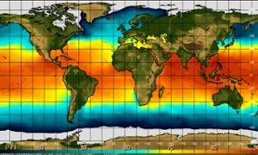

The global El Niño weather phenomenon, whose impacts cause global famines, floods – and even wars – now has a 90% chance of striking this year, according to the latest forecast released to the Guardian.
El Niño begins as a giant pool of warm water swelling in the eastern tropical Pacific Ocean, that sets off a chain reaction of weather events around the world – some devastating and some beneficial.
India is expected to be the first to suffer, with weaker monsoon rains undermining the nation’s fragile food supply, followed by further scorching droughts in Australia and collapsing fisheries off South America. But some regions could benefit, in particular the US, where El Niño is seen as the “great wet hope” whose rains could break the searing drought in the west.
The knock-on effects can have impacts even more widely, from cutting global gold prices to making England’s World Cup footballers sweat a little more.
The latest El Niño prediction comes from the European Centre for Medium-range Weather Forecasts (ECMWF), which is considered one the most reliable of the 15 or so prediction centres around the world. “It is very much odds-on for an event,” said Tim Stockdale, principal scientist at ECMWF, who said 90% of their scenarios now deliver an El Niño. "The amount of warm water in the Pacific is now significant, perhaps the biggest since the 1997-98 event.” That El Niño was the biggest in a century, producing the hottest year on record at the time and major global impacts, including a mass die-off of corals.
“But what is very much unknowable at this stage is whether this year’s El Niño will be a small event, a moderate event – that’s most likely – or a really major event,” said Stockdale, adding the picture will become clearer in the next month or two. “It is which way the winds blow that determines what happens next and there is always a random element to the winds.”
The movement of hot, rain-bringing water to the western Pacific ramps up the risk of downpours in the nations flanking that side of the great ocean, while the normally damp eastern flank dries out. Governments, commodity traders, insurers and aid groups like the Red Cross and World Food Programme all monitor developments closely and water conservation and food stockpiling is already underway in some countries.
Professor Axel Timmermann, an oceanographer at the University of Hawaii, argues that a major El Niño is more likely than not, because of the specific pattern of winds and warm water being seen in the Pacific. “In the past, such alignments have always triggered strong El Niño events,” he said.
El Niño events occur every five years or so and peak in December, but the first, and potentially greatest, human impacts are felt in India. The reliance of its 1 billion-strong population on the monsoon, which usually sweeps up over the southern tip of the sub-continent around 1 June, has led its monitoring to be dubbed “the most important weather forecast in the world”. This year, it is has already got off to a delayed start, with the first week’s rains 40% below average.
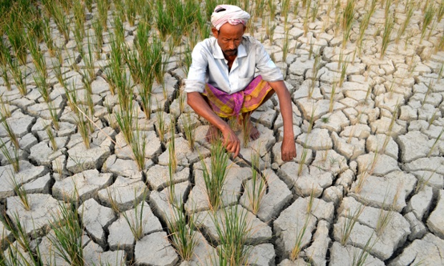
A farmer awaits rain on his drought-hit paddy field in Morigoan, Assam, India.
“El Niño could be quite devastating for agriculture and the water supply in India,” said Dr Nick Klingaman, an El Niño expert at the University of Reading in the UK. Two-thirds of Indian farmland lacks irrigation and is reliant solely on rainfall, meaning even current official prediction of a 5% reduction in monsoon rains would have a major impact: a 10% fall is an official drought. Krishna Kumar, an Indian meteorologist and El Niño expert, said that even if the 2014 El Niño turns out not to be a very hot one, it can still have a major effect on the monsoon because it is the specific location of the warm Pacific water which is the critical factor. “The moderate El Niños of 2002 and 2009 impacted the monsoon in India much more greatly then the major 1997 event,” he said, adding that the biggest cut in rainfall is not usually felt until September.
Open contributions: How has El Niño weather phenomenon affected you?
Rana Kapoor, president of the Associated Chambers of Commerce of India, warned: “We recommend the government to immediately announce steps to control food inflation in view of the impending El Niño and the cascading negative affect it will have on crop production.” The impact on farmers means past monsoon failures have cost the nation $20bn (£12bn) in lost output and, because the Indian market dominates global gold prices, the cost of the precious metal has already fallen.
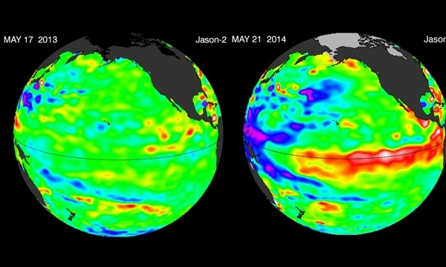
Global sea surface temperature in May 2013 and May 2014.
New research in May showed the global impact of El Niño events on food supplies, with corn, rice and wheat yield much lower than normal, although soybean harvests tend to rise. While food production has improved in the last year, El Niño is set to reverse that trend, according to Leo Abruzzese, global forecasting director for the Economist Intelligence Unit. “It may reduce agricultural output over the next few years, which could weigh on global food security”. Drought linked to the 2007 El Niño led to a surge in food prices in 2008 that sparked riots in countries as far afield as Egypt, Cameroon and Haiti.
After India, El Niño’s impacts roll eastwards and officials in Cebu, the Philippines’ second city, have already urged all households to save water to reduce the impact of the drier weather due to hit by the end June. In Malaysia, the national water authority is preparing for a dry spell of up to 18 months and calling for water rationing, while meteorologists have warned of forest fires.
The hot, dry skies will then track to heat-wracked Australia, where 2013 was already its hottest year on record and El Niño is threatening to turn the temperature up even further. Andrew Watkins, manager of climate prediction services at the Australian Bureau of Meteorology, said: “El Niño is one of the largest influences on Australia’s climate. It’s why historically Australia has had one of the most variable climates on the planet.” Watkins said El Niño increases the chances of low rainfall in the country’s southern and most populous half and tends to deliver hotter years and higher extreme temperatures.
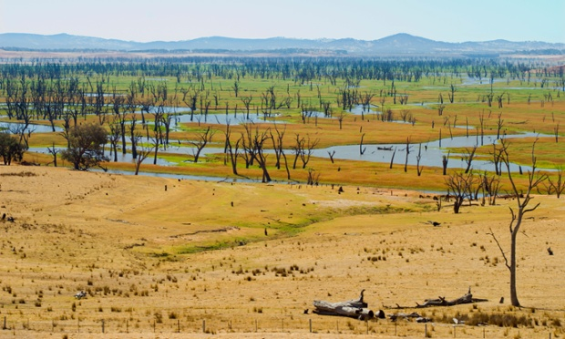
Low water levels at Lake Hume, north-eastern Victoria, Australia,
during the dry summer of 2007, when the last El Niño occurred.

Brent Finlay, president of Australia’s National Farmers’ Federation, said he was hoping El Niño just does not happen. “We have farmers and graziers in New South Wales and Queensland who are in drought now, and so to have this prediction of a possible El Niño will be of grave concern.” Severe drought at any time could have “tragic” consequences on rural communities where he said some farmers had even taken their own lives, he said: “That is what drought does.”
However, on the opposite side of the Atlantic, in the US, El Niño holds out the prospect of relief for the parched western states and nowhere is more desperate for rain than California. The entire state is in severe or extreme drought, after receiving barely a quarter of its annual rainfall, and communities have been under water rations since March, which ordinarily would still be the rainy season. The result is a tinder box, with governor Jerry Brown warning the state faces the worst wildfire season on record.
A strong El Niño would bring rain, typically double the annual average in southern California. “I commonly refer to El Niño as the great wet hope,” said Bill Patzert, a climate scientist at Nasa’s Jet Propulsion Laboratory in California. “Everyone in the west has their fingers crossed because we are bone dry. We have had three of the four driest years in the west in recorded history. Dry land farmers and ranchers are definitely on their knees right now. We are running on reserves, we are pumping aquifers, and our reservoirs are at record lows.” El Niños also typically lead to wetter winters in Texas, and other parts of the south-west, which also depend on getting most of their rain in the winter months.
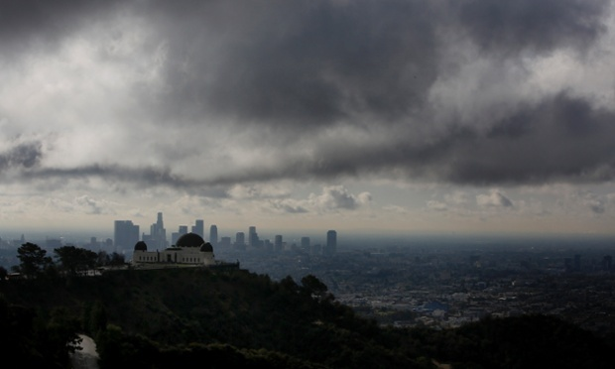
Griffith Observatory stands as clouds gather above the skyline of downtown Los Angeles, California.
However, big El Niños like the 1997-98 event – what Patzert calls “godzillas” – are rare and forecasters at the US government’s climate prediction centre said on 5 June that time was running out for a significant El Niño to be set in train. A modest or small El Niño would have little impact on the drought, said Patzert, noting that the 2006-07 drought – the worst on record at the time – occurred during a weak El Niño year. Even a “godzilla” would not be enough on its own to bail California out, he said: “But it would be a fantastic down payment on drought relief.”
Strong El Niños also typically bring warmer winters to the northern US states, which would be a relief after last winter’s Arctic conditions.
El Niños also typically damp down hurricane activity. But Prof Kerry Emanuel, an atmospheric scientist at MIT, said even in an El Niño year a hurricane, given the right conditions, could still cause tremendous destruction. Hurricane Andrew, one of the deadliest and costliest in recent history, roared through Florida in 1992, which was an El Niño year. “It would be tragic if everyone let their guard down,” Emanuel said.
Elsewhere in the Americas, a careful watch is being kept in Peru, where the huge anchovy fishery has been wiped out by previous El Niños – it was Peruvian sailors who first named the phenomenon “the Christ child” because its peak occurs at Christmas. The 1997-98 El Niño slashed the catch by 80%, as the fish migrated away from the abnormally warm waters. Luis Icochea, a fisheries expert at the National Agrarian University in Lima, warned that the event this year is developing in a similar way.
Rodney Martínez, at Ecuador’s International El Niño Centre, said El Niño would affect the whole of south America, meaning heavy rainfall and floods in Ecuador, Peru, Chile and northern Argentina but potential drought relief in Chile and Bolivia. The early effects of El Niño in Brazil are expected to raise temperatures during the football World Cup.
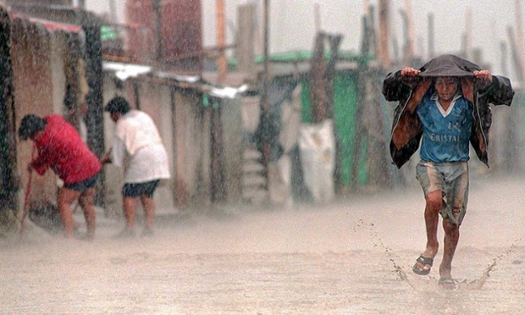
Flooded streets in the town of Tuman, Peru.
But, despite better El Niño warnings nowadays, Martinez said many nations were worse prepared than in 1997: “In many cases the vulnerability has increased: more exposed population, more land degradation, river sedimentation, collapse of underground water sources, degradation of natural protection in riversides, badly designed infrastructure and lack of coordination and planning to cope with El Niño.”
Stockdale said other global impacts could be droughts in the Caribbean and southern Africa at the end of the year, and also in central Asia, although the precise impacts of each El Niño vary due to local climatic variations. Europe is the continent least affected by El Niño by virtue of being on the opposite side of the world.
However, in the tropics and sub-tropics, another deadly impact of El Niño is becoming better understood: its ability to spark civil wars. Solomon Hsiang, at Columbia University, New York, showed in 2011 that 50 of the 250 conflicts between 1950 and 2004 were triggered by the El Niño cycle, probably due to the loss of crops, jobs and the psychological effects of hotter weather.
Hsiang told the Guardian that, based on historical data, a Pacific warming of 0.8C is associated with a rise in the annual risk of conflict of 15%. The current forecasts indicate that this year’s warming will most probably lie between 0.5C and 1.5C. “Of course, conflicts may not occur just because the risk of conflict is higher, in the same way car accidents don’t always occur on rainy days when the risk of accident is higher,” Hsiang said. “But it is certainly a developing situation that we should keep track of and it would be excellent to have policy-makers and the public aware of the potential risk.”
Policymakers are likely also to feel the heat of El Niño in the negotiations towards a global deal to cut carbon emissions and tackle global warming, which must culminate in Paris in December 2015. Since the scorching year of 1998, the rate of global warming has slowed, with over 90% of the heat trapped by CO2 going into the oceans.
“A lot of energy that should have been in the atmosphere has gone into the Pacific,” said Kumar. “If El Niño does set in that could trigger the release of that heat and faster warming: that has been a major concern.” An El-Niño-boosted 2015 could well be the hottest year on record, according to Klingaman, just as nations have to agree a climate change deal.
“If 2014 turns out to be an El Niño year as currently forecast, increased public awareness of the dangers of human-induced climate change is likely to follow,” said Prof Michael Raupach, director of the Climate Change Institute at the Australian National University. “However, it is very important that our policy responses do not wax and wane with El Niño.”
The link between global warming and El Niño, a natural climate phenomenon, is not yet well understood by scientists. But a study published in January predicted a doubling of extreme El Niño events, as climate change ramps up.
Either way, adding the impacts of El Niño to the extreme weather already being driven by climate change increases the damage caused, said Stockdale: “El Niño can be the thing that pushes you over the edge. It will be in the years when you get a big El Niño when you feel the impact of climate change the most.”

IBD
Obama calls Israeli ties 'unbreakable'; He should know after 5 years of trying
by Andrew Malcolm

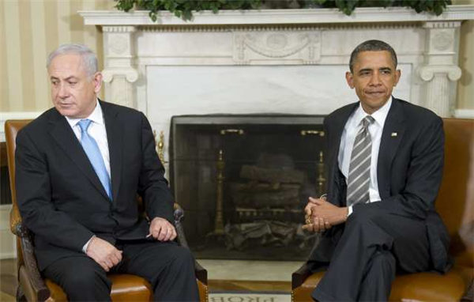
Obama and Netanyahu share their warm friendship by a cozy fire.
Jay Leno spoke at an awards ceremony in Israel recently honoring Michael Bloomberg. He commented on how Obama‘s administration has handled its 'special relationship' with Israel.
Leno said, “President Obama declared the month of May to be Jewish American Heritage Month. He is calling it an opportunity to renew our ‘unbreakable bond with the nation of Israel.’ And Obama knows it’s unbreakable because he’s been trying to break it for the last five years.”
Meyers: Scientists are attaching sensors to sharks to predict hurricane intensity. They're hoping their information will save enough lives to offset the number of lives lost attaching sensors to sharks.
Meyers: Phil Mickelson is under investigation by the FBI for insider trading of Clorox stock. By the way, insider trading of Clorox stock by a pro golfer is the whitest collar crime possible.
Fallon: Just in time, a California company has created a grill that can text when your burgers are done. A great way to enjoy grilling with none of the fun of grilling.
Meyers: Apple officially announced the other day its new operating system, iOS 8. Just in time for iOS 7 to finish downloading.
Fallon: Facebook's people are encouraging Pope Francis to join. But he said: “I already have enough people confessing to me what they did last weekend."
Fallon: Obama says Hillary Clinton would be very effective if she ran for President. And Joe Biden said, “Thank you very--Wait, what?”
Conan: In Texas, a family was attacked by a swarm of bees in a town called Beeville. The family said they’re fed up with Beeville, and they are moving to Wolfetown.
Fallon: CNN had terrible 10 p.m. ratings with only 35,000 viewers tuning in the other night. I left it on for my dog and when I came back, she was reading a newspaper.
Conan: A new report reveals Chicago's crime rate plummets during NFL games. Mainly because the most dangerous criminals are busy on the field.
Conan: Pope Francis says married people should have more kids. Married people said the Pope should “have a kid and then get back to us.”
Meyers: President Obama unveils a 600-page proposal to lower carbon emissions and help stop global warming. Step One: Stop printing 600-page proposals.
Conan: NASA is putting wireless Internet on the moon. So now the Moon is identical to Starbucks, except it costs less money to go to the Moon.
Conan: In her new book Hillary Clinton says she’s “moved on” from the Monica Lewinsky scandal. For more, read Bill Clinton’s new book “No, She Hasn’t.”
Conan: NASA is testing an aircraft that is shaped like a flying saucer and they’re sending it over Hawaii. Just for fun, nobody tell Hawaii.
Conan: MIT scientists have created a suit simulating the feeling of being an 80-year-old man. Unfortunately, the guy testing the suit has wandered off.
Conan: A 13-year-old is the youngest female to climb Mount Everest. She didn’t mean to. She was just texting her friend and next thing she was atop Mount Everest.
Meyers: French President Hollande had two official dinners the other night to keep Obama and Putin apart. It's an old trick he learned from having a wife and a mistress.
Meyers: Dr Dre bought Tom Brady’s 18,000-square=foot LA mansion for $40 million. Now, $40 million might sound like a lot of money. But remember, he’s a doctor.
Meyers: The Miami Heat and San Antonio Spurs are facing off in the NBA Finals, the NBA’s annual contest to determine whose city will be set on fire.
Conan: Donald Sterling sells the LA Clippers for $2 billion. So, let that be a lesson: If you make racist remarks to your mistress, you'll get a check for $2 billion.
Meyers: A six-year-old Phoenix girl helped deliver her baby sister after her mother prematurely went into labor. Best. Show and Tell. Ever.
Meyers: Australian scientists have rediscovered a bat species believed extinct for over 120 years. But thanks to one scientist's quick reflexes, it’s extinct again.
Meyers: A Danish firm has developed a beer fridge called eCool using underground conditions to keep beer cold. So congratulations, I guess, for inventing the “hole.”
Conan: A Japanese clothier is being criticized for its "skinny,” “fat” and “jumbo” size labels. So it changed them to “small,” “medium” and “American.”



