April 6, 2014

Good time to look at November's voting for the senate. Jason Riley is first.
When Democratic Sen. Carl Levin announced that he would retire this year, few people saw a pickup opportunity for the GOP. Yet it's turning into that kind of year for Republicans, who need a net gain of six seats in the fall to retake control of the Senate.
Terri Lynn Land, who's running to replace Mr. Levin, was not the Republican establishment's first choice (that would have been Rep. Mike Rogers), but the former Michigan secretary of state continues to perform above expectations. Yet another poll, out this week, has her statistically tied with Democratic Rep. Gary Peters in a state that President Obama carried by nearly 10 points in 2012.
In Colorado last month, a tea party Republican who lost a previous Senate race agreed to step aside for a more viable candidate, Rep. Cory Gardner. Suddenly, incumbent Democratic Sen. Mark Udall isn't as invulnerable as everyone thought when the cycle began. Scott Brown's decision to challenge Democratic Sen. Jeanne Shaheen in New Hampshire has had a similar effect. ...

Jennifer Rubin is next.
To the dismay of Democrats, the playing field for control of the Senate has expanded beyond what even Republicans imagined would be possible. Let’s consider the total picture, and which seats are now in play.
While they won’t admit it, Democrats have all but lost Senate seats in West Virginia, Montana and South Dakota. Republicans recruited top candidates, and the Democrats are unlikely to spend significant money. That is in large part because there is a very good possibility they will also lose Arkansas (where incumbent Mark Pryor trails in recent polling), North Carolina (same there for Kay Hagan) and Alaska (where Dan Sullivan now seems the most capable opponent.) So stop there. If only these races go as expected and the Republicans lose no seats, then the GOP wins the Senate. It is very easy to imagine this occurring. And we haven’t yet mentioned the imperiled Mary Landrieu, who is trying to survive the association with the party of Obamacare and opposition to domestic energy production).
Take then the next level of races. ...

Karl Rove devoted his weekly column to the races.
With seven months until the midterm election, there's little for Democrats to cheer in the growing number of polls on this year's Senate contests.
Republicans have double-digit leads in the three races in red states Mitt Romney carried where the incumbent Democrat retired. West Virginia Rep. Shelley Moore Capito is up by 14 points, 49%-35%, over Secretary of State Natalie Tennant in a Feb. 20 Rasmussen poll. Former South Dakota Gov. Mike Rounds leads Democratic congressional staffer Rick Weiland 51%-31% in a Feb. 26 Rasmussen survey. Montana Rep. Steve Daines is 14 points ahead of interim Sen. John Walsh, 51%-37% in a March 18 Rasmussen matchup. These public polls mirror private ones, suggesting Republicans are positioned to win if they keep the pressure on.
The next benchmark for these races is the April 15 Federal Election Commission fundraising reports for the first quarter. All three Republican candidates had a commanding financial advantage at the end of 2013. If they maintain the money edge for 2014's first and second quarters, Democratic donors may start cutting their losses and shifting funds elsewhere.
Then there are the four red states where incumbent Democratic senators are trying to retain their seats. Each race is a dogfight, though every Democrat has much higher name identification than the Republican challenger. ...

Tablet Magazine has a profile of Eugene Volokh and the Volokh Conspiracy.
Last week, when the Supreme Court heard arguments over whether religiously owned corporations like Hobby Lobby should be exempt from providing contraception coverage to their employees, the government’s reply brief cited dozens of cases and statutes—and one blog with a weird name, The Volokh Conspiracy.
It wasn’t the first time the site made itself heard before the nation’s highest court. In the wake of the passage, in 2010, of the Affordable Care Act—the cornerstone of President Obama’s domestic agenda—libertarian writers for The Volokh Conspiracy were instrumental in building the constitutional challenge to the law’s individual mandate. “When the Affordable Care Act was going through the legislative process, most law professors agreed that the ACA was constitutional,” said South Texas College of Law’s Josh Blackman, who wrote the definitive scholarly account of the challenge.
Then The Volokh Conspiracy entered the fray, and everything changed. “Usually these kinds of legal arguments develop over the course of many years in law reviews, in conferences and symposiums,” Blackman continued, “but this was on warp speed. You had blog posts on the day where you could actually see the arguments shaping before you.” Soon the challenge was being hotly debated among law professors and was adopted by state attorneys general across the United States. What the legal establishment once considered an open-and-shut laugher turned into a 5-4 Supreme Court nail-biter.
It was, perhaps, the first time that a highly technical legal debate on a matter of national policy importance—the sort of discussion usually confined to law reviews, academic panels, and conference rooms at the Justice Department—played out in real time for the consumption of lay readers as well as professionals, and it cemented the site’s role as a public clearinghouse for cutting-edge legal debate. As Paul Clement, the former U.S. solicitor general who represented the 26 states opposing Obamacare, put it, “The Constitution had its Federalist Papers, and the challenge to the Affordable Care Act had The Volokh Conspiracy.”
Founded as a solo operation in April 2002, the site is now one of the Internet’s most-read legal blogs, boasting a diverse readership of scholars and policymakers—as well as Supreme Court Justices—across the ideological spectrum. (Justice Elena Kagan has said she reads it daily.) In January, The Volokh Conspiracy moved to the Washington Post, giving it an even more prominent role in the national conversation—and more power to shape the discourse surrounding issues currently being decided in the courts, from religious freedom to gay marriage.
How did a center-right blog written by libertarian-leaning professors become the most influential in American legal circles? The story begins with its founder and namesake, a Soviet Jewish refugee named Eugene Volokh.
In 1975, Volokh arrived with his parents in the United States from Ukraine. The family settled in California; five years later, Volokh was admitted to UCLA on a full scholarship after scoring 780 out of 800 on the mathematical portion of his SAT. It would have been an impressive achievement for any student, let alone any recent immigrant—but Volokh was also just 12 years old at the time. In 1981, the Los Angeles Times ran a profile in which the writer dubbed Volokh a “prodigy, a genius, or, simply, staggeringly bright,” and reported his IQ at 206. He chose to attend UCLA, the article noted, because he wanted to stay close to home—and because he wasn’t old enough to drive. ...

The Economist has come around to the point of view that much of the money spent on higher education is wasted. Virginia residents will be heartened by the four most rewarding degrees. First is University of Virginia and fourth is William and Mary. And, this is further proof of Pickerhead's sagacity since four of his children earned degrees at those schools.
WHEN LaTisha Styles graduated from Kennesaw State University in Georgia in 2006 she had $35,000 of student debt. This obligation would have been easy to discharge if her Spanish degree had helped her land a well-paid job. But there is no shortage of Spanish-speakers in a nation that borders Latin America. So Ms Styles found herself working in a clothes shop and a fast-food restaurant for no more than $11 an hour.
Frustrated, she took the gutsy decision to go back to the same college and study something more pragmatic. She majored in finance, and now has a good job at an investment consulting firm. Her debt has swollen to $65,000, but she will have little trouble paying it off.
As Ms Styles’s story shows, there is no simple answer to the question “Is college worth it?” Some degrees pay for themselves; others don’t. American schoolkids pondering whether to take on huge student loans are constantly told that college is the gateway to the middle class. The truth is more nuanced, as Barack Obama hinted when he said in January that “folks can make a lot more” by learning a trade “than they might with an art history degree”. An angry art history professor forced him to apologise, but he was right.
College graduates aged 25 to 32 who are working full time earn about $17,500 more annually than their peers who have only a high school diploma, according to the Pew Research Centre, a think-tank. But not all degrees are equally useful. And given how much they cost—a residential four-year degree can set you back as much as $60,000 a year—many students end up worse off than if they had started working at 18. ...
... What is not in doubt is that the cost of university per student has risen by almost five times the rate of inflation since 1983, and graduate salaries have been flat for much of the past decade. Student debt has grown so large that it stops many young people from buying houses, starting businesses or having children. Those who borrowed for a bachelor’s degree granted in 2012 owe an average of $29,400. The Project on Student Debt, a non-profit, says that 15% of borrowers default within three years of entering repayment. At for-profit colleges the rate is 22%. Glenn Reynolds, a law professor and author of “The Higher Education Bubble”, writes of graduates who “may wind up living in their parents’ basements until they are old enough to collect Social Security.” ...

WSJ - Political Diary
A Mighty Wind?
by Jason L. Riley
When Democratic Sen. Carl Levin announced that he would retire this year, few people saw a pickup opportunity for the GOP. Yet it's turning into that kind of year for Republicans, who need a net gain of six seats in the fall to retake control of the Senate.
Terri Lynn Land, who's running to replace Mr. Levin, was not the Republican establishment's first choice (that would have been Rep. Mike Rogers), but the former Michigan secretary of state continues to perform above expectations. Yet another poll, out this week, has her statistically tied with Democratic Rep. Gary Peters in a state that President Obama carried by nearly 10 points in 2012.
In Colorado last month, a tea party Republican who lost a previous Senate race agreed to step aside for a more viable candidate, Rep. Cory Gardner. Suddenly, incumbent Democratic Sen. Mark Udall isn't as invulnerable as everyone thought when the cycle began. Scott Brown's decision to challenge Democratic Sen. Jeanne Shaheen in New Hampshire has had a similar effect.
In addition to fielding quality Senate candidates in blue states, the GOP has also had some good luck. Rep. Bruce Braley of Iowa, who's running for the state's open Senate seat, decided to demean "two Iowa institutions: Sen. Chuck Grassley and farming," as The Wall Street Journal put it. Mr. Braley's gaffe at a fundraising event, where he dismissed Mr. Grassley as a "farmer from Iowa who never went to law school," may have expanded the Republican map by yet another state.
As GOP strategist Karl Rove notes in his Journal column Thursday, the Republican Senate candidate has a double-digit lead in all three red states where Democratic incumbents are retiring: West Virginia, South Dakota and Montana. And in the four red state where Democrats are running for re-election—Alaska, Louisiana, Arkansas and North Carolina—"each race is a dogfight, though every Democrat has much higher name identification than the Republican challenger."
We're still seven months from Election Day, but right now the wind at the back of the GOP seems to be getting stronger.

Right Turn
How big is the Senate playing field?
by Jennifer Rubin
To the dismay of Democrats, the playing field for control of the Senate has expanded beyond what even Republicans imagined would be possible. Let’s consider the total picture, and which seats are now in play.
While they won’t admit it, Democrats have all but lost Senate seats in West Virginia, Montana and South Dakota. Republicans recruited top candidates, and the Democrats are unlikely to spend significant money. That is in large part because there is a very good possibility they will also lose Arkansas (where incumbent Mark Pryor trails in recent polling), North Carolina (same there for Kay Hagan) and Alaska (where Dan Sullivan now seems the most capable opponent.) So stop there. If only these races go as expected and the Republicans lose no seats, then the GOP wins the Senate. It is very easy to imagine this occurring. And we haven’t yet mentioned the imperiled Mary Landrieu, who is trying to survive the association with the party of Obamacare and opposition to domestic energy production).
Take then the next level of races. Michigan is now, as one GOP operative put it, a “coin toss.” In Colorado (where mainstream Republican Cory Gardner has cleared out the primary field) and Iowa (where the trial lawyer Democrat Bruce Braley has gotten crosswise with farmers) the Democrats have hit the skids. (We’re up to 10 races in play.)
But wait. The GOP now has highly credible candidates in New Hampshire (Scott Brown) and Virginia (Ed Gillespie). They are each more than ten points behind, but both sides expect these races to close significantly. That’s twelve.
It once seemed improbably that Democrat Al Franken would be in trouble in deep blue Minnesota. It’s still a long-shot for Republicans. However, it’s not as long as it used to be. A GOP poll shows, “Only 41 percent of respondents had a favorable view of Sen. Franken, while 45 percent had an unfavorable view of him. Only 44 percent approve of the job he is doing. 54% of respondents disapprove of the Affordable Care Act, and only 38% approve. Only 40% of respondents think Al Franken deserves re-election.” It’s not likely to go to the GOP, but it’s not nutty to think it might. And in the same category, you have a highly competent female Republican doctor Monica Wehby running against Jeff Merkley in Oregon. So if you squint, the number gets to 14.
As for turf the GOP is defending, Minority (currently) Leader Mitch McConnell is way ahead of tea party crank Matt Bevin. And he’s now the hero of the First Amendment, having once more championed an assault on anti-speech campaign laws. Is Kentucky pining to send a Hollywood-backed, socially liberal Democrat to the Senate or the guy who is likely to be majority leader? Put McConnell in the safe column for now.
So the Democrats’ pick-up opportunity seems to be in Georgia. Pause. Georgia. With President Obama on the ballot and a heavy African-American turnout the Democrats still lost the state in 2012 by nearly 8 points. Yes, the “Nunn” name is solid among those voters old enough to remember Democratic candidate Michelle’s father, the former senator (who retired in 1997), but the Republicans look likely to pick the well-liked former governor Sonny Perdue. Is Georgia yearning for a Democrat to go to Washington to defend Obamacare? Not so much. (In her first ad, Nunn’s grabbing footage material of her with Bush 41, while the rest of her party still likes to trash Bush 43.)
Is the GOP going to pick up 14 seats? Almost certainly not. But think about it: If Republicans win less than half of those, they get the Senate majority. Put differently, the Dems have to win at least eight. Could some of these races go downhill for the GOP? Sure, but you have to think there are a whole lot that won’t.

WSJ
Why the Senate Races Will Soon Get Ugly
If GOP candidates don't define themselves to voters, Democratic attack ads will.
by Karl Rove
With seven months until the midterm election, there's little for Democrats to cheer in the growing number of polls on this year's Senate contests.
Republicans have double-digit leads in the three races in red states Mitt Romney carried where the incumbent Democrat retired. West Virginia Rep. Shelley Moore Capito is up by 14 points, 49%-35%, over Secretary of State Natalie Tennant in a Feb. 20 Rasmussen poll. Former South Dakota Gov. Mike Rounds leads Democratic congressional staffer Rick Weiland 51%-31% in a Feb. 26 Rasmussen survey. Montana Rep. Steve Daines is 14 points ahead of interim Sen. John Walsh, 51%-37% in a March 18 Rasmussen matchup. These public polls mirror private ones, suggesting Republicans are positioned to win if they keep the pressure on.
The next benchmark for these races is the April 15 Federal Election Commission fundraising reports for the first quarter. All three Republican candidates had a commanding financial advantage at the end of 2013. If they maintain the money edge for 2014's first and second quarters, Democratic donors may start cutting their losses and shifting funds elsewhere.
Then there are the four red states where incumbent Democratic senators are trying to retain their seats. Each race is a dogfight, though every Democrat has much higher name identification than the Republican challenger.
Take Alaska: 91% of Alaskans felt they knew enough about Democratic Sen. Mark Begich to have an opinion of him in a Jan. 22 Harper poll for American Crossroads (the super-PAC I helped organize). The Republican front-runner, former Natural Resources Commissioner Dan Sullivan, had 73% name recognition. Yet a March 24 Rasmussen survey found the race tied at 44%, similar to the earlier Harper poll matchup. Mr. Sullivan's name recognition is probably overstated: Some voters probably confuse him with Anchorage's two-term mayor, also named Dan Sullivan.
In a Feb. 20 poll from Democratic firm Hickman Analytics, Arkansas's Democratic Sen. Mark Pryor had 94% "effective recognition" to Rep. Tom Cotton's 79%. Yet Mr. Pryor only led Mr. Cotton by 40%-37%.
Another Hickman poll on Feb. 20 showed Louisiana Democratic Sen. Mary Landrieu with 95% "effective recognition," while her leading GOP opponent, Rep. Bill Cassidy, clocked in at 42%. Despite this substantial gap, Mr. Cassidy led Ms. Landrieu by four points (46%-42%).
In a third Feb. 20 Hickman poll, North Carolina Democratic Sen. Kay Hagan had a 50-point "effective recognition" advantage over the leading Republican, State House Speaker Thom Tillis (84% vs. 34%). Mr. Tillis only trailed by four points.
There is a similar pattern in blue states President Obama won in 2012. The Democratic opinion research firm Public Policy Polling showed incumbent Colorado Sen. Mark Udall narrowly ahead of Rep. Cory Gardner, 42%-40%, in a March 16 poll. Yet Mr. Gardner has been in the race only five weeks and has significantly less name recognition than Mr. Udall, having represented one-seventh of Colorado's citizens for two terms in the House.
An incumbent with much higher name recognition than an opponent—but only a narrow lead this early on—is evidence of a low ceiling of support. It also suggests that the challenger can rise as his background, values and agenda becomes better known.
Democrats understand this, which is why Sen. Harry Reid's Majority PAC, liberal interest groups, and some Democratic candidates have launched early attacks on Republican challengers, attacking Mr. Sullivan as a carpetbagger and Messrs. Cassidy, Cotton and Tillis as shills for the insurance industry. They want to define the GOP candidates before they define themselves—like the Obama campaign did to Mitt Romney in 2012.
It won't be easy for Republicans to offer the right mix of messages and raise the funds to deliver those messages. They must keep their fire trained on the economy, ObamaCare's shortcomings, the national debt and the military's hollowing-out. They must convince voters that Democratic incumbents have blindly followed Mr. Obama. And they need to sharpen awareness of their own histories and values. The last is often given short shrift.
Right now, the Senate midterms feature crucial races between well-known, well-defined Democrat incumbents and lesser-known, largely undefined Republicans. The political map and landscape favors the GOP. But dislodging a sitting U.S. senator is hard—and Republican hopes of taking the Senate depends on doing exactly that. Republicans should be encouraged but not complacent. Mr. Reid and his allies will make certain these races get very intense and very ugly soon.
Mr. Rove, a former deputy chief of staff to President George W. Bush, helped organize the political-action committee American Crossroads.

Tablet Magazine
The Volokh Conspiracy Is Out To Get You—And Everyone in America
Run by a Soviet Jewish legal scholar, the blog took on the ACA and is now hosted by the ‘Washington Post’
by Yair Rosenberg

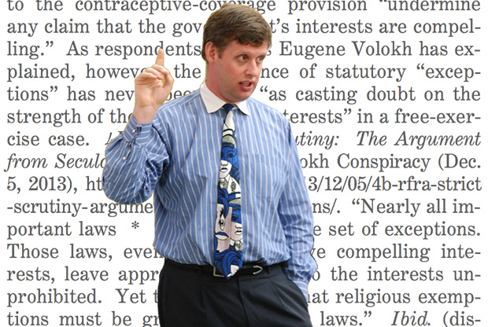

Professor Eugene Volokh
Last week, when the Supreme Court heard arguments over whether religiously owned corporations like Hobby Lobby should be exempt from providing contraception coverage to their employees, the government’s reply brief cited dozens of cases and statutes—and one blog with a weird name, The Volokh Conspiracy.
It wasn’t the first time the site made itself heard before the nation’s highest court. In the wake of the passage, in 2010, of the Affordable Care Act—the cornerstone of President Obama’s domestic agenda—libertarian writers for The Volokh Conspiracy were instrumental in building the constitutional challenge to the law’s individual mandate. “When the Affordable Care Act was going through the legislative process, most law professors agreed that the ACA was constitutional,” said South Texas College of Law’s Josh Blackman, who wrote the definitive scholarly account of the challenge.
Then The Volokh Conspiracy entered the fray, and everything changed. “Usually these kinds of legal arguments develop over the course of many years in law reviews, in conferences and symposiums,” Blackman continued, “but this was on warp speed. You had blog posts on the day where you could actually see the arguments shaping before you.” Soon the challenge was being hotly debated among law professors and was adopted by state attorneys general across the United States. What the legal establishment once considered an open-and-shut laugher turned into a 5-4 Supreme Court nail-biter.
It was, perhaps, the first time that a highly technical legal debate on a matter of national policy importance—the sort of discussion usually confined to law reviews, academic panels, and conference rooms at the Justice Department—played out in real time for the consumption of lay readers as well as professionals, and it cemented the site’s role as a public clearinghouse for cutting-edge legal debate. As Paul Clement, the former U.S. solicitor general who represented the 26 states opposing Obamacare, put it, “The Constitution had its Federalist Papers, and the challenge to the Affordable Care Act had The Volokh Conspiracy.”
Founded as a solo operation in April 2002, the site is now one of the Internet’s most-read legal blogs, boasting a diverse readership of scholars and policymakers—as well as Supreme Court Justices—across the ideological spectrum. (Justice Elena Kagan has said she reads it daily.) In January, The Volokh Conspiracy moved to the Washington Post, giving it an even more prominent role in the national conversation—and more power to shape the discourse surrounding issues currently being decided in the courts, from religious freedom to gay marriage.
How did a center-right blog written by libertarian-leaning professors become the most influential in American legal circles? The story begins with its founder and namesake, a Soviet Jewish refugee named Eugene Volokh.
***
In 1975, Volokh arrived with his parents in the United States from Ukraine. The family settled in California; five years later, Volokh was admitted to UCLA on a full scholarship after scoring 780 out of 800 on the mathematical portion of his SAT. It would have been an impressive achievement for any student, let alone any recent immigrant—but Volokh was also just 12 years old at the time. In 1981, the Los Angeles Times ran a profile in which the writer dubbed Volokh a “prodigy, a genius, or, simply, staggeringly bright,” and reported his IQ at 206. He chose to attend UCLA, the article noted, because he wanted to stay close to home—and because he wasn’t old enough to drive.
While still in high school, Volokh had begun working as a professional computer programmer, and he continued in the industry for six years after graduating UCLA, writing software for Hewlett Packard. But then he got bored. “I really liked computers,” he told me over brunch during a recent visit to New York, “but I felt I’d hit a plateau.” The young Volokh had grander aspirations. “I wanted to be involved in public policy debates,” he went on, “and I realized that especially back then, public policy debates were mostly run by lawyers.”
So, he went to UCLA Law School, not quite sure if it would pan out. “I thought to myself,” he recalled, “if it looks like I’ll be an unsuccessful lawyer, I can just quit.” But it turned out that Volokh was quite a good lawyer, and after graduation he went on to clerk for Judge Alex Kozinski on the Ninth Circuit Court of Appeals and then for Supreme Court Justice Sandra Day O’Connor. Now 46, Volokh is a professor of law at UCLA and widely acknowledged as one of the country’s preeminent experts on the First Amendment.
But it was in 2002 that he started the site that would revolutionize the law’s place in the public discourse. At the time, the conservative blogosphere was just beginning to take off, led by University of Tennessee professor Glenn Reynolds, who launched InstaPundit. Reynolds offered Volokh a guest-blogging gig there, and he was soon hooked, enamored with the ability to disseminate his views in real time to a popular audience.
“I’m a law professor and I’m a Jew, and we both like to hear ourselves talk,” Volokh said wryly. “I’ve always wanted to spread my ideas; I think that’s an important part of my job—not just to speak to a little corner of the academy, not just to speak to the professionals like judges and lawyers, but to speak to the public on public policy.”
While Volokh had published op-eds in prominent forums like the Wall Street Journal and the Washington Post, he found the format restrictive with its word limits and reliance on the whims of editors. Blogging, on the other hand, had no such impediments. “It was something that was tailor-made for my temperament, which was to speak out about what I want, when I want, the way I wanted,” he said. “Now that I mention it this way, it sounds kind of self-indulgent. But what’s wrong with self-indulgence?” He grins. “I mean, no one else is going to indulge you, so you might as well indulge yourself!”
And so he launched his own blog, drawing on his technical acumen to build the site. He quickly invited his brother Sasha, then a graduate student at Harvard, aboard and christened it The Volokh Brothers. In the following months, the blog added several other libertarian-leaning voices and became The Volokh Conspiracy—a nod to Hillary Clinton’s line about being hounded by a “vast right-wing conspiracy.”
But though the blog was unabashedly of the right, its politics were—and are—not so much partisan as ideologically committed to a general philosophy of libertarianism, which emphasizes individual rights and a profound skepticism of state power. Thus, posts supporting limited government and gun rights mingle with those supporting gay rights and drug legalization. An atheist, Volokh advocates a robust, if not unrestricted, conception of religious liberty. Underlying all these stances is a consistent preference for personal freedom, wherever it leads. “I think I’ve always had a ‘presumption of liberty,’” said Volokh. “Generally speaking, people should be free to do what they like, unless there’s a really good reason to stop them.”
Some of this worldview stems from Volokh’s academic research. For instance, despite growing up in a home without a gun culture, he became an advocate for gun rights after examining the data on the efficacy of gun control laws, and concluding that many did not substantially curb crime. But a significant influence on Volokh’s outlook—and that of several other contributors to the blog—has been the Soviet Jewish refugee experience. Having grown up in families that experienced firsthand the oppressive potential of untrammeled state power, these individuals naturally gravitated toward libertarianism, with its deep-rooted suspicion of government overreach. “Those of us who share that story share the same reason for why we became libertarian,” explained Sasha Volokh, now an associate professor at Emory Law School.
“If I had been born in the United States and I had the same kind of personality and interests that I do, I think there’s a good likelihood I would have become a liberal or even more left-wing than that,” said Ilya Somin, a professor at George Mason University who has written about his family’s encounter with Soviet repression and anti-Semitism, and who joined the blog in 2006. “But the experience of coming from the Soviet Union made that a lot less likely, and therefore made me more open to becoming a libertarian.”
One way the Russian Jewish experience manifests itself on the blog is in the realm of foreign policy, where many of the “conspirators” tend to be more open to American intervention abroad than others in the libertarian community. As Tyler Cowen, a George Mason professor and former Conspirator, puts it, Soviet immigrant writers at the blog are more inclined to back such action “because they understand what it’s like to live under tyranny.” Most notably, when many libertarians—like isolationist former Texas Congressman Ron Paul—opposed the Iraq war, seeking to avoid overseas entanglements, others at The Volokh Conspiracy supported it.
“I do leave more room for intervention than some libertarians,” Somin explained, “because I know that the alternative to many interventions is not free markets or individual freedom, but rather much more oppressive regimes than anything that would likely be put in place by an intervention by the U.S. or its allies.”
Similarly, The Volokh Conspiracy is also generally sympathetic in its outlook toward Israel, a topic that frequently divides the libertarian community. “Since many of the Western enemies of Israel are so conspicuously un-libertarian, I think many libertarians sort of have the sense that if the Noam Chomskys of the world are against Israel, we should be for it,” Volokh told me. “But at the same time, there’s also a very substantial isolationist, non-foreign-interventionist wing of the libertarian movement that says ‘Why are we involved in Israel?’ ” Writers at The Volokh Conspiracy who discuss Israel fall decidedly into the former camp, even as they are often critical of its policies. Somin’s George Mason colleague David Bernstein makes the libertarian case for Israel quite succinctly. “Would it be a more libertarian world if there was a Palestine in place of Israel?” Bernstein asked when we spoke. “That’s pretty hard to imagine.”
But without question, the blog’s primary impact has been on the American domestic front, from disputes surrounding eminent domain to the case against the Affordable Care Act. Indeed, the Obamacare challenge exemplified how The Volokh Conspiracy has radically transformed the legal landscape. In the past, the academy often looked askance at blogging as a distraction from more serious legal writing, to the extent that some professors initially joined the Conspiracy under pseudonyms to conceal their involvement. Today, however, blogs have become the driver of the discourse. “The way law professoring used to work was that you would spend a year writing a law review article, you would workshop it among other professors, and maybe in 18 months, it would come out in a printed book that no one would ever read,” explained Blackman, the South Texas professor. “Now a case is decided and within a few minutes you can post a few hundred words on a blog, which becomes now the narrative shaper —and I think you can credit that to Eugene Volokh and the other conspirators.”
***
Political scientist James Q. Wilson once said that the trick to being a successful conservative in the overwhelmingly liberal realm of academia was to “be twice as productive and four times as nice as your colleagues.” It’s a dictum that perfectly encapsulates Volokh, who despite his manifold achievements—“He’s somehow managed to find more than 24 hours in the day for all the things he does,” said co-blogger Jonathan Adler of Case Western University—is unfailingly gracious, both in writing and in person, toward ideological friends and foes alike.
“Tolerance,” he has written, “means acknowledging that even if people may be wrong in one thing that means a lot to you, it doesn’t follow that they’re wrong in all things. It means (among other things) being willing to see the merits, if there are merits, in people who believe things that you think are wrong, foolish, or even evil.” It’s a generous philosophy that will be put to the test now that the Conspiracy has joined the Post, where many readers—judging by initial comments—are less inclined to be generous back after reading Volokh and his fellow bloggers’ arguments in favor of conservative causes like gun rights.
Volokh, for his part, seems to relish the challenge of preaching to the unconverted. “I hope the payoff will be a broader reach for our ideas,” he recently wrote, “which is why we blog in the first place.”

The Economist
Higher education - Is college worth it?
Too many degrees are a waste of money. The return on higher education would be much better if college were cheaper

WHEN LaTisha Styles graduated from Kennesaw State University in Georgia in 2006 she had $35,000 of student debt. This obligation would have been easy to discharge if her Spanish degree had helped her land a well-paid job. But there is no shortage of Spanish-speakers in a nation that borders Latin America. So Ms Styles found herself working in a clothes shop and a fast-food restaurant for no more than $11 an hour.
Frustrated, she took the gutsy decision to go back to the same college and study something more pragmatic. She majored in finance, and now has a good job at an investment consulting firm. Her debt has swollen to $65,000, but she will have little trouble paying it off.
As Ms Styles’s story shows, there is no simple answer to the question “Is college worth it?” Some degrees pay for themselves; others don’t. American schoolkids pondering whether to take on huge student loans are constantly told that college is the gateway to the middle class. The truth is more nuanced, as Barack Obama hinted when he said in January that “folks can make a lot more” by learning a trade “than they might with an art history degree”. An angry art history professor forced him to apologise, but he was right.
College graduates aged 25 to 32 who are working full time earn about $17,500 more annually than their peers who have only a high school diploma, according to the Pew Research Centre, a think-tank. But not all degrees are equally useful. And given how much they cost—a residential four-year degree can set you back as much as $60,000 a year—many students end up worse off than if they had started working at 18.
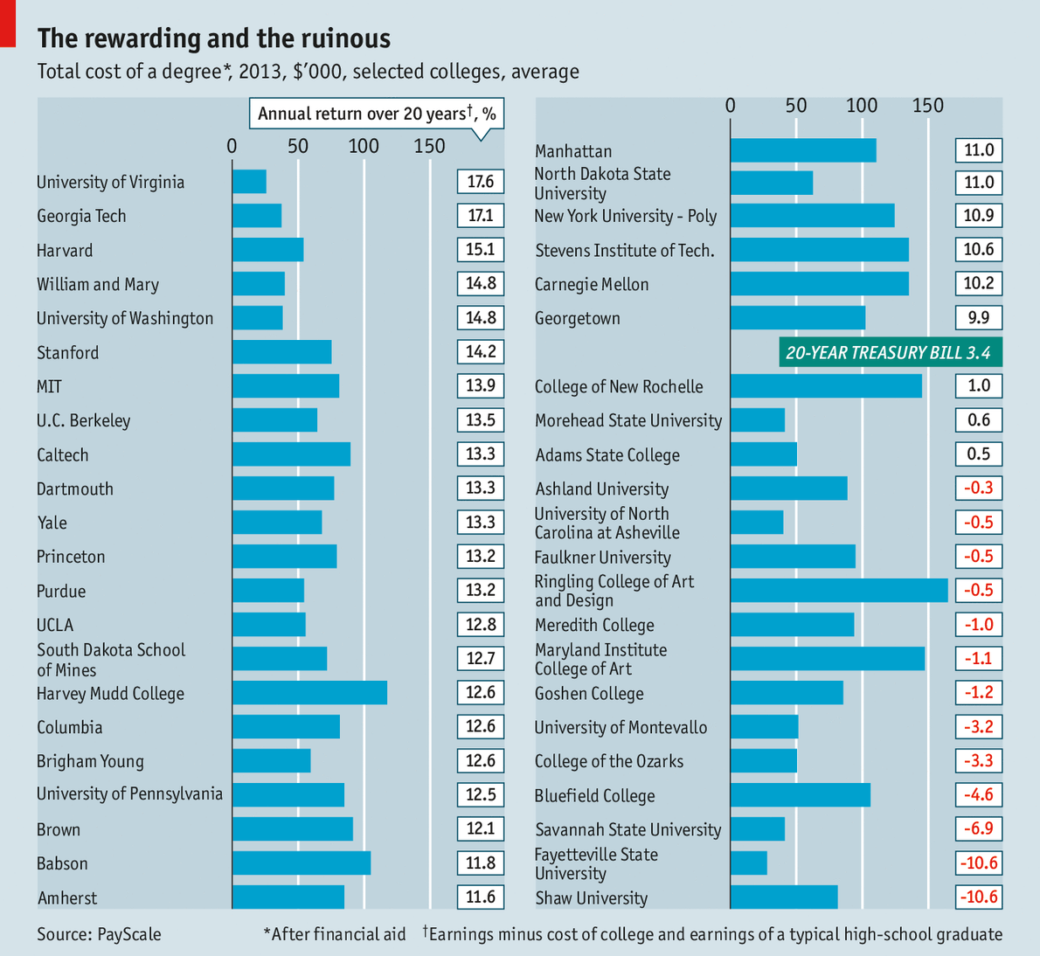
PayScale, a research firm, has gathered data on the graduates of more than 900 universities and colleges, asking them what they studied and how much they now earn. The company then factors in the cost of a degree, after financial aid (discounts for the clever or impecunious that greatly reduce the sticker price at many universities). From this, PayScale estimates the financial returns of many different types of degree (see chart).

Hard subjects pay off
Unsurprisingly, engineering is a good bet wherever you study it. An engineering graduate from the University of California, Berkeley can expect to be nearly $1.1m better off after 20 years than someone who never went to college. Even the least lucrative engineering courses generated a 20-year return of almost $500,000.
Arts and humanities courses are much more varied. All doubtless nourish the soul, but not all fatten the wallet. An arts degree from a rigorous school such as Columbia or the University of California, San Diego pays off handsomely. But an arts graduate from Murray State University in Kentucky can expect to make $147,000 less over 20 years than a high school graduate, after paying for his education. Of the 153 arts degrees in the study, 46 generated a return on investment worse than plonking the money in 20-year treasury bills. Of those, 18 offered returns worse than zero.
Colleges that score badly will no doubt grumble that PayScale’s rankings are based on relatively small numbers of graduates from each institution. Some schools are unfairly affected by the local job market—Murray State might look better if Kentucky’s economy were thriving. Universities that set out to serve everyone will struggle to compete with selective institutions. And poor colleges will look worse than rich ones that offer lots of financial aid, since reducing the cost of a degree raises its return.
All these caveats are true. But overall, the PayScale study surely overstates the financial value of a college education. It does not compare graduates’ earnings to what they would have earned, had they skipped college. (That number is unknowable.) It compares their earnings to those of people who did not go to college—many of whom did not go because they were not clever enough to get in. Thus, some of the premium that graduates earn simply reflects the fact that they are, on average, more intelligent than non-graduates.
What is not in doubt is that the cost of university per student has risen by almost five times the rate of inflation since 1983, and graduate salaries have been flat for much of the past decade. Student debt has grown so large that it stops many young people from buying houses, starting businesses or having children. Those who borrowed for a bachelor’s degree granted in 2012 owe an average of $29,400. The Project on Student Debt, a non-profit, says that 15% of borrowers default within three years of entering repayment. At for-profit colleges the rate is 22%. Glenn Reynolds, a law professor and author of “The Higher Education Bubble”, writes of graduates who “may wind up living in their parents’ basements until they are old enough to collect Social Security.”
That is an exaggeration: students enrolling this year who service their debts will see them forgiven after 20 years. But the burden is still heavy for many. It does not help that nearly a third of those who take out such loans eventually drop out of college; they must still repay their debts. A third transfer to different schools. Many four-year degrees drag on longer, and so cost more. Overall, the six-year graduation rate for four-year institutions is only 59%.
The lousy national job market does not help, either. A report by McKinsey, a consultancy, found that 42% of recent graduates are in jobs that require less than a four-year college education. Some 41% of graduates from the nation’s top colleges could not find jobs in their chosen field; and half of all graduates said they would choose a different major or school.
Chegg, a company that provides online help to students, collaborated the study. Dan Rosensweig, its boss, says that only half of graduates feel prepared for a job in their field, and only 39% of managers feel that students are ready for the workforce. Students often cannot write clearly or organise their time sensibly. Four million jobs are unfilled because jobseekers lack the skills employers need.
Grading the graders
For all their flaws, studies like PayScale’s help would-be students (and their parents) make more informed choices. As Americans start to realise how much a bad choice can hurt them, they will demand more transparency. Some colleges are providing it, prodded by the federal government. For example, the University of Texas recently launched a website showing how much its graduates earn and owe after five years.
“Opportunity”, said Mr Obama on April 2nd, “means making college more affordable.” In time, transparency and technology will force many colleges to cut costs and raise quality. Online education will accelerate the trend. In 2012, 6.7m students were taking at least one online course. Such courses allow students to listen to fine lecturers without having to pay for luxurious dormitories or armies of college bureaucrats. They will not replace traditional colleges—face-to-face classes are still valuable—but they will force them to adapt. Those that offer poor value for money will have to shape up, or disappear.





