December 4, 2013

Corner Post from Mark Steyn on the growing Arctic and Antarctic ice.
News from Santa’s Grotto:
Global warming hysterics at the BBC warned us in 2007 that by summer 2013, the Arctic would be ice-free. As with so many other doomsday predictions by warmists, the results turn out to be quite the opposite.
Meanwhile, down the other end at Santa’s summer vacation condo:
Antarctic sea ice has grown to a record large extent for a second straight year, baffling scientists seeking to understand why this ice is expanding rather than shrinking in a warming world.
Antarctic ice is now at a 35-year high. But scientists are “baffled” by the planet’s stubborn refusal to submit to their climate models. Maybe the problem with Nobel fantasist Michael Mann’s increasingly discredited hockey stick is that he’s holding it upside down.
Nonetheless, the famously settled science seems to be re-settling:
Scientists Increasingly Moving To Global Cooling Consensus
Global warming will kill us. Global cooling will kill us. And if it’s 54 and partly cloudy, you should probably flee for your life right now. Maybe scientists might usefully consider moving to being less hung up on “consensus” – a most unscientific and, in this context, profoundly corrupting concept.

Here's the Daily Mail, UK article that prompted Steyn's post.
A chilly Arctic summer has left 533,000 more square miles of ocean covered with ice than at the same time last year – an increase of 29 per cent.
The rebound from 2012’s record low comes six years after the BBC reported that global warming would leave the Arctic ice-free in summer by 2013.
Instead, days before the annual autumn re-freeze is due to begin, an unbroken ice sheet more than half the size of Europe already stretches from the Canadian islands to Russia’s northern shores.
The Northwest Passage from the Atlantic to the Pacific has remained blocked by pack-ice all year. More than 20 yachts that had planned to sail it have been left ice-bound and a cruise ship attempting the route was forced to turn back.
Some eminent scientists now believe the world is heading for a period of cooling that will not end until the middle of this century – a process that would expose computer forecasts of imminent catastrophic warming as dangerously misleading.
The disclosure comes 11 months after The Mail on Sunday triggered intense political and scientific debate by revealing that global warming has ‘paused’ since the beginning of 1997 – an event that the computer models used by climate experts failed to predict.
In March, this newspaper further revealed that temperatures are about to drop below the level that the models forecast with ‘90 per cent certainty’.
The pause – which has now been accepted as real by every major climate research centre – is important, because the models’ predictions of ever-increasing global temperatures have made many of the world’s economies divert billions of pounds into ‘green’ measures to counter climate change.
Those predictions now appear gravely flawed. ...

The Verge takes us behind the scenes of a FOX NFL broadcast.
It's 90 minutes to game time in Foxboro, Massachusetts, and Troy Aikman's not speaking to anyone.
Around him, a dozen or so crew members, assistants, and friends chatter as they finish last-minute preparations, making sure Gillette Stadium is ready for football. They're testing cables and video feeds, rechecking stats, and setting up the fabric "NFL on FOX" backdrop that will turn this bland, gray, carpeted room into the tiny booth millions will soon see on TV.
Through it all, Aikman stays silent. He's surrounded by four computer monitors displaying every stat and feed he'll need for the next several hours, but he's focused on a small tablet on the desk in front of him. He's scrubbing back and forth in a single play, over and over, looking for something only he can see. The gold Super Bowl ring on his left hand occasionally catches the mid-afternoon sun as it shines into the booth, just above the first level of stands at the 50 yard line.
In an hour and a half, the New Orleans Saints and the New England Patriots will kick off one of the most important and most anticipated games of the young NFL season. Aikman will stand next to Thom Brennaman, his play-by-play partner for the day, and call the game for an audience that will total 26.7 million viewers. The game will be decided on a last-second desperation pass, will shape one quarterback's legacy and two teams' seasons, and will be endlessly discussed and replayed in the days and weeks to come.
But Aikman’s not worried about any of that. For him, and the entire Fox Sports NFL crew in the annals of the stadium below, it’s just another Sunday.
To watch a football broadcast is to see much more than a football game. There are only about 11 minutes of actual action during a three-hour game, which means 95 percent of the time there’s something else going on. The graphics, replays, highlights, and analysis that make a football game into the at-home experience millions of people know and love — it’s all from Fox, and it’s all done on the fly. Nearly everyone on the crew says that while they broadcast the game, what they really do is make television. ...
... All 31 NFL arenas are different, and everything from stadium height to the type of lighting can affect the broadcast. (Light frequencies can clash with the high-frame-rate cameras, producing dark and light frames instead of a consistent shot — Callahan says Detroit causes problems every time.) But after years together, this crew knows the oddities of every one. Fred Aldous, Fox’s audio consultant, even has presets for every stadium on his enormous audio mixing console. "The colder it gets, the better off, because everybody bundles up… they're wearing a sound blanket, if you will." That’s why Aldous loves mixing in Green Bay. "This stadium," he says, pointing toward the field behind him, "it's nice because it's an open stadium." The sound escapes from the field, he says, rather than just reverberating throughout the stadium. ...
... It’s the end of the game. Tom Brady’s just thrown a 17-yard touchdown to Kenbrell Thompkins, winning a seemingly lost game with five seconds to spare. Nearly half the game’s 68,756 fans left early, and the cheers from the parking lot and the highway drown out the ones from the stadium. The replay — a perfect shot of the moment, Thompkins snatching the ball in the back-left corner of the end zone — loops on the giant screens in Gillette, and presumably on every TV in every bar in Boston. There will be much celebrating tonight.
Underneath the stadium, the Fox crew starts to break down, to load its massive production back into 53-foot trucks. In two hours, they'll be gone. And next week, they'll pull into Lincoln Financial Field in Philadelphia and do it all again.
That's just what they do on Sundays.

Eliana Johnson reports for WSJ on the healthcare "navigators."
Even when the Obama administration was under the impression that the launch of the Affordable Care Act was going to work splendidly, with a first-rate website, the plan still called for "navigators" to help people sign up. Now, with the ACA website Healthcare.gov hobbled, and even many of the president's supporters grumbling that the law may need a radical rethinking, the work of the tens of thousands of these helpers is more vital than ever.
How's it going? Not well, to judge from a visit with navigators in North Carolina, one of 34 states that decided not to open their own health-insurance exchanges.
Durham is a relatively low-income city—nearly 19% of the residents are below the poverty level—that is 41% African-American and 14% Hispanic. It is the type of place that the White House expects to benefit most from ObamaCare. Yet the navigators I spoke with there earlier this month say interest has been sparse. Organizations like the Alcohol and Drug Council of North Carolina and the Lincoln Community Health Center that received federal funds to hire navigators are contemplating how to reach out to potential enrollees, given that waiting for phone calls or walk-ins is not proving fruitful.
Occasionally, the navigators even make house calls. I accompanied Nyi Myint, a navigator with the Alcohol and Drug Council of North Carolina, to the home of Kimberly Munier, a self-employed single mother. Her Blue CrossBlue Shield plan was canceled over the summer, and she asked Mr. Myint for help with the federal exchange.
He begins by laying a wrinkled paper on the kitchen table, a green-and white-certificate indicating that he has completed the "Navigator Curriculum." It is not a particularly official looking document: In the top left corner, it reads, "Print Close Window." "This is how they sent it to us," he says, laughing. ...

The Corner
Ice Everywhere, But No Hockey Sticks
by Mark Steyn
News from Santa’s Grotto:
Global warming hysterics at the BBC warned us in 2007 that by summer 2013, the Arctic would be ice-free. As with so many other doomsday predictions by warmists, the results turn out to be quite the opposite.
Meanwhile, down the other end at Santa’s summer vacation condo:
Antarctic sea ice has grown to a record large extent for a second straight year, baffling scientists seeking to understand why this ice is expanding rather than shrinking in a warming world.
Antarctic ice is now at a 35-year high. But scientists are “baffled” by the planet’s stubborn refusal to submit to their climate models. Maybe the problem with Nobel fantasist Michael Mann’s increasingly discredited hockey stick is that he’s holding it upside down.
Nonetheless, the famously settled science seems to be re-settling:
Scientists Increasingly Moving To Global Cooling Consensus
Global warming will kill us. Global cooling will kill us. And if it’s 54 and partly cloudy, you should probably flee for your life right now. Maybe scientists might usefully consider moving to being less hung up on “consensus” – a most unscientific and, in this context, profoundly corrupting concept.

Daily Mail, UK
And now it's global COOLING! Return of Arctic ice cap as it grows by 29% in a year
by David Rose
A chilly Arctic summer has left 533,000 more square miles of ocean covered with ice than at the same time last year – an increase of 29 per cent.
The rebound from 2012’s record low comes six years after the BBC reported that global warming would leave the Arctic ice-free in summer by 2013.
Instead, days before the annual autumn re-freeze is due to begin, an unbroken ice sheet more than half the size of Europe already stretches from the Canadian islands to Russia’s northern shores.
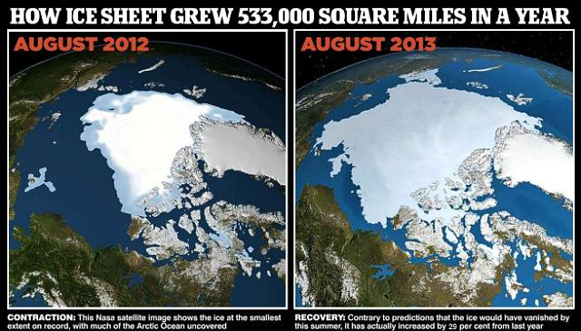
The Northwest Passage from the Atlantic to the Pacific has remained blocked by pack-ice all year. More than 20 yachts that had planned to sail it have been left ice-bound and a cruise ship attempting the route was forced to turn back.
Some eminent scientists now believe the world is heading for a period of cooling that will not end until the middle of this century – a process that would expose computer forecasts of imminent catastrophic warming as dangerously misleading.
The disclosure comes 11 months after The Mail on Sunday triggered intense political and scientific debate by revealing that global warming has ‘paused’ since the beginning of 1997 – an event that the computer models used by climate experts failed to predict.
In March, this newspaper further revealed that temperatures are about to drop below the level that the models forecast with ‘90 per cent certainty’.
The pause – which has now been accepted as real by every major climate research centre – is important, because the models’ predictions of ever-increasing global temperatures have made many of the world’s economies divert billions of pounds into ‘green’ measures to counter climate change.
Those predictions now appear gravely flawed.
The continuing furore caused by The Mail on Sunday’s revelations – which will now be amplified by the return of the Arctic ice sheet – has forced the UN’s climate change body to reconsider its position.
The UN Intergovernmental Panel on Climate Change (IPCC) was due in October to start publishing its Fifth Assessment Report – a huge three-volume study issued every six or seven years. It will hold a pre-summit in Stockholm later this month.

THERE WON'T BE ANY ICE AT ALL! HOW THE BBC PREDICTED CHAOS IN 2007
Only six years ago, the BBC reported that the Arctic would be ice-free in summer by 2013, citing a scientist in the US who claimed this was a ‘conservative’ forecast. Perhaps it was their confidence that led more than 20 yachts to try to sail the Northwest Passage from the Atlantic to the Pacific this summer. As of last week, all these vessels were stuck in the ice, some at the eastern end of the passage in Prince Regent Inlet, others further west at Cape Bathurst.
Shipping experts said the only way these vessels were likely to be freed was by the icebreakers of the Canadian coastguard. According to the official Canadian government website, the Northwest Passage has remained ice-bound and impassable all summer.
The BBC’s 2007 report quoted scientist Professor Wieslaw Maslowski, who based his views on super-computer models and the fact that ‘we use a high-resolution regional model for the Arctic Ocean and sea ice’.
He was confident his results were ‘much more realistic’ than other projections, which ‘underestimate the amount of heat delivered to the sea ice’. Also quoted was Cambridge University expert
Professor Peter Wadhams. He backed Professor Maslowski, saying his model was ‘more efficient’ than others because it ‘takes account of processes that happen internally in the ice’.
He added: ‘This is not a cycle; not just a fluctuation. In the end, it will all just melt away quite suddenly.’
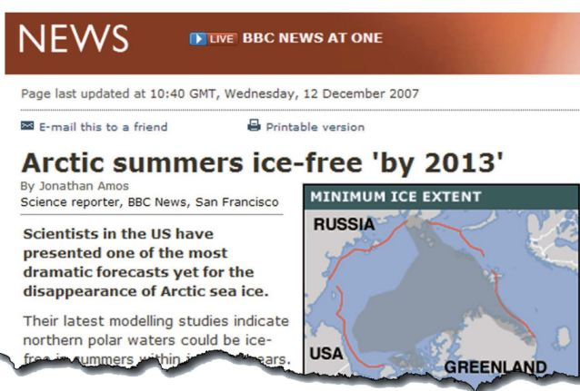

Leaked documents show that governments which support and finance the IPCC are demanding more than 1,500 changes to the report’s ‘summary for policymakers’. They say its current draft does not properly explain the pause.
At the heart of the row lie two questions: the extent to which temperatures will rise with carbon dioxide levels, as well as how much of the warming over the past 150 years – so far, just 0.8C – is down to human greenhouse gas emissions and how much is due to natural variability.
In its draft report, the IPCC says it is ‘95 per cent confident’ that global warming has been caused by humans – up from 90 per cent in 2007.
This claim is already hotly disputed. US climate expert Professor Judith Curry said last night: ‘In fact, the uncertainty is getting bigger. It’s now clear the models are way too sensitive to carbon dioxide. I cannot see any basis for the IPCC increasing its confidence level.’
She pointed to long-term cycles in ocean temperature, which have a huge influence on climate and suggest the world may be approaching a period similar to that from 1965 to 1975, when there was a clear cooling trend. This led some scientists at the time to forecast an imminent ice age.
Professor Anastasios Tsonis, of the University of Wisconsin, was one of the first to investigate the ocean cycles. He said: ‘We are already in a cooling trend, which I think will continue for the next 15 years at least. There is no doubt the warming of the 1980s and 1990s has stopped.


Then... NASA satellite images showing the spread of Arctic sea ice 27th August 2012


...And now, much bigger: The same Nasa image taken in 2013
‘The IPCC claims its models show a pause of 15 years can be expected. But that means that after only a very few years more, they will have to admit they are wrong.’
Others are more cautious. Dr Ed Hawkins, of Reading University, drew the graph published by The Mail on Sunday in March showing how far world temperatures have diverged from computer predictions. He admitted the cycles may have caused some of the recorded warming, but insisted that natural variability alone could not explain all of the temperature rise over the past 150 years.
Nonetheless, the belief that summer Arctic ice is about to disappear remains an IPCC tenet, frequently flung in the face of critics who point to the pause.
Yet there is mounting evidence that Arctic ice levels are cyclical. Data uncovered by climate historians show that there was a massive melt in the 1920s and 1930s, followed by intense re-freezes that ended only in 1979 – the year the IPCC says that shrinking began.
Professor Curry said the ice’s behaviour over the next five years would be crucial, both for understanding the climate and for future policy. ‘Arctic sea ice is the indicator to watch,’ she said.

The Verge
Any given Sunday: inside the chaos and spectacle of the NFL on Fox
The NFL's most exciting game doesn't happen on the field
by David Pierce

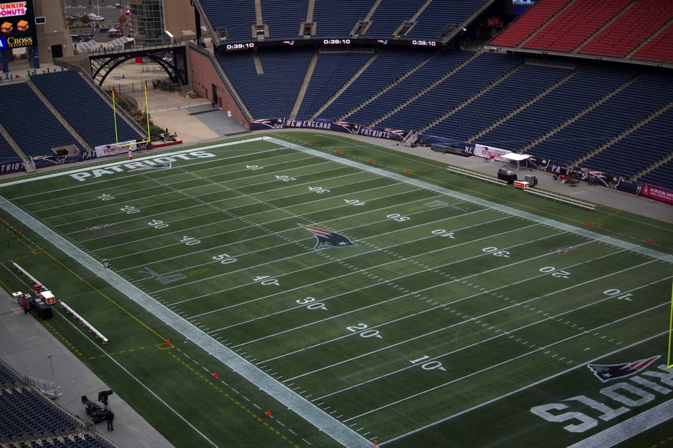

It's 90 minutes to game time in Foxboro, Massachusetts, and Troy Aikman's not speaking to anyone.
Around him, a dozen or so crew members, assistants, and friends chatter as they finish last-minute preparations, making sure Gillette Stadium is ready for football. They're testing cables and video feeds, rechecking stats, and setting up the fabric "NFL on FOX" backdrop that will turn this bland, gray, carpeted room into the tiny booth millions will soon see on TV.
Through it all, Aikman stays silent. He's surrounded by four computer monitors displaying every stat and feed he'll need for the next several hours, but he's focused on a small tablet on the desk in front of him. He's scrubbing back and forth in a single play, over and over, looking for something only he can see. The gold Super Bowl ring on his left hand occasionally catches the mid-afternoon sun as it shines into the booth, just above the first level of stands at the 50 yard line.
In an hour and a half, the New Orleans Saints and the New England Patriots will kick off one of the most important and most anticipated games of the young NFL season. Aikman will stand next to Thom Brennaman, his play-by-play partner for the day, and call the game for an audience that will total 26.7 million viewers. The game will be decided on a last-second desperation pass, will shape one quarterback's legacy and two teams' seasons, and will be endlessly discussed and replayed in the days and weeks to come.
But Aikman’s not worried about any of that. For him, and the entire Fox Sports NFL crew in the annals of the stadium below, it’s just another Sunday.
To watch a football broadcast is to see much more than a football game. There are only about 11 minutes of actual action during a three-hour game, which means 95 percent of the time there’s something else going on. The graphics, replays, highlights, and analysis that make a football game into the at-home experience millions of people know and love — it’s all from Fox, and it’s all done on the fly. Nearly everyone on the crew says that while they broadcast the game, what they really do is make television.
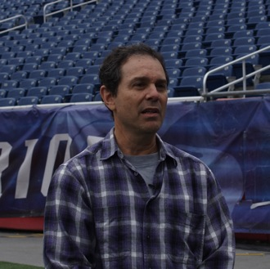
Producer Richie Zyontz
Fox's team totals more than 150, its equipment more than $25 million
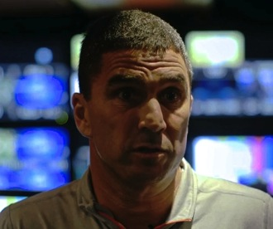
Director Rich Russo
It starts at 6AM on Saturday, in the cold, dark Foxboro morning, as the Fox team shows up to unload three 53-foot trucks. Stadiums don’t have much in the way of built-in A / V equipment, so Fox (and every other network) carries everything the crew will need for the weekend inside those trucks — the show has to be built and broken down every weekend. This Saturday, it has to be even faster: there's a college football game at 4PM.
Kevin Callahan, Fox’s director of technical operations, estimates Fox credentialed between 150 and 200 people for the weekend, from Troy Aikman and director Rich Russo to runners and microphone holders. The network brings in about $25 million worth of equipment, with thousands of individual parts. (Callahan is reluctant to even guess at the number: "It depends on how small you want to get," he says. "I mean, the production switcher alone has 1,000 buttons on it.") Callahan and his crew have to wire the entire stadium, rig up cameras and audio, and make sure hundreds of different parts are able to connect to each other. "This is actually a very well-oiled machine," he says. "The mobile units that we're using here were designed in 2005 and 2006 — at the time they were eight years ahead of their time."
In one truck, graphics and production. In another, 20 feet away in the concrete garage underneath the stands, replay and audio. Russo estimates he has 15 cameras and 13 tape machines this week, capturing and replaying angles from all over the stadium — there’s even a helicopter flying around shooting from above. The graphics team, eight or so young guys in polo shirts, is preparing more than 1,000 graphics, with every record or outcome accounted for. Rich Russo and producer Richie Zyontz talk to everyone through speakers and headsets, voicing their constant chatter to the 150-member Fox crew throughout the weekend. Colby Bourgeios, the team’s technical director, sits at his giant switcher ready to put any camera, any person, any replay on TV with the press of one of a thousand buttons. Audio consultant Fred Aldous watches and listens on his own console, making sure everything sounds as good as it looks — in stereo and 5.1-channel surround sound.
Eventually, nearly everyone says, you just learn to do it by feel.
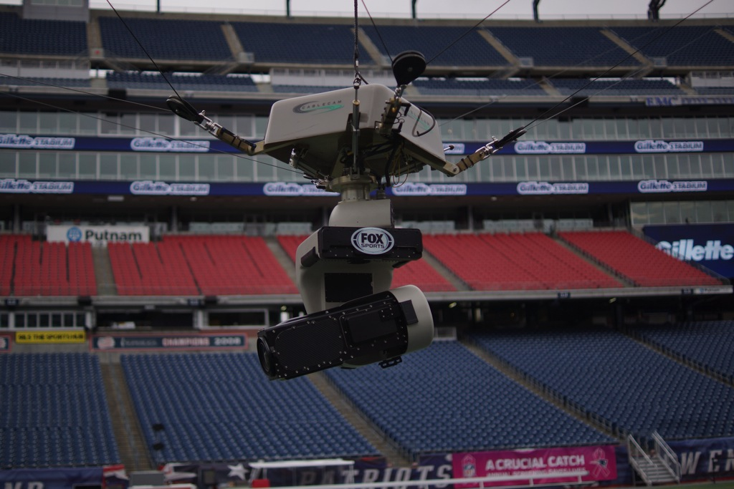
If Aikman is the quarterback of the broadcast, Rich Russo is the head coach. He’s the director on Fox's A Crew, its best sports broadcast team. Ultimately, he's in charge of what viewers see on their TVs during a football game. He says his job is to make the viewer feel like they're sitting in the stands, seeing and hearing everything as if they're inside Gillette Stadium on this brisk Sunday afternoon. "You have to put yourself in the audience’s shoes," he says. "What does the viewer want to see?"
It’s equally a storytelling challenge and a technical one, and the technology is changing constantly. Inside a fourth truck at Gillette Stadium is the Cablecam, the flying camera that shoots behind the line of scrimmage during plays, sees huddles from above, and finds players in spots no other camera can. It’s been a staple of the Fox setup since 2003, and it's now a key piece of any NFL broadcast. "There's a lot of cameras here shooting stuff," says Cablecam VP Brett Crutcher, "but we can pick off certain shots that the other cameras maybe can't… we have the ability to get right in the guy’s face, and we usually get pretty good shots from there."
All 31 NFL arenas are different, and everything from stadium height to the type of lighting can affect the broadcast. (Light frequencies can clash with the high-frame-rate cameras, producing dark and light frames instead of a consistent shot — Callahan says Detroit causes problems every time.) But after years together, this crew knows the oddities of every one. Fred Aldous, Fox’s audio consultant, even has presets for every stadium on his enormous audio mixing console. "The colder it gets, the better off, because everybody bundles up… they're wearing a sound blanket, if you will." That’s why Aldous loves mixing in Green Bay. "This stadium," he says, pointing toward the field behind him, "it's nice because it's an open stadium." The sound escapes from the field, he says, rather than just reverberating throughout the stadium.
His setup changes every week, but Aldous’ goal is always the same. "I want the viewer at home to be a part of the audience in the stands, because the field of play never moves in front of you when you're in the stands," he says.
"I want them to feel like they're sitting in the crowd, so I put crowd 360 degrees around, my announcers in the center speaker, and fill in the front left and rights with my effects mix — that's kind of being an observer of a game." There are offensive linemen and coaches wearing mics, with others set up all over the field and stadium. "The HD picture is absolutely beautiful," Aldous says, "but without sound, without hearing the quarterback, hearing some of the hits, hearing the emotion of the crowd in everything, I don't think it would be nearly as good."
Troy Aikman is responsible for driving the broadcast, for actually telling viewers the game’s most important stories. The Hall-of-Fame quarterback turned superstar analyst spends Friday and Saturday with Russo and Zyontz, meeting with both teams and watching them practice. They learn about each team's game plan, and identify some of the key story lines for the game. The three men also spend hours together each week watching game film, making sure Zyontz and Russo are ready for everything Aikman might bring up on the broadcast.
This week, the stories write themselves, Zyontz says. "You have two of the great quarterbacks, future Hall-of-Famers, Drew Brees and Tom Brady. Tom Brady is standing there frustrated as heck: he doesn't have Gronkowski back, he has young receivers, and he looks across the field and Drew Brees has a plethora of riches. He's got Darren Sproles, he's got Jimmy Graham, he's got Marques Colston. That's interesting to me." Every camera angle is covered, every exciting player accounted for, every team’s tendencies analyzed.
But from the moment assistant director Rich Gross stands in the truck and says "20 to red," and Fox’s live feed shifts from the Los Angeles-based pregame show to Gillette Stadium, all that goes out the window. All there is is this game, this Sunday, on dozens of screens in front of Rich Russo's face. Thom Brennaman will describe the game as it happens, and Aikman will tell its stories — the ones he predicted and the many more he couldn’t. "It's instincts, it's reactions," Zyontz says, "and it happens really quick."
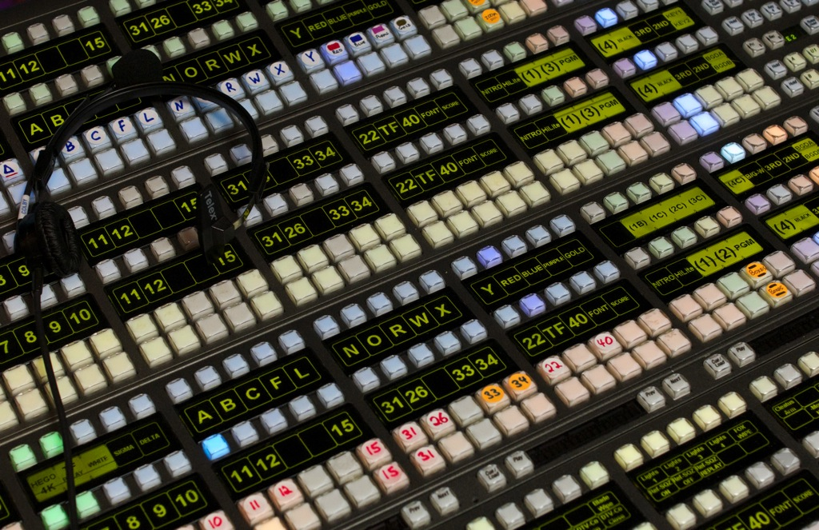
It's the fourth quarter, 2:24 remaining. New Orleans leads 27-23, but the Patriots have the ball. During a quick game-break to the game between the Arizona Cardinals and San Francisco 49ers, a small square in the corner of the Fox broadcast shows Tom Brady walking onto the field. Then Foxboro comes back into focus, and we're back on Brady. This, Richie Zyontz is telling us, is the man to watch right now. He puts on his helmet, jogs calmly on to the field.
As Brady bends over center, Rich Russo zooms us out, switching to the standard sideline camera for the play. Brady drops back to about the 12 yard line, steps up, and heaves the ball down the field toward receiver Julian Edelman. The camera perfectly tracks the ball high into the air — and down into the arms of New Orleans cornerback Keenan Lewis. We watch briefly as Edelman wrestles him to the ground, then follow Lewis up the field as he celebrates with his teammates.
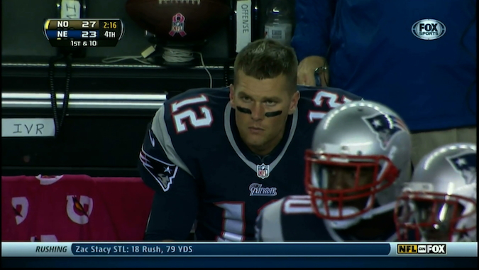
But after only a moment, Russo takes us back to Tom Brady. Tight on Brady's face, as his head drops — one of history’s great quarterbacks knows he's cost his team the game. He eventually breaks into a jog, and only then does the camera switch — to Bill Belichick, with a murderous grimace on his face. We go briefly back to Keenan Lewis dancing on the sidelines, before the Fox logo flashes, and a replay shows us Julian Edelman's entire failed route. Next, a close-up of the interception, with a look right at Keenan Lewis' face as he grabs the ball with his pink gloves.
Then it's back again to Tom Brady, as he shuts his eyes in disbelief and curses loudly at no one in particular. One last shot of Keenan Lewis getting high-fives and helmet taps from his coaches and teammates, one more Fox logo, and it's time for the Saints to take the field.
It’s more than a dozen live shots, replays, and graphics, and it all happens in 71 seconds.
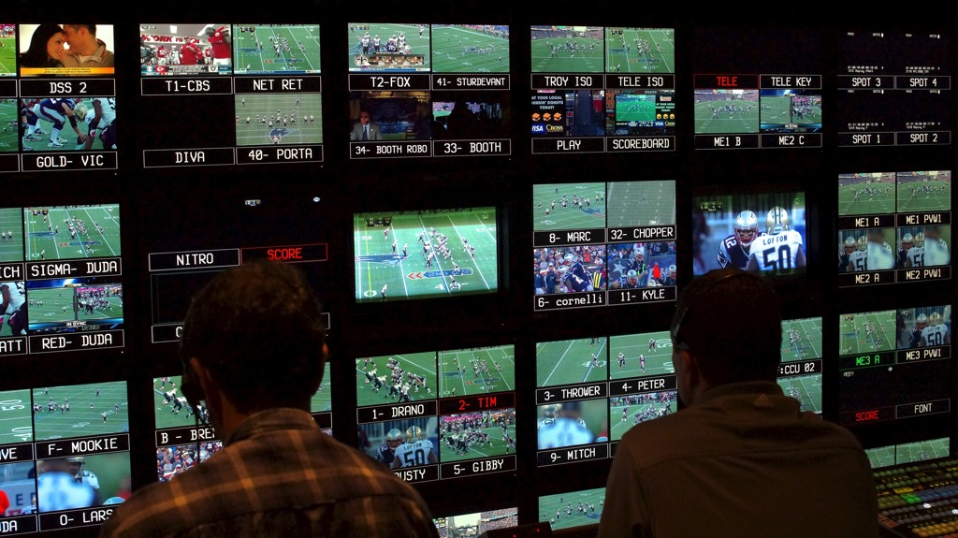
Producer Richie Zyontz and director Rich Russo watch the game unfold from a dozen angles at once.
Richie Zyontz likes to talk about stories, about subtleties. The things you might see from the stands or on the sidelines that you’d never notice from your couch. "The guys that have been with me for years know," he says, "don't sell me a reaction where the guy's self-servingly acting like an asshole. Show me the shot where they come to the bench and they don't realize cameras are on them, and there's a little wink. A little smile, a little tap on the helmet from the coach — those are the shots I like to see."
"When the play's over," Paul Duda says, "we'll get it on the air almost immediately. Before the guy stands up to go back to the huddle, [Zyontz] will know which replay machine to go to." Duda and his team are constantly pitching replays, watching which camera had the best angle on a play, and they’re able to play it back in real time — Zyontz or Russo picks an angle, Colby Bourgeios presses a button, and the replay is live. Each tape machine is like an always-recording camera, ready to play back anything at any time. Until it’s time for the next play, anyway.
This Fox crew will broadcast the Super Bowl in February, and every week leading up to it is an experiment with some new tweak or technology. Most are tried and ignored, or integrated only in small ways. "Ultimately, when it comes down to it," says Callahan, "everything that we're trying to do is about telling a story, and giving the producers and directors the tools that they need to tell that story." Last year, Fox focused on integrating the parabolic mics that now roam the sideline, pointing at players and plays to get hyper-focused audio. Previously it's been graphics, and in 1996 it was the Fox Box — Fox was the first network to have the score displayed at all times in the top corner of the screen, and even other networks refer to it as the Fox Box. This year it's 4K, as Fox seeks a perfect and incontrovertible replay system.
Fox has been using 4K cameras for three years, but not to broadcast the game, which the crew says would be pointless given current bandwidth and TV technology. It’s all about replay. "We can do things like zoom in, look at a guy's foot… we can see precisely a nice, solid foot, and a line right there, and know that the guy is in," says Colby Bourgeios, Fox's technical director. This year is about fine-tuning — finding the right camera, the right lens, the right capture and extraction devices. But even when 4K works convincingly, Callahan says, "we need it to be the first or second replay. If we were to sit there and have a 4K replay that we could show two plays later… and that would have reversed the official’s call, well, that’s awful." He won’t add anything to the Fox broadcast that will slow it down, or impede it in any way.
The system as it exists now is astonishing in its immediacy. Russo, Zyontz, and Bourgeios speak in often unintelligible shorthand, and seem to mostly just know exactly what the others want. The whole Fox A crew has been together for years, some for decades, and like any dynastic team there’s a sense of trust and calm that Rich Russo says is crucial to the whole process. "Everyone gets excited, and you get excited, and you want things to be perfect, but you know that you have such a great team here… you have to be able to listen."
That’s why, as the Patriots and Saints near kickoff, no one in Fox's crew ever seems nervous, or overwhelmed. It's just the opposite, in fact. They live for these moments. "There's nothing like the adrenaline of being part of a live broadcast," Zyontz says. "You just don't know how a given game is going to go. So you can talk to broadcasters and former athletes: there's nothing like playing, but the closest thing you can get to playing or coaching is being in TV and covering an NFL game."
Fred Aldous agrees. "When you hear that three-count going into the open of the show, I'll tell you what: the rush is absolutely incredible, knowing there is no going back, there are no retakes, you have to do it right, do it right the first time. I still get that rush even after all these years." He shows me his arm. "God, I'm starting to get goosebumps now."
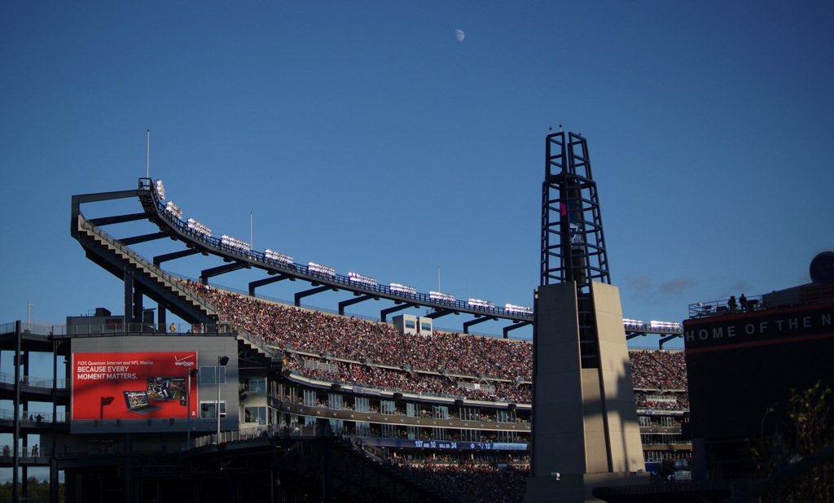
It’s the end of the game. Tom Brady’s just thrown a 17-yard touchdown to Kenbrell Thompkins, winning a seemingly lost game with five seconds to spare. Nearly half the game’s 68,756 fans left early, and the cheers from the parking lot and the highway drown out the ones from the stadium. The replay — a perfect shot of the moment, Thompkins snatching the ball in the back-left corner of the end zone — loops on the giant screens in Gillette, and presumably on every TV in every bar in Boston. There will be much celebrating tonight.
Underneath the stadium, the Fox crew starts to break down, to load its massive production back into 53-foot trucks. In two hours, they'll be gone. And next week, they'll pull into Lincoln Financial Field in Philadelphia and do it all again.
That's just what they do on Sundays.

WSJ
In the Trenches With the ObamaCare Army
One group of navigators planned to sign up 5,800 people by March. So far: zero.
by Eliana Johnson
Durham, N.C.
Even when the Obama administration was under the impression that the launch of the Affordable Care Act was going to work splendidly, with a first-rate website, the plan still called for "navigators" to help people sign up. Now, with the ACA website Healthcare.gov hobbled, and even many of the president's supporters grumbling that the law may need a radical rethinking, the work of the tens of thousands of these helpers is more vital than ever.
How's it going? Not well, to judge from a visit with navigators in North Carolina, one of 34 states that decided not to open their own health-insurance exchanges.
Durham is a relatively low-income city—nearly 19% of the residents are below the poverty level—that is 41% African-American and 14% Hispanic. It is the type of place that the White House expects to benefit most from ObamaCare. Yet the navigators I spoke with there earlier this month say interest has been sparse. Organizations like the Alcohol and Drug Council of North Carolina and the Lincoln Community Health Center that received federal funds to hire navigators are contemplating how to reach out to potential enrollees, given that waiting for phone calls or walk-ins is not proving fruitful.
Occasionally, the navigators even make house calls. I accompanied Nyi Myint, a navigator with the Alcohol and Drug Council of North Carolina, to the home of Kimberly Munier, a self-employed single mother. Her Blue CrossBlue Shield plan was canceled over the summer, and she asked Mr. Myint for help with the federal exchange.
He begins by laying a wrinkled paper on the kitchen table, a green-and white-certificate indicating that he has completed the "Navigator Curriculum." It is not a particularly official looking document: In the top left corner, it reads, "Print Close Window." "This is how they sent it to us," he says, laughing. (The federal curriculum, which instructs navigators in topics from the "definition of health insurance" to how to handle "consumers who are lonely and just want to talk," takes between five and 20 hours to complete.)
News stories have reported on the HHS's admission that it doesn't vet navigators' backgrounds. But the navigators for the Alcohol and Drug Council seem a cut above. Mr. Myint, the project manager, says that nine of the 13 navigators he hired have masters degrees—an indictment of the miserable jobs market, yes, but good for ObamaCare guidance. His group received about $300,000 from HSS, and the navigator jobs pay $20 an hour.
Before the navigation process gets underway, Mr. Myint has Ms. Munier sign a consent form. Then her health-insurance details come out. Ms. Munier had been paying $639 a month for a plan with a $1,000 deductible. If she takes no action, Blue Cross will move her automatically to a similar plan that meets ObamaCare's minimum standards. "My costs would go down, but the deductible and stuff would go up," she says. To be exact, her monthly cost would decrease by $157. When using in-network providers, her deductible would nearly triple; out of network, it would more than quintuple. When the Blue Cross notification arrived, she says, her response was: "Ugh, I don't really know what to do."
Now, navigating Healthcare.gov is proving equally confusing. Just getting the home page to open was hard, then it turned out that the instructions for choosing a username are defective. The stipulations (6-74 characters, a numeral, "one of these symbols _.@/-,") include "must contain a lowercase or capital letter." Swiping a lock of blonde hair out of her eyes, Ms. Munier sees the list of instructions and mutters, "Oh, Lord, have mercy." Then she has an idea: "I wonder if they mean a lowercase and a capital." Bingo.
To determine whether she is eligible for subsidies, the site prods Ms. Munier to enter her projected 2014 income. She expects to make $60,000 this year but isn't sure. If she makes $60,000 from renting a house and work she does as an early-childhood education consultant, she will barely qualify for a subsidy. Mr. Myint advises her against making an educated guess. If she gets a subsidy and then winds up making more money than expected, she will have to repay the excess.
After about an hour, dozens of plans for which Ms. Munier and her daughter qualify appear on the screen. On average, the plans she's looking at hover around $400 per month, but with deductibles far higher than her old policy—up to $11,000 more. "That seems astronomical," she says.
Mr. Myint is prohibited from steering her toward one plan or another, and Ms. Munier, saying it's all too confusing, wants more time to look over her options. For today, she doesn't enroll on the exchange.
It's a familiar experience for Mr. Myint. After starting Oct. 1, when the exchanges went live, his organization was aiming to sign up 5,800 people by the end of March 2014. It has a long way to go.
"We have yet to see an application from start to finish," he says.
The current HHS navigator grants last for one year, ending next fall. Surveying the battlefield, Mr. Myint says: "I think there will be plenty of navigation left to do after this year."
Other navigators in Durham agree with his assessment. Ricardo Correa, a navigator with the Lincoln Community Health Center, is determined to sign people up for health-care insurance one way or another. "We have to be very creative on how we reach the community," he says. "We have to think outside the box." At a meeting that includes Mr. Correa, Duke University officials, and other groups that received navigator grants, they discuss the feasibility of tucking brochures promoting the Affordable Care Act in water bills or sending them home with school children.
Mr. Correa tells me that, in spreading the word about ObamaCare, he has gone to churches, barbershops, homeless shelters and La Oficina, a tax-preparation center that caters to Hispanics. To date, Mr. Correa says, he has enrolled nine people for ObamaCare—using old-fashioned paper applications.
But the paper applications are no panacea. That's because information from paper applications must be entered into the same dysfunctional federal data hub used by online applicants. Notes from an Oct. 3 meeting of officials from the Centers for Medicare and Medicaid Services state that "The same portal is used to determine eligibility no matter how the application is submitted (paper, online)." Notes from an Oct. 11 meeting among the same officials read: "At the end of the day, we are all stuck in the same queue." I ask Mr. Correa if he turned to paper applications just to give people a sense that they are moving forward. "They are moving forward," he insists.
Such unshakable confidence in ObamaCare among its proselytizer-navigators, despite its bungled debut, will be essential if the law is to succeed. The Affordable Care Act "makes a lot of sense," Mr. Correa says. "It's kind of like the youth is taking care of the elderly. Young people are paying more but using the system less, and older people are paying less but using the system more." That line might be a hard sell to a skeptical public, but it reflects the essence—and one of the many challenges—of ObamaCare.
Ms. Johnson is the media editor at the National Review.





