December 29, 2013

Big treat today with Dave Barry's End of the Year Review. Our Summary, is a sampling.

January
… which begins with a crisis in Washington, a city that — despite having no industries and a workforce consisting almost entirely of former student council presidents — manages to produce 93 percent of the nation’s crises.

February

If the sequester goes into effect, federal spending will continue to rise, but not quite as fast as it would have risen without the sequester. To a normal human, this means government spending is still increasing, but to Washington, the sequester means “draconian cuts” and is a looming disaster of epic proportions.

The beleaguered cruise-ship industry suffers another blow when the Carnival Triumph loses power in a fire and drifts helplessly for days in the Gulf of Mexico. Fortunately, the passengers are able to survive the ordeal by eating each other.

March
… as the federal budget deadline passes without Congress reaching agreement, the devastating, draconian, historically catastrophic sequester goes into effect, causing a mild reduction in the rate of increase in government spending that for some inexplicable reason goes unnoticed by pretty much everybody outside the federal government.

April
In other alarming foreign developments, Iran announces that it is constructing a new uranium enrichment plant, which according to a government spokesman will be used for “youth sports.”
Weather scientists at both the Weather Channel and Colorado State University, using sophisticated computer models, predict that the 2013 hurricane season will be unusually active. These scientists are immediately recruited to work on the much-anticipated rollout of Obamacare.

May
In New York City, Anthony Weiner announces his intention to enter … No, let’s rephrase that. Weiner announces his intention to plunge into … No, wait, sorry. He announces that he plans to run for mayor, using the campaign slogan “Weiner: You Know Where He Stands.” His announcement sets off a joyous celebration among headline writers for the New York Post.
In technology news, Microsoft, acknowledging widespread consumer dissatisfaction with Windows 8, announces that it has been chosen as the operating system for the much-anticipated Obamacare Web site.

June
The California legislature, as always staying ahead of the curve, passes a law making it mandatory for state residents to possess marijuana.
In an annual rite of passage, millions of young people graduate from college, and, following in the footsteps of the millions who have gone before them, move back in with their parents.
In sports, organizers of the Tour de France announce that this year they’re going to skip the bicycle-riding part and instead just gather all the competitors into a room and see who can do the most drugs.

July
In Obamacare action, the White House announces a one-year delay on the mandate requiring businesses to provide health insurance but insists that “we are right on schedule for rolling out the Web thing on the Intertubes.” With that concern out of the way, the Obama administration decides to once again pivot back to the economy, which continues to falter because — economists agree unanimously on this — not enough presidential speeches have been given about it.

August
In sports, New England Patriots tight end Aaron Hernandez is indicted for murder; if convicted, under the strict new NFL rules aimed at reducing violence, he will have to sit out at least two games.

September
… when Kerry, continuing to stress the dire urgency of the situation, compares Assad to Hitler, only to declare a few days later — moments before his aides are able to fell him with a tranquilizer dart — that any strike against Assad will be an “unbelievably small, limited kind of effort.” President Obama clarifies this by stating that “the United States military doesn’t do pinpricks.”
Just when it seems as if there is no good way out of the Syria mess, help miraculously arrives in the form of our generous old friends the Russians, who, despite being longtime allies of Syria, are willing to lend us a helping hand without any thought of benefiting themselves. Under their plan, Assad gets to remain in power but must give up his chemical weapons and go back to killing people in a more humane, less Hitlerish way. With the crisis averted, everybody in Washington heaves a sigh of relief, and that is the last we hear about the crisis in Syria.

October
Things do not go nearly as smoothly with the rollout of Obamacare , which turns out to have a lot of problems despite being conceived of by super-smart people with extensive experience in the field of being former student council presidents. The federal Web site, Healthcare.gov, is riddled with glitches, resulting in people being unable to log in, people getting cut off, people being electrocuted by their keyboards, people having their sensitive financial information suddenly appear on millions of TV screens during episodes of “Duck Dynasty,” etc.
Fortunately, as the initial rush of applicants tapers off, the system starts to work a little better, and by the end of the second week U.S. Secretary of Blame Kathleen Sebelius is able to announce that the program has amassed a total enrollment, nationwide, of nearly two people, one of whom later turns out to be imaginary. But this is not good enough for a visibly angry and frustrated and, of course, surprised President Obama, who promises to get the Web site fixed just as soon as somebody answers the Technical Support hotline, which has had the White House on hold for 73 hours.

November
… public dissatisfaction with Obamacare continues to grow as many Americans discover that their current insurance plans are being canceled. A frustrated and — it goes without saying — surprised President Obama reveals to the nation that “insurance is complicated to buy” and clarifies that when he said “if you like your plan, you can keep your plan,” he was using “you” in the sense of “not necessarily you personally.” Observers note that the White House has stopped referring to the program as “Obamacare” and is now calling it by the more formal legal name “George W. Bush.”

December
Detroit is kicked out of Canada for shoplifting.
On the Obamacare front, the administration declares that the federal Web site has been significantly improved, although there are still occasional glitches, such as one that enables a Milwaukee woman seeking to compare dental plans to accidentally launch a tactical nuclear strike against Guatemala. But as Secretary of Blame Sebelius notes, “This kind of thing happens all the time with Orbitz.”

Washington Post
Dave Barry’s Review of 2013, the Year of the Zombies
by Dave Barry
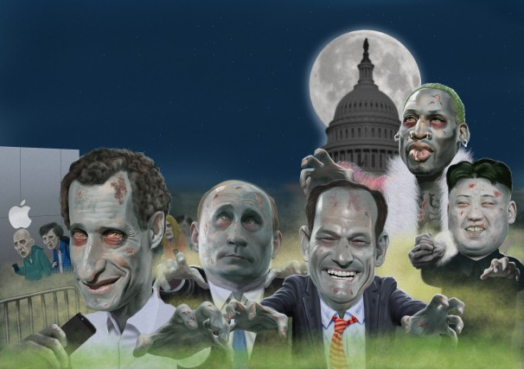

It was the Year of the Zombies. Not in the sense of most of humanity dying from a horrible plague and then reanimating as mindless flesh-eating ghouls. No, it was much worse than that. Because as bad as a zombie apocalypse would be, at least it wouldn’t involve the resurrection of Anthony Weiner’s most private part.
We thought that thing was out of our lives forever, but suddenly there it was again, all over the Internet, as Weiner came back from the political grave like the phoenix, the mythical bird that arose from the ashes to run for mayor of New York and use the name “Carlos Danger” to text obscene photos of its privates to somebody named “Sydney Leathers.”
Speaking of pathologically narcissistic sex weasels: Also coming back from the dead in 2013 to seek elective office in New York (What IS it with New York?) was Eliot “Client 9” Spitzer, who ran for city comptroller under the slogan: “If you can’t trust a proven sleazebag with your municipal finances, who CAN you trust?”
And then — not to leave out the ladies — there was Miley Cyrus. We thought her career was over; we remembered her fondly as a cute and perky child star who played Hannah Montana, wholesome idol of millions of preteens. And then one night we turned on MTV’s Video Music Awards and YIKES there was this horrifying, mutant, vaguely reptilian creature in Slut Barbie underwear twerking all over the stage while committing unhygienic acts with both Robin Thicke and a foam finger, both of which we hope were confiscated by a hazmat team.
This year was so bad that twerking wasn’t even the stupidest dance craze. That would be the “Harlem Shake,” which is not so much a dance as a mass nervous-system disorder, and which makes the “Gangnam Style” dance we mocked in 2012 look like “Swan Lake.”
We miss 2012.
But getting back to the zombies: It wasn’t just people who came back alarmingly in 2013. The Cold War with Russia came back. Al-Qaeda came back. Turmoil in the Middle East came back. The debt ceiling came back. The major league baseball drug scandal came back. Dennis Rodman came back and went on humanitarian missions to North Korea (or maybe we just hallucinated that). The Endlessly Looming Government Shutdown came back. People lining up to buy iPhones to replace iPhones that they bought only minutes earlier came back. And for approximately the 250th time, the Obama administration pivoted back to the economy, which has somehow been recovering for years now without actually getting any better. Unfortunately, before they could get the darned thing fixed, the administration had to pivot back to yet another zombie issue, health care, because it turned out that Obamacare, despite all the massive brainpower behind it, had some “glitches,” in the same sense that the universe has some “atoms.”
Were there any new trends in 2013? Yes, but they were not good. Kale, for example. Suddenly this year restaurants started putting kale into everything, despite the fact that it is an unappetizing form of plant life that until recently was used primarily for insulation. Even goats will not eat it. Goats, when presented with kale, are like, “No, thanks, we’ll just chew on used seat cushions.”
Another annoying 2013 trend was people who think it is clever to say “hashtag” in front of everything. Listen carefully, people who think this is clever: Hashtag shut up.

Did anything good happen in 2013? Yes! There was one shining ray of hope in the person of Toronto Mayor Rob Ford , who admitted that, while in office, he smoked crack cocaine, but noted, by way of explanation, that this happened “probably in one of my drunken stupors.” This was probably the most honest statement emitted by any elected official this year, and we can only hope that more of our leaders follow Mayor Ford’s lead in 2014. (We mean being honest, not smoking crack in a drunken stupor.) (Although really, how much worse would that be?)
But before we look ahead to next year, let’s take one last look back at the fiasco that was 2013, starting with …
January
… which begins with a crisis in Washington, a city that — despite having no industries and a workforce consisting almost entirely of former student council presidents — manages to produce 93 percent of the nation’s crises. This particular crisis is a “fiscal cliff” caused by the fact that for years the government has been spending spectacular quantities of money that it does not have, which has resulted in a mess that nobody could possibly have foreseen unless that person had a higher level of financial awareness than a cucumber. At the last minute, congressional leaders and the White House reach an agreement under which the government will be able to continue spending spectacular quantities of money that it does not have, thus temporarily averting the very real looming danger that somebody might have to make a decision.
In other Washington news, President Obama is sworn in for a second term at a quiet White House ceremony that, because of an e-mail glitch, Vice President Biden does not find out about until several days later.
Abroad (this actually happened) Iran announces that the Iranian Space Agency has sent a monkey into space aboard the Pishgam rocket and returned it safely to Earth. Intelligence experts fear the Iranians are developing a much larger, more powerful monkey that could be used to rampage around Tel Aviv knocking down buildings. The New York Times reports that Chinese hackers broke into its computer system, a security breach resulting in what observers describe as “the hardest crossword puzzle ever.”
On the business front, Boeing suffers a setback when the Federal Aviation Administration issues an order grounding all of the new 787 “Dreamliners” after inspections reveal that many of the planes have just the one wing.
NASA announces that the latest data sent back by the Mars Reconnaissance Orbiter appear to confirm data previously transmitted by the Mars Pathfinder, Mars Surveyor, Mars Wanderer, Mars Trailbreaker, Mars Roamer, Mars Walker, Mars Strider, Mars Meanderer, Mars Stroller, Mars Lunger and Mars Traipser, suggesting that Mars is pretty much covered with rocks.
In a shocking interview, Lance Armstrong, after years of denial, admits to Oprah Winfrey that he took illegal drugs in all seven of his Tour de France victories, as well as using a motorcycle for certain stages of the race and “occasionally” shooting opponents with poison-tipped darts. Also he played “a small role” in the JFK assassination.
Elsewhere in sports, Alabama wins the college football national championship by trouncing Notre Dame, which had been ranked No. 1 by a computer program coincidentally created by the same company that is developing the much-anticipated Obamacare Web site. Major league baseball is once again rocked by scandal following published reports that a number of players — including such stars as Alex Rodriguez, Ryan Braun and Melky Cabrera — have on more than one occasion participated in the Tour de France.
Speaking of shocking developments that nobody could have seen coming,
in …

February
… Washington faces another crisis in the form of a “sequester” that will happen automatically unless Congress can agree on a budget, which seems unlikely inasmuch as Congress cannot agree on what planet this is. If the sequester goes into effect, federal spending will continue to rise, but not quite as fast as it would have risen without the sequester. To a normal human, this means government spending is still increasing, but to Washington, the sequester means “draconian cuts” and is a looming disaster of epic proportions. Panic grips the city, as grim-faced former student council presidents write talking points far into the night.
In the month’s biggest surprise, Pope Benedict XVI announces his resignation after giving an interview to Oprah Winfrey in which he reveals that he is not Catholic. Also stepping down is Hillary Rodham Clinton, who, after decades of public service, resigns as secretary of state so she will finally have a chance to spend some personal quality time with her team of campaign advisers.
The beleaguered cruise-ship industry suffers another blow when the Carnival Triumph loses power in a fire and drifts helplessly for days in the Gulf of Mexico. Fortunately, the passengers are able to survive the ordeal by eating each other. In other transportation news, American Airlines and US Airways announce plans to merge into one huge company that will be, according to the official announcement, “the most bankrupt airline in the world.”
Abroad, an increasingly belligerent North Korea gets drunk and detonates a small nuclear device. In the worsening European economic crisis, Spain, Portugal, Ireland and Greece, facing massive debts, are forced to move in with Germany.
Speaking of crises, in …
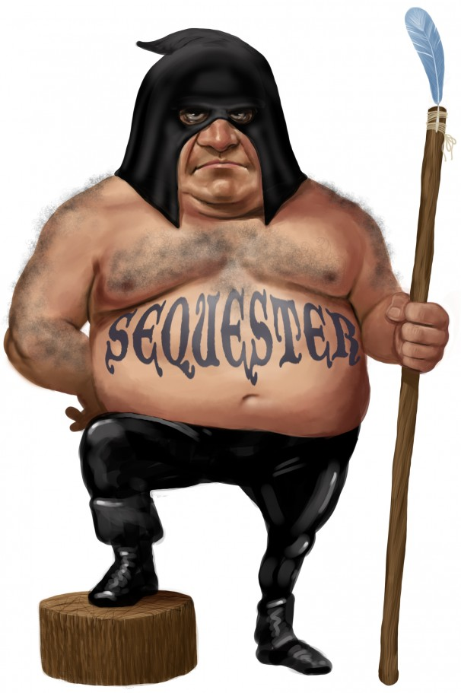
March
… as the federal budget deadline passes without Congress reaching agreement, the devastating, draconian, historically catastrophic sequester goes into effect, causing a mild reduction in the rate of increase in government spending that for some inexplicable reason goes unnoticed by pretty much everybody outside the federal government. Undaunted, Washington turns its massive collective brainpower toward the task of deciding what to do about the next major national crisis, whatever it may be.
In other government-finance news, the Securities and Exchange Commission accuses Illinois of fraud after determining that the assets of the state employee pension fund — which has liabilities totaling more than $100 billion — consist entirely of expired Groupons.
President Obama departs on a planned four-day trip to the Middle East, although because of what administration officials describe as a technical scheduling “glitch,” he winds up spending two of the days in Albania. Meanwhile, the U.N. Security Council, meeting in emergency session, votes to unfollow North Korea after the increasingly belligerent rogue nation posts an unmistakably threatening tweet about South Korea.
In Rome, the College of Cardinals, apparently seeking to move the church in a new direction, chooses, as the first non-European pope in over a thousand years, a retired New Jersey tax accountant named Harvey Schwartz. Appearing before a massive crowd gathered in St. Peter’s Square, the new pontiff vows to, quote, “give it a shot.”
In what could be seen as a troubling omen, on March 10, millions of Americans are forced to turn their clocks ahead one hour, despite repeated assurances from the Obama administration that “if you like the current time, you can keep the current time.”
Speaking of troubling, in…
April
… tensions on the Korean peninsula mount still further as South Korea is awakened at 3 a.m. to discover that its northern border is blocked by a burning bag of dog excrement the size of a soccer stadium. North Korea denies any involvement, but the U.N. Security Council goes into emergency session, after which Secretary General Ban Ki-moon announces that he wants to have his name legally changed.
In other alarming foreign developments, Iran announces that it is constructing a new uranium enrichment plant, which according to a government spokesman will be used for “youth sports.”
At home, the horrific Boston Marathon bombing demonstrates yet again the vital service provided by the powerful information-gathering resource that is the journalism/Twitter complex, which — faced with a wildly chaotic, confusing situation — is somehow able, within mere minutes, to get pretty much everything wrong. Leading the way is CNN, which is forced to retract a widely repeated report, attributed to “high-level police sources,” that the attack was carried out by a Belgian submarine. Eventually the facts surrounding the tragedy are sorted out, enabling both the media and the political establishment to get on with the crucial work of using it to score political points.
Weather scientists at both the Weather Channel and Colorado State University, using sophisticated computer models, predict that the 2013 hurricane season will be unusually active. These scientists are immediately recruited to work on the much-anticipated rollout of Obamacare.
In sports, basketball player Jason Collins becomes the first athlete in a major U.S. professional sport to openly declare that he has participated in the Tour de France. Meanwhile, in Masters golf action, Tiger Woods, after hitting a ball into the water, drops a replacement ball two yards from where he should have; this turns out to be just about the most exciting thing that has ever happened in the history of golf.
Speaking of excitement, in …
May
… Washington, exhausted from dealing with crises, turns its attention to the other thing it is really good at: scandals. The two main ones involve the Internal Revenue Service, which admits that it has been targeting conservative political groups for special scrutiny, and the Justice Department, which admits that it secretly seized phone records from the Associated Press. A shocked and outraged and, of course, surprised President Obama states that he knew nothing about these activities until he read about them in the newspapers; he vows to make every effort, as chief executive of the executive branch, to find out who is responsible. For their part, Republican leaders vow to harp on these scandals until everybody hates them even more.
In New York City, Anthony Weiner announces his intention to enter … No, let’s rephrase that. Weiner announces his intention to plunge into … No, wait, sorry. He announces that he plans to run for mayor, using the campaign slogan “Weiner: You Know Where He Stands.” His announcement sets off a joyous celebration among headline writers for the New York Post.
In other urban news, the city of Detroit admits that for the past 15 years it has been stealing all of its electricity from Cleveland.
In technology news, Microsoft, acknowledging widespread consumer dissatisfaction with Windows 8, announces that it has been chosen as the operating system for the much-anticipated Obamacare Web site.
In sports, the Kentucky Derby is won by a Harley-Davidson ridden by Lance Armstrong.
Meanwhile, in Europe, the worsening unemployment crisis leaves millions of jobless workers with nothing to do except sit around in cafes all day drinking coffee and smoking cigarettes. This is also what they do when they are employed, but still. Elsewhere abroad, tensions on the Korean peninsula continue to mount when 17 million South Korean mailboxes are destroyed by what are believed to be North Korean firecrackers.
Speaking of worsening, in …

June
… Washington is rocked by leaked documents showing that the National Security Agency has been secretly collecting massive amounts of data on the phone calls, e-mails and other electronic activities of millions of American citizens. An NSA spokesperson insists that this program is vital to the fight against terrorism, and that Americans “have absolutely no reason to fear that their privacy is being invaded, or that there are tiny government video cameras concealed in every low-flow toilet in America.” The spokesperson adds that “as a totally unrelated side note, you people need to increase your dietary fiber.”
The person responsible for leaking the NSA documents is identified as former CIA computer specialist Edward Snowden, who has all classified U.S. documents for the past 50 years on a single thumb drive, which apparently was handed out as a favor at the CIA Christmas party.
In legal affairs, the Supreme Court overturns the Defense of Marriage Act, eliciting high praise from many politicians who enacted the Defense of Marriage Act. The California legislature, as always staying ahead of the curve, passes a law making it mandatory for state residents to possess marijuana.
In an annual rite of passage, millions of young people graduate from college, and, following in the footsteps of the millions who have gone before them, move back in with their parents.
In sports, organizers of the Tour de France announce that this year they’re going to skip the bicycle-riding part and instead just gather all the competitors into a room and see who can do the most drugs.
In Rome, Pope Schwartz introduces the Vatican’s first-ever Mah-Jongg Night. Elsewhere abroad, U.N. observers express concern when Syria receives a large shipment of crates from North Korea marked “AQUARIUM SUPPLIES. OR FRUIT. DEFINITELY NOT CHEMICAL WEAPONS.”
Speaking of trouble in the Middle East, in …
July
… the Egyptian military ousts President Mohamed Morsi and, in a move that worries international observers, installs, as his replacement, Richie Incognito.
Elsewhere abroad, the already tense relationship between the United States and Pakistan worsens when Pakistani Prime Minister Nawaz Sharif returns home to find his wife in bed with a Predator drone. A spokesperson for the U.S. State Department insists that they are “just friends.”
In Obamacare action, the White House announces a one-year delay on the mandate requiring businesses to provide health insurance but insists that “we are right on schedule for rolling out the Web thing on the Intertubes.” With that concern out of the way, the Obama administration decides to once again pivot back to the economy, which continues to falter because — economists agree unanimously on this — not enough presidential speeches have been given about it.
George Zimmerman is acquitted in the shooting death of Trayvon Martin and accepts a high-level post as a security adviser to North Korea.
The beleaguered city of Detroit, having run out of all other financial options, formally applies to become a province of Canada.
In baseball, Ryan Braun of the Milwaukee Brewers is suspended for the season without pay after testing positive for trans-fats.
In the month’s happiest story, Great Britain rejoices at the much-anticipated birth of a royal baby who one day will, in accordance with hallowed tradition, become an old person waiting around for an even older person to kick the bucket.
And the good times continue to roll in …
August
… when Amazon billionaire Jeff Bezos buys The Washington Post with his own personal money, thereby ensuring that one of the nation’s most important newspapers will be able to continue producing in-depth, hard-hitting journalism, including an estimated 400 stories and columns in August alone about what a genuinely brilliant yet humanitarian genius Jeff Bezos is. Bezos says he does not plan to make any major changes, other than to deliver the paper in cardboard boxes and replace the stories with reader reviews of news events, using a five-star ranking system.
U.S. Attorney General Eric Holder, signaling a major change in the federal government’s policy regarding the War on Drugs, tells a meeting of the American Bar Association that he has a family of tiny, invisible harmonica-playing giraffes living inside his nose.
In sports, New England Patriots tight end Aaron Hernandez is indicted for murder; if convicted, under the strict new NFL rules aimed at reducing violence, he will have to sit out at least two games.
In politics, San Diego Mayor Bob “Bob” Filner resigns as a result of allegations that he is a compulsive serial horn dog who groped pretty much the entire female population of Southern California. He immediately becomes a leading contender in the New York City mayoral race.
But the big story brewing in August concerns the crisis in Syria, which becomes a huge issue when the White House accuses Syrian President Bashar al-Assad of using chemical weapons, thereby crossing the “red line” that President Obama announced in 2012 while distracted by an important putt. Secretary of State John Kerry, making the case for a military strike, calls Assad “a thug and a murderer” who killed nearly 1,500 people, including children, in a chemical attack. Citing the urgency of the situation, the administration prepares to launch an attack without congressional approval. But then, in a surprise move, the president announces that he has decided to take the matter to Congress after all, raising the distinct possibility that nothing will actually happen during anybody’s lifetime.
The situation becomes even murkier in …
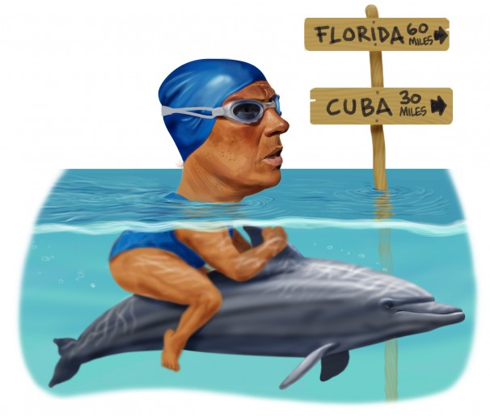
September
… when Kerry, continuing to stress the dire urgency of the situation, compares Assad to Hitler, only to declare a few days later — moments before his aides are able to fell him with a tranquilizer dart — that any strike against Assad will be an “unbelievably small, limited kind of effort.” President Obama clarifies this by stating that “the United States military doesn’t do pinpricks.”
Just when it seems as if there is no good way out of the Syria mess, help miraculously arrives in the form of our generous old friends the Russians, who, despite being longtime allies of Syria, are willing to lend us a helping hand without any thought of benefiting themselves. Under their plan, Assad gets to remain in power but must give up his chemical weapons and go back to killing people in a more humane, less Hitlerish way. With the crisis averted, everybody in Washington heaves a sigh of relief, and that is the last we hear about the crisis in Syria.
In other foreign-affairs news, Dennis Rodman travels to North Korea for a loon-to-loon meeting with Supreme Leader Kim Jong Un, who presents the former NBA star with a commemorative set of 50 political prisoners.
In technology news, Apple introduces the iPhone 5, which features an improved camera, time travel and the ability to text with the dead.
On the entertainment front, “Breaking Bad” airs its final episode, leaving us with basically no reason to go on living.
Diana Nyad completes an unprecedented swim from Cuba to Florida, a feat made all the more difficult by the fact that she had a family of five clinging to her back.
With Obamacare about to go into effect, Sen. Ted Cruz, a staunch opponent of the program, stages a 21-hour filibuster on the Senate floor in an effort to drive home to the American people the inarguable fact that the letters in “Senator Ted Cruz” can be rearranged to spell “A Zero-Scent Turd.”
As the month draws to a close, Washington again lurches into crisis mode as Congress is unable to agree on a budget, which means that at midnight on the first day of …
October
… the federal government, in an unthinkable development that we cannot even think about, partially shuts down. The result is a catastrophe of near-sequester proportions. Within hours wolves are roaming the streets of major U.S. cities, and bacteria the size of mature salmon are openly cavorting in the nation’s water supply. In the Midwest, thousands of cows, no longer supervised by the Department of Agriculture, spontaneously explode. Yellowstone National Park — ALL of it — is stolen. In some areas gravity stops working altogether, forcing people to tie themselves to trees so they won’t float away. With the nation virtually defenseless, the Bermudan army invades the East Coast, within hours capturing Delaware and most of New Jersey.
By day 17, the situation has become so dire that Congress, resorting to desperate measures, decides to actually do something. It passes, and the president signs, a law raising the debt ceiling, thereby ensuring that the federal government can continue spending spectacular quantities of money that it does not have until the next major totally unforeseeable government financial crisis, scheduled for February 2014.
Things do not go nearly as smoothly with the rollout of Obamacare , which turns out to have a lot of problems despite being conceived of by super-smart people with extensive experience in the field of being former student council presidents. The federal Web site, Healthcare.gov, is riddled with glitches, resulting in people being unable to log in, people getting cut off, people being electrocuted by their keyboards, people having their sensitive financial information suddenly appear on millions of TV screens during episodes of “Duck Dynasty,” etc.
Fortunately, as the initial rush of applicants tapers off, the system starts to work a little better, and by the end of the second week U.S. Secretary of Blame Kathleen Sebelius is able to announce that the program has amassed a total enrollment, nationwide, of nearly two people, one of whom later turns out to be imaginary. But this is not good enough for a visibly angry and frustrated and, of course, surprised President Obama, who promises to get the Web site fixed just as soon as somebody answers the Technical Support hotline, which has had the White House on hold for 73 hours.
In an aviation landmark, a Delta Airlines flight from Atlanta to Los Angeles becomes the first plane to fly under new FAA rules allowing expanded passenger use of electronic gadgets, landing safely and uneventfully in Moscow.
In sports, another major league baseball season draws to a satisfying close with a World Series victory by some team other than the Yankees.
In foreign affairs, the German government angrily accuses the United States of spying after German Chancellor Angela Merkel’s mobile phone conversations are repeatedly interrupted by somebody with an American accent asking her to “please speak English.” An NSA spokesperson denies involvement, saying, “We don’t even have international roaming.”
Speaking of angry, in …
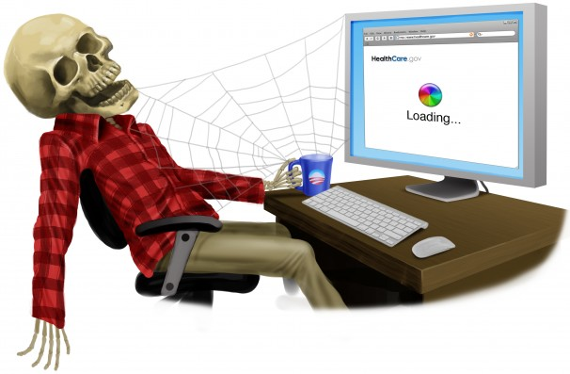
November
… public dissatisfaction with Obamacare continues to grow as many Americans discover that their current insurance plans are being canceled. A frustrated and — it goes without saying — surprised President Obama reveals to the nation that “insurance is complicated to buy” and clarifies that when he said “if you like your plan, you can keep your plan,” he was using “you” in the sense of “not necessarily you personally.” Observers note that the White House has stopped referring to the program as “Obamacare” and is now calling it by the more formal legal name “George W. Bush.”
As the president’s popularity slides in the polls, House Speaker John Boehner, sensing a tactical opening for the Republicans, calls a press conference to point out that he is exactly the same color as a Creamsicle.
In non-Obamacare news, George Zimmerman, continuing a pattern of increasingly erratic behavior, invades Taiwan. But the big international story takes place in Geneva, where Iran, pressured by the United States and five other powers, accepts an arms-limitation agreement under which it may continue making enriched uranium but must promise that it will be used only for science fairs.
In other international news, U.N. Secretary-General Trevor Ki-moon asks the security council to send U.N. peacekeeping troops to Manhattan in an effort to quell Alec Baldwin.
In politics, Chris Christie establishes himself as a leading contender for the 2016 Republican presidential nomination when he handily wins reelection as governor of New Jersey after defeating the occupying Bermudan army by threatening to sit on it.
As the month draws to a close, Americans pause to observe the Thanksgiving holiday by assaulting each other over discounted electronics. In what has become a Washington tradition, President Obama attempts to pardon two turkeys but fails to get enough votes in the House.
Speaking of failure, in …
December
… retailers report that the Black Friday shopping weekend was weaker than expected, with a nationwide total of just six shoppers killed, 148 seriously injured and only 357 arrested — all numbers well below last year’s totals.
In other retail news, Jeff Bezos reveals that Amazon is experimenting with a system that would deliver parcels weighing up to five pounds via drones; heavier packages would be delivered via surplus World War II howitzers. Some observers express concerns about this concept, but it gets a rare five-star rating from The Washington Post.
Detroit is kicked out of Canada for shoplifting.
On the Obamacare front, the administration declares that the federal Web site has been significantly improved, although there are still occasional glitches, such as one that enables a Milwaukee woman seeking to compare dental plans to accidentally launch a tactical nuclear strike against Guatemala. But as Secretary of Blame Sebelius notes, “This kind of thing happens all the time with Orbitz.”
In other government news, the Federal Communications Commission meets to consider allowing airline passengers to talk on their mobile phones in flight, as it has been shown that this does not interfere with navigational equipment. Other activities that do not interfere with navigational equipment include blowing air horns, throwing knives and beekeeping, so WHAT THE HELL LET’S ALLOW THOSE ACTIVITIES ON PLANES, TOO.

Sorry.
In foreign news, Bermuda offers to return Delaware to the United States; the United States rejects the offer. Toronto Mayor Rob Ford, in a move that raises eyebrows, officiates at a ribbon-cutting ceremony for a meth lab.
On a happier holiday note, the traditional Christmas Eve service at the Vatican ends with Pope Schwartz going into St. Peter’s Square and personally leading thousands of the faithful to dinner at a Chinese restaurant.
As the year draws to a close, hopes for peace on the Korean peninsula soar when North Korea’s Kim Jong Un, in what is seen as a conciliatory gesture, sends a gift to South Korea’s President Park Geun-hye. Unfortunately, the gift — a set of professional-quality barbells weighing nearly a ton — is delivered via Amazon’s new “Nowitzer!” system and levels the presidential residence.
And with that, this hideous brain-dead zombie of a year finally staggers off into oblivion, making way for 2014, which surely will be better, because how could it possibly be worse?
Do NOT answer that.
Happy New Year.





