December 24, 2013

We started this week with kudos for the president for his refusal to take part in the Olympics. Today we have more compliments. This time for his recent pardons. Debra Saunders has the story.
President Obama commuted the sentences of eight crack-cocaine offenders Thursday, including that of Clarence Aaron, who was serving a sentence of life without parole for a first-time nonviolent drug conviction when he was 23.
Aaron's story represents the worst excesses of the federal criminal justice system. Aaron, of Mobile, Ala., had no criminal record. He had held jobs. In 1992, he was a college student who decided to address his money problems by acting as an intermediary between two career drug dealers. The dealers paid him $1,500 to set up two large cocaine deals. They got caught. The ringleaders knew how to game the system. They pleaded guilty and testified against Aaron.
Aaron wasn't as savvy. He pleaded not guilty and lied on the stand -- which enhanced his sentence. The buyer planned on converting powder cocaine to crack -- that, too, enhanced Aaron's sentence. One deal didn't happen, but federal prosecutors charged Aaron for it anyway. Voila, he won the same sentence that was imposed on FBI agent-turned-Russian spy Robert Hanssen and now-deceased serial killer Jeffrey Dahmer.
Aaron knows he broke the law. He had earned prison time. But what does it say when federal prosecutors seek and win life without parole for a first-time offender while letting the big fish finagle lesser sentences? All but one of Aaron's cohorts have been out of prison since 2000.
Aaron's cousin, Aaron Martin, said the commutation made this season "the best Christmas ever." Attorney Margaret C. Love said, "We are grateful to President Obama." ...

More on the pardons from Jacob Sullum in Forbes.
President Obama issued eight commutations today, which is eight times the number he issued in the first 58 months of his administration. The best-known prisoner who will be freed as a result of today’s clemency actions is Clarence Aaron, who was sentenced to three consecutive life sentences in 1993 for his role in arranging a cocaine deal. Aaron's case received a lot of publicity recently thanks to reporting by ProPublica’s Dafna Linzer, who revealed that his clemency petition probably would have been granted by George W. Bush if the Office of the Pardon Attorney had not omitted important information from its evaluation.
Another commutation beneficiary, Stephanie George, received a life sentence in 1997 for letting her boyfriend stash his crack at her house. New York Times reporter John Tierney highlighted her case in a front-page story last December. Thanks to Obama’s commutations, Aaron and George will both be released next April instead of spending the rest of their lives behind bars. ...

John Podhoretz reviews the president's terrible year.
When Barack Obama sings “Auld Lang Syne” on New Year’s Eve, he will have reason to think back, with a deep sense of nostalgia and not a small amount of regret, on the last time he sang the song.
If he gets a lump in his throat as he recollects that glorious night one year ago, who would blame him? After all, he was riding about as high as a man can ride on New Year’s Eve 2012.
There he was, almost literally the master of the universe — the canny victor of the 2012 election, having run what was instantly regarded as the most brilliant technical campaign in American history. He used that victory to prevail in a “fiscal cliff” showdown with Republicans the last week of December that led to the significant tax increases on the well-to-do he had sought since the beginning of his first term. He had a 53% approval rating; only 40% disapproved.
In a few weeks, he would be inaugurated for a second term and, liberated from the demands of running again and emboldened by his win, he would that day offer the country an unabashedly and unapologetically left-wing vision of the American future toward which he was guiding it.
“Preserving our individual freedoms,” he said in a startling turn of phrase, “ultimately requires collective action.” ...

Glenn Reynolds thinks 2014 will be even worse. Condign punishment is what we say.
A lot of people are saying that 2013 was President Obama's worst year. Roll Call headlined, "Subdued Obama Hopes For Better 2014." The Hill reported, "Obama names health care rollout his biggest mistake of dismal year." Most people seem to think it was. But I think it was average, in the manner of the old Soviet joke:
Ivan: So how was your day?
Boris: Average.
Ivan: What do you mean, average?
Boris: Worse than yesterday, better than tomorrow. So, average.
Unless something turns around, Obama's 2013 is likely to be similarly "average": Worse than 2012, but better than 2014.
It's true that Obamacare has been a debacle, wrapped in a catastrophe, shrouded in a disaster. But it's also become clear that it was founded upon a lie: ...

We were going to ignore the Duck Dynasty flap, but Mark Steyn wrote his weekly column on it. So, here we go.
Last week, following the public apology of an English comedian and the arrest of a fellow British subject both for making somewhat feeble Mandela gags, I noted that supposedly free societies were increasingly perilous places for those who make an infelicitous remark. So let’s pick up where we left off:
Here are two jokes one can no longer tell on American television. But you can still find them in the archives, out on the edge of town, in Sub-Basement Level 12 of the ever-expanding Smithsonian Mausoleum of the Unsayable. First, Bob Hope, touring the world in the year or so after the passage of the 1975 Consenting Adult Sex Bill:
“I’ve just flown in from California, where they’ve made homosexuality legal. I thought I’d get out before they make it compulsory.”
For Hope, this was an oddly profound gag, discerning even at the dawn of the Age of Tolerance that there was something inherently coercive about the enterprise. Soon it would be insufficient merely to be “tolerant” — warily accepting, blithely indifferent, mildly amused, tepidly supportive, according to taste. The forces of “tolerance” would become intolerant of anything less than full-blown celebratory approval.
Second joke from the archives: Dean Martin and Frank Sinatra kept this one in the act for a quarter-century. On stage, Dino used to have a bit of business where he’d refill his tumbler and ask Frank, “How do you make a fruit cordial?” And Sinatra would respond, “I dunno. How do you make a fruit cordial?” And Dean would say, “Be nice to him.”
But no matter how nice you are, it’s never enough. ...

Now, for the important stuff. According to Nautilus, it was beer that civilized the world.
The domestication of wild grains has played a major role in human evolution, facilitating the transition from a hunter-gatherer lifestyle to one based on agriculture. You might think that the grains were used for bread, which today represents a basic staple. But some scientists argue that it wasn’t bread that motivated our ancestors to start grain farming. It was beer. Man, they say, chose pints over pastry.
Beer has plenty to recommend it over bread. First, and most obviously, it is pleasant to drink. “Beer had all the same nutrients as bread, and it had one additional advantage,” argues Solomon H. Katz, an anthropology professor at the University of Pennsylvania. Namely, it gave early humans the same pleasant buzz it gives us. Patrick E. McGovern, the director of the Biomolecular Archaeology Project for Cuisine, Fermented Beverages, and Health at the University of Pennsylvania, goes even further. Beer, he says, was more nutritious than bread. It contains “more B vitamins and [more of the] essential amino acid lysine,” McGovern writes in his book, Uncorking the Past: the Quest for Wine, Beer, and Other Alcoholic Beverages. It was also safer to drink than water, because the fermentation process killed pathogenic microorganisms. “With a four to five percent alcohol content, beer is a potent mind-altering and medicinal substance,” McGovern says, adding that ancient brewers acted as medicine men.
In fact, McGovern has found that the ancients used beer as medicine.

John Hinderaker points out 2013 was one of the ten coldest years on record in the U. S.
2013 will go down in the record books as one of the 10 coldest years in the U.S. since 1895. This chart, from Real Science, shows the average temperatures recorded at all NOAA USHCN stations from 1895 to the present: ...

This is our last post for a few days. As a parting gift, here is the story of Twas The Night Before Christmas by Sal Monella.

Click here for Sal's Christmas message.

San Francisco Chronicle
After Long Struggle, Justice Finally Prevails
by Debra Saunders
President Obama commuted the sentences of eight crack-cocaine offenders Thursday, including that of Clarence Aaron, who was serving a sentence of life without parole for a first-time nonviolent drug conviction when he was 23.
Aaron's story represents the worst excesses of the federal criminal justice system. Aaron, of Mobile, Ala., had no criminal record. He had held jobs. In 1992, he was a college student who decided to address his money problems by acting as an intermediary between two career drug dealers. The dealers paid him $1,500 to set up two large cocaine deals. They got caught. The ringleaders knew how to game the system. They pleaded guilty and testified against Aaron.
Aaron wasn't as savvy. He pleaded not guilty and lied on the stand -- which enhanced his sentence. The buyer planned on converting powder cocaine to crack -- that, too, enhanced Aaron's sentence. One deal didn't happen, but federal prosecutors charged Aaron for it anyway. Voila, he won the same sentence that was imposed on FBI agent-turned-Russian spy Robert Hanssen and now-deceased serial killer Jeffrey Dahmer.
Aaron knows he broke the law. He had earned prison time. But what does it say when federal prosecutors seek and win life without parole for a first-time offender while letting the big fish finagle lesser sentences? All but one of Aaron's cohorts have been out of prison since 2000.
Best Christmas ever
Aaron's cousin, Aaron Martin, said the commutation made this season "the best Christmas ever." Attorney Margaret C. Love said, "We are grateful to President Obama."
In 2001, I began hectoring President George W. Bush to commute Aaron's sentence. Bush asked his pardon attorney to reconsider the petition, but the official misled him, failing to inform him that the judge and the U.S. attorney had come to support Aaron's petition, so the president said no.
When Obama was first elected, Aaron's family was convinced that America's first black president would free Aaron, who is African-American. In the first term, their hopes were dashed. Until Thursday, Obama had commuted only one sentence, that of crack-cocaine offender Eugenia Jennings, in 2011; Jennings died of leukemia in October. Finally, on Thursday, it happened.
"Today, I am commuting the prison terms of eight men and women who were sentenced under an unfair system" that was reformed three years ago under the Fair Sentencing Act, Obama said in a statement. "Each of them has served more than 15 years in prison. In several cases, the sentencing judges expressed frustration that the law at the time did not allow them to issue punishments that more appropriately fit the crime."
Nonviolent offenses
According to the White House, six of the inmates whose sentences were commuted were serving life sentences for nonviolent offenses.
It's about time. Drug-war critics have been waiting for commutations ever since Attorney General Eric Holder told the American Bar Association in August that "certain low-level nonviolent drug offenders who have no ties to large-scale organizations, gangs or cartels will no longer be charged with offenses that impose draconian mandatory minimum sentences."
Political science Professor P.S. Ruckman Jr., who hosts the Pardon Power blog, had rated Obama "one of the most merciless (presidents) in history."
Nearing Bush's record
On Thursday, Ruckman observed, "I don't think that changes his record that much." With nine acts of clemency, however, Obama is approaching the 11 commutations granted by Bush.
The American Civil Liberties Union estimates that close to 2,000 nonviolent offenders are serving life without parole in federal prisons.
"If we were reading about this stuff and it were in another country," noted the head of Families Against Mandatory Minimums, Julie Stewart, "we'd be saying, 'Oh, my god, they're putting away people for life for nonviolent offenses.'"
It is amazing how many liberals will support Obama's reticence to use his clemency power. "Willie Horton!" they chime -- noting that Republicans made former Massachusetts Gov. Michael Dukakis answer for the furlough of a murderer who raped a woman during an armed robbery after he was furloughed. Be it noted: Horton was ineligible for parole and should not have been given a weekend pass.
Aaron has no record of violence. He has a clean prison record. He has taken responsibility for the actions that led to his prosecution. His family wants to help him establish a productive life.
During a 2002 phone call from prison, Aaron told me he could not believe that in America, a young man could be condemned to spend the rest of his life behind bars for a stupid, criminal, but nonviolent, decision.
"These people literally would have died in prison without this act of compassion and mercy by the president," Stewart noted. "He will not regret it."
Indeed, I believe Obama will feel so good about these commutations, he'll do it again soon.

Forbes
Obama Frees Clarence Aaron And Seven Other Drug Offenders Sentenced Under Old Crack Law
by Jacob Sullum
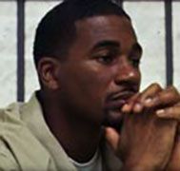
Clarence Aaron
President Obama issued eight commutations today, which is eight times the number he issued in the first 58 months of his administration. The best-known prisoner who will be freed as a result of today’s clemency actions is Clarence Aaron, who was sentenced to three consecutive life sentences in 1993 for his role in arranging a cocaine deal. Aaron's case received a lot of publicity recently thanks to reporting by ProPublica’s Dafna Linzer, who revealed that his clemency petition probably would have been granted by George W. Bush if the Office of the Pardon Attorney had not omitted important information from its evaluation.
Another commutation beneficiary, Stephanie George, received a life sentence in 1997 for letting her boyfriend stash his crack at her house. New York Times reporter John Tierney highlighted her case in a front-page story last December. Thanks to Obama’s commutations, Aaron and George will both be released next April instead of spending the rest of their lives behind bars.
All of the prisoners whose sentences Obama has shortened (including Eugenia Jennings, whose petition was granted in 2011) were convicted of crack offenses prior to passage of the Fair Sentencing Act, the 2010 law that reduced penalties for possessing and distributing the smoked form of cocaine. That law, which passed Congress almost unanimously, reflected a consensus that the old penalties were inappropriately harsh, but it did not apply retroactively. It should therefore be a no-brainer to shorten the prison terms of crack offenders sentenced under the old rules, which virtually everyone now agrees were unjust. Here is how Obama put it today:
This law began to right a decades-old injustice, but for thousands of inmates, it came too late. If they had been sentenced under the current law, many of them would have already served their time and paid their debt to society. Instead, because of a disparity in the law that is now recognized as unjust, they remain in prison, separated from their families and their communities, at a cost of millions of taxpayer dollars each year.
Families Against Mandatory Minimums estimates that 8,800 federal crack offenders are serving prison terms that could be shorter if they had been sentenced under current law. As of today, Obama has used his clemency power to help 0.1 percent of them.
Obama nevertheless deserves credit for acting, albeit belatedly and timidly, on his avowed belief that thousands of people in federal prison do not belong there. In addition to issuing these commutations, he has endorsed the Smarter Sentencing Act, a bill co-sponsored by Sens. Mike Lee (R-Utah) and Richard Durbin (D-Ill.) that would allow some crack offenders convicted before 2009 to seek shorter sentences. But as Obama demonstrated today, he does not have to wait for congressional action. It is completely within his power to free any federal prisoner whose sentence he deems unjust. If he exercises that power a little more, he will not be in danger of going down in history as the least merciful president ever.
Today’s clemency actions put Obama’s total at nine commutations and 52 pardons over 59 months, within striking distance (assuming he picks up the pace) of George W. Bush, who managed just 11 commutations and 189 pardons during his 96 months in office. But Obama still has a lot of work to do before can equal that notorious softie Richard Nixon, who issued 863 pardons and 60 commutations over 67 months.

NY Post
Obama and the terrible, horrible, no good, very bad year
by John Podhoretz

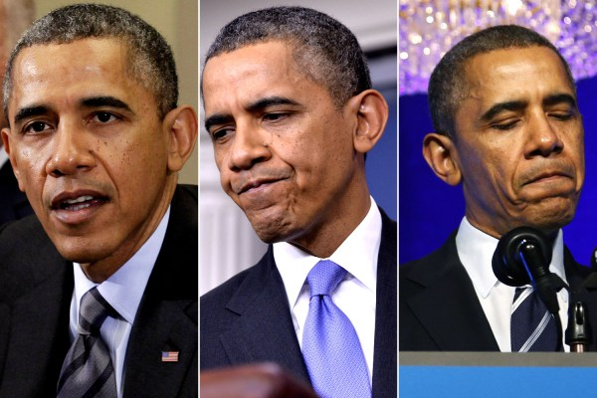
When Barack Obama sings “Auld Lang Syne” on New Year’s Eve, he will have reason to think back, with a deep sense of nostalgia and not a small amount of regret, on the last time he sang the song.
If he gets a lump in his throat as he recollects that glorious night one year ago, who would blame him? After all, he was riding about as high as a man can ride on New Year’s Eve 2012.
There he was, almost literally the master of the universe — the canny victor of the 2012 election, having run what was instantly regarded as the most brilliant technical campaign in American history. He used that victory to prevail in a “fiscal cliff” showdown with Republicans the last week of December that led to the significant tax increases on the well-to-do he had sought since the beginning of his first term. He had a 53% approval rating; only 40% disapproved.
In a few weeks, he would be inaugurated for a second term and, liberated from the demands of running again and emboldened by his win, he would that day offer the country an unabashedly and unapologetically left-wing vision of the American future toward which he was guiding it.
“Preserving our individual freedoms,” he said in a startling turn of phrase, “ultimately requires collective action.”
There were guarantees to move forward on climate-change legislation, on new tax hikes as a means of combatting inequality, and on a panoply of liberal social policy goals from so-called “pay equity” to further steps on gay rights beyond his support for marital equality. And let us not forget the issue on everyone’s mind — gun control, in the wake of the Newtown school massacre of December 2012.
This was his moment. And moments of blissful triumph for great men are precisely why legend has it that Roman emperors hired men to walk beside them as they paraded through the Eternal City, whispering the words “Caesar, thou art mortal.”
For, as he rings in the new year of 2014, Obama has rueful cause to reflect on the words of the prophet Samuel: “Oh, how art the mighty fallen.”
In his case, we can calculate the fall precisely — anywhere from 10 to 15 points in his job-approval rating. And he has taken severe hits when it comes to how much people like him and how trustworthy they find him.
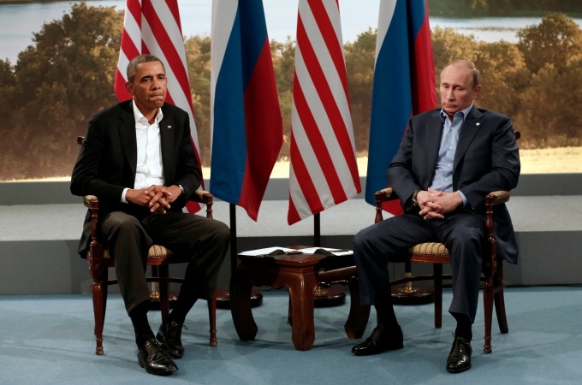
Barack Obama and Vladimir Putin have an uncomfortable meeting at the G8 Summit in Northern Ireland in June.
All in all, when it comes to public opinion, Barack Obama ends his fifth year in worse shape than any president since Richard Nixon. And Nixon didn’t even manage to finish his sixth year.
That fate will not befall Obama, obviously. But as the hopeful stories pour out of Washington about how he’s retooling his White House to dig himself out from under the rubble of the ObamaCare launch, and as liberals continue to assure themselves that once the website is working all will be well, the truth is that Obama’s return to his former glory in the coming year is highly unlikely.
For one thing, the president has gone from being someone in charge of events to someone who is being buffeted about by them — and once a leader loses his hold on the levers of power it’s very difficult to get them back.
Machiavelli says in “The Prince,” the greatest analysis of political power ever written, that successful leaders work to control their fortunes the way people construct dams and dikes to contain and direct powerful rivers.
“Fortune shows her power where the brave have not made preparations to resist her,” Machiavelli writes. “She turns her forces where she knows that barriers and defenses have not been raised to constrain her.”
In the eyes of his friends and admirers, who are shocked at how badly things have gone, Obama did not raise “barriers and defenses” to prepare for the exigencies of fortune and now “everything is flying before it, all are yielding to its violence, without being able in any way to withstand it.”
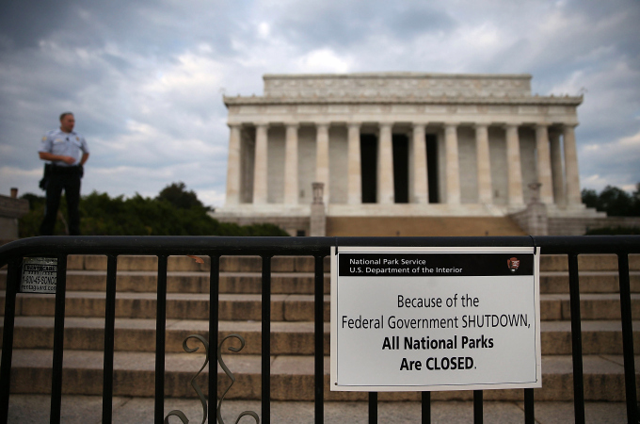
His response to the nightmarish ObamaCare rollout was only the capper in a year when his general response to questionable behavior by the executive branch was, almost literally, to play dumb.
When the IRS confessed it had inappropriately targeted conservative groups for scrutiny entirely owing to their political stances, the White House expressed bewilderment, some concern and upset, but acted as though it was happening far, far away — in some field office in Cincinnati.
Meanwhile, senior IRS officials were taking the Fifth before Congress, there were hurried retirements, and a general sense that something very, very dirty had gone down. The president’s general attitude was that he hadn’t known and anyway it wasn’t his business.
Over at the Department of Justice, it came to light that his attorney general Eric Holder had approved a highly problematic surveillance of the Associated Press in its effort to find a leaker, and had consented to the appalling designation of Fox News reporter James Rosen as a “criminal co-conspirator” in another leak investigation. The president’s response was no response: “I have complete confidence in Eric Holder as attorney general.”
Then came the discovery of what may be the worst security breach in US history, with contractor Edward Snowden dancing around the globe with tens of millions of highly classified documents. The president looked powerless and feckless when he proved unable to get the Chinese or the Russians to intercept or intercede to assist in Snowden’s return — indeed, Snowden is now living under the Russian umbrella.
In response, a peeved Obama cancelled a visit to Russia — only to find himself in Vladimir Putin’s perverse debt a month later. The president had announced he would strike Syria because of its use of chemical weapons, but was clearly reluctant to do so. Putin said he’d get the Assad government to cough up the weapons and Obama was let off the hook at the cost of an evil going unpunished and the regime solidifying its hold on power.
None of this made the president look good — even avoiding military action in Syria didn’t, because he was the one who had said he would do it in the first place.
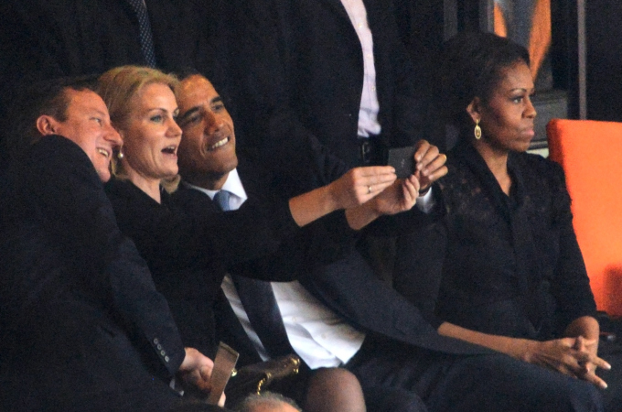
Nothing to smile about. Barack Obama poses in a selfie with Denmark’s Prime Minister Helle Thorning Schmidt and British Prime Minister David Cameron
The one moment when he seemed to have gotten the upper hand was the government shutdown at the beginning of October, but that was only because the Republicans looked worse. And that was illusory in any case, because polls during the shutdown showed he was accruing little or no benefit from it — the public blamed the GOP more but people blamed him plenty too.
And, of course, there came ObamaCare — two months of unrelievedly disastrous news followed by news that wasn’t so bad only by comparison with what had preceded it. Most important for Obama’s future, the killer moment wasn’t when the website didn’t work but when everybody had to acknowledge his four-year claim that “if you like your plan you can keep it” was an out-and-out lie.
This was so important because it exposed another lie — what you might call the great cover story of 2013.
People have come to believe Obama is out of touch and in over his head because having us believe these things was actually the least bad option for the president this year. It is actually better (or less damaging) for Obama to look incompetent than for him to look purposeful.
That’s one leadership device even Machiavelli didn’t foresee.
So now his admirers and supporters worry the job is too much for him, while those who are neither watch the spectacle with a certain grim satisfaction.
And so Barack Obama’s 2013 comes to its ignominious close. Auld lang syne, indeed.

Obama’s 2013: A year to forget
January 16 — In the wake of the Newtown shootings, Obama outlines his gun-control proposals. After a backlash, nothing gets passed. In fact, gun sales skyrocket — up 55% in Texas and 46% in Pennsylvania.
January 20 – Obama is sworn into his second term; his inaugural address is “heavy on broad rhetoric and light on policy specifics” according to the Washington Post. More people talk about Beyonce lip-synching the National Anthem.
January 29 – In Las Vegas, Obama addresses the issue of comprehensive immigration reform. Though the Senate passed a bill in June, Obama again couldn’t get anything passed in the House.
February 12 – President Obama delivers the State of the Union address and announces a drawdown in Afghanistan. While “green on blue” insider attacks on US troops continue, President Karzai of Afghanistan holds out on signing any sort of security agreement. Without the deal, all US troops will be gone from Afghanistan in 2014.
March 1 — Despite saying his sequestration plan “will not happen” during the 2012 presidential campaign, Congress fails to reach a deal and sequestration cuts $85 billion across the board.
March 2 — Open-air parks like the WWII memorial are closed by the parks department. Insiders later tell reporters the reason was political. The administration wanted the public to “feel the pain” of sequester cuts.
May 10 — Lois Lerner, a director in the IRS, responds to a planted question at a speaking engagement, admitting the tax agency targeted conservative groups — delaying and denying their tax-exempt status. It’s later alleged that the IRS leaked tax returns of conservative groups and ordered up audits of political enemies.
May 12 — It’s revealed that the administration, angry that the AP broke a story about a terrorism plot, had the private phone records of reporters secretly subpoenaed. Attorney General Eric Holder denies knowing about the seizure, but defends it because of the “very, very serious leak.”
May 22 — Lerner claims before Congress she “didn’t break any laws” then invokes the Fifth Amendment against self-incrimination.
May 23 — At the National Defense University, Obama tries to placate the left about his drone attacks by saying, “To say a military tactic is legal, or even effective, is not to say it is wise or moral in every instance. For the same human progress that gives us the technology to strike half a world away also demands the discipline to constrain that power — or risk abusing it.”
Apparently that “discipline” is “whatever Obama thinks is right.” Drone attacks continue unabated — including a strike on a Yemen wedding party earlier this month that killed at least 11.
June 6 — The Washington Post and Guardian newspapers both publish information about spying programs by the NSA, courtesy of Edward Snowden, a former NSA employee who stole the material and fled to Hong Kong.
June 23 — Edward Snowden arrives in Moscow, where Vladimir Putin refuses to give him up, and smirks when asked about him.
June 25 — In a speech on climate change, Obama again waffles on the Keystone pipeline, pleasing neither side. As months go on without it being built, Canada has been making plans to ship oil by sea to China instead.
July 2 — After taking off from Russia, the plane of Bolivian President Evo Morales is re-routed to Austria and searched, on reports he could be carrying Snowden. He isn’t — and the heavy-handed stop increases pressure on the US and angers NATO allies.
July 19 — Obama decides to weigh in on one criminal case out of thousands nationwide, saying, “Trayvon Martin could have been me 35 years ago” after George Zimmerman is found not guilty of murdering the teen. Obama calls for “soul searching.”
August 31 — Obama claims Syria has used chemical weapons in the country’s civil war, crossing the “red line” he had laid down. Obama claims he doesn’t need authorization to strike, but will ask Congress anyway. He later says even if Congress even says no, he can still do it.
September 15 — Weeks after his Syria ultimatum, Obama accepts a Russian deal that allows Syria’s Bashar al-Assad to stay in power if he gives up chemical weapons. Putin smirks.
September 23 — Lois Lerner retires suddenly; the investigation into the IRS targeting of conservative groups is ongoing.
October 1 — Depsite passing in 2010, the actual launch of ObamaCare is a complete failure — the website crashes, few if any people can sign up and millions discover that their insurance is cancelled. Obama is forced to admit that his promise that “if you like your insurance, you can keep your insurance” is a lie.
October 1 — Unable to reach a budget deal, the government shuts down.
October 17 — In a rare Obama victory, the shutdown ends with no concession to Republicans on the budget.
October 23 — Snowden’s leaks reveal the US listened to German Chancellor Angela Merkel’s phone calls. She angrily confronts Obama and latter compares the behavior to the Stasi.
November 1 — Obama signs an executive order saying local governments must prepare for the “impact of global warming” — like making buildings stronger.
December 10 — With the selfie seen round the world, Obama upstages Nelson Mandela’s memorial with a cellphone picture with UK Prime Minister David Cameron and Danish PM Helle Thorning Schmidt.
December 18 — Congress passes a bipartisan budget agreement. Bob Woodward says deal was reached, “because Obama was not part of the negotiations.”
December 19 — Under pressure, Obama says people who have had their insurance cancelled don’t have to pay the penalty for not having insurance for one year. It’s the 14th change to the law since passage.
December 31 — Estimates indicate more people may find their old health-care policies cancelled than who successfully signed up for new health insurance from ObamaCare.

USA Today
Obama is a loser at 2013's end
2014 will be even worse for our president.
by Glenn Harlan Reynolds
A lot of people are saying that 2013 was President Obama's worst year. Roll Call headlined, "Subdued Obama Hopes For Better 2014." The Hill reported, "Obama names health care rollout his biggest mistake of dismal year." Most people seem to think it was. But I think it was average, in the manner of the old Soviet joke:
Ivan: So how was your day?
Boris: Average.
Ivan: What do you mean, average?
Boris: Worse than yesterday, better than tomorrow. So, average.
Unless something turns around, Obama's 2013 is likely to be similarly "average": Worse than 2012, but better than 2014.
It's true that Obamacare has been a debacle, wrapped in a catastrophe, shrouded in a disaster. But it's also become clear that it was founded upon a lie: Obama's "if you like your health insurance plan, you can keep it" statement was named by PolitiFact its lie of the year for 2013. Many Americans have already learned that their individual plans are being cancelled because they don't live up to Obamacare, causing enough chaos that the Obama administration has had to give certain people a last-minute "waiver" of the mandate that they buy insurance. But many more problems have just been kicked down the road -- into 2014 -- by Obama's unilateral decision. Ironically, the White House and Democrats were, just a couple of months ago, calling Republicans who wanted to delay the mandate anarchists and terrorists, and loudly proclaiming that Obamacare was "the law of the land."
Regardless, the mandate delay doesn't solve problems, it just kicks the can down the road. And, as Bloomberg's Megan McArdle notes, the White House seems to be reacting to short-term political problems, rather than shoring up the system in ways that will make it work better:
However incoherent these fixes may seem, they send two messages, loud and clear. The first is that although liberal pundits may think that the law is a done deal, impossible to repeal, the administration does not believe that. ... This is at best, damage control. Which suggests that the administration is expecting a fair amount of damage.
I think that's right, and the damage will come in 2014. What we've seen so far, most likely, isn't the worst of it.
Then there is the foreign affairs realm, where 2014 also looks to be worse than 2013. The Obamacare debacle did one useful thing for Obama: It drove the Syria debacle off the front pages. But Obama's precipitous decline in the polls didn't start with the Obamacare rollout; he was already slipping from the ineptitude displayed over Syria, where we went from "Syria Must Be Attacked!" to "Never Mind" in the space of three weeks. Obamacare -- and the NSA spying scandals, and the ongoing drip-drip of the IRS and Benghazi scandals -- has only made it worse. Obama is currently less popular than any postwar president except Richard Nixon at this stage in their terms.
Increasingly, Americans see him as a loser. But more importantly, he's perceived by our friends and enemies abroad as weak and preoccupied. The Saudis are livid about our handling of Iran; needless to say, so are the Israelis. The Iranians clearly don't take us seriously, and Vladimir Putin, who outfoxed Obama over Syria, is plainly unimpressed. The combination of distrust by our friends and disrespect from our enemies is a dangerous mix, and comes at an unsettled time that some scholars are comparing to the years before World War I. It's a time when we need better than usual diplomacy, and that does not appear to be in the offing.
All told, it's likely that 2013 won't be Obama's worst year ever. Or, sadly, America's. Happy New Year!
Glenn Harlan Reynolds is professor of law at the University of Tennessee and the author of The New School: How the Information Age Will Save American Education from Itself. He blogs at InstaPundit.com.

National Review
The Age of Intolerance
The forces of “tolerance” are intolerant of anything less than full-blown celebratory approval.
by Mark Steyn

Last week, following the public apology of an English comedian and the arrest of a fellow British subject both for making somewhat feeble Mandela gags, I noted that supposedly free societies were increasingly perilous places for those who make an infelicitous remark. So let’s pick up where we left off:
Here are two jokes one can no longer tell on American television. But you can still find them in the archives, out on the edge of town, in Sub-Basement Level 12 of the ever-expanding Smithsonian Mausoleum of the Unsayable. First, Bob Hope, touring the world in the year or so after the passage of the 1975 Consenting Adult Sex Bill:
“I’ve just flown in from California, where they’ve made homosexuality legal. I thought I’d get out before they make it compulsory.”
For Hope, this was an oddly profound gag, discerning even at the dawn of the Age of Tolerance that there was something inherently coercive about the enterprise. Soon it would be insufficient merely to be “tolerant” — warily accepting, blithely indifferent, mildly amused, tepidly supportive, according to taste. The forces of “tolerance” would become intolerant of anything less than full-blown celebratory approval.
Second joke from the archives: Dean Martin and Frank Sinatra kept this one in the act for a quarter-century. On stage, Dino used to have a bit of business where he’d refill his tumbler and ask Frank, “How do you make a fruit cordial?” And Sinatra would respond, “I dunno. How do you make a fruit cordial?” And Dean would say, “Be nice to him.”
But no matter how nice you are, it’s never enough. Duck Dynasty’s Phil Robertson, in his career-detonating interview with GQ, gave a rather thoughtful vernacular exegesis of the Bible’s line on sin, while carefully insisting that he and other Christians are obligated to love all sinners and leave it to the Almighty to adjudicate the competing charms of drunkards, fornicators, and homosexuals. Nevertheless, GLAAD — “the gatekeepers of politically correct gayness” as the (gay) novelist Bret Easton Ellis sneered — saw their opportunity and seized it. By taking out TV’s leading cable star, they would teach an important lesson pour encourager les autres — that espousing conventional Christian morality, even off-air, is incompatible with American celebrity.
Some of my comrades, who really should know better, wonder why, instead of insisting Robertson be defenestrated, GLAAD wouldn’t rather “start a conversation.” But, if you don’t need to, why bother? Most Christian opponents of gay marriage oppose gay marriage; they don’t oppose the right of gays to advocate it. Yet thug groups like GLAAD increasingly oppose the right of Christians even to argue their corner. It’s quicker and more effective to silence them.
As Christian bakers ordered to provide wedding cakes for gay nuptials and many others well understand, America’s much-vaunted “freedom of religion” is dwindling down to something you can exercise behind closed doors in the privacy of your own abode or at a specialist venue for those of such tastes for an hour or so on Sunday morning, but when you enter the public square you have to leave your faith back home hanging in the closet. Yet even this reductive consolation is not permitted to Robertson: GLAAD spokesgay Wilson Cruz declared that “Phil and his family claim to be Christian, but Phil’s lies about an entire community fly in the face of what true Christians believe.” Robertson was quoting the New Testament, but hey, what do those guys know? In today’s America, land of the Obamacare Pajama Boy, Jesus is basically Nightshirt Boy, a fey non-judgmental dweeb who’s cool with whatever. What GLAAD is attempting would be called, were it applied to any other identity group, “cultural appropriation.”
In the broader sense, it’s totalitarian. While American gays were stuffing and mounting the duck hunter in their trophy room, the Prince of Wales was celebrating Advent with Christian refugees from the Middle East, and noting that the land in which Christ and Christianity were born is now the region boasting “the lowest concentration of Christians in the world — just four percent of the population.” It will be three, and two, and one percent soon enough, for there is a totalitarian impulse in resurgent Islam — and not just in Araby. A few miles from Buckingham Palace, Muslims in London’s East End are now sufficiently confident to go around warning local shopkeepers to cease selling alcohol. In theory, you might still enjoy the right to sell beer in Tower Hamlets or be a practicing Christian in Iraq, but in reality not so much. The asphyxiating embrace of ideological conformity was famously captured by Nikolai Krylenko, the People’s Commissar for Justice, in a speech to the Soviet Congress of Chess Players in 1932, at which he attacked the very concept of “the neutrality of chess.” It was necessary for chess to be Sovietized like everything else. “We must organize shock brigades of chess players, and begin immediate realization of a Five-Year Plan for chess,” he declared.
Six years later, the political winds having shifted, Krylenko was executed as an enemy of the people. But his spirit lives on among the Commissars of Gay Compliance at GLAAD. It is not enough to have gay marriage for gays. Everything must be gayed. There must be Five-Year Gay Plans for American bakeries, and the Christian church, and reality TV. There must be shock brigades of gay duck-hunters honking out the party line deep in the backwoods of the proletariat. Obamacare pajama models, if not yet mandatorily gay, can only be dressed in tartan onesies and accessorized with hot chocolate so as to communicate to the Republic’s maidenhood what a thankless endeavor heterosexuality is in contemporary America.
Look, I’m an effete foreigner who likes show tunes. My Broadway book was on a list of “Twelve Books Every Gay Man Should Read.” Andrew Sullivan said my beard was hot. Leonard Bernstein stuck his tongue in my mouth (long story). But I’m not interested in living in a world where we have to tiptoe around on ever thinner eggshells. If it’s a choice between having celebrity chefs who admit to having used the N-word in 1977 (or 1965, or 1948, or whenever the hell it was) and reality-show duck-hunters who quote Corinthians and Alec Baldwin bawling out some worthless paparazzo who’s doorstepping his family with a “homophobic” slur, or having all of them banished from public life and thousands upon millions more too cowed and craven to speak lest the same fate befall them, I’ll take the former any day.
Because the latter culture would be too boring for any self-respecting individual to want to live in, even more bloody boring than the current TV landscape where, aside from occasional eruptions of unerotic twerking by sexless skanks, every other show seems to involve snippy little Pajama Boys sitting around snarking at each other in the antiseptic eunuch pose that now passes for “ironic.” It’s “irony” as the last circle of Dante’s cultural drain; it’s why every show advertised as “edgy” and “transgressive” offers the same pitiful combination of attitude and impotence as a spayed cat humping.
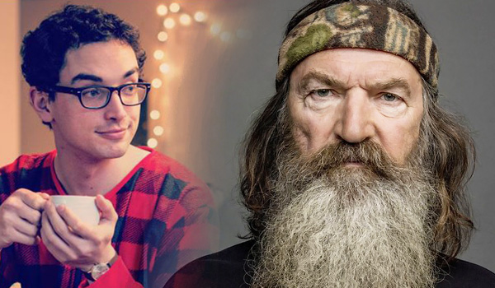
Such a pansified culture is going nowhere. I hasten to add I don’t mean “pansified” in the sense of penetrative sex with other men, but in the Sarah Silverman sense of “I mean ‘gay’ like ‘retarded.’” Miss Silverman can get away with that kind of talk because she’s a Pajama Boy–friendly ironist posing as a homophobic disablist. Unless, of course, she’s a homophobic disablist posing as a Pajama Boy–friendly ironist. Maybe we should ban her just to be on the safe side.
How do you make a fruit cordial?
Be nice to him. Or else.

Nautilus
Beer Domesticated Man
Early man chose pints over pastry. Wouldn’t you?
by Gloria Dawson
The domestication of wild grains has played a major role in human evolution, facilitating the transition from a hunter-gatherer lifestyle to one based on agriculture. You might think that the grains were used for bread, which today represents a basic staple. But some scientists argue that it wasn’t bread that motivated our ancestors to start grain farming. It was beer. Man, they say, chose pints over pastry.
Beer has plenty to recommend it over bread. First, and most obviously, it is pleasant to drink. “Beer had all the same nutrients as bread, and it had one additional advantage,” argues Solomon H. Katz, an anthropology professor at the University of Pennsylvania. Namely, it gave early humans the same pleasant buzz it gives us. Patrick E. McGovern, the director of the Biomolecular Archaeology Project for Cuisine, Fermented Beverages, and Health at the University of Pennsylvania, goes even further. Beer, he says, was more nutritious than bread. It contains “more B vitamins and [more of the] essential amino acid lysine,” McGovern writes in his book, Uncorking the Past: the Quest for Wine, Beer, and Other Alcoholic Beverages. It was also safer to drink than water, because the fermentation process killed pathogenic microorganisms. “With a four to five percent alcohol content, beer is a potent mind-altering and medicinal substance,” McGovern says, adding that ancient brewers acted as medicine men.
In fact, McGovern has found that the ancients used beer as medicine. Working with the Abramson Cancer Center of the University of Pennsylvania, McGovern discovered traces of sage and thyme in ancient Egyptian jars. Luteolin, which is in sage, and ursolic acid, which is in thyme, both have anti-cancer properties. Similarly, artemisinin and isoscopolein from wormwood fight cancer, and were found in ancient Chinese rice wine. “The ancient fermented beverages constituted the universal medicine of humankind before the advent of synthetic medicines,” McGovern says.
Beer also played an important societal role in bonding early communities together. It was popular at religious ceremonies, communal events, and celebrations. Brian Hayden, an archaeology professor at Simon Fraser University in Canada, believes that communal feasting fostered social bonding—and lots of beer was consumed during those feasts. Moreover, beer was thought to be a necessary component in the afterlife—throughout the Middle East, the dead were buried with jugs of frothy refreshments. It was even used as currency—in Egypt, the pyramid workers were paid in beer.
The beer thesis is not universally accepted, however, and the debate over its truth goes back to the 1950s. It was around then that Robert Braidwood, a leading scholar in Middle East prehistory at The University of Chicago, discovered sickles and hollow casts of grain in clay in the early settlements of the Natufians, who from 13,000 to 9,000 B.C. inhabited a region in the Eastern Mediterranean which is now Syria, Jordan, and Israel. Braidwood argued that domestication of wild barley motivated early humans to build permanent homes and switch to a sedentary way of life. Others have since extended this argument.
The great advantage of grain is that it didn’t spoil like fruit or berries, and could be kept for months and used as needed. That motivated our ancestors to build permanent structures to store their grains and homes close to their fields—which in turn led to the creation of villages. Archeologists have found stone silos dating from the Neolithic to the Bronze Age at sites in the Middle East.
Braidwood believed Natufians used the grain as food, and not for fermentation. But his work lead to a symposium titled “Did Man Once Live on Beer Alone?” Braidwood’s main opponent, Jonathan Sauer, a botanist at the University of Wisconsin, took a firm pro-beer stand. Sauer argued that growing grain with the primitive tools Natufians had would gain them a “pitifully small return of grain for their labor.” Natufians had to have been motivated by something more rewarding than mere food, Sauer believed. “Thirst rather than hunger may have been the stimulus behind the origin of small grain agriculture,” he said.
The symposium came to little consensus, but the debate continued. In the 1980s, Katz concluded from his own research that there was little evidence of bread’s popularity among the ancient tribes of the Middle East, particularly the Levant. To bolster his claim, Katz used a well-preserved sample of carbonized plant remains from about 7,000 to 6,000 B.C. recovered from the Ali Kosh site in southwestern Iran, where only 3.4 percent of the plants were domesticated cereals. If cereals didn’t make up a large part of early humans’ diet, what motivated them to begin to farm these grains? Katz argued they were farming and storing the grain to make beer.
Today, the earliest chemical evidence of barley-based beer is at the Godin Tepe archaeological site near the Iran and Iraq border, and dates back to 3,500 B.C. But scientists believe that grain-based fermented drinks have a much longer history than that, and were used around the world. “It isn’t just wheat and barley in the Middle East,” says McGovern. “It’s rice in China—rice wine was made from grain, similar to beer. It’s corn in the new world—Chicha is made from corn.”
How did man originally discover beer? McGovern and Katz theorize that man first learned to make some sort of gruel from barley. Then, natural yeast, likely supplied by insects, would have fermented the gruel, leading to a primitive form of a beer. Beer was actually easier to make than bread. Once early humans sipped these ancient suds—whether barley, corn, or rice-based—they began cultivating grain, becoming sedentary creatures. “All of these grains could have jump-started civilization as we know it because you really have to stick around the whole year to take care of your plants,” McGovern says.
In 2010, Hayden and his colleagues set off to prove that the primitive tools of the Paleolithic era, such as mortar and pestle, were sufficient for brewing. The team created three different types of beer using the ancient grains—einkorn wheat, rye, and barley. “They all tasted a bit bland,” Hayden admits, but the brews had about 2.5 percent alcohol content—enough to pique early man’s interest.
“The question is really a no-brainer,” McGovern writes. “If you had to choose today, which would it be: bread or beer?”
Gloria Dawson is a journalist based in New York City, where she writes about science, food, and other topics.

Power Line
A Frigid 2013 Draws to a Close
by John Hinderaker
2013 will go down in the record books as one of the 10 coldest years in the U.S. since 1895. This chart, from Real Science, shows the average temperatures recorded at all NOAA USHCN stations from 1895 to the present:
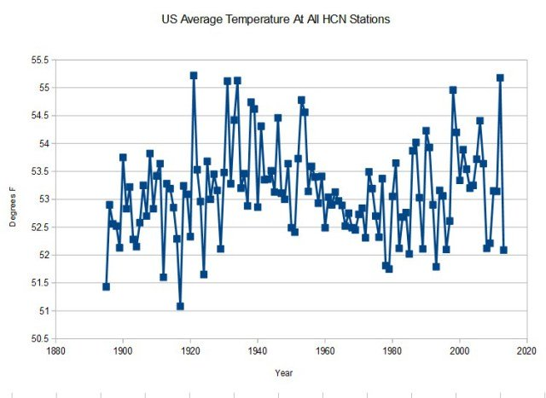
As Real Science points out, and as we have noted several times, NOAA does not report temperatures as they are actually recorded at the time. Rather, NOAA alters the historical record to make past temperatures look lower so as to bolster its bogus global warming claims:
NOAA will reporting something very different, because they subtract up to 1.7 degrees from older temperatures. Essentially all reported US warming is due to a hockey stick of temperature adjustments, which makes the past appear to be much colder than what the thermometers measured at the time. (They of course do not mention this in their press releases.)
Climate scientists get billions of dollars in funding from the U.S. government, and they serve their paymasters by “adjusting” the data. Climate alarmism isn’t just misguided, it is corrupt.

National Geographic Photo Contest

Grand Prize and Nature Winner: The Ice Bear- A polar bear peers up from beneath the melting sea ice on Hudson Bay



