November 25, 2013

A treat today. We'll not include anything about the people in DC who are busy ruining our country.

The secret life of a Manhattan doorman was in Business Insider.
The smells are the thing I don’t forget. Harsh cleaners, dead bodies, the results of four a.m. bodega runs, cluttered apartments filled with rotting paper. I can recall each smell distinctively; they are unique to that time and place. It also works in reverse: if I stumble upon one of the smells, it takes me back to being a naïve seventeen-year-old, working in the hot New York City summer—the buzz of air conditioners working in the night, straining power grids. The city was asleep and I was awake. I was a doorman.
Through the best Catholic invention of all time—nepotism—my uncle gave me a summertime job. While most of the youth of America struggled to find any money-making position, I was going to make $660 for my forty hours a week, after taxes. Union rules—god bless union rules—added time-and-a-half for overtime and double time-and-a-half for holidays. I covered vacations—most of the doormen and porters in the building had at least three weeks paid—so I would work whenever I was needed and, as a result, worked the crappy shifts. The swing shifts—literally working any time of day or night—and the midnight-to-eight a.m. shift became my summer.
That first summer, I dedicated myself to finding some kind of spiritual awakening. I decided to read the entire Kurt Vonnegut canon. It was not in order, but during lunch breaks and slow times at the door I would peel back the pages and plunge in. ...

A reviewer in Telegraph, UK provides an overview of the latest JFK books. He gives a nod to one - written by UVA's Larry Sabato.
"Telling the truth can be a scary thing sometimes.” So says Jim Garrison, the New Orleans district attorney, in Oliver Stone’s JFK. In the film, Garrison, played by Kevin Costner, is the archetypal underdog, a hero who sacrifices everything in search of truth. In real life, he was a paranoid fantasist, a publicity hound and a crooked DA. Truth can be scary, but it’s never as frightening as the power of a good lie.
I had occasion to recall Garrison a few weeks ago when a box of books was delivered to my door. That box was physical proof of the desire by publishers to cash in on the 50th anniversary of John F Kennedy’s assassination on November 22 1963. It contained 12 books, ...
... The obsession with Kennedy has inspired an insatiable need to know. That’s demonstrated by Those Few Precious Days (Simon & Schuster), by Christopher Andersen, a wonderful book for voyeurs. It examines, in painful detail, the last year of John and Jackie’s marriage. Andersen’s account of the death of their son, Patrick Bouvier Kennedy, on April 9 1963, after 39 hours of life, made me feel like an intruder at a stranger’s deathbed. Apparently Jackie hoped that Patrick would cure Jack of his addiction to other women. Obsession forces open windows that should remain shut.
Larry Sabato examines that obsession in The Kennedy Half Century (Bloomsbury). Of all the JFK books, this one will endure. It’s certainly the most original. Sabato examines how the Kennedy legacy has been manipulated, marketed and abused in the 50 years since Dallas. In the process, he reveals a great deal about Kennedy, but even more about the generations of Americans whose lives have been shaped by his death. It’s nice to see that while small men debate the minute detail of Dallas, a genuine scholar has the vision to recognise an issue that really matters: the grip that Kennedy continues to exert on us all.
As Sabato shows, Kennedy’s assassination was so painful because the myth was so perfect. ...

David Bernstein in Volokh goes after one of the most pernicious of the assassination myths - that JFK was done in by right wing "hate" in Dallas. The NY Times and WaPo were retailing this over the anniversary.
This is really amazing to me. The New York Times and the Washington Post each manages to publish a piece on the Kennedy assassination, by two different authors, focusing on what they see as the right-wing extremist environment in Dallas in 1963, and while never saying so directly, implicitly blaming Kennedy’s assassination on that environment. [UPDATE: The Washingtonian magazine is more explicit: "The city of hate had, in fact, killed the President."]
Look, guys. Lee Harvey Oswald murdered JFK. Oswald was a Communist. Not a small c, “all we are saying is give peace a chance and let’s support Negro civil rights” kind of Communist, but someone so committed to the cause (and so blind to the nature of the USSR) that he actually went to live in the Soviet Union. And when that didn’t work out, Oswald became a great admirer of Castro. He apparently would have gone to live in Cuba before the assassination if the Cubans would have had him. Before assassinating Kennedy, Oswald tried to kill a retired right-wing general. As near as we can tell, he targeted Kennedy in revenge for Kennedy’s anti-Castro actions. ...

PJ Media lists 6 reasons why the media/left keep the JFK assassination story moving.
1. Camelot. The brief Kennedy years represent for many in the media their own golden moment. JFK was their royalty, their idol, their ideal, their handsome and rich young war hero. Jackie Kennedy was their queen.
And then it was all cut short, like a Shakespearean tragedy or fairy tale. The mythic Camelot fell to lust. The American Camelot fell to an assassin. For those of us who grew up after JFK, it’s all so much history. I grew up around Dallas and heard about the assassination any time I visited anywhere else as a child, and later on I visited the Sixth Floor Museum. It’s haunting but it’s history. For many in that generation, which was mostly born after World War II and then ended up losing Vietnam, JFK provides a meaningful anchor point, or at least a point that they have infused with meaning. Don’t bring up his womanizing or how the Kennedy patriarch behaved toward the Nazis. None of that has any place in the myth.

2. It provides them a chance to bash handy villains they already hate: Dallas, Texas, and the South.

Megan McArdle on how the great disruption has come to auto dealers.
At the turn of the millennium, when I was in business school, the auto dealership business model seemed ripe for disruption. Dell Inc. was already doing a bang-up business building computers to order. It seemed only a matter of time before General Motors Co. did the same, and we could buy our cars easily over the Internet rather than having to haggle with a dealer.
Ah, the optimism of youth! Ten years later, auto dealers are still very much with us. It turns out that building and selling cars is a bit more complicated than doing the same with computers. Oh, and auto dealers are extremely well connected in Congress and especially in state legislatures; they are often among the richest people in a legislator’s district, which has translated, over the years, into protective franchise laws that make it very hard for automakers to prune their dealer networks.
And yet, the dream of low, no-haggle pricing seems to be moving closer. The Internet didn’t get rid of the dealers, but it forced them to become much more competitive. Pricing is much more transparent, thanks to a wealth of Web-based information, and because dealers are now advertising. Lower your price a bit, and you’ll poach customers who in the old days might not have thought to check a dealer an hour and a half away when they had to make inquiries by phone. But they’ll happily drive that far to save a few hundred dollars. ...

In Slate we learn anacondas are living in the Everglades.
On a muggy day about 10 years ago in the Florida Everglades, Jack Shealy was riding his bike along a dirt road leading into the Trail Lakes Campground, where he has worked for decades. Like any good gladesman, Shealy has a substantial portion of his brain wired to recognize snakes in places where the rest of us would see only leaves and shadows. He skidded to a stop at the sight of a serpentine form stretched out in the sun.
This particular snake was not especially large—only about a meter in length. Yet the color was something different. Greenish brown with dark, oval spots. This was not a snake that belonged in the Everglades. Shealy did something that comes naturally to the family. (His nephew Jack M. Shealy recently became notorious for jumping into the water to wrestle an invasive Burmese python.) He jumped off of the bike and captured the angry snake by hand.
Trail Lakes Campground just happened to have a herpetologist on staff. Rick Scholle, who runs the campground’s roadside zoo, examined the snake and realized that he was looking at a juvenile green anaconda. A nonvenomous constrictor native to South America, the green anaconda is the biggest, heaviest species of snake in the world. It definitely does not belong in the Florida Everglades. ...

The Boston Globe provides another example of porkers in college administrations.
When Brandeis University president Jehuda Reinharz stepped down three years ago, he moved back into his old faculty office.
But unlike most history professors, Reinharz does not teach any classes, supervise graduate students, or attend departmental meetings. He did not bother posing for the department photo. The chairwoman for Near Eastern and Judaic Studies said she did not even know whether he was officially a member of her department.
Yet Reinharz remains one of the highest paid people on campus.
He received more than $600,000 in salary and benefits in 2011, second only to the new Brandeis president, according to the school’s most recent public tax returns. And that’s on top of the $800,000 Reinharz earned in his new job as president of the Mandel Foundation, a longtime Brandeis benefactor.
“There is puzzlement from faculty about why he gets paid at all” by Brandeis, said Gordon Fellman, a sociology professor at Brandeis. “His term as president ended.”
Like Reinharz, many other college presidents across the country are negotiating huge exit packages when they step down, which critics say is emblematic of schools’ unrestrained spending on everything from administrative salaries to elaborate new buildings that drive up the cost of higher education. Schools and public records say:
Lawrence S. Bacow, president emeritus of Tufts, received $1.7 million in 2011 for “end of service compensation.” ...

Business Insider
The Shocking Things You See As A Manhattan Doorman
A college student is stoked to land a summer gig as a union-wage doorman—until he learns the job description includes everything from hauling out hoarders to discovering dead bodies.
by Garrett McGrath
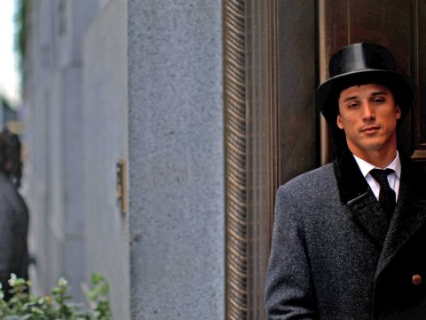
The smells are the thing I don’t forget. Harsh cleaners, dead bodies, the results of four a.m. bodega runs, cluttered apartments filled with rotting paper. I can recall each smell distinctively; they are unique to that time and place. It also works in reverse: if I stumble upon one of the smells, it takes me back to being a naïve seventeen-year-old, working in the hot New York City summer—the buzz of air conditioners working in the night, straining power grids. The city was asleep and I was awake. I was a doorman.
Through the best Catholic invention of all time—nepotism—my uncle gave me a summertime job. While most of the youth of America struggled to find any money-making position, I was going to make $660 for my forty hours a week, after taxes. Union rules—god bless union rules—added time-and-a-half for overtime and double time-and-a-half for holidays. I covered vacations—most of the doormen and porters in the building had at least three weeks paid—so I would work whenever I was needed and, as a result, worked the crappy shifts. The swing shifts—literally working any time of day or night—and the midnight-to-eight a.m. shift became my summer.
That first summer, I dedicated myself to finding some kind of spiritual awakening. I decided to read the entire Kurt Vonnegut canon. It was not in order, but during lunch breaks and slow times at the door I would peel back the pages and plunge in.
The summer went by quickly. June and July were consumed by Nazi propagandists (Mother Night), Watergate (Jailbird), and Kilgore Trout. It was those unrelenting August nights that played and preyed on my mind my first year. The lobby A/C barely worked and I constantly sweat through my baby blue polyester building-issued shirt. I would spend the midnight-to-eight-a.m. shift reading at the desk. At around four I would lock the front door and walk to the bodega on Broadway with a box cutter in my pocket (“Always carry this,” my uncle told me the first night). There I would buy cups of iced coffee, Red Bull and gum.
I hated walking back. The lack of social interactions on the overnight shift killed me. I would be lucky if I had the chance to talk with anybody coherent. Midnight to three consisted of the drunks—rich residents and rich friends stumbling around, fumbling for keys, phones, wallets. Three to five was dead—nobody in or out. While I waited for sunrise, five to eight was work—peeling my back from the stool, locking the door, taking the newspapers that magically appeared on the stoop (I never saw the delivery van), and putting out garbage bins on all of the floors. Residents ran out yelling on phones, at children, at occupied taxis speeding by as I handed out keys to housekeepers, learning to communicate in broken English. I greeted the porters and day doorman, who never came up to the desk at eight, always at 8:05 a.m. or later, wearing a snide smile.
At the end of the shift, I would run to the subway and take it to Grand Central Terminal to reverse commute. I was going home from work to the suburbs while most people were traveling to their jobs in the city. Sleeping against the sun on the train, then in my bed, I would wake up in the afternoon.
“What am I doing?” I asked myself.
“You are making money,” I answered.
What day is it? What month is it?
I lost all sense of time and all ability to interact. The weeks on the overnight shift were like solitary confinement. My day planner from that period makes no sense; pages either blank or full of scribbling of strange ideas. It was my own personal Groundhog Day every night, the same, unmovable time loop over and over and over. Vonnegut, of all people, tried to keep me sane.

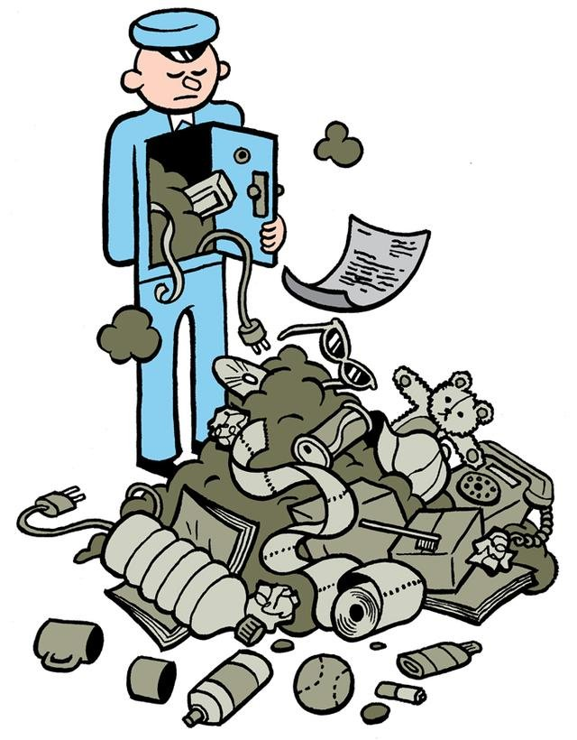
6H - The Hoarder
New York City residents know an incredible amount about their neighbors, without even doing too much detective work. Smells and open doors can give you insightful knowledge into neighboring rooms, but the remaining mystery of what residents don’t know about their neighbors is exploited. It is exploited by those working in buildings.
Nobody ever went inside 6H. In a building with 120 apartments you recognize faces, names on packages and number-letter combinations. 6H never came up.
“We’re going upstairs,” my uncle said one day. He fished a key from his shirt pocket and tossed it to me. “To 6H.”
“What are we doin’?”
“You’ll see.”
After the short elevator ride, I tried the key in the door of 6H. My uncle laughed at the struggle; he knew exactly what he was doing.
“What are you doing?” he mockingly yelled and motioned me away. He opened the door in one swift motion, but it only moved in three inches. It was pitch black, bizarre for an early afternoon summer day. I fished out my mini Maglite and pushed hard on the door. Something crashed and all I saw was paper. Rotting sheets revealed the half-life of newsprint. I couldn’t see walls or windows. We stepped over old newspapers and issues of magazines. I remember a New Yorker issue covered with an army of snowmen. It was dated January 8, 1972.
“This lady died two years ago,” my uncle informs me. “Not in here, thank god. We would have never found her.”
It sat empty of humans but full of stories, clips, bills, letters. I made a joke about turning up the heat to 451 degrees Fahrenheit. My uncle stared at me. I mumbled something back to cover my embarrassment.
The son of the dead woman was finally able to sell the one-bedroom apartment, after two years of court probate due to the lack of a will. We found the will when we were emptying out the apartment. The garbage filled three forty-cubic-yard dumpsters. The will left all of the woman’s fortune and apartment to various public institutions, with no mention of the son. He was cut out. The next day we revealed this to him. We gave him the document, for which he tipped us an extra $200 each. Nothing was said. The apartment was repainted and sold for over a million dollars, which a court allowed the son to keep. The will ended up like all of those other words—in a landfill, forgotten, never to be read again.
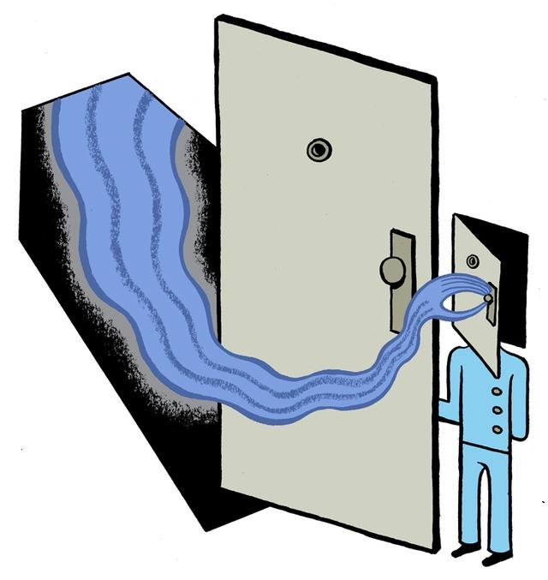
2B – The Body
New York City residents also have an interesting relationship with death. We are constantly surrounded by it, but we're blissfully ignorant, even when it happens to our neighbors.
“Aunt ______ isn’t answering my calls. Can you check on her?”
This was the scariest two-sentence combination I heard as a doorman. That old lady in 2B wasn’t in the Hamptons. I knew exactly where she was. She was fucking dead, in her apartment.
The doorman and porters gathered around the front desk, drawing imaginary straws. I walked up.
The key was on top of the doorman podium. All three men—the two other porters and daytime doorman—looked at me, grinning.
“What?”
“Mrs. ______’s relative called. They haven’t heard from her in a few days.”
Corey, the daytime doorman, answered.
“So?”
“So, you have to—” Corey was cut off.
“She is fucking dead in there, man,” Eddie yelled. “You have to go check before we call the cops.”
“Just call them.”
Corey tried to retain order. “We can’t, you have to check first.”
“Shit, why do I have to?”
“Because.”
“Fuck that, I’m not.”
All three guys stared at me, the seventeen-year-old Kurt Vonnegut-reading summertime worker. I was their peon all summer: mopping, cleaning, lifting, pulling and climbing while they sat in air conditioning and watched NY1 in the break room.
I didn't want to see a dead body.
“Fine, fine, fine. You pendejo,” the oldest porter, Manny, said. “Let’s go.”
On the elevator ride up, he told me that this would be his fourth dead body, bragging about his experienced undertaker status. It is sick, but I understood the joy Manny could not help but express.
Some of the residents constantly talked down to us:
“Boy, did you empty those bins?”
“This hallway hasn’t been mopped in weeks! I’m calling the building management company.” (I had cleaned it the previous day.)
Nothing compared to being asked my first day by a longtime resident—who was hated equally by porters, doormen and her neighbors—if I spoke English. She followed it up with , “It’s about time they got some white people working here.”
Even the ones who pretended to be nice only did so for ulterior motives:
“Hey! How’s it going? How about those Yankees?"
(Translation: I know you know that I’m cheating on my wife after you saw me coming home in that cab last week. You opened the door when I was pulling my hand out of my mistress’s skirt. I will be nice to you, and tip you well, if you don’t tell anyone.)
“You want a soda? You hungry?”
(I know you know I have male prostitutes visit me in my apartment late at night. I will continue to buy you food if you don’t tell anyone.)
Manny was in control. His joy came from being one of the first to see Mrs. ______; all the residents would ask him about it. He would be the center of the building gossip, temporarily, but at the center nonetheless.
“I hope,” he grinned, “that she isn’t burnt alive.”
“Come on,” I said.
“Two years ago, Mr. ______ was smoking a cigar in his bedroom,” Manny said. “All of the rooms are fireproofed. He had a heart attack in his bed and the cigar burnt his body.”
I didn’t believe him. I couldn’t believe him. Later I confirmed with my uncle, my only friend here, that Mr. ______ did in fact die of a heart attack and get incinerated by a cigar. My uncle, who smoked cigarettes while he recounted this story, looked under the coroner’s white sheet because his curiosity of what burnt flesh looks like got the better of him.
The elevator doors opened. I pushed the key into the keyhole and wiggled it until it caught. All the lights were on. I scanned the living room. Then, I saw it. An arm, completely dark blue, limp over the side of the couch. She was facing the TV. The smell in the apartment was every cliché from every horrible television detective procedural. It was acrid; it smelled like rotting meat. I couldn’t take it and I ran outside. I desperately wanted to vomit but couldn’t show weakness in front of Manny. He would tell the others and I would be mocked for the entire summer. Manny and I went downstairs and he told Corey to call 911.
The cop car was followed by the coroner’s van. The coroners carried the body on a stretcher out of the service entrance. As the body went into the van, all of the porters stared at each other. I went back inside and worked extremely fast so I could make the 4:20 train. I focused on my work so I could ignore the smell my brain couldn’t get rid of. I made the train, got home and showered for a long time to try to get rid of the smell. I looked at the water circling the drain, and felt nothing.
My first summer as a doorman came to a close. I worked for two more summers during college. At the end of my third, I knew it would be my last. The union leadership in the building was changing and 32BJ was strong. I also knew I wouldn’t miss it.
“Corey’s dead.”
“What?”
“Corey’s dead. This morning, heart attack.”
I could tell this wasn’t a prank. I could tell my uncle was tearing up over the phone, trying to fight showing any emotion at all.
“I’m going to need you to work all break,” my uncle continued. “The money will be great. Lot of holiday and overtime pay.”
I had just finished finals at NYU, right before winter break. I hadn’t slept in three days.
I said yes and hung up.
I hated Corey. He showed up late all the time and always yelled at me for rules that he himself violated continually. And now, I had to be him. I had to wear his fancy clothes and play the part of the daytime doorman. On the overnight shift, I didn’t have to dress up, but during my short reign over the coveted eight-to-four daytime shift I had to wear a hat that hung over my ears and an overcoat that dragged on the floor when it was slung over my shoulders.
The snow did nothing to slow or freeze my hatred of Corey, or of the way the residents treated me. This was the end.
After that break, I never went back to work as a doorman. My uncle is now retired and most of the workers have been replaced—some after forty years of service—due to a change in union leadership. I hate walking by the front door. It’s like going back to the carnival or office you worked at when you were a teenager. When you had no idea who you were.
Garrett McGrath is a frequent Narratively contributor. Follow him on Twitter @garrettpmcgrath.
Ben Juers is a Sydney-based cartoonist whose work has appeared in The Lifted Brow, Seven Days and the Australian Book Review.

Telegraph, UK
The truth about John F Kennedy
Fifty years after JFK’s death our obsession with conspiracy theories clouds our view of the man
by Gerard DeGroot
"Telling the truth can be a scary thing sometimes.” So says Jim Garrison, the New Orleans district attorney, in Oliver Stone’s JFK. In the film, Garrison, played by Kevin Costner, is the archetypal underdog, a hero who sacrifices everything in search of truth. In real life, he was a paranoid fantasist, a publicity hound and a crooked DA. Truth can be scary, but it’s never as frightening as the power of a good lie.
I had occasion to recall Garrison a few weeks ago when a box of books was delivered to my door. That box was physical proof of the desire by publishers to cash in on the 50th anniversary of John F Kennedy’s assassination on November 22 1963. It contained 12 books, five of which question the official version of what happened in Dealey Plaza. It gave off an odour of dirty macs and overflowing ashtrays. What, I wondered, was the total weight of truth in that box?
The Warren Commission concluded in 1964 that Kennedy was killed by Lee Harvey Oswald, who fired three bullets from the sixth floor of the Texas School Book Depository. Conspiracy theorists insist that the Commission was a cover-up and that at least one more gunman was involved. They also argue that Oswald was hired by the CIA, the Mafia, Fidel Castro or another clandestine group – including aliens. Every year, I ask my students to find the most bizarre assassination theory on the Internet. The best so far maintains that Elvis, racked by jealousy over Marilyn Monroe, shot Kennedy. Once a conspiracy theory starts it never stops. This explains the reissue of Crossfire by Jim Marrs (Basic), a book that was “the basis” for JFK. That seems reason enough not to reissue it. Stone’s fantasy was once mildly intriguing because we knew almost nothing about the characters he introduced, including Garrison and Clay Shaw, the only person ever tried in connection with the assassination. Now we know more and can see how preposterous JFK is. But publishers understand that there are gullible people hungry for assassination porn.
Matthew Smith claims that Who Killed Kennedy? (Mainstream) is the “definitive account”. That’s slightly ironic, since definitive usually means big, and this was the smallest book. Smith’s tawdry volume never answers the question posed by its title, except to suggest that the villain was someone in the CIA. Wow, that’s a revelation. The CIA are often the culprits of choice. The agency is a synonym for secrecy and deceit – and blaming the CIA means you don’t have to name a perpetrator.
Smith quotes Earl Warren, who once told reporters: “you may never get the truth in your lifetime”. For conspiracy theorists that’s proof of a plot. That quote also inspires the title of Not in Your Lifetime (Headline) by Anthony Summers, another “definitive” account. His book, first published in 1980, has been revised four times. The latest edition is “the most definitive”, a grammatical impossibility. I’d be more patient with conspiracy theorists if they didn’t murder the English language.
Alex Cox offers what looks the most intriguing of the assassination chronicles. His book, The President and the Provocateur (Oldcastle), is billed as the “parallel lives” of Kennedy and Oswald. That’s an exciting idea. Unfortunately, the book’s a Trojan Horse. Lurking inside is another conspiracy yarn. The same holds for Philip Shenon’s A Cruel and Shocking Act (Little, Brown). It aims for the respectable market – it’s sombre and short on hyperbole. But that’s where the book fails, since this subject is attractive precisely because it’s sordid. Assassination books should make one feel a little dirty. This one aims to be clean, but ends up being dull. At the end of 500 pages, we’re told that the CIA probably lied about their involvement in the assassination. Ho-hum.
Imagine if a cast-iron explanation for Kennedy’s assassination could be found. And imagine if it involved a lone gunman firing three bullets from the Texas School Book Depository. Overnight, the huge market for conspiracy books would disappear. That’s the irony of the new books on the assassination: each depends on the mystery never being solved. Conspiracy theories thrive because the truth is often boring. Take John Kennedy. A life so large requires a death of equal magnitude – he was too important to be eliminated by a mediocrity.
Oswald was a pathetic loser, a point demonstrated superbly in Peter Savodnik’s The Interloper (Basic), which recounts the three years the assassin spent in the Soviet Union. Fed up with America, Oswald embraced communism and tried to sell himself as a spy. The Russians, however, rightly judged him a nutter. Like Savodnik, James Swanson’s End of Days (William Morrow) takes a restrained approach to the assassination, concluding that Oswald acted alone. Both books are carefully researched and elegantly written, but both will probably suffer on account of their sobriety. It’s reassuring that, amid the lunacy, publishers still give sanity a voice.
Opinion polls regularly find that Kennedy was the most popular president in American history. Yet strip away the myths and his achievements seem thin. Now it’s virtually impossible to separate myth from man. Kennedy, in life and death, was adept at fooling people. Behind the image of youthful vigour walked a man of poor health. His famous suntan, supposedly the result of yachting, was caused by steroids taken for Addison’s disease. He presented himself as a family man, but was in fact a womaniser. Millions would come to love Kennedy not for what he was but for what he seemed.
The obsession with Kennedy has inspired an insatiable need to know. That’s demonstrated by Those Few Precious Days (Simon & Schuster), by Christopher Andersen, a wonderful book for voyeurs. It examines, in painful detail, the last year of John and Jackie’s marriage. Andersen’s account of the death of their son, Patrick Bouvier Kennedy, on April 9 1963, after 39 hours of life, made me feel like an intruder at a stranger’s deathbed. Apparently Jackie hoped that Patrick would cure Jack of his addiction to other women. Obsession forces open windows that should remain shut.
Larry Sabato examines that obsession in The Kennedy Half Century (Bloomsbury). Of all the JFK books, this one will endure. It’s certainly the most original. Sabato examines how the Kennedy legacy has been manipulated, marketed and abused in the 50 years since Dallas. In the process, he reveals a great deal about Kennedy, but even more about the generations of Americans whose lives have been shaped by his death. It’s nice to see that while small men debate the minute detail of Dallas, a genuine scholar has the vision to recognise an issue that really matters: the grip that Kennedy continues to exert on us all.
As Sabato shows, Kennedy’s assassination was so painful because the myth was so perfect. Something almost divine was taken from the American people in Dealey Plaza. That divinity is perfectly evoked in My Kennedy Years (Thames & Hudson) a posthumous publication by Jacques Lowe, the president’s personal photographer. The images accurately convey a golden time when the American president was young, handsome, intelligent and heroic. Yet they are just images, carefully chosen to sell a mythical leader to a credulous public.
The desire to sanitise the Kennedy image remains strong. This is demonstrated by The Letters of John F Kennedy (Bloomsbury) edited by Martin Sandler. It’s interesting and beautifully presented, but the correspondence is censored. Sandler did not include the lurid notes the young Kennedy wrote to his friends, boasting of sexual conquests. In any case, letters, do not adequately reveal the man. The best revelations lately are from the Oval Office recordings, which demonstrate just how cynical Kennedy could be.
“Sometimes you get the feeling nothing has gone right since John Kennedy died,” one American remarked around the time of Watergate. That sad refrain has echoed across the decades since November 1963. Because so much importance was invested in his life, so much magnitude has been assigned to his death. It became, inevitably, a watershed. The Kennedy assassination has often been called the end of American innocence, a statement no less accurate for being trite. Innocence died not just because a promising president had been murdered, but also because it would become apparent just how much the myth depended upon gullibility.
Real or imagined, truth or lie, there’s never been another man like Kennedy. That’s because the assassination destroyed the credulity essential for a similar hero to emerge. As the years passed, Americans would cling desperately to their hero, while they were battered by evidence of his shortcomings. This latest conspiracy of Kennedy books reveals how, since 1963, both the truth and the lies have corroded the American spirit.

Volokh Conspiracy
Remarkable Take on JFK’s Assassination
by David Bernstein
This is really amazing to me. The New York Times and the Washington Post each manages to publish a piece on the Kennedy assassination, by two different authors, focusing on what they see as the right-wing extremist environment in Dallas in 1963, and while never saying so directly, implicitly blaming Kennedy’s assassination on that environment. [UPDATE: The Washingtonian magazine is more explicit: "The city of hate had, in fact, killed the President."]
Look, guys. Lee Harvey Oswald murdered JFK. Oswald was a Communist. Not a small c, “all we are saying is give peace a chance and let’s support Negro civil rights” kind of Communist, but someone so committed to the cause (and so blind to the nature of the USSR) that he actually went to live in the Soviet Union. And when that didn’t work out, Oswald became a great admirer of Castro. He apparently would have gone to live in Cuba before the assassination if the Cubans would have had him. Before assassinating Kennedy, Oswald tried to kill a retired right-wing general. As near as we can tell, he targeted Kennedy in revenge for Kennedy’s anti-Castro actions.
The attempt to at best distract us from who the killer was and why he killed JFK, and at worst to pin the blame on entirely innocent people for inciting Dallas opinion against JFK (or perhaps to imply that the right-wingers plotted the assassination), even though those innocents were exactly the type of people Oswald hated, is just pathetic, and the Times and Post should be embarrassed for publishing these pieces. The Post piece is especially embarrassing because it explicitly links Dallas “right-wing extremism” circa 1963 to the modern “Tea Party,” as if to say, “if the Tea Party had been around in 1963, one of its members would have killed Kennedy.”
And please, assassination conspiracy theorists, stay away from the comments section.

PJ Tattler
6 Reasons the Media/Left Refuse to Let the Kennedy Assassination Go
by Bryan Preston

1. Camelot. The brief Kennedy years represent for many in the media their own golden moment. JFK was their royalty, their idol, their ideal, their handsome and rich young war hero. Jackie Kennedy was their queen.
And then it was all cut short, like a Shakespearean tragedy or fairy tale. The mythic Camelot fell to lust. The American Camelot fell to an assassin. For those of us who grew up after JFK, it’s all so much history. I grew up around Dallas and heard about the assassination any time I visited anywhere else as a child, and later on I visited the Sixth Floor Museum. It’s haunting but it’s history. For many in that generation, which was mostly born after World War II and then ended up losing Vietnam, JFK provides a meaningful anchor point, or at least a point that they have infused with meaning. Don’t bring up his womanizing or how the Kennedy patriarch behaved toward the Nazis. None of that has any place in the myth.
2. It provides them a chance to bash handy villains they already hate: Dallas, Texas, and the South. Not a JFK anniversary goes by without the New York Times publishing at least one piece blaming the assassination on Dallas, and more broadly on Texas and the South. The fact is, while Dallas had its share of mainstream Kennedy-haters, none of them fired a shot. Texas went narrowly for Kennedy in 1960. Dallas citizens actually turned out on November 22, 1963, to greet the Kennedys warmly. Even the horrible Zapruder film shows happy, cheering crowds lining the streets in Dealey Plaza just to get a glimpse of the First Couple.
One lone nut can change all that, and did, which is unsettling to the point of horror. But Dallas was not and is not to blame, any more than Ford’s Theater is to blame for Abraham Lincoln’s killing. Texas is not to blame. The South is not to blame. But many on the left would rather blame their preferred villains than look at the truth.
3. The truth is more horrible than the fiction. The truth is, the assassination of John F. Kennedy is the killing of one of life’s genetic lottery winners by a small-time loser. If JFK was larger than life, his killer was much smaller than life. The JFK assassination could have been a conspiracy, but it probably wasn’t. The evidence points directly at one man whose ideology, coupled with his combination of grandiosity and mediocrity, led him to kill the president in order to elevate himself.
Lee Harvey Oswald was a Communist who had defected to the Soviet Union, become disillusioned, returned to the U.S., and then supported the Communist Castro regime in Cuba against the United States. He wanted to be a big man. Kennedy, the president of the United States, fit the definition of a Big Man perfectly. He was a resolute anti-Communist. Oswald was a traitor who put his ideology above his country. He was also barely employable because he had no skills apart from rabble rousing. He knew how to use a rifle, and that was the extent of his abilities. Ideologically he may have been the first Occupier. He was someone whose outsized self-esteem frustrated and bedeviled him. It destroyed his marriage. It ultimately cost him and police officer J. D. Tippit and President Kennedy their lives. The killing had no broader meaning. It was the act of a madman taking revenge on the leader of the world because he failed and never fit in. But because he killed a man that the media and left idolized, they infuse his madness with deeper meaning.
But supposing the conspiracies have any truth in them, the villain still is not Dallas or Texas or the South. The villain then is the very government that the left wants to grant more and more power. Oswald is either just a willing participant in a grander scheme, or maybe even a victim himself.
4. What might have been… On CNN, Gerald Posner made this somewhat gruesome point: Kennedy is remembered as “great” mainly because he didn’t have enough time to make too many mistakes.
Would JFK have prevented the Vietnam debacle? We’ll never know? Would the wasteful Great Society programs have happened on his watch? We’ll never know. Would Kennedy have been as effective on civil rights as LBJ turned out to be? JFK’s assassination resonates for the same reason that Marilyn Monroe’s image still sells posters. Their youthful image is all we have, and we can dream and speculate about what might have been, because we were robbed of the reality.
The two most lionized assassinated presidents are very different in this respect. Abraham Lincoln is lionized because of what he did in office. He existed before the media age, when image was far less important than thoughts and action. The first Republican president preserved the Union, he freed the slaves, he was a self-made man and profound thinker and writer and debater who handed down thoughts that we still study and recite today. We just passed the 150th anniversary of his Gettysburg Address, arguably the most important address ever delivered by an American president. In that brief address Lincoln gave meaning to the bloody Civil War that still raged, calling America to a “new birth of freedom, under God” to preserve liberty for future generations.
John Kennedy, on the other hand, is the first media age president. He is lionized mainly due to the possibilities lost because his time was cut tragically short, and because the image of the man is forever young and vigorous.
The two other American presidents who were assassinated while in office, James Garfield and William McKinley, both Republicans, are mostly forgotten.
5. They (we) love a conspiracy theory. For all the left’s talk of devotion to logic and facts, they love to craft and sell conspiracy theories. As soon as a conservative comes along to fund causes they believe in, the left will craft wheels within wheels to explain it all. They will turn the new funder into a boogeyman, an enemy of the state. When a liberal policy fails it’s not their fault, it’s the Republicans’ fault. Barack Obama is particularly fond of that one. The Warren Commission, LBJ’s corruption, the “magic bullet,” Oliver Stone’s JFK — it’s all fertile soil for conspiracies to grow left, right and center. The JFK assassination affords the opportunity to gaze wistfully at a perfect past that never really was, and to blame the usual suspects — the CIA, the military-industrial complex, the South, Republicans — for its demise.
6. He was a Democrat. This is the shallowest reason that Kennedy is still lionized in the media, but it’s a fact that three of the four assassinated presidents were Republicans, yet Kennedy is the only one so revered. Part of that has to do with his timing. Kennedy came after a pragmatic and unglamorous Republican president, Eisenhower, and ahead of a corrupt machine Democrat and then a disgraced Republican. By comparison to the surrounding presidents, JFK was young and glamorous and lost too soon. His spot in history also comes at the dawn of the media age, before the onset of Vietnam, the drug culture, the dissolution of the family and the decline of Western confidence, and before Reagan’s restoration of the latter. In terms of policy, he opposed Communism, sought to keep the Soviets in check, and cut taxes, putting him on the center-right in today’s politics. The fact is, the Bush family is strikingly similar to the Kennedys — wealthy, powerful, producer of dynastic political power — but will never be as lionized by the media, both because of the tragedies that befell the Kennedys, and because the Kennedys are Democrats.
About 90% of the media vote Democratic. When they seek subject matter experts, they tend to gravitate toward fellow liberals and their own institutions. It’s only natural that the same media would lionize Democrats past and present, shielding Obama now, making a statesman out of Bill Clinton, glossing over the failures of the Carter years while whittling away at the successes of the Reagan years. We never hear much about the efficiency of the Eisenhower years or his record on civil rights, but you can’t get Doris Kearns Goodwin to stop talking up how “great” Johnson was despite his obvious corruption.
John Kennedy was a chiseled Democrat who had it all, cut down in his prime. The media mythologize him because they just can’t help themselves.

Bloomberg News
The Great Disruption Comes to Auto Dealers
by Megan McArdle
At the turn of the millennium, when I was in business school, the auto dealership business model seemed ripe for disruption. Dell Inc. was already doing a bang-up business building computers to order. It seemed only a matter of time before General Motors Co. did the same, and we could buy our cars easily over the Internet rather than having to haggle with a dealer.
Ah, the optimism of youth! Ten years later, auto dealers are still very much with us. It turns out that building and selling cars is a bit more complicated than doing the same with computers. Oh, and auto dealers are extremely well connected in Congress and especially in state legislatures; they are often among the richest people in a legislator’s district, which has translated, over the years, into protective franchise laws that make it very hard for automakers to prune their dealer networks.
And yet, the dream of low, no-haggle pricing seems to be moving closer. The Internet didn’t get rid of the dealers, but it forced them to become much more competitive. Pricing is much more transparent, thanks to a wealth of Web-based information, and because dealers are now advertising. Lower your price a bit, and you’ll poach customers who in the old days might not have thought to check a dealer an hour and a half away when they had to make inquiries by phone. But they’ll happily drive that far to save a few hundred dollars.
The result, reports the Wall Street Journal, is falling profits for dealers, with some moving toward no-haggle pricing:
According to AutoTrader Group, a research and marketing firm, the average car shopper spends more than 11 hours online researching cars and only 3½ hours offline, including trips to the dealership. Two years ago, the average time spent offline was more than six hours.
The economics is forcing some of the changes. Average gross profit on a new-car sale dropped to $1,283 last year from $1,531 in 2002, according to the National Automobile Dealers Association.
Average salary of a sales person rose to $63,800 last year from $45,940 in 2002, but that is only slightly ahead of inflation during the same period, said Ted Kraybill, president of DeltaTrends, a firm that studies workforce trends at car dealership.
Responding to such trends, Spitzer Auto in Ohio got rid of sales commissions three years ago, and now pays all its salespeople a flat rate for each car they sell and a twice-monthly bonus for hitting sales targets.
The chain also instituted a no-haggle policy, setting an advertised price and sticking to it. "The customers like it because they don't feel pressured," said Jeff Deisz, a 30-year-old salesman at Al Spitzer Ford in Cuyahoga Falls, Ohio.
One of the things I learned in business school is that incumbents have more ability to resist disruption than you’d think -- by regulatory and legal means, of course, but also by co-opting the disruption. Incumbents often have the complementary assets, such as marketing and sales teams, to maximize a disruptive technology’s commercial value. General Electric Co. did not invent the CAT scan, but the technology has made the company a lot of money.
Still, one of the things I learned after business school is that if the disruptive force is powerful enough, it will eventually breach even the most impressive walls that incumbents can erect. That’s a lesson the dealers seem to be learning right now.

Slate
The Largest Snake in the World Has Invaded the United States
by Jackson Landers
On a muggy day about 10 years ago in the Florida Everglades, Jack Shealy was riding his bike along a dirt road leading into the Trail Lakes Campground, where he has worked for decades. Like any good gladesman, Shealy has a substantial portion of his brain wired to recognize snakes in places where the rest of us would see only leaves and shadows. He skidded to a stop at the sight of a serpentine form stretched out in the sun.
This particular snake was not especially large—only about a meter in length. Yet the color was something different. Greenish brown with dark, oval spots. This was not a snake that belonged in the Everglades. Shealy did something that comes naturally to the family. (His nephew Jack M. Shealy recently became notorious for jumping into the water to wrestle an invasive Burmese python.) He jumped off of the bike and captured the angry snake by hand.
Trail Lakes Campground just happened to have a herpetologist on staff. Rick Scholle, who runs the campground’s roadside zoo, examined the snake and realized that he was looking at a juvenile green anaconda. A nonvenomous constrictor native to South America, the green anaconda is the biggest, heaviest species of snake in the world. It definitely does not belong in the Florida Everglades.
I met Shealy and Scholle while I was on an expedition in February to hunt invasive Burmese pythons in the Everglades. The Burmese pythons have become a well-publicized problem, but once I got down there and started spending time with the fishermen, bikers, reformed gator poachers, tour guides, smugglers, and biologists who inhabit the sparsely populated southern Glades, I found that the situation wasn’t everything it was made out to be on the evening news. The pythons were less of a problem than the media had made them out to be. And many other invasive species were crawling around without receiving nearly as much attention.
Hanging out with other python hunters, I realized within a few days that the vast majority of pythons had been captured by locals who just happen to bump into them while doing other things. Those locals see a lot of other weird things out there in the swamp. This is, after all, the home of the legendary skunk ape. Most people who think that they spot a skunk ape tend to keep the news to themselves for fear of sounding crazy, and until recently they felt the same way when they caught sight of a strange green snake big enough to swallow a Great Dane.
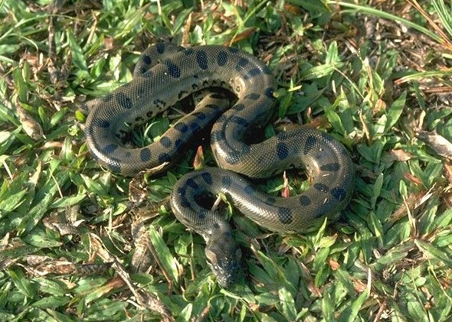
A green anaconda

I had a long conversation about green anacondas with Scholle one morning while he showed me the live 15-foot specimen in his own collection. The anaconda that Shealy had brought to him 10 years previously had refused to eat in captivity and died within a few months—which suggests the snake may have been born in the wild. Another green anaconda was later captured in the Everglades and given to Scholle. That snake gave birth to the behemoth wrapped around Scholle’s body as he spoke to me.
He pointed out that the Burmese pythons, as bad as their invasion seems, face a constraint on their numbers that the green anaconda doesn’t. The Everglades are riddled with another invasive species that has conquered most of the Gulf Coast: fire ants. Fire ants were brought to Gulf of Mexico ports accidentally by cargo ships from South America. They are notorious for attacking in swarms with extremely painful stings. Most ants have a bit of formic acid in their bite, but the fire ant also has a stinger equipped with a necrotizing venom.
Normally an animal stung by a fire ant will flee and survive. But creatures that can’t or won’t move away are at risk of being swarmed, killed, and eaten. Newborn calves are sometimes killed by fire ants before they can get to their feet. Burmese pythons are sometimes at a similar disadvantage. The females spend several months each year guarding their eggs by wrapping their bodies around them and defending against any would-be egg thieves. This places the python—and her leathery eggs—at risk of attack by marauding ants.
One Burmese python at Trail Lakes, captured in the wild and kept in a large outdoor enclosure, was swarmed by fire ants that tunneled up from beneath her while she guarded her eggs. By the end of the day she and her brood had been reduced to little more than scales and bones. Given the ubiquity of fire ants in the Everglades, it’s imaginable that the ants are limiting the population growth of the pythons.
The green anaconda does not have this problem. Unlike its smaller relative, the anaconda gives birth to live young rather than laying eggs. It can easily slither away from fire ant bites. What’s more, the anaconda would be less likely to encounter fire ants in the first place. Unlike the Burmese pythons, which are found on land and in trees as often as in the water, the green anaconda is an almost wholly aquatic snake. Perhaps this is why the green anaconda can afford to be about 50 percent heavier than a python of the same length. All of that enormous bulk is borne by the water most of the time.
Really large anacondas are rarely reported by white people, but African-Americans who live in or near the Everglades tell stranger stories. White people there usually go fishing the same way that I do—noisily and conspicuously. Standing up, constantly casting, and moving along to new spots when nothing is happening. But African-Americans of the Everglades have different fishing traditions. They sit very still and quietly along the water for a very long time with a piece of live or cut bait under a bobber. Waiting. When you wait quietly in nature that way, you tend to see things that other people don’t see. Like a great green and black snake as big around as a Hula Hoop, gliding slowly and smoothly past you through the dark water, so close you could almost touch it.
These stories of what could be record-breaking snakes are impossible to substantiate. Eyewitnesses are usually alone, and everything grows in a fisherman’s recollections. In most environments, a snake that large would be difficult to hide. But in the Everglades, living almost entirely in the water, a number of snakes large enough to swallow a man could spend their whole lives without ever being photographed or captured.
It is impossible to contemplate a snake so large without wondering whether it would swallow a human. The evidence for this ever having happened anywhere in the world is sketchy, but then again I suspect that the anacondas haven’t been filing their reports diligently and the victims have also been slow to talk.
Green anacondas haven’t gained much attention as an invasive species, but the state of Florida has become concerned enough about them that photos for identification were included in the study guide that I was assigned before participating in the “Python Challenge” hunting contest. Based on the specimens that people I’ve spoken to have collected, I am convinced that a breeding population of anacondas has become established. The questions are how many there are and how big they can really get.
In the long run, anacondas make the Burmese pythons look like garter snakes. Between their advantage over fire ants, sneaky aquatic lifestyle, and sheer size that discourages even the largest of alligators from messing with them, the green anaconda could eventually prove to be the biggest problem in the United States’ wildest place.

Boston Globe
A gilded goodbye for many private college leaders
Presidents’ retirement pay and perks can run into the millions, one more driver of soaring college tuition costs
by Todd Wallack

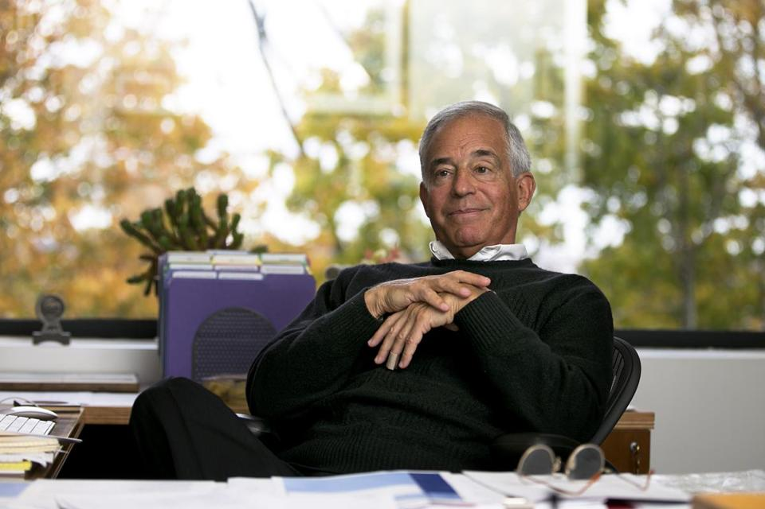
Jehuda Reinharz, former president of Brandeis University, has remained among the highest paid people on campus.
When Brandeis University president Jehuda Reinharz stepped down three years ago, he moved back into his old faculty office.
But unlike most history professors, Reinharz does not teach any classes, supervise graduate students, or attend departmental meetings. He did not bother posing for the department photo. The chairwoman for Near Eastern and Judaic Studies said she did not even know whether he was officially a member of her department.
Yet Reinharz remains one of the highest paid people on campus.
He received more than $600,000 in salary and benefits in 2011, second only to the new Brandeis president, according to the school’s most recent public tax returns. And that’s on top of the $800,000 Reinharz earned in his new job as president of the Mandel Foundation, a longtime Brandeis benefactor.
“There is puzzlement from faculty about why he gets paid at all” by Brandeis, said Gordon Fellman, a sociology professor at Brandeis. “His term as president ended.”
Like Reinharz, many other college presidents across the country are negotiating huge exit packages when they step down, which critics say is emblematic of schools’ unrestrained spending on everything from administrative salaries to elaborate new buildings that drive up the cost of higher education. Schools and public records say:
Lawrence S. Bacow, president emeritus of Tufts, received $1.7 million in 2011 for “end of service compensation.” At Harvard, president Lawrence Summers kept his presidential salary of $580,000 for several years after he stepped down in 2006 (even as he earned millions working for a hedge fund). And Wellesley College had two former presidents on its payroll in the last six years, including one who received $430,000 a year for two years after she retired and her duties ended.
Reinharz, formerly one of the best paid college presidents in the country, has received at least $1.2 million more from Brandeis since his 2010 retirement and is in line to receive hundreds of thousands more in coming years.
“We’re seeing more and more of these farewell packages to presidents,” said Andrew Gillen, senior researcher with Education Sector at American Institutes for Research, a Washington think tank. “It’s symbolic of the growth of the cost of college.”
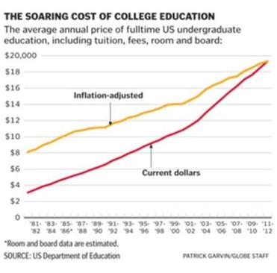
Rising administrative expenses are one reason that the average cost of higher education has soared 70 percent during the past decade — twice the rate of inflation — and elite schools such as Brandeis now charge nearly $60,000 a year or more for tuition, room, and board. The number of college administrative jobs has increased 57 percent during 10 years while pay for university presidents has ballooned, with dozens of college leaders receiving at least $1 million a year.
Some Brandeis officials defend the deal with Reinharz, saying it was crucial to retain his expertise to help with the transition to a new president who had not previously worked at Brandeis. They also wanted his help to maintain relations with major donors.
“He knows how to raise money,” said Jack Connors, who was vice chairman of the board when it signed an agreement to keep paying Reinharz after he stepped down.
Reinharz argued that he deserved the post-presidential pay as a reward for his past achievements as president, saying that he raised more money for the school during his 16-year-tenure than all previous presidents combined, and that he upgraded the campus infrastructure and improved the university’s academic standing.
“I am compensated according to my accomplishments,” said Reinharz in an interview at his Brandeis office. “It’s the way America usually works.”
While it is hard to find data on the typical pay for former college presidents, educational watchdogs say they have seen more reports of outgoing leaders receiving golden parachutes, including:
■ Highly paid sabbaticals and new jobs. Some schools are now giving outgoing leaders year-long leaves at their administrative pay, and then keeping them on as professors or advisers at elevated salaries. Former University of Massachusetts president Jack Wilson kept his presidential salary of $425,000 during a yearlong sabbatical after stepping down to become a professor at University of Massachusetts Lowell, where he now earns $269,180.
■ Hefty severance and other lump sum payments. Suffolk University president David J. Sargent, who left in 2010, received $854,085 in 2011, mostly for severance. And former Amherst College president Anthony W. Marx received $1.4 million after he retired in 2011, mostly for deferred compensation he accrued during his eight-year presidency and a sabbatical he never took.
■ Generous retirement pay. Some former leaders receive significant pensions, free housing, or other retirement perks. Northeastern University president emeritus Richard M. Freeland, who resigned in 2006, receives an annual pension of $209,690, in addition to the $30,000 he earns some years to teach a history class.
Such exit packages have long been a staple at major corporations. But former Boston University chief John Silber helped pioneer the practice of handsomely compensating former presidents in higher education. Silber persuaded the school to place him in the long vacant job of chancellor when he retired as president in 1996, where he continued to earn more than most college presidents. Even after giving up the chancellorship in 2003, he received $6.1 million in 2005, mostly for deferred compensation promised years earlier. He continued to reside in a 10-bedroom university home until his death last year.
While Silber’s post-presidential deal was considered exceptional, some say such pay packages are becoming routine.
“It used to be egregious,” said Joshua Humphreys, a fellow at Tellus Institute, which has studied compensation at Massachusetts universities. “Now it’s just business as usual.”
However, Brandeis officials say the career of Reinharz, 69, is anything but usual. Born in Israel, Reinharz immigrated to the United States as a teenager, earning his doctorate in modern Jewish history at Brandeis in 1972, joining the faculty in 1982, and starting his run as the school’s second longest-serving president in 1994.
Reinharz ran into controversy near the end of his tenure after an aborted plan to close the campus art museum and sell the collection in 2009. But both Reinharz and former trustees say he was not pushed out.
“I left because I felt it was time for me to leave and because I had a great offer from the Mandel Foundation,” said Reinharz. “It was my decision.”
The new positions paid well, too.
Between his new deal with Brandeis and the Cleveland-based Mandel Foundation, which supports Jewish education and other causes, tax filings show that Reinharz made at least $1.4 million in 2011, more than he made in his final year as president.
The foundation, which pays for half of Reinharz’s office expenses, did not make it easy for the public to discover Reinharz’s pay, listing him as an unpaid board member on forms filed with the IRS, while staff said his compensation was confidential. But reports filed by three related Mandel family foundations suggest he earned a total of $800,000 in consulting fees in 2011, more than double what chief executives of similar-sized grantmaking organizations normally earn.
An attorney who advises nonprofits, Barbara K. Wheaton of Portland, Maine, said the Mandel foundations’ IRS reports appear to be inaccurate or misleading in claiming they did not pay employees or contractors more than $50,000 despite the hefty fees to Reinharz.
Reinharz, a member of the Mandel Foundation board, said he had never seen the group’s tax filings. But asked whether the $800,000 figure was accurate, Reinharz said only: “It could be. It could be.”
Separately, Brandeis signed what it called an “unprecedented” deal in 2009 to keep Reinharz on the university payroll after he stepped down — as president emeritus, the Richard Koret Professor of Modern Jewish History, and director of the Tauber Institute for the Study of European Jewry, which sponsors symposiums and publishes research.
As part of the pact, the university agreed to pay Reinharz $500,000 in salary in 2011, $287,500 a year through June 2014 and then $180,000 a year as a “half time professor.” The university also let him remain in the Brandeis president’s spacious home in Newton for six months after he stepped down.
And Reinharz could have earned even more if Brandeis had not clarified the agreement in 2012 to limit him to half time as president emeritus after 2011. Otherwise, Reinharz could have reported working full time in the position and collected $575,000 a year.
But it is unclear exactly how much work Reinharz does to earn all that money.
Reinharz has the title of president of the Mandel Foundation, which has given $50 million to Brandeis during the past two decades through its affiliates, leaving its name on landmarks all over campus. Barbara Mandel, the wife of foundation chairman Morton Mandel, is an officer on Brandeis’ board of trustees.
A Mandel staffer said Reinharz works for the foundation full-time, but Reinharz said he is actually a consultant without a set schedule.
“I don’t punch a clock,” said Reinharz, adding that his main job is to help the 92-year-old chairman, Morton Mandel. “I work when my work is needed.”
Reinharz was equally noncommittal about how much time he devotes to Brandeis, where he mainly works as an adviser to president Frederick Lawrence and other staffers. “I’ve never worked at Brandeis by the hour,” he said. Lawrence “asks for advice. I give it. And I don’t look at my watch.”
However, Reinharz confirmed that he spent the entire first year of Lawrence’s presidency on sabbatical, when presumably his advice would have been needed the most.
Joe Baerlein, the university spokesman, said Reinharz was expected to continue to help Lawrence during his sabbatical year, but “was excused from being on campus . . . so the spotlight would remain on president Lawrence and not on him.”
Reinharz said he helps raise money for Brandeis and introduces the new president to donors, but he declined to name any of the donors or estimate how much money he’s brought in.
“The money that is raised is Fred’s,” referring to Lawrence.
Finally, Reinharz said he regularly talks to faculty and students, but does not attend department meetings because he is too busy and does not want to overshadow other professors. His third Brandeis role, as director of the Tauber Institute, is also strictly advisory, says its executive director.
The one area where Reinharz was specific about how he spends his time was his own research, including a book he is co-writing on the history of the donkey in literature, arguing that the animal is often used as a substitute for people.
“There are smart donkeys, stupid donkeys, evil donkeys, etc., and no one has ever contemplated this on a large scale,” said Reinharz, who commissioned an artist to make a wood carving of a donkey that stands proudly on his desk. “It’s probably the most ambitious topic I have ever contemplated.”
While some college presidents negotiate their exit packages as part of their original contracts, Reinharz worked out his deal with Brandeis trustees when he decided to step down. The board got advice from Raymond Cotton , an attorney who often represents college presidents and provided Brandeis with a list of seven past presidents who remained on the payroll, including Silber at BU and Summers at Harvard.
But some professors asked why Reinharz is paid so much for what even the university acknowledges is part-time work.
“You can imagine how the faculty feels about this,” said Carol L. Osler, a business professor at Brandeis, noting that Brandeis was named after a leader in social justice. “One has to wonder if it is consistent with the values of Justice Louis Brandeis.”
And Brandeis is sensitive to the criticism. When the Globe started asking about Reinharz’s post-presidential pay, the university hired an outside public relations firm, Rasky Baerlein Strategic Communications — the same firm it hired four years ago to handle the museum controversy.
But not every college president steps down with a new job or lavish severance package.
When Edward A. Parrish retired as president of Worcester Polytechnic Institute in 2004, he asked for moving expenses and access to resources such as updated software.
“I didn’t ask for much,” said Parrish. “I think you can look at the others as outliers.”







